Model predictive control
- Modeling
Given a discrete dynamic system
$$x\left(t+k+1\right)=Φx\left(t+k\right)+Γu\left(t+k\right) (1) \\ y\left(t+k\right)=Cx\left(t+k\right)$$
with initial points $x(t)$,
and with constraints
$$x_{m}≤x\left(t+k\right)≤x_{M} (2) \\ u_{m}≤u\left(t+k\right)≤u_{M}$$
Find the optimal controller $u\left(t\right)$to minimize the cost function as
$$J = \min_{u}{\sum_{k=0}^{N-1}{q(x\left(t+k\right), u\left(t+k\right))}}$$
%%% Kim’s comment
Differences between finite interval optimal control
- Finite Time optimal Control Problem(FTO):
$$\min_{u}{J}{= \int_{t_{0}}^{t_{f}}{(x^{T}Qx+u^{T}R u)dt}}$$
Subject to
$$\dot{x}= Ax+Bu,$$
where $t_{0}, t_{f}$ are fixed.
Then the optimal controller is given by using HJB method,
$$u^{*}\left(t\right)= -R^{-1}B^{T}P\left(t\right)x$$
Here
$$-\dot{P}=Q+PA+A^{T}P-PBR^{-1}B^{T}P, P\left(t_{f}\right)= 0$$
Remember that in the finite horizon, the optimal controller is time varying, contrast the constant in the infinite horizon.

- Differences between MPC and FTO
- In FTO, $t_{f}$ is fixed. In MPC the time interval is fixed, i.e., $t_{f}-t_{0}=N$ is fixed. We may call MPC as a $receding horizon, or prediction horizon$ optimal problem.
- In FTO, initial point is fixed,$x(t_{0})$, but MPC , at every sampled time $x\left(t_{0}\right)=x(t)$,
- In FTO, the optimal controller $u^{*}(t)$, if it is founded, it will be $u^{*}\left(t\right), t∈[t_{0}, t_{f}]$, In MPC
at every sampled time $t$ with the measured value $x\left(t\right)$, which is the initial condition $x\left(t\right),$the optimal control $u^{*}(t)$ should be determined in $t ∈\left[ t, t+N\right)$, here $N$ is called as the receding horizon size, the window size and so on.
- In terminology, in FTO, with the optimal $u^{*}(t)$, the trajectory $x^{*}\left(t\right)$ is determined in $t∈[t_{0}, t_{f}]$. In MPC, with the different initial point $x(t)$and corresponding to the initial condition, the optimal controller $u^{*}\left(t\right)$ is not same.
- In general, FTO is without constraints as inequality constraints (2). There is NO closed form of the optimal solution with inequality constraints in general. In MPC, the solution is found by searching numerical method (recursively)
- MPC stands for Model Predictive Control. It may be misleading the “Predictive”. Let’s consider the following.
This is a little peculiar concept. Consider a system
$$\dot{x}\left(t\right)=Ax, x\left(0\right)=x_{0}$$
Then, $x\left(t\right)=e^{At}x\left(0\right)=e^{A\left(t-τ\right)}x\left(τ\right) , 0≤τ≤t$, which implies for any initial condition $x(τ)$, it is determined ! not predicted !
However in MPC frame, consider
$$\dot{x}\left(t\right)=Ax+Bu, x\left(t\right)=x_{0} , t∈[t, t+N)$$
And with some constraints, assume we may find $u^{*}\left(t\right)$, now at the next sampling time
$$\dot{x}\left(t\right)=Ax+Bu, x\left(t+t_{s}\right)=x_{s} , t∈[t_{s}, t_{s}+N)$$
with the same constraints, the optimal control $v^{*}\left(t\right)$ is different from $u^{*}\left(t\right)$ (Of course if $x_{s}=x_{0}$, then $v^{*}\left(t\right)=u^{*}\left(t\right)$, due to time-invariant).
- In other words, in the fixed time interval, if you find the optimal controller whose state trajectories follow the prescribed optimal trajectories, if the output of model is exact to the output of the system, we may not need to use MPC.
- However, if the optimal model output is different from the output of the measured plant, in this case there should be model errors or unpredicted noise and something, your optimal controller is not correct, so it should be corrected.
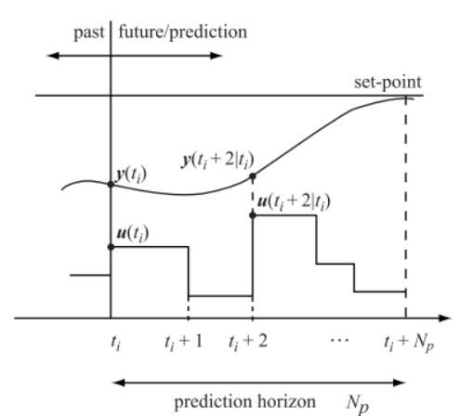
- In this sense, in MPC society it may called the prescribed trajectory ( future trajectory) as a predicted trajectory. Do not confuse the predict in Kalman filtering.[1],[2]

Or the other model as [2]
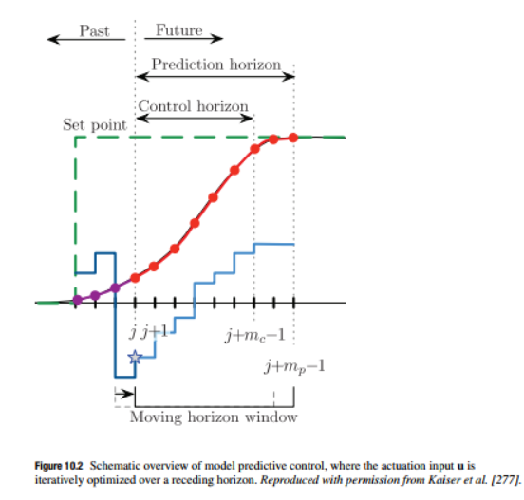

Here they define another variable as “control horizon”, the controller is calculate up to control horizon time, and the lest control up to prediction horizon, it keeps the constant”, In general, the control horizon is the same as the prediction horizon,
%%%
%%% Some math in MPC – Inequality constraint
The famous optimal solution without constraints in finite time interval is done by Hamitonian-Jacobian-Bell equations[1]. With constrains (more over inequality constraints), the optimal solution is difficult to get, so that recursive way(Dynamic Programming, Quadrature Programming,..) should be used numerically.
The Problem is
- Without constraints
$$\min{g\left(x,u\right)}$$
- With equality constraints
$$\min{g\left(x,u\right)}, subject to f\left(x,u\right)=0$$
- With inequality constraints
$$\min{g\left(x,u\right)}, subject to f\left(x,u\right)≤0$$
Those problem 1) and 2) are considered in the class. But 3) is not introduced. It is very, very difficult to solve analytically. In MPC 3) problem is considered. %%%
- The base math for MPC , Quadratic Program (QP)
2.1 Problem in Quadratic Program Optimization Problem
$$\min_{x}{\frac{1}{2}x^{T}Hx +f^{T}x}$$
Subject to:
$$Ax≤b$$
$$A_{eq}x=b_{eq}$$
$$l_{b}≤x≤u_{b}$$
2.2 Solutions
In [3], some introductions are there, and there are several algorithms are developed(in matlab, python,R,..) . As I said, it is not a simple problem. In our class, we may not develop the algorithms but just to use them which are already developed
2.3 In control frame
Since our control model is (in discrete time) is
Find
$$\min_{u}{J = \min_{u}{\sum{{\left(r-x\right)}^{T}Q\left(r-x\right)+∆u{\left(k\right)}^{T} R∆u\left(k\right)}}}$$
Subject to:
$$x\left(k+1\right)=Ax\left(k\right)+Bu\left(k\right) \\ y\left(k\right)=Cx(k)$$
$$lower bounds≤ x\left(k\right), y\left(k\right), u\left(k\right)≤ Upper bounds$$
Hence to adopt the QP algorithm, our control model should be modified as
First, if the plant model is continuous, change to discrete
Second, construct an augmented plant model suitable to use QP algorithms
Third, assuming the input is given, find the trajectories.
Forth, apply the QP algorithms
There are many algorithms so that you may not follow from the first to forth,
- Preliminary of MPC frame
  - Continuous to Discrete Model
Given a continuous model
$$\dot{x}=Ax+Bu \\ y=Cx$$
The equivalent discrete model with Zero-order –hold (ZOH) is
$$x\left(k+1\right)=Φx\left(k\right)+Γu\left(k\right) \\ y\left(k\right)=Cx\left(k\right)$$
where
$$Φ=e^{Ah}, Γ= \int_{0}^{h}{e^{Aη}Bdη}, h;the sample time$$
- HWeek_9_1
Given the plant
$$\dot{x}\left(t\right)= \left[\begin{matrix}0 & 1 & 0 \\ 3 & 0 & 1 \\ 0 & 1 & 0\end{matrix}\right]x+ \left[\begin{matrix}1 \\ 1 \\ 3\end{matrix}\right]u$$
$$y=\left[0 1 0\right]x$$
- Find the equivalent discrete model with ‘ZOH’ , sampling time= 1,
- Find the eigenvalues of the discrete model
- Simple Discrete-Time MPC frame
  - Construct Augmented System mode for MPC
Consider
$$x\left(k+1\right)=Φx\left(k\right)+Γu\left(k\right) \\ y\left(k\right)=Cx\left(k\right)$$
$Φ∈R^{n×n}, n:$the number of the state
$Γ∈R^{n×m}, m:$ the number of the control input
$C∈R^{p×n},p:$ the number of the measurement
Now then the increment of the state and inputs
$∆x\left(k+1\right)=Φ∆x\left(k\right)+Γ∆u\left(k\right)$
And
$$∆y\left(k+1\right)=C∆x\left(k+1\right)$$
$$=CΦ∆x\left(k\right)+CΓ∆u\left(k\right)$$
which is
$$y\left(k+1\right)=y\left(k\right)+CΦ∆x\left(k\right)+CΓ∆u\left(k\right)$$
combining these into one equation to obtain
$$\left[\begin{matrix}∆x(k+1) \\ y(k+1)\end{matrix}\right]=\left[\begin{matrix}Φ & 0 \\ CΦ & I_{p}\end{matrix}\right]\left[\begin{matrix}∆x(k) \\ y(k)\end{matrix}\right]+ \left[\begin{matrix}Γ \\ CΓ\end{matrix}\right]∆u(k)$$
Now we define an augmented system model as
Define
$$x_{a}\left(k\right)= \left[\begin{matrix}∆x(k) \\ y(k)\end{matrix}\right]$$
Let
$$Φ_{a}= \left[\begin{matrix}Φ & 0 \\ CΦ & I_{p}\end{matrix}\right], Γ_{a}=\left[\begin{matrix}Γ \\ CΓ\end{matrix}\right], C_{a}= \left[\begin{matrix}0 & I_{p}\end{matrix}\right]$$
So that
$$x_{a}\left(k+1\right)=Φ_{a}x_{a}\left(k\right)+Γ_{a}∆u\left(k\right) (3) \\ y\left(k\right)=C_{a}x_{a}(k)$$
- HWeek_9_2
- From HWeek_9_1, construct the state-space model as (3)
- Find eigenvalues of 1) and compare with the e-values of 9_1
  - The solution to (3)
Suppose at each sampling time $k$, it is known a control sequence
$$∆u\left(k\right), ∆u\left(k+1\right),…,∆u(k+N_{p}-1)$$
where $N_{p}$ is the size of the prediction horizon. Find a predicted states as
$$x_{a}\left(k+1 | k\right), x_{a}\left(k+2 | k\right),…,x_{a}(k+N_{p}|k)$$
First
$$x_{a}\left(k+1 | k\right)=Φ_{a}x_{a}\left(k\right)+Γ∆u\left(k\right) \\ x_{a}\left(k+2 | k\right)=Φ_{a}x_{a}\left(k+1\right)+Γ∆u\left(k+1\right) \\ x_{a}\left(k+1 | k\right)=Φ_{a}^{2}x_{a}\left(k\right)+Φ_{a}Γ_{a}∆u\left(k\right)+Γ_{a}∆u\left(k+1\right)$$
$$⋮$$
$$x_{a}\left(k+N_{p} | k\right)=Φ_{a}^{N_{p}}x_{a}\left(k\right)+Φ_{a}^{N_{p}-1 }Γ_{a}∆u\left(k\right)+…+Γ_{a}∆u\left(k+N_{p}-1\right)$$
In the matrix form as
$$\left[\begin{matrix}x_{a}(k+1|k) \\ x_{a}(k+2|k) \\ \begin{matrix}⋮ \\ x_{a}(k+N_{p}|k)\end{matrix}\end{matrix}\right]=\left[\begin{matrix}Φ_{a} \\ Φ_{a}^{2} \\ \begin{matrix}⋮ \\ Φ_{a}^{N_{p}}\end{matrix}\end{matrix}\right]x_{a}\left(k\right)+\left[\begin{matrix}Γ_{a} & & \\ Φ_{a}Γ_{a} & Γ_{a} & \\ \begin{matrix}⋮ \\ Φ_{a}^{N_{p}-1}Γ_{a}\end{matrix} & \begin{matrix}⋱ \\ …\end{matrix} & \begin{matrix} \\ Γ_{a}\end{matrix}\end{matrix}\right]\left[\begin{matrix}∆u(k) \\ ∆u(k+1) \\ \begin{matrix}⋮ \\ ∆u\left(k+N_{p}-1\right)\end{matrix}\end{matrix}\right]$$
The output is
$$Y={Wx}_{a}\left(k\right)+Z∆U (4)$$
Where
$$Y=\left[\begin{matrix}y\left(k+1 | k\right) \\ y\left(k+2 | k\right) \\ \begin{matrix}⋮ \\ y\left(k+N_{p} | k\right)\end{matrix}\end{matrix}\right] , ∆U=\left[\begin{matrix}∆u\left(k\right) \\ ∆u\left(k+1\right) \\ \begin{matrix}⋮ \\ ∆u\left(k+N_{p}-1\right)\end{matrix}\end{matrix}\right]$$
$$W=\left[\begin{matrix}C_{a}Φ_{a} \\ {C_{a}Φ}_{a}^{2} \\ \begin{matrix}⋮ \\ C_{a}Φ_{a}^{N_{p}}\end{matrix}\end{matrix}\right] , Z=\left[\begin{matrix}Γ_{a} & & \\ Φ_{a}Γ_{a} & Γ_{a} & \\ \begin{matrix}⋮ \\ Φ_{a}^{N_{p}-1}Γ_{a}\end{matrix} & \begin{matrix}⋱ \\ …\end{matrix} & \begin{matrix} \\ Γ_{a}\end{matrix}\end{matrix}\right]$$
%%% Kim’s comment
Look at (the equation (4), which are the solution trajectories of the difference equation (3), in other word, to adapt QP, the real plant, which may be continuous, is transformed to the algebraic equation as (4) %%%
- The Optimal controller without constraints
Assume, Cost function is
$$J\left(∆U\right)=\frac{1}{2}{\left(r_{p}-Y\right)}^{T}Q\left(r_{p}-Y\right)+\frac{1}{2}∆U^{T}R∆U , Q>0, R>0$$
Then the first order necessary condition (FONC) is
$$\frac{∂J}{∂U}=-{\left(r_{p}-Wx_{a}-Z∆U\right)}^{T}QZ+∆U^{T}R=0$$
- $∆U^{*}={\left(R+Z^{T}QZ\right)}^{-1}Z^{T}Q\left(r_{p}-Wx_{a}\right) (21)$
The second derivative for sufficient condition (SONC) is
$$\frac{∂^{2}J}{∂U^{2}}=R+Z^{T}QZ>0$$
Hence $∆U^{*}$ is a strict minimizer of $J$
Now from (21)
$$∆u\left(k\right)= \left[\begin{matrix}I_{m} & O & \begin{matrix}… & O\end{matrix}\end{matrix}\right]{\left(R+Z^{T}QZ\right)}^{-1}Z^{T}Q(r_{p}-Wx_{a}) \\ =K_{r}r_{p}-K_{x}∆x\left(k\right)-K_{y}y(k)$$
Where
$$K_{r}= \left[\begin{matrix}I_{m} & O & \begin{matrix}… & O\end{matrix}\end{matrix}\right]{\left(R+Z^{T}QZ\right)}^{-1}Z^{T}Q, K_{x}=K_{r}W\left[\begin{matrix}I_{n} \\ 0\end{matrix}\right]$$
$$K_{y}=K_{r}W\left[\begin{matrix}0 \\ I_{p}\end{matrix}\right]$$
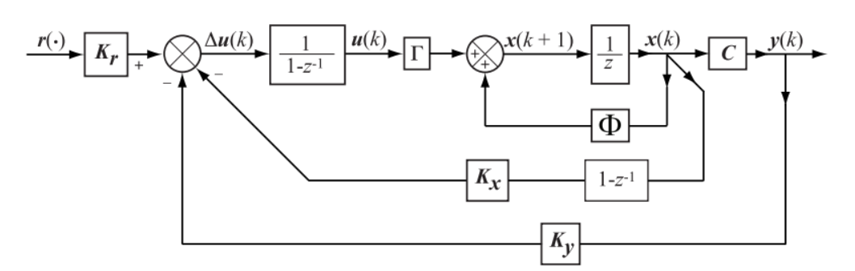

%%% Kim’s comment
In the above Block Daigram
- Gains:
-$K_{r}:$ the pre-compensator
-$K_{x}:$ the state feedback
-$K_{y}:$ the output feedback
- The filters
- In the state loop; there are two filters.
In the feedback loop : $(1-z^{-1})$
In the feedforward loop: $\frac{1}{1-z^{-1}}$
Hence the state loop, the overall filter is identity
- In the output loop: there is one filter as
$$1/(1-z^{-1})$$
This is the integral filter, since
$$y\left(t\right)= \int{x(t)}dt$$
- $y\left(k\right)= \sum_{l=1}^{l=k}{x\left(l\right)}= \sum_{l=1}^{l=(k-1)}{x(l)}+x\left(k\right)=y\left(k-1\right)+x(k)$
- $Y\left(z\right)=z^{-1}Y\left(z\right)+X\left(z\right)$
- $Y\left(z\right)=\frac{1}{1-z^{-1}}X\left(z\right)$ i.e., $\frac{1}{1-z^{-1}}$ is the discrete integrator.
- In conclusion , in this BD, to reduce the reference error we use the precompensator and the integral filter(controller)
- In the frame of MPC , the in-equality constraints asre in general as
- The amplitude of the control
$$u^{min}≤u\left(k\right)≤u^{max}$$
- The amplitude of the increament of the control
$$∆u^{min}≤∆u\left(k\right)≤{∆u}^{max}$$
- The amplitude of the output
$$y^{min}≤y\left(k\right)≤y^{max}$$
The reason the argumented transfrom model from the original plant model is due to the constraint of the increament of the control.
[1] https://engineering.purdue.edu/~zak/ECE680/MPC_handout.pdf
[2] Brunton, “Data-Drive Science and Engineering”.Chapter 10.1

