Model predictive control-2
- Simple Discrete-Time MPC frame
  - Construct Augmented System mode for MPC
Consider
$$x\left(k+1\right)=Φx\left(k\right)+Γu\left(k\right) \\ y\left(k\right)=Cx\left(k\right)$$
$Φ∈R^{n×n}, n:$the number of the state
$Γ∈R^{n×m}, m:$ the number of the control input
$C∈R^{p×n},p:$ the number of the measurement
Now then the increment of the state and inputs
$∆x\left(k+1\right)=Φ∆x\left(k\right)+Γ∆u\left(k\right)$
Define
$$x_{a}\left(k\right)= \left[\begin{matrix}∆x(k) \\ y(k)\end{matrix}\right]$$
Let
$$Φ_{a}= \left[\begin{matrix}Φ & 0 \\ CΦ & I_{p}\end{matrix}\right], Γ_{a}=\left[\begin{matrix}Γ \\ CΓ\end{matrix}\right], C_{a}= \left[\begin{matrix}0 & I_{p}\end{matrix}\right]$$
So that
$$x_{a}\left(k+1\right)=Φ_{a}x_{a}\left(k\right)+Γ_{a}∆u\left(k\right) (3) \\ y\left(k\right)=C_{a}x_{a}(k)$$
  - The solution to (3)
The output is
$$Y={Wx}_{a}\left(k\right)+Z∆U (4)$$
- The Optimal controller without constraints
Assume, Cost function is
$$J\left(∆U\right)=\frac{1}{2}{\left(r_{p}-Y\right)}^{T}Q\left(r_{p}-Y\right)+\frac{1}{2}∆U^{T}R∆U , Q>0, R>0$$
$$∆u\left(k\right)= \left[\begin{matrix}I_{m} & O & \begin{matrix}… & O\end{matrix}\end{matrix}\right]{\left(R+Z^{T}QZ\right)}^{-1}Z^{T}Q(r_{p}-Wx_{a}) \\ =K_{r}r_{p}-K_{x}∆x\left(k\right)-K_{y}y(k)$$
if we consider only $∆u(k)$, then
$$K_{r}= \left[\begin{matrix}I_{m} & O & \begin{matrix},… & O\end{matrix}\end{matrix}\right]{\left(R+Z^{T}QZ\right)}^{-1}Z^{T}Q, K_{x}=K_{r}W\left[\begin{matrix}I_{n} \\ 0\end{matrix}\right]$$
$$K_{y}=K_{r}W\left[\begin{matrix}0 \\ I_{p}\end{matrix}\right]$$
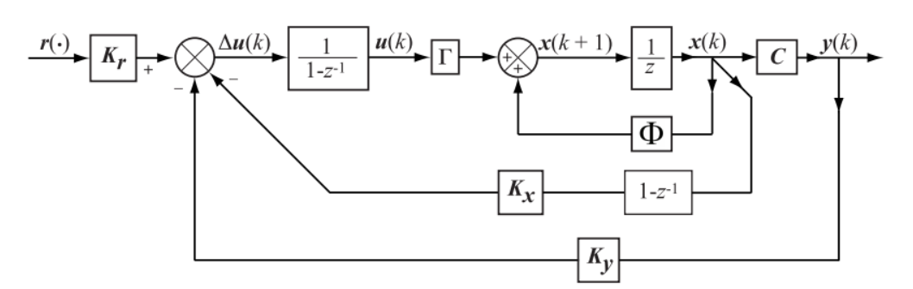

%%% Kim’s comment
In the above Block Daigram
- Gains:
-$K_{r}:$ the pre-compensator
-$K_{x}:$ the state feedback
-$K_{y}:$ the output feedback
- The filters
- In the state loop; there are two filters.
In the feedback loop : $(1-z^{-1})$
In the feedforward loop: $\frac{1}{1-z^{-1}}$
Hence the state loop, the overall filter is identity
- In the output loop: there is one filter as
$$1/(1-z^{-1})$$
- Change into MPC frame with constraints
  - Constraints on the Rate of Change of the Control Action
The constraints on the control at the time $k$ are as
$${∆u}_{i}^{min}≤{∆u}_{i}≤∆u_{i}^{max}, i=1,2,…,m$$
These are in a vector form
$$∆u^{min}≤∆u\left(k\right)≤∆u^{max}$$
which is equivalent to
$$\left[\begin{matrix}-I_{m} \\ I_{m}\end{matrix}\right]∆u\left(k\right)≤ \left[\begin{matrix}-∆u^{min} \\ ∆u^{max}\end{matrix}\right] (25)$$
If at all sampling times there are constraints, it is
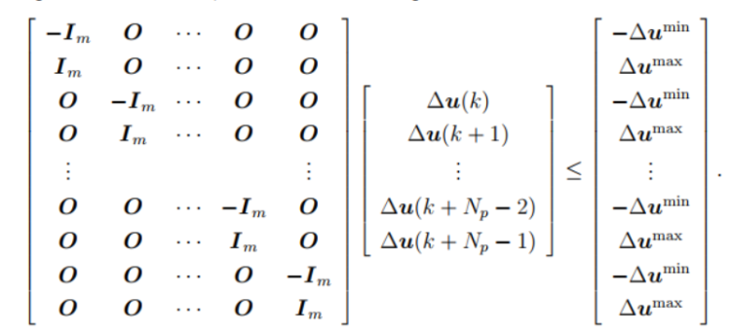

If the constraint are imposed only on the first component,
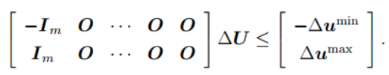

  - Constraints on the Control Action Magnitude
The constraints are
$$u_{i}^{min}≤u_{i}\left(k\right)≤u_{i}^{max}$$
Then
$$u\left(k\right)=u\left(k-1\right)+∆u(k) \\ =u\left(k-1\right)+\left[I_{m} 0,…,0\right]∆U$$
Similarly
$$u\left(k+1\right)=u\left(k\right)+∆u(k+1) \\ =u\left(k-1\right)+\left[I_{m} I_{m},…,0\right]∆U$$
Continue to get
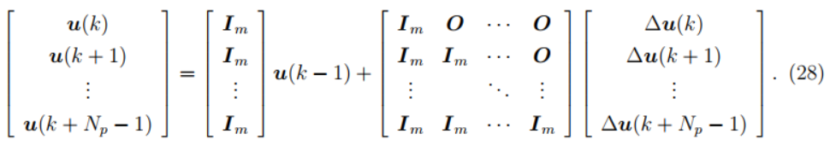

Then (28) is in the form
$$U=Eu\left(k-1\right)+H∆U (29)$$
Hence if there is an inequality constraints as
$$U^{min}≤U≤U^{max}$$
which is
$$\left[\begin{matrix}-U \\ U\end{matrix}\right]≤ \left[\begin{matrix}-U^{min} \\ U^{max}\end{matrix}\right]$$
Using (29)
$$\left[\begin{matrix}-(Eu\left(k-1\right)+H∆U) \\ (Eu\left(k-1\right)+H∆U)\end{matrix}\right]≤ \left[\begin{matrix}-U^{min} \\ U^{max}\end{matrix}\right]$$
Which is in turn
$$\left[\begin{matrix}-H \\ H\end{matrix}\right]∆U≤ \left[\begin{matrix}-U^{min}+Eu\left(k-1\right) \\ U^{max}- Eu\left(k-1\right)\end{matrix}\right] (31)$$
If we consider only the first component,
$$\left[\begin{matrix}-I_{m} 0…0 \\ I_{m} 0…0\end{matrix}\right] ∆U≤ \left[\begin{matrix}-U_{min}+Eu\left(k-1\right) \\ U^{max}-Eu\left(k-1\right)\end{matrix}\right] (32)$$
  - Constraints on the Plant Output
Consider the output in (19)
$$Y={Wx}_{a}(k)+Z∆U$$
The constraints are
$$Y^{min}≤Y≤Y^{max}$$
These will be
$$\left[\begin{matrix}-Z \\ Z\end{matrix}\right]∆U≤ \left[\begin{matrix}-Y^{min}+Wx_{a}\left(k\right) \\ Y^{max}-Wx_{a}\left(k\right)\end{matrix}\right]$$
%%% Kim’s comments:
As you see, the constraints are all in the form as
$$∆u^{min}≤∆u\left(k\right)≤∆u^{max} -→\left[\begin{matrix}-I_{m} \\ I_{m}\end{matrix}\right]∆u\left(k\right)≤ \left[\begin{matrix}-∆u^{min} \\ ∆u^{max}\end{matrix}\right] \\ U^{min}≤U≤U^{max} -→\left[\begin{matrix}-I_{m} 0…0 \\ I_{m} 0…0\end{matrix}\right] ∆U≤ \left[\begin{matrix}-U_{min}+Eu\left(k-1\right) \\ U^{max}-Eu\left(k-1\right)\end{matrix}\right] for only u(k) \\ Y^{min}≤Y≤Y^{max} -→ \left[\begin{matrix}-Z \\ Z\end{matrix}\right]∆U≤ \left[\begin{matrix}-Y^{min}+Wx_{a}\left(k\right) \\ Y^{max}-Wx_{a}\left(k\right)\end{matrix}\right]$$
which is
$$A∆U≤B$$
This is the basic MPC formulation. %%%
- An Optimizer for solving Constrained Optimization problems
  - Problem
$$\min{J\left(∆U\right)}$$
subject to
$$g\left(∆U\right)≤0$$
  - Unconstrained Problem
Consider the miminization of the cost function
$$\min{J\left(∆U\right)}$$
The cost function is an any smooth function, i.e., linear , non-linear but smooth.
%% Kim’s Comment
If the cost function is a quadratic form, it may have the closed form, as
$$J ={\left(x_{1}-1\right)}^{2}+{\left(3x_{2}-1\right)}^{2}$$
%%%
- Gradient Method
- Theorem 1
At a given point $x^{\left(0\right)}$, the vector
$$v= -∇f(x^{\left(0\right)})$$
points in the direction of most rapid decrease of $f$ and the rate of increase of $f$ at $x^{\left(0\right)}$ in the direction $v$ is $-\left\|∇f(x^{\left(0\right)})\right\|$, equivalently, the rate of decrease of $f$ at $x^{\left(0\right)}$ in the direction $v$ is $\left\|∇f(x^{\left(0\right)})\right\|$
- Recursive way
$$x^{\left(k+1\right)}=x^{k}-α∇f(x^{\left(k\right)})$$
where $α>0$ is a step size
- Newton’s method
- Theorem 2
Suppose that $f\left(x\right), f^{'}\left(x\right), f''(x)$ exist on the closed interval $\left[a,b\right]= \left\{x∈R:a≤x≤b\right\}.$ If $x^{*}, x$ are any two different points of $\left[a,b\right],$then there exists a point $z$ strictly between $x^{*}$ and $x$ such that
$$f\left(x\right)=f\left(x^{*}\right)+f^{'}\left(x^{*}\right)\left(x-x^{*}\right)+\frac{f^{''}\left(z\right)}{2}{\left(x- x^{*}\right)}^{2} (a)$$
%%% Kim’s comment
Compare to taylor series, the function is approximated by a finite polynomial order with a unknown point $z$ in the finite interval.
Now in (a) if
- $f^{'}\left(x^{*}\right)=0$ and
- $f^{''}\left(x^{*}\right)>0$
Then $x^{*}$ is a local minimizer of $f$
The condition i) means $x^{*}$ is satisfied the necessary condition of the optimal condition. And the condition ii) means $x^{*}$ is the sufficient condition of the minimal condition. For example
$$\min_{x}{f}={x\left(x-1\right)}^{2}$$
- Necessary condition : $\frac{df}{dx}=0 -→$
$$\frac{df}{dx}= {\left(x-1\right)}^{2}+x\left(2\right)\left(x-1\right)=\left(x-1\right)\left(\left(x-1\right)+2x\right)=(x-1)(3x-1)$$
Hence $x^{*}=\frac{1}{3} , 1$
- Sufficient condition : $\frac{d^{2}f}{dx^{2}}>0$
$$\frac{d^{2}f}{dx^{2}}=\left(3x-1\right)+3\left(x-1\right)=6x-4$$
For $x^{*}=\frac{1}{3}, \frac{d^{2}f}{dx^{2}}|_{x^{*}=\frac{1}{3}} =2-4<0$--> not minimum
For $x^{*}=1, \frac{d^{2}f}{dx^{2}}|_{x^{*}=1} =6-4>0$--> minimum
%%%%
- Newton’s method
- Define
$$q\left(x\right)=f\left(x^{*}\right)+∇f{\left(x^{*}\right)}^{T}\left(x-x^{*}\right)+\frac{1}{2}{\left(x-x^{*}\right)}^{T}F\left(x^{*}\right)\left(x-x^{*}\right)$$
Then $q\left(x^{*}\right)=f\left(x^{*}\right), ∇q\left(x^{*}\right)=∇f\left(x^{*}\right)$ and the Hessian of $q$
$$\left[\begin{matrix}\frac{∂^{2}q}{∂x_{1}^{2}} & \frac{∂^{2}q}{∂x_{1}∂x_{2}} & \begin{matrix}… & \frac{∂^{2}q}{∂x_{1}x_{n}}\end{matrix} \\ ⋮ & ⋮ & ⋮ \\ \frac{∂^{2}q}{∂x_{n}∂x_{1}} & \begin{matrix}\frac{∂^{2}q}{∂x_{n}∂x_{2}} & …\end{matrix} & \frac{∂^{2}q}{∂x_{n}^{2}}\end{matrix}\right]$$
Is the same to the Hessian of $f$
- The problem is to find $x^{*}$
- Assume $x_{k+1}=x_{k}+∆x$ around $x^{*}$
Then
$$q\left(x_{k+1}\right) \sim f\left(x_{k}\right)+∇f\left(x_{k}\right)∆x+\frac{1}{2}{∆x}^{T}F\left(x_{k}\right)∆x$$
which is minimum for all $∆x$, implies
$$\frac{∂q\left(x_{k+1}\right)}{∂\left(∆x\right)}=∇f\left(x_{k}\right)+F\left(x_{x}\right)∆x=0$$
- $∆x^{*}=F{\left(x_{k}\right)}^{-1}∇f\left(x_{k}\right)$
- To find $x^{*}$ , using recursive method
$$x^{k+1}=x^{k}-∆x^{k}$$
Where
$$F\left(x^{k}\right)∆x^{k}= ∇f\left(x^{k}\right), i.e., ∆x^{k}={\left(F\left(x^{k}\right)\right)}^{-1}∇f(x^{k})$$
%%% Kim’s comment in multivariable calculus
Assume $f\left(x\right) , x∈R^{n}$ then
- Gradient : $∇f = {\left[\frac{∂f}{∂x_{1}}, …,\frac{∂f}{∂x_{n}}\right]}^{T}$
- Hessian ; $\left[\begin{matrix}\frac{∂^{2}f}{∂x_{1}^{2}} & \frac{∂^{2}f}{∂x_{1}∂x_{2}} & \begin{matrix}… & \frac{∂^{2}f}{∂x_{1}x_{n}}\end{matrix} \\ ⋮ & ⋮ & ⋮ \\ \frac{∂^{2}f}{∂x_{n}∂x_{1}} & \begin{matrix}\frac{∂^{2}f}{∂x_{n}∂x_{2}} & …\end{matrix} & \frac{∂^{2}q}{∂x_{n}^{2}}\end{matrix}\right]$
- Laplacian $∇^{2}f$= Trace of Hessian = $\frac{∇^{2}f}{∂x_{1}^{2}}+ ,,,+\frac{∇^{2}f}{∂x_{n}^{2}}$
Assume $f_{i}\left(x\right), x∈R^{n}, i=1,2,…, m$
- Jacobian : $Jac of f= J =\left[∇f_{1} ,…, ∇f_{m} \right]= \left[\begin{matrix}\frac{∂f_{1}}{∂x_{1}} & … & \frac{∂f_{m}}{∂x_{1}} \\ ⋮ & ⋮ & ⋮ \\ \frac{∂f_{1}}{∂x_{n}} & … & \frac{∂f_{m}}{∂x_{n}}\end{matrix}\right]$
%%%%%
- Minimization Subject to Equality Constraints
  - Lagrange Multipliers
- Problem
$$\min_{x}{f\left(x\right)} , x∈R^{n}$$
Subject to
$$h_{i}\left(x\right)=0, i=1,2,…, M , M≤N$$
- Termilogy
- Regular points (or a critical point)
$x^{*}$ is a regular points if
- $h\left(x^{*}\right)=0 ,$
- the gradient vectors $∇h_{1}\left(x^{*}\right),…, ∇h_{M}(x^{*})$ are linearly independent
- Theorem
Let $x^{*}$ be a local minimizer(or maximizer) of $f$ subject to the constraints $h\left(x\right)=0$ and $x^{*}$ be a regular point of the constrinats. Then
$∃ λ^{*}$ such that
$$∇f\left(x^{*}\right)+ \left\lceil ∇h_{1}\left(x^{*}\right), …., ∇h_{M}\left(x^{*}\right)\right\rceil λ^{*}=0$$
%%% Kim’s comment : the lagrange multiplier
$$l\left(x\right)≡ f\left(x\right)+λ^{T}h\left(x\right)$$
- $λ:$ the lagrange multiplier %%%
  - Newton’s method
Consider following the minization problem
$$\min_{x}{f\left(x\right), x∈R^{n}}$$
Subject to
$$h_{i}\left(x\right)=0, i=1,2,…,m$$
- Define the lagrange multiplier vector as $λ$
$$l=f\left(x\right)+λ^{T}H$$
- Calculate the Hessian $L (x,λ)$ and Jacobian $D(H\left(x\right))$
- Assume iinitial point as ${(x}^{0}, λ^{0})$
- Find the $(x^{1}, λ^{1})$ as
$$\left[\begin{matrix}x^{1} \\ λ^{1}\end{matrix}\right]=\left[\begin{matrix}x^{1} \\ λ^{1}\end{matrix}\right]= \left[\begin{matrix}x^{0} \\ λ^{0}\end{matrix}\right]+ \left[\begin{matrix}d^{0} \\ y^{0}\end{matrix}\right]$$
where $d^{0}, y^{0}$ satifsy the linear matrix equation
$$\left[\begin{matrix}L(x^{0},λ^{0}) & D{\left(H\left(x^{0}\right)\right)}^{T} \\ D\left(H\left(x^{0}\right)\right) & 0\end{matrix}\right]\left[\begin{matrix}d^{0} \\ y^{0}\end{matrix}\right]= \left[\begin{matrix}-∇_{x}l(x,λ) \\ -H(x^{0})\end{matrix}\right]$$
- Repeat $x^{k}, λ^{k}$ until $(x^{k+1}, λ^{k+1}) \sim ( x^{k}, λ^{k})$
  - Another methos; A Lgrangian Algorithm
$$x^{k+1}=x^{k}-α_{k}\left(∇f(x^{k}\right)+D{\left(H\left(x\right)\right)}^{T}λ^{k}) \\ λ^{k+1}=λ^{k}+β_{k}H(x_{k})$$
Where $α_{k}, β_{k}$ are positive numbers.

[1] https://engineering.purdue.edu/~zak/ECE680/MPC_handout.pdf

