1. Batch and Recursive type estimators

Consider

$$z=x+v , x\sim N\left(3,1\right), v\sim N(0,1/2)$$

We have three measurements of $z$ =(1,-1,3).

1.1 Find $E\left[x | z\right]$ using batch type process (Hint: (3.14) in the textbook)

* 1. Find using recursive type process (Hint: (3.32) in the textbook)

1. (Kalman Filter) Scalar case : Example 3.9

Suppose that you are driving a car for precisely one hour. To estimate your driving distance, there are two measurements. One by a trip meter whose quantization is 0.1meters is 61km. The other one by a velocity meter whose quantization is 1km is constant as 60km during your driving. Estimate your driving distance.

1. (Kalman Filter) Vector case: Example 3.10

To estimate Satellite Attitude, consider the dynamics, an angular deviation $θ$, the control input $u$, the disturbance $w$, are governed by

$$\ddot{θ}=u+w, w \sim N(0,1)$$

which is in state – space form as

$$\left[\begin{matrix}\dot{θ} \\ \ddot{θ}\end{matrix}\right]=\left[\begin{matrix}0 & 1 \\ 0 & 0\end{matrix}\right]\left[\begin{matrix}θ \\ \dot{θ}\end{matrix}\right]+ \left[\begin{matrix}0 \\ 1\end{matrix}\right]u\left(t\right)+\left[\begin{matrix}0 \\ 1\end{matrix}\right]w\left(t\right) (1)$$

with the real initial values of

$$\left[θ, \dot{θ }\right]=[0.01, -0.001]$$

Now at every $T$ seconds , the measurement $y(kT)$ is

$$y\left(kT\right)=θ\left(kT\right)+v\left(kT\right), v \sim N(0,1)$$

3.1 Find the discrete time system of (1)

3.2 To design the Kalman filter, construct the prediction and correction states discrete time dynamic system equation

3.3 Assume the initial state estimate as

$${\hat{x}}_{0}=\left[0, 0\right], P_{0}=[\begin{matrix}10 & 0 \\ 0 & 10\end{matrix} ]$$

what is the prediction states characteristics i.e., ${\overline{x}}_{1} , M_{1}$

3.4. Construct the kalman filter algorithm, then find the estimator at $t=10T, T=1$

3.5 (Discretization) construct the equivalent the discrete system to the following continuous system

$$\left[\begin{matrix}\dot{θ} \\ \ddot{θ}\end{matrix}\right]=\left[\begin{matrix}0 & 1 \\ -1 & -1\end{matrix}\right]\left[\begin{matrix}θ \\ \dot{θ}\end{matrix}\right]+ \left[\begin{matrix}1 \\ 0\end{matrix}\right]u\left(t\right)+\left[\begin{matrix}1 \\ 1\end{matrix}\right]w\left(t\right)$$

1. Kalman Filter

If you have been to an airport, you may have seen many radars near airplane landing tracks. What are the purposes of these radar? The requirements on the airplane to land the airport is to maintain its speed and altitude. How to measure the speed and the altitude of the airplane, using radars on the ground station? Radars are generally to measure the distance between the airplanes and the radar site. They send microwave signals and receive the reflected wave to measure the distance.

Let us see a simple model

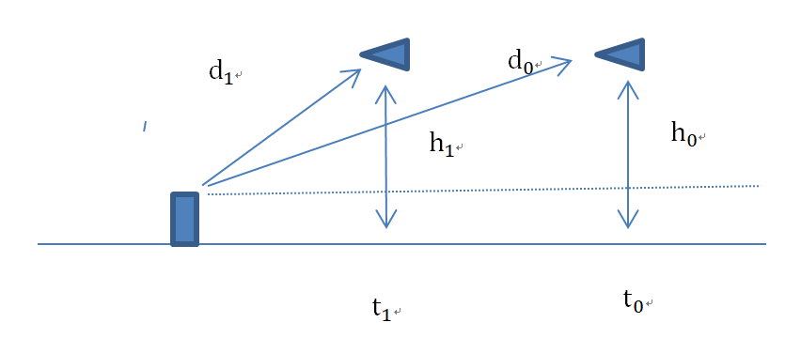

At the radar site, the measurements are C:\Users\김태욱\AppData\Local\Temp\ConnectorClipboard4920979716439442574\image16424197863491.png, the distance.

* 1. Deterministic Problem **:** Assumption

1) there is no noise

2) the height and the speed of the airplane are constant.

Let you have two measurements as C:\Users\김태욱\AppData\Local\Temp\ConnectorClipboard4920979716439442574\image16424197863732.png

Prob.1) if you know the height of the airplane, determine the speed of the airplane.

Prob.2) if you know the speed of the airplane constant, determine the height of the airplane.

(comment: If you have many measurements which are not perfect, you may use non-linear square estimator)

4.2 Stochastic problem: Now if we do not know the height of the speed, either, how to estimate (not to determine) them? Here we may use estimator algorithm. I will give some parameters,

* plant (airplane) model

- Airplane approaching speed and height = 500m/s , 1000m, they are perfect, i.e., no randomness. Initial airplane horizontal distance = 10km

- Radar measurement noiseC:\Users\김태욱\AppData\Local\Temp\ConnectorClipboard4920979716439442574\image16424197863853.png, which is not dependent of the distance(in our tutorial model, noise intensity depends on the distance)

- Air plane State = [horizontal position, horizontal speed, altitude]

- process noise intensity = [ 0 0 0 ; 0 0.001 0; 0 0 0.001]

- sampling time = 10 seconds

- measurement noise intensity = [100]

- initial estimate states = [ 10000 400 1200]'

* Using EKF

Prob.3) Estimate the speed and the height of the airplane up to 100 seconds

Prob.4) If there is an abnormal weather conditions, so that the airplane horizontal speed is corrupted noise as ~N(0,5) , and the altitude of the airplane is also corrupted by ~N(0,100). Estimate the speed and the height.

* Using UKF

Prob.5) How many sigma points?

Prob.6) Find Sigma points and its weighting factors if the tuning parameter $λ=2$

Prob.7) Estimate the speed and the height of the airplane up to 100 seconds

1. Find $x_{m}$ to minimize the cost function $J$
$$J=\min\left\|x^{T}Px+Mx+C\right\|,x ∈R^{n}, P>0$$

2. Non-linear least square estimator(Nitrification experiment) The maximal oxygen demand rate $r_{smax}\left(t\right)$ in a nitrification experiment can be expressed as

$$r_{smax}\left(t\right)=r_{smax}\left(0\right)e^{-bt}+\frac{μ_{max}}{b}B\left[ 1-e^{-bt}\right]$$

Here $B=0.281 kg\frac{N}{m^{3}day}$. Unknown parameters are

$$b:the death rate of the nitrifying biomass, \\ μ_{max}:the maximal growth rate of the nitrifying biomass$$

Given measurement data as

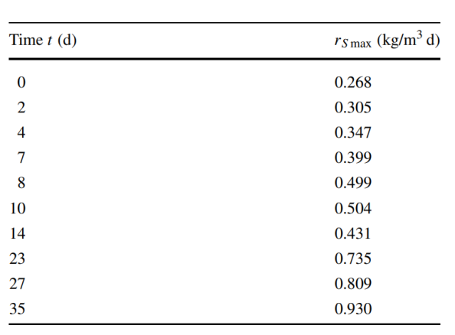

Estimate $b and μ_{max}$

--The End--