* Ex. 3.2-3 : temperature control in a Room

1. Problem formulation

$$\dot{θ}= -a\left(θ-θ_{a}\right)+bu$$

$θ,θ_{a} :$ The temperature in the room and the ambient

$u :$ the rate of heat supply to the room

Define $$x\left(t\right)=θ-θ_{a}$$

Then $$\dot{x}= -ax+bu$$

And the index

$$J\left(0\right)=\frac{1}{2}S{\left(x\left(T\right)-10\right)}^{2}+\frac{1}{2}\int_{0}^{T}{u^{2}dt }$$

Here design the optimal controller to minimize the index such the at the fixed time $T$,the room temperature $x\left(T\right)$ will be a fixed temperature or free.

1. Hamiltonian
$$H=\frac{u^{2}}{2}+λ\left(-ax+bu\right)$$

2. The necessary conditions

$$\dot{x}=H_{λ}= -ax+bu \\ \dot{λ}= -H_{x}=aλ \\ 0=H_{u}=u+bλ$$

3.1) first $u\left(t\right)$

$$u\left(t\right)= -bλ$$

3.2) second $λ$

$$λ=e^{-a\left(T-t\right)}λ\left(T\right) (11)$$

3.3) together 3.1) and 3.2) solve $x\left(t\right)$

$$\dot{x}= -ax-b^{2}λ\left(T\right)e^{-a\left(T-t\right)}$$

Using Laplace transform,

$$X\left(s\right)=\frac{x\left(0\right)}{s+a} -\frac{b^{2}λ\left(T\right)e^{-aT}}{\left(s+a\right)\left(s-a\right)} \\ =\frac{x\left(0\right)}{s+a}-\frac{b^{2}}{a}λ\left(T\right)e^{-aT}( -\frac{1/2}{s+a}+\frac{1/2}{s-a} )$$

so that

$$x\left(t\right)=x\left(0\right)e^{-at}-\frac{b^{2}}{a}λ\left(T\right)e^{-aT}\sinh{at} (14)$$

%%%

$$\sinh{x}=\frac{e^{x}-e^{-x}}{2}$$

%%%

1. The final boundary conditions

Still $λ\left(T\right)$ is unknown.

4.1) Fixed final state

$$θ\left(0\right)={60}^{o} , θ\left(T\right)={70}^{o} -→ x\left(0\right)=0, x\left(T\right)={10}^{o}$$

First, this is the case of the final state fixed, so that the weighting factor $S$ for the final state in the index is zero, so that the index will be

$$J\left(0\right)=\frac{1}{2}\int_{0}^{T}{u^{2}dt }$$

Now from (14)

$$x\left(T\right)= x\left(0\right)e^{-aT}-\frac{b^{2}}{2a}λ\left(T\right)\left(1-e^{-2aT}\right) (17)$$

solving it

$$λ\left(T\right)=-\frac{20a}{b^{2}\left(1-e^{-2aT}\right)}$$

Hence the optimal costate

$$λ\left(t\right)= \frac{10ae^{at}}{b^{2}\sinh{aT }}$$

and the optimal control(the optimal heat rate supply to the room)

$$u\left(t\right)=bλ=\frac{10ae^{at}}{b\sinh{aT }}$$

and the optimal state is

$$x\left(t\right)=10\frac{\sinh{at}}{\sinh{aT }} (21)$$

4.2) Free Final state

Remember the index is

$$J\left(0\right)=\frac{1}{2}S{\left(x\left(T\right)-10\right)}^{2}+\frac{1}{2}\int_{0}^{T}{u^{2}dt }$$

The necessary condition at the final time $T$

$$λ\left(T\right)=\frac{∂ϕ}{∂x\left(T\right)}=S(x\left(T\right)-10)$$

with (17), solving for $λ\left(T\right)$,

$$λ\left(T\right)=(-20aS)/(2a+b^{2}S\left(1-e^{-2aT}\right)$$

From (11)

$$λ\left(t\right)=(-10aSe^{at})/(ae^{aT}+Sb^{2}\sinh{aT)}$$

so that

$$u\left(t\right)=\left(10abSe^{at}\right)/(ae^{aT}+Sb^{2}\sinh{aT) } (27)$$

the optimal trajectory is from (3), $\dot{x}=-as+bu$

$$x\left(t\right)=(10Sb^{2}\sinh{at)/(ae^{aT}+Sb^{2}\sinh{aT) } (29)}$$

* HW_Week_3.3

From (3), (27) prove (29)

4.3) Discussion :

from (29) is not $x\left(T\right)≠10,$ however if $S-→∞ , x\left(T\right)-→10, i.e., θ\left(T\right)={70}^{o}$

* Ex. 3.3-1 (Zero input) : Propagation of Cost for uncontrolled Scalar system

1. Problem
$$\dot{x}=ax$$

$$J\left(t\right)=\frac{1}{2}S\left(T\right)x^{2}\left(T\right)+\frac{1}{2}\int_{t}^{T}{qx^{2}\left(τ\right)dτ}$$

2. Lyapunov Eq.(Here no Hamiltonian!)

$$-\dot{S}=2aS+q , S\left(T\right) (3)$$

The solution: $$S\left(t\right)=e^{2a\left(T-t\right)}S\left(T\right)+ \int_{t}^{T}{e^{2a\left(T-τ\right)}qdτ}$$

so that

$$S\left(t\right)=\left(S\left(T\right)+\frac{q}{2a}\right)e^{2a\left(T-t\right)}-\frac{q}{2a} (4)$$

So the cost will be

$$J_{t}=\frac{1}{2}S\left(t\right)x^{2}\left(t\right)$$

%%% Kim’s comment:

To solve (3), which is backward, define $t^{'}=T-t, dt^{'}=-dt, S\left(0\right)|_{t^{'}}=S(T)|_{t}$ so the changed parameter, (3) will be forward. %%

1. The steady state cost

If $a<0 ,$ from (4) , $S_{∞}= -\frac{q}{2a}-→ J_{∞}=\frac{1}{2}S_{∞}x^{2}\left(0\right)= -\frac{q}{4a}x^{2}\left(0\right)$

* Ex.3.3-3 (fixed final point) Open-loop Control of Motion Obeying Newton’s law

1. Problem
$$\dot{x}=\left[\begin{matrix}0 & 1 \\ 0 & 0\end{matrix}\right]x+ \left[\begin{matrix}0 \\ 1\end{matrix}\right]u, x\left(0\right)=x_{0}, x\left(T\right)=x_{T}$$

$$J\left(0\right)=\frac{1}{2}\int_{0}^{T}{ru^{2}dt}$$

2. From Hamiltonian and necessary conditions

$$\dot{x}=Ax-BR^{-1}B^{T}λ \\ \dot{λ }= -A^{T}λ$$

Then

$$λ\left(t\right)=e^{A^{T}\left(T-t\right)}λ(T)$$

and

$$\dot{x}=Ax-BR^{-1}B^{T}e^{A^{T}\left(T-t\right)}λ\left(T\right)$$

1. Boundary conditions

Since $x\left(T\right)$ is given,

$$x\left(T\right)=e^{A\left(T-t_{0}\right)}x\left(t_{0}\right)-G\left(t_{0}, T\right)λ\left(T\right)$$

here the reachability (controllability) Grammian, $G(0,T)$ is the solution of Lyapunov equation

$$\dot{P}=AP+PA^{T}+BR^{-1}B^{T}, P\left(t_{0}\right)=0$$

Hence

$$\dot{P}=\left[\begin{matrix}0 & 1 \\ 0 & 0\end{matrix}\right]P+P\left[\begin{matrix}0 & 0 \\ 1 & 0\end{matrix}\right]+ \left[\begin{matrix}0 & 0 \\ 0 & 1/r\end{matrix}\right], P\left(0\right)=0_{2×2}$$

which yields

$$\dot{p_{1}}=2p_{2} \\ {\dot{p}}_{2}=p_{3} \\ \dot{p_{3}}=\frac{1}{r}$$

Hence

$$G=P=\left[\begin{matrix}\frac{t^{3}}{3r} & \frac{t^{2}}{2r} \\ \frac{t^{2}}{2r} & \frac{t}{r}\end{matrix}\right] (11)$$

The sate transition matrix is

$$e^{At}= \left[\begin{matrix}1 & t \\ 0 & 1\end{matrix}\right]$$

So the optimal controller is

$$u^{*}\left(t\right)=R^{-1}B^{T}e^{A^{T}\left(T-t\right)}G^{-1}\left(t_{0}, T\right)[r_{N}-e^{A\left(T-t_{0}\right)}x(t_{0}) ] \\ =\frac{1}{r}\left[\begin{matrix}T-t & 1\end{matrix}\right]\left[\begin{matrix}12r/T^{3} & -6r/T^{2} \\ -6r/T^{2} & 4r/T\end{matrix}\right]\left(x_{T}- \left[\begin{matrix}1 & T \\ 0 & 1\end{matrix}\right]x_{0}\right)$$

or

$$u\left(t\right)=\left[\begin{matrix}\frac{6T-12t}{T^{3}} & \frac{-2T+6t}{T^{2}}\end{matrix}\right]\left(x_{T}- \left[\begin{matrix}1 & T \\ 0 & 1\end{matrix}\right]x_{0}\right) (14)$$

1. Discussion

The optimal control is not dependent of $r$ and open loop control. **More control is required to move the system more quickly from one state to another.**

* **Ex. 3.3-5 (free final state) Optimal feedback control of a damped harmonic oscillator**

1. Problem

$$\dot{x}= \left[\begin{matrix}0 & 1 \\ -ω_{n}^{2} & -2δω_{n}\end{matrix}\right]x+ \left[\begin{matrix}0 \\ b\end{matrix}\right]u$$

And

$$J\left(t_{0}\right)=\frac{1}{2}x^{T}\left(T\right)\left[\begin{matrix}s_{1}\left(T\right) & 0 \\ 0 & s_{3}\left(T\right)\end{matrix}\right]x\left(T\right) +\frac{1}{2}\int_{t_{0}}^{T}{\left(x^{T}\left[\begin{matrix}q_{1} & 0 \\ 0 & q_{2}\end{matrix}\right]x+ru^{2}\right)dt}$$

1. Hamiltonian and necessary conditions
$$\dot{x}=Ax-BR^{-1}B^{T}λ \\ -\dot{λ}= Qx+A^{T}λ$$

2. Boundary conditions

Since $λ\left(T\right)=S\left(T\right)x\left(T\right)$, assume $λ\left(t\right)=S\left(t\right)x\left(t\right),$ $S\left(t\right)$ satisfies the Riccati equation

$$-\dot{S}=A^{T}S+SA-SBR^{-1}B^{T}S+Q , t≤T$$

Define

$$S\left(t\right)= \left[\begin{matrix}s_{1}(t) & s_{2}(t) \\ s_{2}(t) & s_{3}(t)\end{matrix}\right]$$

Simplifying the Riccati equation is

$$-{\dot{s}}_{1}= -2ω_{n}^{2}s_{2}-\frac{b^{2}}{r}s_{2}^{2}+q_{1} \\ {-\dot{s}}_{2}=s_{1}-2δω_{n}s_{2}-ω_{n}^{2}s_{3}-\frac{b^{2}}{r}s_{2}s_{3} \\ -\dot{s_{3}}=2s_{2}-4δω_{n}s_{3}-\frac{b^{2}}{r}s_{3}^{2}+q_{2}$$

The optimal feedback gain is

$$K\left(t\right)=R^{-1}B^{T}S \\ =\left[\begin{matrix}\frac{bs_{2}}{r} & \frac{bs_{3}}{r}\end{matrix}\right]$$

See the Riccati equation, It is a nonlinear differential equation. How to get the solution? Maybe numerically. See p151, matlab code.

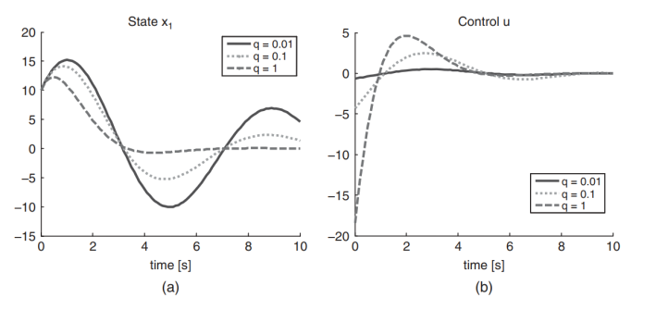

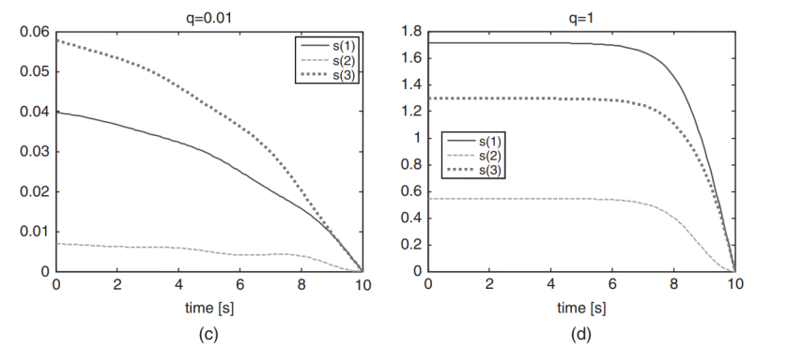

Here an example in the textbook.

$$x\left(0\right)= \left[\begin{matrix}10 & 0\end{matrix}\right], S\left(T\right)=0_{2x2} , q_{1}=q_{2}=q, r=1$$

If $q$ increasing $x\left(T\right)-→0$, $S(t)$ is almost constant in $[0, T]$ except near the boundary.

* HW_Week_3.4

Run the program to get the graph in the above

%%% The END %%