1. Final-Time-Free and Constrained Control

5.1 Final time free problems

* Introduction

One special class of final-time free problem is defined by the index as

with path constraints

The general boundary condition is

1. Hamiltonian
2. The boundary conditions

* Various cases

1. Final state fixed but final time free
2. Final state and time are free and independent
3. Final time and final sate are free but dependent as

* Transversality condition

In the case of 1), the BC is

In case of 2), the BC is

and

In case of 3) the BC is needed to be modified as.

Since the final state and time are dependent,

and

Hence (5.1-1) becomes

Since

* Ex.5.12 – fixed state free final time : **Simple** Zermelo’s Problem

A ship travel through a region of strong currents with a constant speed along y direction -The ship has **a constant speed, but its heading can be varied.**  **with a speed of , a constant**

1. Problem

The ship with an initial position is desired to the final position, in minimum time

Math. Model

And the index is

1. Necessary conditions

-Hamiltonian

-Necessary conditions

Hence

The final time is from the state equation,

If

which gives

* Ex.5.1-2 original Zermelo’s problem

Now the current speed is not constant but the current is directed in the x-direction with a speed of

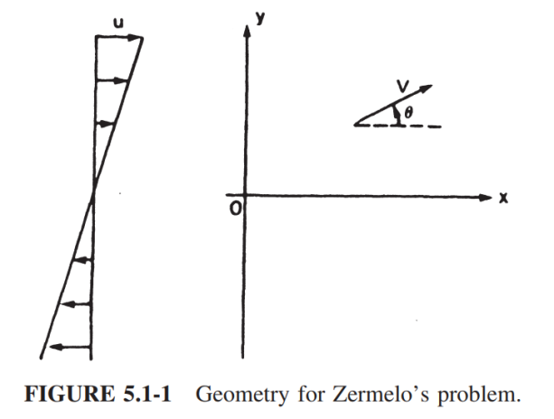

1. Necessary conditions

Hamiltonian :

* Costate Differential equations
* The boundary condition

1. The solution in the book

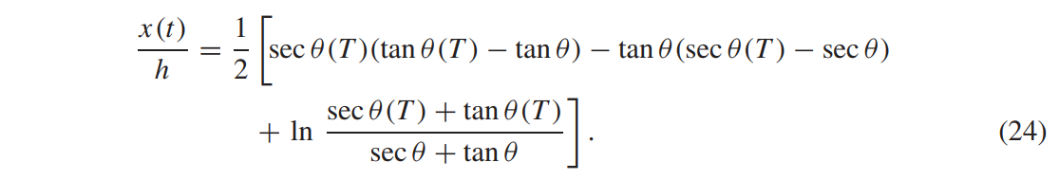

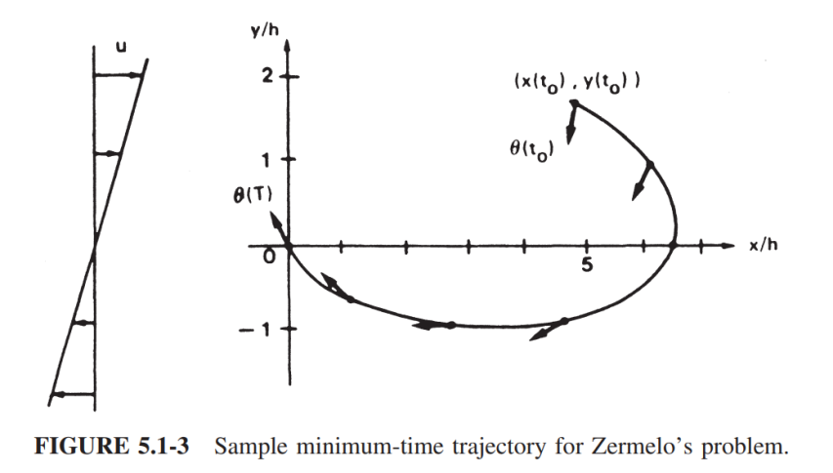

* 1. Constrained input problems

1. Pontryagin’s Minimum principle

If is unconstrained,

If , is an admissible region, then

* Ex. 5.2-1 Optimization with constraints

subject to

1. If ,

* Bang-bang control : minimum time with input constraints

1. Problem
2. Hamiltonian
3. Necessary condition

If

By pontryagin’s law

It leads to

1. Assume a scalar case

* If
* And
* Bang-bang control
* Ex. 5.2-3 Bang-bang Control of systems

Find the control to inminimum time

1. Hamiltonian
2. Necessary conditions

And at the terminal

1. Application by Pontryagin’s
2. Application to phase plane rather than solving the necessary conditions.

Since

deleting “t” ,

this is a family of parabola trajectories through

Here and the switching curve

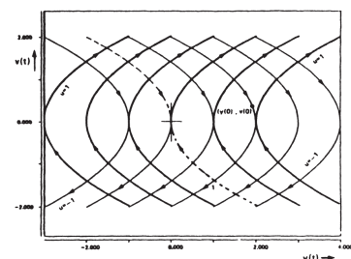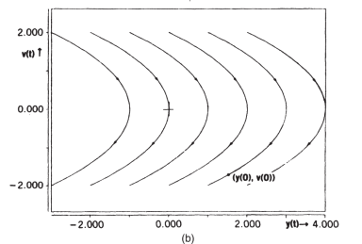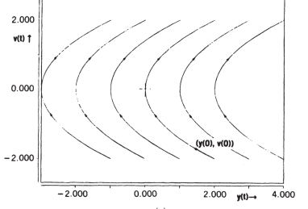

* Bang-off-Bang problem : Minimum fuel with input constraint

If the final state is fixed , and free final time , the controller is

* 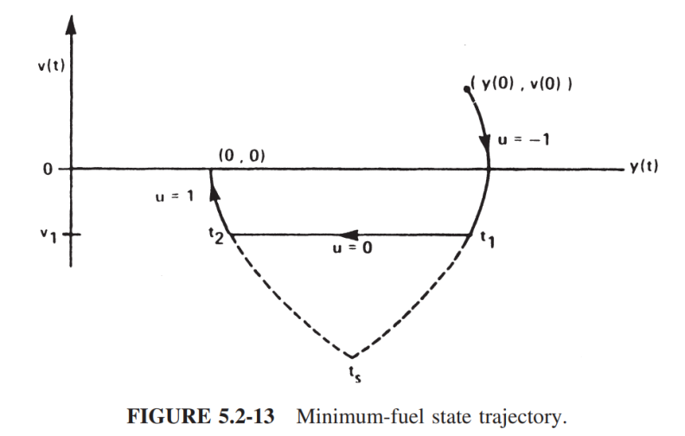 controller
* Constrained minimum-energy problems

1. Problem

with inequality constraint,

1. Hamiltonian

From Pontryagin’s minimum principle

Adding

1. Lemma :

Proof : since

Hence

which implies

Now

Therefore

1. The optimal controller

From the Lemma,

In summary

If

* If
* If

1. To get the optimal controller, should be calculated as in the previous chapter.