Introduction:

Integral:

Any smooth trajectory, whose the first derivative exists, can be integrated. However some noise motion is continuous but not smooth. That is the big problem in the end of 20c. The noise, we may called , Brownian motion. Let us see a deterministic input of a linear differential equation

$$\dot{x}=-x+u(t)$$

Then $$x\left(t\right)= \int_{0}^{t}{g\left(t-τ\right)u\left(τ\right)}dτ$$

which is the famous convolution integral. Let us consider the input is noise, i.e., random process.

$$\dot{x}=-x+w(t)$$

Here, we do know, as heuristically, $x(t)$ is a random process with a pdf. Then how to characterize

$$E\left[x\left(t\right)\right] , σ_{x}^{2}\left(t\right),…$$

in case of a continuous but not differentiable noise…Last semester, we may consider “The best estimator “ , the conditional expectation in discrete system. How about in continuous system? In the optimal controller design of a linear system, which is continuous, we Do know, Lyapunov, or Riccati equation regarding to optimal controller design problem. Let us tackle “ a difficult “ stochastic integral “ **so called Ito integral. The following will be the last semester subject which are skipped.. So the reference is the last semester textbook, “Speyor’s Stochastic,…”**

1. Stochastic Processes and Stochastic Calculus

* Reference “ Optimal control, Lewis Chap.9.4)

%%% Kim’s comments

In the microscopic motion of molecular its position is measureable so that

$$x\left(t\right)=a+(noise)$$

Now the velocity of the molecular is

$$v\left(t\right)= \frac{dx}{dt}=\frac{d\left(noise\right)}{dt}$$

* If the noise is a Brownian motion, $\frac{d\left(noise\right)}{dt}= \frac{dB\left(t\right)}{dt}$ is not defined at any time.

In fact if you measure something using a continuous sensor, the noise is look like a Brownian motion. Hence the derivative of the output of the sensor is not defined.

Engineers are **approximated this** as a white noise even if the derivative is not exist.

$\frac{dB\left(t\right)}{dt}=white noise=W(t)$

So that

%%%%

* 1. Random Walk and Brownian Motion
* Def. 5.1 A scalar Brownian motion process $X(t)$ is defined as a process such that

1. $\{X_{t}, t≥0\}$ is a Gaussian random variable
$E\left[X_{t}\right]=0, E\left[X_{t}X_{s}\right]=σ^{2}min⁡(t,s)$

2. $\{X_{t}, t≥0\}$ has independent increments, i.e., the increment

is independent

* 1. Mean Square Calculus

Consider the following

$$\dot{x}\left(t\right)=Ax+w$$

Then the solution is

$$x\left(t\right)=Φ\left(t,t_{0}\right) x\left(t_{0}\right)+ \int_{t_{0}}^{t}{Φ\left(η,t_{0}\right)w\left(η\right)dη (5.13)}$$

If w is the white noise, it is not integral in common sense.

* 1. Wiener Integrals

Consider

$$y\left(t\right)=C\left(t\right)x\left(t\right) \left(5.29\right)$$

Then

$$\frac{dy}{dt}=\frac{dC\left(t\right)}{dt}x\left(t\right)dt +C\left(t\right)\frac{dx\left(t\right)}{dt}$$

$$dy= \dot{C}(t)x\left(t\right)dt +C\left(t\right)dx\left(t\right)$$

* Are the same to the ordinary integral
  1. $It\hat{o}$ integral

$${dx}_{t}=f_{t}\left(x_{t}\right)dt+g_{t}\left(x_{t}\right)dβ_{t}$$

where

$${dx}_{t}=x_{t+dt}-x_{t}, dβ_{t}=β_{t+dt}-β_{t}$$

is defined in terms of its integral representation as

$$x\left(t\right)=x\left(t_{0}\right)+ \int_{t_{0}}^{t}{f_{t}\left(x_{t}\right)dt}+ \int_{t_{0}}^{t}{g_{t}\left(x_{t}\right)dβ_{t}}$$

* $It\hat{o}$ stochastic integral:
$$I\left(t,ω\right)=\int_{a}^{b}{g\left(t,ω\right)dβ(t,ω)}$$

* Remark
$E\left[I\left(t,ω\right)\right]=E\left[\int_{a}^{b}{g_{t}\left(ω\right)dβ_{t}(ω)}\right]=0$

$E\left[ \int_{a}^{b}{g\left(τ,ω\right)dβ\left(τ,ω\right)} \int_{a}^{b}{g\left(t,ω\right)dβ(t,ω)}\right]=σ^{2}\int_{a}^{b}{E[g{\left(t\right)}^{2} ]}$

* Example 5.20

Let $g_{t}\left(ω\right)=β_{t}-β_{a},$ Then

$$\int_{a}^{b}{g_{t}dβ_{t}}= \int_{a}^{b}{\left(β_{t}-β_{a}\right)dβ_{t}}=\frac{1}{2}\left[{\left(β_{t}-β_{a}\right)}^{2}-σ^{2}(b-a)\right] (5.40)$$

%%% Kim’s Comment

$$\int_{a}^{b}{(x-a)dx}= \int_{x=a}^{x=b}{(x-a)dx}$$

Let us define , 🡪

%%%%

* Kim’s comment on (5.40)

1. Eq.(5.40) is not a normal integral There is an additional term.
2. The left and right side of (5.4) are random variables. How to prove the random variables are equal i.e.,

$$X=Y$$

* If 🡪 two random variables are equal in the sense of mean square sense.

1. In the text book, it is proved in the mean square sense.
   1. Second order Ito integral 🡪 skip
   2. Stochastic Differential Equations and Exponentials 🡪 skip
   3. The Ito Stochastic Differential

* Theorem 5.23

Let $x_{t}$ be the unique solution to the vector Ito stochastic differential equation,

$${dx}_{t}=f\left(x_{t}, t\right)dt+G\left(x_{t},t\right)dβ_{t} (5.48)$$

$$x, f ∈R^{n}, G ∈R^{nxm}$$

and $E\left[dβ_{t}dβ_{t}^{T}\right]=Qdt$.

Let $ϕ\left(x_{t},t\right)$ be a scalar-valued real function of $x_{t}$ that is continuously differentiable in $t$ and that has continuous second derivatives with respect to $x$. The stochastic differential of $ϕ$ is then

$$dϕ=ϕ_{t}dt+ϕ_{x}^{T}dx_{t}+\frac{1}{2}trace GQG^{T}ϕ_{xx}dt (5.49)$$

* Example. 5.24 : Consider

$${dx}_{t}=\frac{σ^{2}}{2}x_{t}dt+x_{t}dβ_{t}, E\left[dβ_{t}^{2}\right]=σ^{2}dt (5.51)$$

Calculate $X=E\left[x_{t}^{2}\right]$

Sol: Let $ϕ=x_{t}^{2},$ so that

$$\frac{∂ϕ}{∂t}=0,\frac{∂ϕ}{∂x}=2x_{t},\frac{∂^{2}ϕ}{∂x^{2}}=2$$

Using (5.49)

$$dϕ=d\left(x_{t}^{2}\right)=2x_{t}dx_{t}+σ^{2}x_{t}^{2}dt (5.52)$$

Substitute (5.51) into (5.52)

$$d\left(x_{t}^{2}\right)=2x_{t}\left(\frac{σ^{2}}{2}x_{t}dt+x_{t}dβ_{t},\right)+σ^{2}x_{t}^{2}dt \\ ={2σ}^{2}x_{t}^{2}dt+2x_{t}^{2}dβ_{t}$$

Take the Expectation on both sides

$$d\left(E\left[x_{t}^{2}\right]\right)=2σ^{2}E\left[x_{t}^{2}\right]dt+2E\left[x_{t}^{2}dβ_{t}\right] \\ =2σ^{2}E\left[x_{t}^{2}\right]dt+2E\left[x_{t}^{2}] E[dβ_{t}\right]∵independent \\ =2σ^{2}E\left[x_{t}^{2}\right]dt ∵E\left[β_{t}\right]=0$$

Hence

$${dX}_{t}=2σX_{t}dt$$

$X_{t}=e^{2σt}$

%%% Kim’s comment

Consider Eq.5.52, in an ordinary differential equation,

$${(x+dx)}^{2}=x^{2}+2x dx+{\left(dx\right)}^{2} ∵taylor series or…$$

$d\left(x^{2}\right) = d\left({\left(x+dx\right)}^{2}-x^{2}\right)=2xdx as first approximate$

$d\left(x^{2}\right)=2xdx$

However, the RHS of Eq.(5.52) is different!!

%%%%

* 1. Continuous – Time Gauss-Markov Processes

Consider continuous time Gauss-Markov process(linear system)

$${dx}_{t}=F\left(t\right)x_{t}dt+G(t)dβ_{t} (5.56)$$

1. **The mean of $x_{t}$, $E\left[x_{t}\right]= {\overline{x}}_{t}$**
$$d{\overline{x}}_{t}=F{\overline{x}}_{t}dt (5.58)$$

2. The correlation of $\left[x_{t}x_{t}^{T}\right]= \dot{X}$
$$\dot{X}=FX+XF^{T}+GQG^{T}$$

3. **The covariance of $E[{\left(x_{t}-{\overline{x}}_{t}\right)}^{T}{\left(x_{t}- {\overline{x}}_{t}\right)}^{T}= \left[e\left(t\right)e{\left(t\right)}^{T}\right]=P(t)$**

$$\dot{P}(t)=FP+PF^{T}+GQG^{T} (5.59)$$

%%% Kim’s comment

From (5.56)

$${E[dx}_{t}]=E\left[F\left(t\right)x_{t}\right]dt+\left[G\left(t\right)dβ_{t}\right]$$

Since

$$E\left[β_{t+dt}-β_{t}\right]=0$$

$${E[dx}_{t}]=dE\left[x_{t}\right] , ∵ probability and time space are independent$$

and

$$E\left[F\left(t\right)x_{t}\right]dt=F\left(t\right)E\left[x_{t}\right]dt$$

Hence

$$d{\overline{x}}_{t}=F\left(t\right)\overline{x}(t)$$

Now however covariance?

1. In linear system, in order to check the stability, one method is Lyapunov.

Given a dynamic system

$$\dot{x}=Fx$$

If there is a $Q>0$, the solution $Q$ of the following Lyapnov equation

$F^{T}P+PF = -Q a)$

is a positive definite, $P>0$, then the system is asymptotically stable.

Now the steady state of eq.(5.59) is

$$FP+PF^{T}=-GQG^{T} b)$$

Compare a) and b), they are similar to each other but the order is different.

And the solutions are different even if they are positive definite.

%%%%%%%%

1. Continuous time Gauss-Markov Systems: Continuous Time Kalman Filter, Stationarity, Power Spectral Density and the Wiener Filter
   1. The continuous Time Kalman Filter

* Model

$${dx}_{t}=F\left(t\right)x\left(t\right)dt+G\left(t\right)dβ_{t} \\ dz\left(t\right)=H(t)x\left(t\right)+dη_{t}$$

Where

$$E\left[dβ_{t}\right]=0, E\left[dη_{t}\right]=0$$

$$E\left[dβ_{t}dβ^{T}\right]=W\left(t\right)dt, E\left[dη_{t}dη_{t}^{T}\right]=V\left(t\right)dt$$

* The innovation process $r(t)$

$$r\left(t\right)=dz\left(t\right)-H\left(t\right)\hat{x}\left(t\right)dt \\ =H\left(t\right)e\left(t\right)dt+dη_{t}$$

where $\hat{x}\left(t\right):$ the estimator, $e\left(t\right):$ the estimator error

* The conditional estimator $E\left[x_{t} | z_{t}\right]= {\hat{x}}_{t}$

$$d{\hat{x}}_{t}=F\left(t\right){\hat{x}}_{t}dt+P\left(t\right)H{\left(t\right)}^{T}V{\left(t\right)}^{-1}\left[dz\left(t\right)-H\left(t\right){\hat{x}}_{t}dt\right] (6.10)$$

where $P(t)$ is the solution to the **Riccati** equation as

$$\dot{P}\left(t\right)=F\left(t\right)P\left(t\right)+P\left(t\right)F{\left(t\right)}^{T}-P\left(t\right)H{\left(t\right)}^{T}V{\left(t\right)}^{-1}H\left(t\right)P\left(t\right)+G\left(t\right)W\left(t\right)G{\left(t\right)}^{T} \\ P\left(0\right)=P_{0}$$

* In continuous time filter, there is no separation as Prediction and estimation.

%%% Kim’s comment

1. The problem is to find the **optimal estimator(optimal filter , optimal observer)** such that

$$\min_{\hat{x}}{E[{\left(x-\hat{x}\right)}^{T}(x-\hat{x})|Z]}$$ The optimal solution is $\hat{x} =E[x|Z]$, which is given in (6.10)

1. **The model may be written in engineering textbook,** as

$$\frac{{dx}_{t}}{dt}=F\left(t\right)x\left(t\right)+G\left(t\right)W(t) \\ z\left(t\right)=H(t)x\left(t\right)+V(t)$$

where $W\left(t\right), V(t)$ as the white noise

$$E\left[W\left(t\right)W\left(s\right)\right]=δ(t-s)$$

Strictly speaking, the derivative of Brownian motion is not defined,(it we measure the position with a Brownian noise, the speed of the position, which is derivative of it, is not defined), hence this model is not correct. However, it is culture to write as it is.

1. In discrete system, it may allowed since the time interval between the sampling is finite,

the difference of the Brownian motion is defined.

1. The Riccati equation is a non-linear differential equation, and in control engineering, it is important for another optimal problem.
2. What is another implication of $E[x|Z]$? This is the minimum mean variance estimator(or observer) , as

$$\underset{\tilde{x}}{argmin}{E[{\left(x-\tilde{x} \right)}^{T}(x-}\tilde{x})\left|Z\right]= \hat{x}=E[x|Z]$$

%%% Kim’s comment: Kalman filter – Understanding , Introduction

<http://www.swarthmore.edu/NatSci/echeeve1/Ref/Kalman/ScalarKalman.html>

* Problem – scalar case

1. Model

* Noise –free dynamic

$$x_{j+1}=ax_{j}+bu_{j} (1)$$

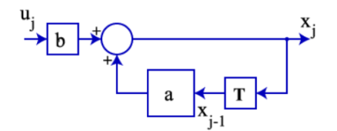

$T:$ one step delay

* With state noise

$$x_{j+1}=ax_{j}+bu_{j}+w_{j} (2)$$

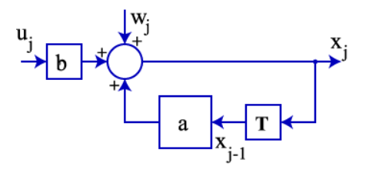

* Measurement noise

$$z_{j}=hx_{j}+v_{j} (3)$$

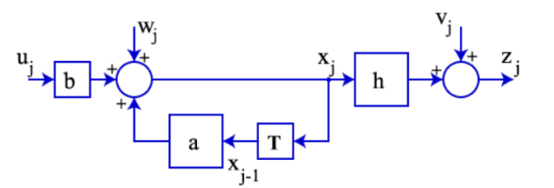

What is the best observer / estimator for $x_{j}$ given $z_{j}$? Remember the noises are random.

1. The Solution
   1. One solution
 $$\hat{x_{j}}=z_{j}$$

  2. Another solution – construct a computer model

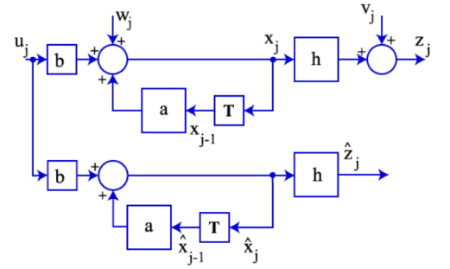

1. If $(a,b,h)$ or the initial point of $x_{0}$ is not same to real values
2. If the noises are not compensated.

There are no correction.

* 1. Optimal solution

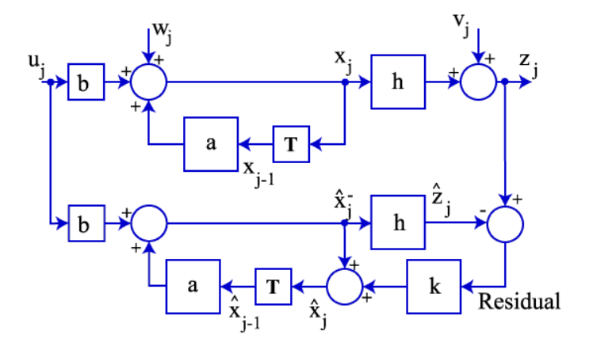

* Corrections are implemented.
* Residual: Innovation: error $z_{j}-h{\hat{x}}_{j}$ or in our textbook as $z_{j}-h{\overline{x}}_{j}$
* The estimator

$${\hat{x}}_{j}= {\overline{x}}_{j}+k(z_{j}-h{\overline{x}}_{j} )$$

where $k:$ kalman gain

1. The equivalent solution but different equations to Kalman Gain

~~~ Check it ~~~

1. The advanced problems
   1. If the system parameters are not equivalent
   2. If the noises’ characteristics are not measured properly
   3. In case of steady state, the transfer function
   4. If the system is time varying, what is the performance?
   5. If the system is non-linear,
2. How about Kalman controller?