Engineering Model

1. Inverted Pendulum

* In the literature, there are several kinds of modeling of an inverted pendulum, which depends on its application.
* The pendulum is mounted on the moving cart, their dynamic models ae different.
* Hence to stabilize the unstable pendulum , the controllers are different (totally different)

1. The first example
   1. The physical model [1] -

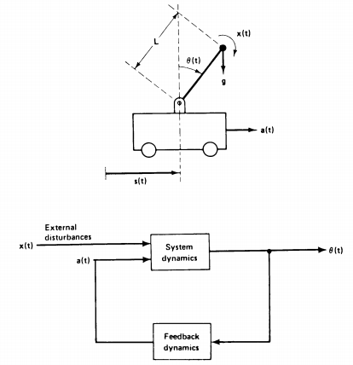

* 1. Mathematical model

The torque by the gravity, $g$, is

$$g sin\left(θ\left(t\right)\right)$$

The torque by the acceleration $,a ,$ is

$$-a\left(t\right)\cos{(θ\left(t\right))}$$

The torque by the external disturbance x, is $Lx$

The total torque equation is

$$L\frac{d^{2}θ}{dt^{2}}= g sin\left(θ\left(t\right)\right) -a\left(t\right)\cos\left(θ\left(t\right)\right)+Lx$$

which is linearized as

$$L\frac{d^{2}θ}{dt^{2}}= gθ -a+Lx$$

The transfer function from the disturbance $x$ to the angle

i.e.,

* 1. The stabilizing controller is suggested as PD
  2. Realization

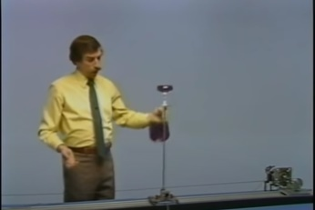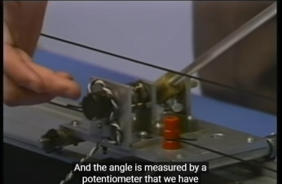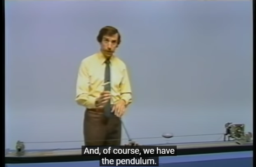

1. On the cart Inverted pendulum on the cart.
   1. Mathematical Model

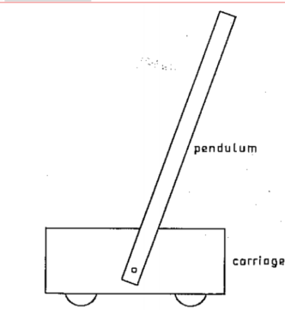

* 1. mathematical model

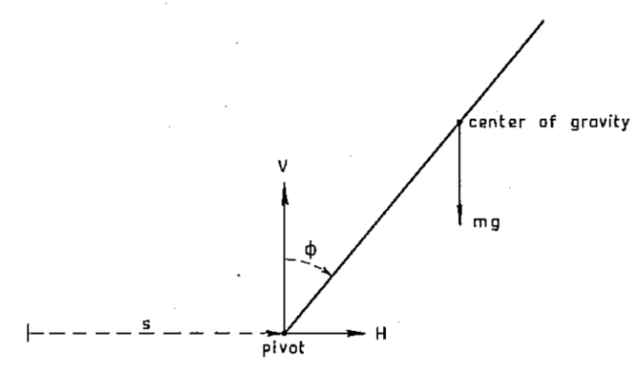

1. Terminology

$H\left(t\right):$ The horizontal force

$V\left(t\right):$ The vertical force

$μ:$ The external force

$F_{c}:$ the friction coefficient of the cart in the horizon direction

$F_{p}:$ the friction coefficient of the pendulum in the rotational direction

1. Mathematical model
   1. For the horizontal force

$$H= m\frac{d^{2}}{dt^{2}}(s+L\sin{ϕ) }=m(\ddot{s}-Lsin ϕ {\dot{ϕ}}^{2}+L cos ϕ\ddot{ϕ})$$

And the dynamics is

$$M\ddot{s}=μ-H-F_{c}\dot{s}$$

Plugging it into gives

$$M\ddot{s}=μ-F_{c}\dot{s}-m(\ddot{s}-Lsin ϕ {\dot{ϕ}}^{2}+L cos ϕ\ddot{ϕ})$$

Arranging it

$$\left(M+m\right)\ddot{s}= μ-F_{c}\dot{s}+mLsin ϕ {\dot{ϕ}}^{2}-mL cos ϕ \ddot{ϕ} (1)$$

%% Here are two activate forces, One is due to the slanted pendulum $H$, the other is the external force $μ$.. make sense? %%%

* 1. For the vertical force $$m\frac{d^{2}}{dt^{2}}\left(L cos ϕ\right)=V-mg$$

so that

$$-mL\sin{ϕ-mL {\left(\frac{dϕ}{dt}\right)}^{2}\cos{ϕ=V-mg} }$$

Arranging it with respect to the vertical force

$$V =mg-mLsin ϕ \ddot{ϕ}-mL cosϕ {\dot{ϕ}}^{2}$$

And its dynamics

$$J\ddot{ϕ}= LV sin ϕ-LHcosϕ-F_{p}\dot{ϕ}$$

Together with the vertical and horizontal forces,

$$J\ddot{ϕ}=Lsin ϕ \left(mg-mLsin ϕ \ddot{ϕ}-mL cosϕ {\dot{ϕ}}^{2}\right)-Lcosϕ \left(m\ddot{s}-mLsin ϕ {\dot{ϕ}}^{2}+mL cos ϕ\ddot{ϕ}\right)-F_{p}\dot{ϕ} \\ =Lmg sinϕ-{mL}^{2} \sin^{2}ϕ\ddot{ϕ}-mL^{2}\sin{ϕ}\cos{ϕ} {\dot{ϕ}}^{2}-mLcosϕ\ddot{s}+mL^{2}\sin{ϕ\cos{ϕ}{\dot{ϕ}}^{2}} \\ -{mL}^{2}\cos^{2}{ϕ\ddot{ϕ}}-F_{p}\dot{ϕ} \\ =Lmg sinϕ-{mL}^{2}\ddot{ϕ}-mL cosϕ\ddot{s}-F_{p}\dot{ϕ}$$

Arranging it gives

$$\left(J+{mL}^{2}\right)\ddot{ϕ}=Lmg sinϕ-mL cosϕ\ddot{s}-F_{p}\dot{ϕ} (2)$$

1. Combining two equations

Substitute (2) into (1)

$$\ddot{s}=\frac{1}{M+m} ( μ-F_{c}\dot{s}+mLsin ϕ {\dot{ϕ}}^{2})- \frac{mL cos ϕ}{(M+m)(J+mL^{2})} (Lmg sinϕ-mL cosϕ\ddot{s}-F_{p}\dot{ϕ} )$$

Arrange in terms with $\ddot{s}$

$$\left((M+m)\left(J+{mL}^{2}\right)-m^{2}L^{2}\cos{ϕ}\right)\ddot{s}=\left(J+mL^{2}\right)\left( μ-F_{c}\dot{s}+mLsin ϕ {\dot{ϕ}}^{2}\right)- mLcosϕ (Lmg sinϕ-F_{p}\dot{ϕ} )$$ So that

$$\ddot{s}=\frac{\left(J+mL^{2}\right)\left(μ-f_{c}\dot{s}+mLsin ϕ {\dot{ϕ}}^{2} \right)}{\left(\left(M+m\right)\left(J+{mL}^{2}\right)-m^{2}L^{2}\cos^{2}{ϕ}\right)} -\frac{m^{2}L^{2}cosϕsinϕg-{mL\cos{ϕ}F}_{p}\dot{ϕ} }{\left(\left(M+m\right)\left(J+{mL}^{2}\right)-m^{2}L^{2}\cos^{2}{ϕ}\right)} (3)$$

And with the same way

$$\ddot{ϕ}=\frac{-mLcos ϕμ-m^{2}L^{2}{\dot{θ}}^{2}\sin{ϕ\cos{ϕ+f_{c}mL\cos{ϕ\dot{s}}}}}{(\left(M+m\right)\left(J+mL^{2}\right)-m^{2}L^{2}\cos^{2}{ϕ) }} \\ +\frac{-F_{p}\left(M+m\right)\dot{θ}+mgL\left(M+m\right)\sin{θ}}{\left(\left(M+m\right)\left(J+{mL}^{2}\right)-m^{2}L^{2}\cos^{2}{ϕ}\right)} (4)$$

1. Comparison with others
   1. Sivan, Kwaterrnaak -

$$M\ddot{s}=μ-F\dot{s} \\ \ddot{ϕ}-\frac{g}{L^{'}}\sin{ϕ +\frac{1}{L^{'}}\ddot{s}}\cos{ϕ}=0, L^{'}=\frac{J+mL^{2}}{mL}$$

Here the assumption is the cart movement does not depend on the pendulum’s movement , i.e.,

$$M\ddot{s}=μ-F\dot{s}$$

Is it reasonable?

* 1. Brunton “ Data-Driven..”

$$\dot{x}=ν \\ \dot{ν}=(-m^{2}L^{2}g\cos{ϕ}\sin{ϕ}+mL^{2}\left(mL{\dot{ϕ}}^{2}-F_{c}ν\right)+mL^{2}u)/(mL^{2}(M+m(1-\cos{{\left(ϕ\right)}^{2}) } \\ \dot{ϕ}=ω\ddot{ϕ}=(\left(m+M\right)mgL sin ϕ -mL cosϕ\left(mL\sin{ϕ}-F_{c}ν\right)+mL\cos{ϕu}$$)/

$({mL}^{2}(M+m(1-\cos{{(ϕ}^{2})}$)

Here the inertia of the pendulum is smaller than ${mL}^{2}$ i.e..

$\left(J+{mL}^{2}\right)=mL^{2 . }$ But the rod inertia is ${mL}^{2}$. (and the denominator term ‘s $\cos{{\left(ϕ\right)}^{2}}$ should be $\cos^{2}{ϕ}$

1. Controller design - Linearization
   1. Controller design

The inverted pendulum is the common problem to design a stabilizing controller at the unstable stationary point, i.e., to keep the pendulum at the up position, which is unstable stationary point. In non-linear system, it is difficult to design stabilizing controller whose system is unstable.

1. Lyapupov method: there are several papers to design a non-linear controller based on Lyapunov method.
2. Time optimal / energy minimization optimal controller (?)
3. Linearization
   1. Linearization
4. Plant
$$\left(M+m\right)\ddot{s}= μ-F_{c}\dot{s}+mLsin ϕ {\dot{ϕ}}^{2}-mL cos ϕ \ddot{ϕ} (1) \\ \left(J+{mL}^{2}\right)\ddot{ϕ}=Lmg sinϕ-mL cosϕ\ddot{s}-F_{p}\dot{ϕ} (2)$$

5. Linearization at the up-position

Here $ϕ\sim 0$, then,

$$\sin{ϕ} \sim ϕ, \cos{ϕ \sim 1}$$

And

$$\dot{ϕ^{2}} \sim 0$$

Then the approximated system may be, the translational motion,

$$\left(M+m\right)\ddot{s}==μ-F_{c}\dot{s }-mL \ddot{ϕ} (1)'$$

The rotational motion may be

$$\left(J+{mL}^{2}\right)\ddot{ϕ}==Lmg ϕ-mL \ddot{s}-F_{p}\dot{ϕ} (2)'$$

1. The controller design

Two eq’s (1)’ and (2)’ are linear w.r.t. $s, ϕ$. So there are plenty of linear controllers to stabilize an unstable system.Good~~

There are another problem… as you know, how many sensors to stabilize it? In our problem, there is 4th ODE, so 4 sensors are enough. Too many isn’t it?