System Simulation –Ref. “Data –Driven,…”

1. Problem

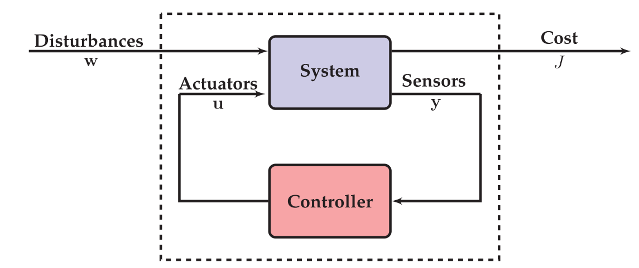

* 1. Definition

System : A real physical plant / non-linear / continuous system

a mathematical model : in State space model , state /

input : disturbance / controller output (Actuator input)

reference signal

output: one for performance / the others for control input

Controller: real H/W / computer based digital system

Input

* 1. Simulation
* HILS : hardware in the loop simulation - real time important
* PILS : program in the loop simulation (some parts of plants are replaced into

Mathematical programs)

1. PILS
   1. Direct controller design

Assume, if a controller is designed without approximation of the mathematical model,

* 1. Approximation

In order to design a linear feedback, the plant may be approximated into an linear system(remember this is not a real mathematical plant) so that it is easy to apply Linear Control Theory.

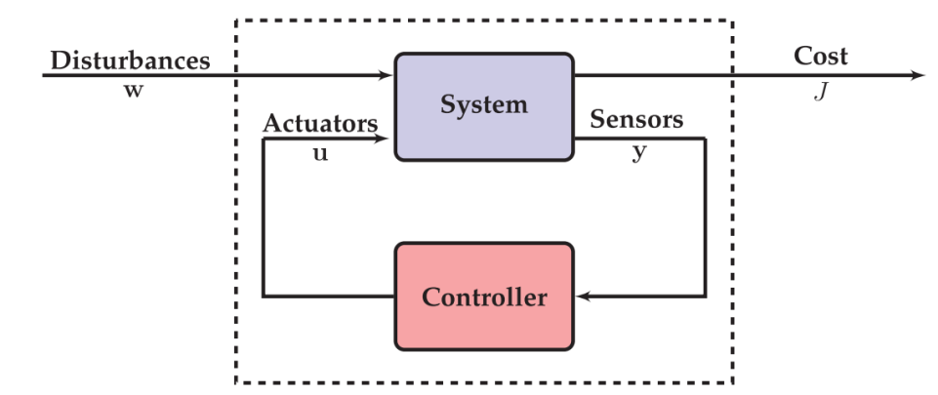

here the gain is designed for the “approximated linear system, not the real math model”, and this “controller” is applied to the “ real math plant. What is the rationale?

Even if the “K” is designed for the approximated system”, **the feedback may guarantee good performances in the real plant!!**

**How does this verify?**

1. **First verify with the approximated linear system to be good.**
2. **Then, with the real math plant, verify it to be good.**
   1. Observer design : we will see later
3. PILS
   1. matlab script

* Inverted_2022.m : main program

math plant : cartpend2022 using ode45

* drawcartpend_2022.m : simulated plant
  1. simulink script
* Pendulum_2022.slx
* PemdulumParameter.m
  1. Comments
* In Simulink environment, **it is not allowed to use ode45**
* In Simulink model it is good to understand to closed loop system performances later

HW_Week_6

Using “Kwakernaak,…” page 5, the simplified math model is

1. Code a matlab script with the same parameter values in the class
2. Draw a Simulink code with the same parameter values in the class
3. Compare the trajectory in the class and yours.