1. Introduction
   1. Linear Time invariant systems

Ordinary differential equations

$$\frac{d^{2}x}{dt^{2}}+a\frac{dx}{dt}+bx =u$$

Change into state space model

* 1. Nonlinear Systems $$\dot{x}=f(t,x,u)$$

$$y=h(t,x,u)$$

change into state space model

* Terminology
* Unforced state equation
$$\dot{x}=f\left(t,x,0\right)$$

* Autonomous system
$$\dot{x}=f\left(x\right)$$

* Time invariant
* Ex.1.1 / 1.2

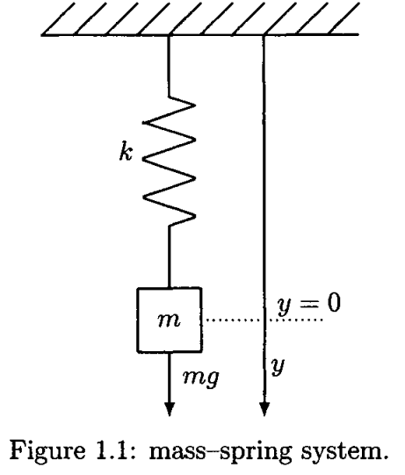Consider a mass-spring system. Then the dynamic equation by Newtons’ law is

$$m\ddot{y}= \sum{forces} \\ =f\left(t\right)-f_{k}-f_{β} (1)$$

here $y:$ displacement. $f\left(t\right):$ external force. $f_{k}:$ restoring force of the spring, $f_{β}:$ friction (viscosity)

1. Linear system : assume

$$f_{k}=ky$$

$$f_{β}=β \dot{y}$$

Then

$$m \ddot{y}+β\dot{y}+ky=mg$$

Define $x_{1}=y, x_{2}= \dot{y}$, the SS model is

$$\left[\begin{matrix}\dot{x_{1}} \\ {\dot{x}}_{2}\end{matrix}\right]= \left[\begin{matrix}0 & 1 \\ -\frac{k}{m} & -\frac{β}{m}\end{matrix}\right]\left[\begin{matrix}x_{1} \\ x_{2}\end{matrix}\right]+\left[\begin{matrix}0 \\ 1\end{matrix}\right]g$$

1. Nonlinear system (more realistic case)

Assume :

$$f_{k}=ky(1+a^{2}y^{2}) \\ f_{β}=β \dot{y}$$

Then the SS model is

* 1. Equilibrium Points
* Def.1.1 : A point $x=x_{e}$ is an equilibrium point of the autonomous system

$$\dot{x}=f\left(x\right)$$

If it has the property that the state of the system starts at $x=x_{e}$, it remains at $x_{e}$ for all future time.

* Ex. 1.3 : Equilibrium points

$$\dot{x}=r+x^{2}$$

To find equilibrium points, in this case we may consider $r>0, r=0, r<0$

%% Kim’s comment: a quick differences between linear and nonlinear cases

1. Static case

* $Ax=b$: The solution may exist or not. If exist, then the number of solution is one or infinite
* $f\left(x\right)=b$: The solution may exist or not. If exist, then the number of solution is one , several or infinite

1. dynamic case

* $\dot{x}=Ax, x(0)$: the solution always exist and is one and unique. The number of equilibrium point is one and $x_{e}=0$
* $\dot{x}=f\left(x\right), x(0)$: the existence of the solution may not be guaranteed. If the solution exists, it may be difficult to get analytically. Moreover the number of solution may be one, several or infinite. Existence. The equilibrium points may be non, finite or infinite
  1. First Order Autonomous NL systems
$$\dot{x}=f(x)$$

* Qualitative Analysis

$f\left(x\right):$ the velocity vector at $x$

* Ex.1.4,

$$\dot{x}=\cos{x}$$

1. Equilibrium points

, 🡪

Near the equilibrium points

* 1. Attractive $x_{e}$, for $k$ even integers
  2. Repelling $x_{e}$ for $k$ odd integers
  3. Second- Order Systems: Phase- Plane Analysis

Consider

$${\dot{x}}_{1}=f_{1}\left(x_{1}, x_{2}\right) \\ \dot{x_{2}}=f_{2}(x_{1}, x_{2})$$

If the solution with an initial condition $(x_{10}, x_{20})$, the trajectory will be drawn in $(x_{1},x_{2})$ plane. In this case a qualitative analysis will be done to draw the vector field $f\left(x\right)={\left[f_{1}, f_{2}\right]}^{T}$ in the $(x_{1},x_{2})$ plane.

* Ex. 1.6 consider

$${\dot{x}}_{1}=x_{2} \\ \dot{x_{2}}= -x_{1}^{2}-x_{2}$$

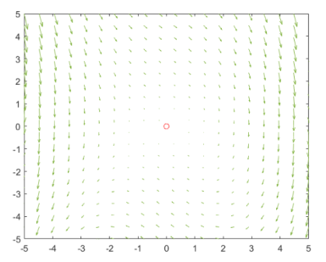The phase planes are drawn

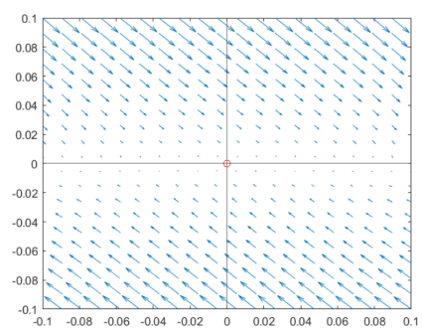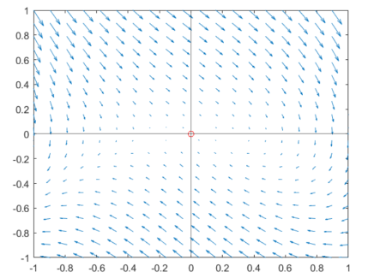

In the phase plane, at $x_{e}$ is a repellant and there is no attractive point, i.e., the system is unstable

* 1. Phase-Plane Analysis of LTI Systems

Given

$$\dot{x}=Ax, A ∈R^{2×2}$$

For simple analysis, there are categorized into several cases regarding the system matrix $A$

Case 1) Diagonalizable system,

If $∃ T$ such that

$$T^{-1}AT=D, D:a diagonal matrix$$

Then define $x=Ty,$ so that

$$\dot{y}=T^{-1}\dot{x}=T^{-1}ATy=Dy=\left[\begin{matrix}λ_{1} & 0 \\ 0 & λ_{2}\end{matrix}\right] \left[\begin{matrix}y_{1} \\ y_{2}\end{matrix}\right]$$

Then the stability of the decoupled system $y$ depends on the eigenvalues $λ_{1}, λ_{2}$

Case 2) Non diagonalizable system

If $∃ T$ such that

$$T^{-1}AT=\left[\begin{matrix}λ_{1} & 1 \\ 0 & λ_{2}\end{matrix}\right], D:a diagonal matrix$$

The trajectories are some what distorted to the above case, however the stability depends on the $λ_{1}, λ_{2}$

Case 3) Complex eigenvalues

If a similar matrix to the system matrix is

$$T^{-1}AT=\left[\begin{matrix}α & -β \\ β & α\end{matrix}\right]$$

whose eigenvalues are $α ±jβ$. Then the transformed system is

$${\dot{y}}_{1}=αy_{1}-βy_{2} \\ {\dot{y}}_{2}=βy_{1}+αy_{2}$$

Introduce the polar coordinate as

$$ρ= \sqrt{y_{1}^{2}+y_{2}^{2}} \\ θ=\tan^{-1}\left(\frac{y_{2}}{y_{1}}\right)$$

Then

$$\frac{dρ}{dt}=\frac{d{\left(y_{1}^{2}+y_{2}^{2}\right)}^{\frac{1}{2}}}{dt}=\frac{1}{2}{\left(y_{1}^{2}+y_{2}^{2}\right)}^{-\frac{1}{2}} \left(2y_{1}\frac{dy_{1}}{dt}+2y_{2}\frac{dy_{2}}{dt}\right) \\ =\frac{1}{2}ρ^{-1} (2y_{1}\left(αy_{1}-βy_{2}\right)+2y_{2}(βy_{1}+αy_{2}) \\ =\frac{1}{2}ρ^{-1}\left(2αy_{1}^{2}+2αy_{2}^{2}\right) \\ =\frac{1}{2}ρ^{-1}2αρ^{2} \\ =αρ$$

Similarly

$\dot{θ}=β$

which leads to the following solution:

$$ρ= ρ_{0}e^{αt} \\ θ=θ_{0}+βt$$

Hence if $α=0$, the trajectories are circle with radius $ρ_{0}={\left(y_{10}^{2}+y_{20}^{2}\right)}^{\frac{1}{2}}$ rotating speed $β$

Depending on the sign of $α$ the radius is decreasing or increasing.

* Ex. 1.11

Consider

$$\left[\begin{matrix}{\dot{x}}_{1} \\ {\dot{x}}_{2}\end{matrix}\right]= \left[\begin{matrix}0 & -3 \\ 1 & 0\end{matrix}\right]\left[\begin{matrix}x_{1} \\ x_{2}\end{matrix}\right]$$

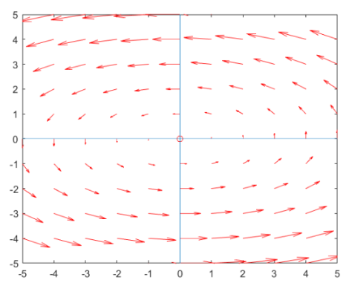The eigenvalues $λ= 0±j\sqrt{3}$, $ρ=ρ_{0}, β= \sqrt{3}$. The phase plane is

The ellipsoidal depend on the initial point, i.e., the trajectory remains on the ellipsoid determined by the initial points.

In conclusion, 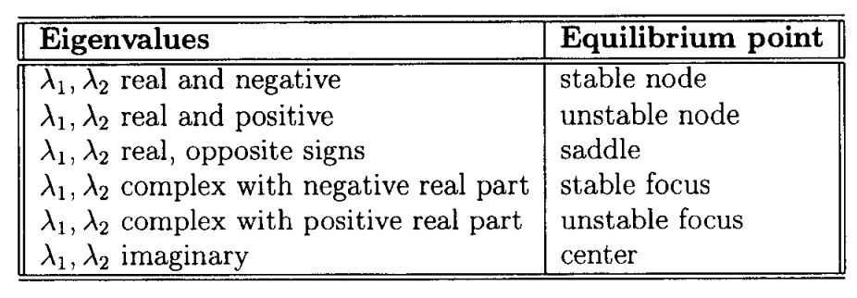the trajectories are rotation inbound or outbound at the center.

* 1. Phase-Plane Analysis of NL
     1. Limit Cycle

One of the special features of NODE compared to LODE is a limit cycle.

Van der Pol Oscillator:

$$\ddot{y}-μ\dot{\dot{\left(1-y^{2}\right)}} \dot{y}+y=0, μ>0$$

Define $x_{1}=y, x_{2}=\dot{y}$

The S.S. model is

$${\dot{x}}_{1}=x_{2} \\ {\dot{x}}_{2}=x_{1}+μ\left(1-x_{1}^{2}\right)x_{2}$$

1. Linearize

At equilibrium point , $\left(x_{1} , x_{2}\right)=\left(0,0\right)$

$$\left[\begin{matrix}{\dot{x}}_{1L} \\ {\dot{x}}_{2L}\end{matrix}\right]= \left[\begin{matrix}0 & 1 \\ -1 & 0\end{matrix}\right]\left[\begin{matrix}x_{1L} \\ x_{2L}\end{matrix}\right]$$

So that the linearized system is of oscillation with the initial point.

1. Original case with different $μ>0$, assuming $\left(x_{1}, x_{2}\right)=\left(1,0\right) and (3,0)$
   1. If $μ=0$, then which is the equivalent to the linearized system
   2. $μ=0.125$, then the circle of the linearized trajectories is distorted
   3. $μ=1$, regardless of initial points the trajectories converge to only one isolated orbit.

This isolated orbit is called a limit cycle.

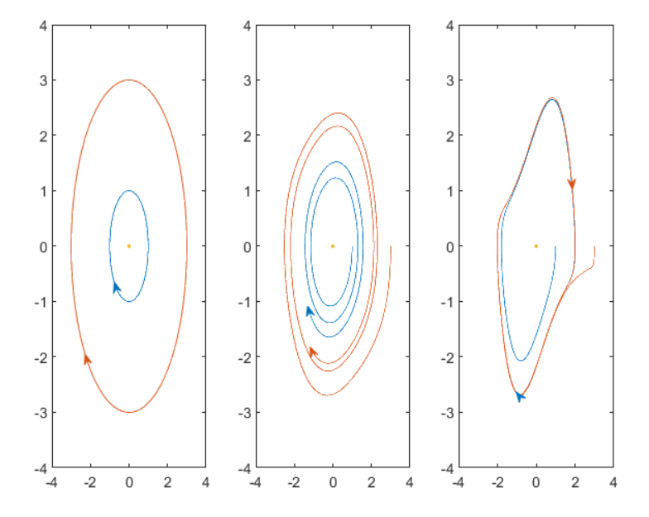

And w.r.t time (fro wiki)

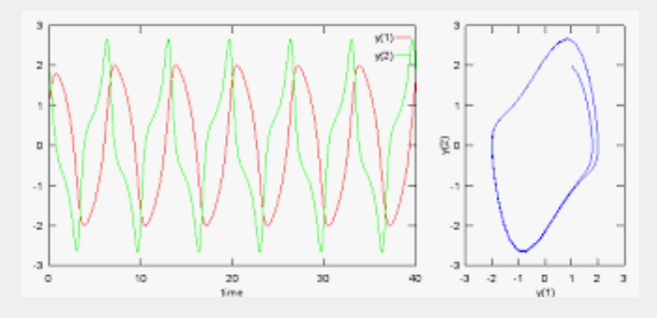

* There are three types limit cycles , stable , unstable and semi stable.

There are unsolved problems regarding limit cycles. i.e. on what conditions are there limit cycles existence or not with a given non linear equation.

* An example of realization for van der Pol equation. In this example the resistance is negative.

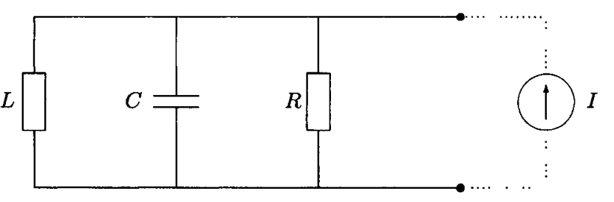

1.8 Higher-order system

1.8.1 Chaos

Consider (called Lorenz equation)

$$\dot{x}=σ\left(y-x\right) \\ \dot{y}=rx-y-xz \\ \dot{z}=xy-bz$$

where $σ,r b>0$. Assign the parameters as

$$σ=10, r=28, b=\frac{8}{3} with \left(x\left(0\right), y\left(0\right), z\left(0\right)\right)=[-15,15, 20]$$

Then the trajectory in $\left(x,z\right), (x,y)$ plane are

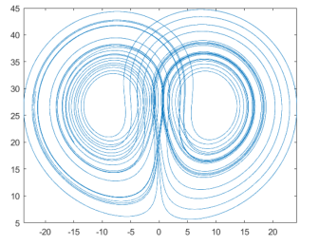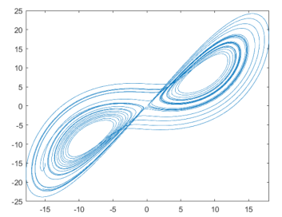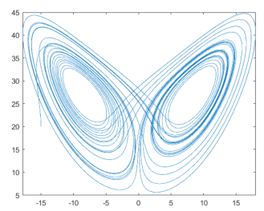

%% Lorenz and Lorentz : they are different !!