1. Feedback Stabilization

* https://open4416.medium.com/passivity-and-its-connection-to-h-stability-2d91377b422f
  1. Passivity Control
* Passivity : remind

$$\dot{x}=f\left(x,u\right), y=h\left(x\right) \left(9.18\right)$$

The system (9.8) is **passive** if $∃ V\left(x\right)≥0 ,$ semidefinite storage function such that

$$u^{T}y≥ \dot{V}=\frac{∂V}{∂x}f\left(x,u\right).$$

And the system (9.8) is zero-state observable if no solution of $\dot{x}=f(x,0)$ can stay identically in the set $\{h\left(x\right)=0\}$ other than the zero solution $x\left(t\right)=0.$ In this section, $V(x)$ is assumed **positive** definite.

* Theorem 9.1 If the system (9.18) is

1. Passive with a radially unbounded **positive** storage function and
2. Zero-state observable

then the origin $x=0$ can be **globally stabilized** by $u= -ϕ\left(y\right),$ where $ϕ$ is any locally Lipschitz function such that $ϕ\left(0\right)=0$ and $y^{T}ϕ\left(y\right)>0 ∀y≠0$

* Proof

Let $V(x)$ the storage function as a Lyapunov function candidate for the closed loop system,

$$\dot{x}=f\left(x, -ϕ\left(y\right)\right).$$

Then the derivative of $V$ is given by

$$\dot{V}=\frac{∂V}{∂x}f\left(x, -ϕ\left(x\right)\right)≤-y^{T}ϕ\left(y\right)≤0$$

Which is negative semi definite. By Lasalle’s theorem, $y=0-→x=0$

Hence the origin is asympt.stable. – The EnD-

* Ex.9.14

$${\dot{x}}_{1}=x_{2}, \dot{x_{2}}= -x_{1}^{3}+u$$

With $V\left(x\right)=\frac{1}{4}x_{1}^{4}+\frac{1}{2}x_{2}^{2}$

$$\dot{V}=x_{1}^{3}x_{2}-x_{2}x_{1}^{3}+x_{2}u=x_{2}u$$

Select $y=x_{2}$, then

$$\dot{V}=x_{2}u=yu≤uy$$

And if with $u=0$, $y\left(t\right)=0=x_{2}\left(t\right) -→x_{1}\left(t\right)=0$. Hence the origin is asympt. stable by Theorem 9.1

* 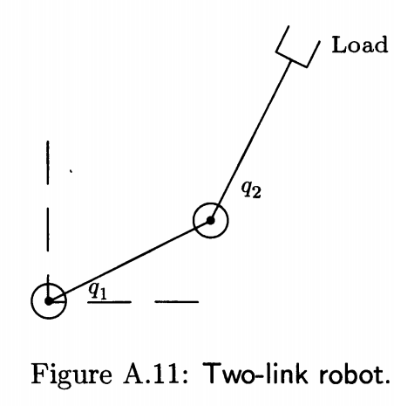Ex.9.15

$$M\left(q\right)\ddot{q}+C\left(q,\dot{q}\right)+D\dot{q}+g\left(q\right)=u$$

$q=\left[\begin{matrix}q_{1} \\ q_{2}\end{matrix}\right]:$ angle

$u=\left[\begin{matrix}u_{1} \\ u_{2}\end{matrix}\right]$: control (torque) input

$M\left(q\right):$ a symmetric positive definite inertia matrix

$C\left(q,\dot{q}\right)\dot{q} , D\dot{q}, g\left(q\right):$ centrifugal / Coriolis forces, viscous damping, gravity

1. Problem

Design $u$ such that

$e=q_{r}-q$: to converge to zero, regulate $q$ to a constant reference $q$

1. Design input $u$: select

$u=g\left(q\right)-K_{p}e+v , K_{p} >0 PDM$

the controlled system is

$$M\left(q\right) \ddot{e}+C\left(q, \dot{q}\right)\dot{e}+D\dot{e}+K_{p}e=v$$

The sum of kinetic energy and potential energy is,a storage function,

$$V=\frac{1}{2}{\dot{e}}^{T}M\left(q\right)\dot{e}+\frac{1}{2}e^{T}K_{p}e$$

The derivative is

$$\dot{V}={\dot{e}}^{T}M \ddot{e}+\frac{1}{2}\dot{e}\dot{M}\dot{e}+e^{T}K_{p}e$$

$$=\frac{1}{2}{\dot{e}}^{T}\left(\dot{M}-2C\right)\dot{e}-{\dot{e}}^{T}D \dot{e}-{\dot{e}}^{T}K_{p}e+{\dot{e}}^{T}v+e^{T}K_{p}\dot{e}$$

Since $\dot{M}-2C$ is a skew symmetric, (i.e,. A is a skew symmetric if $-A=A^{T}$) , $x^{T}\left(\dot{M}-2C\right)x=0, D$ is a symmetric and positive semidefinite

$$\dot{V}=-{\dot{e}}^{T}D \dot{e}+{\dot{e}}^{T}v$$

Let us select $y=\dot{e}$ and if $v= -ϕ\left(\dot{e}\right) , y^{T}ϕ\left(y\right)>0 ∀ y≠0$, then

$$\dot{V}=-{\dot{e}}^{T}D \dot{e}+{\dot{e}}^{T}v =-{\dot{e}}^{T}D \dot{e}+{\dot{e}}^{T}v-y^{T}ϕ(\dot{e}) \\ =-{\dot{e}}^{T}D \dot{e}+y^{T}v-y^{T}ϕ(\dot{e})$$

So that $$\dot{V}+y^{T}ϕ\left(\dot{e}\right)=-{\dot{e}}^{T}D \dot{e}+y^{T}v≤y^{T}v$$

Which is strictly output passive. For zero—state observable, with ,

🡪 , from $$V=\frac{1}{2}{\dot{e}}^{T}M\left(q\right)\dot{e}+\frac{1}{2}e^{T}K_{p}e$$

$$e-→0$$

which is zero-state observable.Hence with the feedback $$u=g\left(q\right)-K_{p}e+v , \\ =g\left(q\right)-K_{p}\left(q-q_{r}\right)-ϕ(\dot{q})$$

will stabilize the closed loop system asymptotically.

1. Analysis:

The original system is

$$M\left(q\right)\ddot{q}+C\left(q,\dot{q}\right)+D\dot{q}+g\left(q\right)=u$$

With the controller $u$

$$u=g\left(q\right)-K_{p}e-ϕ\left(\dot{e}\right),$$

* $∀ K_{p} >0 PDM, and ∀ ϕ(y)$ such that $yϕ\left(y\right)>0 ∀ y≠0$
* These give a lot of design possibilities !!
* The difficulties to handle this problem is due to the non-linearity

$$M\left(q\right) and C\left(q,\dot{q}\right)$$

However if $\dot{M}-2C$ is a skew symmetric, the controller does not depend on these non-linearity. WONDERFUL!!

* The other thing is the “damping ” or “viscosity “ D which is not one of the control parameters. You may think this damping will attributed the stability, however, if it is positive definite, then it does not matter to stabilize using “ passive controller”.
* Cascade system feedback passivation : Consider

$$\dot{x}=f_{a}\left(x\right)+F\left(x,y\right)y (9.23) \\ \dot{z}=f\left(z\right)+G\left(z\right)u (9.24) \\ y=h\left(z\right) (9.25)$$

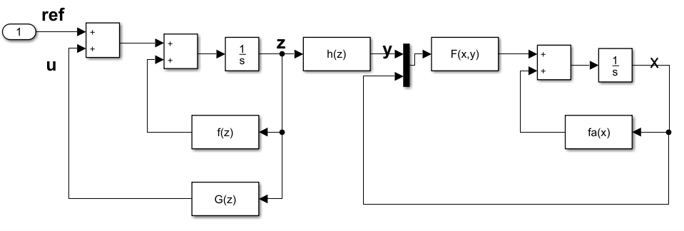

Assume:

- Driving system : passive with a positive definite storage function

- Driven system: stable with a Lyapunov function $W(x)$

So that $\dot{W}=\frac{∂W}{∂x} f_{a}\left(x\right)≤0 , ∀x$

* Theorem 9.2 (cascade feedback passivation)

Suppose

1. (9.24)-(9.25) is zero-state observable and passive with a positive definite storage function.
2. The origin of $\dot{x}=f_{a}(x)$ is asympt.stable with a Lyapunov function $W$ such that

$$\dot{W}=\frac{∂W}{∂x} f_{a}\left(x\right)≤0 , ∀x$$

Then with a controller $u$

$$u={\left(\frac{∂W}{∂x} F\left(x,y\right)\right)}^{T}+v$$

the system is stabilized.

* Ex. 9.16 Consider

$$\dot{x}= -x+x^{2}z , \dot{z}=u$$

First, consider $\dot{z}=u, y=z$ is passive with $V\left(z\right)=\frac{1}{2}z^{2}$ and zero-state observable. The second , $\dot{x}=-x$ is globally exponential stable with $W\left(x\right)=\frac{1}{2}x^{2}.$ Hence by the Theorem 9.2 the controller $u$

$$u=-{\left( \frac{∂W}{∂x}F\left(x,y\right)\right)}^{T}-ϕ\left(y\right) \\ =-x\left(x^{2}\right)-ky \\ =-x^{3}-kz$$

-The EnD-

* 1. Control Lyapunov Function – skip