Ch.3

1. Stability and Equilibrium

* Equilibrium points:

Consider an autonomous system

$$\dot{x}=f(x)$$

The equilibrium points $x_{e}$ are $f\left(x_{e}\right)=0$.

%% Kim’s comment

1. If $x\left(0\right)=x_{e} , x\left(t\right)=0 ∀ t≥0$
2. In Non-linear, the stability is analyzed in $N(x_{e}, r)$, i.e., $x\left(0\right)∈N(x_{e}, r)$,is $x(t)$ converged to $x_{e}$?
3. If $f(x)$ is continuous and differentiable, then

$$f\left(x\right)=f\left(a\right)+\frac{df}{dx}\left(x-a\right)+\frac{1}{2}\frac{d^{2}f}{dx^{2}}{\left(x-a\right)}^{2}+ ,…$$

Let us define $a=x_{e}$

$$f\left(x\right)=f\left(x_{e}\right) +\frac{df}{dx}\left(x-a\right) +\frac{1}{2}\frac{d^{2}f}{dx^{2}}{\left(x-a\right)}^{2}+,… \\ =\frac{df}{dx}\left(x-a\right) +\frac{1}{2}\frac{d^{2}f}{dx^{2}}{\left(x-a\right)}^{2}+,…$$

Let us define a small deviation(or perturbation) of x from $x_{e}$ such that $x ∈N(a,r)$, then

$$x-a ∈N(0,r)$$

Define the deviation as $δx=x-a$. **Since $δx$**  is small enough

$$\frac{d\left(δx\right)}{dt}=\frac{d}{dt}\left(x-a\right)=\frac{dx}{dt}-\frac{da}{dt}=\frac{dx}{dt}=f\left(x\right)=\frac{df}{dx}δx +O{\left(δx\right)}^{2}\sim \frac{df}{dx}δx$$

Here due to $δx$**is small, the higher order term converge to zero faster than the first order.** Hence, near $x∈N(a,r)$

$$\frac{d\left(δx\right)}{dt}=\frac{df}{dx}δx$$

which is linear DE. Be sure that this is a LDE only in $x∈N(a,r)$

We may write as $δx(t) =x_{L}(t)$ in the previous lecture.

3.1 Basic Concepts

* Definition 3.1

The $x_{e}=0$ is

1. stable if for each $ε>0$ there is $δ>0$ s.t.
$$\left\|x(0)\right\|<δ ⇒ \left\|x(t)\right\|<ε ∀t≥0$$

2. unstable if it is not stable
3. **asymptotically stable if it is stable** and $δ>0$ can be chosen s.t.

$$\left\|x(0)\right\|<δ ⇒\lim_{t→∞}\left\|x(t)\right\|=0$$

%% Kim’s comment

1. $x_{e}=a , a≠0$ is not mattered as linearized cases.
2. So if there are many $x_{e}$, the stability should be analyzed at every $x_{e}$

%%%

* 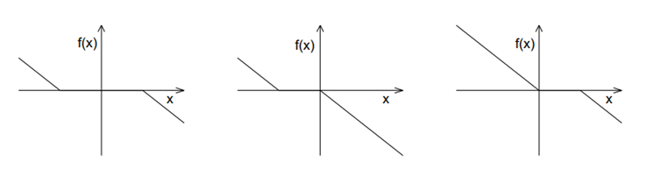Example

1. Stable
2. Unstable

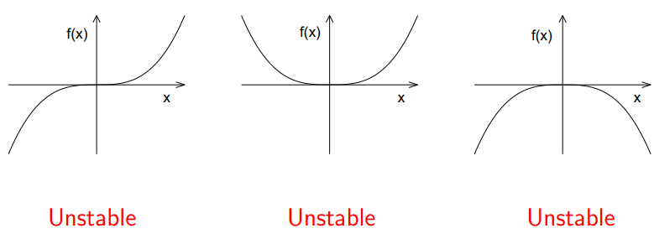

1. Asymptotically stable

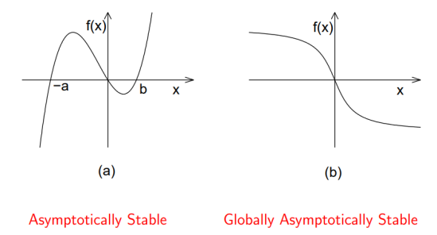

* Def.3.2 (The region of attraction)

Let the origin be an asymptotically stable equilibrium point of the system $\dot{x}=f(x)$, where f is a locally Lipschitz defined over a domain $D⊂R^{n} (0 ∈D)$.

Then The region of attraction (also, the region of asymptotic stability, or domain of attraction, or basin) is the set of all points $x_{0}∈D$,

$\lim_{t→∞}{x\left(t\right)=0 }$-END -

%% Kim’s comment:

* One of the BIG problem is how to find the basin? If you linearize a NODE, and at $x_{e}$ is asymptotic stable. Then how to guarantee with a perturbed initial condition $δx ∈N\left(x_{e}, a\right), x(t)$ is asymptotic stable? One of the solutions is Lyapunov method which is the nest section.
* **One of the mistakes almost all master students thesis, they linearized a nonlinear system to design a “Linear Control “ for Linearized System not the original non linear system.**

**%%%**

* Def. 3.3

$x_{e}$ is exponentially stable if

$$\left\|x(t)\right\|≤k \left\|x\left(0\right)\right\|e^{-λt} , ∀t≥0, k≥1, λ>0, ∀ \left\|x\left(t\right)\right\|<c$$

It is globally exponentially stable if the inequality is satisfied for any $x(0)$

* Ex. 3.2

$$\dot{x}= -x^{3}$$

The origin is asymptotic stable since

$$x\left(t\right)= \frac{x(0)}{\sqrt{1+2tx^{2}(0)}}$$

but is not exponentially stable.

* 1. Linearization

$$\dot{x}=f\left(x\right), f\left(0\right)=0$$

Then the linearized system at $x=0$ is

$$\dot{x_{L}}=Ax_{L}$$

where

$$A=\frac{∂f}{∂x}|_{x=0}$$

* Theorem 3.2

1. The origin $\left(f\left(0\right)=0\right)$ is exponentially stable iff $Re\left[λ_{i}\right]<0$ for all e-values.
2. The origin is unstable if $Re\left[λ_{i}\right]>0$ for one or more of the e-values

-The End –

* Ex. 3.3 : $\dot{x}=ax^{3}$

1. Find $x_{e}$ =? $x_{e}= 0$
2. Linearizing as

🡪 , we may not say about stability at $x=0$

* Ex: 3.3 –Kim: $\dot{x}=-x+x^{3}$

1. Find $x_{e}$:
$$x_{e}=0,1 ,-1$$

2. Linearizing at each $x_{e}$

Since $A=\frac{∂f}{∂x}= -1+3x^{2}$

2.1) 🡪 exponentially stable at $x_{e}=0$

2.2) 🡪 unstable at $x_{e}=-1$

2.3) 🡪 unstable at $x_{e}=1$

* Ex.3.4 :Check the stability: the pendulum equation

$${\dot{x}}_{1}=x_{2} , {\dot{x}}_{2}= -\sin{x_{1}}-bx_{2} ,$$

Sol:

1. Find $x_{e}$?
$$x_{e}=\left[kπ, 0\right] , k=0, ±1,2,…$$

2. For $x_{e}=[0,0]$

Since $A=\frac{∂f}{∂x}=\left[\begin{matrix}\frac{∂f_{1}}{∂x_{1}} & \frac{∂f_{1}}{∂x_{2}} \\ \frac{∂f_{2}}{∂x_{1}} & \frac{∂f_{2}}{∂x_{2}}\end{matrix}\right]|_{x_{e}}= \left[\begin{matrix}0 & 1 \\ -\cos{x_{1}} & b\end{matrix}\right]|_{x_{e}}=\left[\begin{matrix}0 & 1 \\ -1 & -b\end{matrix}\right]$

The e-values are $λ=-\frac{1}{2}b± \frac{1}{2}\sqrt{b^{2}-4}$. Hence for all , 🡪exponentially stable

1. For $x_{e}=[π,0]$

$$A=\frac{∂f}{∂x}=\left[\begin{matrix}0 & 1 \\ -\cos{x_{1}} & b\end{matrix}\right]|_{x_{e}}=\left[\begin{matrix}0 & 1 \\ 1 & -b\end{matrix}\right]$$

The e-values are $λ=-\frac{1}{2}b± \frac{1}{2}\sqrt{b^{2}+4}$. Here one e-value has 🡪unstable stable

* 1. Lyapunov Method
* Terminology

Def: Positive definite function $V\left(x\right) , x∈R^{n}$

$V\left(x\right)∈R , x ∈ D , D⊂R^{n}$ is a positive definite function if

1. Continuously differentiable over $D$

$V\left(0\right)=0 , V\left(x\right)>0 , ∀ x\left(≠0\right) ∈D$

%% Kim’s Comment

* Careful think over the condition 2). It is positive for all $x\left(≠0\right), ∈ D$

-. $V\left(x_{1}, x_{2}\right)=x_{1}^{2}+x_{2}^{2}$: a PDF $∀\left(x_{1}, x_{2}\right)∈R^{2}$

-. $V\left(x_{1}, x_{2}\right)=(1-\cos{(x_{1})) }+x_{2}^{2}$ a PDF in $-π≤x_{1}≤π , x_{2}∈R$

-. $V\left(x_{1}, x_{2}\right)=x_{2}^{2}$ is not a positive definite function since $V\left(x_{1},0\right)=0 ∀x_{1}$

* A common PDF is quadratic form as $V=x^{T}P x , P∈R^{n×n}$

If $P=P^{T}$ and $x^{T}Px>0 , ∀x \left(≠0\right)$, then $P$ is a positive definite matrix.

Or equivalently

If $P=P^{T}$ and all the eigenvalues are positive, then $P$ is a positive definite matrix.

%%% Kim’s comment : PDF

1. it may be transformed into a quadratic forum as

$$V=\left[x_{1}, x_{2}\right]P\left[\begin{matrix}x_{1} \\ x_{2}\end{matrix}\right]=\left[x_{1}, x_{2}\right]\left[\begin{matrix}0 & 0 \\ 0 & 1\end{matrix}\right]\left[\begin{matrix}x_{1} \\ x_{2}\end{matrix}\right]$$

Then check the e-values of $P$, which are 0, 1 not to be a PD.

%%%

* In Linear system, $∃ a Q>0$ such that the Lyapunov equation has the solution $P>0$

$$A^{T}P+PA= -Q,$$

Then all e-values of $A$ have negative (if it is complex, then real(e-values)).

%%%

* Theorem 3.3

Let $f(x)$ is a locally Lipschitz function over $D ∈R^{n}$, $f\left(0\right)=0.$ Let $V(x)$ be a positive definite

1. , 🡪 at $x=0$ is asymptotically stable
2. , 🡪 at $x=0$ is stable

Proof : I will skip but using the following formula

$$V\left(x\left(t\right)\right)=V\left(x\left(0\right)\right)+\int_{0}^{t}{\dot{V}(x\left(τ\right))}dτ$$

And $0≤V\left(x\left(t\right)\right)≤V(x\left(0\right)) -→ x\left(t\right)→0$-QED-

* Terminology : $V(x)$ is called a Lyapunov function.

%% Kim’s comment : How to find a positive definite function?

1. The stability is said, upto now, It is analyzed at the equilibrium point, $x_{e}$. In linearizing method, we do not know the “domain of attraction” as $x ∈N\left(x_{e}, r\right), r>0$, but what is $r$?
2. If you are lucky to find a Lyapunov function, $V(x)$,and it is stable or asymptotic stable then $x\left(0\right)∈\overline{D }=\left\{x: V\left(x\right)≤ c \right\}, x\left(t\right)∈\overline{D }$, which is one of the domain of attraction.
3. The theorem is important and useful in the stability check since we may not solve the solution but to find a function ( Lyapunov function if it is stable) indirectly.
4. The theorem is a **sufficient condition**, hence a candidate positive function may be negative, you may not conclude it is not stable.
5. Using the theorem, you may try and error to find a good candidate Lyapunov function.

If you find it, you are lucky. In general

1. If $P$ is a positive matrix, then $V\left(x\right)=x^{T}Px$ a candidate a Lyapunov function in Linear system.
2. Here $x ∈R^{n}$, so for asymptotic stability one of the sufficient conditions

If $\dot{V}\left(x\right)<0 ∀ x∈D , x≠0$

Careful thought needed. $x≠0 , \dot{V}\left(x\right)<0$ means at $x=\left(x_{1}, 0,,…, x_{n}\right), x_{1}≠0,$ evenif $\dot{ V}\left(x\right)<0$**, the asymptotic stability is not guaranteed**.

For example assume $\dot{V}\left(x_{1}, x_{2}\right)=-x_{2}^{2}$. Then if $x=\left(x_{1}, 0\right), x_{1}≠0$, $\dot{V}\left(x_{1}, x_{2}\right)=0$ which is not negative. Hence it does not satisfy the condition If $\dot{V}\left(x\right)<0 ∀ x∈D , x≠0$.

* Ex.3.6 : The pendulum equation

$${\dot{x}}_{1}=x_{2} , {\dot{x}}_{2}= -\sin{x_{1}}-bx_{2}$$

1. Case 1: $b=0$

A Lyapunov candidate may be

$$V\left(x_{1}, x_{2}\right)=\left(1-\cos{x_{1}}\right)+\frac{1}{2}x_{2}^{2}$$

Check $V(x)$ is a positive definite at $x_{e}=0$

* $V(0$) = 0
$V\left(x\right)>0 ∀x( ≠0) -π<x<π$

* Positive slope along $x$

$$\frac{dV}{dt}= \dot{V}=\frac{∂V}{∂x}\frac{dx}{dt} \\ =\frac{∂V}{∂x_{1}}\frac{dx_{1}}{dt}+ \frac{∂V}{∂x_{2}}\frac{dx_{2}}{dt} \\ =\sin{x_{1}} \frac{dx_{1}}{dt}+x_{2}\frac{dx_{2}}{dt} \\ =\sin{x_{1}} x_{2}-x_{2}\sin{x_{1}} =0$$

Hence $at x=0$, it is stable, however we may not conclude it is asymptotical stable.

1. Case 2: the friction is positive, $b>0$

If we select a Lyapunov candidate as the same,

$$\frac{dV}{dt}= \dot{V}= -bx_{2}^{2}$$

Here $x_{a}=\left(x_{1}, 0\right) , V\left(x_{a}\right) =0$ which is not negative, using this Lyapunov function , we may conclude it is stable at $x=0$ but we may not conclude it is asymptotic stable.

Since in phase plane, at this point it is asymptotic stable(really?), we may conclude in this case **the Lyapunov candidate is not appropriate**.

1. Find an appropriate Lyapunov function guarantee the asymptotic stable for $b>0$ Here we may select another Lyapunov candidate. Choose a $P=P^{T}$ which is unknown.
$$V\left(x_{1}, x_{2}\right)=\frac{1}{2}x^{T}Px+(1-\cos{x_{1})}, P= \left[\begin{matrix}p_{11} & p_{12} \\ p_{12} & p_{22}\end{matrix}\right] , P>0$$

2. Check the positive definite

Since $(1-\cos{x_{1})}>0$ need 🡪

1. The derivative $P$ along $x(t)$ should be negative for asymptotic stability’
$$\dot{V}\left(x\right)=\left(1-p_{22}\right)x_{2}\sin{x_{1}-p_{12}x_{1}}\sin{x_{1}}+\left(p_{11}-p_{12}b\right)x_{1}x_{2}+\left(p_{12}-p_{22}b\right)x_{2}^{2}$$

2. For sign definite, $x_{2}\sin{x_{1}}, x_{1}x_{2}$ are sign indefinite, their coefficient should be zero as

$$p_{22}=1, p_{11}=p_{12}b$$

Then

$$\dot{V}\left(x\right)=-p_{12}x_{1}\sin{x_{1}}+\left(p_{12}-p_{22}\right)x_{2}^{2} b.1)$$

For $\dot{V}\left(x\right)<0$, if we select $0<p_{12}<p22=1$, then $\dot{V}\left(x\right)<0$

1. In conclusion, Let a PDF as

$$V\left(x_{1}, x_{2}\right)=\frac{1}{2}x^{T}\left[\begin{matrix}p_{12}b & p_{12} \\ p_{12} & 1\end{matrix}\right]x+(1-\cos{x_{1})}, o<p_{12}<1$$

so that

$$\dot{V}= -\frac{1}{2}bx_{1}\sin{x_{1}}-\frac{1}{2}bx_{2}^{2}<0 , -π≤x_{1}≤π, x_{2}∈R$$

So that $x=0$ is asymptotic stable point.

%% Kim’s comment

1. If $f\left(x\right), g(x)$ are positive definite, then $f\left(x\right)+g(x)$ is also a positive definite.
2. In linear algebra or optimization

- matrix is a positive definite matrix if and only if all the eigenvalues are positive.

- matrix is a positive definite matrix if and only if the all the principal minors are positive. Ex.

Principle minor : $\left[\begin{matrix}a & b \\ b & c\end{matrix}\right]$

1. The first minor : determinant of $a=a$
2. The second minor : determinant of $\left[\begin{matrix}a & b \\ b & c\end{matrix}\right]=ac-b^{2}$

You may check positive for $P_{nxn}$ matrix using determinant

%%%