1. Input-Output Stability
   1. $L$ Stability

The magnitude of a function $u\left(t\right)∈R^{n}. t∈[0 , ∞)$ is defined using “norm”, norm of $u\left(t\right)= \left\|u\right\|$. The operator $\left\|u\right\| ∈R$ should be satisfied

$\left\|u\right\|>0 , \left\|u\right\|=0 if and only if u=0$

$\left\|au\right\|=a\left\|∙\right\|$

$\left\|u_{1}+u_{2}\right\|≤\left\|u_{1}\right\|+ \left\|u_{2}\right\|$

* Ex.
* Piecewise continuous function space : $L_{∞}$ norm space $${\left\|u\right\|}_{L_{∞}}=\sup_{t≥0}\left\|u(t)\right\|$$
* Square integral function space: $L_{2}$ norm space
$${\left\|u\right\|}_{L_{2}}= \sqrt{\int_{0}^{∞}{u^{T}\left(t\right)u\left(t\right)dt }}$$

${\left\|u\right\|}_{L_{p}}={\left( {\int_{0}^{∞}{\left\|u\left(t\right)\right\|}}^{p} dt \right)}^{\frac{1}{p}}$

* Def. 6.1 A $g\left(r\right)∈R$, defined for $r∈\left[0 , ∞\right),$ is a gain function if it is non decreasing and $g\left(0\right)=0$
* Def. 6.2 A mapping $H:L^{m}-→L^{q}$ is stable if $∃ again function g(r)$ and non-negative constant $β$ such that

$${\left\|\left(Hu\right)\right\|}_{L}≤g(\left\|u\right\|)+β$$

or finite –gain stable if $∃ γ, β≥0$ such that

* 1. Stability of State Models - skip
  2. $L_{2}$ Gain – skip

1. Stability of **Feedback System**

%% Kim’s comment: Aizermann’s Conjecture and Kalman’s Conjecture

1. Aizermann’s conjecture

If $\dot{z}=Az+bkc^{T}z$ is asymp.stable $∀ k∈(k_{1}, k_{2})$., then the origin is asymptotic stable?

$$\dot{x}=Ax+bφ\left(δ\right), δ=c^{T}x , φ\left(0\right)=0, k_{1}<\frac{φ\left(σ\right)}{σ}<k_{2} ,$$

This conjecture is false

1. Kalman’s Conjecture

With the same system but $k_{1}<\frac{dφ\left(σ\right)}{dσ}<k_{2}$

This conjecture is also false. However, With some modifications Aizermann’s conjecture, it is true with new definition “Absolute stability” %%

* 1. Passivity Theorems

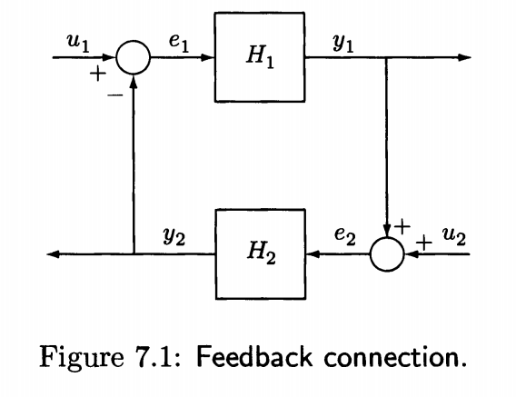

%% Kim’s comment: for simple understanding the Fig.4.1

1. Here $H_{1}, H_{2}$ are mapping as $y_{1}=H_{1}e_{1}$
$e_{1}=reference input-controller output=u_{1}-y_{2}$

$e_{2}=the plant output+sensor noise=u_{2}+y_{1}$

2. $u_{2}$: sensor noise
3. $H_{2}$: controller dynamics

%%%

%% Kim’s comment passivity and stability

In Lemma 5.6

1. If $u^{T}y$ is **strictly passive**, i.e. , $u^{T}y≥\dot{V}+φ\left(x\right),φ\left(x\right) is PDF,$
2. If $u^{T}y≥ \dot{V}+yψ\left(y\right)>0, yψ\left(y\right)>0 ∀ y \left(≠0\right),$ and zero-state observable

then the origin of the system is asymptotic stable.

Ok… Let us check the meaning of these. The condition 1) means $u=0$

$$u^{T}y=0≥ \dot{V}+φ\left(x\right) -→ \dot{V}≤-φ(x)$$

Since $φ$ is a PDF 🡪 the unforced system is asympt.stable. Now consider condition 2) with $u=0$, $\dot{V}≤-yφ(y)$. Here $yφ(y)$ maybe semi-definite, by Lasalle’s theorem, zero-observable implies if $y→0 -→x→ 0$. Hence the origin is asympt.stable.

1. Is it complicate compared to Lyapunov method directly? True. But you **connect many passive systems**, to prove asymptotic stable is a little bit difficult. Here, we may consider only the output to guarantee the origin’s asymptotic stable. %%%

* **Theorem 7.1** The feedback connection of two passive system is **passive.**

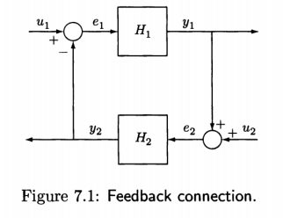**Proof:** Let $V_{1}\left(x_{1}\right), V_{2}(x_{2})$ be the storage functions for $H_{1} , H_{2}$, i.e.,

$e_{1}^{T}y_{1}≥V_{1}\left(x_{1}\right) , e_{2}^{T}y_{2}≥V_{2}(x_{2})$

Then

$$e_{1}^{T}y_{1}+ e_{2}^{T}y_{2}≥{\left(u_{1}-y_{2}\right)}^{T}y_{1}+{\left(u_{2}+y_{1}\right)}^{T}y_{2}=u_{1}^{T}y_{1}+u_{2}^{T}y_{2}≥{\dot{V}}_{1}+ {\dot{V}}_{2}$$

Take $V\left(x\right)=V_{1} \left(x_{1}\right)+V(x_{2})$ as a storage function, $u^{T}y =\left[u_{1} u_{2}\right]\left[\begin{matrix}y_{1} \\ y_{1}\end{matrix}\right]≥ \dot{V}$

Implies the feedback system is passive.

* **Theorem 7.2** Consider

$$\dot{x}=f\left(x,e\right), y=h(x,e)$$

which is for passivity analysis

$$\dot{x}=f\left(x,u\right), y=h\left(x,u\right), f\left(0,0\right)=0, h\left(0,0\right)=0$$

The origin of the unforced system i.e., $u=0$, is **asymp. stable** if one of the following conditions is satisfied

1. Both feedback components are **strictly passive**
2. Both feedback components are **output strictly passive and zero-state observable**
3. One component is **strictly passive and the other one is output strictly passive and zero-state observable.**

Proof:

Case 1) Since two are strictly passive, the storage function $V_{1}\left(x\right), V_{2}\left(x\right)$ are PDFs.

Select $V\left(x\right)=V_{1}\left(x\right)+V_{2}\left(x\right)$ for the closed loop system, then $∃ ψ_{1}\left(x_{1}\right),ψ_{2}\left(x_{2}\right) PDF$ s.t.

$$\dot{V}≤u^{T}y -ψ_{1}\left(x_{1}\right)-ψ_{2}\left(x_{2}\right)= -ψ_{1}\left(x_{1}\right)-ψ_{2}(x_{2})$$

Implies $\dot{V}$ negative definite 🡪 the closed loop(unforced) is asymp.stable.

Case 2) since two are **output strictly passive**

$$\dot{V}≤-y_{1}^{T}ρ_{1}\left(y_{1}\right) -y_{2}^{T}ρ(y_{2})$$

Which is only negative **semi** definite(because $V\left(x_{1}\right), V\left(x_{2}\right)$ may not be zero when $x_{1},x_{2}≠0$. )Now by Lasalle’s theorem, since $\dot{V}=0-→y_{1}=0 and y_{2}=0$.

First $Since H_{1}$ is zero-state observable, $y_{1}=0-→x_{1}=0$

Second $Since H_{2}$ is zero-state observable, $y_{2}=0-→x_{2}=0$

Hence with $H_{1}, H_{2}$ are zero-state observable, $\left(y_{1}, y_{2}\right)=\left(0,0\right)-→\left(x_{1}, x_{2}\right)=(0,0)$,

The closed loop system is zero-state observable,by Lemma 5.6, it is asymp.stable, Case 3) assume $H_{1}$ strictly passive

$$\dot{V}≤ -φ_{1}\left(x_{1}\right)-y_{2}^{T}ρ_{2}(y_{2})$$

Hence $\dot{V}=0 -→x_{1}=0, y_{2}=0-→ e_{1}=0-→x_{1}=0-→y_{1}=0-→e_{2}=0$

And b zero-state observability of 🡪 🡪 the origin is asympt.stable -EnD-

* Ex.7.1

$$H_{1}: \left\{\begin{aligned}\begin{matrix}{\dot{x}}_{1}=x_{2} \\ {\dot{x}}_{2}= -ax_{1}^{3}-kx_{2}+e_{1}\end{matrix} \\ y_{1}=x_{2} \end{aligned}\right. H_{2}: \left\{\begin{aligned}\begin{matrix}{\dot{x}}_{3}=x_{4} \\ {\dot{x}}_{4}= -bx_{3}-x_{4}^{3}+e_{2}\end{matrix} \\ y_{2}=x_{4} \end{aligned}\right.$$

Where a, b, k > 0

1. For $H_{1}$ select 🡪

* 🡪 **output strictly passive**

by definition of zero-state observable, $e_{1}=0$

${\dot{V}}_{1}=-ky_{1}^{2}-→y_{1}=0-→x_{2}=0 , {\dot{x}}_{2}=0-→x_{1}=0 -→y_{1}\left(0\right)-→\left(x_{1}, x_{2}\right)=0$

* $H_{`1}$ is zero-state observable

1. For $H_{2}$ select 🡪

* 🡪 output strictly passive.

by definition of zero-state observable, $e_{2}=0$

${\dot{V}}_{2}=-ky_{2}^{2}-→y_{2}=0-→x_{4}=0 , {\dot{x}}_{4}=0-→x_{3}=0 -→y_{2}\left(0\right)-→\left(x_{3}, x_{4}\right)=0$

* $H_{`2}$ is zero-state observable

1. From **Theorem 7.2 the second condition**, The closed loop is asymp.stable.

* Ex. 7.2 (Combined $V_{1} and V_{2}$)

Here the system is same to Ex.7.2 but $y_{1}=x_{2}+e_{1}$

1. For $H_{1}$, if we select $V_{1}=\frac{1}{4}ax_{1}^{4}+\frac{1}{2}x_{2}^{2}= -k{\left(y_{1}-e_{1}\right)}^{2}-e_{1}^{2}+y_{1}e_{1}$

* $H_{1}$: **passive but cannot conclude strict passivity or output strict passivity**.

1. Select $V=V_{1}+V_{2}=\frac{1}{4}ax_{1}^{4}+\frac{1}{2}x_{2}^{2}+\frac{1}{2}bx_{3}^{2}+\frac{1}{2}x_{4}^{2}$. Then

$$\dot{V}= -kx_{2}^{2}+x_{2}e_{1}-x_{4}^{2}+x_{4}e_{2}= -kx_{2}^{2}-x_{4}^{4}-x_{4}^{2}≤0$$

It is negative semi definite

1. Lasalle’s theorem : $\dot{V}=0-→x_{2}=x_{4}=0-→x_{1}=0 , x_{3}=0 with e_{1}=e_{2}=0$

Therefore the origin is asymp.stable

* Ex.7.3

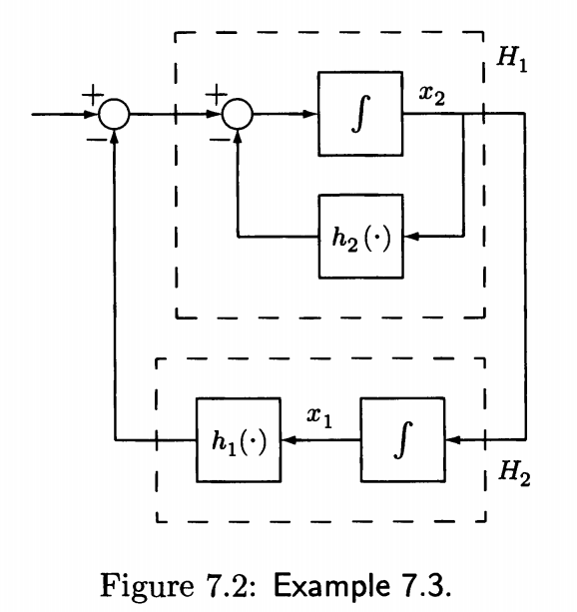 ${\dot{x}}_{1}=x_{2}, {\dot{x}}_{2}= -h\left(x_{1}\right)-h_{2}\left(x_{2}\right) , h_{1} , h_{2} ∈Sector \left(0, ∞\right)$ and locally Litschitz

(Ex. 3.8: Pendulum equation

${\dot{x}}_{1}=x_{2}, {\dot{x}}_{2}= -\sin{x_{1}}-x_{2} , x_{1}∈(-π, π)$)

* In Blcok

1. $H_{1}$: output strictly passive $V_{1}=\frac{1}{2}x_{2}^{2}$
2. $H_{2}:$ lossless with passive 🡪 not strictly passive

nor output strictly passive. $V_{2}=\int_{0}^{x_{1}}{h_{1}(σ)}dσ$

1. Select $V=V_{1}+V_{2}$

$$V=\frac{1}{2}x_{2}^{2}+\int_{0}^{x_{1}}{h_{1}(σ)}dσ$$

$$\dot{V}=h_{1}\left(x_{1}\right)x_{2}+x_{2}\left(-h\left(x_{1}\right)-h\left(x_{2}\right)\right)= -x_{2}h\left(x_{2}\right)≤0$$

* Negative semi definite 🡪 passive

For aympt.stable, zero-state observability is needed

By lasalle’s theorem (invariant theorem), $\dot{V}=0-→x_{2}=0-→ {\dot{x}}_{2}=0$

* From ${\dot{x}}_{2}=-h_{1}\left(x_{1}\right)-h_{2}\left(x_{2}\right) -→0=h_{1}\left(x_{1}\right) -→h_{1}\left(x\right) in sector \left(0, ∞\right)-→x_{1}=0$
* Zero state observable 🡪 the system is asymp. stable

%%% Kim’s comment

See Ex.3.6 Ex.3.7(variable gradient), Ex.3.8 and Ex.7.3 What are the differences? %%%

* 1. The small gain theorem 🡪 skip
  2. Absolute Stability

1. Problem formulation : Lure’s Problem

$$\dot{x}=Ax+Bu, y=Cx+Du , u=-ψ\left(t,x\right) (7.21)$$

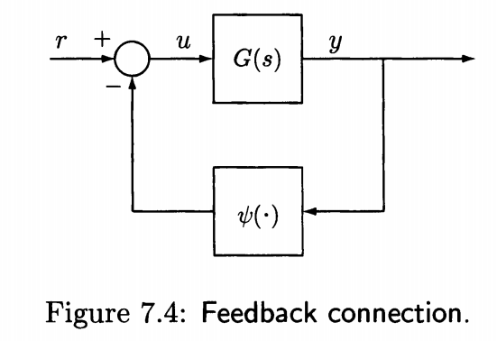Assumption: $\left(A,B\right), \left(A,C\right)$ controllable, observable. $ψ∈in a sector$

* $ψ(t,x)$ is memoryless and may be time varying.
* In Tut_5, the feedforward $G(s)$ and the linear feedback $G_{2}\left(s\right)$ is a strictly positive real, then the closed loop is strictly positive 🡪 asymp.stable
* Definition 7.1 :

The system (7.21) is absolutely stable if the origin is globally uniformly asymp.stable for any non-linearity in the sector.

* + 1. Circle Criterion - See Aizemann’s Conjecture in Week_8
* Theorem 7.8 The system (7.21) is absolutely stable if

1. $ψ∈[K_{1}, ∞)$ and $G\left(s\right){\left[I+K_{1}G\left(s\right)\right]}^{-1}$ is strictly positive real , **or**
2. $ψ∈\left[K_{1}, K_{2}\right], K=K_{2}-K_{1}=K^{T}>0$ and $\left[I+K_{2}G\left(s\right)\right]{\left[I+K_{1}G\left(s\right)\right]}^{-1}$ is

strictly positive real.

%%% Kim’s comment : If SISO case

$H(s)$ is strictly positive real if $H(s)$ is a Hurwitz and Re[H(s)] >0 %%

* Consider single Input single output case $G\left(s\right)∈C^{1} ,$. To check the absolute stability, $ψ∈\left[α, β\right], β>α$. there are 3 cases,

$β>α>0$

$0=α<β$

$β>0>α$

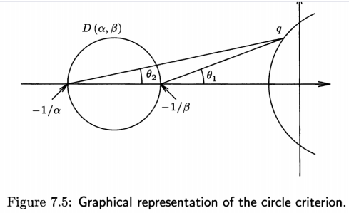Case a) $β>α>0$

a.1) Consider the second condition first

$$Re \{\left[1+βG\left(jω\right)\right]{\left[1+αG\left(jω\right)\right]}^{-1}\}>0$$

$Re \left[\frac{\frac{1}{β}+G\left(jω\right)}{\frac{1}{α}+G\left(jω\right)}\right]>0$

$Re \left[\frac{l_{1}e^{j1}}{{l_{2}e}^{j2}}\right]=\frac{l_{1}}{l_{2}} Re [e^{j\left(θ_{1}-θ_{2}\right)}]>0$

$θ_{1}-θ_{2}<\frac{π}{2}$

* Consider 🡪 **the circle at the boundary $-\frac{1}{α}+j0, -\frac{1}{β}+j0$**
* In order $θ_{1}-θ_{2}<\frac{π}{2}$ if $q$ is outside the Disk $D(α, β)$

a.2) $\frac{1+βG\left(s\right) }{1+αG\left(s\right)}$ is Hurwitz,

🡪 is Hurwitz

* $\frac{G\left(s\right)}{\frac{1}{α}+G(s)}$ is Hurwitz if and only if $G(s)$ encircles $-\frac{1}{α}+j0$ $p$ times , where $p$ is the number of poles of $G(s)$ in RHP, in the counter clock wise direction.

a.3) In conclusion: ( In SISO case)

The Nyquist plot of $G(s)$ does not enter the disk $D(α, β)$ and encircles it $p$ times in the ccw direction, $p=\# poles in RHP$

Case b) $0=α<β$,

a.1) By the theorem,

🡪

🡪 Nyquist of $G(s)$ should be in the right of the vertical line $Re \left[s\right]= -1/β$

a.2) $\left[1+βG\left(s\right)\right]$ is Hurwitz,

🡪 is Hurwitz

a.3) In conclusion

$G(s)$ is Hurwitz and the Nyquist plot lies to the of the vertical line $Re\left[s\right]=-1/β$

Case c) $α<0< β$,

c.1) For $Re\left[\frac{\left[1+βG\left(s\right)\right]}{\left[1+αG\left(s\right)\right]}\right]>0$ using a.1) method

🡪

🡪

🡪The Nyquist plot should be inside of $D(α, β)$

c.2) $\frac{1+βG\left(s\right) }{1+αG\left(s\right)}$ is Hurwitz,

🡪 Since the Nyquist of $G\left(s\right)$ is inside of $D(α, β)$, $\frac{G\left(s\right) }{1+αG\left(s\right)}$ is Hurwitz

🡪 Due to c.1), The Nyquist plot of $G(s)$ can not encircle $-\frac{1}{α}+j0$,

-> $G(s)/(1+αG\left(s\right))$ to be Hurwitz, $G(s0$ should be Hurwitz.

c.3) In conclusion

$G(s)$ is Hurwitz

And the Nyquist of $G(s)$ lies in the interior of the Disk $D(α, β)$

In all cases, the conclusion are in the following Theorem

* Theorem 7.9

In SISO, where a minimal realization of the (7.21) $G\left(s\right), ψ∈[α, β]$. Then the system is absolutely stable if one of the following conditions is satisfied

1. If $0<α<β$, the Nyquist plot of $G(s)$ does not enter the disk $D(α, β)$ and encircles it $p$ times in the counter clock wise direction, $p$ is the number of poles of $G(s)$ with positive real parts.
2. If $0=α< β$, $G(s)$ is Hurwitz and the Nyquist plot of $G(s)$ lies to the right of the vertical line $Res= -1/β$
3. If $α<0<β$, $G(s)$ is Hurwitz and the Nyquist plot of $G(s)$ lies in the interior of the Disk $D(α, β)$

-the EnD -

* 1. Popov Criterion-skip

Similar to the Absolute Stability, however, the sector condition is $[0, α]$.