HW_3

1. Check the following functions whether positive definite or not
$V\left(x_{1}, x_{2}\right)=x_{1}^{2}+2x_{2}^{2}$

$V\left(x_{1}, x_{2}\right)= x_{1}^{2}+4x_{1}x_{2}+2x_{2}^{2}$

$V\left(x_{1}, x_{2}\right)={\left(x_{1}+x_{2}\right)}^{2}$

$V\left(x_{1}, x_{2}\right)=x_{1}x_{2}+x_{2}^{2}$

$V\left(x_{1}, x_{2}\right)=x_{1}^{2}+\frac{2x_{2}^{2}}{1+x_{2}^{2}}$

2. Exercises 3.2
3. Exercises 3.3
4. Exercises 3.4
5. Consider the following feedback system $T>0$

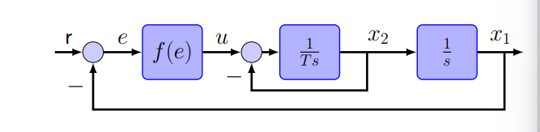

The state space model is, $e=r-x_{1}, r is a constant$

$$\left[\begin{matrix}\dot{e} \\ {\dot{x}}_{2}\end{matrix}\right]= \left[\begin{matrix}-x_{2} \\ \frac{f\left(e\right)}{T} -\frac{1}{T}x_{2}\end{matrix}\right]$$

where

$$f\left(e\right)=0 when e=0, ef\left(e\right)≥0$$

Choose a Lyapunov candidate as

$$V\left(e, x_{2}\right)= \int_{0}^{e}{f\left(σ\right)dσ}+\frac{T}{2}x_{2}^{2}$$

1. Is it stable?
2. If r = step function, $r\left(t\right)=1, t≥0,$ $with e\left(0\right)=x_{2}\left(0\right)=0$ plot the $x_{1}\left(t\right), 0≤t≤5$

3.1) when $f\left(e\right)=2e\left(t\right)$

3.2) when $f\left(e\right)= \left\{\begin{aligned}2e , \left|e\right|≤1 \\ 2, otherwise\end{aligned}\right.$

3.3) when $f\left(e\right)= e^{3}$

-The End-