* Ex. 7.4

1. Problem

$${\dot{x}}_{1}= -x_{1}+x_{2} \\ {\dot{x}}_{2}= -ψ_{1}\left(x_{1}\right)-x_{2}+u, y=x_{2} ,$$

$$ψ_{1}∈Sec\left[k, ∞\right]$$

Is the origin of the unforced closed loop system globally uniformly asymp.stable?

1. Solution

The unforced closed loop system is

$$\left(Σ\right) {\dot{x}}_{1}= -x_{1}+x_{2} \\ {\dot{x}}_{2}= -ψ_{1}\left(x_{1}\right)-x_{2}, ψ_{1}∈Sec[k, ∞)$$

Since $ψ_{1}\left(x_{1}\right) ∈Sec [k, ∞)$, i.e., $$x_{1}\left(ψ_{1}\left(x_{1}\right)-kx_{1}\right)≥0$$

Or

$$x_{1}ψ_{1}\left(x_{1}\right)≥kx_{1}^{2}≥0 ∵k>0$$

implies

$$x_{1}ψ_{1}\left(x_{1}\right)≥0$$

Or

$$\int_{0}^{x_{1}}{ψ_{1}\left(s\right)ds≥0} , ∀x_{1}$$

1. Globally asympt.stable.

Define a candidate Lyapunov function $V$

$$V=\int_{0}^{x_{1}}{ψ_{1}\left(s\right)ds}+ \frac{1}{2} x_{2}^{2}$$

$V\left(x_{1}=0, x_{2}=0\right)=0,$ and $V\left(x_{1}, x_{2}\right)> 0$, and

$$\lim_{x→∞}{V(x)}=∞$$

so that it is a radially unbound positive definite function.

Its derivative is

$$\dot{V}=ψ_{1}\left(x_{1}\right)\left(-x_{1}+x_{2}\right)+x_{2}(-ψ_{1}\left(x_{1}\right)-x_{2}) \\ =-ψ_{1}\left(x_{1}\right)x_{1}+ψ_{1}\left(x_{1}\right)x_{2} -x_{2}ψ_{1}\left(x_{1}\right)-x_{2}^{2} \\ =-ψ_{1}\left(x_{1}\right)x_{1}-x_{2}^{2}<0$$

Hence at the origin of the closed loop system $Σ$ is globally stable.

1. Uniformity:

Since $Σ$ is time-invariant system, i.e., by the theorem 4.1 if $∃ W_{1}\left(x\right), W_{2}(x)$

$$W_{1}\left(x\right)≤V\left(x\right)≤W_{2}(x)$$

the origin of $Σ$ is uniform stable, hence take $W_{1}\left(x\right)=W_{2}\left(x\right)=V(x)$,it is uniform stable.

%%% Kim’s comment;

Uniform stable is regarding an initial time $t_{0}$ in the time varying system. If the system is tine invariant, always it is uniform.

%%%

* Ex. 7.5 (a)

1. Problem

$${\left(Σ\right) \dot{x}}_{1}=x_{1}+x_{2} \\ {\dot{x}}_{2}= -x_{1}-2x_{2}+x_{2}^{3}$$

is globally exponentially stable?

1. Solution

To find equilibrium point,

$$x_{1}+x_{2}=0 -→x_{1}={-x}_{2}$$

$$-x_{1}-2x_{2}+x_{2}^{3}=-x_{2}+x_{2}^{3}=0-→x_{2}=0, 1$$

There are another equilibrium point different from $(0, 0)$, so that $Σ$ has no global stable point. Moreover, the linearized system is not asympt. stable, which implies $Σ$ is not asympt.stable.

* Ex.7.10 (Circle criteria)

Given a transfer function with a non-linear $ϕ$, the closed loop system is absolute stability or not.

$G\left(s\right)=1/(s+4)(s-2)$

1. $0<α<β$ case

Since in RHP, there is a one pole. To be absolute stable, select a circle with radius 0.023 at the center -0.1, which Nyquist encircle in the CCW direction one time.

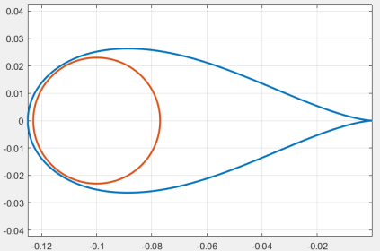

$$-\frac{1}{α}= -0.123 , -\frac{1}{β}=-0.077$$

Hence the non-linear is in the sector $ϕ∈ S(α, β)$ = S(8.13, 12.987)

1. $0=α<β$: Since $G\left(s\right)$ is not Hurwitz, the circle criteria can not insure the absolute stability.
2. $α<0<β$: Since $G\left(s\right)$ is not Hurwitz, the circle criteria can not insure the absolute stability.

%%% Kim’s comment

Let us see the characteristic equation of the closed loop assuming $ϕ$ is a constant,

$$\left(s+4\right)\left(s-2\right)+k=0$$

Hence if $k>$ 8, the closed loop is asymptotic stable. However if $ϕ$ is nonlinear in a Sector,

1. The circle criterion is sufficient condition
2. Moreover for any non-linear in the sector, the closed loop is asymptotic stable. %%

$G\left(s\right)=1/[\left(s+4\right)\left(s+2\right)]$

$0<α<β$

The circle is with 0.003 radius at the center -0.008

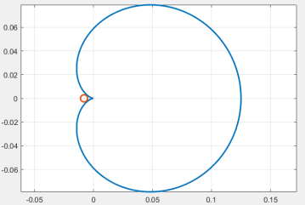

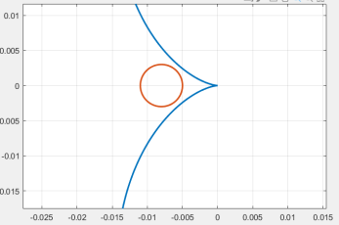

If 🡪 , , i.e.,

the $ϕ∈Sector [91, 200]$, by the circle criteria the system is absolute stable.

$0=α<β$

The minimum real value of the Nyquist is -0.0143, hence

$$-\frac{1}{β}=-0.0143 -→β\sim 70$$

The $ϕ∈Sector \left(0, 70\right)$ will ensure the absolute stability.

1. $α<0<β$. Since the transfer function is a Hurwitz, $α$ may be a negative. The circle is

with radius 0.08 at the center 0.05 Hence

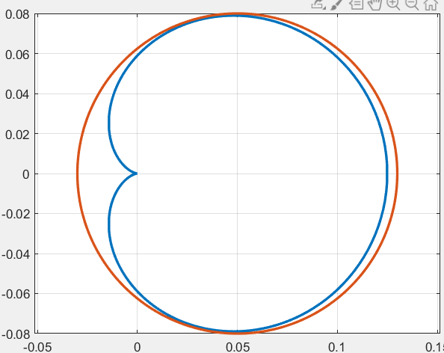 $\frac{1}{α}= -0.03 ,\frac{1}{β}=0.13$

Hence the closed loop is absolutely stable with

$ϕ∈Sec ($-33, 7.7)

$G\left(s\right)=2s/(s^{2}-8s+2)$

Since $G(s)$ is not Hurwitz, by the circle criterion only $0<α<β$ is considered.

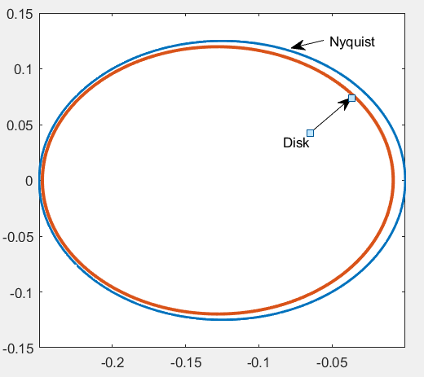One pole of $G(s)$ is RHP, the Nyquist encircles a disk in the CCW, select a Disk with $R=0.12$ at $-0.128$

Hence $-\frac{1}{α}= -0.248, -\frac{1}{β}=0.008$

$$ϕ∈Sector (4.03, 125)$$

$G\left(s\right)=2s/(s^{2}+8s+2)$

$0<α<β$

Since there is no poles of G(s) in RHP, for the absolute stability, the Nyquist plot does not enter a Disk, We may select a disk with a radius large enough so that

$$-\frac{1}{α}= -∞ , -\frac{1}{β}=0$$

i.e., $α=0 , β=∞$, $ϕ∈Sec (0, ∞)$

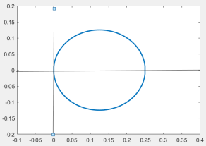

$0=α<β$

Since $G(s)$ is a Hurwitz, this is the same condition to a)

$α<0<β$

The Nyquist plot should be inside a disk, assume a disk with radius 0.125 at the center 0.125 which is equivalent of the Nyquist plot except the direction. Hence $∀ α<0$ and $\frac{1}{β}>0.25-→β<4$, $ϕ∈\left(α , 4\right), α<0$, it is absolute stable.

$G\left(s\right)=1/{\left(s+2\right)}^{3}$

Since $G(s)$ is a Hurwitz and no pole on RHP, we may consider all three cases.

$0<α<β$

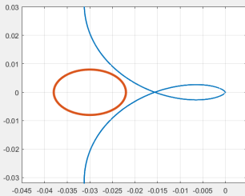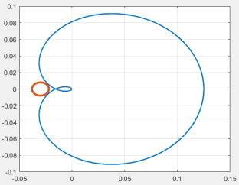

The Disk with radius = $0.008$

At the center -0.03. Hence

$$-\frac{1}{α}= -0.038, -\frac{1}{β}=-0.022$$

$α=26, β=45$

Hence $ϕ∈Sec(25, 45)$

$0=α<β$

The minimum of the real of part Nyquist plot is -0.0309, so that $β=32.36$

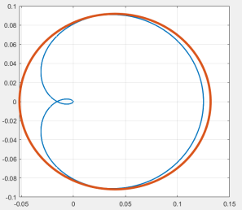Hence $ϕ∈Sector (0, 32.36)$, the closed system is absolute stable

$α<0<β$

The circle with radius 0.092 at 0.04 is encircled the Nyquist,

$$-\frac{1}{α}=-0.052 ,\frac{1}{β}=0.132$$

Hence $ϕ∈Sec (-19.2 , 7,5)$ the system is absolute stable.

$G\left(s\right)=(s-4)/(s+4)(s+2)$

$0<α<β$

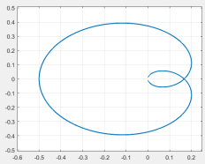The min of real Nyquist is -0.497, hence 🡪 the system is absolute stable.

1. $0=α<β$ In this case $ϕ∈Sector (0, 2.02)$
2. 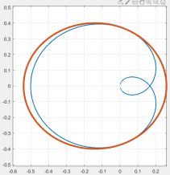 $α<0<β$

The radius of the circle is 0.4 at the center -0.14 .Hence

$$\frac{1}{α}= -0.54, \frac{1}{β}=0.26$$

* $ϕ ∈Sector ($-1.85, 3.84)

$G\left(s\right)=\frac{s+2}{\left(s^{2}-4\right)\left(s+2\right)}$

-Since $G(s)$ is not a Hurwitz, by the circle criterion, only in $0<α<β$ is considered.

- is not a minimal realization, the circle criterion can not be applied.

- Let $G'(s)$ be the minimal realization, $G'\left(s\right)=\frac{1}{s^{2}-4}$, it is not Hurwitz. Hence $0<α<β$ is considered. One pole of $G'(s)$ is in RHP, the Nyquist should be circled in the direction of CCW, however, $G'(s)$ is always a real number $∀ ω , s=jω$. Hence it is NOT absolute stable for any $α, β$-The EnD-

$G\left(s\right)=(s+2)/(\left(s^{2}-4\right)\left(s+2\right))$

Since $G(s)$ is not a Hurwitz, by the circle criterion, only in the case of $o<α<β$ is considered for absolute stability.

The Nyquist plot should encircle two times of the disk in the CCW direction.

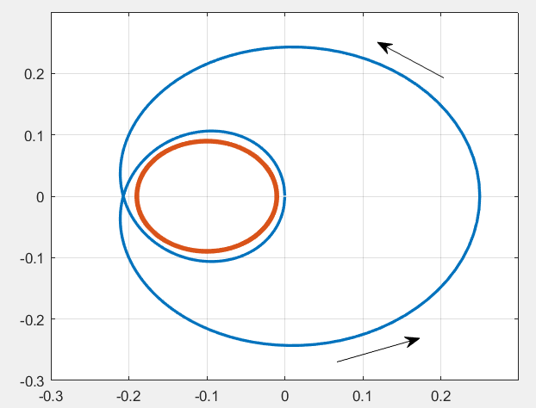Select a disk with a radius 0.09 at the center -0.1

Hence

$$-\frac{1}{α}= -0.19 , -\frac{1}{β}= -0.01$$

i.e., with $ϕ∈Sector (5.23 , 100)$ it is absolute stable.

* Ex. 9.1

1. Problem

$$\left(Σ\right) \dot{x}=3x-5x^{2}+u$$

Pick a candidate

$$V=\frac{1}{2}x^{2}>0$$

$$\dot{V}=x\left(3x-5x^{2}+u\right)=3x^{2}-5x^{3}+xu$$

Select $u= -3x+5x^{2}-x$, then

$$\dot{V}= -x^{2}<0$$

Hence with $u , Σ$ is globally asympt. stable

1. Problem

$${\dot{x}}_{1}=x_{2} \\ { \dot{x}}_{2} = -x_{1}^{3}+u$$

Pick a candidate

$V=\frac{1}{2}(x_{1}^{2}+x_{2}^{2})$,

$$\dot{V}=x_{1}x_{2}+x_{2}\left(-x_{1}^{3}+u\right)$$

Select $u$ as

$$u= x_{1}^{3}-x_{1}-x_{2}$$

Then

$$\dot{V}=-x_{2}^{2}≤0$$

By Lasalle’s Theorem, $x_{1}-→0$ (Why?), the system is globally asymp. stable

1. Problem:

$${\dot{x}}_{1}=x_{1}x_{2}^{2}-x_{1} \\ {\dot{x}}_{2}=x_{2}+u$$

Pick a candidate

$V=\frac{1}{2}(x_{1}^{2}+x_{2}^{2})$,

$$\dot{V}=x_{1}(x_{1}x_{2}^{2}-x_{1})+x_{2}(x_{2}+u)$$

Select $u$ as

$$u= -2x_{2}-x_{1}^{2}x_{2}$$

Then

$$\dot{V}= -x_{1}^{2}-x_{2}^{2} <0$$

Hence globally asympt. stable

1. Problem:

$${\dot{x}}_{1}=2x_{1}^{2}+x_{2} \\ {\dot{x}}_{2}=u$$

Using backstepping

1. First define $ξ=x_{2}$. The first equation is

$${\dot{x}}_{1}=2x_{1}^{2}+ξ$$

Select $V_{a}=\frac{1}{2}x_{1}^{2} -→{\dot{V}}_{a}=x_{1}\left(2x_{1}^{2}+ξ\right) -→ξ= -2x_{1}^{2}-x_{1}-→{\dot{V}}_{a}=-x_{1}^{2}<0$

Define $z=x_{2}-ξ$. Then the system is

$${\dot{x}}_{1}=2x_{1}^{2}+ z+ξ=2x_{1}^{2}+z+\left(-2x_{1}^{2}-x_{1}\right)= -x_{1}+z \\ \dot{z}={\dot{x}}_{2}-\dot{ξ}=u-\left(-4x_{1}\dot{x_{1}}-{\dot{x}}_{1}\right)=u+4x_{1}\left(-x_{1}+z\right)+(-x_{1}+z)$$

Select $V=V_{a}+\frac{1}{2}z^{2}=\frac{1}{2}(x_{1}^{2}+z^{2})$

$\dot{V}={\dot{V}}_{a}+z\dot{z}=x_{1}\left(-x_{1}+z\right)+z(u+4x_{1}\left(-x_{1}+z\right)+(-x_{1}+z)$)

Design $u as$

$$u= -4x_{1}\left(-x_{1}+z\right)-\left(-x_{1}+z\right)-x_{1}-z$$

Then

$$\dot{V}= -x_{1}^{2}-z^{2}<0$$

Hence with $z=x_{2}-ξ=x_{2}-\left(-2x_{1}^{2}-x_{1}\right)=x_{2}+2x_{1}^{2}+x_{1}$ and u, the system is globally asym. Stable.

1. Problem

$${\dot{x}}_{1}=x_{1}^{5}-x_{1}^{6}+x_{2} \\ {\dot{x}}_{2}=u$$

Using back stepping

1. Define $ξ=x_{2}$. The first equation is

$${\dot{x}}_{1}=x_{1}^{5}-x_{1}^{6}+ξ$$

Select a $V_{a}=\frac{1}{2}x_{1}^{2} >0$,

$${\dot{V}}_{a}=x_{1}\left(x_{1}^{5}-x_{1}^{6}+ξ\right)$$

Choose $ξ= -x_{1}^{5}+x_{1}^{6}-x_{1}-→ {\dot{V}}_{a}= -x_{1}^{2} <0$

Select $z=x_{2}-ξ$

Then the system is

$${\dot{x}}_{1}=x_{1}^{5}-x_{1}^{6}+z+ξ=x_{1}^{5}-x_{1}^{6}+z-x_{1}^{5}+x_{1}^{6}-x_{1}= -x_{1}+z \\ \dot{z}={\dot{x}}_{2}-\dot{ξ}=u-(-5x_{1}^{4}+6x_{1}^{5}-1)(-x_{1}+z)$$

Select a $V=V_{a}+\frac{1}{2}z^{2}>0$

$$\dot{V}={\dot{V}}_{a}+z\dot{z}=x_{1}\left(-x_{1}+z\right)+z\left(u-\left(-5x_{1}^{4}+6x_{1}^{5}-1\right)\left(-x_{1}+z\right)\right)$$

Design $u as$

$$u=\left(-5x_{1}^{4}+6x_{1}^{5}-1\right)\left(-x_{1}+z\right)-x_{1}-z$$

so that

$$\dot{V}= -x_{1}^{2}-z^{2}<0$$

Hence the original system is asym. Stable.

1. Problem

$${\dot{x}}_{1}=2x_{1}^{2}+x_{2} , {\dot{x}}_{2}=x_{3}, {\dot{x}}_{3}=u$$

Sol:

First assume $x_{3}$ as an input so that

$${(Σ}_{1}) {\dot{x}}_{1}=2x_{1}^{2}+x_{2} , {\dot{x}}_{2}=v$$

Define $ξ=x_{2}$. The first equation is

$${\dot{x}}_{1}=2x_{1}^{2}+ξ$$

Select $V_{a}=\frac{1}{2}x_{1}^{2} -→{\dot{V}}_{a}=x_{1}\left(2x_{1}^{2}+ξ\right) -→$

$$ξ= -2x_{1}^{2}-x_{1}-→{\dot{V}}_{a}=-x_{1}^{2}<0$$

Define $z_{1}=x_{2}-ξ$. Then the system $Σ_{1}$ is

$${\dot{x}}_{1}=2x_{1}^{2}+ z_{1}+ξ=2x_{1}^{2}+z_{1}+\left(-2x_{1}^{2}-x_{1}\right)= -x_{1}+z_{1} \\ {\dot{z}}_{1}={\dot{x}}_{2}-\dot{ξ}=v-\left(-4x_{1}-1\right){\dot{x}}_{1}=v+\left(4x_{1}+1\right)(-x_{1}+z_{1})$$

Select $V=V_{a}+\frac{1}{2}z_{1}^{2} >0$

$\dot{V}=x_{1}{\dot{x}}_{1}+z_{1}{\dot{z}}_{1} = x_{1}\left(-x_{1}+z_{1}\right)+z_{1}(v+\left(4x_{1}+1\right)\left(-x_{1}+z_{1}\right))$

Design $v$ as

$$v=ϕ\left(x_{1}, x_{2}\right)= -\left(4x_{1}+1\right)\left(-x_{1}+z_{1}\right)-x_{1}-z_{1}$$

to result in

$$\dot{V}= -x_{1}^{2} -z_{1}^{2}$$

The next backstepping,

Define $z_{2}=x_{3}-ϕ(x_{1}, x_{2})$ the additional system is

$$\left(Σ_{2}\right) {\dot{x}}_{1}=2x_{1}^{2}+x_{2} , {\dot{x}}_{2}=ϕ+z_{2},$$

And

$${\dot{z}}_{2}={\dot{x}}_{3}-\dot{v}=u-\frac{∂ϕ}{∂x_{1}}\left(2x_{1}^{2}+x_{2}\right)-{\frac{∂ϕ}{∂x}}_{2}(ϕ+z_{2})$$

Select $V_{f}=V+\frac{1}{2}z_{2}^{2} ,$ where $V =\frac{1}{2}x_{1}^{2}+\frac{1}{2}z_{1}^{2}+\frac{1}{2}z_{2}^{2}=\frac{1}{2}x_{1}^{2}+\frac{1}{2}\left(x_{2}+x_{1}+2x_{1}^{2}\right)$, where , $V_{f}, V >0$

The time derivative

$$\dot{V_{f}}=\frac{∂V}{∂x_{1}}{\dot{x}}_{1}+\frac{∂V}{∂x_{2}}{\dot{x}}_{2}+z\left(u-\frac{∂ϕ}{∂x_{1}}\left(2x_{1}^{2}+x_{2}\right)-{\frac{∂ϕ}{∂x}}_{2}\left(ϕ+z_{2}\right)\right)$$

Since

$$\frac{∂V}{∂x_{1}}{\dot{x}}_{1}+\frac{∂V}{∂x_{2}}{\dot{x}}_{2}= -x_{1}^{2} -\left(x_{2}+x_{1}+2x_{1}^{2}\right) <0$$

And design $u$ as

$$u=\frac{∂ϕ}{∂x_{1}}\left(2x_{1}^{2}+x_{2}\right)+{\frac{∂ϕ}{∂x}}_{2}\left(ϕ+z_{2}\right)-z_{2}$$

So that

$${\dot{V}}_{f}=-x_{1}^{2} -\left(x_{2}+x_{1}+2x_{1}^{2}\right)-z_{2}^{2}<0$$

* Example.1 – the backstepping procedure.

1. Problem
$${\dot{x}}_{1}=x_{1}+x_{2} \\ x_{2}=u$$

2. Fictitious controller $ξ$ as $x_{2}=ξ$ at the first equation

$${\dot{x}}_{1}=x_{1}+ξ$$

Select a Lyapunov equation

$$V_{a}=\frac{1}{2}x_{1}^{2}$$

So that

$${\dot{V}}_{a}=x_{1}\left({\dot{x}}_{1}\right)=x_{1}\left(x_{1}+ξ\right)$$

To be negative

$$ξ= -x_{1}-x_{1}=-2x_{1}$$

so that

$${\dot{V}}_{a}=x_{1}\left(x_{1}-x_{1}-x_{1}\right)= -x_{1}^{2}<0$$

1. Define fictitious state $z$ at the second equation

$$z=x_{2}-ξ=x_{2}+2x_{1}$$

Its dynamics is with $ξ= -2x_{1}$, the first equation is

$${\dot{x}}_{1}=x_{1}+x_{2}=x_{1}+ \left(z+ξ\right)=x_{1}+z -2x_{1}=-x_{1}+z$$

The second equation is

$$\dot{z}={\dot{x}}_{2}-\dot{ξ} =u-\dot{ξ}=u+2{\dot{x}}_{1}=u-2x_{1}+2z$$

Now select a lyapunov function $V=V_{a}+\frac{1}{2}z^{2}=\frac{1}{2}x_{1}^{2}+\frac{1}{2}z_{2}^{2}$

$$\dot{V}={\dot{V}}_{a}+z\dot{z} \\ =x_{1}\left(-x_{1}+z\right)+z\left(\dot{z}\right) \\ =-x_{1}^{2}+x_{1}z +z\left(u-2x_{1}+2z\right)$$

Select $u$ as

$$u= 2x_{1}-2z-x_{1}-z$$

Then

$$\dot{V}=-x_{1}^{2}-z^{2}$$

The final controller $u$ in terms of $x_{1}, x_{2}$ is with $z=x_{2}+2x_{1}$

$$u=x_{1}-3z=x_{1}-3\left(x_{2}+2x_{1}\right)=-5x_{1}-3x_{2}$$

* **9.3 (2) : backsteeping**

${\dot{x}}_{1}=\sin{x_{1}}+x_{2}$, ${\dot{x}}_{2}=u$

1. first fictitious controller $ξ$

$${\dot{x}}_{1}=\sin{x_{1}}+ξ \\ V_{a}=\frac{1}{2}x_{1}^{2}-→{\dot{V}}_{a}=x_{1}(\sin{x_{1}}+ξ)$$

Pick 🡪

1. Second fictitious state with $ξ = -\sin{x_{1}}-x_{1}$

$$z=x_{2}-ξ$$

The first equation is

$${\dot{x}}_{1}=\sin{x_{1}}+x_{2}=\sin{x_{1}}+ξ+z=\sin{x_{1}}-\sin{x_{1}}-x_{1}+z= -x_{1}+z$$

The second is

$$\dot{z}= {\dot{x}}_{2}-\dot{ξ}=u+\cos{x_{1}}{\dot{x}}_{1}+{\dot{x}}_{1} \\ =u+\cos{x_{1}}\left(-x_{1}+z\right)-x_{1}+z$$

Pick a Lyapunov function $V=\frac{1}{2}x_{1}^{2}+\frac{1}{2}z^{2}$

Then

$$\dot{V}=x_{1}\left({\dot{x}}_{1}\right)+z\left(\dot{z}\right) =x_{1}\left(-x_{1}+z\right)+z(u+\cos{x_{1}}\left(-x_{1}+z\right)-x_{1}+z)$$

Hence if the controller is

$$u= -\cos{x_{1}}\left(-x_{1}+z\right)+x_{1}-z-z-x_{1}$$

The time derivative of $V$

$$\dot{V}= -x_{1}^{2}-z^{2}<0$$

1. The controller $u$ in terms of the states with $z=x_{2}-ξ=x_{2}+\sin{x_{1}}+x_{1}$

$$u=-\cos{x_{1}}\left(-x_{1}+z\right)-2z \\ =-\cos{x_{1}}\left(-x_{1}+x_{2}+\sin{x_{1}}+x_{1}\right)-2\left(x_{2}+\sin{x_{1}}+x_{1}\right) \\ = -\cos{x_{1}}\left(\sin{x_{1}}+x_{2}\right)-2x_{2}-2\sin{x_{1}}-2x_{1}$$

* **Ex.9.3) (3) : backstepping**

$${\dot{x}}_{1}=x_{2}+1+{\left(1-x_{1}\right)}^{3} \\ {\dot{x}}_{2}= -x_{1}+u$$

1. The origin is not at $(0,0)$, but (0,-2).
2. first define a fictitious $ξ$ as $ξ=x_{2}$

The first equation is

$${\dot{x}}_{1}=ξ+1+{\left(1-x_{1}\right)}^{3}$$

Take a Lyapunov function as

$$V_{a}=\frac{1}{2}x_{1}^{2}$$

So that

$${\dot{V}}_{a}=x_{1}\left({\dot{x}}_{1}\right)=x_{1}\left(ξ+1+{\left(1-x_{1}\right)}^{3}\right)$$

Take $ξ$ for ${\dot{V}}_{a}$ to be negative definite

$${ξ = -1-{\left(1-x_{1}\right)}^{3}-x_{1}, -→ \dot{V}}_{a}= -x_{1}^{2}$$

1. Second , define a fictitious state $z$

$$z=x_{2} -ξ=x_{2}+1+{\left(1-x_{1}\right)}^{3}+x_{1}$$

The first equation is

$${\dot{x}}_{1}=x_{2}+1+{\left(1-x_{1}\right)}^{3} \\ =z+ξ+1+{\left(1-x_{1}\right)}^{3} \\ =z-1-{\left(1-x_{1}\right)}^{3}-x_{1}+1+{\left(1-x_{1}\right)}^{3} \\ =z-x_{1}$$

The second is

$$\dot{z}={\dot{x}}_{2}-\dot{ξ} \\ ={\dot{x}}_{2}+\left\{3{\left(1-x_{1}\right)}^{2}\left(-{\dot{x}}_{1}\right)+{\dot{x}}_{1}\right\} \\ =-x_{1}+u-\left\{3{\left(1-x_{1}\right)}^{2}\left(-{\dot{x}}_{1}\right)+{\dot{x}}_{1}\right\} \\ =-x_{1}+u-\left\{3{\left(1-x_{1}\right)}^{2}\left(x_{1}-z\right)+(z-x_{1})\right\}$$

Select a lyapunov function for the total system as

$$V=V_{a}+\frac{1}{2}z^{2}=\frac{1}{2}x_{1}^{2}+\frac{1}{2}z^{2}$$

The time derivative is

$$\dot{V}=x_{1}{\dot{x}}_{1} +z\dot{z} \\ =\left(x_{1}\left(z-x_{1}\right)\right)+z(-x_{1}+u-\left\{3{\left(1-x_{1}\right)}^{2}\left(x_{1}-z\right)+\left(z-x_{1}\right)\right\}) \\ =-x_{1}^{2}-x_{1}z +z(-x_{1}+u-\left\{3{\left(1-x_{1}\right)}^{2}\left(x_{1}-z\right)+\left(z-x_{1}\right)\right\})$$

To be negative,

$$u=3{\left(1-x_{1}\right)}^{2}\left(x_{1}-z\right)+\left(z-x_{1}\right)-z$$

which results in

$$\dot{V}=-x_{1}^{2}-z^{2}<0$$

Then at $(0,0)$ the system is asymptotic stable, $x_{1}-→0, z-→0$, i.e,

$$z=x_{2}-ξ-→0$$

Since , 🡪

1. Now $z=x_{2}-ξ=x_{2}-\{-1-{\left(1-x_{1}\right)}^{3}\}$, the controller $u$ is calculated in terms of $(x_{1}, x_{2})$

$$u=3{\left(1-x_{1}\right)}^{2}\left(x_{1}-z\right)+\left(z-x_{1}\right)-z$$

with $z=x_{2}-ξ=x_{2}+ 1+{\left(1-x_{1}\right)}^{3}+x_{1}$

%%% Announcement

As a reference, the answers to the Home assignment is up-loaded except exercise 9.2

**I have to exclude Ex. 9.2. The problem Ex. 9.2 is not well defined.**

**Final Exam will be related to this HA problems, (70%),**

**the others (30%)**

* **Stabilization by Linearization and comparison with state feedback**
* **Linear observer.**

--The EnD--%%%