Estimation of the currents and voltage in the self-resonant Mazilli circuit

Abstract: Mazilli self-resonant circuit has its own merits compared to other resonant circuit. It’s a simple topology and do not need external control signals. There are several studies and hardware realizations, however the design the Mazilli resonant circuit, the electrical properties, voltage and current, should be known before hardware realization. Due to the complexity it is difficult to get the analytic solution, in this article we may assume certain conditions to estimate the resonant currents and voltage.

1. Introduction

Mazilli self-resonant circuits are popular for generating high-frequency power signals to use induction applications. Regarding to generate a power signals with a high frequency there are several methods such as Mazilli self-resonant circuits[1],[2], Quasi resonant circuits[3], Half Bridge Resonant [4] are introduced in many articles and hardware-implemented examples. In case of self-resonant circuits, the external control signals does not need whereas Quasi-resonant or Half Bridge Resonant need the external control switching circuit.

There are many realization of Mazilli self-resonant circuits in the Youtube world [5], [6]. They show the resonant signals and some characteristics qualitatively, but there is no analysis quantitatively to what the magnitudes of resonant currents and voltage including the external power current are. In this article we analyze a Mazilli self-resonant circuit to estimate these values approximately.

1. Mazilli Zero Voltage Switching circuit
   1. Operation principles

Consider a self-resonant Mazilli Simulink block diagram Fig.1.In the diagram, DC source generates a high-frequency resonant current to transfer electrical energies by induction to remote places. The transferred induction energy  is equivalently modeled as resistor $R$. The resonant circuit, so called the tank circuit, is composed of the inductor $L_{3}$ and the capacitor $C$  including the modeled resistor. For steady resonant current and voltage regardless of the energy loss due to the resistor $R$, there are two side inductors $L_{1}$ and $L_{2}$ of the same inductance, and two switches with 0 voltage threshold for automatic feedback depending on the sign of the voltage $v_{a}(t)$, which is the resonant voltage in the tank circuit.

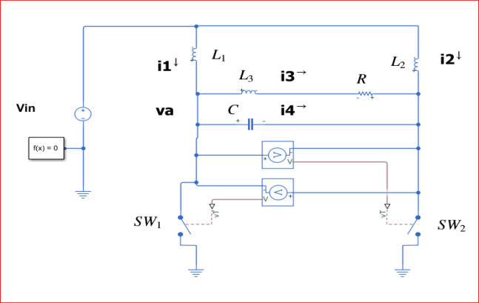

<Fig.1> Mazilli Simulink Diagram

During the resonant period, the power loss due to the resistor $R$ is happened. To sustain the resonant, two side inductors $L_{1}$ and $L_{2}$ supply the power to compensate the power loss. The two switches turn on and off depending on the polarity of the resonant voltage $v_{a}\left(t\right)$. During the resonant in the tank circuit, if the $v_{a}\left(t\right)$ is negative, ${SW}_{1}$ is on and ${SW}_{2}$ is off, so that $L_{1}$ is charged the electrical energy by the DC source and $L_{2}$ is discharged the energy to the tank circuit. If $v_{a}(t)$ is positive, then charging and discharging by the inductor is happened alternatively. Hence by the polarity of the resonant voltage $v_{a}(t)$ two switches are on and off, known as Zero Voltage Switching, it is allowed the power supply to compensate the power loss due to the resistor $R$ automatically. Since this resonant frequency is determined by the

tank circuits components, not by the external oscillating signal, it is a self-resonant circuit.

Under certain conditions, the tank current is oscillatory with an almost constant magnitude resonant with a certain angular frequency in Fig.2.

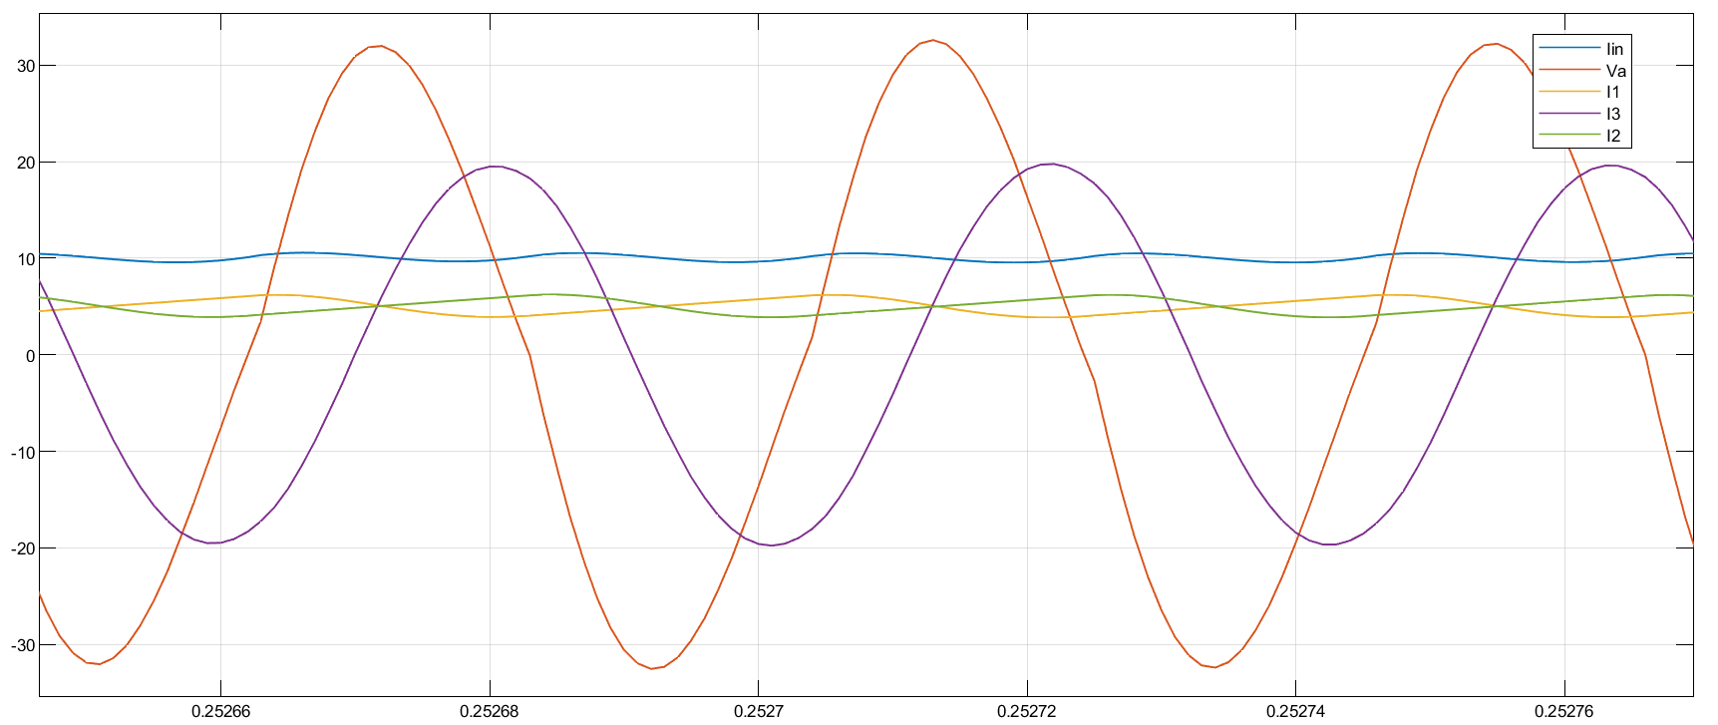

<Fig.2> The resonant current $i_{3}, v_{a}\left(t\right), i_{1}\left(t\right), i_{2}(t)$ in time axes

when the input $V_{in}=10 V DC$

In this Figure.2, it clearly shows the periodic behavior. To sustain the resonant property, there are two side inductors to provide and compensate for the power loss thru the $i_{1}(t)$ and $i_{2}(t)$ to the tank circuit. The circuit governing differential equations in Fig.1 is dependent on two switches' conduction states. In addition, the coefficients of the differential equation are variables of $L,C$ and , the solution to the differential equation is difficult and complicate to get analytically. For example, when $v_{a}\left(t\right)≥0$, the differential equation for the $i_{3}(t)$ is

$$\frac{d^{3}i_{3}}{dt^{3}}+\frac{R}{L_{3}}\frac{d^{2}i_{3}}{dt^{2}}+\frac{1}{CL_{3}}(1+\frac{L_{3}}{L_{1}})\frac{di_{3}}{dt}+\frac{R}{{CL}_{1}L_{3}}i_{3}=\frac{1}{{CL}_{1}L_{3}}V_{in}$$

This is a third-order differential equation with dependent coefficients of $L_{1}, L_{3}, C$ and R. To get the analytic solution to this differential equation, it is complicate and difficult. Hence to estimate the magnitude of $i_{3}\left(t\right), v_{a}(t)$ and $i_{in}\left(t\right)$, we may assume certain conditions in the following.

* 1. Assumptions

During the resonant in the tank circuit, to estimate the values of the currents and voltage, we may assume the following.

(Assumption 1)

$$v_{a}\left(t\right)=V_{a}\sin{(ωt}) , i_{3}=I_{3}\sin\left(ωt+ϕ\right) ,$$

$$V_{a}, I_{3}:constant$$

and the resonant angular frequency $ω$

$$ω=\sqrt{\frac{1}{L_{3}C}- \frac{R^{2}}{4L_{3}}}$$

(Assumption 2)

At the switching time $t_{0}$, in the time interval $t_{0}<t≤t_{0}+\frac{T}{2} ,$

$$v_{a}\left(t\right)=V_{a}\sin{(ωt)}$$

which leads to

$$v_{a}\left(t_{0}\right)=V_{a}\sin\left(ωt_{0}+\frac{T}{2}\right)=0, T=\frac{2π}{ω}$$

Under these assumptions, if in the simulated circuit Fig.1, $v_{a}\left(t\right)$ or $i_{3}(t)$ are not purely sinusoidal, they are assumed pure sinusoids with the constant magnitude to sustain the resonant.

* 1. Estimation of $v_{a}\left(t\right), i_{3}(t)$

Under the Assumption 1, in the tank circuit, $i_{3}(t)$ and $v_{a}(t)$ are governed by the differential equation

$$L_{3}\frac{di_{3}}{dt}+Ri_{3}=v_{a}$$

${v_{a}\left(t\right)=V_{a}\sin{(ωt)}, i}_{3}\left(t\right)=I_{3}\sin{(ωt+ϕ)}$ are the solution of the equation, plugging it in the equation results in

$$L_{3}ωI_{3}\cos\left(ωt+ϕ\right)+RI_{3}\sin{(ωt}+ϕ)=V_{a}\sin{(ωt)}$$

Then the magnitude between $I_{3}$ and $V_{a}$ is related

$$V_{a}=I_{3}\sqrt{{\left(ωL_{3}\right)}^{2}+R^{2}} (2.1)$$

And its phase

$$\operatorname{atan}{(ϕ)}= - \frac{ωL_{3}}{R}$$

Now consider time in the time interval $t_{0}<t≤t_{0}+\frac{T}{2}$, $v_{a}=V_{a}\sin\left(ωt\right) ≥0 ,$ the threshold of two switches is zero voltage, the ${SW}_{1}$ is open and ${SW}_{2}$ is closed, then the current $i_{1}(t)$ of $L_{1}$ is the solution to the differential equation

$$\frac{di_{1}}{dt}=\frac{1}{L_{1}}\left(V_{in}-v_{a}\right) (1)$$

Since $v_{a}\left(t\right)=V_{a}\sin{(ωt})$, the current $i_{1}(t)$ is

$$i_{1}\left(t\right)-i_{1}\left(t_{0}\right)=\frac{V_{in}}{L_{1}}\left(t-t_{0}\right) -\frac{1}{L_{1}}\int_{t_{0}}^{t}{V_{a}\sin\left(ωτ\right)dτ} \\ =\frac{V_{in}}{L_{1}}\left(t-t_{0}\right)+\frac{V_{a}}{ωL_{1}}\left(\cos\left(ωt\right)-\cos\left(ωt_{0}\right)\right)$$

At the right boundary time $t=t_{0}+\frac{T}{2}$

$$i_{1}\left(t_{0}+\frac{T}{2}\right)-i_{1}\left(t_{0}\right)=\frac{V_{in}}{L_{1}}\frac{T}{2}+\frac{V_{a}}{ωL_{1}}\left(\cos\left(ω\left(t_{0}+\frac{T}{2}\right)\right)-\cos\left(ωt_{0}\right)\right)$$

Since $\sin\left(ωt_{0}\right)$ and $\sin\left(ωt \right)≥0$, $\cos\left(ωt_{0}\right) =1$, the difference magnitude between the left and right boundary time is

$i_{1}\left(t_{0}+\frac{T}{2}\right)-i_{1}\left(t_{0}\right)=\frac{V_{in}}{L_{1}}\frac{T}{2}+\frac{V_{a}}{ωL_{1}}(cos\left(ω\left(t_{0}+\frac{T}{2}\right)\right)-1)$

The resonant period $T$ is $\frac{ωT}{2}=π$, and $\cos\left(ωt_{0}+π\right) = -\cos\left(ωt_{0}\right)= -1$,

$i_{1}\left(t_{0}+\frac{T}{2}\right)-i_{1}\left(t_{0}\right)=\frac{V_{in}}{L_{1}}\frac{T}{2}-\frac{{2V}_{a}}{ωL_{1}}$

Consider the previous half period time interval, $t_{0}-\frac{T}{2}≤t≤t_{0}$, $v_{a}\left(t\right)≤ 0$ when the ${SW}_{1}$ is closed and ${SW}_{2}$ is open, the current of $i_{1}(t)$ satisfies

$$\frac{{di}_{1}}{dt}=\frac{1}{L_{1}}V_{in}$$

The solution to this is at time $t=t_{0}$,

$$i_{1}\left(t_{0}\right)=\frac{V_{in}}{L_{1}}\left(\frac{T}{2}\right)+i_{1}(t_{0}-\frac{T}{2})$$

And the periodicity property of the current

$$i_{1}\left(t_{0}-T/2\right)=i_{1}(t_{0}+T/2)$$

Substituting this into the above

$i_{1}\left(t_{0}\right)- \frac{V_{in}}{L_{1}}\left(\frac{T}{2}\right)+i_{1}\left(t_{0}\right)=\frac{V_{in}}{L_{1}}\frac{T}{2}-\frac{2V_{a}}{ωL_{1}}$

Simplifying this equation, the magnitude of the resonant voltage $V_{a}$ is

$$V_{a}=πV_{in}$$

And substituting $V_{a}$ into the (2.1)

* 1. Estimation the current $i_{in}\left(t\right)$

In the tank circuit, due to resistance, there is the power loss, i.e., in the half period the average power loss in the tank, APL, is

$$APL=\frac{2}{T}\int_{t_{0}}^{t_{0}+\frac{T}{2}}{i_{3}^{2}R}dt \\ =\frac{RI_{3}^{2}}{2}$$

To sustain the resonant, the external power to the tank circuit should be supplied to the tank circuit and its magnitude is equivalent to the power loss. The average power supply by the external source, $V_{in}$ and its current $i_{in}\left(t\right)$ is

$$APS=\frac{2}{T}\int_{t_{0}}^{t_{0}+\frac{T}{2}}{V_{in}(i_{in}\left(t\right)})dt=\frac{2}{T}\int_{t_{0}}^{t_{0}+\frac{T}{2}}{V_{in}(i_{1}\left(t\right)+i_{2}(t)})dt$$

The external current $i_{in}\left(t\right)$ are supplied to the two side inductors $L_{1}$ and $L_{2}$ so that

The current thru the side inductance $L_{1}$ and $L_{2}$ under the assumption of ${SW}_{1}$ and ${SW}_{2}$ are off and on respectively, $v_{a}\left(t\right).≥0 , t_{0}<t≤t_{0}+\frac{T}{2}$, from equation (1),

$$i_{1}\left(t\right)= \frac{V_{in}}{L_{1}}\left(\left(t-t_{0}\right)+\left(\frac{T}{2}\right)\left(\cos\left(ωt\right)-1\right)\right)+i_{1}\left(t_{0}\right)$$

And

$$i_{2}\left(t\right)= \frac{V_{in}}{L_{2}}\left(t-t_{0}\right)+i_{2}(t_{0})$$

Hence

$$APS=\frac{2V_{in}}{T}\int_{t_{0}}^{t_{0}+\frac{T}{2}}{(\frac{V_{in}}{L_{1}}\left(\left(t-t_{0}\right)+\left(\frac{T}{2}\right)\left(\cos\left(ωt\right)-1\right)\right)+i_{1}\left(t_{0}\right)+}\frac{V_{in}}{L_{2}}\left(t-t_{0}\right)+i_{2}\left(t_{0}\right))dt$$

Selecting the inductance $L_{1}=L_{2}$,

$$APS=\frac{2V_{in}}{T}\int_{t_{0}}^{t_{0}+\frac{T}{2}}{(\frac{{2V}_{in}}{L_{1}}(\left(t-t_{0}\right)+\left(\frac{T}{2}\right)\left(\cos\left(ωt\right)-1\right)}) dt+V_{in}i_{in}(t_{0}) \\ =V_{in}i_{in}(t_{0})$$

Since the average power supply APS is equal to the average power loss APL

$$\frac{RI_{3}^{2}}{2}=V_{in}i_{in}(t_{0})$$

$$i_{in}\left(t_{0}\right)=\left(\frac{1}{2}\right)\left(\frac{R}{V_{in}}\right)\left(I_{3}^{2}\right)$$

From the equation $I_{3}$

$$i_{in}\left(t_{0}\right)=\left(\frac{R}{2}\right)\frac{{\left(π\right)}^{2}V_{in}}{{\left(ωL_{3}\right)}^{2}+R^{2}}$$

In summary the supplied current $i_{in}\left(t\right)$ is

$$i_{in}\left(t\right)=\frac{{2V}_{in}}{L_{1}}\left(\left(t-t_{0}\right)+\left(\frac{T}{2}\right)\left(\cos\left(ωt\right)-1\right)\right)+\left(\frac{R}{2}\right)\frac{{\left(π\right)}^{2}V_{in}}{{\left(ωL_{3}\right)}^{2}+R^{2}}$$

which is the sum of the sinusoidal with the tank resonant frequency and the linear function of time and the bias as $i_{in}(t_{0})$. This $i_{in}(t)$ is not a sinusoid even if the current in the tank is sinusoidal.

1. Comparison between the simulation and the estimated values

To check the estimated value compared to the Matlab simulation, the values of the component are assumed as

$$V_{in} :10 VDC, the inductance L_{1}=L_{2}=100μH, L_{3}=10μH, C=4μF$$

And the initial capacitance voltage is 10VDC.

In the Table.1, varying the resistance from $0.1 to 0.7Ω$, the estimated vales are within 10% of the simulated values, which may be acceptable to design the specification on the hardware components to be realized. However, the resistance is increased, the error of the resonant frequency is also increased, it may be due to the dependency of the inductance of $L_{1}$ and $L_{2}$ which is not variable to the assumed resonant frequency $ω$

$$ω=\sqrt{\frac{1}{L_{3}C}- \frac{R^{2}}{4L_{3}}}$$

|  |  |  |  |  |  |  |  |  |  |  |  |  |
| --- | --- | --- | --- | --- | --- | --- | --- | --- | --- | --- | --- | --- |
|  | R = 0.1 $(Ω)$ | | | R=0.3 $(Ω)$ | | | R = 0.5 $(Ω)$ | | | R=0.7 $(Ω)$ | | |
| Sim | Est | Err | Sim | Est | Err | Sim | Est | Err | Sim | Est | Err |
| Freq(kHz) | 25.7 | 25.2 | 2 | 25.3 | 25.2 | 0 | 24.2 | 25.2 | -4 | 22.6 | 25.2 | -10 |
| $V_{a}$ (V) | 31.6 | 31.4 | 1 | 32.0 | 31.4 | 2 | 32.2 | 31.4 | 2 | 32.9 | 31.4 | 5 |
| $I_{3}$ (A) | 19.5 | 19.8 | -2 | 19.5 | 19.5 | 0 | 19.6 | 18.9 | 4 | 19.8 | 18.2 | 3 |
| $i_{in}\left(t_{0}\right)$, (A) | 1.93 | 1.97 | -2 | 6.00 | 5.92 | 1 | 10.1 | 9.87 | 2 | 14.6 | 13.8 | 5 |

<Table 1> the comparison between the simulated and estimated values. Sim = simulated, Est = estimated, Err = percent error.

1. Conclusion

In this article, we estimate the currents and voltage in Mazilli self- resonant circuit, which are not shown in the open journals. To implement a Mazilli self-resonant circuit, the estimated values should be a guide to select appropriate components. We may assume that during the resonant, signals in the tank circuit are purely sinusoidal even if they are not. To validate the estimated and the simulated values are compared, which shows the errors are within the bound of 10% . Two remarks should be stated that under what conditions this circuit will generate stable resonant signals, i.e., the relation between the resistance and other values to ensure the resonance in the tank circuit, and the others of possibility using AC rather than DC source to generate the resonant signals. These may be the next study area.

References

[1] Mr.Amit Bajpai , etc., “Solar Induction Cooker using Mazilli Driver Circuit”, IRJEET, Vol. 07 Issue: 04. Apr. 2020

[2] Dian Ahmad Hapidin, etc., “ Design and Development of a Series –Configuration Mazilli Zero Voltage Switching Flyback Converter as a High-Voltage Power Supply for Needleless Electro-spinning”, EPIC 2016

[3] Mehmet Emin TULU, etc, “Induction Cooker Design with Quasi Resonant Topology using Jitter Drive Method”, 12th on Environment and Electrical Engineering(EEEIC),5-8 May. 2013

[4] Metin OZTURK, etc., “Comparison of Induction Cooker Power Converters”, 2018 6th International Conference on Control Engineering & Information Technology (CEIT), 25-27, Oct. 2018

[5] <https://pe-basics.com/p/56dabed4/>

[6] <https://blog.ioces.com/matt/posts/improving-mazzillis-driver/>