* Least Square Estimator(LSE)
  1. Linear Static Systems
* Definition: linear regression
$$y\left(t\right)=ϕ_{1}\left(t\right) ϑ_{1}+,…,+ϕ_{p}\left(t\right) ϑ_{p}+e\left(t\right) (1)$$

* (1) linear regression model
* $y\left(t\right), ϕ\left(t\right), ϑ\left(t\right),$ is an observed output, regressor, an unknown parameter
$$y=Φ^{T}ϑ+e (2)$$

$$n>m , n=\# of measurements , m=\# of unknown parametes$$

* Why regression? The opposite of regression is (advancement, development, evolution)
* Linear system solution:

1. One and unique solution
2. Infinite many solution
3. Non-solution

* In this case we may estimate the solutions in some sense:

$$Y=AX;$$

$$\left[\begin{matrix}1 \\ 2 \\ 3\end{matrix}\right]= \left[\begin{matrix}1 & 0 \\ 1 & 1 \\ 1 & 3\end{matrix}\right]\left[\begin{matrix}a \\ b\end{matrix}\right]$$

++ Pseudo-inverse: $Y =AX$

At both side of the equation multiply , then

* 1. Least Squares Estimation
* Def: the prediction error(or residuals)
$$ε\left(t\right)≔y\left(t\right)-ϕ^{T}\left(t\right)ϑ$$

* If the measurement N, if $ε_{i}^{2}={\left(y_{i}-ϕ_{i}ϑ\right)}^{2}$, $\sum_{i=N}{ε_{i}^{2}}$ is as small as possible. 🡪 Least square estimator.
* Problem statement:

find $\hat{ϑ },$ the least square error estimator of $ϑ$

$$J\left(\hat{ϑ}\right)=\arg{\min_{ϑ}{\sum_{t=1}^{N}{ε^{2}\left(t\right)}}} =\arg{\min_{ϑ}{\sum_{t=1}^{N}{{\left(y-ϕ^{T}ϑ\right)}^{2}}}} (3)$$

* Solution

Let (3) in the matrix form as

$$J\left(ϑ\right)= ε^{T}ε={\left(y-Φϑ\right)}^{T}(y-Φϑ)$$

Hence

$$\frac{∂J(ϑ)}{∂ϑ}=-2Φ^{T}y+2Φ^{T}Φϑ$$

The gradient of $J\left(ϑ\right)$ is zero iff $ϑ= \hat{ϑ}$, such that

$Φ^{T}Φ\hat{ϑ}=Φ^{T}y (4)$

We call $\hat{ϑ}$ as LSE $\hat{ϑ}={\hat{ϑ}}_{LSE}$ as

${\hat{ϑ}}_{LSE}={\left(Φ^{T}Φ\right)}^{-1}Φ^{T}y \left(5\right)$

++ Pseudo-inverse: $Y =Φϑ$

-. If ${\left(Φ\right)}^{-1}$ exists; $ϑ={\left(Φ\right)}^{-1}y$

$$Y=Φϑ$$

where $Φ$ is a NxM , N>M matrix. How to get the LSE?

At both side of the equation multiply , then

* 1. Performance of LSE
* Characteristic of a Random variable:

The solution of LSE

$$\hat{ϑ}={\left(Φ^{T}Φ\right)}^{-1}Φy .$$

Since y is a random variable, $\hat{ϑ}$ is a random variable.

We may need the mean and variance of Random V $\hat{ϑ}$ ariabe.

1. Mean of $\hat{ϑ}$: biased or unbiased
2. Variance of $\hat{ϑ}$; accurate(precision) or not

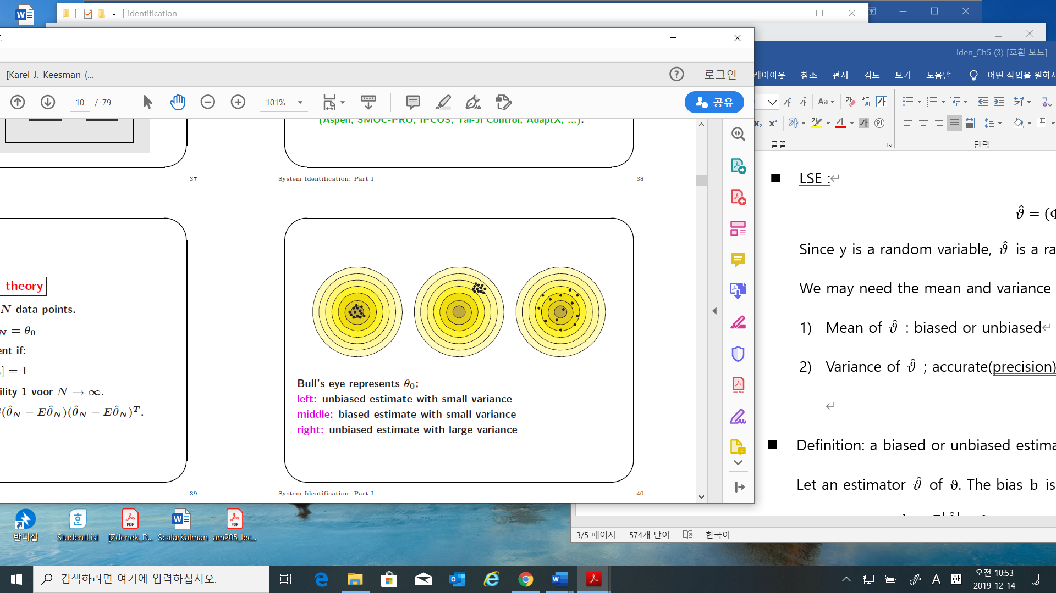** in googling.

* Definition: a biased or unbiased estimator

Let an estimator $\hat{ϑ}$ of $ϑ$. The bias $b$ is defined as

$b≔E\left[\hat{ϑ}\right]-ϑ (5.24)$

The unbiased estimator if $b=0$, otherwise the biased estimator.

* The unknown of the covariance of $\hat{ϑ}$

$$Cov \hat{ϑ}=E\left[\left(\hat{ϑ}-E\left[\hat{ϑ}\right]\right){\left(\hat{ϑ}-E\left[\hat{ϑ}\right]\right)}^{T}\right]$$

$=E\left[\left({\left[Φ^{T}Φ\right]}^{-1}Φ^{T}y-E\left[\hat{ϑ}\right]\right){\left({\left[Φ^{T}Φ\right]}^{-1}Φ^{T}y-E\left[\hat{ϑ}\right]\right)}^{T}\right]$

$=E\left[\left({\left[Φ^{T}Φ\right]}^{-1}Φ^{T}\left(Φϑ+e\right)-ϑ\right){\left({\left[Φ^{T}Φ\right]}^{-1}Φ^{T}\left(Φϑ+e\right)-ϑ\right)}^{T}\right]$

$=E\left[{\left[Φ^{T}Φ\right]}^{-1}Φ^{T} Cov\left(e\right)Φ{\left[Φ^{T}Φ\right]}^{-1}\right]$

$= σ^{2}{\left[Φ^{T}Φ\right]}^{-1}$ (6)

* Sample mean and variance in scalar case
* Sample mean
$$\overline{x}=\frac{1}{N}\sum_{i=1}^{N}{x_{i}}$$

* Unbiased Sample variance(standard deviation)

$$s = \sqrt{(\sum_{i=1}^{N}{{\left(x - \overline{x} \right)}^{2})/(N-M)} }$$

Where M is the number of unknowns

* Check the biased and accuracy
* 🡪 the sample error is zero

$$\sum{ε_{i}}=\sum{y_{i}-ϕ_{i}\hat{ϑ}}=0$$

If $\sum{ε_{i}}$ is not zero,

1. Increase the number of measurements and check. If not
2. Change model, then check the bias

* Check the accuracy

1. Calculate the unbiased sample variance

$$s^{2} = (\sum_{i=1}^{N}{{\left(ε_{i} - \overline{ε} \right)}^{2})/(N-M)}$$

This $s^{2}$ will be used to $σ^{2}$ in (6)

Calculate ${\left[Φ^{T}Φ\right]}^{-1}$

Calculate the variance of ${\hat{ϑ}}_{i}=s ×\sqrt{diag{\left[Φ^{T}Φ\right]}^{-1}}$

Check the accuracy with ${\hat{ϑ}}_{i}$ and the variance of ${\hat{ϑ}}_{i}$

* Example

Model: the distance $x\left(t\right)=x_{o}+v_{o}t+\frac{1}{2}a t^{2}$

Observations of the distance $y(t)$

$$y\left(t\right)=ϕ{\left(t\right)}^{T}ϑ+e$$

$$= {\left[1 ; t ; \frac{t^{2}}{2}\right]}^{T}[ϑ_{1}; { ϑ}_{2} ; ϑ_{3}]+e,$$

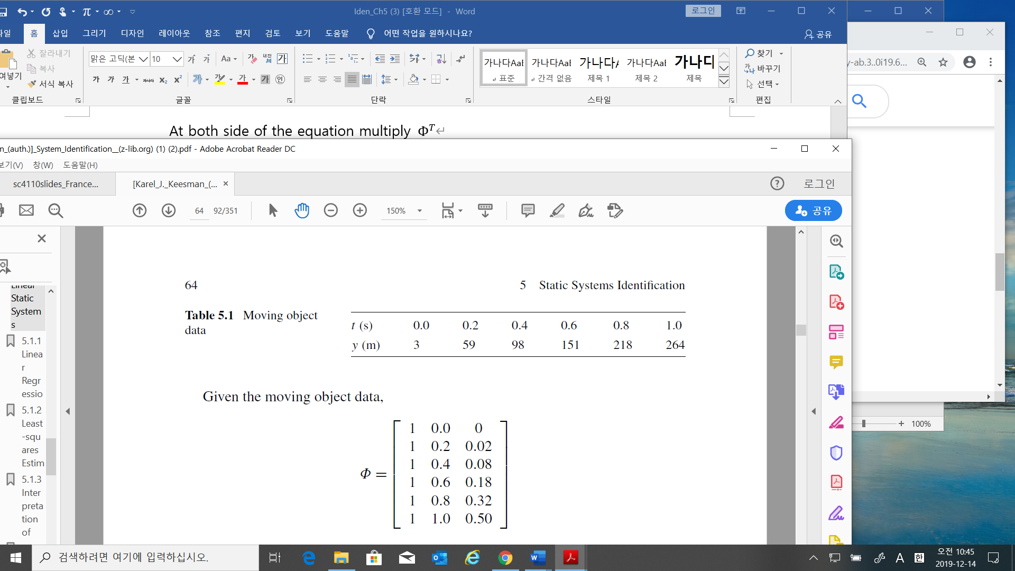

1. Matlab program: the first section of Simulation_LSE.m

-mean of the residual = $E[ε]$

-MSE(the variance) of the residual $var\left(ε\right)=E\left[ε^{T}ε\right]-E^{2}\left[ε\right]=\sqrt{\frac{ε^{T}ε}{N-p}}$

* Ex.5.6: This estimator is not the LSE but an unbiased estimator)

$$y\left(t\right)=αu\left(t\right)+e(t)$$

Define an estimator $\hat{α}$ is

$$\hat{α}=\frac{1}{N}\sum_{t=1}^{N}{(y\left(t\right)}/u\left(t\right))$$

Then

$$\hat{α}=\frac{1}{N}\sum_{t=1}^{N}{\frac{αu+e}{u}}=\frac{1}{N}\left(\sum{α+ }\sum{\frac{e}{u}}\right)$$

Hence

$$b=E\left[\hat{α}\right]-α$$

$$=E\left[\frac{1}{N}\sum{α}+\frac{1}{N}\sum{\frac{e\left(t\right)}{u\left(t\right)}}\right] -α$$

$$=E[\frac{1}{N}\sum{\frac{e\left(t\right)}{u\left(t\right)}]}$$

$$=\frac{1}{N}\sum{\left(\frac{E\left[e\left(t\right)\right]}{u\left(t\right)}\right)}$$

Hence

- If $E\left[e\left(t\right)\right]=0,$ then the estimator is unbiased.

- Or if $u(t)$ is large, the estimator converges to be unbiased

- Or if $n$ is large, the estimator converges to be unbiased

* Ex.5.7: The estimator is not unbiased
* The LSE is unbiased in the system $y=Φ^{T}ϑ+e$

$$b=E\left[{\left(Φ^{T}Φ\right)}^{-1}Φ^{T}y\right]-ϑ$$

$$=E[{\left(Φ^{T}Φ\right)}^{-1}Φ^{T}e]$$

Hence the LSE is unbiased if

1. $\left(Φ, e\right)$ is independent and
2. $E\left[e\right]=0$, where $y=Φ^{T}ϑ+e$

Or if $Φ$ is deterministic, i.e., $Φ^{T}ε=Φ^{T}\left(y-Φ\hat{ϑ}\right)$

$$=Φ^{T}\left(y -{\left(Φ^{T}Φ\right)}^{-1}Φ^{T}Φ\right)y) \\ =0$$

Hence $E\left[Φ^{T}ε\right]=0$, which implies the estimator is always unbiased.

* + 1. Accuracy (Variance) of LSE
* The unknown of the covariance of $\hat{ϑ}$

$$Cov \hat{ϑ}=E\left[\left(\hat{ϑ}-E\left[\hat{ϑ}\right]\right){\left(\hat{ϑ}-E\left[\hat{ϑ}\right]\right)}^{T}\right]$$

$=E\left[\left({\left[Φ^{T}Φ\right]}^{-1}Φ^{T}y-E\left[\hat{ϑ}\right]\right){\left({\left[Φ^{T}Φ\right]}^{-1}Φ^{T}y-E\left[\hat{ϑ}\right]\right)}^{T}\right]$

$=E\left[\left({\left[Φ^{T}Φ\right]}^{-1}Φ^{T}\left(Φϑ+e\right)-ϑ\right){\left({\left[Φ^{T}Φ\right]}^{-1}Φ^{T}\left(Φϑ+e\right)-ϑ\right)}^{T}\right]$

$=E\left[{\left[Φ^{T}Φ\right]}^{-1}Φ^{T} Cov\left(e\right)Φ{\left[Φ^{T}Φ\right]}^{-1}\right] (5.31)$

If ${\left\{e\right\}}_{t=1}^{N}$ is a white noise with constant variance $σ^{2}$, then $Cov e=σ^{2}I_{N}$.

(5.31) is

$$Cov \hat{ϑ}=σ^{2}E\left[{\left[Φ^{T}Φ\right]}^{-1}\right] (5.32)$$

Since $σ^{2}$ is unknown, the variance of the prediction error

$$σ_{ε}^{2}=E\left[ε^{2}\left(t\right)\right]-E^{2}\left[ε\right]= E\left[ε^{2}\left(t\right)\right] ,$$

The prediction error sequence

$${{\hat{σ}}_{ε}}^{2}=\frac{1}{N-p}\sum_{t=1}^{N}{ε^{2}\left(t\right)} (5.33)$$

Thus $σ^{2}$ in the variance of the estimator in (5.32) will be replaced by ${{\hat{σ}}_{ε}}^{2}$