1. **A stirred tank regulation problem– Linear Quadratic Regulator controller Design**

1.1 Problem:

- Two Inputs: two incoming flows with rates $F_{1}\left(t\right)$ and $F_{2}(t)$, containing dissolved material with constant concentrations $c_{1}$ and

- Output: the outgoing flows with rate $F(t)$, containing concentration $c$

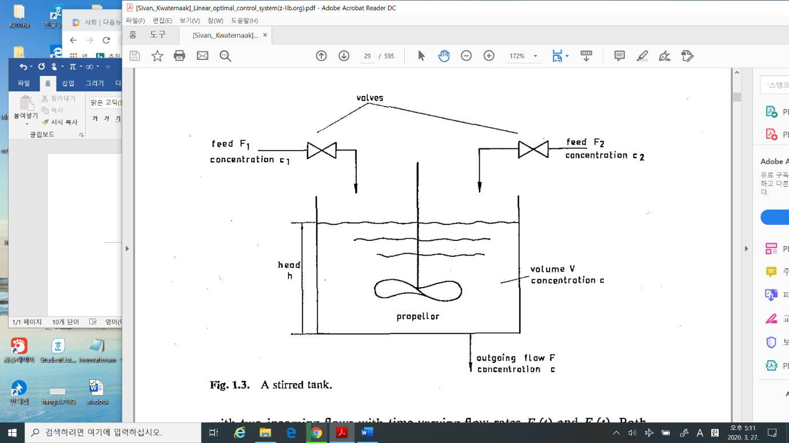

* Find the control algorithm to valves for the output concentration to be constant.

1.2 Procedure

1) modelling

2) system response

3) linearization

4) controllability and observability

5) Optimal linear quadratic regulator(LQR) controller design

6) Optimal linear quadratic gaussian(LQG) controller design

* 1. Method

1) standard literature review

2) previous literature review

3) environment set-up

4) simulation

5) verification

**2. Missile Guidance -Proportional Navigation (PN) Guidance / (fire and forget)**

2.1 problem

1) Find the guidance command for a fire-forget missile to pursuit the target

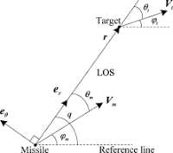

2.2 Procedure

1) physical understanding- component

2) mathematical modelling

3) linearization

4) pursuit algorithm

2.3 Method

1) standard literature review

2) previous literature review

3) environment set-up

4) simulation

**3. Missile guidance – Command Line of sight (CLOS) guidance**

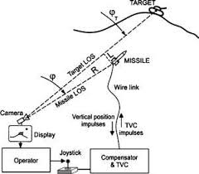

3.1 problem

1) Find a command line of sight guidance(remote) to the target



3.2 Procedure

1) The system, subsystems physical understanding

2) mathematical modelling

3) linearization

4) Line of sight command algorithm

3.3 Method

1) standard literature review

2) previous literature review

3) environment set-up

4) simulation

**4. an inverted pendulum stabilization problem**

4.1 problem

To design a state feedback to stabilize an inverted pendulum

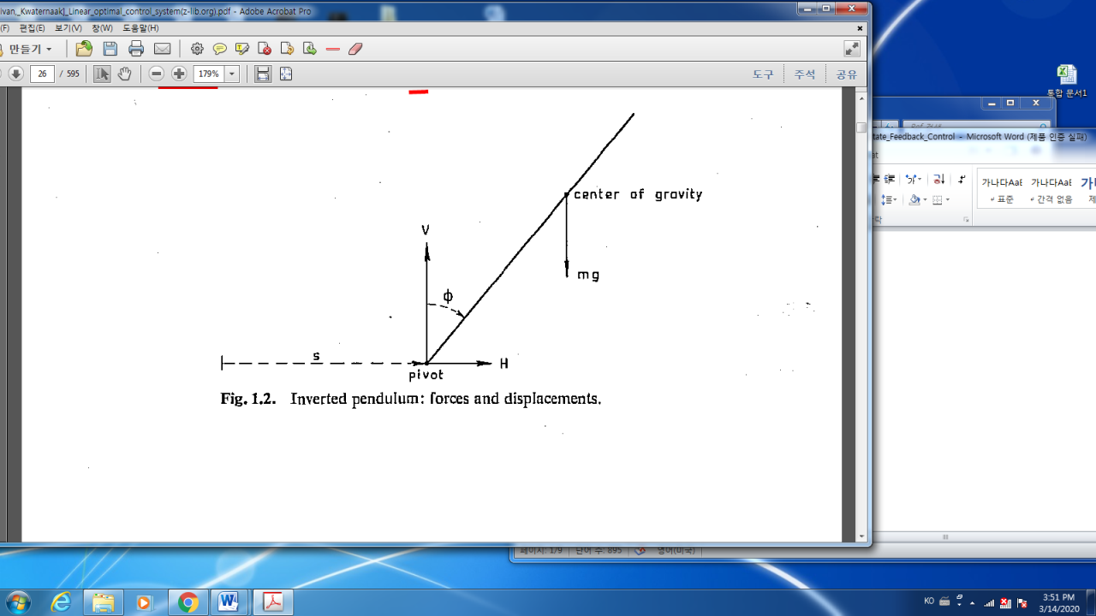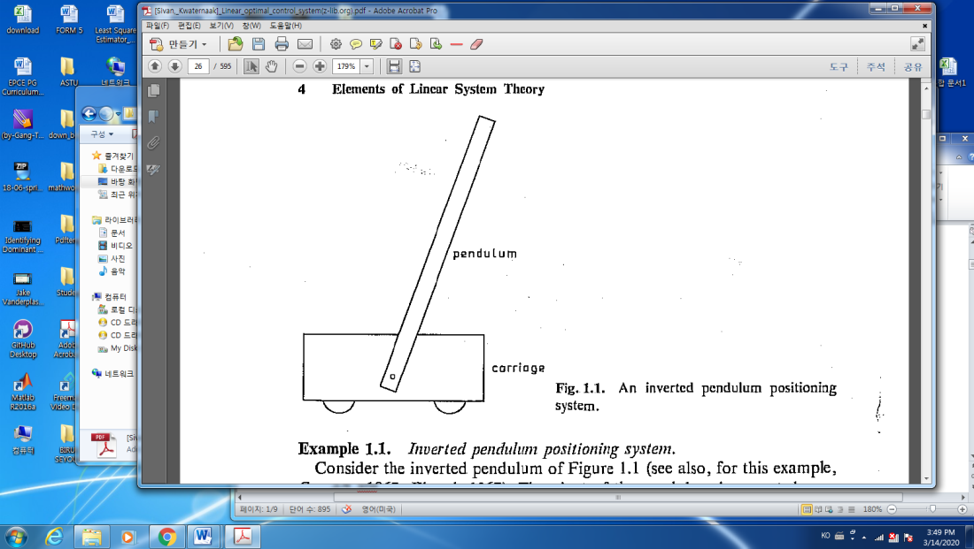

4.2 Procedure

1) modelling

2) system response

3) linearization

4) controllability and observability

5) Optimal linear quadratic regulator(LQR) controller design

6) Optimal linear quadratic gaussian(LQG) controller design

* 1. Method

1) standard literature review

2) previous literature review

3) environment set-up

4) simulation

5) verification