Optimal and adaptive control

* Optimization
* Optimal Control: Linear Quadratic Regulator / Linear Quadratic Gaussian
* Tuning the parameters.

Week_1: symbolic math.

1. concepts

- different from floating point representation.

- good for analytic solution:

+ parameter uncertainty analysis , differentiation , integration ,..

- matlab / mathmetica /…🡪 matlab / python,..

1. matlab commands

* example:

- algebraic equations.

$$f=x+3;g=x^{2}e^{-x^{2}}, h=sin⁡(\cos\left(x\right))$$

->> syms x

->> subs(f,x,1)

-polynomials

- >> simplify

* solve algebraic equations
$$x+3=0$$

$$x^{2}+3x+2=0$$

* solve algebraic solutions with undefined parameters

$${ax}^{2}+bx+c=0$$

->> pretty

* solve linear system equations
$$x+2y=5$$

$$2x+y=4$$

* solve linear system equation with undefined parameters
$$ax+2y=5$$

$$2x+y=4$$

* solve non-linear equations

$$V(t)=V_{0}e^{-\frac{t}{RC}}$$

Find $R$ given the others.

1. dynamic equations.

* Derivatives
$$\frac{{dx}^{3}}{dx}, \frac{d}{dx}\left(x^{3}+\frac{1}{x}\right),\frac{d}{dx}\left(e^{-x^{2}}\right),\frac{d}{dx}(\sin{x)},\frac{d}{dx}(\sin{(\cos{x))}}$$

* Differential equations , scalar – homogeneous

$$\frac{dx}{dt}+ax=0, x\left(0\right)=x0$$

->> dsolve(diff(x) =-a*x, x(0), x0)

* Differential equations , scalar – inhomogeneous

$$\frac{dx}{dt}+ax=sin⁡(t), x\left(0\right)=x0$$

->>dsolve(diff(x) == -a*x + sin(t) ,x(0) == x0)

--solution:

$$\left(x0+\frac{1}{{(a}^{2}+1)}\right)e^{-at}-\frac{1}{a^{2}+1}(\cos{t}-a\sin{t)}$$

->> fplot(f)

* Differential equations.

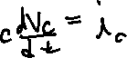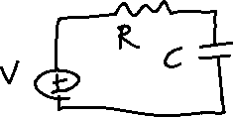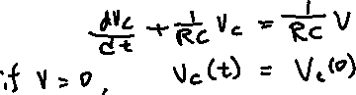

1. Homogeneous solutions

$$\frac{{dv}_{c}}{dt}+\frac{1}{RC}v_{c}=0, v_{c}\left(0\right)=v_{0}, v_{c}\left(t\right) ?$$

->> dsolve(diff(v(t))== - 1/(R*C)*V, V(0) == V0)