Circuit analysis using “Symbolic math” in Matlab

* Linear equation

Last week, I introduced symbolic math to solve symbolic parameter equations. Let’s remind us.

Given

$$ax+2y=5$$

$$2x+y=4$$

Then

syms x y a

f = a*x + 2*y;

g =2*x +y;

eqn =[f == 5, g == 4];

S =solve(eqn,x,y);

S.x

S.y

subs(S.x,a,2)

Matlab gives answer as

$$S.x= -\frac{3}{a-4} , S.y=\frac{2\left(2a-5\right)}{a-4}$$

If $a=2$, S.x = 3/2.

But if the equations are linear(in this case is linear), it is good to use following commands as

syms x y a

A =[a 2; 2 1];

B = [ 5;4];

X =A\B

X(1)

X(2)

subs(X(1),a,2)

which gives the same answers. The operator **“ \ “** may be remembered as

$$b=ax-→x=\frac{b}{a} =inv\left(a\right)b =a^{-1}b ==a \backslash b$$

More importantly, $Ax=b$, if $A^{-1}$ does not exist, then the best linear estimator for $x$

Is $\hat{x}={\left(A^{T}A\right)}^{-1}A^{T}b$.

In Matlab, the “\” will do the job as

$$\hat{x}=A \backslash b$$

* Analyze circuit diagram

As You know KCL, KVL. Let us use “symbolic mathematic in Matlab”

* Case_1 – node equations

1. First find nodes , and independent voltage and current sources
2. Assign voltages and currents as notations $\left(v_{A}, v_{B}\right), (i_{0}, i_{1}, i_{2}, i_{3})$
3. Using KCL and KVL set the equations

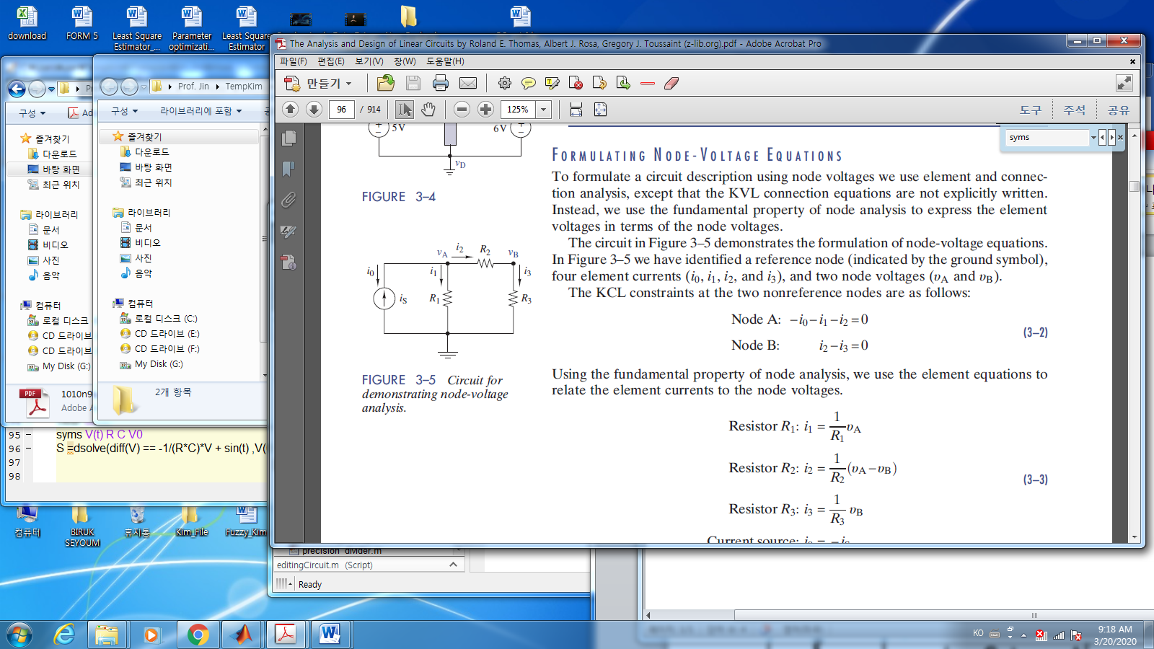Node A: $\left(\frac{1}{R_{1}}+\frac{1}{R_{2}}\right)v_{A}-\frac{1}{R_{2}}v_{B}=i_{s}$

Node B: $-\frac{1}{R_{2}}v_{A}+\left(\frac{1}{R_{2}}+\frac{1}{R_{3}}\right)v_{B}=0$

1. Define state space model
$$\left[\begin{matrix}\left(\frac{1}{R_{1}}+\frac{1}{R_{2}}\right) & -\frac{1}{R_{2}} \\ -\frac{1}{R_{2}} & \left(\frac{1}{R_{1}}+\frac{1}{R_{2}}\right)\end{matrix}\right]\left[\begin{matrix}v_{A} \\ v_{B}\end{matrix}\right]=\left[\begin{matrix}i_{s} \\ 0\end{matrix}\right]$$

2. Now You may solve above one in Matlab

%% Case-1 ,..resistors..

clear all; clc

syms R1 R2 R3 is

A =[(1/R1 + 1/R2) -1/R2; -1/R2 (1/R2 + 1/R3)];

B=[is; 0]

x = A\ B;

vA = x(1)

vB = x(2)

pretty(vA)

1. The solution is

$$v_{A}=\frac{R_{1}(R_{2}+R_{3})}{R_{1}+R_{2}+R_{3}}i_{S}, v_{B} , =…$$

* Case -2. The following circuit is

1. Set the equations.

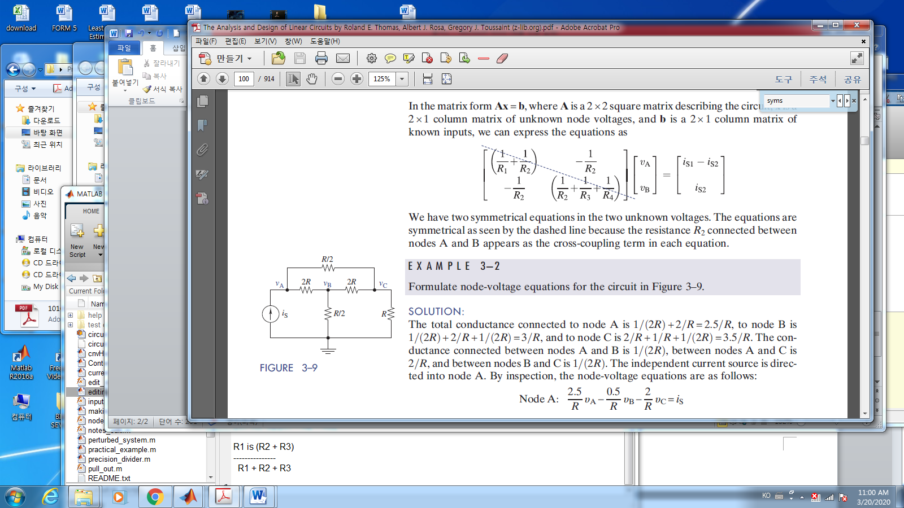 Node A: $\left(\frac{1}{R/2}+ \frac{1}{2R}\right)v_{A}-\frac{1}{2R}v_{B}-\frac{1}{\frac{R}{2}} v_{c}=i_{s}$

Node B: $\left(- \frac{1}{2R}\right)v_{A}+(\frac{1}{2R}+\frac{1}{2R}+\frac{1}{R/2})v_{B}-\frac{1}{2R} v_{c}=0$

Node C: $-\left(\frac{1}{R/2}\right)v_{A}-\frac{1}{2R}v_{B}+(\frac{1}{R/2}+\frac{1}{2R}+ {\frac{1}{R})v}_{c}=0$

1. Define state space model
$$\left[\begin{matrix}2.5/R & -0.5/R & -2/R \\ -0.5/R & 3R & -0.5/R \\ -2/R & -0.5/R & 3.5/R\end{matrix}\right]\left[\begin{matrix}v_{A} \\ v_{B} \\ v_{C}\end{matrix}\right]=\left[\begin{matrix}i_{S} \\ 0 \\ 0\end{matrix}\right]$$

2. You may solve above one in Matlab

%% Case-2 ,... resistors

clear all; clc

syms R is

A =[2.5/R -0.5/R -2/R; -0.5/R 3/R -0.5/R ; -2/R -0.5/R 3.5/R];

B=[is; 0; 0]

x = A\ B;

vA = x(1)

vB = x(2)

vC = x(3)

pretty(vA)

1. You may get the solution as ..

$$v_{A}=\frac{41}{47}is$$

* Case-3 inductance

The voltage $v_{L}\left(t\right)$ between a inductor, “L” with the current $i_{L}(t)$

$$v_{L}= L\frac{di_{L}}{dt}$$

1. In Matlab command , if $i_{L}\left(t\right)=10 e^{-500t}\sin\left(2000t\right), L=2.5mH$

syms t iL vL

iL = 10*exp(-500*t) * sin(2000*t);

L = 0.0025;

vL = L*diff(iL, 't')

tt = 0:0.00001:0.004;

iLtt = subs(iL,t,tt);

vLtt = subs(vL,t,tt);

subplot(2,1,1)

plot(tt,iLtt, 'b','LineWidth',2) ; grid on

title('current')

subplot(2,1,2)

plot(tt,vLtt, 'b','LineWidth',2); grid on

title('voltage')



* Case-4 the capacitance

The current $i_{C}\left(t\right)$ through a conductor, “C” with the voltage $v_{C}(t)$

$$i_{C}= C\frac{dv_{C}}{dt}$$

1. In Matlab command , if $v_{C}\left(t\right)=10 e^{-500t}\sin\left(2000t\right), C=2.5mF$

syms t iC vC

vC = 10*exp(-500*t) * sin(2000*t);

C = 0.0025;

iC = C*diff(vC, 't')

tt = 0:0.00001:0.004;

vCtt = subs(vC,t,tt);

iCtt = subs(iC,t,tt);

subplot(2,1,1)

plot(tt,vCtt, 'b','LineWidth',2) ; grid on

title(' the capacitance voltage')

subplot(2,1,2)

plot(tt,iCtt, 'b','LineWidth',2); grid on

title('the capacitance current')

* Case-5 capacitor and resistor

1. Set the equation

The input(the voltage source) $v_{T}=\sin{(2π50)t}$. $R=100 Ω, C=0.1F$.Find the capacitor voltage $v_{C}.$

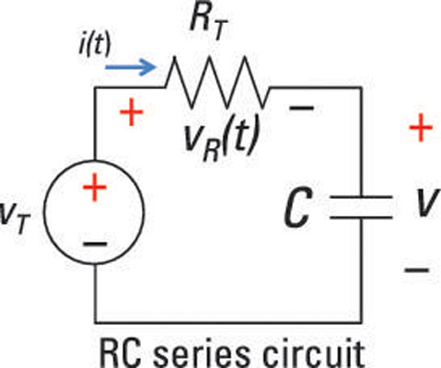

$$v_{R}=Ri_{R},$$

$$i_{C}= C\frac{{dv}_{C}}{dt}$$

Since the loop current $i_{R}=i_{C}=i$ and by KVL

$$v_{T}=v_{R}+v_{C}=Ri+v_{C} \\ =RC\frac{dv_{C}}{dt}+v_{C}$$

With respect to $v_{c}$

$$\frac{{dv}_{c}}{dt}= -\frac{1}{RC}v_{c}+\frac{v_{T}}{Rc}$$

1. Solve in Matlab

clear all;clc

syms Vc(t) Vs

R = 100;

C = 0.1;

T = R*C; % time constant

Vs = sin(2*5*pi*t);

Vc = dsolve( diff(Vc(t)) == -T*Vc(t)+ Vs, Vc(0) ==0);

% for comparison

tt = 0:0.001:1;

Vstt = subs(Vs,t,tt);

Vctt = subs(Vc,t,tt);

subplot(2,1,1)

plot(tt,Vstt, 'b','LineWidth',2) ; grid on

title(' the source voltage')

subplot(2,1,2)

plot(tt,Vctt, 'b','LineWidth',2); grid on

title('the capacitance voltage')



**Week_2 home assignments**

1. **due to next Friday .**

Problem:

For at least 4 any circuits, you select and analyze the circuit using symbolic math in Matlab.

1. Submit by e-mail or upload github…

e-mail: snkim0701@daum.net