1. Ladder and Functional Block Programming

Introduction

* S/W

+Machine code / Assembly language / High level language ( C, C++. Matlab, Ladder programming)

* Ladder programming : depends on the PLC manufactures
* International standard: IEC 1131-3(International Electrotechnical Committee)

+ Ladder programs(LAD)

+Instruction List(IL)

+ Sequential Function Charts(SFC)

+ Structures Text(ST)

+ Functional Block Diagram(FBD)

* 1. Ladder Diagram

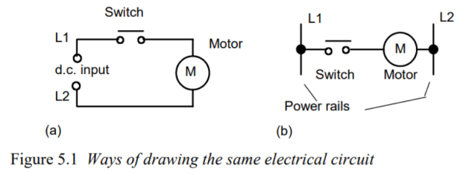

* 1. Logic function

5.2.1 switch

* Standard IEC 1131-3 symbols

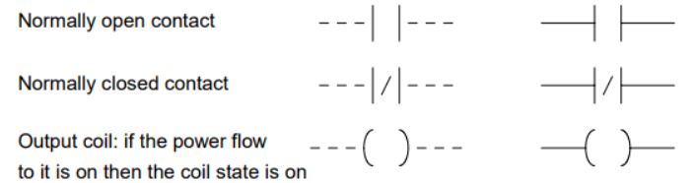

1. Timing diagram

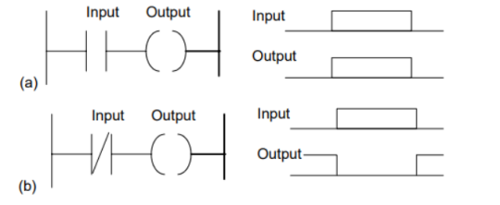

1. Element name(variable) , and Address

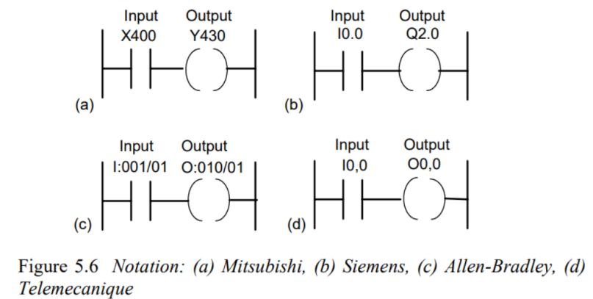

5.2.2 AND

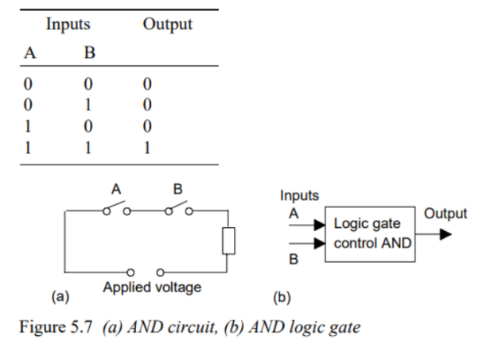

* Ladder and timing

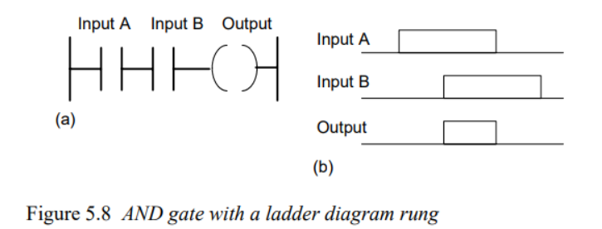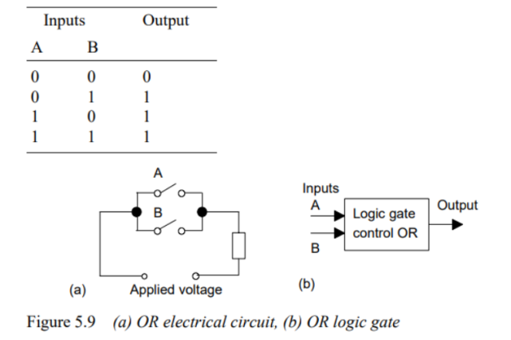

5.2.3 OR

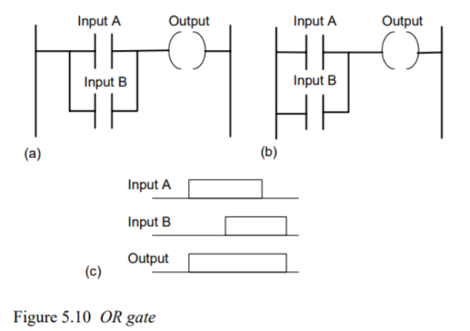

5.2.4 NOT

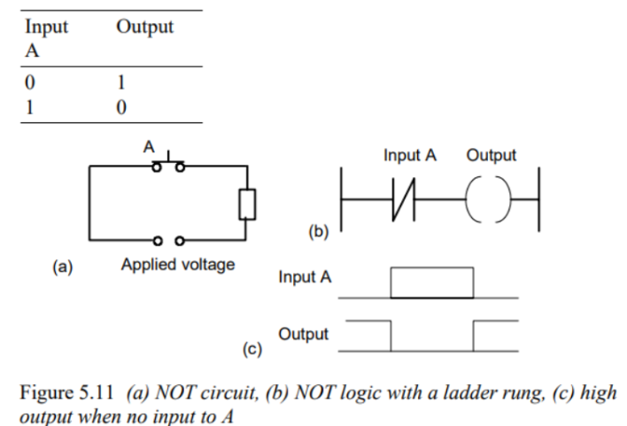

5.2.5 NAND

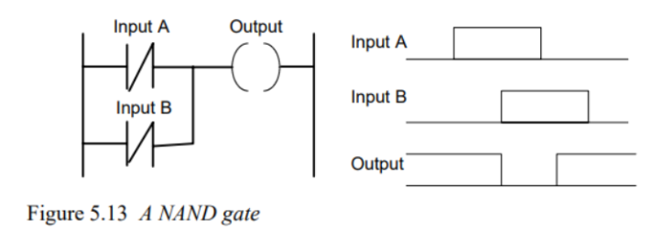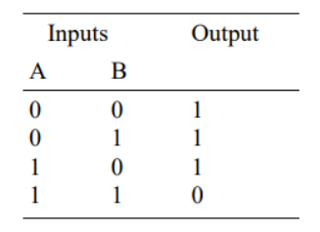

5.2.5 NOR

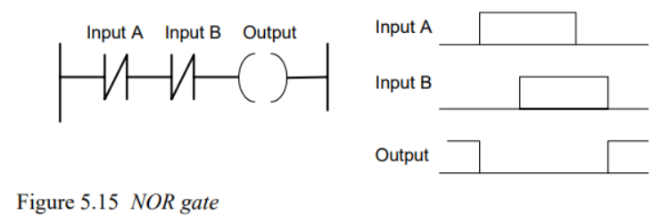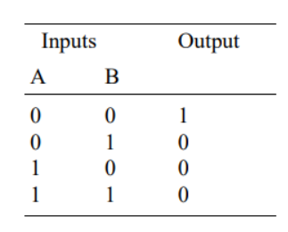

5.2.5 XOR

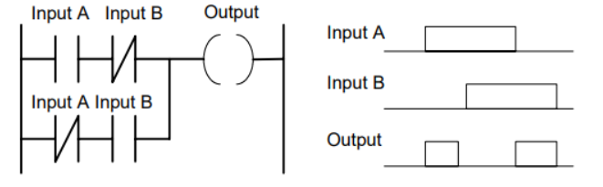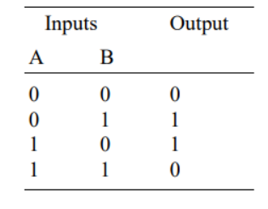

* 1. Latching

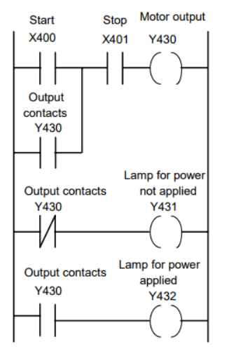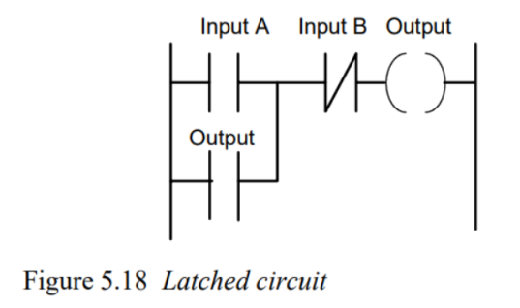

* 1. multiple output

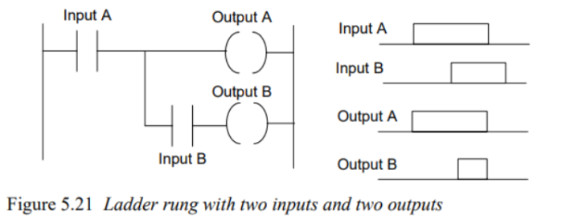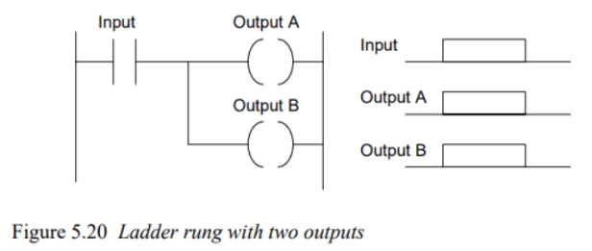

* 1. Entering Program
  2. EFunction Block

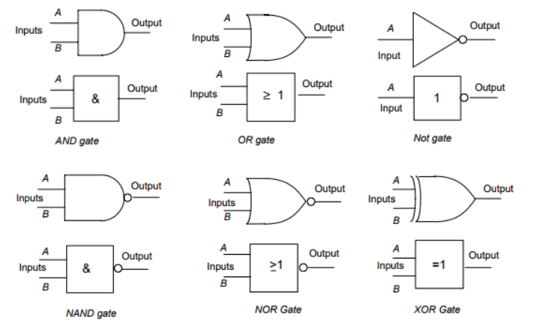

Example

