Introduction: System Identification.

* Def: System identification is the study of Modeling dynamic System from experimental data.

1. Modelling

* Mathematical Description of System Linear / nonlinear, Time invariant /varying.
* Parametric / non parametric

1. Parametric identification/estimation

3) Non-parametric Identification

$$y\left(t\right)= \int_{-∞}^{t}{g\left(t-τ\right)u\left(τ\right)dτ , t∈R}$$

Given, $u\left(t\right), y(t)$ find $g(t)$

* Relation between Machine Learning / AI

Given data, find some features inside the data

* Machine Learning: Supervised Learning / unsupervised learning: classification,

Usually static system.

* System Identification: In/Out relations, Usually dynamic system

Ch.1 Introduction

1. Introduction
   1. System Theory
      1. Terminology

Input $:u$

Disturbance: $w$

State: $x$

Disturbance: $v$, output disturbance ( sometimes noise)

Output:

* + 1. Basic Problems
* Modeling / Analysis / Estimation / Control

1. Modeling

Relation between variables on the basis of prior knowledge, assumption about the uncertainties

Unknown / incomplete known coefficients : $ϑ$

1. Analysis

In system identification, **identifiability analysis:** “can the unknown parameter $ϑ$ be uniquely, albeit locally, identified?”

1. Estimation

-State estimation / parameter estimation

-State estimation: based on the assumption that model is perfect, parameters are exactly known

-Parameter identification: estimate the model parameter $ϑ$ from $u \& y$

1. Control
   1. Mathematical Models
      1. Model Properties

-Discrete-time

$$x\left(t+1\right)=f\left(x,x\left(t\right),u\left(t\right),w\left(t\right);ϑ\right), x\left(o\right)=x_{0}$$

$$y\left(t\right)=h\left(t,x\left(t\right),u\left(t\right);ϑ\right)+v\left(t\right) , t∈Z^{+} (1.1)$$

-Continuous-time

$$\frac{dx\left(t\right)}{dt}=f\left(t,x\left(t\right),u\left(t\right),w\left(t\right);ϑ\right), x\left(0\right)=x_{0}$$

$$y\left(t\right)=h\left(t,x\left(t\right),u\left(t\right);ϑ\right)+v\left(t\right) , t∈R (1.2)$$

* Linearity

Assumption: Input: $u_{1}\left(t\right), u_{2}\left(t\right)$ corresponding output: $y_{1}, y_{2}(t)$

The system is linear if

Input: $αu_{1}\left(t\right)+βu_{2}\left(t\right)$ then Output: $αy_{1}\left(t\right)+βy_{2}(t)$

* Time- Invariance

Assumption: input $u_{1}\left(t\right),$ output $y_{1}\left(t\right)$.

Then if input $u_{1}\left(t+τ\right)$,then $y_{1}(t+τ)$

* Causality: The output does not depend on the future value of the input
$$y\left(t\right) =f\left(u\left(t+τ\right)\right), τ≤0$$

* Estimation/ Prediction
$$\hat{y}\left(t+ τ\right)$$

* Dynamics

If the system depends on its history, and not just on the present input, it is called a dynamic system. See (1.1), (1.2)

* + 1. Structural model Representations
* Ex.1.4 / 1.5 A liquid storage tank:

The volume of the liquid in the storage tank: = $V$

Inflows / outflows: $u\left(t\right), y(t)$

$$\frac{dV\left(t\right)}{dt}=u\left(t\right)-y(t)$$

A proportional level controller: $y\left(t\right)=KV(t)$

$$\frac{dV\left(t\right)}{dt}=u\left(t\right)-KV(t)$$

* $\left(1.2\right)$ Let $V\left(t\right)=x\left(t\right).$
$$\frac{dx\left(t\right)}{dt}=-Kx\left(t\right)+u\left(t\right)$$

$$y\left(t\right)=Kx(t)$$

* Differential Equation

$$\frac{1}{K}\frac{dy\left(t\right)}{dt} +y\left(t\right)=u(t)$$

1. The homogeneous solution: with $u\left(t\right)=0 , ∀t<0$ $$y\left(t\right)=y\left(0\right)e^{-Kt}$$
$$\frac{1}{K}\frac{dy\left(t\right)}{dt} +y\left(t\right)=0$$

2. The total solution with initial condition $y\left(0\right)=0$
$$y\left(t\right)=y\left(0\right)e^{-Kt}+ \int_{0}^{t}{Ke^{-K\left(t-τ\right)}u\left(τ\right)dτ} \\ =\int_{0}^{t}{Ke^{-K\left(t-τ\right)}u\left(τ\right)dτ} ∵y\left(0\right)=0$$

3. The system is linear
4. The system is time – invariant, because

$$y\left(t+l\right)= \int_{0}^{t+l}{Ke^{-K\left(t+l-τ\right)}u\left(τ\right)dτ}$$

$$=_{\left[v:τ-l\right]}\int_{-l}^{t}{Ke^{-K\left(t-v\right)}u\left(v+l\right)dv}$$

$=_{\left[u\left(t\right)=0 for t<l\right]}\int_{0}^{t}{Ke^{-K\left(t-v\right)}u\left(v+l\right)dv}$

1. The system is causal
2. The impulse response $g(t)$
$$y\left(t\right)=\int_{-∞}^{t}{g\left(t-τ\right)u\left(τ\right)dτ} (1.5)$$

3. Convolution model: the output is modelled as (1.5)
4. Differential equation model / state-space model

* The choice of model

-white box / black box (linear) / grey box

Part I data-Based Identification

* SISO LTI, classical data-based / non-parametric identification

$$y\left(t\right)= \int_{-∞}^{t}{g\left(t-τ\right)u\left(τ\right)dτ , t∈R}$$

$$y\left(t\right)= \sum_{k=-∞}^{t}{g\left(t-k\right)u\left(k\right), t∈Z^{+}}$$

1. System Response Methods
   1. Impulse Response
      1. Impulse Response Model Representation

* Unit Impulse function

$$δ\left(t\right)≔0, ∀t≠0, \int_{-∞}^{∞}{δ\left(t\right)dt=1} (2.1)$$

$\int_{-∞}^{∞}{δ\left(t-τ\right)u\left(τ\right)dτ=u(t)}$

* Convolution Model (Impulse response model)
$$y\left(t\right)=\int_{-∞}^{∞}{g\left(t-τ\right)u\left(τ\right)dτ=} \int_{0}^{t}{g\left(t-τ\right)u\left(τ\right)dτ }, g\left(t\right):impulse response (2.2)$$

* If $g\left(t\right)$ is known, then $y\left(t\right)$ is easily computed given
  + 1. Transfer Function Model Representation
* Laplace transform
$$L\left[f\left(t\right)\right] ≡F\left(s\right)≔ \int_{0}^{∞}{f\left(t\right)e^{-st}dt (2.3)}$$

$$Y\left(s\right)=G\left(s\right)U\left(s\right) (2.4)$$

* The transfer function
$$G\left(s\right)≡L\left[g\left(t\right)\right]$$

* Ex.2.1: Recall the liquid storage tank
$$y\left(t\right)=\int_{0}^{t}{Ke^{-K\left(t-τ\right)}u\left(τ\right)dτ} -→g\left(t\right)=Ke^{-Kt}$$

* The transfer function
  + 1. Direct Impulse Response Identification
* Identification of $g(∙)$ given $y\left(∙\right), u(∙)$ in Discrete Convolution Model

1. Discrete convolution model

$$y\left(t\right)= \sum_{k=0}^{t}{g\left(t-k\right)u(k)}= \sum_{k=0}^{t}{g\left(k\right)u\left(t-k\right), t∈Z^{+}} (2.5)$$

Therefore

$$y\left(t\right)=g\left(0\right)u\left(t\right)+g\left(1\right)u\left(t-1\right)+,…+g\left(t\right)u(0)$$

1. Case of Pulse Input

In general, $g\left(0\right)=0,$ let input $u(t)$ as

$$u\left(t\right)= \left\{\begin{aligned}α, t=0 \\ 0, t≠0 \end{aligned}\right.$$

Then the output is

* 1. Step response
     1. Direct Step Response
$$u\left(t\right)= \left\{\begin{aligned}0, t<0 \\ α, t≥0 \end{aligned}\right.$$

* Dead time : 0.2sec
* Time constant
* Static gain : ~ ~ (4.8-1)/(5-0)= 0.76
* 🡪 All three parameter is sufficient to tuning PID controllers

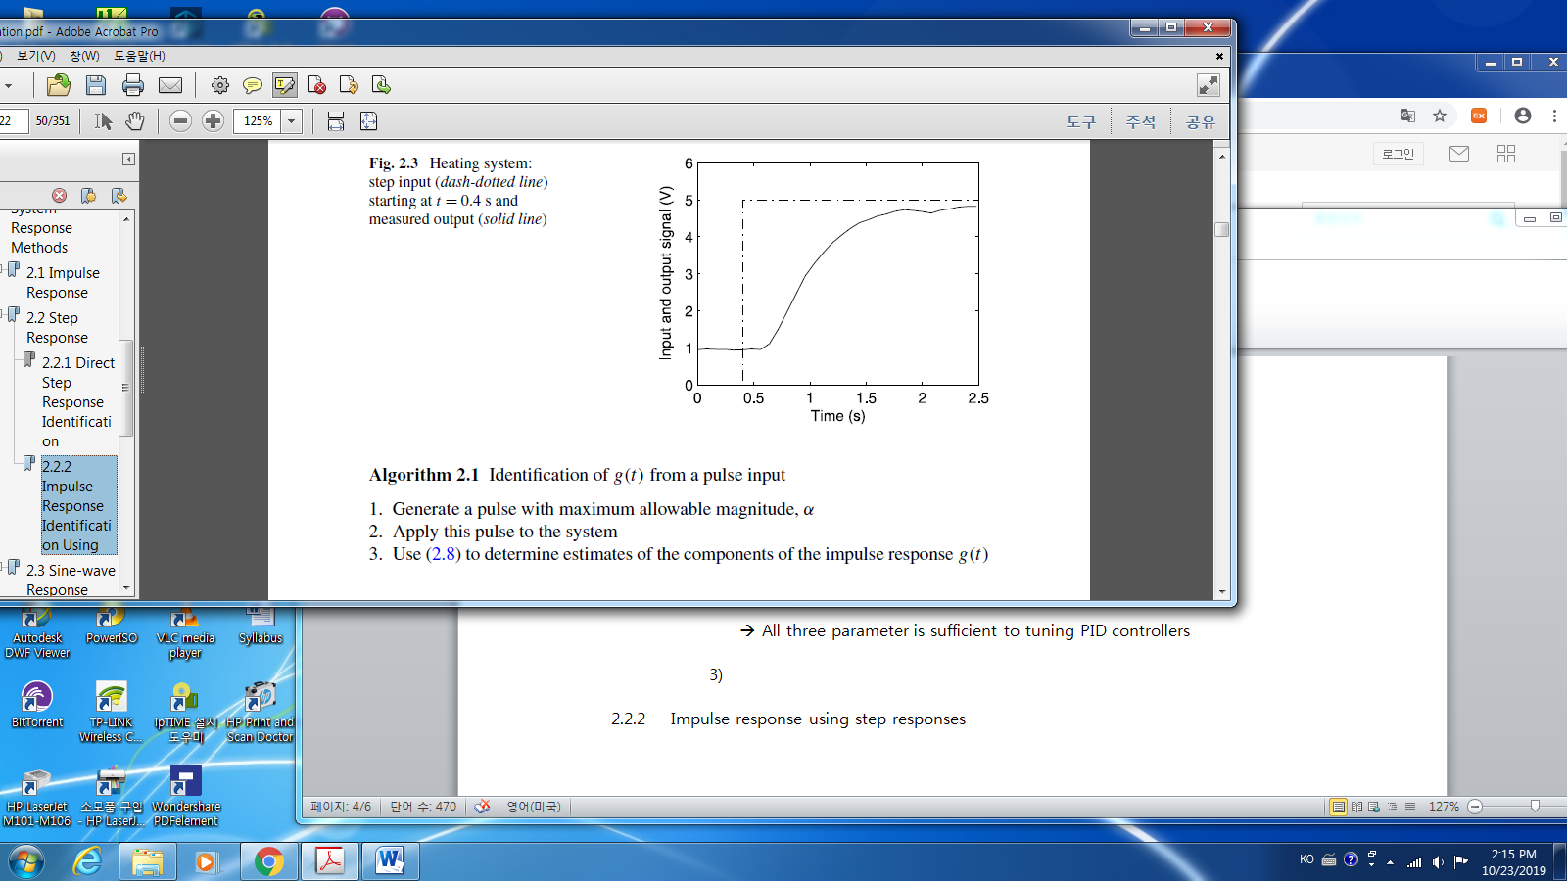

* + 1. Impulse Response Identification Using Step response
$$y\left(t\right)=α\sum_{k=0}^{t}{g(k)}+v\left(t\right) (2.10)$$

* How to get $g(t)$: $y\left(t-1\right)=α\sum_{k=0}^{t-1}{g(k)}+v\left(t-1\right)$
 $$\hat{g}\left(t\right)=\frac{y\left(t\right)-y\left(t-1\right)}{α} (2.11)$$

 1. Sine-Wave Response
     1. Frequency Transfer Function
* Continuous Frequency Response
$$G\left(jω\right)=G\left(s\right){\left.​\right|}_{s=jω}$$

* A sampled system: Discrete Frequency Response Function
  + 1. Sine wave response Identification
* Input $u\left(t\right)=α\sin\left(ωt\right)=α Im(e^{jωt})$

Output from (2.5) with $k= -∞ to ∞$

$$y\left(t\right)= \sum_{k=0}^{t}{g\left(k\right)u\left(t-k\right), } (2.5)$$

$$=α\sum_{k=-∞}^{∞}{g\left(k\right)}Im \left(e^{jω\left(t-k\right)}\right)=α Im\sum_{k=-∞}^{∞}{g(k)}e^{jω\left(t-k\right)}$$

$$=αIm \left(e^{jωt}\sum_{k=-∞}^{∞}{g\left(k\right)}e^{-jωk}\right)=αIm\left(e^{jωt}G\left(e^{jω}\right)\right)$$

$$=α\left|G\left(e^{jω}\right)\right|\sin\left(ωt+ϕ\right)$$

* Ex. 2.5

-. $ω=5\frac{rad}{s}→T=\frac{2π}{ω}\sim \frac{2*3.14 }{5} (s)$

-. Gain: ~ $\frac{7-5}{8-2} =\frac{2}{6}=\frac{1}{3}.$ Phase delay = $-ωΔt=-5* 0.5=-2.5 rad$

* Continuous / Discrete Fourier Transform

Laplace transform, z-transform

$$G\left(s\right):= \int_{o}^{∞}{f(t)}e^{-st}dt < ==>G\left(ω\right)=\int_{-∞}^{∞}{f(t)}e^{-ωt}dt$$

$$G\left(z\right):= \sum_{=-∞}^{∞}{g(k)}z^{-k}< == > G\left(e^{jω}\right)$$

1. Frequency Response Method
   1. Empirical Transfer-function Identification
      1. Sine wave testing

* In order to get “Bode-plot”, we need infinite
  + 1. Discrete Fourier Transform of Signals
* The Discrete Fourier Transform(DFT)

-. $f(t)$ sampled at $t=1,2,…, N$

$$Y_{N}\left(ω\right):=\frac{1}{\sqrt{N}}\sum_{t=1}^{N}{y\left(t\right)}e^{-jωt} (3.1)$$

where

$$ω=\frac{2πk}{N} , k=1,2,…,N$$

* Ex.3.1 Sine-wave signal

-. Given

$$y\left(t\right)=Acos⁡(ω_{o}t)$$

where $A∈R$ and $ω_{0}=\frac{2π}{N_{0}}, N_{0}>1$

-. Find $Y_{N}\left(ω\right)$ when $N=mN_{0}, m∈integer$

$$\cos{ω_{0}t }=\frac{1}{2}[e^{jω_{o}t}+e^{-jω_{0}t}]$$

Hence

$$Y_{N}\left(ω\right):=\frac{1}{\sqrt{N}}\sum_{t=1}^{N}{\frac{A}{2}}[e^{j\left(ω_{0}-ω\right)t}+e^{-j\left(ω_{0}-ω\right)t}]$$

For simplification, using the following relationship:

$$\frac{1}{N}\sum_{k=1}^{N}{e^{j2π\left(\frac{nk}{N}\right)}} = \left\{\begin{aligned}1, n=0 \\ 0, 1≤n<N\end{aligned}\right.$$

so that

* + 1. Empirical Transfer Function Estimate
$$Y\left(jω\right)=G\left(jω\right)U\left(jω\right) (3.2)$$

* Empirical Transfer Function Estimate(ETFE) for Samples systems

For a given N,

* 1. fda

1. Correlation Method
   1. Correlation Functions
      1. Autocorrelation Function
2. Autocorrelation Function

$$r_{uu}\left(τ, t\right)=E[u\left(t\right)u\left(t+τ\right)] (4.1)$$

Continuous time case

$$r_{uu}\left(t\right)= \lim_{T→∞}{\frac{1}{2T} \int_{-∞}^{∞}{u\left(t\right)u\left(t+τ\right)dt } (4.2)}$$

Discrete-time case

* + 1. White Noise Sequence
    2. Cross-correlation Function
 $$r_{uy}\left(τ,t\right)≔E\left[u\left(t\right)y\left(t+τ\right)\right] (4.7)$$

 1. Wiener-Hopf Relationship
     1. Wiener-Hopf Equation

1. The output
$$y\left(t\right)= \sum_{k=0}^{∞}{g\left(k\right)u(t-k)}$$

2. The cross-correlation between $\{u\}$ and $\{y\}$: Wiener-Hopf Equation

Hence

* + 1. Impulse Response Identification Using Wiener-Hopf Equation

1. Examp. 4.3 : **Impulse response identification**

For asymptotically stable systems, it suffices to determine only the first $s$ elements of $g(t)$, so that

$$r_{uy}\left(l\right)= \sum_{k=0}^{s}{g\left(k\right)}r_{uu}\left(l-k\right)$$

* Inputs, and output: $u\left(0\right), u\left(1\right),…, u\left(N\right)$, and $y\left(0\right), y\left(1\right),…,y(N)$

After removal of the initial conditions effect,

$u\left(M\right), u\left(M+1\right),…, u\left(N\right)$, and $y\left(M\right), y\left(M+1\right),…,y(N)$

* The correlation functions can be

$$r_{uu}\left(l\right) \sim \frac{1}{N-M+1-l}\sum_{i=M}^{N-l}{u\left(i\right)u(i+l)}$$

And

1. Dsa
   * 1. Random Binary Sequences
     2. Filter Properties of Wiener-Hopf Relationship
   1. asd

Sda

Das