%% Linear Algebra: G.Strang, ” Differential Equations and Linear Algebra”, Wellesley- Cambridge Press,2014.

Chapter 4 to Chapter 8

1. Linear Equations and Inverse matrices
   1. Two Pictures of linear Equations
   2. Solving linear Equations by Elimination
   3. Matrix Multiplication
   4. Inverse Matrices
   5. Symmetric Matrices and Orthogonal matrices
2. Vector Spaces and Sub Spaces
3. Eigenvalues and Eigenvectors
4. Applied mathematics and ATA
5. Fourier and Laplace Transforms

%% 2 Semester

Problems due next Tuesday(02/18)

1. Vector Spaces and Sub-Spaces
   1. The Column space of a Matrix

* Def: Vector space

<https://en.wikipedia.org/wiki/Vector_space>

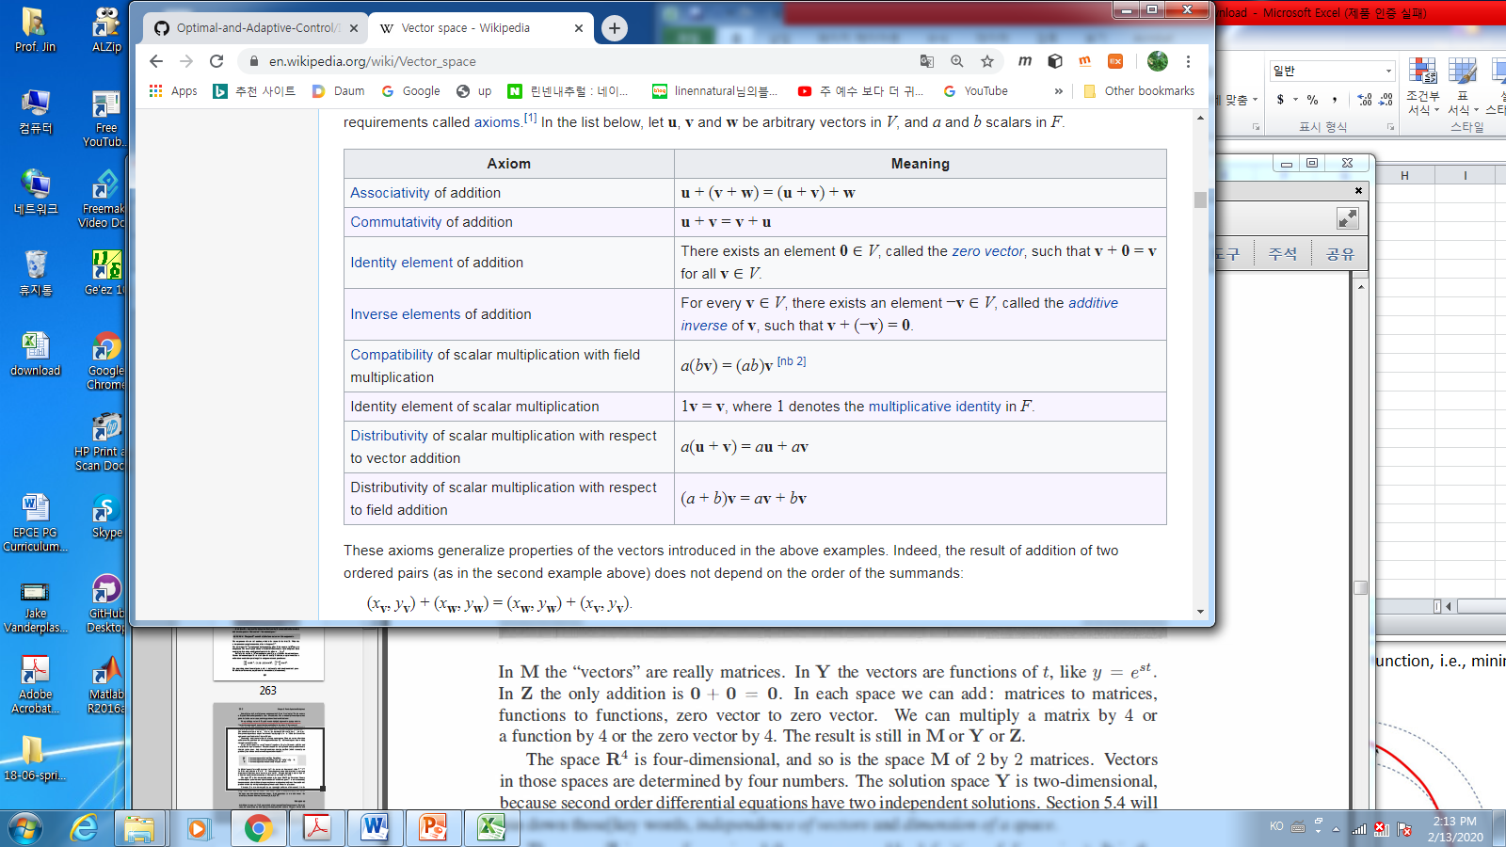

* Examples

The vector space of all real 2x2 matrices

: The vector space of all solutions to

The vector space that consists only a zero vector.

* Def: Subspaces

A subspace of a vector space, denoted by , is a set of vectors(including 0) that satisfies two requirements: If and are vectors in the subspace and is any scalar, then

1. (ii)

* Facts:

1. Every subspace contains the zero vector
2. Line through the origin are also subspaces

* Examples
* Def: The column space, , consists of all combinations of a columns,
* Fact: The system is solvable iff

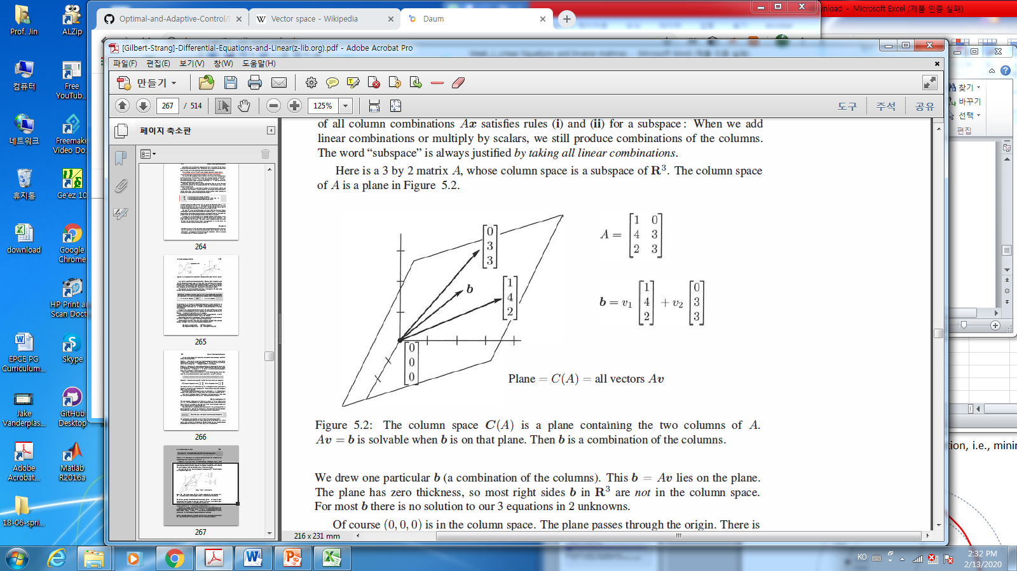

* 1. The null space of A: Solving
* Def: The span of a set of vectors:

<https://homepages.rpi.edu/~mitchj/handouts/linalg/>

* Example:
* is a subspace
* Def: The null space of A, denoted by , consists of all solutions to
* Example_1 : find
* Example_2:
* Example_2: page.262: Find the null space of
* Facts: The nullspace is a subspace
* The number of elements in space / subspace = 1 or inifinte
* The number of elements of null space , = 1 or infinite
* are always solvable.

1. Case 1: the unique solution as
2. Case 2: infinite many solution
3. Case 1: unsolvable
4. Case 2: solvable 🡪 the unique solution OR the infinite many solution
   1. The complete Solution to

* Fact:

Every solution to has the form :

1. The particular solution:
2. The null solution(homogeneous solution):,

* Example
  1. Independence, Basis and Dimension
* Def: The columns of are linearly independent when the only solution to

Is .

* Def: The sequence of vectors is **independent** if the only combination that gives the zero vector is

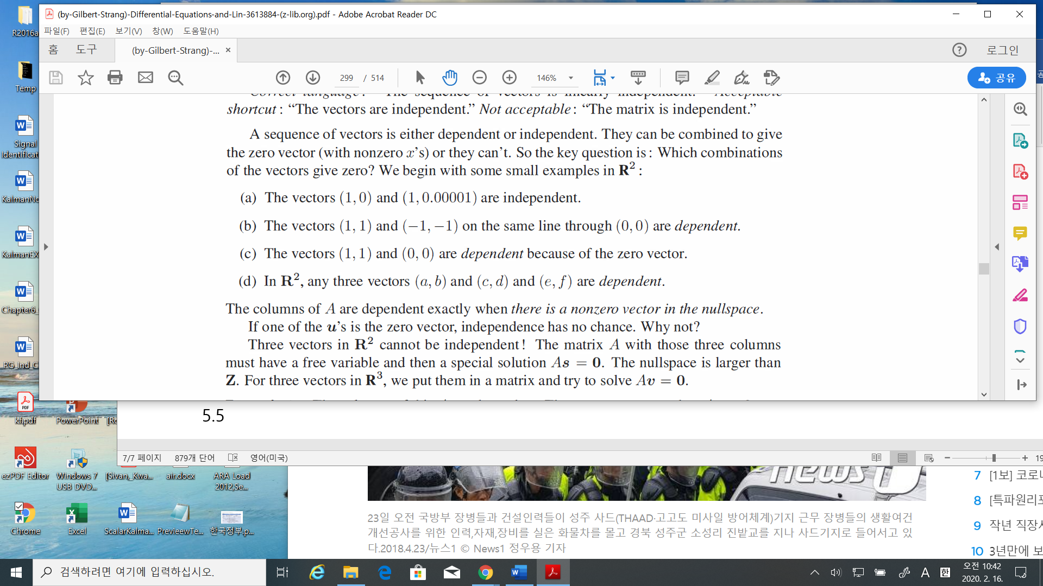

* Def: A set of vectors spans a space if their linear combination fill the space

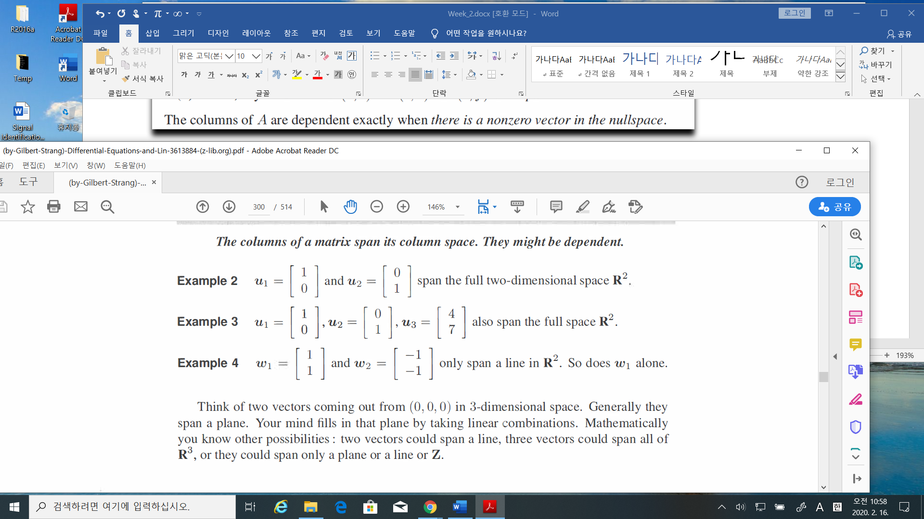

* Def: A basis for a vector space is a sequence of vectors with two properties

The basis vectors are linearly independent and they span the space

* Facts:

1. There is one and only one way to write as a combination of the basis vectors.
2. The columns of every invertible by matrix gives a basis for
3. The vectors are a basis for exactly when they are the columns of an by invertible matrix. The vector space has infinitely many different bases.
4. The number of vectors in any and every basis, is the “dimension” of the space.

* Def: The dimension of a space is the number of vectors in every basis
* The function space:

Sol:

Any solution is a linear combination of

Solution space (null space) = span {(t) , (1)} 🡪

(** what is the particular solution?

Sol:

The Basis of the solution space (null space) = }

Sol:

The Basis of the solution space(null space) =

Sol: 🡪 it is the particular solution.

* Fundamental Theorem: page 304.

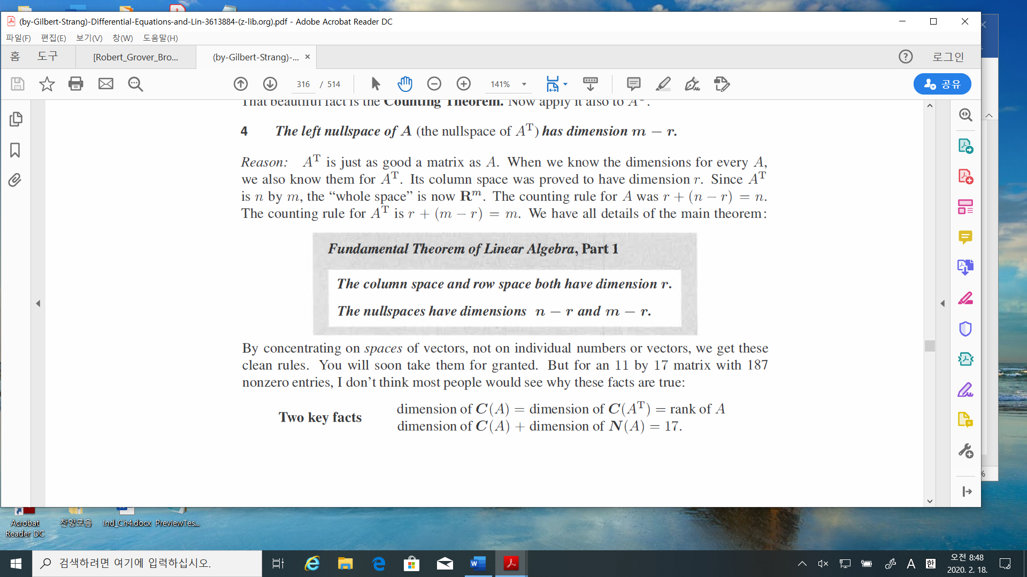

**Skip: Chapter 5.5 / 5.6**

In Gilbert

Chapter 5.1: problem 1 / 10(if false, show an example)

Chapter5.3: problem 4 / 13(except (c) / 19

Chapter5.4: problem 1 / 29/ 31