SEE Week_5_Optimal_Linear_State_Feedback Ex.1.1.

* **Home assignment(W6.1)**:

From (1.15),(1.16),(1.17) and (1.18), derive (1.26)

* **Example 1.4 / Example 1.5 / Example 1.6** (Revisit Example 1.1 – **the solution of Ex.1.1** )

From (1.26) with $u\left(t\right)=0$

$$\dot{x}\left(t\right)=Ax=\left(\begin{matrix}0 & 1 & \begin{matrix}0 & 0\end{matrix} \\ 0 & -\frac{F}{M} & \begin{matrix}0 & 0\end{matrix} \\ \begin{matrix}0 \\ -\frac{g}{L^{'}}\end{matrix} & \begin{matrix}0 \\ 0\end{matrix} & \begin{matrix}\begin{matrix}0 \\ \frac{g}{L^{'}}\end{matrix} & \begin{matrix}1 \\ 0\end{matrix}\end{matrix}\end{matrix}\right)x\left(t\right) (1.26)$$

The e-values are

$${ λ}_{i}= 0,-\frac{F}{M}, \frac{\sqrt{Lg}}{L}, \frac{-\sqrt{Lg}}{L} (1.86)$$

The e-Vectors are $e_{1}= \left[\begin{matrix}1 \\ 0 \\ \begin{matrix}1 \\ 0\end{matrix}\end{matrix}\right], e_{2}=\left[\begin{matrix}1 \\ -F/M \\ \begin{matrix}α \\ -α F/M\end{matrix}\end{matrix}\right], e_{3}=\left[\begin{matrix}0 \\ 0 \\ \begin{matrix}\sqrt{Lg}/g \\ 1\end{matrix}\end{matrix}\right], e_{4}=\left[\begin{matrix}0 \\ 0 \\ \begin{matrix}-\sqrt{Lg}/g \\ 1\end{matrix}\end{matrix}\right], (1,87)$

$$α=\left(\frac{g}{L^{'}}\right)/(\frac{g}{L^{'}}-\frac{F^{2}}{M^{2}})$$

Hence from (1.26) the solution is a linear combination as

$$x\left(t\right)=c_{1}e_{1} e^{λ_{1}t}+ c_{2}e_{2} e^{λ_{2}t}+ c_{3}e_{3} e^{λ_{3}t}+ c_{4}e_{4} e^{λ_{4}t}$$

One of the e-values is positive, hence the system is unstable $λ_{3}>0$.

* **Home assignment(W6.2)**:

Find e-Values and e-Vectors (1.86), (1.87) using symbolic math.

* **Example 1.16 (Revisit Examle.1.1** – Closed loop system. Some output feedback: only angular position is measured)

Without control input, **it is unstable** as U see Example 1.5. U may notice many examples in real life. We design a controller to stabilize this example. But before to stabilize, let us consider a simple controller.

Let us **measure only the angular position** at the pivot, $ϕ(t)$. Then with linear output feedback controller, $u= -kϕ(t)$, the closed loop is stabilizable? Let us design a output controller.

1. Find the $ϕ(t)$ with respect to the state variables in Ex.1.1 $(ξ_{1},ξ_{2},ξ_{3}, ξ_{4})$.

In the Ex.1.1

$$ξ_{3}= ξ_{1}+ϕ(t)$$

$$-→ ϕ\left(t\right)=ξ_{3}-ξ_{1}$$

1. Output $y=ϕ\left(t\right)=(ξ_{3}-ξ_{1})/L'=\left[ -1/L^{'} 0 1/L' 0\right]\left[\begin{matrix}ξ_{1} \\ ξ_{2} \\ \begin{matrix}ξ_{3} \\ ξ_{4}\end{matrix}\end{matrix}\right]=Cx(t)$
2. Linear output control with a negative feedback as
$u\left(t\right)=ky\left(t\right)=k\left[ -1/L^{'} 0 1/L' 0\right]\left[\begin{matrix}ξ_{1} \\ ξ_{2} \\ \begin{matrix}ξ_{3} \\ ξ_{4}\end{matrix}\end{matrix}\right]$

3. The closed loop state space equation

From (1.26)

$$\dot{x}\left(t\right)= \left(\begin{matrix}0 & 1 & \begin{matrix}0 & 0\end{matrix} \\ 0 & -\frac{F}{M} & \begin{matrix}0 & 0\end{matrix} \\ \begin{matrix}0 \\ -\frac{g}{L^{'}}\end{matrix} & \begin{matrix}0 \\ 0\end{matrix} & \begin{matrix}\begin{matrix}0 \\ \frac{g}{L^{'}}\end{matrix} & \begin{matrix}1 \\ 0\end{matrix}\end{matrix}\end{matrix}\right)x\left(t\right)+ \left(\begin{matrix}0 \\ \frac{1}{M} \\ \begin{matrix}0 \\ 0\end{matrix}\end{matrix}\right)u\left(t\right) (1.26) \\ =\left(\begin{matrix}0 & 1 & \begin{matrix}0 & 0\end{matrix} \\ 0 & -\frac{F}{M} & \begin{matrix}0 & 0\end{matrix} \\ \begin{matrix}0 \\ -\frac{g}{L^{'}}\end{matrix} & \begin{matrix}0 \\ 0\end{matrix} & \begin{matrix}\begin{matrix}0 \\ \frac{g}{L^{'}}\end{matrix} & \begin{matrix}1 \\ 0\end{matrix}\end{matrix}\end{matrix}\right)x\left(t\right)- k\left(\begin{matrix}0 \\ \frac{1}{M} \\ \begin{matrix}0 \\ 0\end{matrix}\end{matrix}\right) \left[-\frac{1}{L^{'}} 0\frac{1}{L^{'}} 0\right]x(t) (since negative feedback) \\ =Ax-BKx \left(define K= k\left[-1 0 1 0\right]\right)$$

Hence the closed loop transfer function is

$$T_{closed}\left(s\right)=C{\left(sI-\left(A-BK\right)\right)}^{-1}B \\ =-\frac{Ls}{{LMs}^{3}+FLs^{2}-\left(Lk+Mg\right)s-Fg} (1-252.1)$$

%%%%%%%%%%-------- comment… **textbook (1-252) is not correct.** The sign of $Lks$ is negative but positive in the textbook

----------------------------%%%%%%%%%%%%%%

* Pole-zero cancellation

The denominator of the closed loop transfer function(1-252.1) has the 3rd order of the “s” polynomial, which is not consistent , since the closed loop system is 4th order differential equation. Hence there should be pole zero cancellation.

We should check the determinant of $sI-\left(A-BK\right)$, which is

Determinant of $sI-\left(A-BK\right)$ = $-\{{LMs}^{4}+FLs^{3}-\left(Lk+Mg\right)s^{2}-Fgs\}$.

Hence there is a pole –zero cancellation as “s”. The correct closed loop transfer function is

$$=-\frac{{Ls}^{2}}{s\left({LMs}^{3}+FLs^{2}-\left(Lk+Mg\right)s-Fg\right)} (1.252.2)$$

1. Stability check.

Since the roots of the denominator of the closed loop transfer function (2.16.3) has at least a positive real.

* **Home assignment(W6.3) :** why does the roots have at least one positive real?
* For any feedback gain $k$, it is not stabilized.--> the only measurement of the angular position is not sufficient to stabilize the inverted pendulum.
* **But If you see the MIT OCW**, <https://www.youtube.com/watch?v=D3bblng-Kcc>,

**He consider a different inverted pendulum which is stabilized using PD controller with the angular position feedback!!**

%%%%%%%%%%---- Matlab has an error in symbolic math.

Consider

clear all;clc

syms M

[1;M]

[ 1 M]'

>> ans:

ans =

1

M

ans =

1

conj(M)

in matlab conj(M) means “M is a complex number, conj(M) is the conjugate of the number”. That is incorrect since “M” is a symbol (as a character) not a number. Hence when I have to transpose a symbolic matrix, I do not use the transpose command.

-------------------------%%%%%%%%%%%

1.6 Controllability

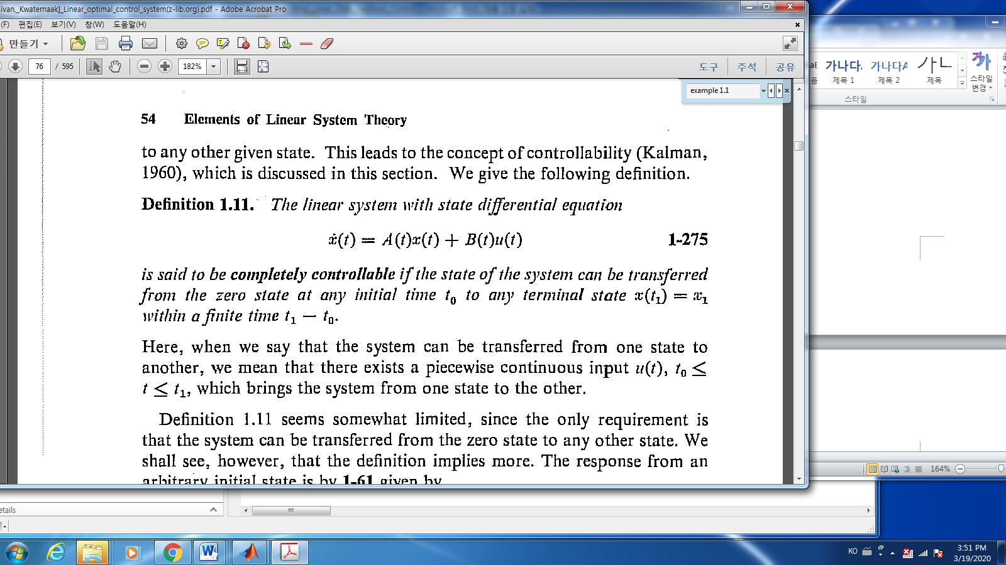

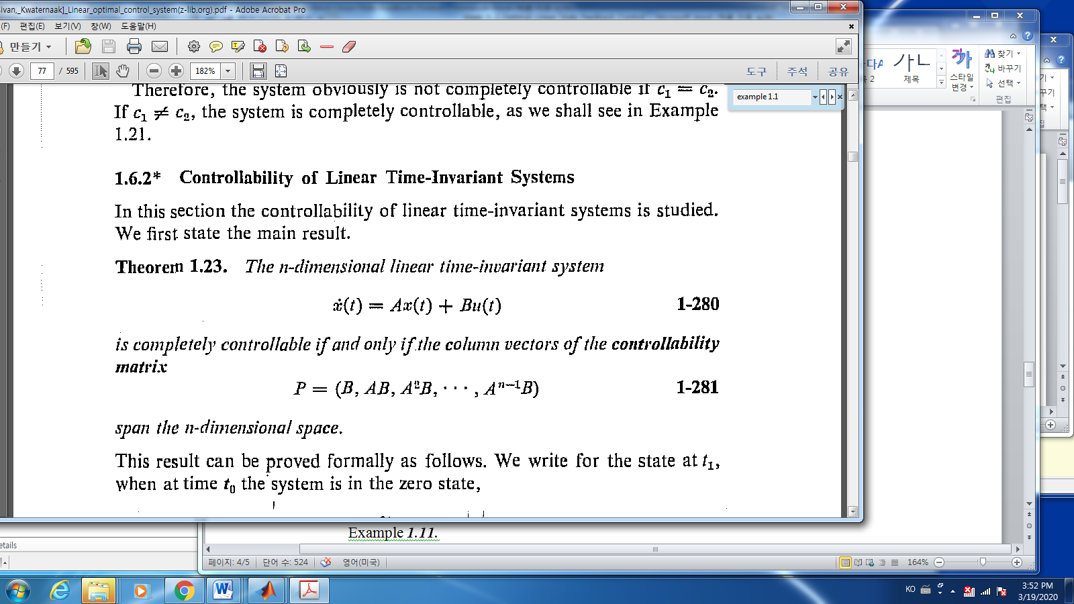

* To be controllable, there is No constraints on the output $y=Cx$.
* Example 1.20 (inverted pendulum): the inverted pendulum in example 1.1 is controllable.

Since the controllability matrix $P$,

$$P=\left[B,AB,A^{2}B,A^{3}B\right]$$

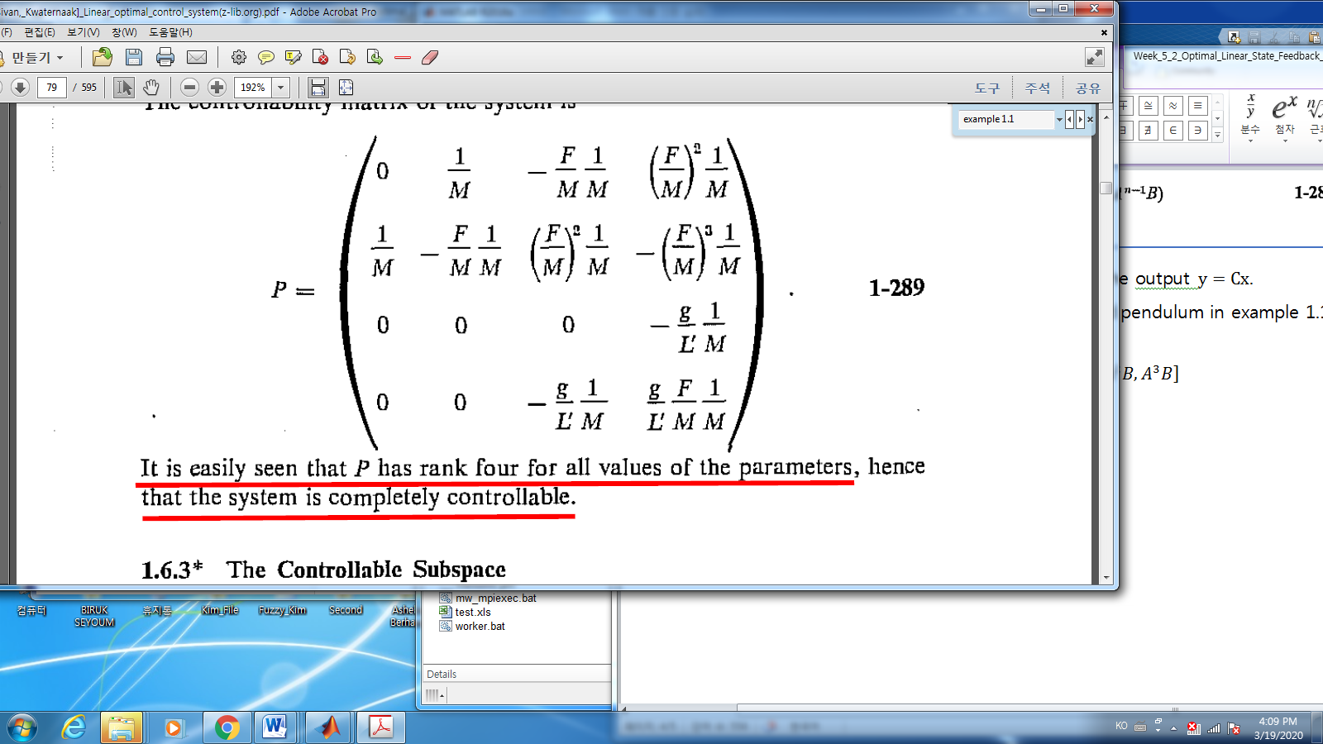

%%%%%%%%%%------- it is said “it is easily seen,…, P has rank four for all values of the parameters. Really?

* **Home assignment:** W6.4 Why does P have rank 4?

-------------------------%%%%%%%%%%%%%%