“Linear Optimal Control Systems”, Kwakernaak, Sivan, 1972

1. Elements of Linear System Theory
   1. Introduction
   2. A State description of Linear System

* Ex.1.1 (Kwak. Page 4): Inverted pendulum: stabilization of the inverted pendulum

To stabilize the pendulum to move the carriage

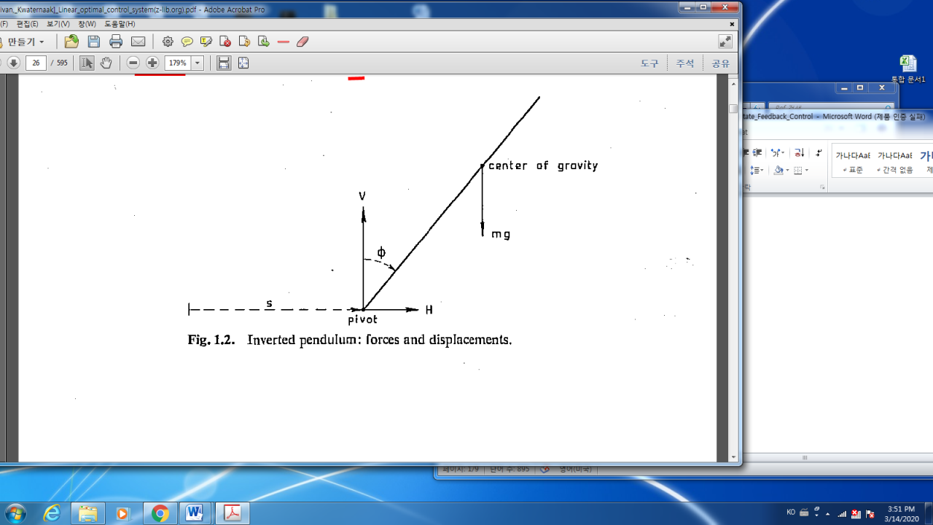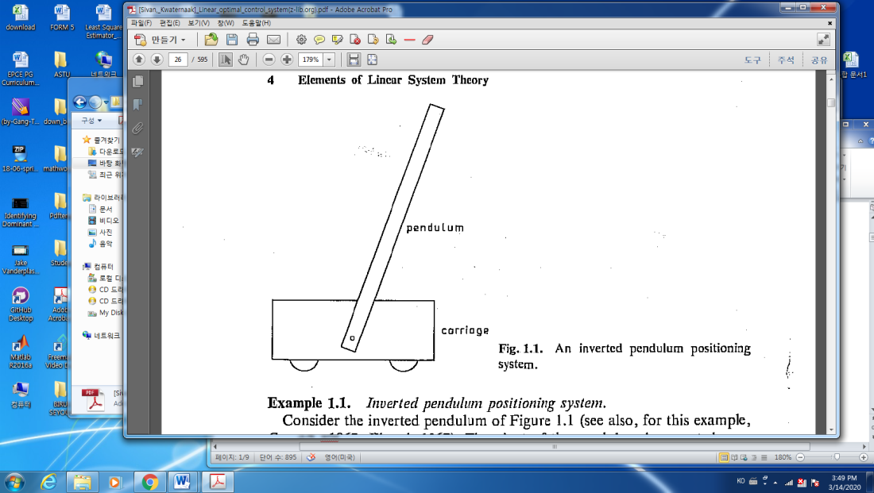

* Parameters of Modeling
* A small motor force to the carriage:
* The displacement of the pivot:
* Angular rotation of the pend:
* The mass of Pend.:
* The distance from the pivot to the center of gravity:
* The moment of inertia:
* The carriage mass:
* The force on the Pend:
* The horizon reaction force:
* The vertical reaction force:
* The horizontal friction between the carriage and the road :
* No friction at the pivot

%%%%%%%%%%%%%%%%----- application of an inverted pendulum - google

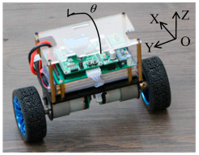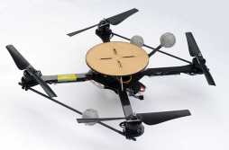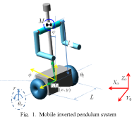

---------------------------%%%%%%%%%%%%%%%%%%%

* Dynamics at the center of the Pend.
* Assumption:
* elimination of in (1.16),(1.17) and (1.18)

which yields to

where : effective pendulum length

* For linearization, choose a nominal solution as , hence
* Define new states for the linearized dynamic system equation (1.23).

,

Then the dynamics of the system is

You may check

The numerical values are

* Home assignment:

From (1.15),(1.16),(1.17) and (1.18), derive (1.26)

%%%%%%%%%%%%------During this semester we will study “Optimal Control” and introduce example this inverted Pendulum inverted pendulum

* modelling
* stability / controllability / observability
* steady state analysis
* optimal regulator design
* Stochastic modelling
* Optimal estimator / optimal controller / separation principle
* Optimal output feedback(in complete measurements)

-------------------------%%%%%%%%%%%%%%

* 1. **Solution of the state differential equation of linear system**
     1. The transition Matrix and the impulse response matrix
     2. The transition matrix of a Time-invariant system
* Theorem 1.4. (P.14)

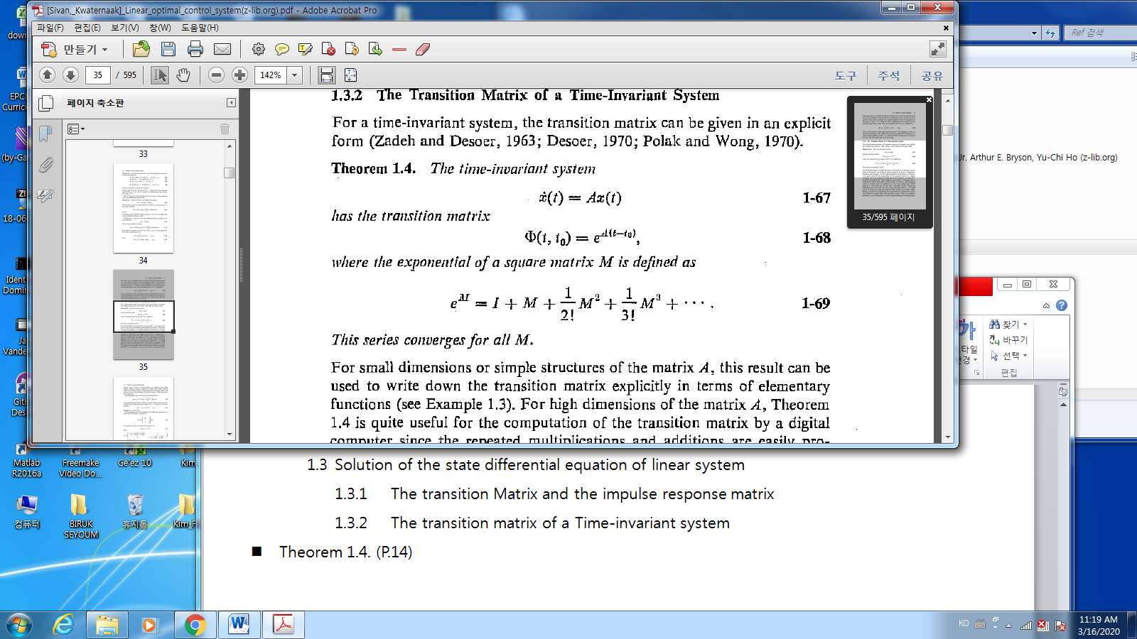

* The solution of (1-67) is
* Using theorem 1.3(p.12), if the new state then

Then

* 1. **Stability**
* Def.1.1 (p.24) : stability in the sense of Lyapunov

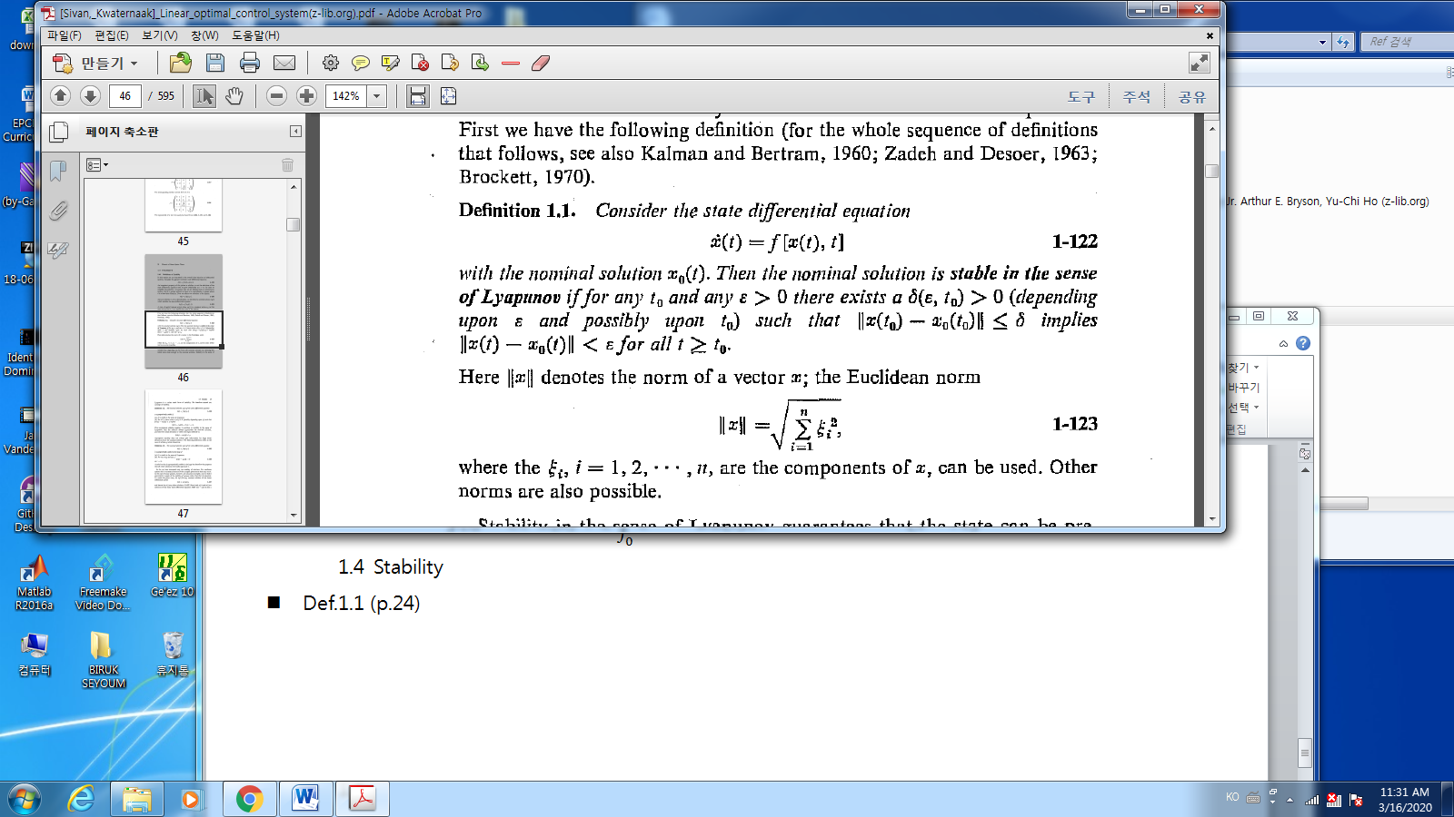

* Def 1.2. Asymptotically stability

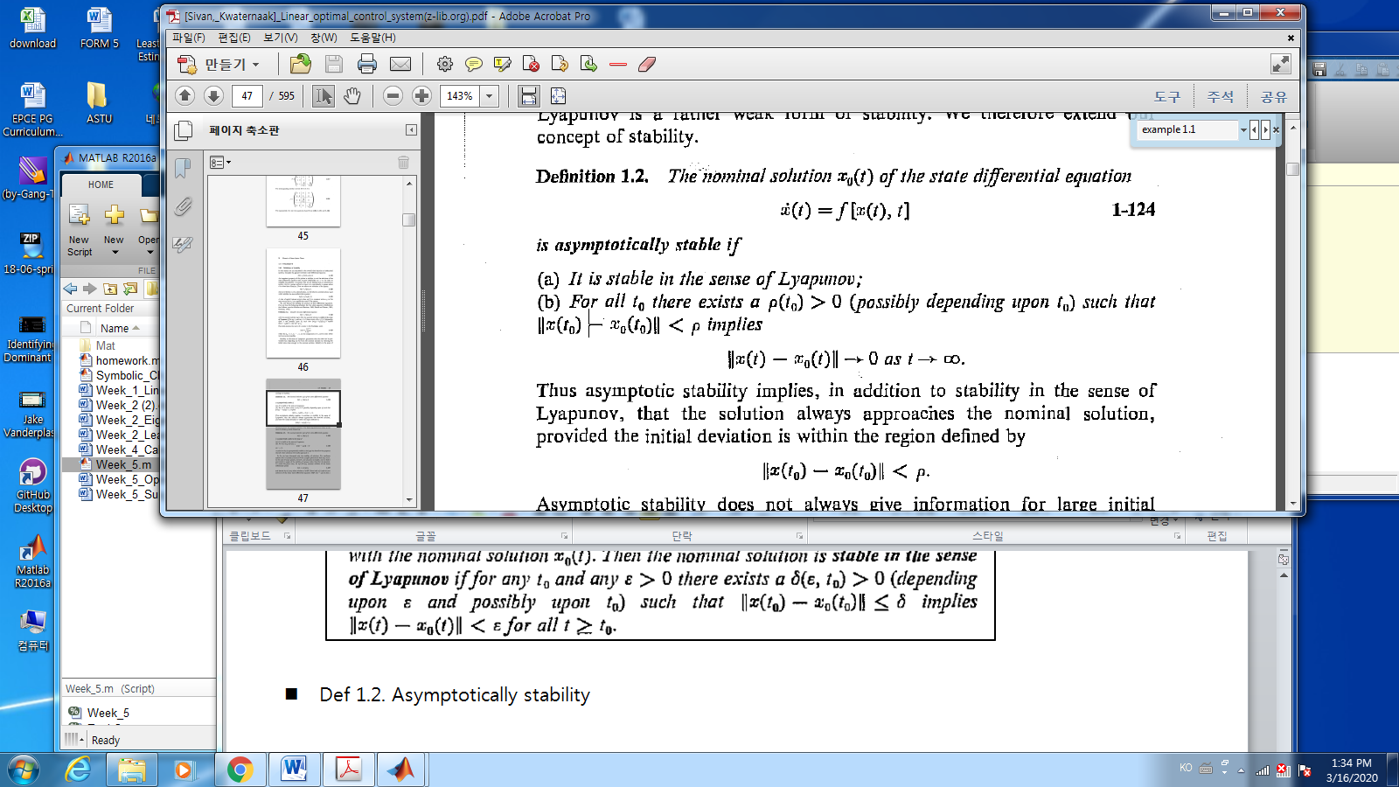

* Theorem 1.14 (p.28): stability of The time-invariant linear system

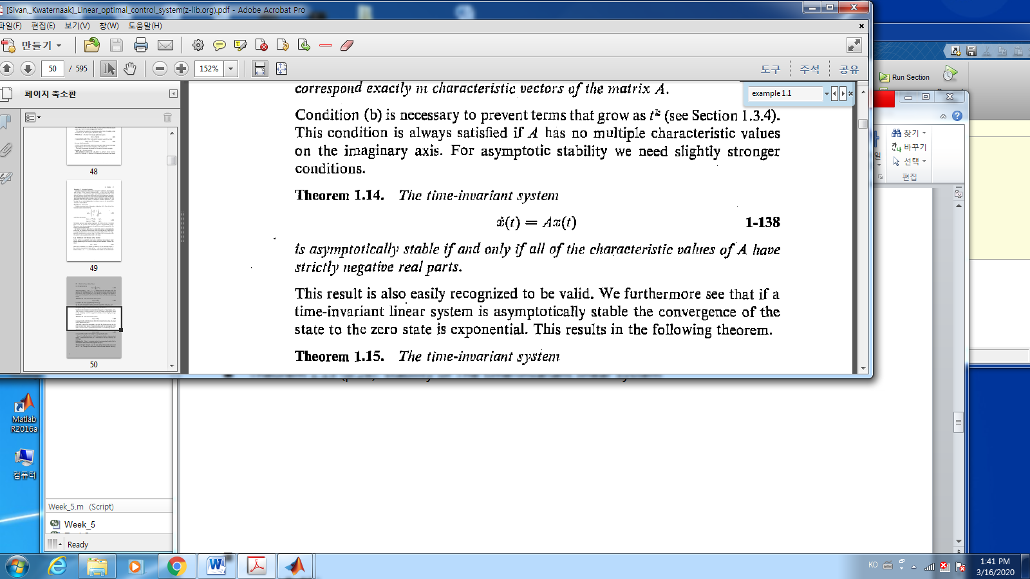

* Def. 1.6 : characteristic values(=eigen-values)

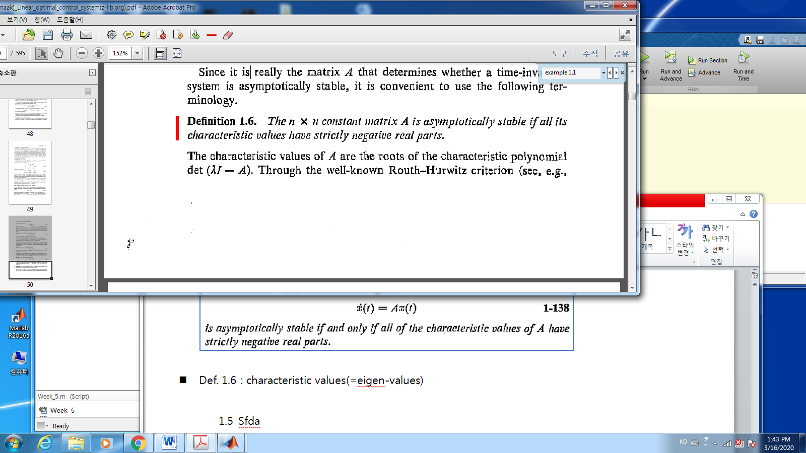

* Ex.1.11 (p.34, the inverted pendulum)

Find the characteristic values. Is it asymptotically?

* 1. Transform analysis of time-invariant systems
     1. Solution of the state differential equation through Laplace Transformation
* Fact(P.33):
* Laplace transform
* The solution of homogeneous LTI

The Laplace transform is

The inverse Laplace transform is

* The solution of inhomogeneous LTI

The Laplace Transform is

* The transfer matrix(function) from u to y
* Def: The poles

The roots of the common denominator of are called the poles of the transfer function.

* 1. Sfda

Sda

A linear time-varying system,

to implement a linear control law

a time-varying state feedback gain matrix

a new input

The closed loop system is asymptotically stable

%%%%%%%%%%-----

Asymptotically: a line approaches a curve but never touches.

-------------- %%%%%%%%%%%%%%%