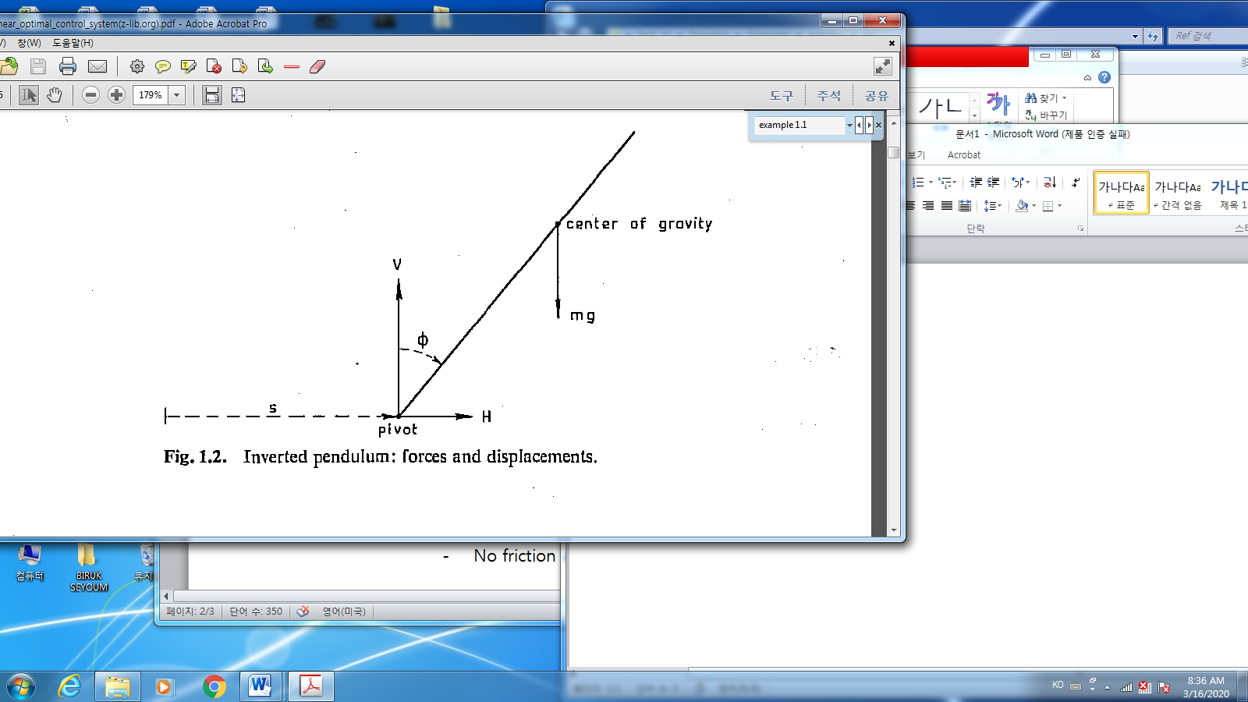

No viscosity at the pivot = $F\frac{ds}{dt}$

Viscosity force between the carriage

and the road

* Translational motion at the pivot : $F=ma=m\ddot{s}$
$$m\frac{d^{2}}{dt^{2}}\left(s\left(t\right)+L\sin{ϕ\left(t\right)}\right) =H\left(t\right)$$

$$m\frac{d^{2}}{dt^{2}}\left(L\cos{ϕ\left(t\right)}\right) =V\left(t\right)-mg$$

* Rotational motion at the pivot : $T=J\dot{ω}=J\ddot{ϕ}, T={LF}_{tangential}$
$$J\frac{d^{2}ϕ\left(t\right)}{dt^{2}}=LV\sin{ϕ\left(t\right)}-LH\left(t\right)\cos{ϕ(t)}$$

* The carriage dynamics:

$$M\frac{d^{2}s\left(t\right)}{dt^{2}}=u\left(t\right)-H\left(t\right)-F\frac{ds\left(t\right)}{dt}$$

1. How many controllers?
2. One: the motor force
3. If you have another controller, what may it be?
4. How many sensors you need?
5. What is the optimal control law to minimum of the force or if the force is allowed as you want?
6. If the force is bounded, what control law?
7. If the measurements by the sensor is corrupted by noise, what algorithm you may need?
8. If the carriage is moving independent of the movement of the pendulum, what else you need?

There are plenty of questions to stabilize the inverted pendulum…..

%%% symbolic math in Matlab (state space transfer function)

State space model

State -space

$$\ddot{x}+a\dot{x}+bx=u,$$

1. Define state as
$$x_{1}=x, x_{2}=\dot{x}={\dot{x}}_{1}$$

$${\dot{x}}_{2}+ax_{2}+bx_{1}=u$$

$$\left[\begin{matrix}\dot{x_{1}} \\ \dot{x_{2}}\end{matrix}\right]=\left[\begin{matrix}0 & 1 \\ -b & -a\end{matrix}\right]\left[\begin{matrix}x_{1} \\ x_{2}\end{matrix}\right]+ \left[\begin{matrix}0 \\ 1\end{matrix}\right]u$$

2. State feedback: case_1

$$u={-k}_{2}x_{2}= \left[\begin{matrix}0 & -k_{2}\end{matrix}\right]\left[\begin{matrix}x_{1} \\ x_{2}\end{matrix}\right]$$

->Closed loop

$$\left[\begin{matrix}\dot{x_{1}} \\ \dot{x_{2}}\end{matrix}\right]=\left[\begin{matrix}0 & 1 \\ -b & -a\end{matrix}\right]\left[\begin{matrix}x_{1} \\ x_{2}\end{matrix}\right]+ \left[\begin{matrix}0 \\ 1\end{matrix}\right]u \\ =\left[\begin{matrix}0 & 1 \\ -b & -a\end{matrix}\right]\left[\begin{matrix}x_{1} \\ x_{2}\end{matrix}\right]+ \left[\begin{matrix}0 \\ 1\end{matrix}\right]\left[\begin{matrix}0 & {-k}_{2}\end{matrix}\right]\left[\begin{matrix}x_{1} \\ x_{2}\end{matrix}\right]$$

$$=\left[\begin{matrix}0 & 1 \\ -b & -a\end{matrix}\right]\left[\begin{matrix}x_{1} \\ x_{2}\end{matrix}\right]+ \left[\begin{matrix}0 \\ 1\end{matrix}\right]\left[\begin{matrix}0 & -k_{2}\end{matrix}\right]\left[\begin{matrix}x_{1} \\ x_{2}\end{matrix}\right] \\ =\left[\begin{matrix}0 & 1 \\ -b & -a\end{matrix}\right]\left[\begin{matrix}x_{1} \\ x_{2}\end{matrix}\right]+ \left[\begin{matrix}0 & 0 \\ 0 & -k_{2}\end{matrix}\right]\left[\begin{matrix}x_{1} \\ x_{2}\end{matrix}\right] \\ =\left[\begin{matrix}0 & 1 \\ -b & -(a+k_{2})\end{matrix}\right]\left[\begin{matrix}x_{1} \\ x_{2}\end{matrix}\right]$$

* Transfer function from $u$ to $x_{2}$
$$y=x_{2}=\left[\begin{matrix}0 & 1\end{matrix}\right]\left[\begin{matrix}x_{1} \\ x_{2}\end{matrix}\right]$$

* Symbolic math

#Declare syms a b k s % warning! S is not the Laplace “s”. just a symbol.

Define (A,B,C)

Calculate

$$C{\left(sI-\left(A+BK\right)\right)}^{-1}B$$

>>ans:

s/(a + b*s + k2*s + s^2)

##

Prob.1: Transfer function from $u= -k_{1}x_{1}$ to $x_{1}$

>>ans: (b + s)/(a + b*k1 + b*s + k1*s + s^2)

Prob.2: Transfer function from $u= -k_{1}x_{1}$ to $x_{2}$

Prob.2: Transfer function from $u=-(k_{1}x_{1}+k_{2}x_{2})$ to $x_{1}$

Prob.3: Transfer function from $u=-(k_{1}x_{1}+k_{2}x_{2})$ to $x_{1}+x_{2}$

1. Output feedback

$$\ddot{x}+a\dot{x}+bx=u, y=cx, u=-ky$$

$$x_{1}=x, x_{2}=\dot{x}={\dot{x}}_{1}$$

$${\dot{x}}_{2}+ax_{2}+bx_{1}=u$$

$$y=x_{1}+x_{2},$$

* State space representation:

$$\left[\begin{matrix}\dot{x_{1}} \\ \dot{x_{2}}\end{matrix}\right]=\left[\begin{matrix}0 & 1 \\ -b & -a\end{matrix}\right]\left[\begin{matrix}x_{1} \\ x_{2}\end{matrix}\right]+ \left[\begin{matrix}0 \\ 1\end{matrix}\right]u$$

$$=\left[\begin{matrix}0 & 1 \\ -b & -a\end{matrix}\right]\left[\begin{matrix}x_{1} \\ x_{2}\end{matrix}\right]+ \left[\begin{matrix}0 \\ 1\end{matrix}\right] \left[-\begin{matrix}k & 0\end{matrix}\right]\left[\begin{matrix}x_{1} \\ x_{2}\end{matrix}\right]$$

$$y=x_{1}+x_{2}=\left[\begin{matrix}1 & 1\end{matrix}\right]\left[\begin{matrix}x_{1} \\ x_{2}\end{matrix}\right]$$

Transfer function $u$ to $y$

>> ans: (b - a + s)/(a + b*k + b*s + k*s + s^2)