2.5 The Steady-State analysis of the Tracking properties -skip

2.6 ~2.7~2.8~2.9~2.10~2.11 skip~~~ of course 2.12 problems are skip.

3. Optimal Linear State Feedback Control Systems

3.1 Introduction

3.2 Stability Improvement of Linear Systems by State Feedback

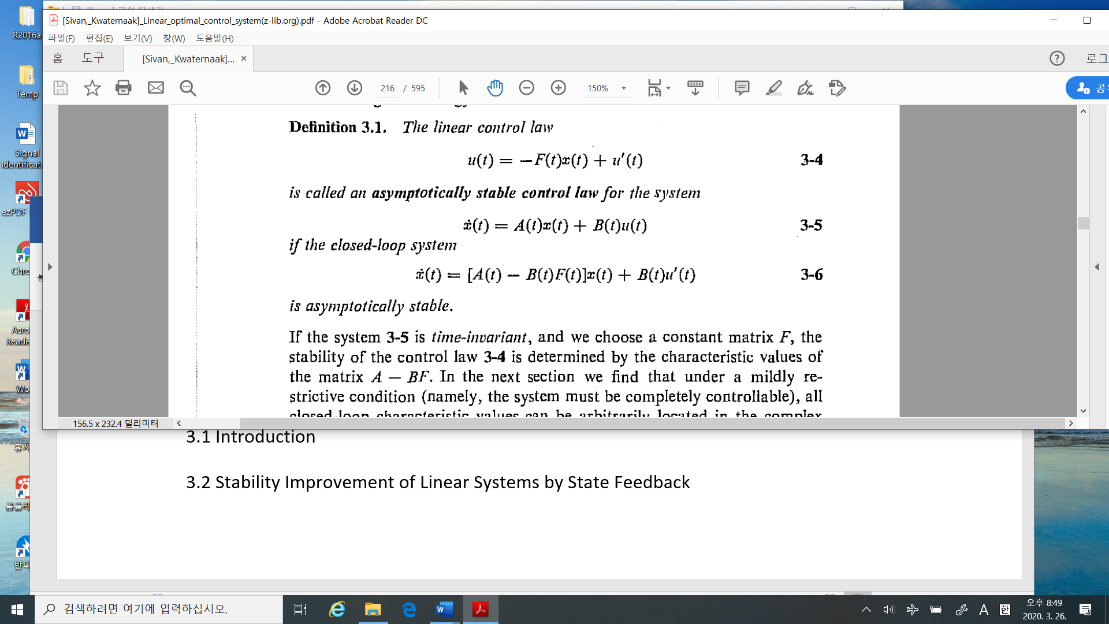

%%%%%%%%%%%%---------------

The control input can be choose anything if you want. One of the strategy is as in Def. 3.1 as

1. First, to stabilize the system. The closed loop system is

asymptotically stable, which means

1. Then the closed loop system as

, which means if you desire the state can be achieved by a corresponding

-----------------------------------%%%%%%%%%%%%%%%

* Example 3.1 Stabilization of the inverted pendulum. Continue example 1.1

The inverted pendulum in Example 1.1 is modeled as

The design goal is to find a state feedback gain so that the closed loop characteristic roots are all the same as .

1. With the state feedback The closed loop system matrix is
2. The characteristic equation is
3. The desired characteristic equation is at
4. Find the gain using (3.10) and (3.11) with the numerical values of Example 1.1

Then

K =

-65.6500 -11.0000 72.6028 21.2704

%%%%%%%%%%%%%----------- I really took two hours to get this result!! --

And sometimes symbolic math is not necessary to solve a differential equation, such as pole assignments. That is correct. Why I should introduce the symbolic math? In fact the system parameters is not correct or there are uncertainty on its value. For example, the “Viscosity ” is not constant and is not estimated exactly. It is impossible. Hence the uncertainty of as

The variation of can affect on the system performance. To analyze the effect of this uncertainty (we may call as “The Sensitivity Analysis”. In this problem, the Symbolic math is a good tool to see the insight of the system dynamics due to these uncertainties. We should study it.

-----------------------------------%%%%%%%%%%%%%%%%%

3.2.2 Conditions for Pole assignment and Stabilization

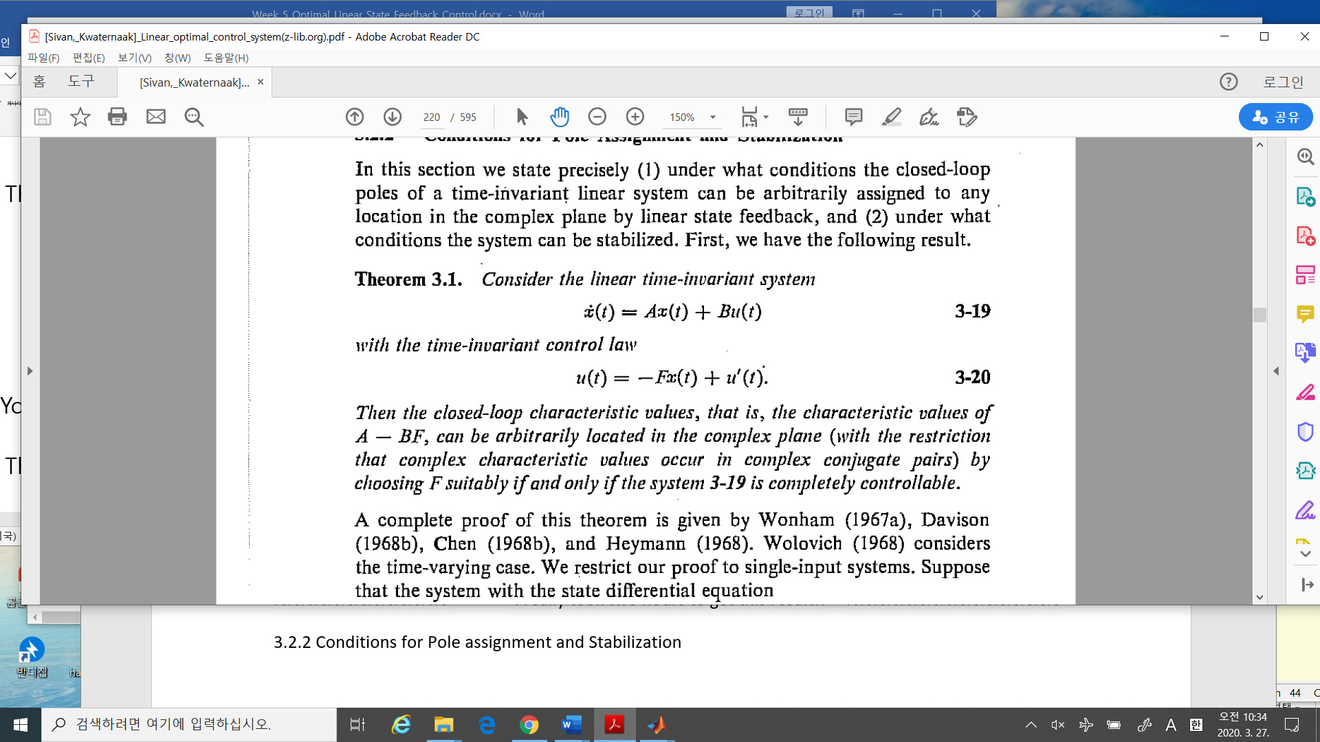



%%%%%%%%%%%-------- As I said in last lecture, in order to be located at arbitrarily location,

A sufficient condition is is a full rank matrix, which is too redundancy. Just the controllability matrix is a full rank matrix ----------------------------------%%%%%%%%%%%%%%%

* A canonical form always guarantees the controllability.

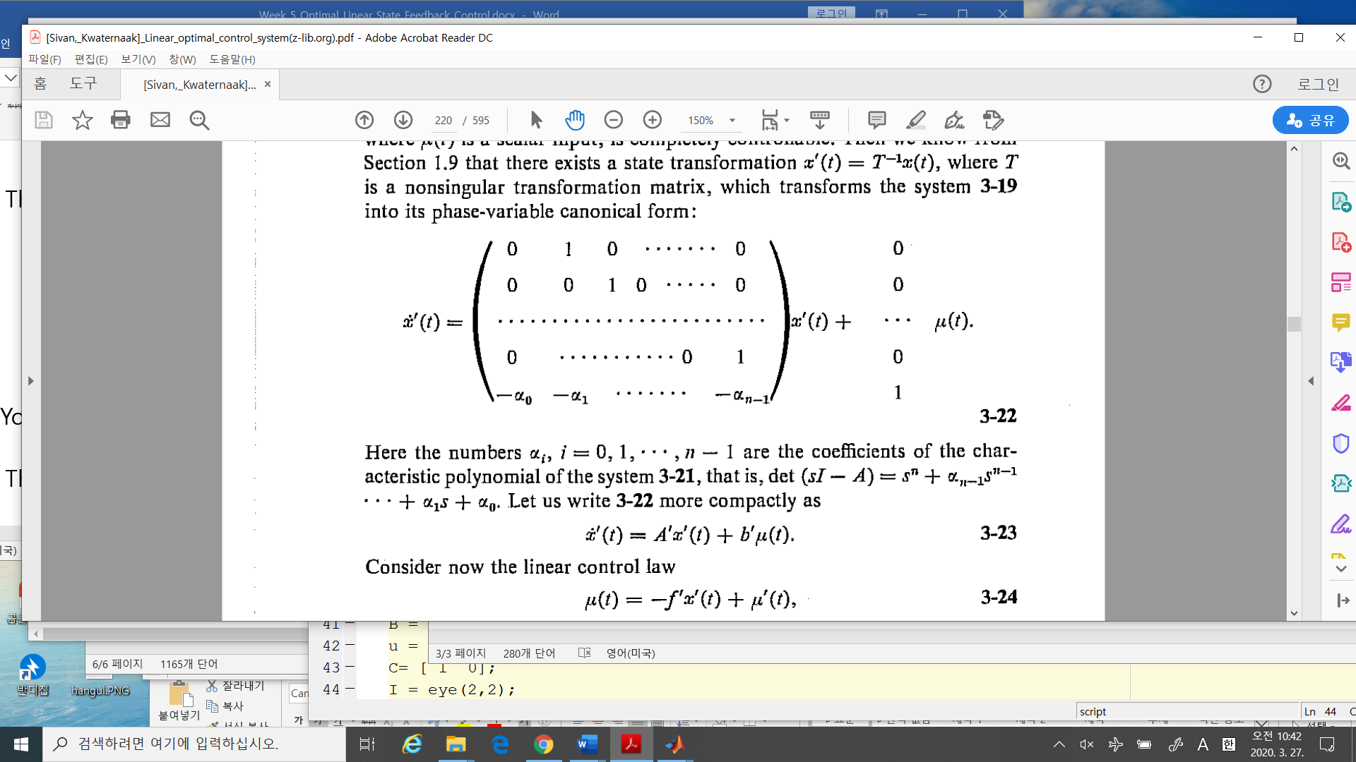

If

Then the characteristic equation of the closed loop system is

So any pole is assigned by an appropriate .

3.3 The Deterministic linear optimal regulator problem

* Definition 3.2

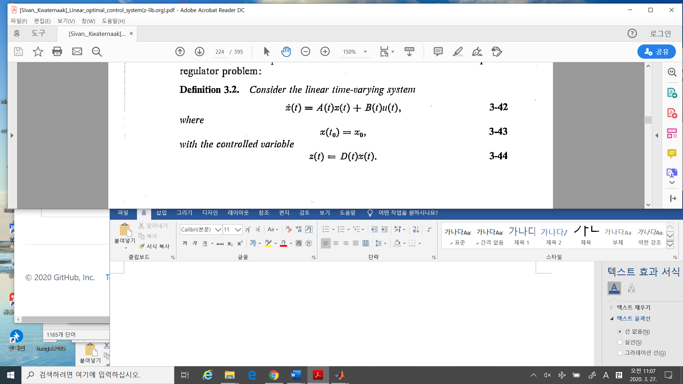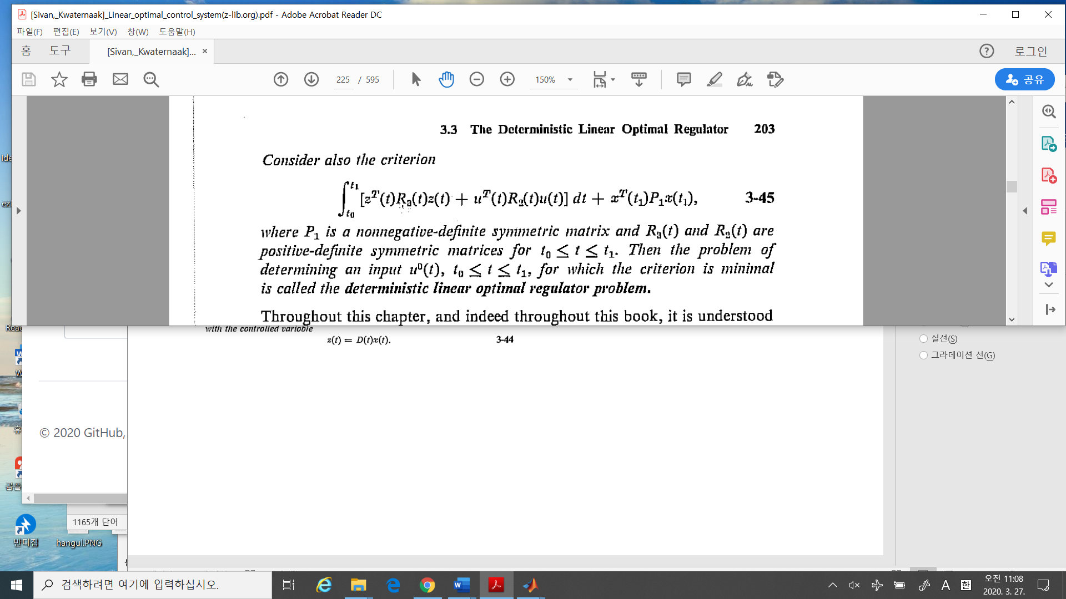

This is an optimal problem.

1. The cost function (the criterion) is as quadratic form as find such that

where controlled variables , (i.e., in the inverted pendulum, . The weighting on the controlled variable, the input and the final state are and ,which are quadratic.

In **the calculus variation**, the cost function is

1. The constraints are
2. Why regulator? The cost

is minimized if .

1. We call this as **Linear Quadratic Regulator 🡺 LQR problem.**

* The solution of LQR problem

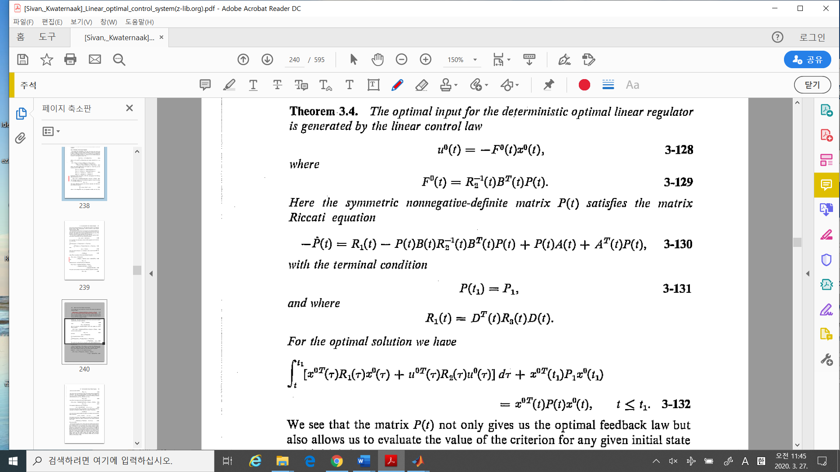



1. The optimal control law (Just “The optimal control “ is enough. Why law?) is a linear .i.e.,



Where

In this textbook, He proved with the assumption on which control is linear. But in the calculus variation, **we do not assume the linearity of the control law.** For all controllers (linear or non-linear) the optimal control of LQR is the linear controller.

1. The Riccati equation:

The matrix differential equation is terminal boundary condition. In general the differential equation is with Initial condition(i.e., initial boundary condition).The Riccati is backward!

The terminal condition of the matrix differential equation is

1. With this optimal control, the minimum cost is 🡪 STRANGE!!
2. One more interesting thing. Remember **The Lyapunov Equation** to check the stability.

