3. Optimal Linear State Feedback Control Systems

3.1 Introduction

3.2 Stability **Improvement** of Linear Systems by State Feedback

3.2.2 Conditions for Pole assignment and Stabilization

%%%%%-- controlability --%%%%

3.3 The Deterministic linear optimal regulator problem

* From (3-42) to (3-45) and from (3-128) to (3-132)

Linear Quadratic Regulator Problem(A simplified notation):

Given

Find the optimal control such that the quadratic cost function is minimized, i.e.,

The solution is

where



%%%%%%%----- Some comments on the above

1. Weighting matrices.

But in order to have the optimal control

1. The optimal control gain is time-varying, since the solution of (3-130,131) is time-varying. If the final time is to be infinite, i.e., steady state, then, is zero, hence

The equation (3-130) is an algebraic equation, not a differential equation. In this case the optimal control gain is **time-invariant, i.e., constant.**

1. The backward Riccati equation / The initial condition

Assume everything is time – invariant.

Define a new variable . Then, . Hence the Riccati equation is

which is an initial condition problem as

After solving the above equation, then change variable to the original time variable.

1. The differential Riccati equation a non-linear, i.e., the RHS of (3-130) contains the square of .In general there is **no analytic solution** of Riccati equation except a scalar case.

Can U solve a scalar case

Hint_1(analytic method): U may know

Hence apply this technic to solve (1)

Hint-2: symbolic math…

* Solve
* Solve
* Solve

However, the matrix case no analytic solution in general, which implies the symbolic math can not give a solution. Hence, You should solve the Riccati **numerically!!, which means You should use a Computer software.**

1. And, (3-130) is backward differential equation, i.e., not the initial value as usual in differential equation(U remember, in circuit, initial value of capacitor voltage.) but **the final value**.
2. In the steady state, the optimal control guarantees the absolute stability of the closed loop system, i.e.,

which implies

Hence the final quadratic cost is vanished as time goes to infinity. Hence

1. The Riccati equation, (1-130) is **a symmetric matix** if the final matrix is a symmetric.

U may check to transpose to the equation (3-130) to result I the same differential equation.

1. U may think that

Hence (3-130) is reduced to

* I am sorry in the matrix case, NO!!. It is different from (3-130)!!

1. U may think (3-130) as

* I am sorry**, NO!!.** It is different from (3-130)!!. However this equation, if U may remember(U are genius!),in the stochastic or identification , was introduced. Later we will see more in detail.
* Example 2.1 / 2.3 / 2.4 / 2.5: A position servo system

1. Problem:

A object is a moving plane. In the ground a rotating antenna is supposed to point in the direction of the plain at all times. The antenna is driven by an electric motor.

The control problem is to command the motor such that

The angular position of the antenna ~~ the angular position of the object

In other words the control objective is

Hence

* The observed variable : the output of the potentiometer to the measured angle
* The measurement noise
* The control input : the driving voltage to the motor to follow
* The system block diagram

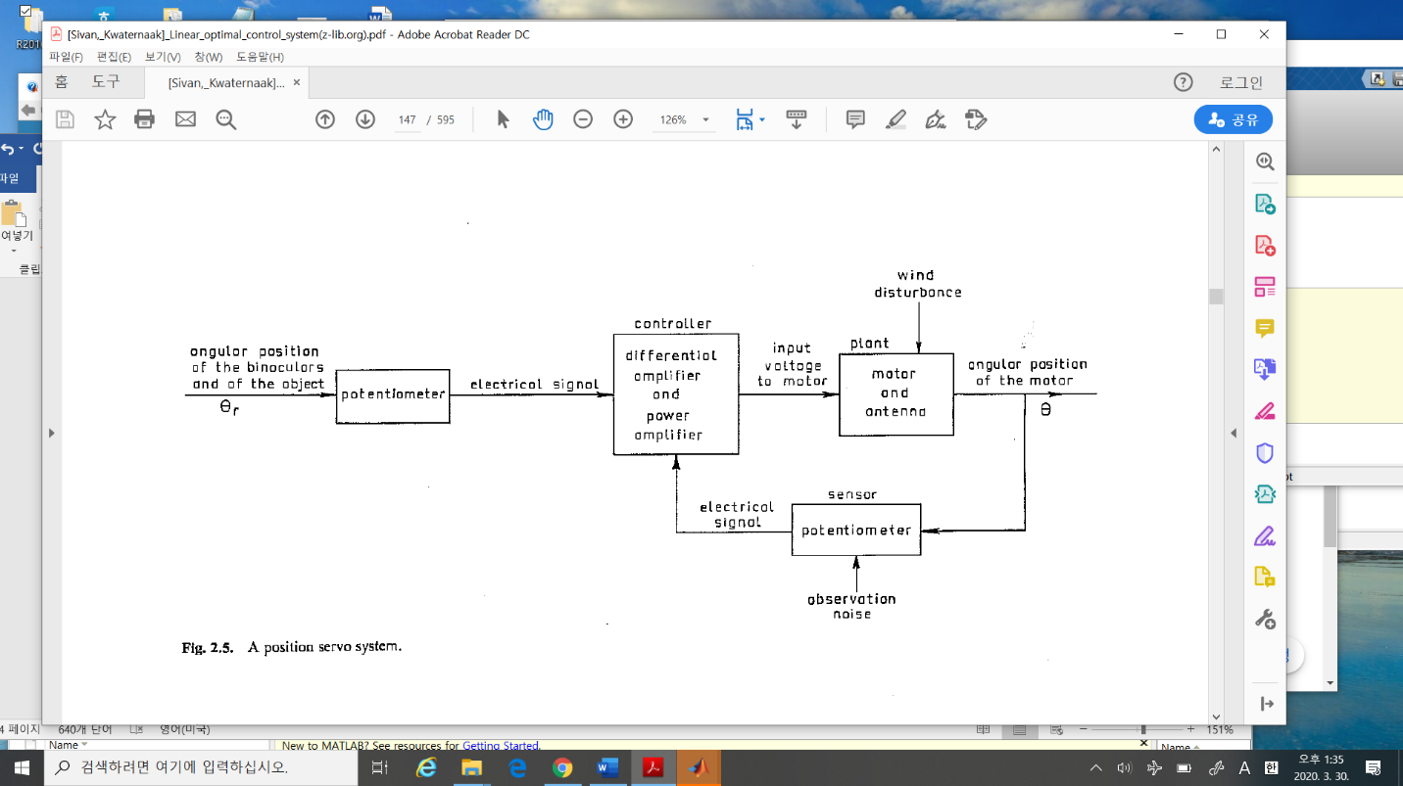

%%%%%%%%%%%%%---------- the tracking antenna ---------binoculors

In the sky there is a plane. The antenna is in the ground. How does the antenna track the plane? If U know mono pulse -radar, U need 2 transmitted pulses in the same time to find an angle between antenna and a target. We call this technique as mono-pulse (in the textbook bi-noculors.)

This technique allows us to follow a remote object. In the radar, the transmitted energy is a microwave energy which can be reached to a long distance,10km ~10,000km,,,??. If U may use an ultrasound energy, it is very cheap compared to a radar, but to a short distance (<= 10m?) . In aduino applications, U may find some.

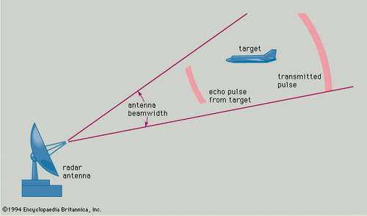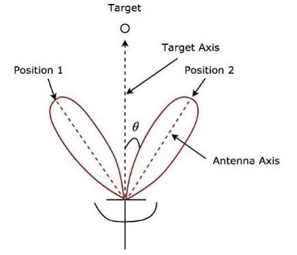

-------------------------%%%%%%%%%%%

* **Example 2.4**: The position servo with three different controllers.

1. Plant modelling:

The motion of the antenna can be modeled as

Here

the moment of inertia of all rotating parts, including the antenna

: the viscous friction coefficient

: the torque applied by the motor

: the disturbing torque by the wind

And the motor torque is generated by the applied motor voltage as

1. Define the states
2. The state space model of the dynamics of (2-18) is

where

The controlled variable (the angle of the antenna) is

1. The known numerical values (2-22)

%%%%%%%%%%%%-------- comments

In order to solve this control problem, U may see there are lots of variables. Control Engineers have the deep in sight of the system. Let’s summarize the variables defined in this textbook.

|  |  |  |  |
| --- | --- | --- | --- |
| The system |  |  |  |
|  | The antenna angle |  |  |
|  | The object angle |  |  |
| The plant |  |  |  |
|  | The moment of inertia |  |  |
|  | The viscous coeff. |  |  |
|  | The torque by the motor |  |  |
|  | The disturbing torque(wind,..) |  |  |
| The input of the plant  (controller) | The applied voltage |  |  |
| The output of the plant | The antenna angle |  |  |
| The measurement |  |  |  |
|  | The output of angle of motor |  |  |
|  | The measurement noise |  |  |

All of these parameters should be carefully examined. In this model the relation between motor torque and applied voltage is not modeled. As U know, a DC motor generates torque proportional to applied voltage (2-18.2). Too simple. There should be time delay and gear-train, so on. U may consider it more in detail. **Does anybody volunteer to model this?**

1. In the model, there are two major uncertainties. The disturbing torque and the measurement noise . Sometimes It should be modelled or neglected. Depends on a system U may consider.

**Now I should talk to you the control engineer. The major roles of control engineers is not only to design a controller (maybe stabilizing problem or PID controller and so on), but the most important, to model a system. So I call the control engineer as a system engineer. Please just to design controller is not enough if U are good control engineers.**

---------------- %%%%%%%%%%%%%%%%%%%%%

In the textbook( I like it), the author considered 3 design strategies without optimal strategy. Let’s study them

* **Design method _1:** Proportional controller( U know PID controller already)

1. The measurement output: Let ‘s assume we measure only the angle of the antenna,

as (2-21),

1. The controller: proportional to the difference of the angle of the plain(object) and antenna

1. The block diagram is

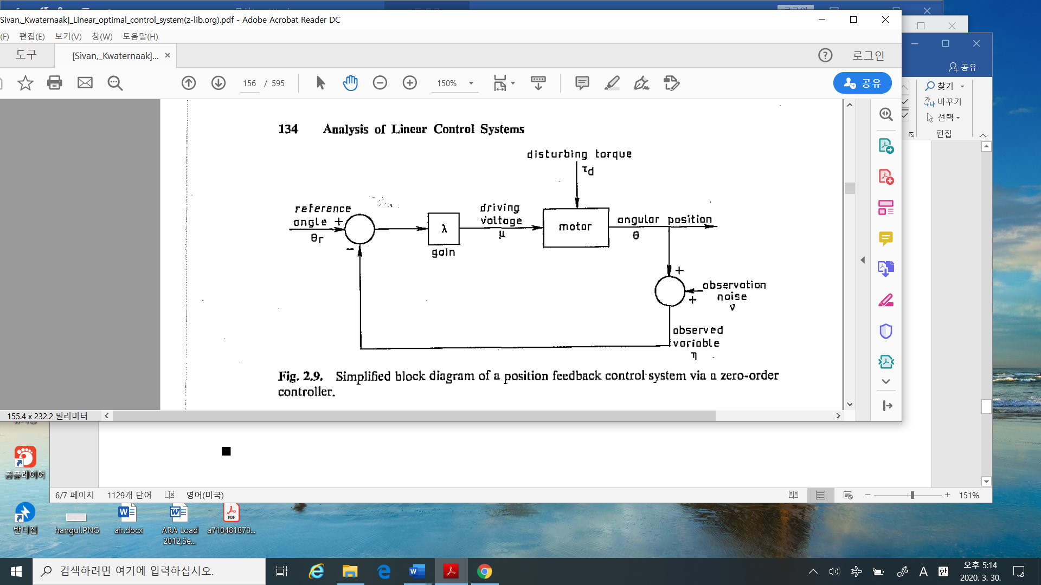



The state space model of the system is

%%%%%%%%%%%----------- comments

* as the proportional gain in PID
* As U see if the value of is increased, the measurement noise has affect more on the system performance
* In the textbook, it is called as zero-order controller, i.e., I think Proportional Gain is enough, forget the terminology zero-order.
* **Design method _2:** Position and velocity feedback via proportional controller.

1. The measured output: assume we may measure full states, i.e., angle and its velocity of the antenna.
2. The controller: proportional to angle difference and the angular velocity as

here is introduced to reduce an overshooting, as a tuning parameter.

1. The block diagram:

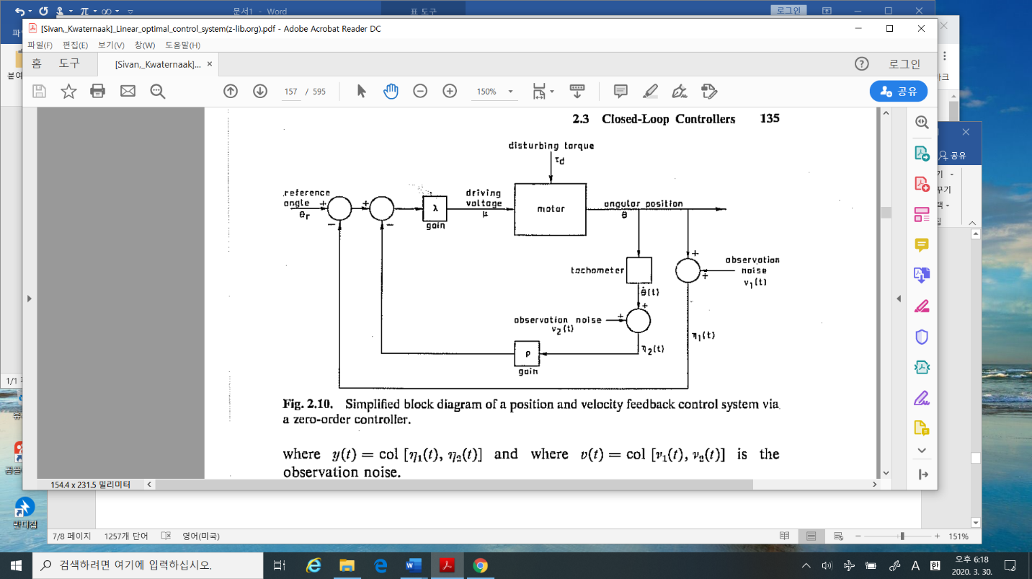

* **Design method _3:** Position feedback via Proportional and prefiltering controller

(Design_1 and modified Design_2)

1. Measured output: The same as Design_1, so that
2. The controller:

Since the angular velocity is not measured, we may approximate the angular velocity as follows.

b.1) derivative of the output measurement: we may differentiate the angle as

,

where is the measurement noise. But the derivative of the noise is very irregular of its magnitude being large. It is not good.

b.2) we may use prefilter the output.

Let’s define another variable as whose dynamics is

If , then ( which is Design_2). The tuning parameter is chosen appropriately, we may lessen the irregularity due to derivative of the output directly, but we may get the approximate of the derivative of angle.

1. Block diagram

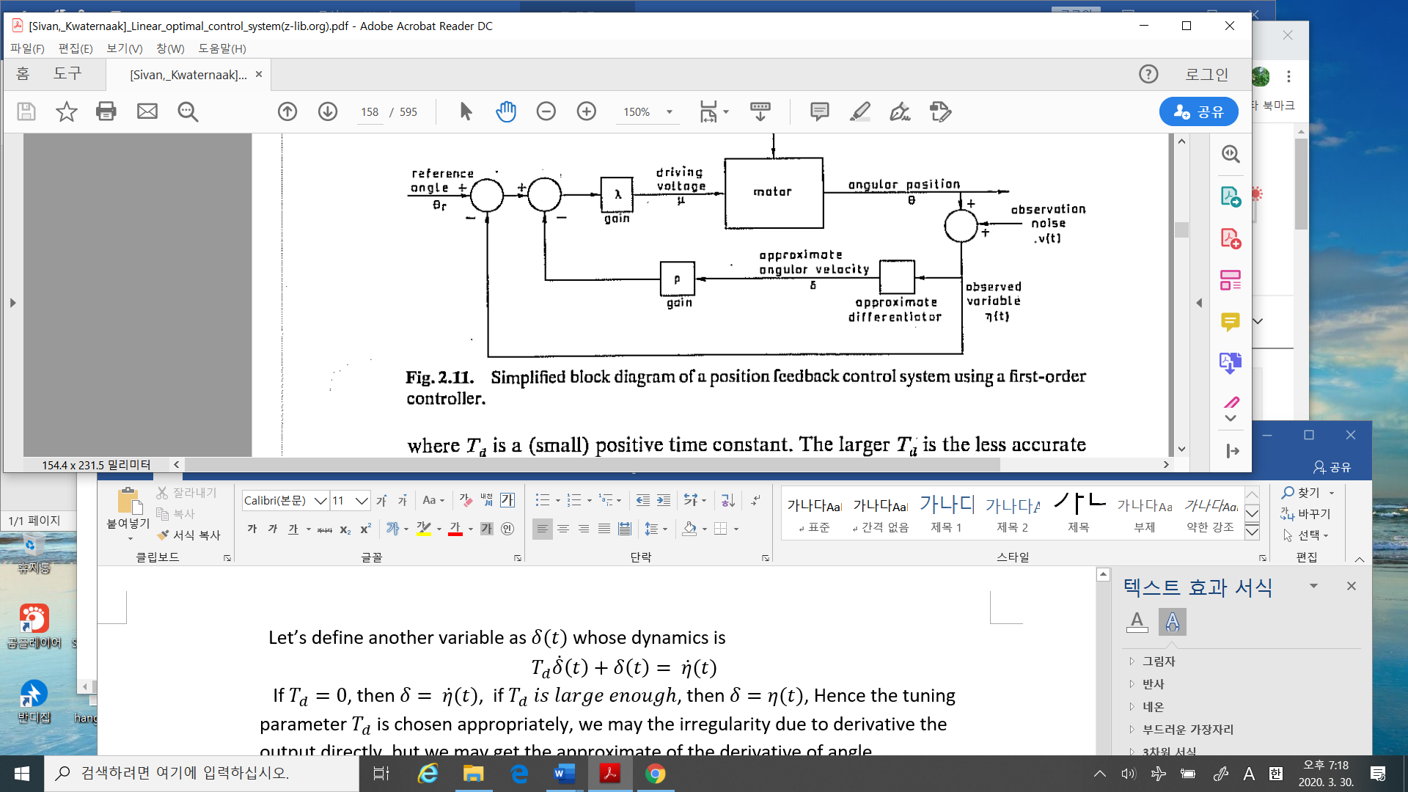

%%%%%%%%%%%%%%%--------Can you calculate the transfer functions of each Design_1, Design_2, and Design_3? To get the transfer function, given the block diagram, it is useful, U may remember how to get the transfer function. Try it

------------------------------------------%%%%%%%%%

Of course without optimality, it may be good performance sometimes, some systems as Design_1,2,3. But the main drawback is it is few guideline to design controllers. Now, we will design using Optimality.

* **Example 3.3/ 3.6** Linear Quadratic Regulator problem: Scalar case

1. Problem:

Control objective: An angular velocity stabilization of the shaft in a dc motor

Controller: input voltage

1. Dynamics:

Here the numerical values are

1. Optimization Criterion
2. The optimal controller

From

where

In this example,

Hence

1. Numerical solution:

The backward Riccati equation is considered as a forward Riccati equation using the change time variable as , which yields to

The numerical values are in (3-58).

Now using matlab.



%%%%------------------------ comment.

* How can we choose the weighting factor ? Delicate…But I will introduce some guideline how to choose the factor later.
* In Fig 3.7, in general so control is constant over long period except near the final point(U may not accept. But Please accept it). And to use the optimal controller U should memorize the whole trajectory of , need large memory capacity. Hence we may consider time-invariant , so as the controller gain to be constant.

------------------------------%%%%%%%%%%%%%%%

3.4 Steady-State Solution of the Deterministic Linear Optimal Regulator Problem.

This is one of the main topics in this semester. In general, we call LQR which is the deterministic, steady-state problem. So it is important.