3. Optimal Linear State Feedback Control Systems

3.1 Introduction

3.2 Stability **Improvement** of Linear Systems by State Feedback

3.2.2 Conditions for Pole assignment and Stabilization

%%%%%-- controlability --%%%%

3.3 The Deterministic linear optimal regulator problem

* From (3-42) to (3-45) and from (3-128) to (3-132)

Linear Quadratic Regulator Problem(A simplified notation):

Given

$$\dot{x}=Ax+Bu, x\left(0\right)=x_{o}$$

Find the optimal control such that the quadratic cost function is minimized, i.e.,

$$\min_{u}\left\{\int_{t_{0}}^{t_{f}}{x^{T}Q x+u^{T}R u dt }+ x^{T}\left(t_{f}\right)P_{1}x(t_{f}) \right\}$$

The solution is

$$u= -R^{-1}B^{T}P(t)x\left(t\right),$$

where



$$-\dot{P}=A^{T}P+PA+Q-PBR^{-1}B^{T}P, P\left(t_{f}\right)=P_{t_{f}} (3-130, 131)$$

%%%%%%%----- Some comments on the above

* **Example 3.3/ 3.6** Linear Quadratic Regulator problem: Scalar case

1. Problem:

Control objective: An angular velocity $ξ(t)$ stabilization of the shaft in a dc motor

Controller: input voltage $μ(t)$

1. Dynamics:

$\dot{ξ}\left(t\right)=-αξ\left(t\right)+κμ\left(t\right) (3-51)$

Here the numerical values are

$α=0.5 s^{-1} (3-58)$

$$κ=150 rad/(V s^{2})$$

1. Optimization Criterion
$$J = \int_{t_{0}}^{t_{1}}{\left[ξ^{2}\left(t\right)+ρμ^{2}(t)\right]dt }+π_{1}ξ^{2}\left(t_{1}\right) (3-57)$$

2. The optimal controller

From

$$u= -R^{-1}B^{T}P(t)x\left(t\right),$$

where

$$-\dot{P}=A^{T}P+PA+Q-PBR^{-1}B^{T}P, P\left(t_{f}\right)=P_{t_{f}} (3-130, 131)$$

In this example,

$$A=-α, B=κ, Q=1, R=ρ.$$

Hence

$$u= -R^{-1}B^{T}P\left(t\right)x\left(t\right), =-\frac{κ}{ρ}p\left(t\right)x\left(t\right),$$

$$-\dot{p}\left(t\right)=-αp-pα+1-{\frac{κ^{2}}{ρ}p}^{2} , (3-131.2) \\ =-2αp+1-\frac{κ^{2}}{ρ}p^{2}, p\left(t_{1}\right)=π_{1}$$

1. Numerical solution:

The backward Riccati equation is considered as a forward Riccati equation using the change time variable as $s=t_{f}-t$, which yields to

$$\dot{s}\left(t\right)=-2αs+1-{\frac{κ^{2}}{ρ}s}^{2} , s\left(t_{0}\right)=π_{1} (3-131.2)$$ The numerical values $α, κ$ are in (3-58).

Now using matlab.



%%%%------------------------ comment.

* How can we choose the weighting factor $ρ$? Delicate…But I will introduce some guideline how to choose the factor later.
* In Fig 3.7, in general $P\left(t\right),$ so control $u(t)$ is constant over long period except near the final point(U may not accept. But Please accept it). And to use the optimal controller U should memorize the whole trajectory of $P(t)$, need large memory capacity. Hence we may consider time-invariant $P$, so as the controller gain to be constant.

------------------------------%%%%%%%%%%%%%%%

3.4 Steady-State Solution of the Deterministic Linear Optimal Regulator Problem.

%%%%%%%%%%----------This is one of the main topics in this semester. In general, we call LQR which is the deterministic, steady-state problem. So it is important.

-----------------------------------%%%%%%%%%%%%%%%%%%%%%%%%%%%%%

* Introduction

The Riccati equation has a steady- state solution as if $t-→∞, \lim_{t→∞}{P\left(t_{f}\right)= \overline{P}}$,

$$-\dot{P}=A^{T}P+PA+Q-PBR^{-1}B^{T}P, P\left(t_{f}\right)=P_{t_{f}} (3-130, 131)$$

$$0 =A^{T}\overline{P}+\overline{P}A+Q-\overline{P}BR^{-1}B^{T}\overline{P}$$

And the optimal control law is

$u\left(t\right)= -R^{-1}B\overline{P} x (3-150)$

With which the closed loop system is asymptotic stable.

%%%%%%%%----------------comment

1. Since the controller is to minimize the cost function, it is necessary the $x\left(t\right)$ should be convergent to zero.
2. Hence for any final state weighting function $P_{t_{f}}$

$$\lim_{t_{f}→∞}{x^{T}P\left(t_{f} \right)x=0}$$

* **Example. 3.7** (continue Example 3.3/ 3.6) : scalar Riccati Equation

In Example 3.6, the differential Riccati Equation is

$$-\dot{p}\left(t\right)=-αp-pα+1-{\frac{κ^{2}}{ρ}p}^{2} , (3-131.2) \\ =-2αp+1-\frac{κ^{2}}{ρ}p^{2}, p\left(t_{1}\right)=π_{1}$$

Now as time goes to infinity, i.e., $\lim_{t→∞}{p(t)}$,

$$0=-2α\overline{p}+1-\frac{κ^{2}}{ρ}{\overline{p}}^{2},$$

$$\overline{p}=\frac{ρ}{κ^{2}}\left(-α± \sqrt{α^{2}+\frac{κ^{2}}{ρ}}\right)$$

Since $\overline{p}≥0,$ (why?),

$$\overline{p}=\frac{ρ}{κ^{2}}\left(-α+\sqrt{α^{2}+\frac{κ^{2}}{ρ}}\right)$$

Then the optimal controller is

$$u= -\frac{κ}{ρ}\overline{p}x=-\frac{κ}{ρ}\left(\frac{ρ}{κ^{2}}\left(-α+\sqrt{α^{2}+\frac{κ^{2}}{ρ}}\right)\right)x(t)$$

$$=\frac{1}{κ}\left(α-\sqrt{α^{2}+\frac{κ^{2}}{ρ}}\right) x(t)$$

From (3.51), the closed loop system is

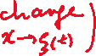

which is asymptotically stable.

* **Example 3.8 (continue Example 2.4)**: Matrix Riccati Equation

1. Problem:

The state space model of the dynamics of (2-18) is

$$\dot{x}=\left[\begin{matrix}0 & 1 \\ 0 & -α\end{matrix}\right]x+ \left[\begin{matrix}0 \\ κ\end{matrix}\right]μ+\left[\begin{matrix}o \\ γ\end{matrix}\right]τ_{d} (2-19)$$

$ζ= \left[\begin{matrix}1 & 0\end{matrix}\right]x (2-21)$

known numerical values (2- 22)

$$α=4.6 s^{-1} \\ κ=0.787 rad/(Vs^{2})$$

Let’s assume the disturbance $τ_{d}$ is zero and the cost function is

$$\dot{x}=\left[\begin{matrix}0 & 1 \\ 0 & -α\end{matrix}\right]x+\left[\begin{matrix}0 \\ κ\end{matrix}\right]μ$$

$J = \lim_{{t→}_{.}∞}{\int_{t_{0}}^{t}{\left[ζ^{2}\left(t\right)+ρμ^{2}(t)\right]dt }} (3-63)$

1. The Steady State Riccati Equation(Algebraic) is



$$0 =A^{T}\overline{P}+\overline{P}A+Q-\overline{P}BR^{-1}B^{T}\overline{P}$$

$$0={\left[\begin{matrix}0 & 1 \\ 0 & -α\end{matrix}\right]}^{T}P+P\left[\begin{matrix}0 & 1 \\ 0 & -α\end{matrix}\right]+\left[\begin{matrix}1 & 0 \\ 0 & 0\end{matrix}\right] -P\left[\begin{matrix}0 \\ κ\end{matrix}\right]\frac{1}{ρ}\left[\begin{matrix}0 & κ\end{matrix}\right]$$

1. The non-negative solution of $P$ is

$$0=1-\frac{κ^{2}}{ρ} P_{12}^{2} \\ 0=-\frac{κ^{2}}{ρ} P_{12}P_{22}+P_{11}-αP_{12} \\ 0=-\frac{κ^{2}}{ρ}P_{22}^{2}+2P_{12}-2αP_{22}$$

The non-negative solution is

$$P_{11}=\frac{\sqrt{ρ}}{κ} \sqrt{α^{2}+\frac{2κ}{\sqrt{ρ }}} \\ P_{12}=\frac{\sqrt{ρ}}{κ} \\ P_{22}=\frac{ρ}{κ^{2}} \left(-α+\sqrt{α^{2}+\frac{2κ}{\sqrt{ρ }}}\right)$$

1. The optimal controller is
$$u= -R^{-1}B^{T}Px\left(t\right) \\ =-\left(\frac{1}{\sqrt{ρ}} , \frac{1}{κ}\left(-α+\sqrt{α^{2}+\frac{2κ}{\sqrt{ρ }}}\right)\right) (3-162)$$

2. The closed loop system matrix
$$\dot{x}= \left[\begin{matrix}0 & 1 \\ -\frac{κ}{\sqrt{ρ }} & -\sqrt{α^{2}+\frac{2κ}{\sqrt{ρ }}}\end{matrix}\right]x (3- 164)$$

3. The closed loop poles are
$$\frac{1}{2}\left(-\sqrt{α^{2}+\frac{2κ}{\sqrt{ρ }} }± \sqrt{α^{2}-\frac{2κ}{\sqrt{ρ }}}\right) (3-165)$$

4. The root-loci of the closed loop

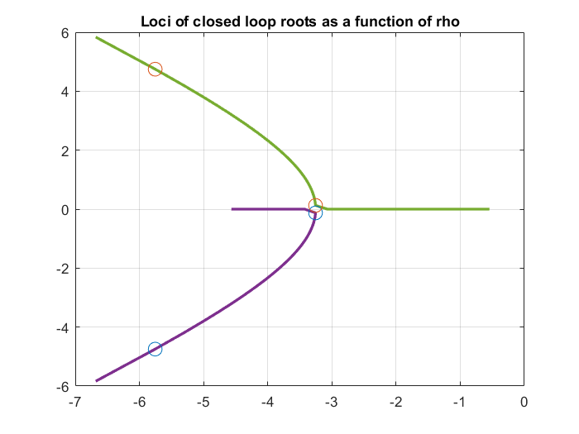

1. For $ρ=0.00002 rad^{2}/V^{2}$, with an initial point $\left[ξ_{1}, ξ_{2}\right]=[θ, \dot{θ]}=[0.1;0]$ (see Week_7_LQR, below (2-18.2) ), the trajectories of the controlled output, i.e., the angle of the antenna and that of the optimal input, i.e., the input pf the DC motor voltage is



OK… At last we may get the optimal control input, for $ρ=0.00002 rad^{2}/V^{2}$. Are U safe?

Hmm. There is a little overshoot, but looks good. But is your power supply for the DC motor enough to generate the $\max\left|u\right|$? **If Ur power supply is NOT enough, this optimal controller is useless**! Check $\max\left|u\right|\sim \sim 23 V.$ If Urs is enough, it is lucky. If not, let us the weighting factor on the control $ρ$ to be is deceased to tenth of the previous value, i.e., $ρ_{new}=\frac{1}{10}ρ_{old}$, then,

$$\max\left|u_{new}\right|\sim \sim 7 V$$

Is it enough? OK. What is a demerit to decrease the weighting factor? One is the response time. In the following graphs, the time of the first zero of the angle is increased as the weighting is decreased, which means the antenna angle is slower to follow the plane compare to the previous one.

**“If there is a merit, there should be a demerit on another respects. “**

**The one** of the main objectives on the control engineer is

**How to decrease the effect of the demerits whereas to increase those of the merits.**

This is the key. Please keep in mind of this if U try to design a controller.



1. One important remark left before conclusion in this example.

The state variable we defined as

$$x\left(t\right)= \left[\begin{matrix}ξ_{1}(t) \\ ξ_{2}(t)\end{matrix}\right]=\left[\begin{matrix}θ(t) \\ \dot{θ}(t)\end{matrix}\right]=\left[\begin{matrix}angle of the antenna \\ angular velocity\end{matrix}\right]$$

Since the control object is that the antenna to follow the plane in the sky, the binocular (i.e,. in antenna, mono pulse radar) gives the error between the angle of the antenna and that of the plane regardless of the absolute angles respectively. So We may change the state as

$$x\left(t\right)= \left[\begin{matrix}θ\left(t\right)-θ_{d} \\ \dot{θ}(t)\end{matrix}\right]=\left[\begin{matrix}error angle of the antenna and the plane \\ angular velocity\end{matrix}\right]$$

If $θ_{d}$ is not so fast moving compared to the antenna, which is an appropriate assumption

in general, we may consider it as a constant. We may re-define as

$$x\left(t\right)= \left[\begin{matrix}θ\left(t\right)-θ_{d} \\ \dot{θ}(t)\end{matrix}\right]=\left[\begin{matrix}ξ_{1}' \\ \dot{ξ_{1}'}\end{matrix}\right]=x'(t)$$

which is the same optimal controller as

$$u\left(t\right)= -BKx^{'}\left(t\right)= -BK\left[\begin{matrix}θ-θ_{d} \\ \dot{θ}\end{matrix}\right]=-k_{1}\left(θ-θ_{d}\right)-k_{2}\left(\dot{θ} \right) (3-171)$$

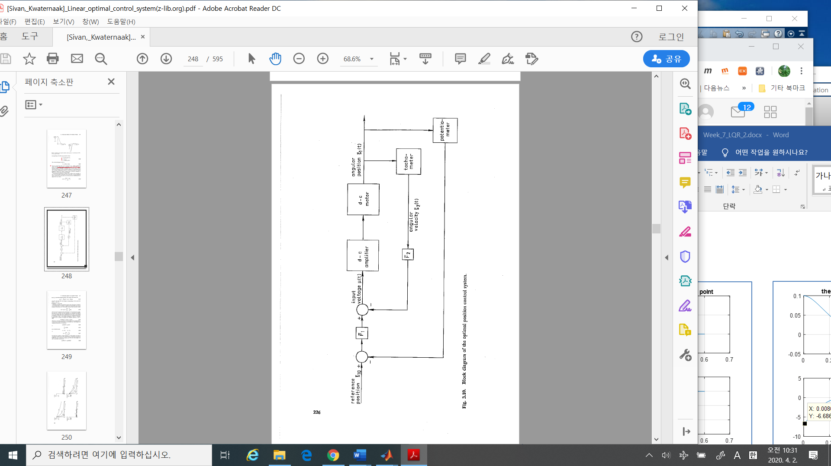 The block diagram of the optimal controller is

The block-diagram Fig 3.10 is similar to that of Fig.2.10 , in Week_7_LQR. In the case of Fig 2.10, the design method_2, **there are two parameters to be tuned, as $λ$ and $ρ$**

$$μ=λ\left(θ_{r}-η_{1}\right)-λρη_{2} (2-27)$$

However in this LQR (remember the cost function) the only one tuned parameter as

$$μ=f(ρ)\left(θ_{r}-η_{1}\right)-g\left(ρ\right)η_{2} (3-171.2)$$

which is the same as (3-171).

**%%%%%%%%%%%%%%%%------------- matlab commands (Week_7.m)**

In this lecture I introduce some functions as

**ode45, solve, ss, lqr, initial** and etc. These are valuable to simulate dynamic system time response. Of course U may make U’s own functions to simulate it, however, these commands are already verified, and, moreover, to reduce time and efforts to see Urs results.

------------------------%%%%%%%%%%%%%%%

%%%%%%%%% Upto now I want to summarize What we have done so far….

1. Define Physical Problems

Example 1.1: inverted pendulum

Example 2.1: tracking antenna

Example 3.3: DC motor

1. Model in mathematic terminology – state space
2. Define the control objective
3. Find a controller

Example 2.1: using conventional controllers

LQR Method (is it conventional nowadays?)

1. Merits and Demerits of LQR

Later if the model is different, (i.e., stochastic,) or some the other constraints (, i.e., the measurements are not available) we may study.

I think if you are preparing an independent study, or thesis, this procedure is a good example of a template…. Please keep in mind What I am doing?

%% another comments on Riccati

It looks simple as

In case of scalar

$$-\dot{p}\left(t\right)=-αp-pα+1-{\frac{κ^{2}}{ρ}p}^{2} , (3-131.2)$$ But case of matirx

$$-\dot{P}=A^{T}P+PA+Q-PBR^{-1}B^{T}P, P\left(t_{f}\right)=P_{t_{f}} (3-130, 131)$$

Things are going into difficulty

Even if in steady state ($\frac{dP}{dt}=0$), it is still difficult. There are several methods developed. But still some applied math / engineer would try to solve efficiently. Still now. If you plug in this problem, it is good to see the insight of linear algebra, however, to some time limit, you should go out of this problem.

------------------------%%%%%%%%%%%%%%%%