4.2 Observers

* Theorem 4.2

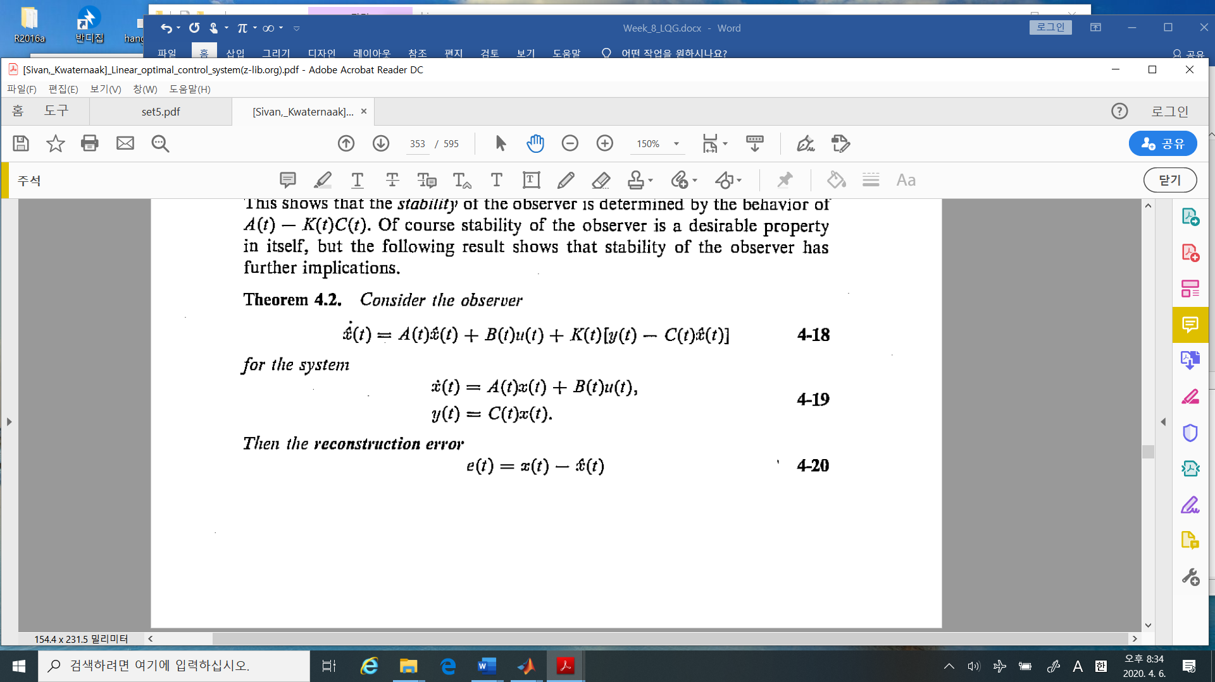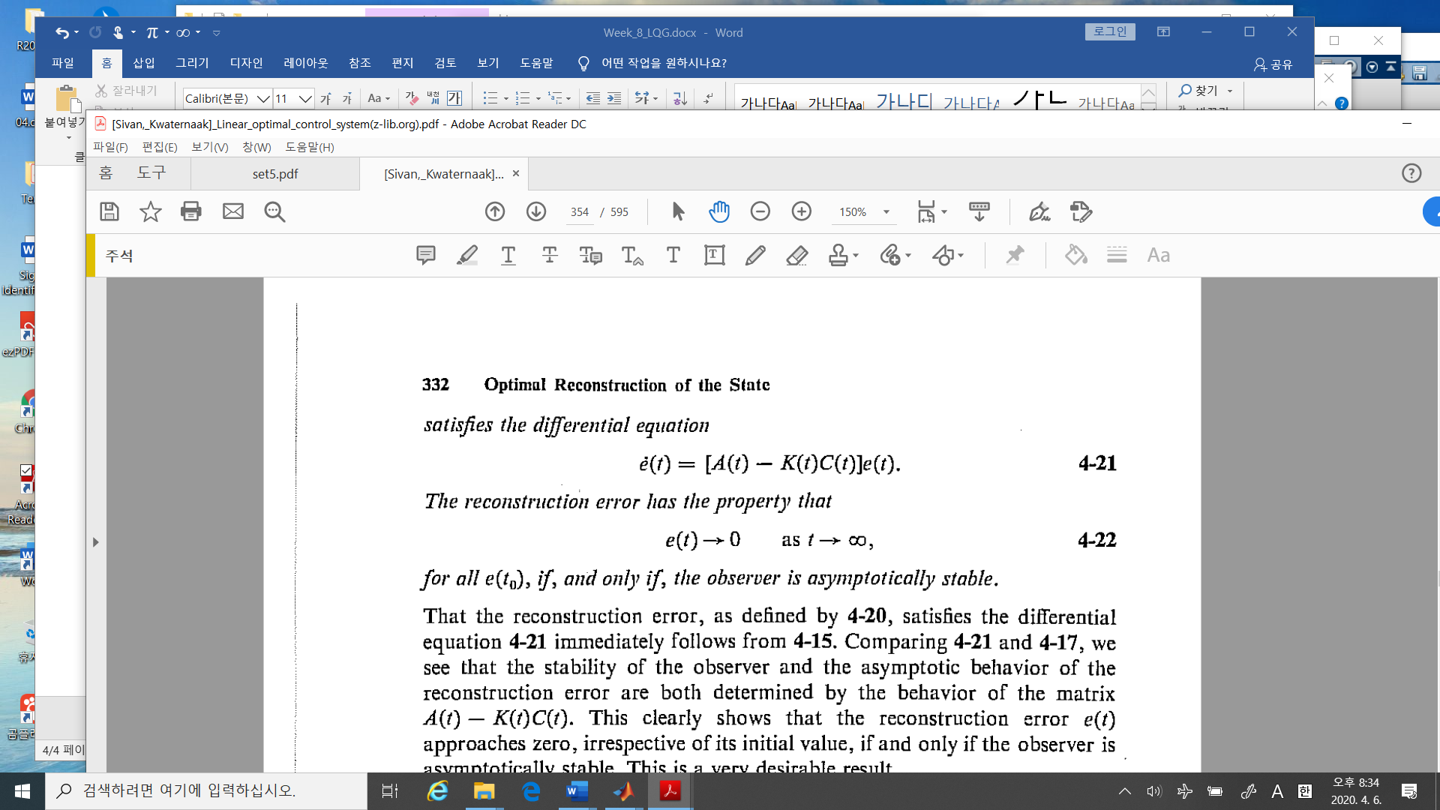

* Theorem 1.32

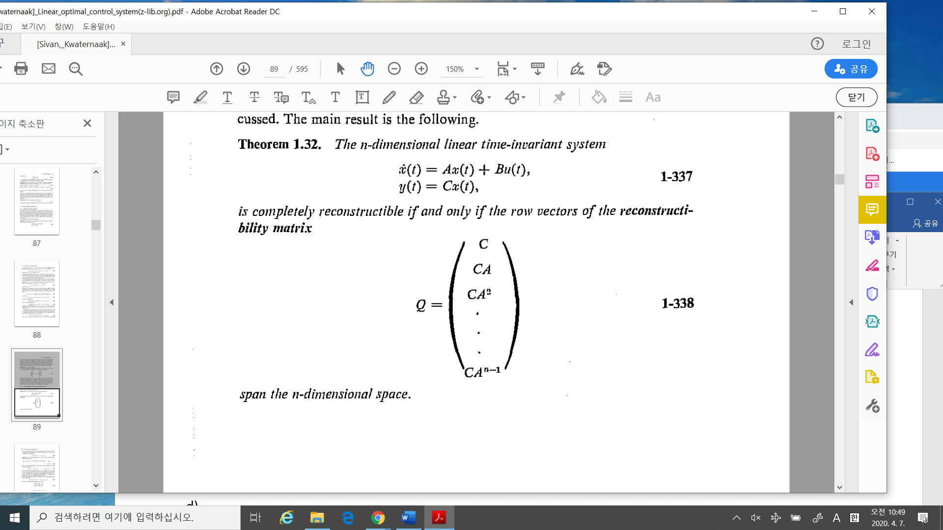

Here the reconstructibility matrix, which is the same as the observability matrix in this case.

4.3 **The Optimal Observer**

4.3.1 A stochastic approach to the observer

* Theorem 4.5 The optimal observer.

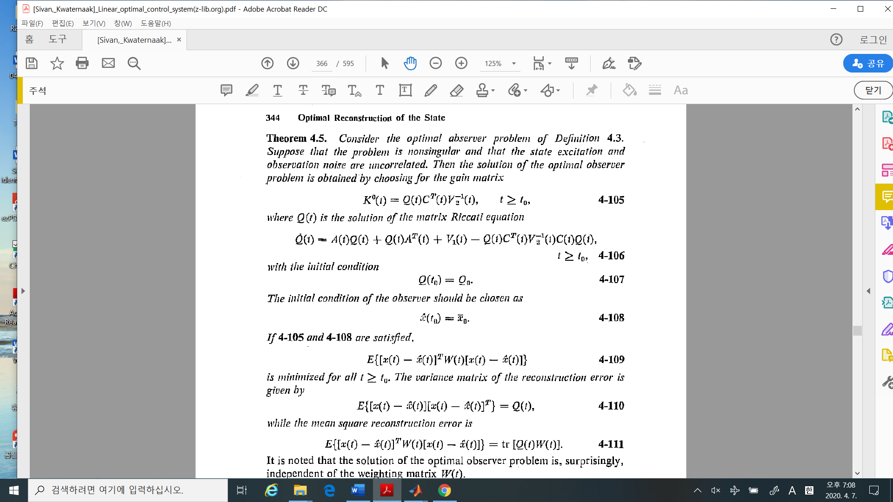



%%%%%%%%%%----------comments

1. The optimal observer gain is determined by (4-105)
2. The observer matrix Riccati equation is similar to the controller Riccati equation.

* Linear Quadratic Regulator Riccati equation (controller)

1. Controller:
2. Observer: :

We call this relation as “**duality property**”

* This optimal observer = The minimum mean square **linear estimator**

= The minimum mean square **estimator**

= **Kalman – Bucy filter**

* Example 4.3:

In this example, in the text book the observed variable is constant, But I change the observed variable is **not constant but dynamic. Please remember it.**

1. Modeling

The state is constant, moving occasionally changes. The measurement is corrupted.

where are white noise with intensity which are independent of each other.

1. The dynamic motion without the observer

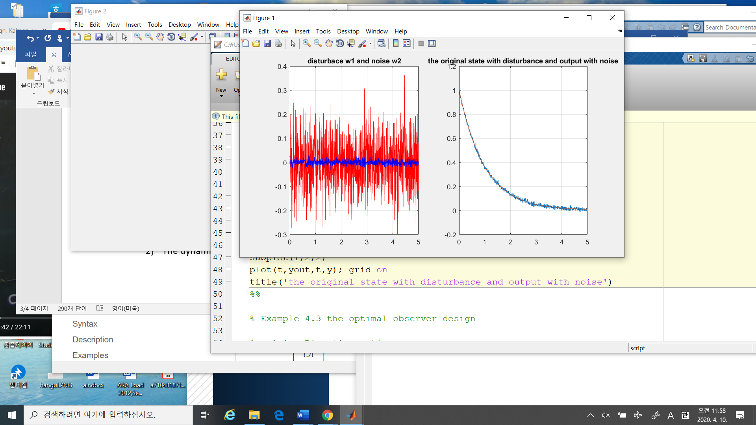

1. The algebraic Riccati equation,

Using the symbolic math and we may get

1. The optimal observer gain is
2. The observer dynamics with a different initial condition

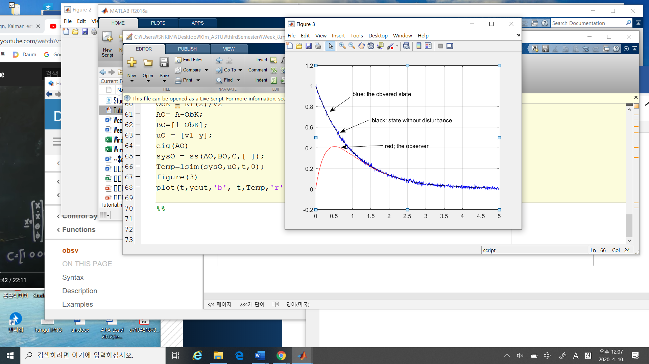

1. Comments:

* The observer is converge the observed variable after . Good…
* The initial point of the obverse may be chosen arbitrarily.
* Check the eigenvalue of the observer system. More importantly as in the cheap control the intensity of the disturbance and noise may be parameterized as

Then you may see the eigenvalue of the observer as varying

1. In the lase semester, we learned about in Stochastic control and in Stochastic Identification.

In there

* The least square estimator: in discrete time system
* The Kalman filter: in discrete time system
* Arma . armax parameter estimation: in discrete time / difference equation.
* In this case, we are dealing with continuous time systems up to now.
* The optimal observer is equivalent to the Kalman estimator.
* More important, this Kalman estimator has better performance over the least square estimator in some sense.

%%%%%%%%%%%%%%---------------------- Comments

In the text book, The author “Kwarkernaak” considered several cases in desigh the optimal observer.

* In order to design the optimal observer, it is necessary to satisfy “Observability matrix should be full rank, i.e., ( rank of the observability matrix = the number of the states),
* Kwarkernaak is considered this case.
* I will skip these topics
* And I will upload the matlab code… please try to run it and you may change parameters to see what is happening…
* As I said, the estimator / observer is more important nowadays. In artificial intelligence / machine learning and so on … Good Luck!!

-------------------------------------%%%%%%%%%%%%%%%%%%%%%%%%%%%%%