3. Optimal Linear State Feedback Control Systems

%%%%%%%%%%-------------- If you are preparing your final Master thesis, it is good the following example to review how to simulate an system.

<http://ctms.engin.umich.edu/CTMS/index.php?example=InvertedPendulum&section=SystemModeling>

It is provided by U.of.M in USA, in control tutorial course. I think it is a PG course.

In there

1. Modelling an inverted pendulum

The math model is a little different from that of presented in Our course(Kwakernaak) The reason is the definition of the states

1. Ours

The state vector where

: the position of the carriage

the velocity of the carriage

the sum of the position and the weighted angular position of the

pendulum

: the derivative of

So the model is

1. U.of.M

The state vector where

: the position of the carriage

the velocity of the carriage

the angular position of the pendulum

: the derivative of

So the model is

1. Which one is better to analyze the problem? It depends on the users.

Since the states in U.of.M is easy to be understood the physical meaning, however, the math model is complicate, i.e., if , the closed loop system matrix is more bulky than Ours. This trick in ours should be recognized by Me and Others to thank to Kawakernaak. He is a clever man(At 1970s there was no computer available, But I did not find errors in this old textbook using 2020 computer…He should be a clever man..)

1. U.of .M lectures gives the simulation tool as a simulink. I have not introduced the simulink up to now, I hope during this semester very little to talk about it. So please

**Study by Yourself**.

If there is any question, first talk to your friends and then talk to me.

If you are willing to prepare your thesis, it is a very good tool, please study with this U.of.M

lectures.

---------------------------%%%%%%%%%

Before starting next big topic, observers, I should talk some limitations of LQR(?)

You may see the cost function is

Linear Quadratic Regulator Problem(A simplified notation):

Given

Find the optimal control such that the quadratic cost function is minimized, i.e.,

So we have to define the weighting matrices as the state , the control , the final state,

OK. We do know at the steady state, the final ==0, since the closed loop system is asymptotically stable, hence , may not be defined.

How about and ? Well, there are several ways to select these matrices.

1. Kwarkernaak Suggestion:

* Two matrices become one scalar parameter

Now change the value of , and simulate the time responses to select the best

If the magnitude of control is not the constraints, we may select the value as small as possible.

* We call this “Cheap control” . Kwakernaak actually did not define the cheap control, but later the engineers call as “cheap control”.
* This cheap control leads to the controller as “Butter worth filter” – One the main filters to reduce

noise.

* So the “butterwoth filter “ is more important any other filters .

1. Bryson “Optimal control” suggestion:

Let’s the maximum allowable values of controllers as

Then choose as

Since there is no proof the optimal controller is guaranteed to satisfy the inequality, this is a one guideline to choose “R”

Chapter 4. Optimal Linear Reconstruction of the State

4.1 Introduction

In LQR problem, in general the optimal controller is generally the full states, i.e., if the state , the controller . So in order to implement the optimal controller we need all values of the sates., which is un-realistic.

What can we do? In fact we already learn the optimal estimators in the last semester. That is the solution.

In briefly , Let’s the model is

And the optimal control is (just as Kalman controller),

Now, If our estimator is good enough to be , then the optimal controller may be considered as

which satisfy to minimize some cost function. Now the problem is how to estimate ? In the optimal control society, we do use the terminology the observer rather than the estimator, which is more understandable, more realistic, and in fact Kalman introduce the “Observer” not “Estimator”.

In the textbook, so Kwakernaak said construct or reconstruct (as you see construct a real building, not predict a future value) the state, i.e., **re-construct the state** which is the same the state in some sense.

So the problem is how to design “**Optimal Observer**” in some sense.

Nowadays, “observer = observe the state” is popular. You may see it in many other materials.

4.2 Observers

* Theorem 4.2

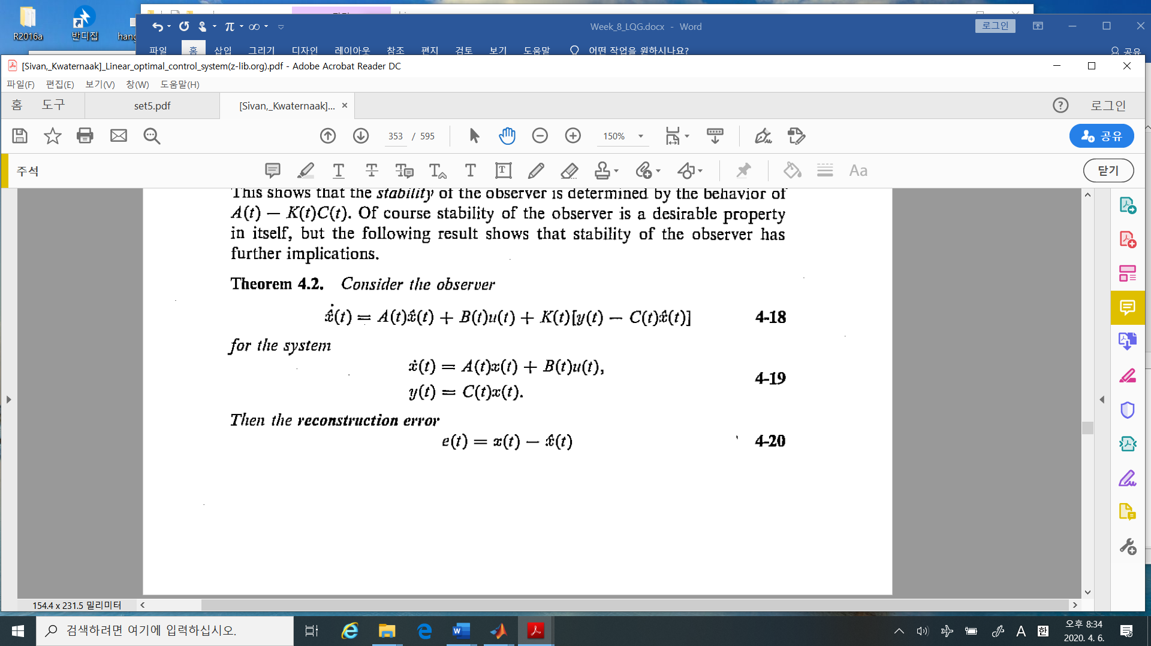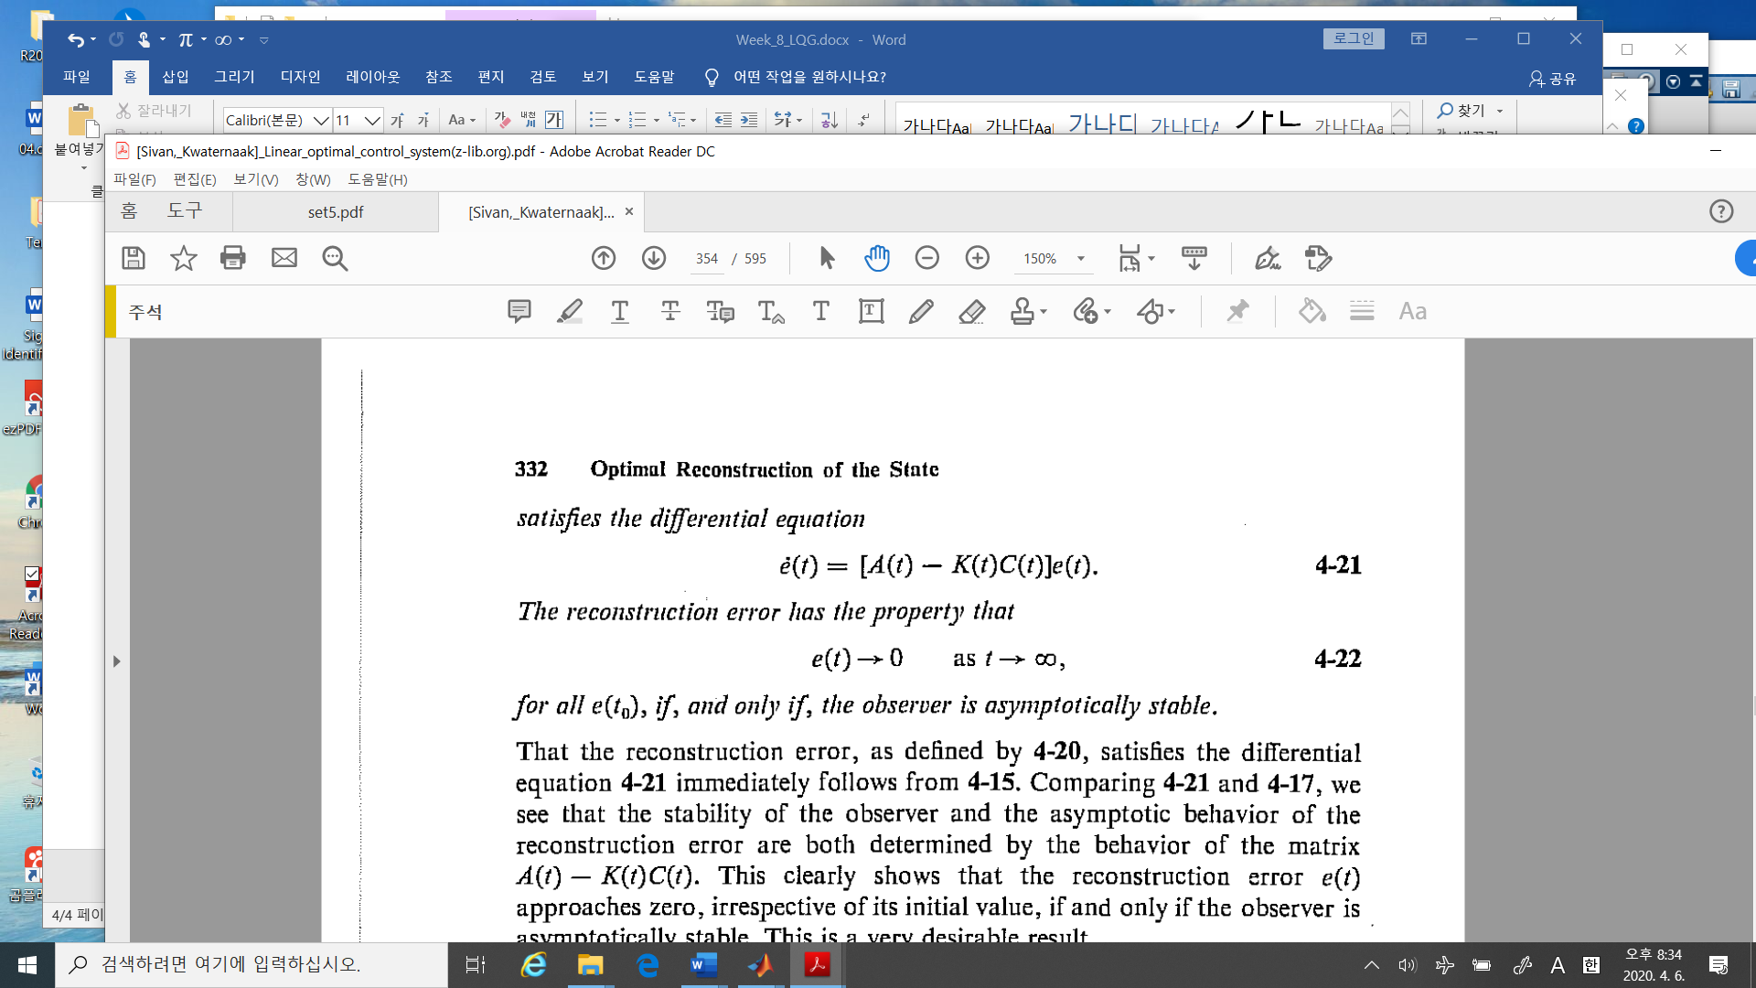

%%%%%%%%%%%---------- comment

1. If the system state , then in this case the observer
2. The observer system matrices and are equivalent to the given system matrices.
3. The observer dynamics as

And



Hence the problem is how to design the observer gain matrix .

(why we do not need to observe input, ?)



1. You may see the closed loop system matrix is different from a controller design as

i.e., the order of and

5) In this deterministic case, the observer is relatively simple to be understood. Let’s model is

Hence the state space (Later I will denote “ss” , which is matlab command), is

Now if you are available only one sensor to measure ), which one U should measure?

Simple.

1. If U measure , then , which is uniquely obtained, which is observable.
2. If U measure , then , which cannot calculate uniquely, since U do not know the initial point of which is not observable.
3. In linear system, U may learn the observability condition

* Theorem 1.32

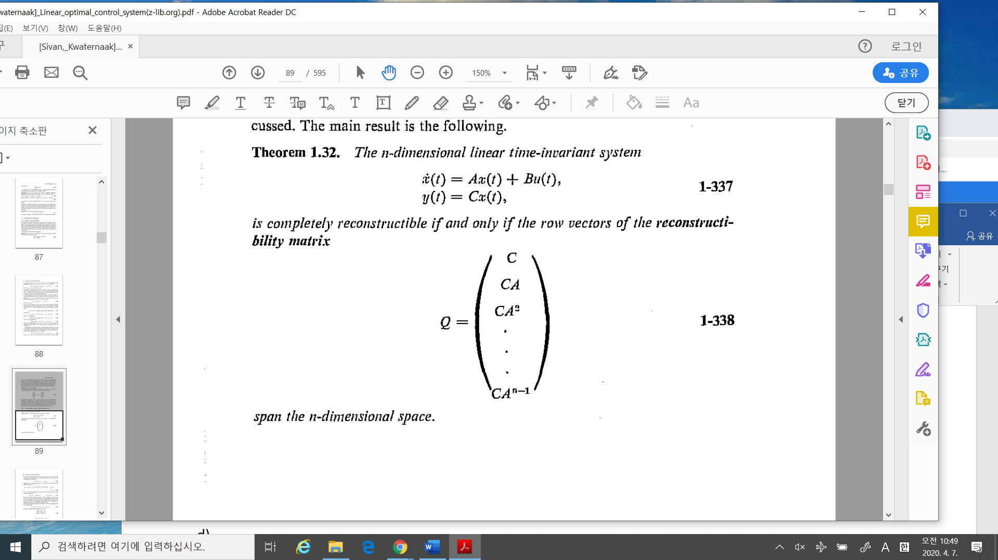

Here the reconstructibility matrix, which is the same as the observability matrix in this case.

1. Now consider this system and compare to previous one

If you measure , which condition on a and b, the system is unobservable?

1. The system block diagram with an observer is

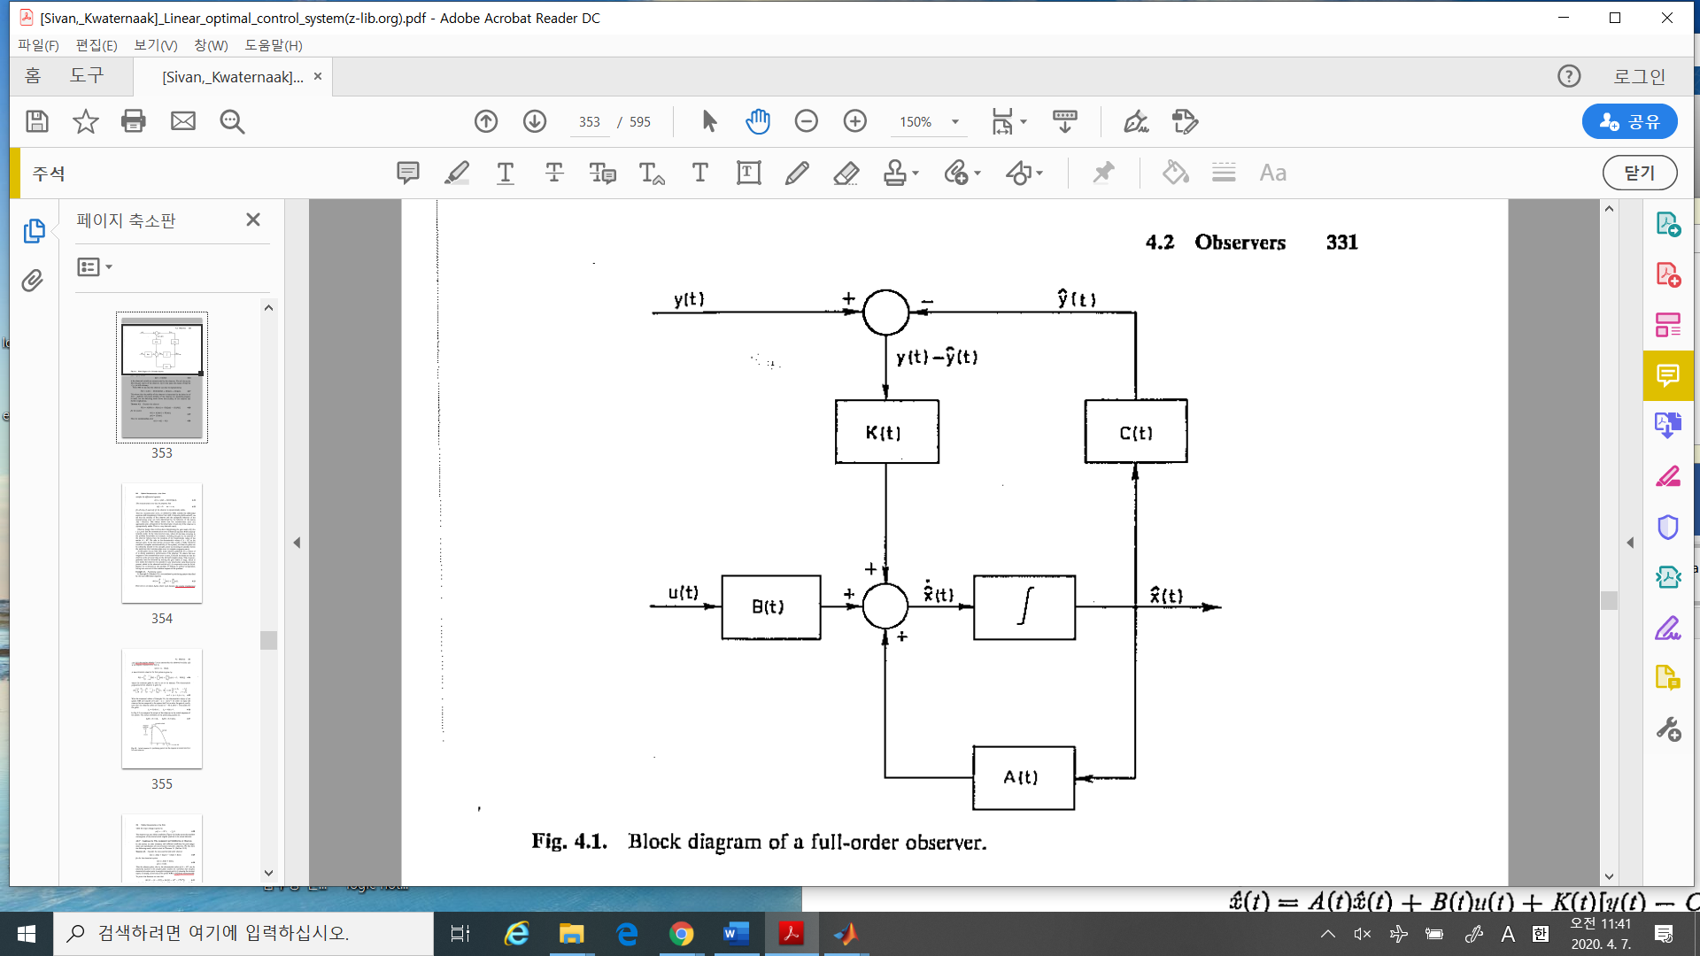

1. In this block, there is no real plant but the modeled plant. All these can be implemented on a computer software except the output and input of the plant.



1. If an observer designed properly, even if the number of the measured variable is less the than the number of the state, You may Observer(not estimate in this deterministic case) all

the state, Kwakernaak said, all the state can be reconstructed.



1. What is difference between the observer and the estimator?

If the solution is determined uniquely, so in this case we do not use the estimator but the observer, for example in a deterministic system. Now if the system is stochastic and even if the system is deterministic but is not uniquely determined, we may estimate the state ,which we may call the observer in control society. Hence in control society whether the system is deterministic or stochastic, if we may estimate or determine, we call the Observer.(In math they do not use the observer but the estimator)



1. The importance of the observer: Nowadays the observer is more important to apply in engineering problems. Let’s simplify the problem.

Given input , and measured output , What is the state of the plant?

U may remember in Identification,

Given find the arma, armax model parameters which is the system parameter. Not only identification, you may see machine learning, neural network so that

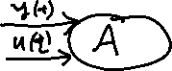

Find the unknown system given output or/and the input….

1. So far, why we have to learn the observer in optimal control?

* Since the best optimal controller is full state feedback, which means we should measure (or observe) all the states.
* So we need the number of sensors is the same that of the state.
* However to implement all the sensors in the system, it is difficult and complicate and expensive.
* Now Kalman, here is also Kalman, he introduced the concept of the observers. His observers can be implemented by the software, computer.
* So the observers simplify the real control problem.

----------------------%%%%%%%%%%%%%%