5. Optimal linear output feedback

5.1 Introduction

Up to now, we design two linear feed laws as

-. Optimal controller: LQR

-. Optimal Observer: LQG / Kalman Estimator

Kalman proved the two feedback laws are designed separately, it may be called as

‘Separation Principle”. In this chapter, we will study his “ Separation Idea”

* The original plant / system dynamics
* The optimal control law(LQR)
* The optimal observer law(LQG) corresponding to the plant

* The brief concept.

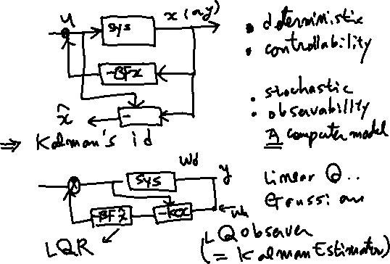

%%%%%%%%%%%%------- comments

-. The controller law and the observer law can be designed separately

-. The observer is “A computer software” not a hardware..

-. If the given system is observable, the full state can be observed(which is more than estimated in control).

-. If the full states are observable, it is available to full – state feedback, using the observers.

-. So to design a system, First, You may check the observability. Is it possible to observe all the states?

How? You may select the sensors to measure the states. Of course the number of sensors is as many as possible, however, due to the physical or economical reasons the number of sensors is limited. So as an system engineer you should select how many and what places sensors are used.

-. One comment is: In order to design an observer, the system parameters, such as are known exactly. If there are uncertainties on these parameters , it affects the system performance.

---------------------------------%%%%%%%%%%%%%%%%%%%%%555

The following figure is another version in textbook.

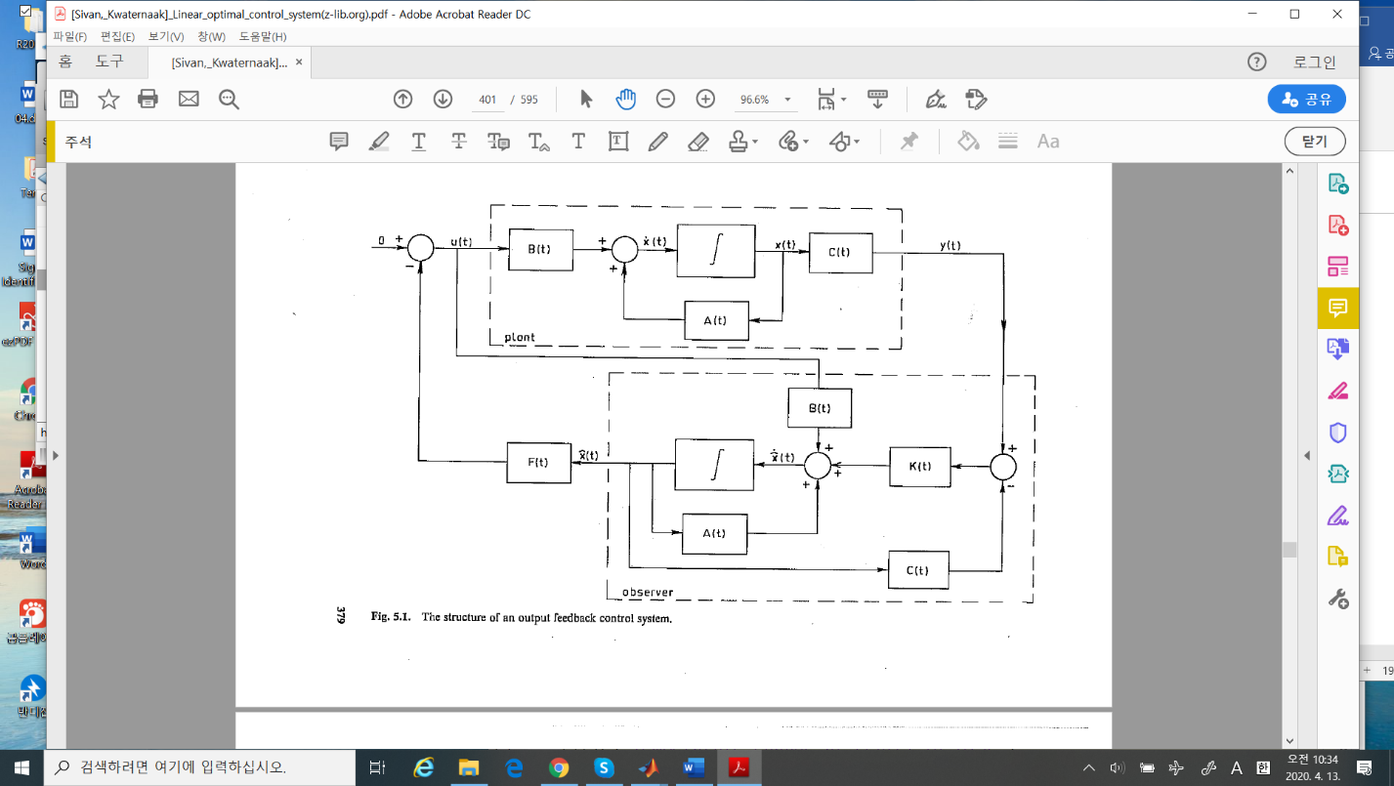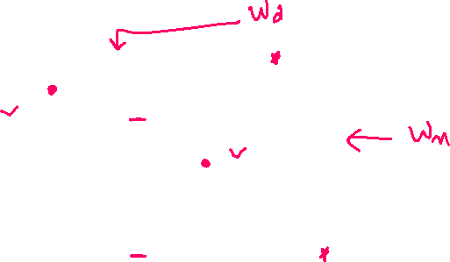

* 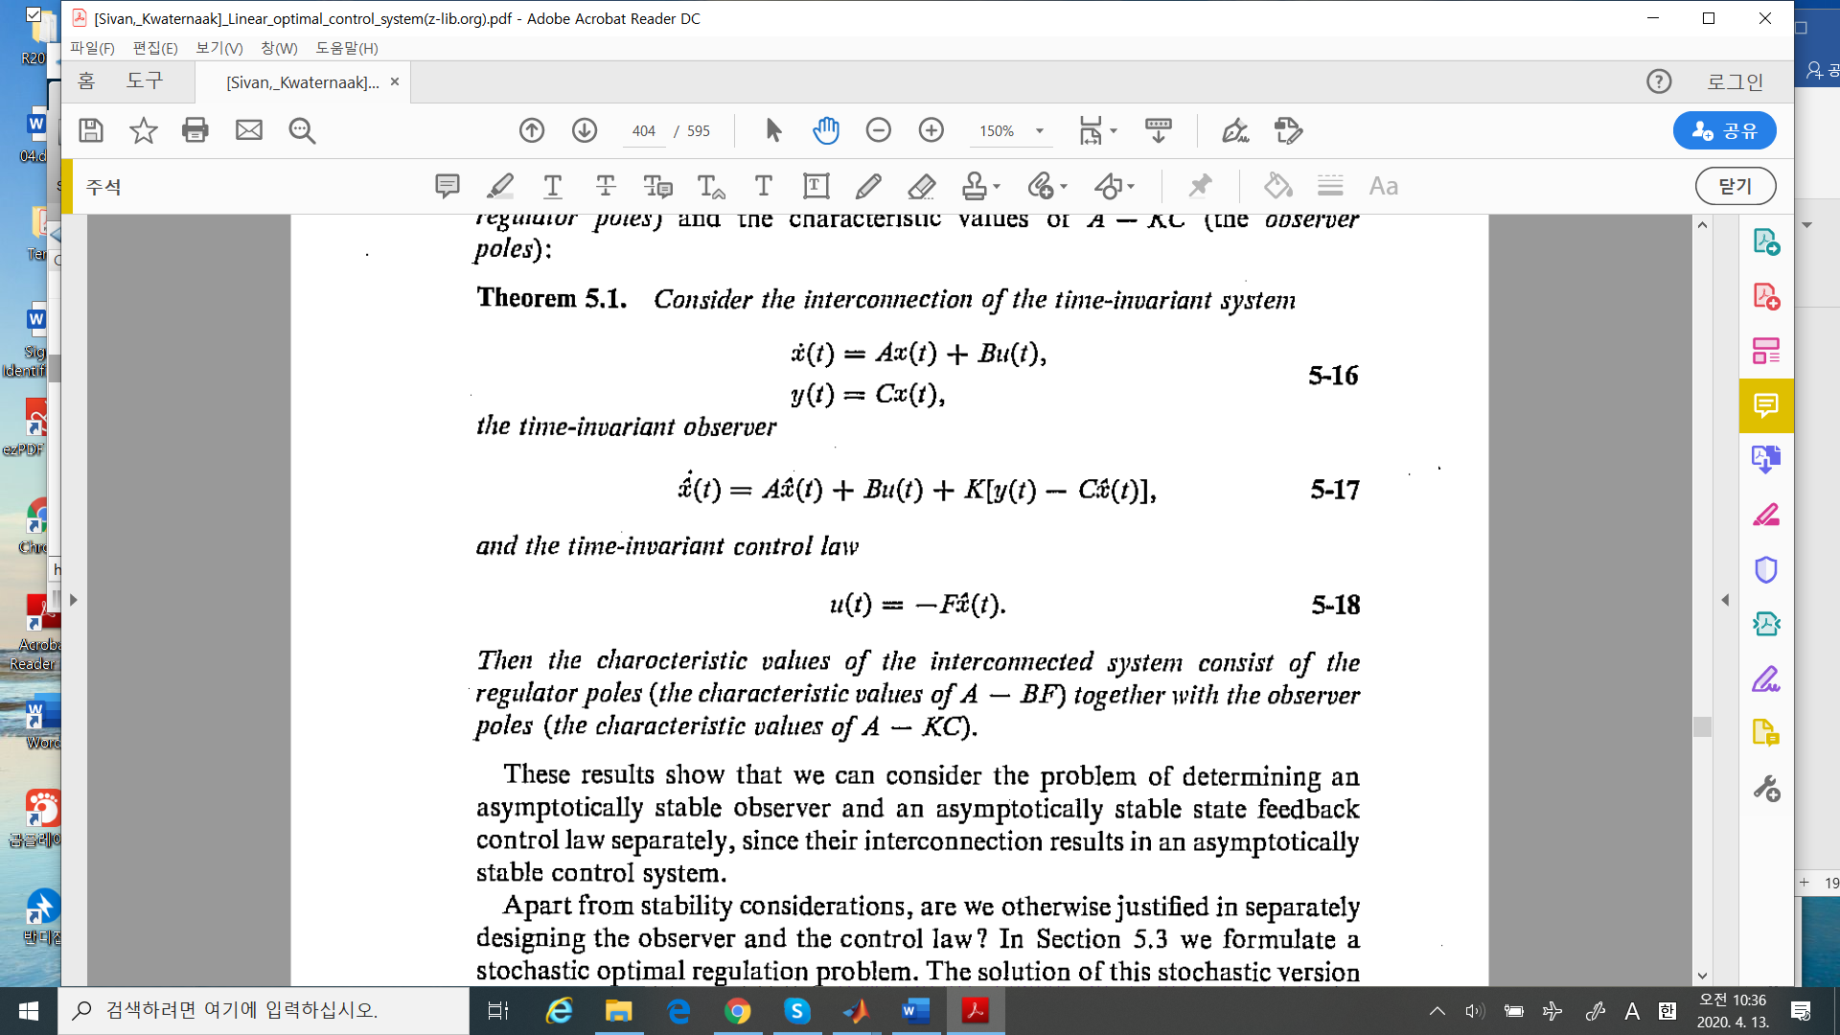Theorem 5.1 Separation Principle

What The theorem 5.1 says in linear system, the controller law and the observer law can be **designed separately**. Hence in the previous study, the optimality cane applied using this theorem.

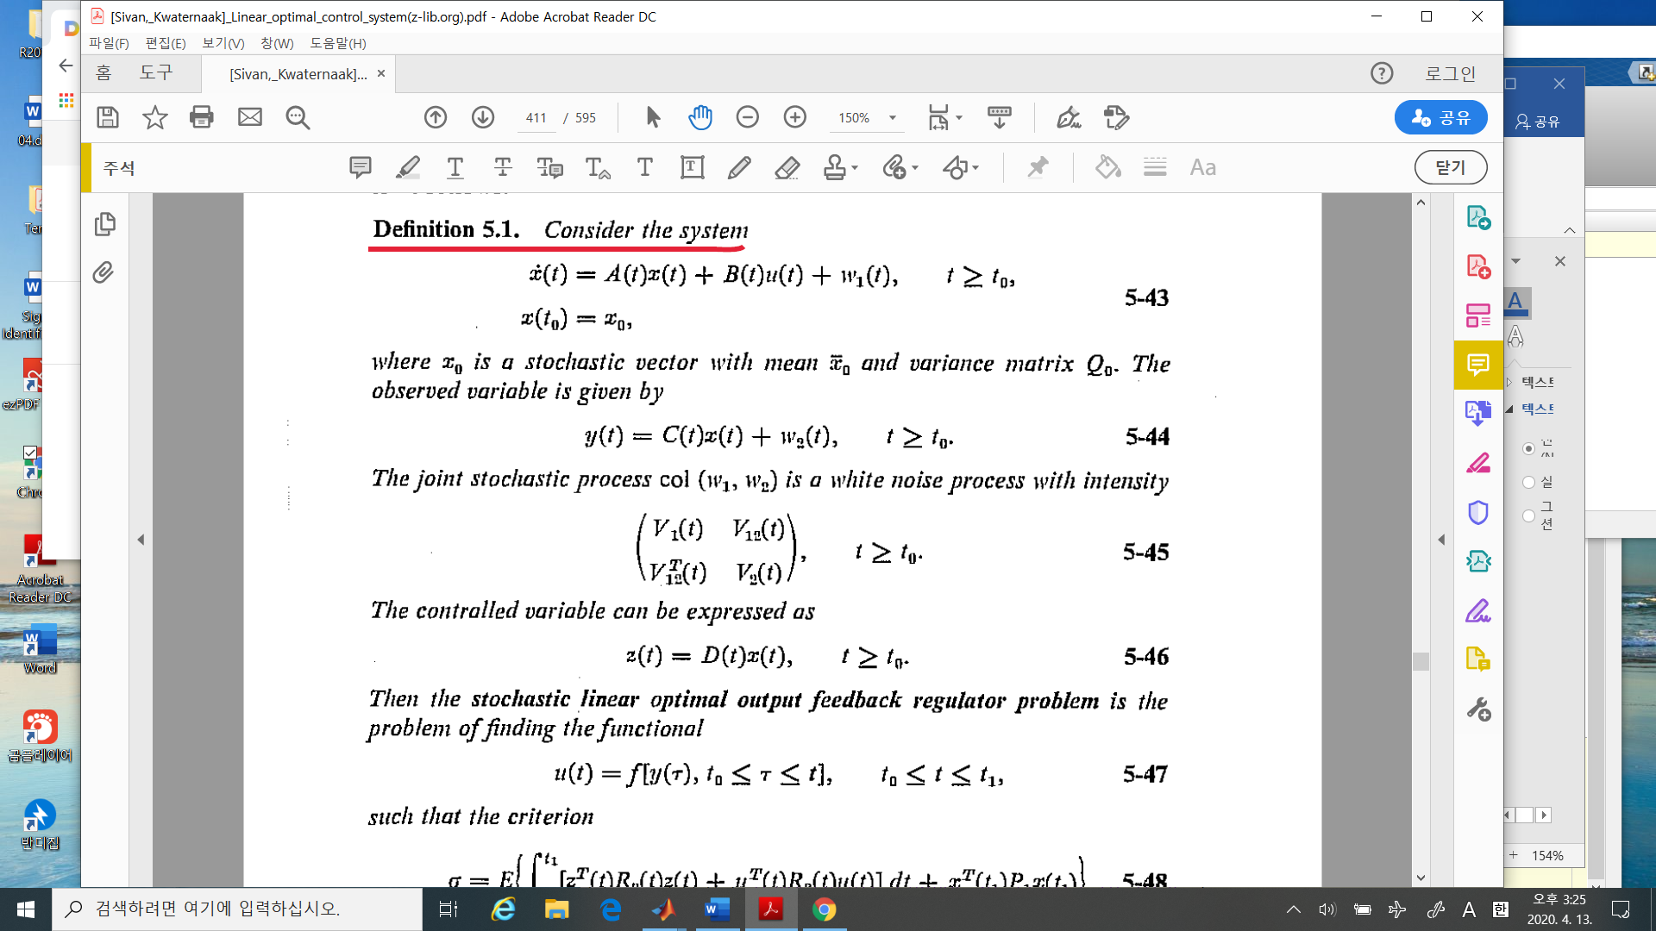

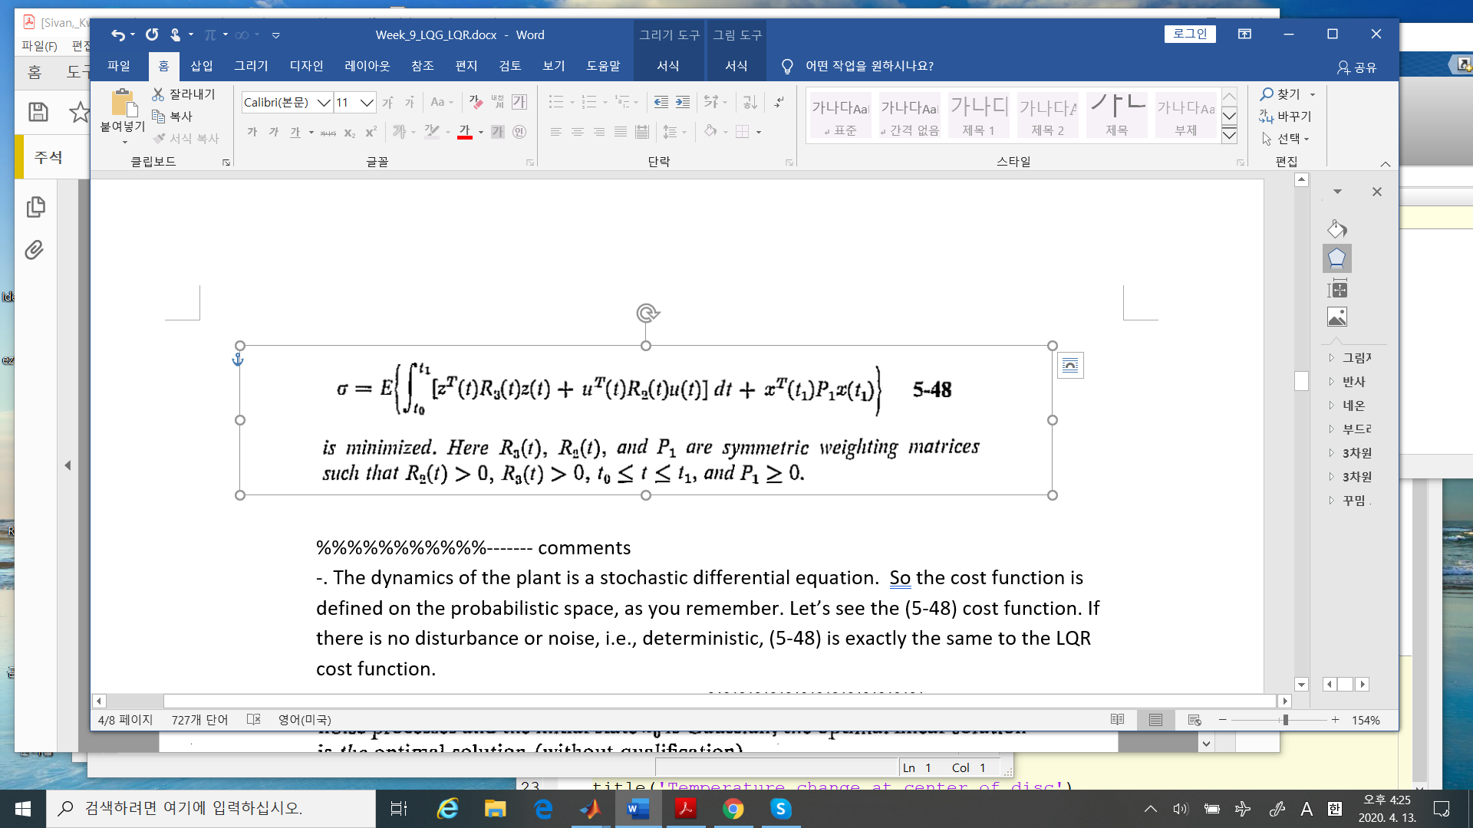

%%%%%%%%%%%------- comments

-. The dynamics of the plant is a stochastic differential equation. So the cost function is defined on the probabilistic space, as you remember. Let’s see the (5-48) cost function. If there is no disturbance or noise, i.e., deterministic, (5-48) is exactly the same to the LQR cost function.

---------------------------------------%%%%%%%%%%%%%%

* Theorem 5.3: **The optimal linear solution**

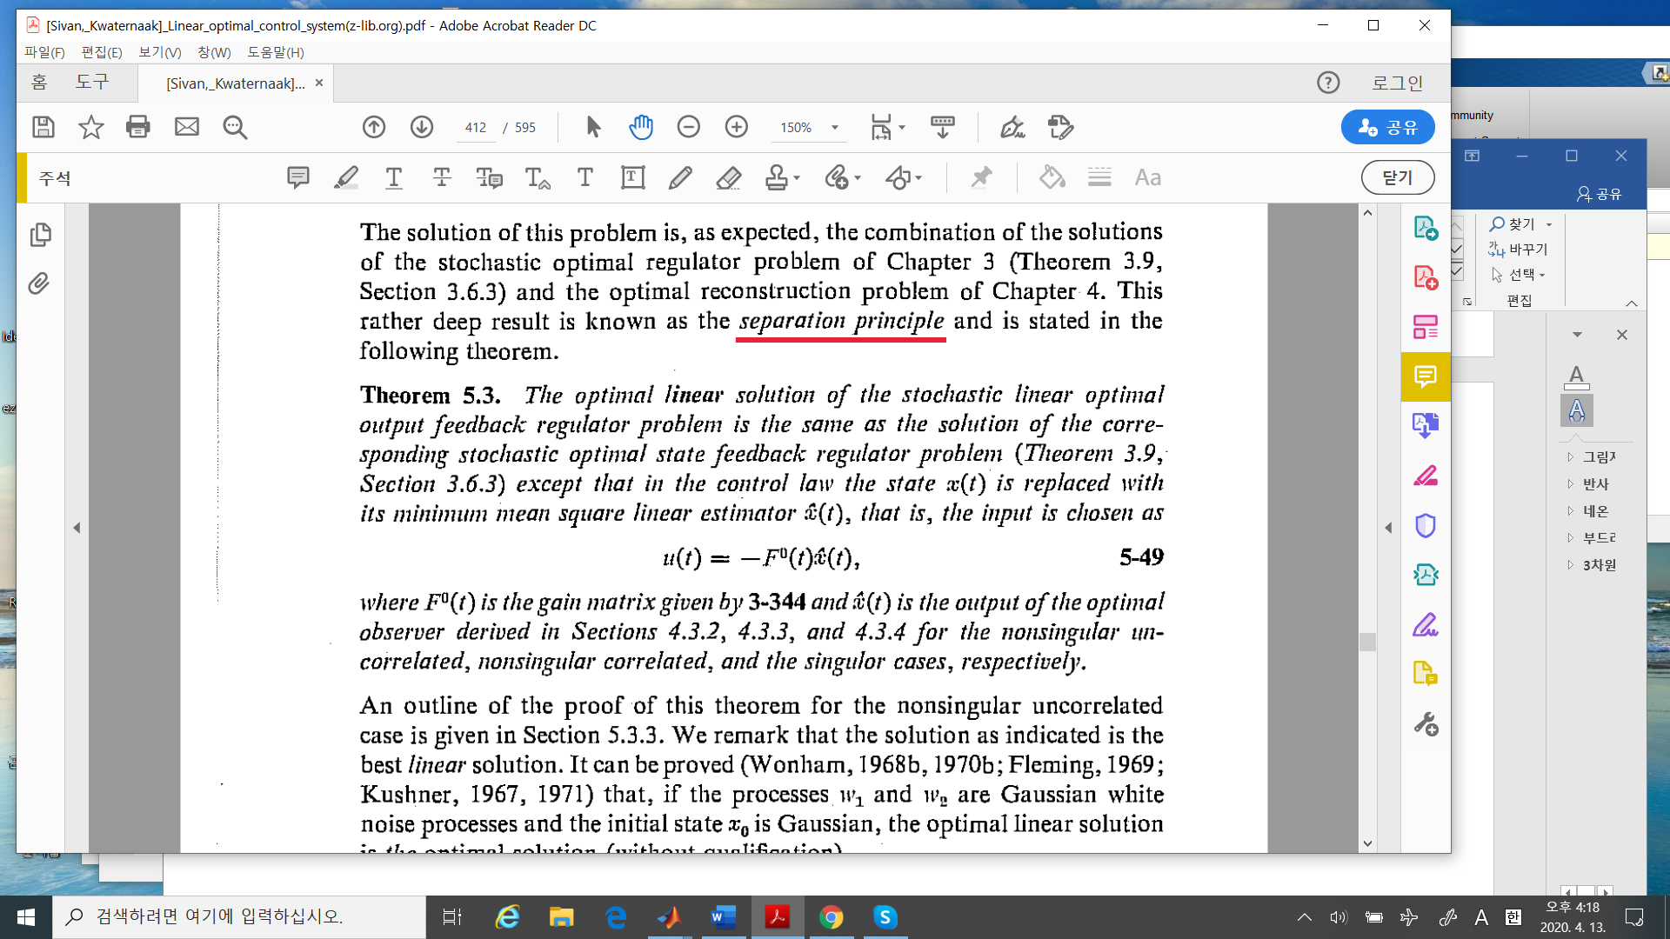

The Theorem 5.5 said: the optimal (linear) solution of the stochastic linear optimal output

feedback regulator problem:

* “Stochastic” means the system is either disturbed by unknown sources, or the measurements are corrupted by noise, white or colored.
* “Linear” means, the feedback is linear. In fact the linear controller is optimal over all other feedbacks.
* “output” means the controller is proportional to the output. Let’s see the output feedback in general,

But in this optimal problem

So the feedback is output feedback.

* Example 5.3 Servo Position Control system

(Week_7_LQR_2.docx, Example 3.8)

1. The system state differential equation (without disturbance )is

Where

The controlled variable is the position, which is given by

The regulator cost function is

where . Then the optimal LQR controller is

Then the closed loop regulator poles are

2) With a disturbance , the system is

where = the rotational moment of inertia of the rotating parts (See Example 2.4)

and the observed variable is given by

Where the observation noise

Assumption: are uncorrelated, and their intensities are

3) The observer design:

Using parameter values, matlab command as

clear all;clc;

a = 4.6;

ka = 0.787;

rho = 0.00002;

gam = 0.1;

Vd = [ 0 0; 0 gam^2]*10;

Vm = 10^-7;

A = [0 1;0 -a];

B = [ 0; ka];

C = [ 1 0];

% solve riccati equation

[X,K,L] = care(A',C',Vd,Vm);

X=

0.000004035731309 0.000081435635980

0.000081435635980 0.003661127383189

K =

-22.478656543485862 +22.242077241121144i

-22.478656543485862 -22.242077241121144i

L =

1.0e+02 *

0.403573130869718 8.143563597999320

4) some comments for matlab

In matlab, the solution of continuous riccati algebraic equation is give by the command is “care”

The format is

>> help care

[X,L,G] = care(A,B,Q,R,S,E) computes the unique stabilizing

X : solution of the continuous-time algebraic Riccati equation

A'XE + E'XA - (E'XB + S)R^-1 (B'XE + S') + Q = 0 .

K: the poles of the closed loop observer

L: the gain of the oserver

1. When omitted, R, S and E are set to the default values R=I, S=0, and E=I

In our case, S and E are omitted, hence S=0, E=I

1. The vector L of closed-loop eigenvalues (i.e., EIG(A-B*G,E)).
2. **Since this is the standard form of the linear regulator control problem, in the observer case, we should change as**
3. The value of the disturbance is scaled by the , since is the only the white noise intensity.

%%%%%%%%---------------------- comments

1. If the value is very large or small, in matlab you may change the format as

>> format long

1. In matlab, “care” command will be changed to “icare” above the version 2016a
2. Let’s see the LQG solution.

The closed loop poles of the optimal regulator are

The closed loop poles of the optimal observer are

(-22.48 +/- 22.24i)

Since the real part of the poles of the observer is bigger than that of the regulator, the

observer converges to the real value faster in general. You should check this condition after

your design LQR

----------------------------------%%%%%%%%%%%%%

Up to now we study the continuous time system for Linear quadratic regulator or Linear Quadratic Gaussian problems. There are many applications these in engineering field. As you see

* Stabilize the unstable system,i.e.,inverted pendulum,
* The position control,i.e., servo control …

Also, you may see the applications in “Wind turbine control”, I hope some of you may study this problem.

Now we may study in discrete system. Before discrete system, I will introduce a little bit of matlab “LQG”. Since you may get some recent technologies and get some insight of the control.

Let’s in matlab command line. Type “lqg” in the “?” window. Pick up the “Design an LQG Regulator”.

1. Introduction:

First You may see the following block diagram.

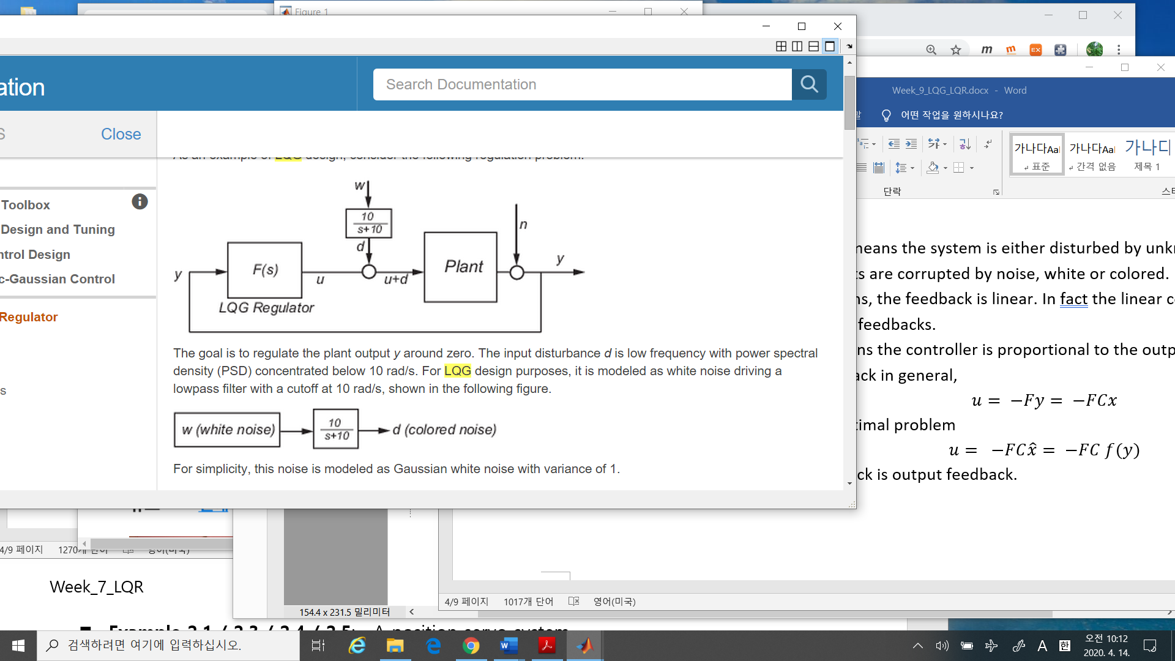

1. “LQG” regulator = the optimal regulator + the optimal observer
2. LQG regulator in this block is familiar to simple controllers. You may design a controller instead of LQG as

* PLC
* PID
* Fussy



* And others.

However, LQG in general is the most complicated. In order to design, you need

* The optimal controller and
* The observer.

The good observer should be implemented by the Plant model, as matrix.

1. The difference between a disturbance and a noise .

In modeling a real plant, the disturbance is

* In the case of inverted pendulum, you may touch the inverted the stick.
* In case of rolling machine, suddenly inserted load
* The wind intensity / direction

The noise is

* Typically in the case of measuring, it is always noise.

Roughly they are unknown inputs to the system, but the noise is always changed ,.i.e.,

the Brownian motion, but the disturbance is not. In general, disturbance is modelled as a

colored noise compare to a white noise.

* Bode plot of the low pass filter
* 

1. The plant model
   1. Change to the state space:

In LQR/LQG , the model should be state-space..

* 1. Design LQR
  2. Design Observer ( =Kalman state estimator)
  3. **LQG regulator = LQR + Observer**
  4. **The positive feedback**
  5. Create the lowpass filter and add it

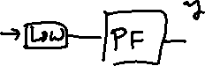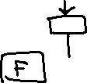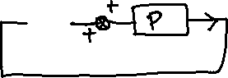



1. Now you may compare LQG to PID/Fuzzy and on …