TITLE OF THE RESEARCH PROJECT: Proposer (S.Kim)

Covid-19 mathematical modeling, and control

1. Abstract (Summary of the Project)

The Covid-19 pandemic is an ongoing pandemic of corona virus. The virus is primarily spread between people during close contact, most often via small droplets produced by coughing, sneezing and talking[1]. The interaction between the infected and the uninfected is difficult to investigate and formulize due to many unknown variables so that the trends of the number of confirmed people are shown different countries as in Fig.1

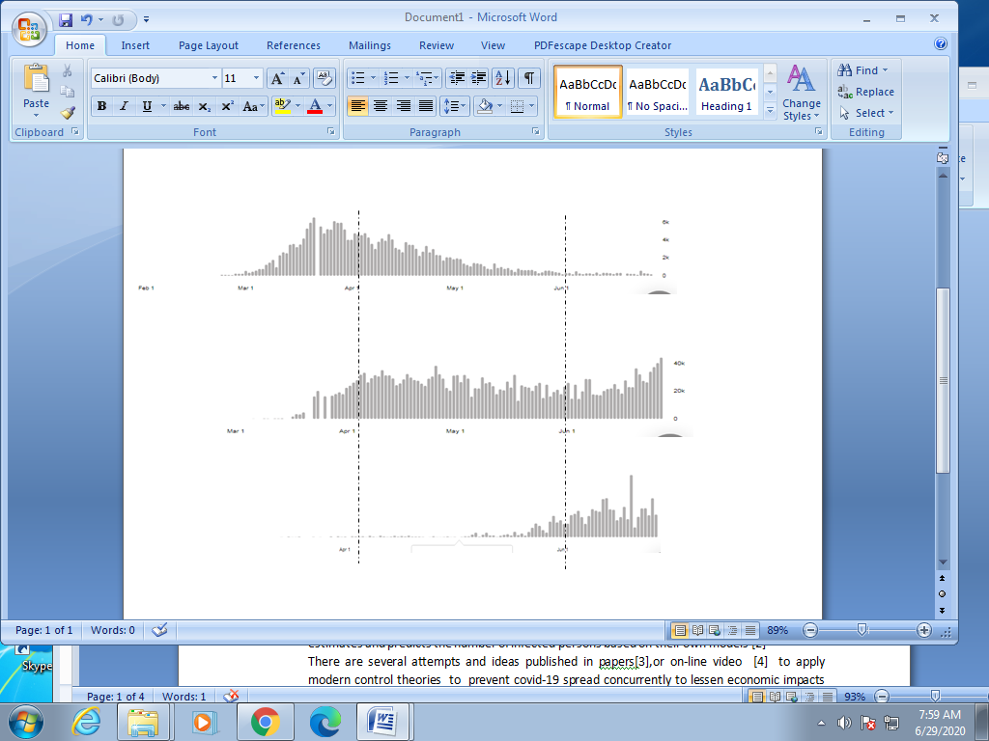

Fig.1 : the number of the confirmed case daily. Italy,USA and Ethiopia in order. The dashed line is April 01 and June 01[2]

However, the slopes of the graph are common to grow as exponentially at first increase and decrease from the sustained peak in time average. In fact there have been many attempts to model covid-19 pandemic in mathematical description so that the pattern of the trend may be manageable by social or political policies[3],[4].

The main goal of this project is to contribute to lessen and manage the slope of the growth rate by developing a reasonable mathematical model for the covid-19 disease system.

Due to the urgent time schedule, the duration of the project will be 6 months at first stage. After reviewing the results of the first stage, the second stage will be start another 6 months probably. To perform the project successively, one supervisor (the proposer) and two legitimated PG students eligible to handle control, data classification who will be selected after the approval of the project.

1. Objectives

The objectives of the project are

* make a mathematical model on the covid-19 disease system. The model should be based on validation and verification within a reasonable accuracy
* design the optimal strategy to manage the slope of the number of infected in time
* assess the control action, such as social distance
* investigate the cause and effect of the whole closed loop system
* simplify the results to be easily understandable

1. Background & Justifications

To prevent the wide-spread of respiratory covid-19 virus, there are several attempts to mathematical models for infectious disease to understand its transition phenomena from infected to susceptible persons [5]. This mathematical model should be born with a lot of uncertainties such as infected person’s un-trackable mobility patterns in addition to the diagnostic methods and so on. Not only the disease system model but the differences of social environments and political policies such as social distance during infection process are more difficult to cause and effect verification of the model. However in recent papers some institutes estimates and predicts the number of infected persons based on their own models [3],[4]

There are several attempts and ideas published in papers or on-line video [6] to apply modern control theories to prevent covid-19 spread concurrently to lessen economic impacts on personal life due to social distance. One of the ideas is Bang-Bang type control strategy to implement social distance on and off. The advantage of Bang-Bang is to give a fast time response but the disadvantage is the trajectories are in general Peak and Peak oscillation. The other control strategy is model based predictive control so that in finite time interval the best optimal policy applied and re-adjusted in concurrent next time times. MPC may not give the fast time response but the control policies are continuous or several levels to adjust to the inherent uncertainties of disease system model.

In this project, two stages are given.

* In the first stage as model validation and verification: Study the present papers on the disease model. Characterize the covid-19 conceptual model and verify the model thru simulation using previous data.
* In the second stage as design optimal policies: Classify the level of social distance or /and supplemental policies such as wearing face mask.

1. Methodology

In the first stage: Infectious mathematical model was issued 1927 [5] at first as Compartmental model. The population is divided into three groups whose dynamics is governed by the differential equation as

$$\frac{dS}{dt}= -\frac{β}{N}SI$$

$$\frac{dI}{dt}=\frac{β}{N}SI-γI$$

$$\frac{dR}{dt}=γI$$

S = susceptible, I = infected, R = recovered and undetermined parameters are

$β:$ transmission constant

$γ:$ the recovery constant

which are time varying. This model is called as SIR model. After this model proposed, there are several variant models appeared. In this project to simplify the model validation, SIR model is studied to estimate the parameters. There are many uncertainties to verify this model. The covid-19 incubation period is up to two weeks dependent on infected individuals, which lead to time delay. Moreover asymptomatic infected peoples are not counted into the active diagnosis. During this project these uncertainties should be considered as much as possible.

In the second stage: Model based predictive control(MPC) is nowadays popular in data-driven control engineering. It was introduced to design automotive automatic control, which is of inherently uncertain driving conditions. Using real time fast computing performances nowadays, it is realized and implemented in real system. In this project MPC will be adopted to design optimal control, i.e., social distance. One of the hurdles in this stage is of assessments on measurements of social distance. WHO recommends 6 feet distance to prevent transferring Covid-19 virus between infected and susceptible. It is impossible to measure this distance at each time whenever the contact between peoples happened. Hence in this second stage, there should be developed a simple and realizable method to assess the social distance[7],[8].

1. Work plan

To perform this project, three persons should be allocated. They are qualified in specific areas as follows

* The number of Working persons: Three

1. One supervisor:
2. Two PG students: One PG\_1 student should be familiar with modern control theory/mathematical back ground. The other PG\_2 has experiences to deal with data collection, classification and visualization.

* Project Duration

1. The first stage: 6months
2. The second stage: after the review of the first stage, 6 months

|  |  |  |  |  |  |  |  |  |
| --- | --- | --- | --- | --- | --- | --- | --- | --- |
|  |  |  |  |  |  |  |  |  |
| Activity |  |  | Month |  |  |  |  | Remarks |
|  | 1 | 2 | 3 | 4 | 5 | 6 | ~12 |  |
| First Stage |  |  |  |  |  |  |  |  |
| Data collection |  |  |  |  |  |  |  | PG1 |
| - Covid-19 data |  |  |  |  |  |  |  |  |
| - measurements of   social distance |  |  |  |  |  |  |  |  |
| Model Validation |  |  |  |  |  |  |  | PG2 |
| -SIR /variants |  |  |  |  |  |  |  |  |
| - Estimation |  |  |  |  |  |  |  |  |
| Model Verification |  |  |  |  |  | |  | | --- | |  | |  | PG2 |
| Second stage |  |  |  |  |  |  |  |  |
| Social distance |  |  |  |  |  |  |  | PG1 |
| - Assessments tools |  |  |  |  |  |  |  |  |
| - Classification |  |  |  |  |  |  |  |  |
| Controller design |  |  |  |  |  |  |  | PG2 |
| -MPC |  |  |  |  |  |  |  |  |
| -Feedback design |  |  |  |  |  |  |  |  |
| Review the first stage results and modify the second stage workplan   |  | | --- | |  | |  |  |  |  |  |  |  |  |
|  |  |  |  |  |  |  |  |  |

1. Facilities

One room equipped with PCs, internet and presentation materials.

1. Amount of time devoted to this project in percent:

The supervisor: 2 hours / a day

Two PG students: 4 hours / a day

1. Benefits and benificiaries of conducting the project

Benefits and benificiaries should be related to the measure of the model accuracy so that the predictions may contribute to the policy makers and healthcare personnel.

1. References

[1] [https://en.wikipedia.org/wiki/COVID-19\_pandemic#cite\_note-Wiles-533](https://en.wikipedia.org/wiki/COVID-19_pandemic" \l "cite_note-Wiles-533)

[2]: <https://covid19.who.int/>

[3]: <https://www.mdpi.com/2076-3417/10/11/3666> .“Covid-19:Modeling,Prediction and Control”,Ahmad,.etc.,Applied sciences,Vol.10.Issue 11.

[4]: <https://institutefordiseasemodeling.github.io>. “Working-paper-model-based estimates of Covid-19 burden in King and Snohomish countries through April 7,2020”,Dan Klein,etc.

[5]: <https://en.wikipedia.org/wiki/Compartmental_models_in_epidemiology>

[6]: <https://www.youtube.com/watch?v=BTLZu-1IMcE> “Control Theory and Covid-19”, Steve L.B., May.01 2020.

[7]: <https://www.medrxiv.org/content/10.1101/2020.04.01.20049981v3> “Sustainable social distancing through facemask use and testing during the Covid-19 pandemic”, Diego Chowell, etc.,medRxiv,

[8]: <https://covid.idmod.org/data/Understanding_impact_of_COVID_policy_change_Seattle.pdf>

“Understanding the Impact of COVID-19 Policy Change in the Greater Seattle Area using Mobility Data”,Roy Burstein, etc., March 29,2020

[9]: <https://www.medrxiv.org/content/10.1101/2020.03.02.20027599v1.full.pdf>, “Effects of weather-related social distancing on city-scale transmission of respiratory viruses”, Michael L.Jackson, etc., medRxicv, March 03,2020

---The End------