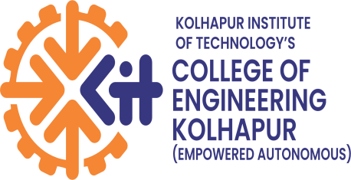

K.I.T’s College of Engineering ( Empowered Autonomous) Kolhapur
Department of Computer Science & Engineering (AIML)
A.Y. 2026-27
A MINI PROJECT SYNOPSIS ON
“STUDYMATE: AI-POWERED PERSONALIZED STUDY AND ASSESSMENT PLATFORM”
Submitted in partial fulfilment of the requirements for the award of the degree of
BACHELOR OF ENGINEERING / TECHNOLOGY IN COMPUTER SCIENCE & ENGINEERING (AIML)

Submitted by
Sankalp Killedar — A26(2425000924)
Shreyash Killedar — A27(2425000226)
Prathamesh Kore—A29(2425000974)
Vedant More –-A35(2425001148)
Under the Guidance of
Mrs. Komal Jadhav
B.Tech, Semester [V],Third Year

CERTIFICATE
This is to certify that the mini project synopsis entitled
“StudyMate: An AI-Powered Personalized Study and Assessment Platform” is submitted by Sankalp Killedar (A26), Shreyash Killedar (A27), Prathamesh Kore (A29), and Vedant More (A35) in partial fulfilment of the requirements for the award of the degree of Bachelor of Engineering / Technology in Computer Science & Engineering, during the academic year 2026-2027.
The synopsis is a record of the work carried out by the student(s) under my/our guidance.
Guide: Mrs. Komal Jadhav
Head of Department: Dr.Uma Gurav

TABLE OF CONTENTS

CERTIFICATE 2
TABLE OF CONTENTS 3
1. Abstract 4
2. Introduction 4
3. Problem Statement 4
4. Objectives 4
5. Literature Survey / Existing System 4
6. Proposed System 4
7. Scope of the Project 4
In Scope 4
Out of Scope 5
8. Methodology / System Design 5
Technology Stack 5
System Architecture 5
Modules 5
9. Hardware and Software Requirements 5
10. Expected Outcome 5
11. Applications 5
12. Timeline / Work Plan 6
13. References 6

1. Abstract
StudyMate is an AI-powered educational platform designed to help students understand, practice, and improve their learning using existing study materials. Students often have to deal with large amounts of notes, PDFs, presentations, lecture content, and previous question papers, making revision and self-assessment time-consuming. StudyMate provides a structured study workflow by converting educational content into concise summaries, important concepts, questions, viva questions, multiple-choice questions, and interactive quizzes. The platform also maintains quiz history and performance records to help students identify their strengths and weak areas. In addition, the system can analyze previous question papers to identify frequently asked topics, topic weightage, question frequency, and historical trends. A teacher interface can allow teachers to upload learning material, create tests, manage batches, and monitor student performance. The proposed system can use AI-based content processing and machine learning techniques for educational content analysis and topic identification. The platform is intended for students, teachers, tutors, educational institutions, and self-learners. The expected outcome is an integrated study and assessment system that transforms raw educational material into personalized learning resources and helps students prepare more effectively for examinations.

2. Introduction
The increasing availability of digital educational content has made learning resources easily accessible to students. However, students frequently need to study from large volumes of PDFs, lecture notes, presentations, videos, and previous examination papers. Manually converting this material into concise notes, practice questions, and quizzes requires considerable time and effort.
StudyMate is proposed as an AI-powered study assistant that creates a complete learning workflow around existing educational content. Instead of only summarizing a document, the system can transform study material into summaries, important concepts, questions, MCQs, viva questions, and quizzes. It can also track a student's quiz performance and identify weak areas that require additional attention.
The platform can support both individual students and teacher-managed learning environments. Teachers can upload course material, create tests, manage batches, and monitor student performance. The system can also analyze previous question papers to identify frequently occurring topics and historical patterns, helping students focus their revision on important areas.

3. Problem Statement
Students often spend significant time processing large amounts of educational material before examinations. Existing study resources may provide information but do not always provide an integrated workflow for content understanding, practice, assessment, and performance analysis.
Therefore, there is a need for an AI-based platform that can convert existing study materials into structured learning resources, generate practice assessments, track student performance, identify weak areas, and analyze previous question papers to support effective examination preparation.

4. Objectives
- To develop an AI-powered study platform that converts educational materials into concise and structured study content.
- To generate learning resources such as summaries, important concepts, questions, MCQs, viva questions, and quizzes from uploaded study material.
- To provide self-assessment functionality through interactive quizzes and maintain students' performance history.
- To identify weak areas and important topics based on student performance and analysis of previous question papers.
- To provide a teacher interface for uploading study material, creating tests, managing student batches, and monitoring performance.
- To create a unified learning workflow that helps students move from raw study material to preparation, assessment, and performance improvement.
5. Literature Survey / Existing System
The project proposal compares StudyMate with existing educational AI and study-assistance platforms. Existing systems mainly provide individual features such as content summarization, question generation, quizzes, or learning assistance. StudyMate addresses these gaps by integrating study-material processing, AI-generated questions and quizzes, performance tracking, weak-area identification, and previous-question-paper analysis into a unified platform.
Paper / System | Approach Used | Limitation
Quizlet – AI Study Tools | Uses AI to create study guides, flashcards, questions, and practice tests from learning material. | Mainly focuses on study and practice; integrated performance analysis and weak-area identification are limited.
Google NotebookLM | Uses AI to process user-provided sources and generate summaries, study guides, questions, and quizzes. | Primarily focuses on source-based learning assistance rather than continuous student performance tracking.
Khanmigo – Khan Academy | Provides AI assistance for students and teachers, including question generation and personalized learning support. | Provides broad educational assistance rather than a dedicated workflow for study material, quizzes, progress analysis, and previous-paper analysis.
Deep Knowledge Tracing – Piech et al. (2015) | Uses neural networks to model and predict changes in a student's knowledge based on learning interactions. | Focuses on knowledge tracing and does not provide AI-based study-material processing or question generation.
Wang et al. (2022) – Educational Question Generation | Uses NLP techniques to generate educational questions from learning content. | Question quality, educational relevance, and instructor control remain challenges.

6. Proposed System
StudyMate is an AI-powered personalized study and assessment platform that helps students prepare effectively from their study materials. The system processes uploaded educational content and generates summaries, important concepts, questions, MCQs, viva questions, and quizzes. It also tracks quiz performance, identifies weak areas, and analyzes previous question papers to highlight frequently asked and important topics. A teacher interface can be provided to upload materials, create tests, manage batches, and monitor student performance. The proposed system aims to provide an integrated workflow for understanding, practicing, and improving academic preparation..

7. Scope of the Project

In Scope
- Processing of educational study materials.
- Generation of summaries and important concepts.
- Generation of MCQs, viva questions and practice questions.
- Interactive quiz and self-assessment functionality.
- Storage and analysis of quiz performance.
- Identification of weak areas based on student performance.
- Analysis of previous question papers.
- Identification of frequently asked and important topics.
- Teacher interface for uploading materials and creating tests.
- Batch-wise student management and performance monitoring.
- Support for individual learners and educational environments.

The platform can potentially be used across schools, colleges, coaching institutes, online learning platforms, corporate training, professional certification preparation, and individual self-study.

Out of Scope
- Fully replacing teachers or human instructors.
- Guaranteeing or predicting the exact questions appearing in a future examination.
- Providing official examination papers or copyrighted study material.
- Complete automated evaluation of every type of subjective answer.
- Replacing a complete Learning Management System for large institutions in the initial version.
8. Methodology / System Design

Technology Stack

Layer | Technology
Mobile Application | React Native + TypeScript
Mobile UI / Styling | NativeWind
Navigation | React Navigation
State Management | Redux Toolkit
API Integration | Axios
Backend | FastAPI + Python
Authentication | JWT, refresh tokens, optional Google OAuth
Validation | Pydantic
ORM | SQLAlchemy
Database | PostgreSQL
Cache | Redis
Database Migration | Alembic
File Storage | Cloudinary
Notifications | Firebase Cloud Messaging
AI Layer | Gemini API
Maps | Google Maps API
Admin Dashboard | React + TypeScript + Tailwind CSS
Development / Testing | VS Code, GitHub, Postman, Swagger UI, Pytest, Jest
Deployment Options | Render/Railway, Neon PostgreSQL, Vercel

System Architecture
StudyMate follows a mobile-first client-server architecture. The Student App and Teacher Dashboard communicate with the FastAPI backend through REST APIs. The backend handles authentication, study materials, quiz and assessment management, progress tracking, and teacher functionality. It communicates with the Gemini API for AI-based summarization, concept extraction, and question generation, while Python-based ML performs performance and previous-question-paper analysis. PostgreSQL stores application data and Cloudinary manages uploaded files. The frontend communicates only with the backend, providing secure and centralized access to all services.
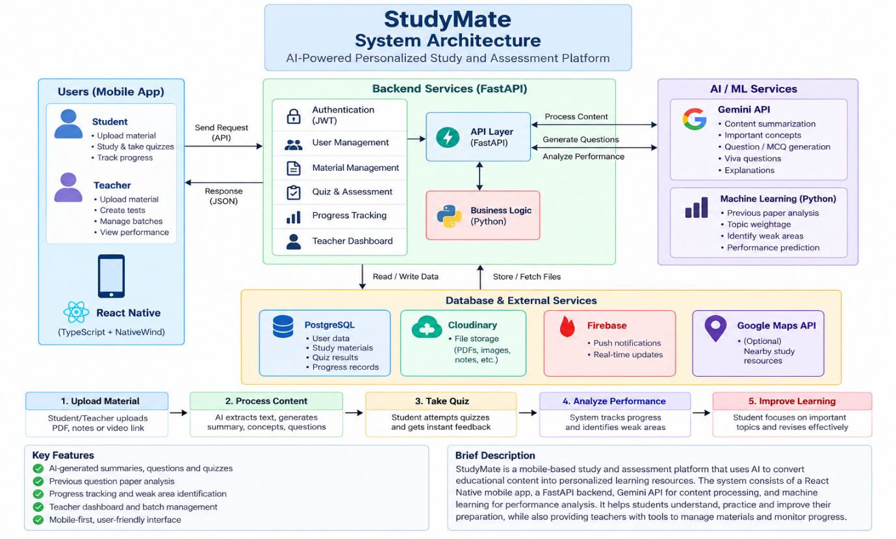

Modules
● Authentication: Secure student and teacher sign-up and login using JWT-based authentication.
● Study Material Management: Supports uploading, storing, and organizing educational materials such as PDFs, notes, and other learning content.
● AI Content Processing: Uses the Gemini API to generate summaries, important concepts, keywords, and explanations from study material.
● Question Generation: Generates practice questions, MCQs, and viva questions based on the provided study content.
● Quiz & Assessment: Provides interactive quizzes to assess student understanding and generate instant results.
● Progress Tracking: Records quiz attempts, scores, and performance history to monitor the student's learning progress.
● Weak Area Identification: Analyzes student performance to identify weak subjects and topics requiring additional preparation.
● Question Paper Analysis: Analyzes previous question papers to identify frequently asked questions, important topics, and topic-wise trends.
● Teacher Dashboard: Allows teachers to upload materials, create tests, manage batches, and monitor student performance.
● Notifications: Provides reminders and alerts related to quizzes, learning activities, and important updates.

9. Hardware and Software Requirements

Hardware Requirements | Software Requirements
- Processor: Intel i5 or equivalent or above | - Operating System: Windows / Linux / macOS
- RAM: 8 GB minimum | - IDE: Visual Studio Code
- Storage: 256 GB SSD or equivalent | - Mobile Development: React Native / Expo / Android Studio Emulator
- Android device for testing (recommended) | - Backend: Python + FastAPI
- Internet connectivity | - Database: PostgreSQL + pgAdmin/Dbeaver
 | - Development Tools: Git, GitHub, Postman, Swagger UI, Figma, Draw.io

10. Expected Outcome
- Generate concise summaries from study material.
- Identify important concepts and keywords.
- Generate MCQs, viva questions and practice questions.
- Conduct interactive quizzes.
- Record and analyze student quiz performance.
- Track improvement across multiple attempts.
- Identify weak subjects/topics.
- Analyze previous question papers and identify frequently occurring topics.
- Provide teacher functionality for managing study materials, tests and student performance.
- Provide students with a structured workflow for understanding, practicing and improving their preparation..

11. Applications
- Schools: Teachers can provide chapter material and students can use the system for revision and practice.
- Colleges and Universities: Students can use lecture notes, PPTs, reference materials and previous question papers for examination preparation.
- Coaching and Tuition Institutes: Teachers can provide study material, generate tests and monitor batch performance.
- Online Learning Platforms: Course content can be transformed into summaries, questions and quizzes.
- Corporate Training: Training documents can be converted into summaries, assessments and progress-based learning workflows.
- Professional Certification Preparation: Learners can use study materials for revision and practice.
- Individual Self-Learning: Students can independently organize and prepare from large amounts of study material.
12. Timeline / Work Plan
Phase | Activity | Duration
Phase 1 | Requirement analysis & literature survey | Week 1-2
Phase 2 | System design & architecture | Week 3-4
Phase 3 | Implementation / coding | .Week 5-8
Phase 4 | Testing & debugging | Week 9-10
Phase 5 | Documentation & final submission | Week 11-12

13. References
- X. Wang, S. Fan, J. Houghton, and L. Wang, “Towards Process-Oriented, Modular, and Versatile Question Generation that Meets Educational Needs,” Proceedings of the 2022 Conference of the North American Chapter of the Association for Computational Linguistics: Human Language Technologies, pp. 291–302, 2022.

- S. Bulathwela, H. Muse, and E. Yilmaz, “Scalable Educational Question Generation with Pre-trained Language Models,” arXiv preprint arXiv:2305.07871, 2023.

- C. Piech, J. Bassen, J. Huang, S. Ganguli, M. Sahami, L. Guibas, and J. Sohl-Dickstein, “Deep Knowledge Tracing,” Advances in Neural Information Processing Systems (NeurIPS), vol. 28, 2015

- Quizlet — AI-generated study guides, questions, quizzes, etc.

- Google NotebookLM — source-based summaries, study guides, questions and quizzes.

