Date: 18/04/2024

Task:

1. Write an HTML code to display images as in the following given output by using table and image tags.
2. <!DOCTYPE *html*>
3. <html *lang*="en">
4. <head>
5. <meta *charset*="UTF-8">
6. <meta *name*="viewport" *content*="width=device-width, initial-scale=1.0">
8. <title>Q1</title>
10. </head>
11. <body >
13. <div *class*="container">
14. <table *style*="width: 600px;">
15. <tr>
16. <th *style*="padding: 50px;">
17. <img *name*="f1" *src*="img3.jpg" *alt*="nothing" *width*="2000em" *height*="1300em" *padding*="150px" *style*="padding-bottom: 50px;">
18. <img *name*="f1" *src*="img2.jpg" *alt*="nothing" *width*="2000em" *height*="1300em" *padding*="150px">
19. </th>
20. <th>
21. <img *name*="f1" *src*="img4.jpg" *alt*="nothing" *width*="1800em" *height*="2800px" *style*="padding:50px">
23. </th>
24. <th *style*="padding: 50px;">
25. <img *name*="f1" *src*="img1.jpg" *alt*="nothing" *width*="2000em" *height*="1300em" *style*="padding-bottom: 50px;">
26. <img *name*="f1" *src*="img5.jpg" *alt*="nothing" *width*="2000em" *height*="1300em">
28. </th>
29. </tr>
31. </table>
32. </div>
33. </body>
34. </html>

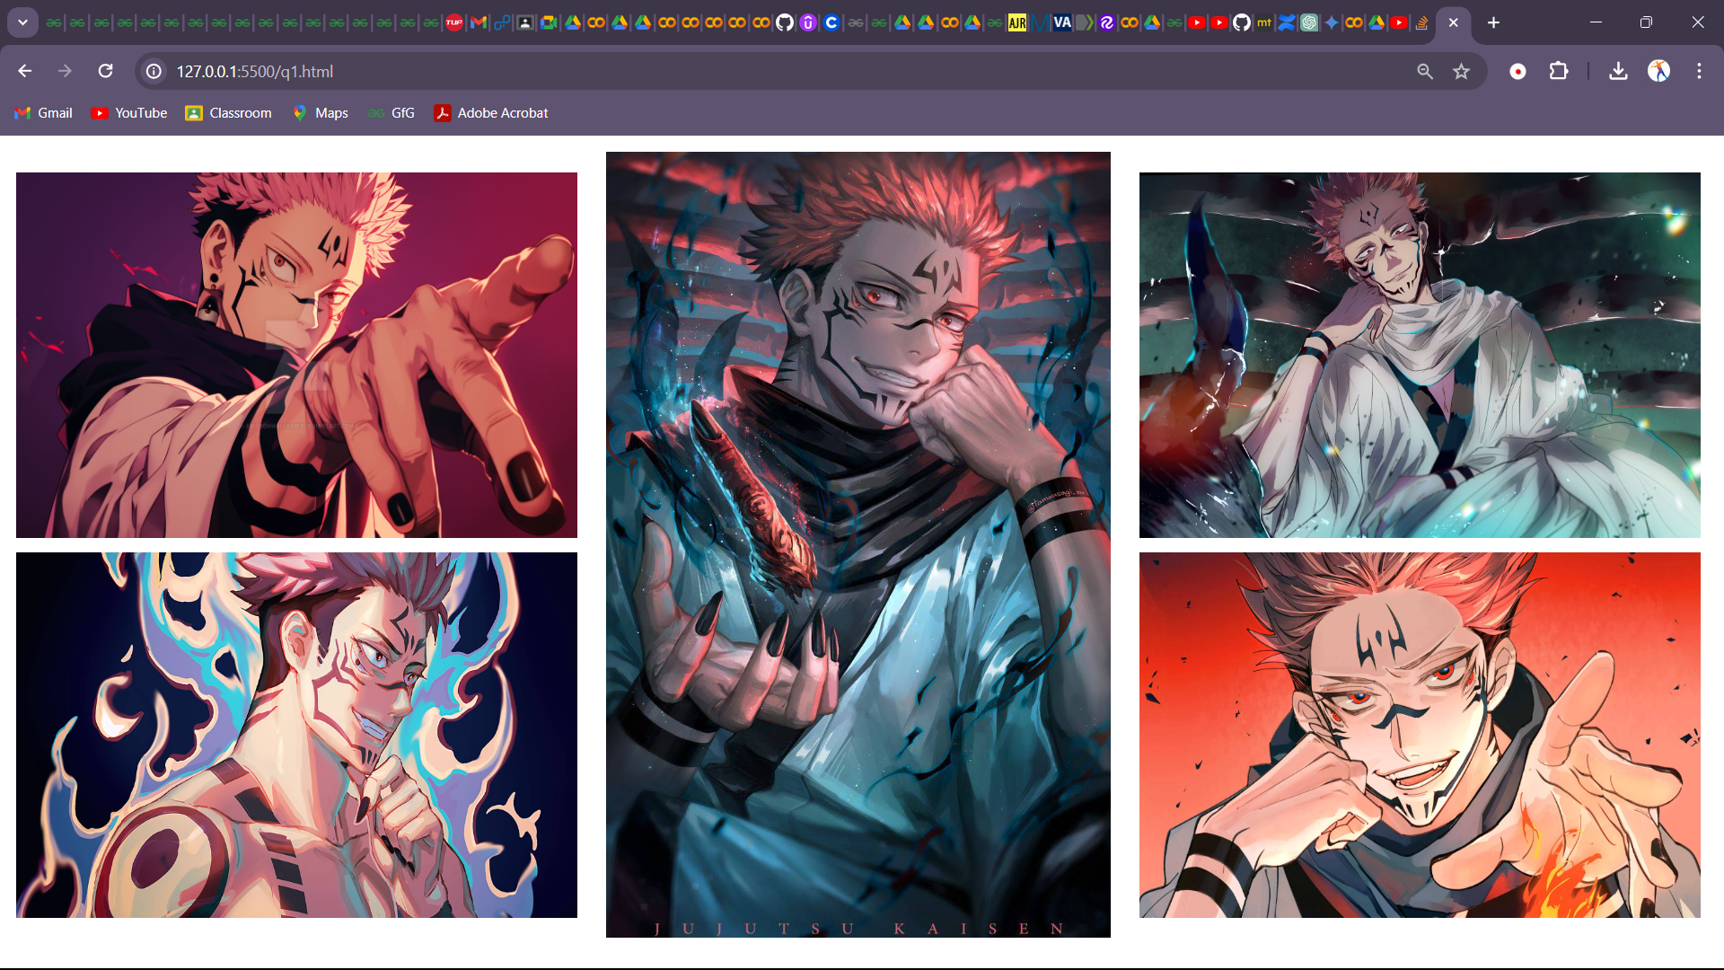

2. Write an HTML document table with lists of veg food and Non-veg with unordered lists.

<!DOCTYPE *html*>

<html *lang*="en">

<head>

    <meta *charset*="UTF-8">

    <meta *name*="viewport" *content*="width=device-width, initial-scale=1.0">

    <title>Q2</title>

</head>

<body>

    <div>

        <h5>Veg Foods</h5>

        <ul>

            <li>Dal Chawal</li>

            <li>Sarson ka Saag</li>

            <li>Mattar Paneer</li>

            <li>Dosa Chutney</li>

            <li>Bharta</li>

        </ul>

        <h5>Non-Veg Foods</h5>

        <ul>

            <li>Prawns Fry</li>

            <li>Chicken 65</li>

            <li>Mutton Biryani</li>

            <li>Chicken Shawarma</li>

            <li>Omlette</li>

        </ul>

    </div>

</body>

</html>

3. Write an HTML document to play audio and video files.

<!DOCTYPE *html*>

<html *lang*="en">

<head>

    <meta *charset*="UTF-8">

    <meta *name*="viewport" *content*="width=device-width, initial-scale=1.0">

    <title>Document</title>

</head>

<body></body>

    <div>

    <h2>Audio</h2>

    <audio *controls*>

        <source *src*="pehlanasha.mp3">

    </audio>

</div>

    <h2>Video</h2>

    <video *controls* *width*="640" *height*="360">

        <source *src*="wallpaper.mp4" *type*="video/mp4">

    </video>

</body>

</html>

