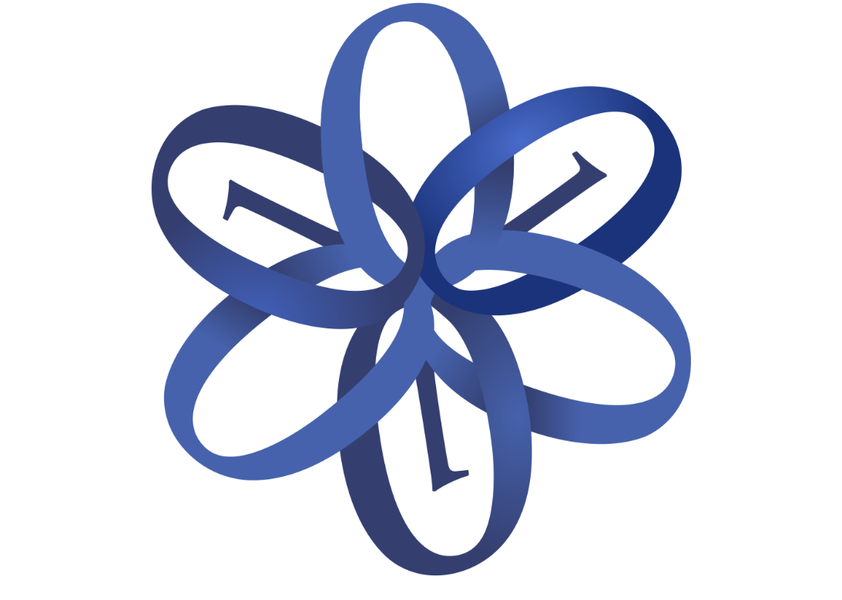Vocational school for computer programming and innovations

Team:

Chillin Programmers

|  |  |
| --- | --- |
| Prepared by | E-mails |
| Ivelin Bachvarov | IPBachvarov18@codingburgas.bg |
| Stoyan Kolev | SNKolev18@codingburgas.bg |
| Emil Ribarev | eiribarev@codingburgas.bg |
| Georgi Georgiev | GNGeorgiev18@codingburgas.bg |
| Aleksandyr Dinev | AGDinev18@codingburgas.bg |
| Klain Chervenkov | KSChervenkov19@codingburgas.bg |
| Vasil Mladenov | VLMladenov19@codingburgas.bg |

Contents

1. History of the game 3

2. Parts of the game 3

3. Tools of the game 4

4. Rules of the game 4

5. Win conditions: 5

5.1 Checkmate 5

5.2 Resignation 5

6. Plot of the game 5

7. Team 5

Graphic designer – VLMladenov19@codingburgas.bg 5

Developer – GNGeorgiev18@codingburgas.bg 5

Game director – IPBachvarov18@codingburgas.bg 5

Manager – SNKolev18@codingburgas.bg 5

8. Technology 5

9. Goals 5

10. Description of the corresponding functions, classes and elements. 6

Figure 1 3

Figure 2 3

Figure 3 3

Table 1 6

# History of the game

We don’t have history of our game.

# Parts of the game

Our game has 3 parts. The first one Is the field of the game. The second one are figures for playing the game. Also we have site about the game form where you can download it.

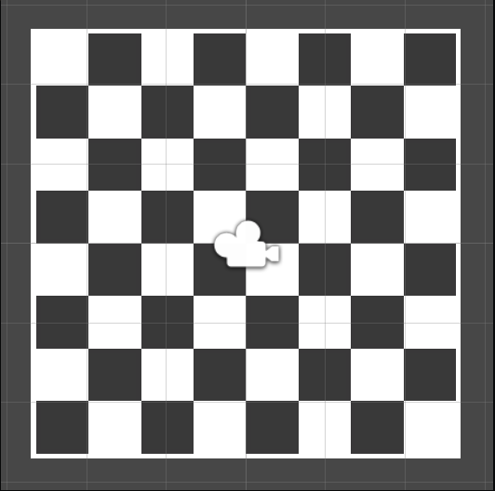

Figure 1

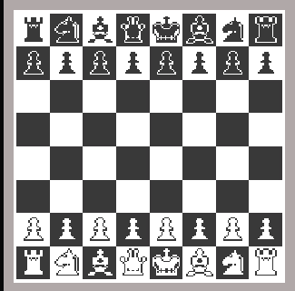

Figure 2

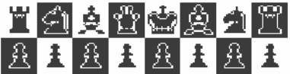

Figure 3

# Tools of the game

There are six tools of the chess: bishop, queen, knight rook, king and pawns.

# Rules of the game

The king moves exactly one square horizontally, vertically, or diagonally. A special move with the king known as castling is allowed only once per player, per game.

A rook moves any number of vacant squares horizontally or vertically. It also is moved when castling.

A bishop moves any number of vacant squares diagonally.

The queen moves any number of vacant squares horizontally, vertically, or diagonally.

A knight moves to the nearest square not on the same rank, file, or diagonal. The knight is not blocked by other pieces: it jumps to the new location.

Pawns have the most complex rules of movement:

A pawn moves straight forward one square, if that square is vacant. If it has not yet moved, a pawn also has the option of moving two squares straight forward, provided both squares are vacant. Pawns cannot move backwards.

Pawns are the only pieces that capture differently from how they move. A pawn can capture an enemy piece on either of the two squares diagonally in front of the pawn.

# Win conditions:

## Checkmate

One of the most common ways to end a chess game is by checkmate. This happens when one of the players is threatening the other king and it cannot move to any other squares, cannot be protected by another piece and the checking piece cannot be captured. If all of these conditions are met, the attacking player wins via checkmate.

## Resignation

While some games end by checkmate, there are many that don't get that far. Sometimes one of the players believes that he or she will be checkmated soon and resigns instead of playing out the game.

# Plot of the game

The game starts when one of the white pieces has been moved. And the game continues till the king get checkmated.

# Team

## Graphic designer – [VLMladenov19@codingburgas.bg](mailto:VLMladenov19@codingburgas.bg)

Graphic designer – [KSChervenkov19@codingburgas.bg](mailto:KSChervenkov19@codingburgas.bg)

## Developer – [GNGeorgiev18@codingburgas.bg](mailto:GNGeorgiev18@codingburgas.bg)

Developer – [AGDinev18@codingburgas.bg](mailto:AGDinev18@codingburgas.bg)

Developer – [eiribarev@codingburgas.bg](mailto:eiribarev@codingburgas.bg)

## Game director – [IPBachvarov18@codingburgas.bg](mailto:IPBachvarov18@codingburgas.bg)

## Manager – [SNKolev18@codingburgas.bg](mailto:SNKolev18@codingburgas.bg)

# Technology

We used Unity and C# for making the game and we used HTML, CSS and JavaScript for the site as well. For the C# scripts and website, we decided to use Visual Studio and Visual Studio Code.

# Goals

Our Goal is to make an offline chess game. That is going to be fun. Also to can be played without having Internet connection.

# Description of the corresponding functions, classes and elements.

|  |  |  |  |  |
| --- | --- | --- | --- | --- |
| Name | Purpose | Arguments | Return value | Methods |
| Start | To spawn chess pieces | No arguments | No returned value | No methods |
| Initiate move plates | To show where different types of plates can go | No arguments | No returned value | Public type method |
| Start | Function for the first frame update | No arguments | No returned value | No method |

Table 1