INDIVIDUAL ASSIGNMENT | CONFIGURATION MANAGEMENT
Automated Web Server
Deployment with Ansible

Sonit Kumar Pradhan
MS Software Engineering
San Jose State University
sonitkumar.pradhan@sjsu.edu | 020622849
GitHub Repository: github.com/snkprdhn/Ansible-CMPE-272

September 3, 2026

1. Overview
This report documents the design, deployment, verification, repeatability, and removal of two Nginx webserver instances using Ansible. The implementation runs locally on a macOS control node and manages two Ubuntu 24.04 LTS virtual machines created with Multipass.
Outcome. VM1 served “Hello World from SJSU-1” and VM2 served “Hello World from SJSU-2” over TCP port 8080. The same playbook also removed the deployed webserver resources.

1.1 Requirement coverage
Requirement | Implementation evidence | Status
Two virtual machines | vm1 and vm2 run Ubuntu 24.04 LTS in Multipass. | Verified
Webserver on port 8080 | Nginx listens on IPv4 and IPv6 port 8080. | Verified
Different VM messages | Inventory variable sjsu_instance renders SJSU-1 or SJSU-2. | Verified
Deploy and undeploy | Separate playbook plays are selected by deploy and undeploy tags. | Verified
Code in GitHub | Repository contains inventory, configuration, playbook, and templates. | Verified

1.2 Environment and architecture
- Control node: macOS on MacBook Air, running Ansible from the assignment repository.
- Managed node VM1: Ubuntu 24.04 LTS at 192.168.252.2, reached through SSH as ubuntu.
- Managed node VM2: Ubuntu 24.04 LTS at 192.168.252.3, reached through SSH as ubuntu.
- Service layer: Nginx with a custom server block and VM-specific Jinja2 page template.
Source repository: github.com/snkprdhn/Ansible-CMPE-272

2. Implementation
Ansible acts as an agentless configuration-management tool. The control node connects to both managed hosts over SSH, applies the same tasks, and substitutes a host-specific variable when rendering each page.

2.1 Inventory and connection configuration
The inventory groups both machines under webservers and stores the value that differentiates each page. The shared variables define the remote Ubuntu account and Python interpreter.
[webservers]
vm1 ansible_host=192.168.252.2 sjsu_instance=1
vm2 ansible_host=192.168.252.3 sjsu_instance=2
[webservers:vars]
ansible_user=ubuntu
ansible_python_interpreter=/usr/bin/python3

2.2 VM-specific page generation
A Jinja2 expression in index.html.j2 uses the inventory value. One template therefore produces the two required messages without duplicating HTML files.
<h1>Hello World from SJSU-{{ sjsu_instance }}</h1>

2.3 Nginx port configuration
The custom Nginx server block listens on port 8080 for both IPv4 and IPv6 traffic and serves content from /var/www/sjsu.
server {
listen 8080 default_server;
listen [::]:8080 default_server;
root /var/www/sjsu;
index index.html;
}

2.4 Deployment lifecycle
Tag | Play behavior | Managed resources
deploy | Converges both VMs to the desired running state. | Nginx package, site directory, HTML page, server block, symlink, service
undeploy | Removes the webserver resources from both VMs. | Nginx package, generated content, configuration, enabled-site link
The deployment uses declarative Ansible modules (apt, file, template, and service) plus a restart handler. This supports predictable reruns.
configuration changes trigger a restart, while an already-correct system remains unchanged.

3. Validation and Deployment Evidence

3.1 Virtual machines
Multipass reported both managed nodes in the Running state with distinct private IPv4 addresses and the Ubuntu 24.04 LTS image.
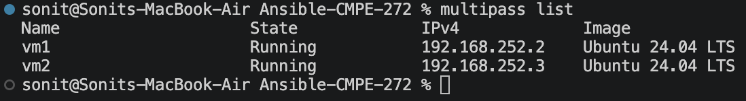
Figure 1. Multipass inventory showing vm1 and vm2 running on Ubuntu 24.04 LTS.

3.2 Inventory resolution and SSH connectivity
The inventory graph resolved both hosts inside the webservers group. The Ansible ping module returned SUCCESS and pong for both systems, confirming SSH connectivity and remote module execution before deployment.
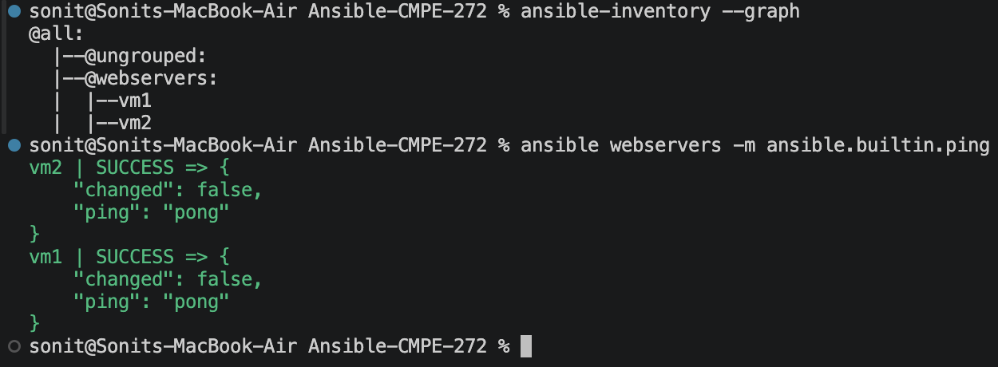
Figure 2. Inventory graph and successful Ansible ping responses from vm1 and vm2.

3.3 Playbook validation
A syntax check completed successfully before any configuration changes were applied.
Figure 3. Successful syntax validation of webserver.yml.

3.4 Initial deployment
The deploy tag installed Nginx, created the website directory, rendered the page, installed and enabled the port-8080 configuration, disabled the default site, started the service, and executed the restart handler. Both hosts completed with failed=0 and unreachable=0.
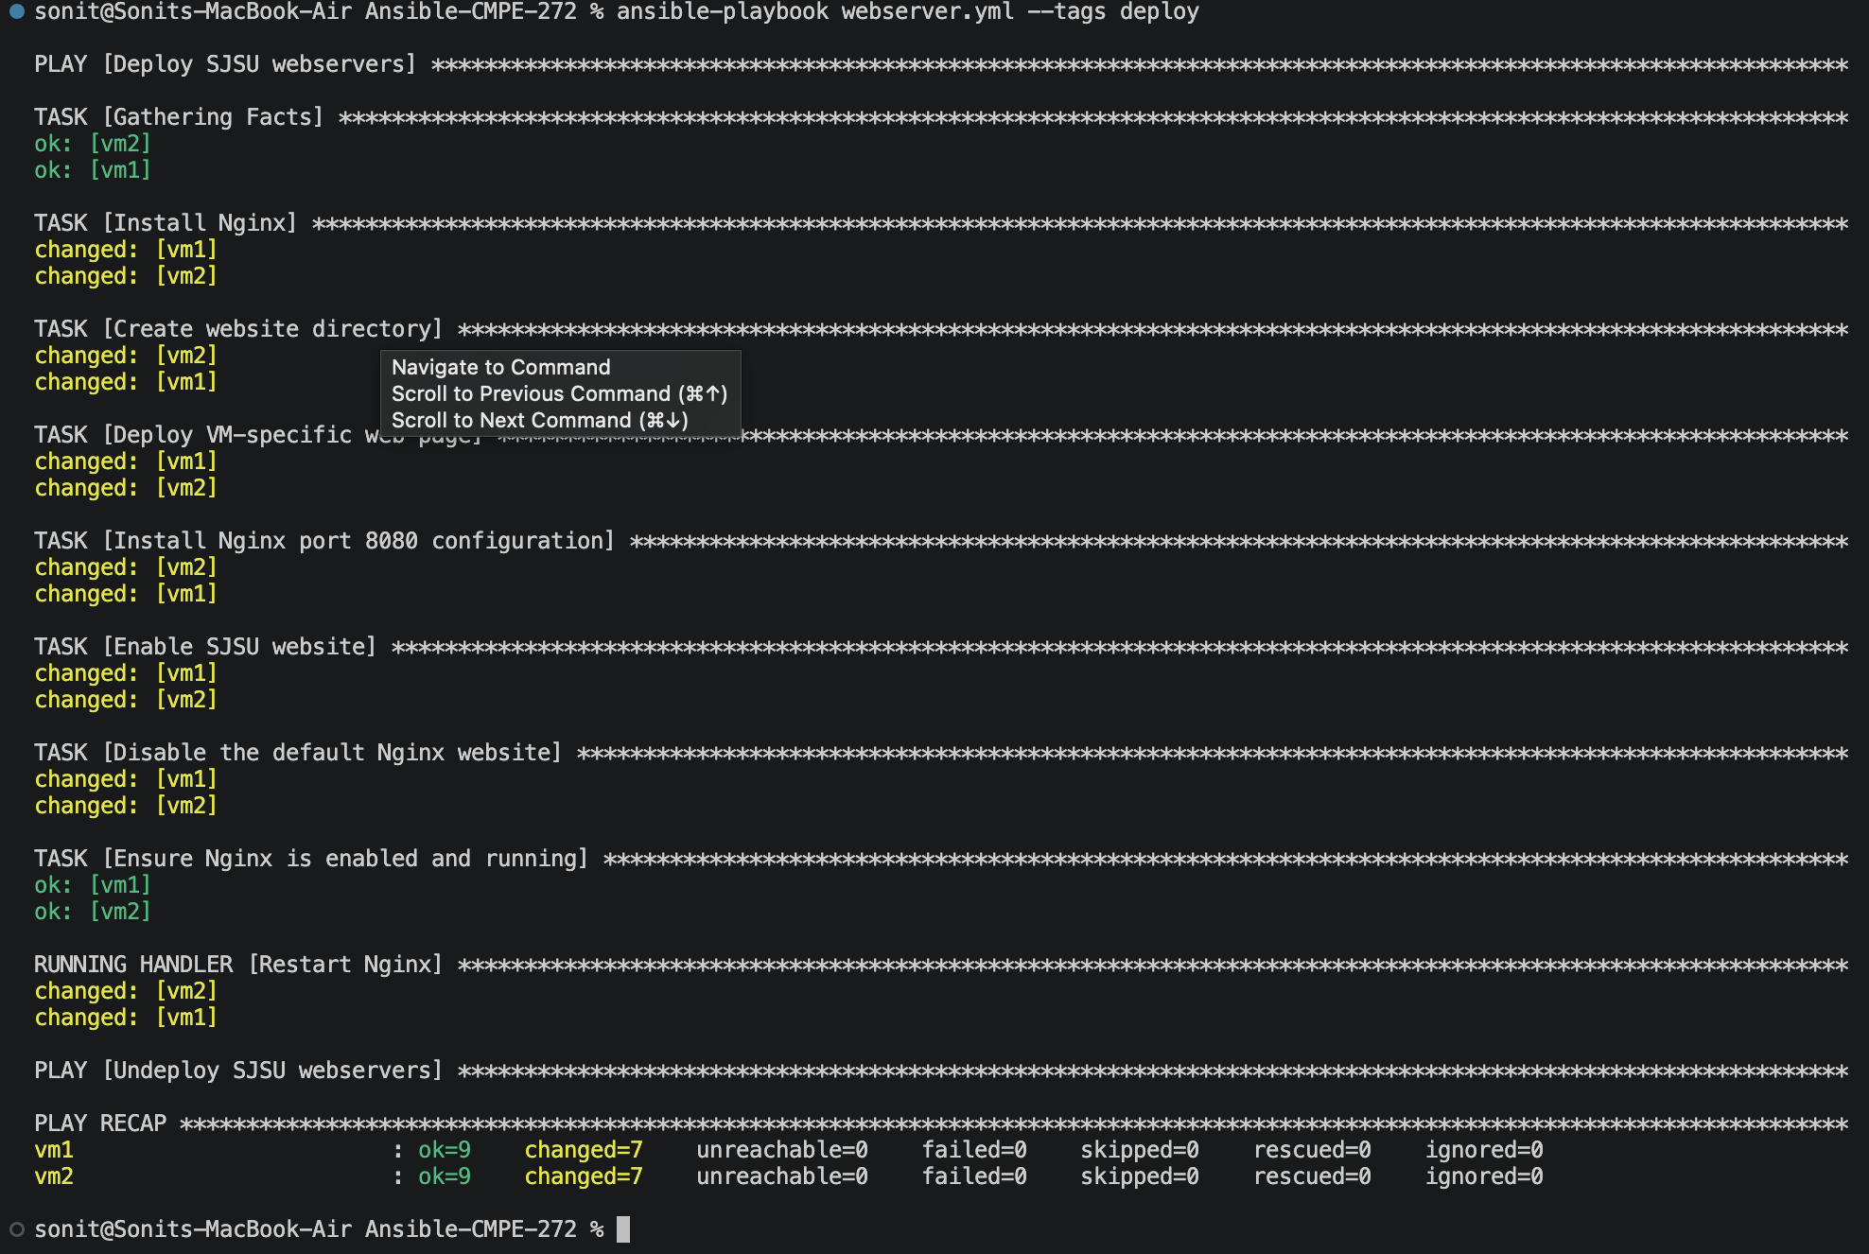
Figure 4. Initial deployment completing successfully on both managed nodes.

4. Webserver Results
The two addresses were opened directly in a browser with port 8080 visible in the address bar. The resulting content demonstrates that a shared template was rendered with the correct per-host value.
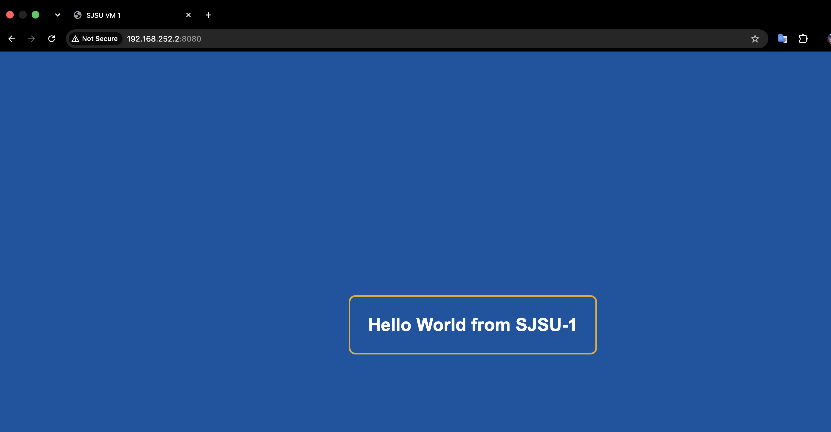
Figure 5. VM1 at 192.168.252.2:8080 displaying “Hello World from SJSU-1.”
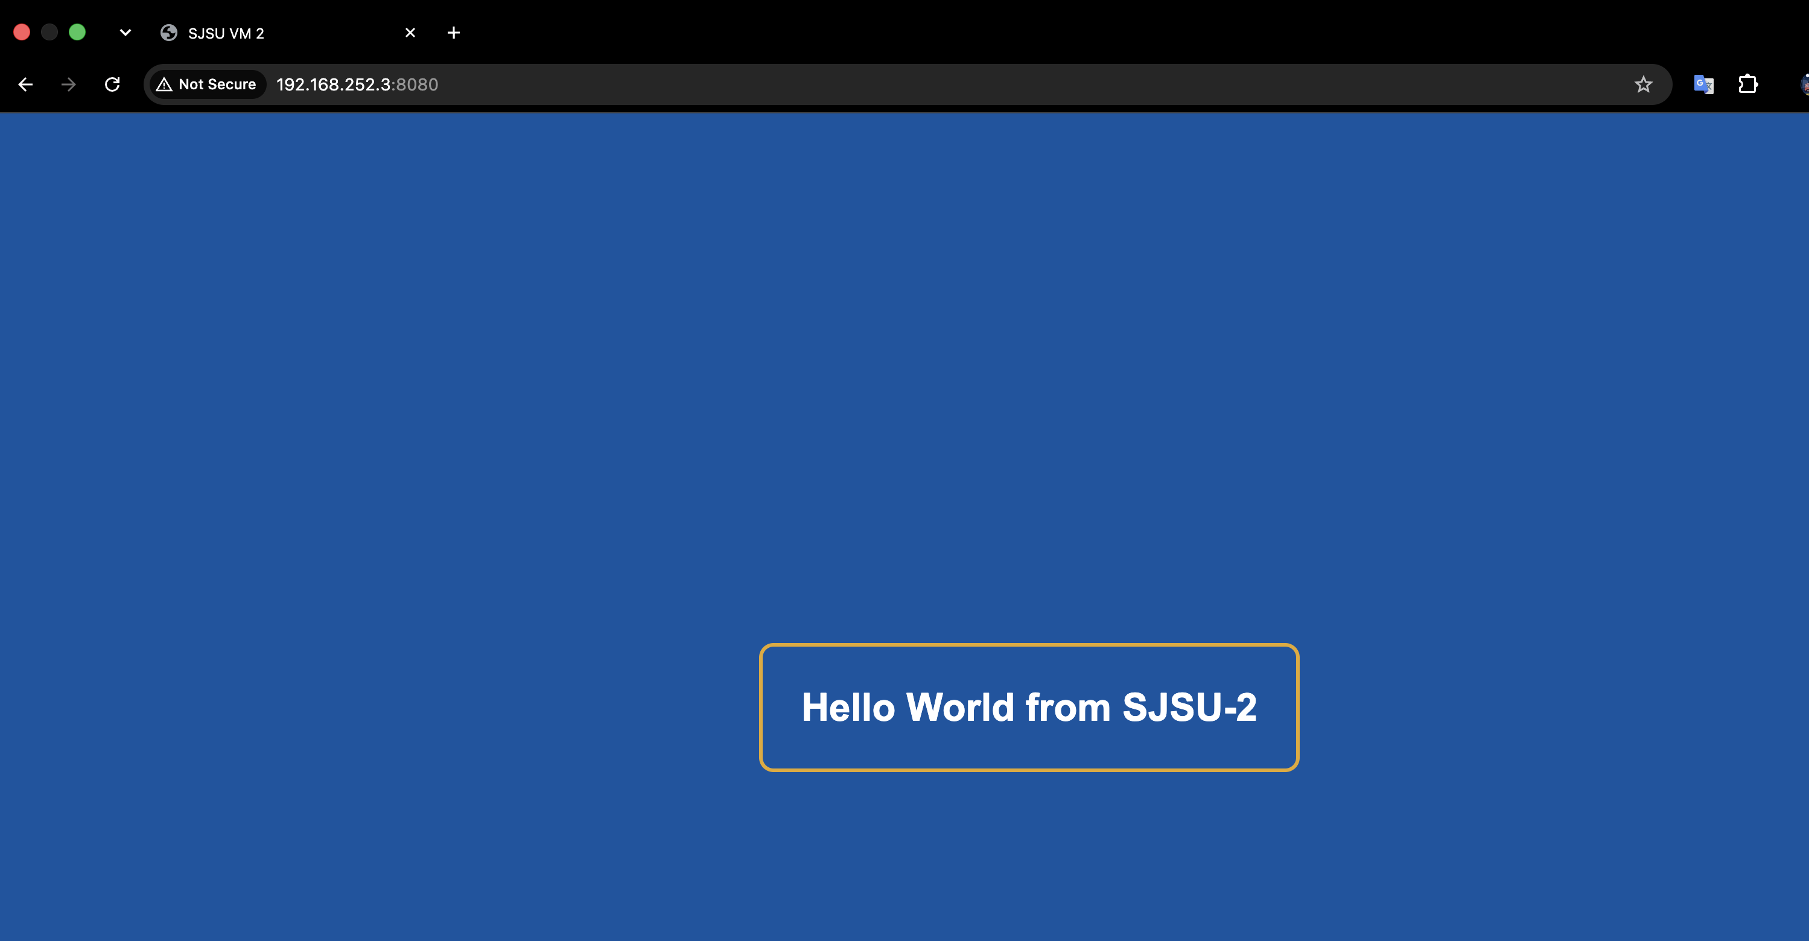
Figure 6. VM2 at 192.168.252.3:8080 displaying “Hello World from SJSU-2.”

5. Repeatability and Undeployment

5.1 Idempotent redeployment
Running the deploy play again produced changed=0 for both hosts. This confirms that the playbook is idempotent: when the target state already matches the declared configuration, Ansible makes no unnecessary changes.
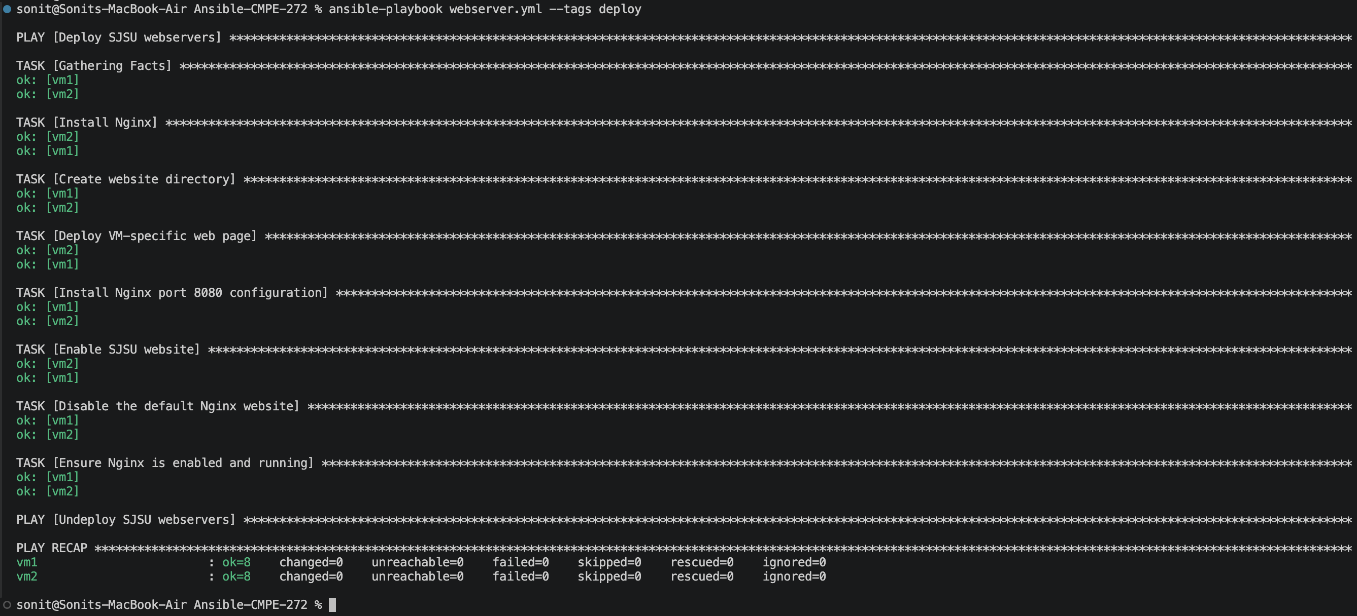
Figure 7. Second deployment run showing changed=0, failed=0, and unreachable=0.

5.2 Resource removal
The undeploy play removed Nginx and the website content from both VMs. The recap shows two changed tasks per host and no failed or unreachable hosts. The virtual machines themselves remained available for later redeployment.
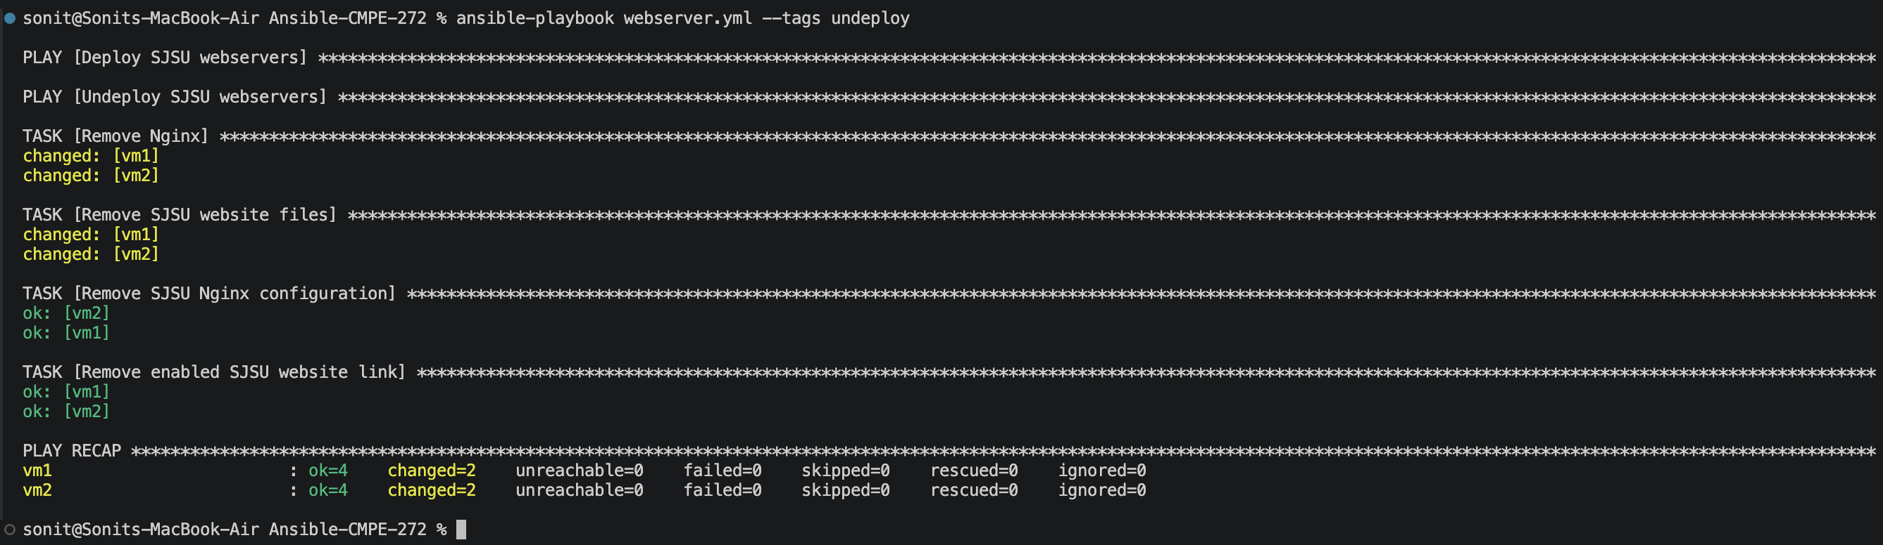
Figure 8. Successful undeployment of webserver resources from vm1 and vm2.

6. Test Results and Discussion
Test | Observed result | Conclusion
VM availability | vm1 and vm2 reported Running with separate IP addresses. | Pass
Configuration validation | Syntax check completed; both hosts returned pong. | Pass
Deployment | The deploy play completed on both hosts with failed=0 and unreachable=0. | Pass
Application output | Correct SJSU-1 and SJSU-2 messages loaded on port 8080. | Pass
Idempotence | Second deployment completed with changed=0 on both hosts. | Pass
Undeployment | Nginx and generated web content were removed from both hosts. | Pass

6.1 Key observations
- A single inventory group allowed the same tasks to execute consistently across both virtual machines.
- The sjsu_instance variable separated host-specific data from reusable configuration logic.
- Handlers avoided unnecessary service restarts and supported clean idempotent behavior.
- Local Multipass virtualization completed the assignment without cloud charges or external infrastructure.

7. Demonstration Sequence
- Run multipass list to show vm1 and vm2 and their private IP addresses.
- Run ansible webservers -m ansible.builtin.ping to demonstrate control-node connectivity.
- Run ansible-playbook webserver.yml --tags deploy and review the successful recap.
- Open both port-8080 URLs and compare the VM-specific messages.
- Repeat deployment to show changed=0, then run the undeploy tag to remove resources.

8. Source Repository and Reproducibility
GitHub repository: github.com/snkprdhn/Ansible-CMPE-272
Repository item | Purpose
webserver.yml | Contains the tagged deploy and undeploy plays.
inventory.ini | Defines vm1, vm2, their addresses, and per-host instance values.
ansible.cfg | Selects the inventory, SSH private key, and Python discovery behavior.
templates/index.html.j2 | Creates the styled, VM-specific Hello World page.
templates/nginx-sjsu.conf.j2 | Configures Nginx to serve the page on port 8080.
Screenshot/ | Stores the assignment's visual evidence.
README.md | Summarizes the objective, architecture, and operating commands.

9. Conclusion
The assignment demonstrates centralized configuration management across two independent Ubuntu virtual machines. One Ansible playbook installed, configured, validated, and removed Nginx resources on both systems. Host variables produced the required VM-specific content, port 8080 was visible in both browser tests, and the zero-change second run demonstrated idempotence. The implementation is reproducible from the linked GitHub repository and can be demonstrated entirely with free local tools.

References
Project source code and screenshots: Open project repository
Ansible documentation: Open Ansible documentation
Canonical Multipass documentation: Open Multipass documentation
Nginx documentation: Open Nginx documentation

