CMPE 272
GitHub Issues Service
UI Evidence Packet
HW #2 — GitHub Service
TEAM MEMBERS
Sonit • Sagar • Joel • Mathew
Repository | https://github.com/snkprdhn/GitHub-service-CMPE-272
Submission date | September 13, 2026
Prepared as execution evidence for local API, GitHub, webhook, test, and container behavior.

TEAM CONTRIBUTIONS
Work division and source ownership
The table below is reproduced from Team_Contributions.docx and matches the authorship comments in the source files.
Member | Work completed | Primary code and artifacts
Sonit | Set up the FastAPI application, environment configuration, request and response models, health endpoint, request IDs, and shared error responses. | app/config.py  app/models.py  app/main.py
Sagar | Implemented the GitHub REST client, issue and comment endpoints, pagination forwarding, and GitHub error and rate limit translation. | app/github.py  app/issues.py
Joel | Implemented GitHub webhook signature verification, supported event and action validation, delivery deduplication, event storage, and webhook routes. | app/webhooks.py  app/webhook_routes.py
Mathew | Wrote unit and live integration tests, prepared the OpenAPI contract, Docker and Make setup, README, design note, and this contribution record. | tests/  openapi.yaml  Dockerfile  README.md  DESIGN.md
Shared review. The team reviewed the API contract, test results, webhook behavior, and documentation together before submission.
Submission overview
This submission documents a FastAPI service for creating, reading, updating, and commenting on issues in a GitHub repository. It also verifies signed webhooks, duplicate-delivery handling, automated tests, Docker execution, and conditional GET behavior.
The evidence follows the assignment workflow. Each figure identifies the request that was executed, the observed result, and why that result confirms the feature.

CONFIGURATION EVIDENCE
Figure 1 — GitHub test repository
Explanation. This establishes the GitHub repository used for all live issue and webhook checks.
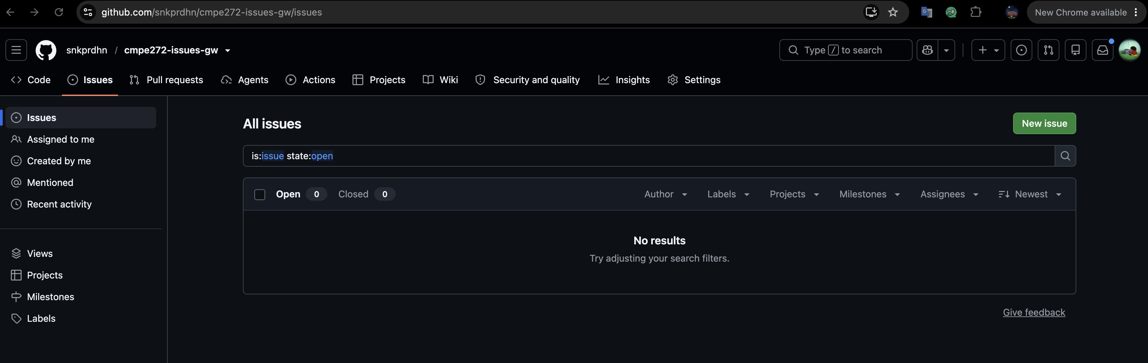
Figure 1. The GitHub Issues page shows the dedicated test repository with Issues enabled and ready for API operations.

CONFIGURATION EVIDENCE
Figure 2 — Secret file exclusion
Explanation. This check confirms that the local environment file will not be included in a commit.
Figure 2. The git check-ignore request returns .env, confirming that local credentials are excluded from version control.

CONFIGURATION EVIDENCE
Figure 3 — Service routes in Swagger UI
Explanation. The route list confirms that the implemented API matches the assignment's required operations.
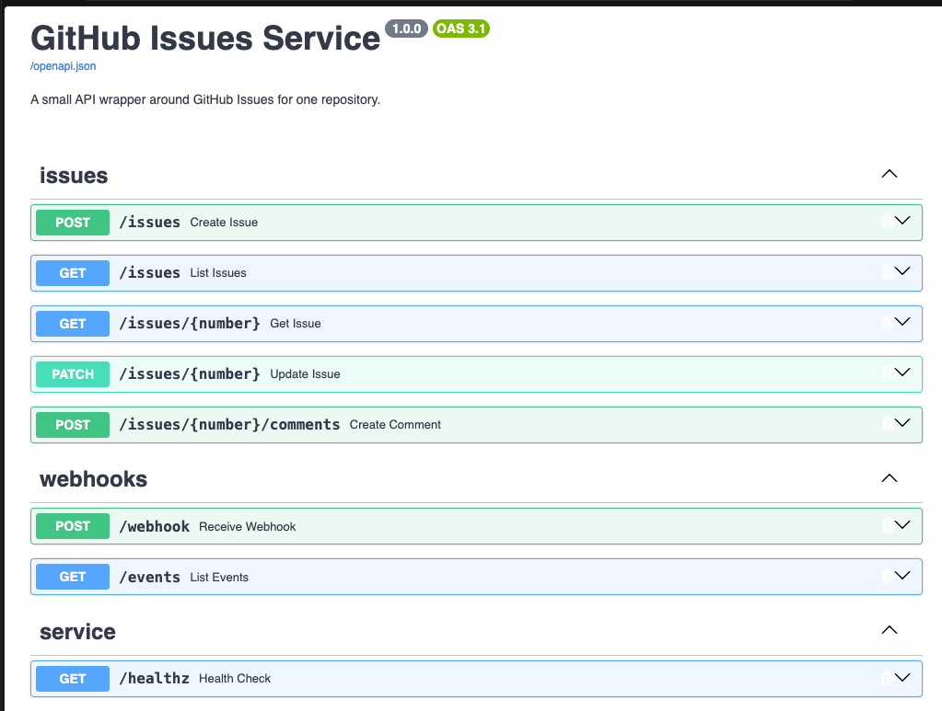
Figure 3. The running service's Swagger UI lists the issue, comment, webhook, event, and health routes required by the assignment.

CONFIGURATION EVIDENCE
Figure 4 — Health endpoint
Explanation. This verifies that the application is running and can return a basic service response.
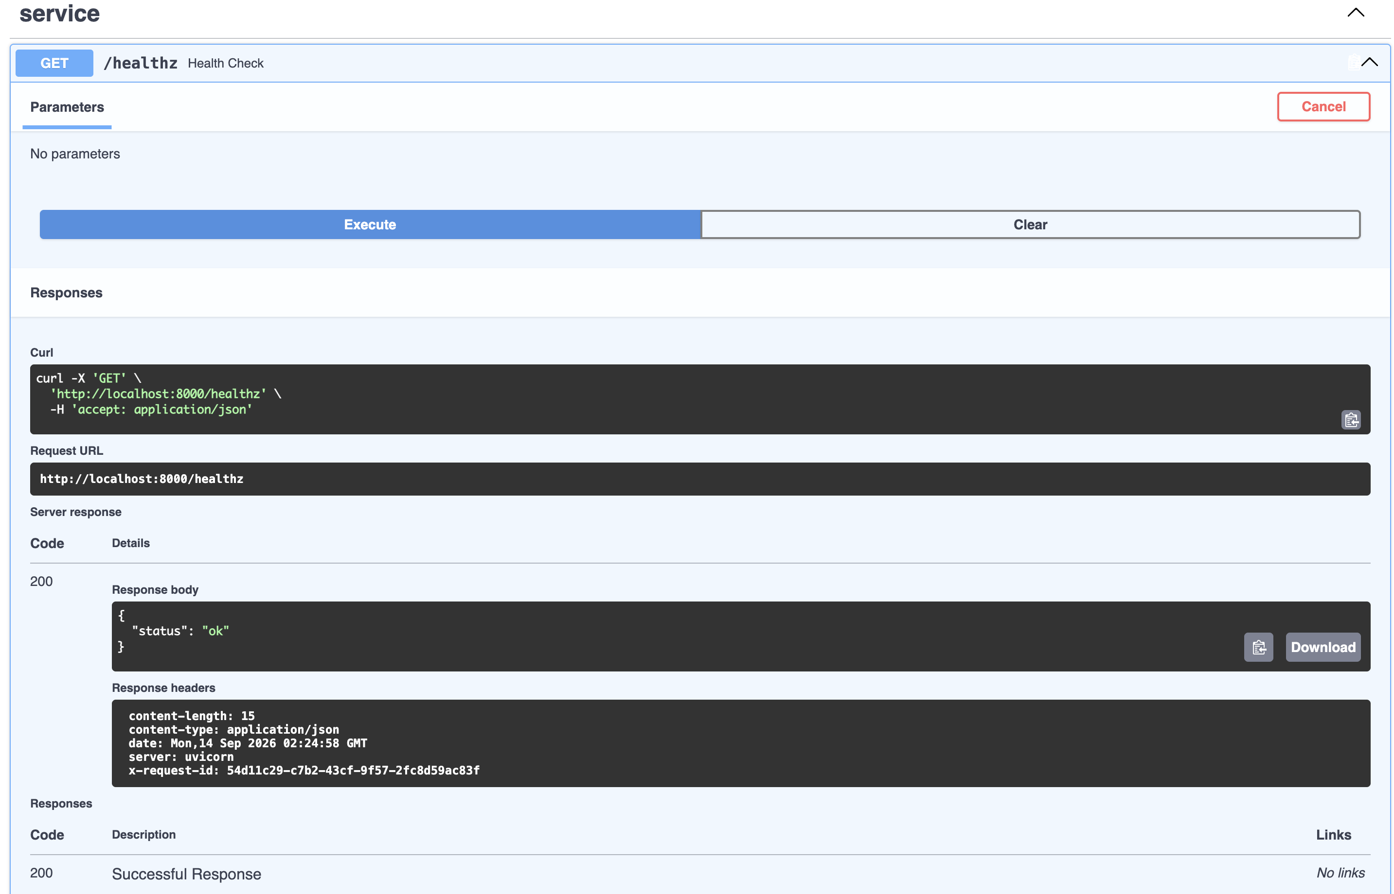
Figure 4. A GET request to /healthz returns HTTP 200 with a status value of ok and an x-request-id response header.

ISSUE CRUD AND COMMENT EVIDENCE
Figure 5 — Create an issue
Explanation. The response confirms that the service can create an issue through the GitHub API.
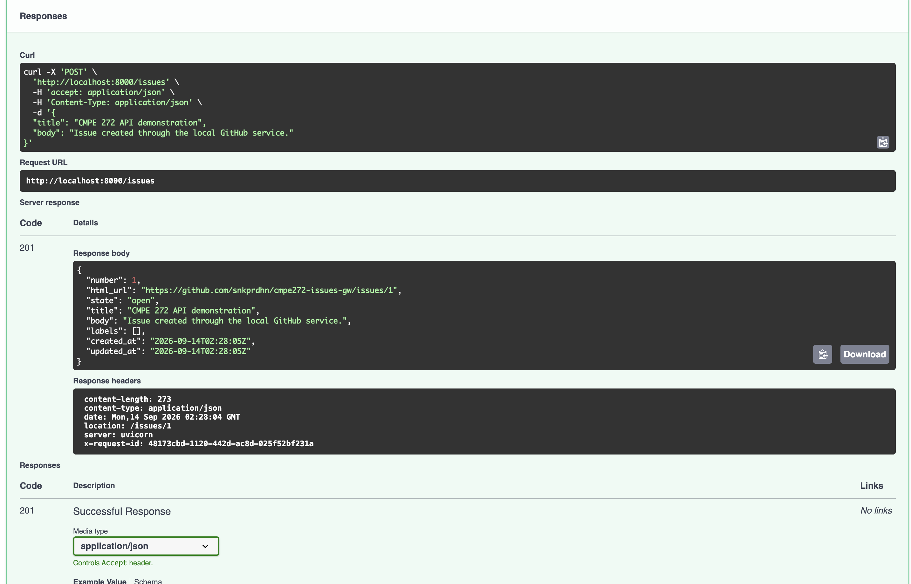
Figure 5. A POST request to /issues returns HTTP 201, issue number 1, an open state, and the GitHub issue URL.

ISSUE CRUD AND COMMENT EVIDENCE
Figure 6 — Created issue on GitHub
Explanation. The matching GitHub page confirms that the created issue was stored in the remote repository.
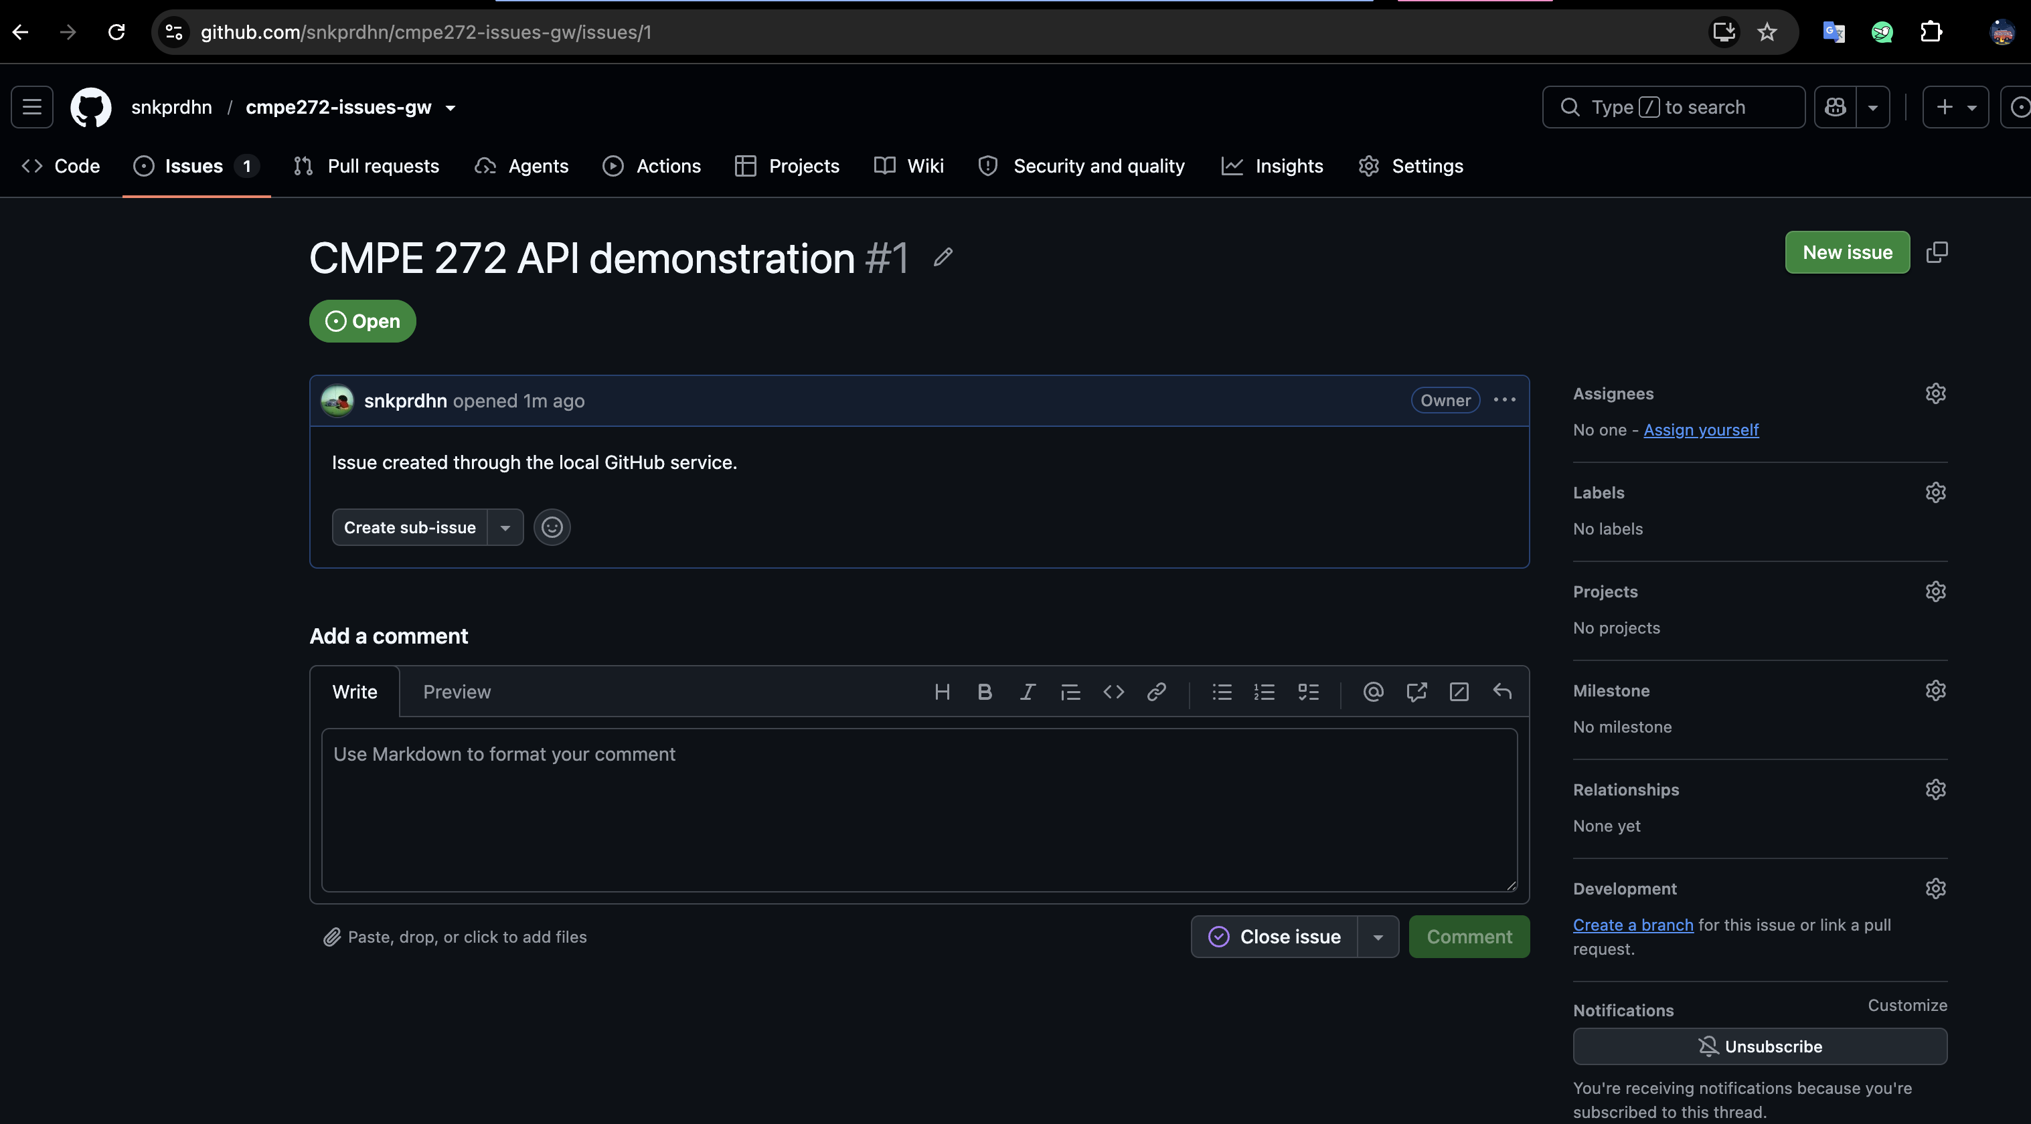
Figure 6. GitHub displays issue 1 with the title and body submitted through the local service.

ISSUE CRUD AND COMMENT EVIDENCE
Figure 7 — List issues with pagination
Explanation. The Link header shows that pagination information from GitHub is preserved for clients.
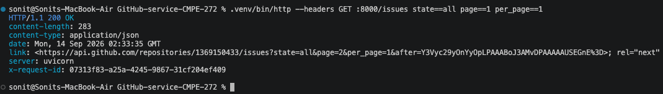
Figure 7. A paginated GET request to /issues returns HTTP 200 and forwards a Link header for the next GitHub results page.

ISSUE CRUD AND COMMENT EVIDENCE
Figure 8 — Retrieve one issue
Explanation. The returned fields confirm that one issue can be retrieved by its number.
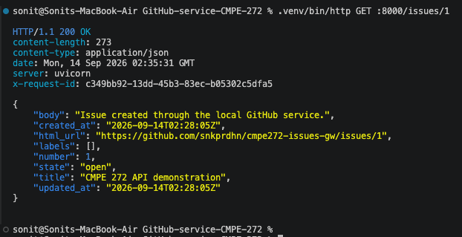
Figure 8. A GET request to /issues/1 returns HTTP 200 with the expected issue number, title, body, state, and GitHub URL.

ISSUE CRUD AND COMMENT EVIDENCE
Figure 9 — Update and close an issue
Explanation. The response verifies that both issue content and issue state can be changed.
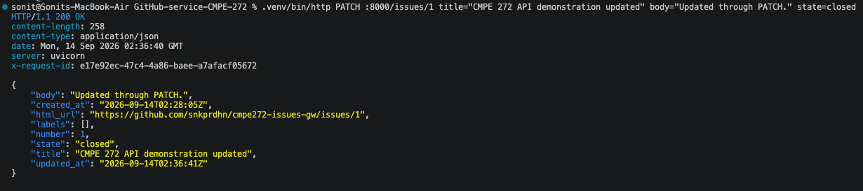
Figure 9. A PATCH request updates issue 1 and returns HTTP 200 with the revised title, body, and closed state.

ISSUE CRUD AND COMMENT EVIDENCE
Figure 10 — Reopen an issue
Explanation. Reopening the same issue confirms that state updates work in both directions.
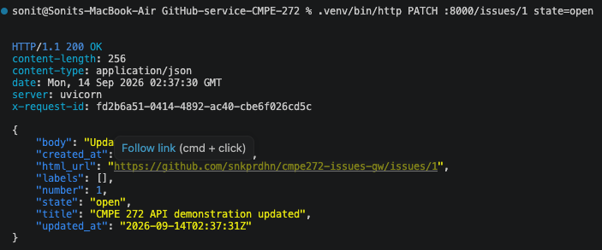
Figure 10. A second PATCH request returns HTTP 200 and changes issue 1 from closed back to open.

ISSUE CRUD AND COMMENT EVIDENCE
Figure 11 — Create an issue comment
Explanation. The response verifies that comments can be created through the service rather than directly on GitHub.
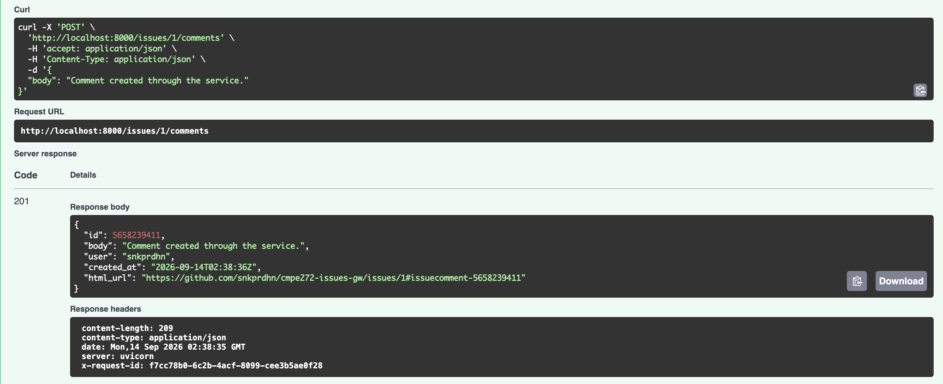
Figure 11. A POST request to /issues/1/comments returns HTTP 201 with the new comment ID, body, author, timestamp, and GitHub URL.

ISSUE CRUD AND COMMENT EVIDENCE
Figure 12 — Issue changes visible on GitHub
Explanation. The GitHub timeline provides external confirmation of the update, close, reopen, and comment operations.
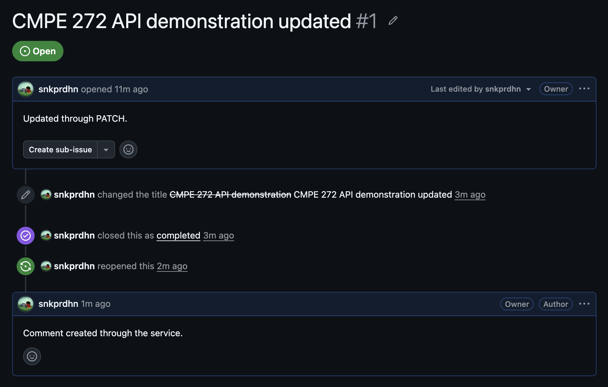
Figure 12. GitHub shows the updated issue, close and reopen events, and the comment created through the service.

WEBHOOK AND IDEMPOTENCY EVIDENCE
Figure 13 — Webhook configuration
Explanation. This configuration allows GitHub to send signed issue events to the local service through the public tunnel.
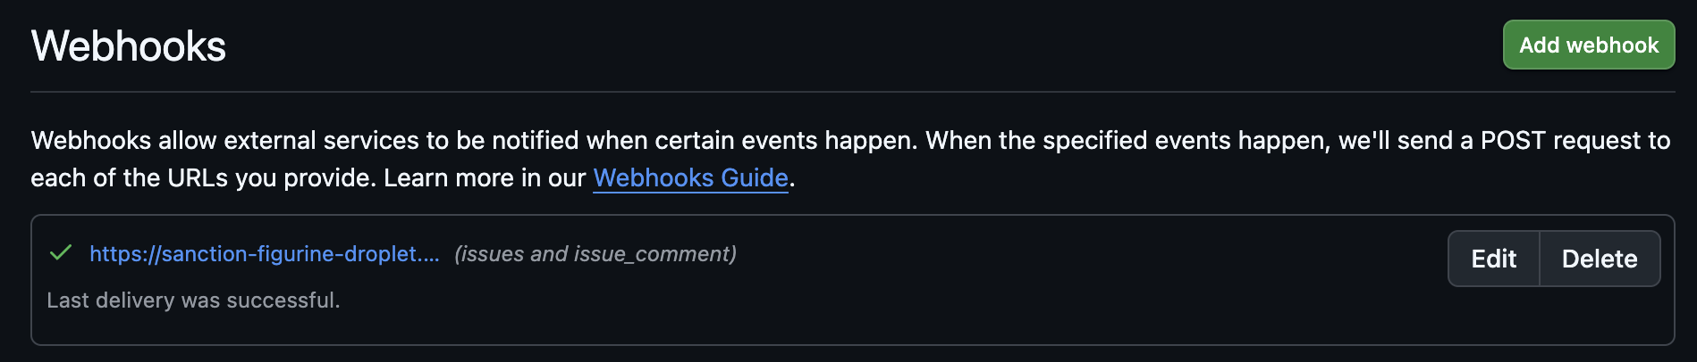
Figure 13. The repository webhook page shows the public endpoint subscribed to issue and issue-comment events with a successful latest delivery.

WEBHOOK AND IDEMPOTENCY EVIDENCE
Figure 14 — Verified GitHub delivery
Explanation. The 204 result confirms that the webhook signature and event payload were accepted.
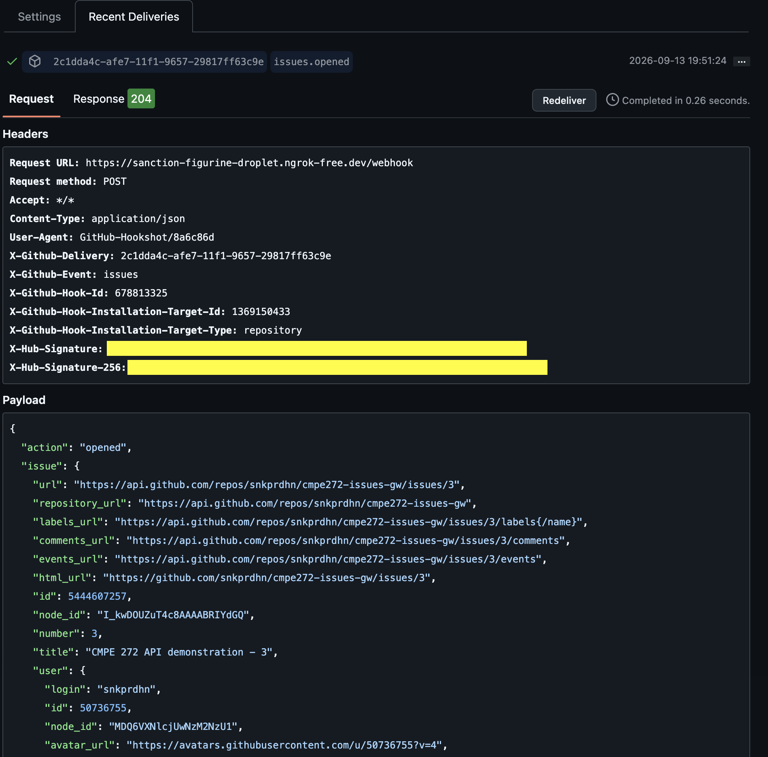
Figure 14. GitHub records an issues.opened webhook request whose signed delivery was accepted by the service with HTTP 204.

WEBHOOK AND IDEMPOTENCY EVIDENCE
Figure 15 — Stored webhook events
Explanation. The events endpoint provides a simple audit view of webhook deliveries received by the service.
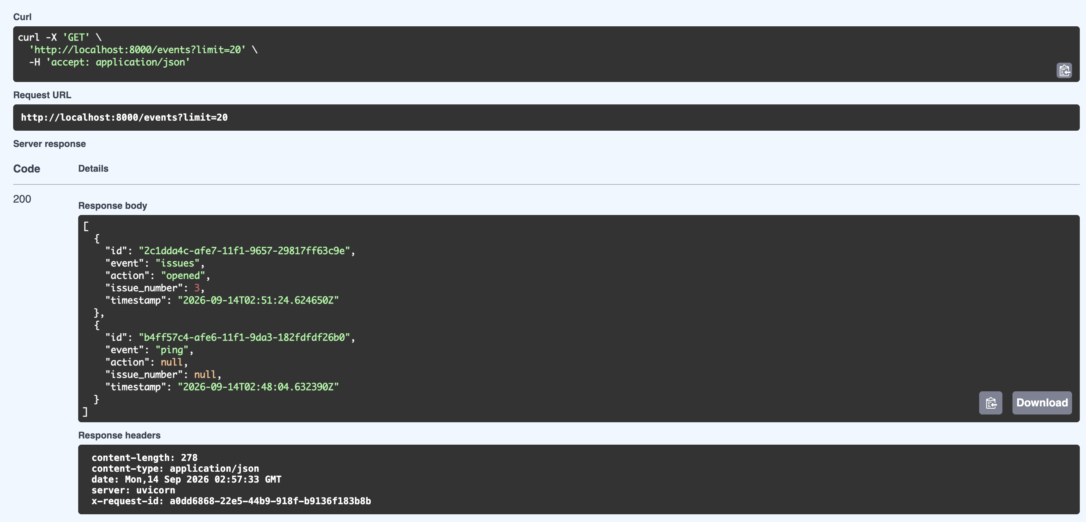
Figure 15. A GET request to /events returns HTTP 200 and exposes the stored delivery ID, event name, action, issue number, and timestamp.

WEBHOOK AND IDEMPOTENCY EVIDENCE
Figure 16(a) — GitHub redelivery
Explanation. Redelivering the same GitHub delivery creates the duplicate request needed to test idempotency.
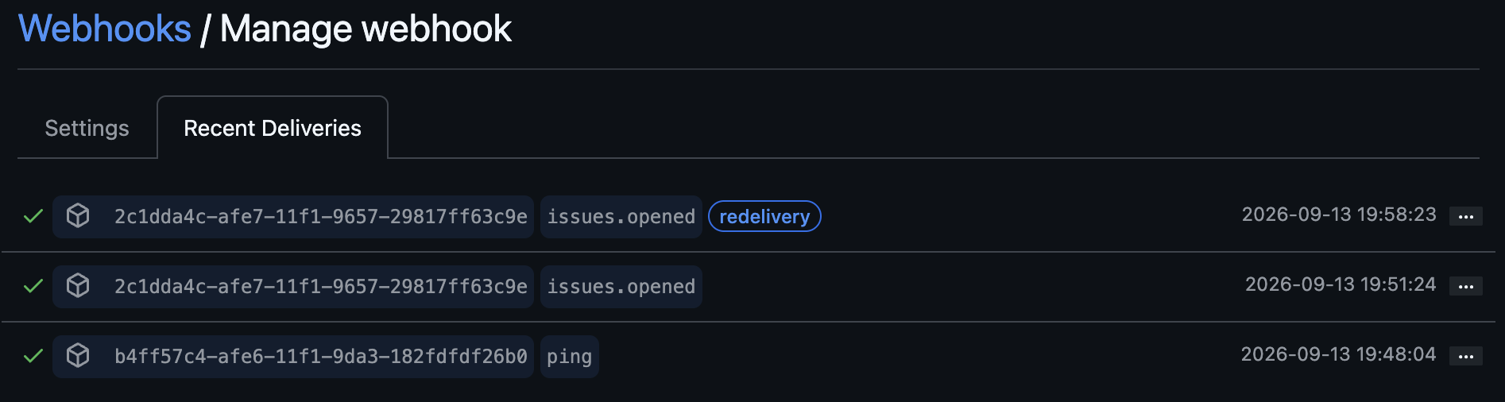
Figure 16(a). GitHub shows the same delivery ID redelivered successfully, providing the duplicate request used for the idempotency check.

WEBHOOK AND IDEMPOTENCY EVIDENCE
Figure 16(b) — Deduplicated event storage
Explanation. Because the delivery ID appears only once, the service did not store the duplicate a second time.
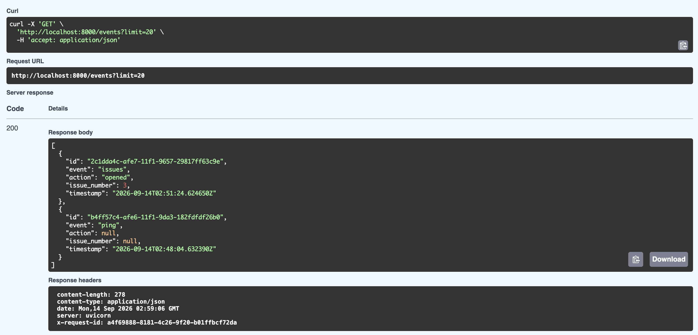
Figure 16(b). After redelivery, /events still contains one record for the repeated delivery ID, demonstrating idempotent webhook storage.

AUTOMATED TEST AND COVERAGE EVIDENCE
Figure 17 — Lint and offline unit tests
Explanation. These checks verify code style and the repeatable offline test suite before live testing.
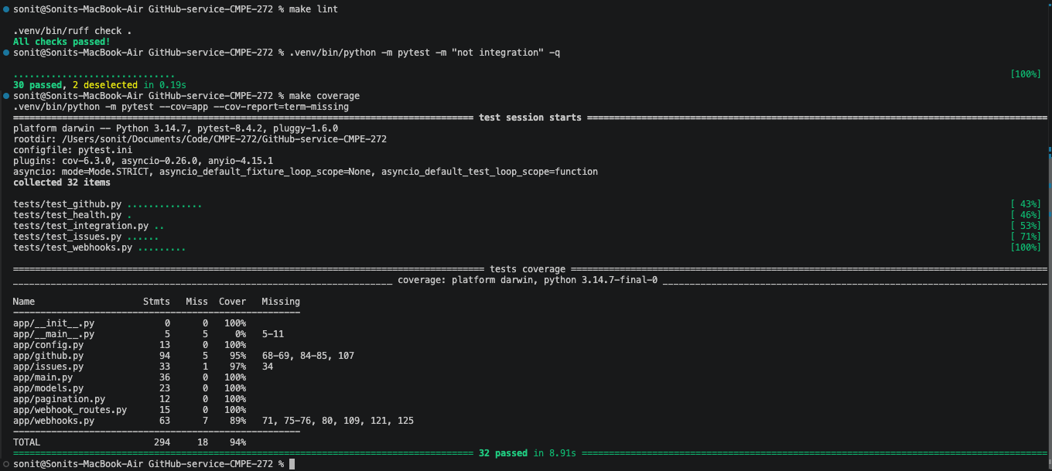
Figure 17. Ruff reports all checks passed and the offline pytest run reports 30 passed with the two live integration tests deselected.

AUTOMATED TEST AND COVERAGE EVIDENCE
Figure 18 — Coverage above 80 percent
Explanation. The reported 94 percent result exceeds the assignment's 80 percent coverage requirement.
Figure 18. The coverage portion of the combined test capture reports 94 percent total coverage across the application modules.

AUTOMATED TEST AND COVERAGE EVIDENCE
Figure 19 — Live GitHub issue integration test
Explanation. This live test verifies the end-to-end issue lifecycle against the configured GitHub repository.
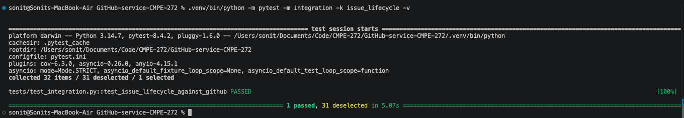
Figure 19. The live issue lifecycle integration request completes successfully with one test passed.

AUTOMATED TEST AND COVERAGE EVIDENCE
Figure 20 — Live webhook integration test
Explanation. This live test confirms that a real webhook becomes available through the events endpoint.
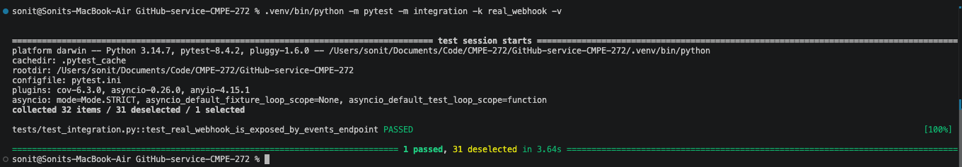
Figure 20. The live webhook event exposure integration request completes successfully with one test passed.

DOCKER AND CI EVIDENCE
Figure 21(a) — Docker image build and container start
Explanation. The build and startup output show that the application can run from the submitted Dockerfile.
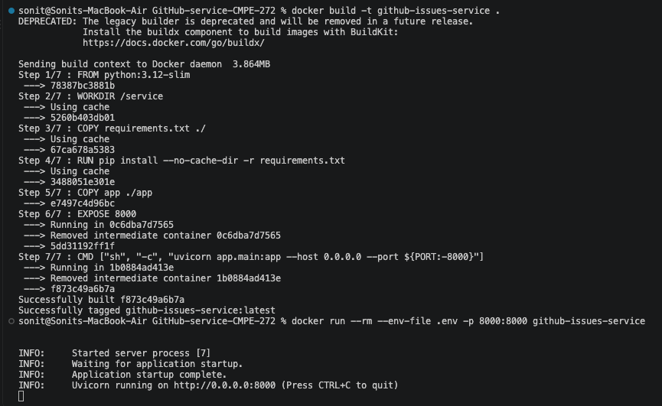
Figure 21(a). Docker builds the github-issues-service image successfully and starts Uvicorn inside the container on port 8000.

DOCKER AND CI EVIDENCE
Figure 21(b) — Container health verification
Explanation. The health response confirms that the container is reachable on the mapped port.
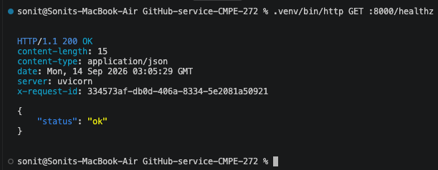
Figure 21(b). A health request against the container returns HTTP 200 with a status value of ok.

DOCKER AND CI EVIDENCE
Figure 22 — GitHub Actions continuous integration
CI should run the same lint and test checks on each push. The screenshot has not been captured yet, so the required placeholder remains below.
#TODO
Add a screenshot of the GitHub Actions workflow showing the lint and test jobs completed successfully.
Figure 22 will document the CI request context and the observed green workflow result after the repository workflow has run.

APPENDIX — EXTRA CREDIT EVIDENCE
Figure EC-1 — Conditional GET with ETag
Explanation. This extra-credit test verifies that a cached ETag is reused for a conditional GitHub request.
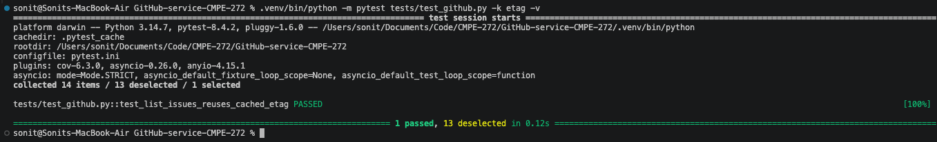
Figure EC-1. The focused ETag test passes, confirming that repeated issue-list requests reuse the cached entity tag for conditional retrieval.

