Ozone Level Classification
Sikem Nkwawir
December 07, 2024

Introduction
In this project, I aim to classify ozone levels in El Paso, a city known for its significant ozone concentration, using data from 2015 to 2019. The focus is on distinguishing between high and low ozone days, a critical task for environmental health, given the detrimental effects of ground-level ozone on human and ecosystem health. I will apply two machine learning techniques, logistic regression and artificial neural networks (ANN), to this binary classification problem. The choice of these methods provides a comparison between a traditional statistical approach and a more complex computational model, potentially offering deeper insights into the patterns and factors influencing ozone levels. This analysis is not only essential for predicting ozone concentrations but also for understanding which model best fits this dataset.
## Importing Libraries Used
library(caret)
library(naniar)
library(glmnet)
library(cvAUC)
library(verification)
library(e1071)
library(ROCR)
library(precrec)
library(ggplot2)
library(neuralnet)

Data Collection: Bring in the Data into R
In this section, I loaded the dataset into R from a local copy saved on my computer. The first step is to determine the dataset's structure by examining its dimensions. This specifically involves counting the number of rows, which represent the observations, and the columns, which indicate the variables.
setwd("/Users/Trade/Desktop/Math 5310/Lecture Note/Lecture 16 - Final Project")
data <- read.csv("ozone-data2.csv", header = T)
dim(data) #Check the dimension of the data
## [1] 973 14
head(data) #Showing the first few lines of the data
## NitricOxide NitrogenDioxide OxidesofNitrogen WindSpeed ResultantWindSpeed
## 1 -0.2 1.7 1.6 9.2 9.0
## 2 0.8 9.2 10.0 3.8 2.0
## 3 0.5 4.0 4.5 12.9 12.2
## 4 1.1 26.9 28.1 4.4 4.1
## 5 0.1 3.6 3.7 8.5 8.1
## 6 0.7 5.6 6.2 6.5 5.5
## ResultantWindDirection MaximumWindGust Std.Dev.WindDirection
## 1 83 17.8 14
## 2 221 8.6 56
## 3 92 25.4 20
## 4 116 9.4 20
## 5 287 17.9 19
## 6 145 15.0 32
## OutdoorTemperature DewPointTemperature RelativeHumidity SolarRadiation PM10
## 1 79.7 51.1 37.0 0.047 31.3
## 2 85.7 43.9 23.3 1.209 66.2
## 3 93.1 45.8 19.8 0.896 35.9
## 4 90.2 34.2 13.8 0.000 50.8
## 5 90.7 44.8 20.7 0.000 13.7
## 6 102.1 6.0 2.9 0.713 31.0
## Ozone
## 1 0
## 2 1
## 3 0
## 4 0
## 5 0
## 6 1
tail(data) #Showing the last few lines of the data
## NitricOxide NitrogenDioxide OxidesofNitrogen WindSpeed ResultantWindSpeed
## 968 0.2 1.5 1.7 9.1 8.8
## 969 -0.1 -0.1 -0.2 7.4 6.8
## 970 0.5 4.3 4.8 6.8 5.7
## 971 0.1 8.9 9.0 4.9 4.6
## 972 -0.3 3.2 3.1 4.6 1.8
## 973 0.6 0.8 1.4 9.3 7.8
## ResultantWindDirection MaximumWindGust Std.Dev.WindDirection
## 968 301 21.1 16
## 969 269 16.5 23
## 970 94 16.9 33
## 971 98 10.4 20
## 972 144 12.0 63
## 973 251 23.9 32
## OutdoorTemperature DewPointTemperature RelativeHumidity SolarRadiation PM10
## 968 54.5 33.4 44.8 0.000 9.4
## 969 73.5 60.8 64.6 0.000 14.3
## 970 90.1 51.0 26.5 1.409 25.2
## 971 92.8 32.8 12.0 0.000 37.0
## 972 84.7 41.5 22.4 1.406 10.5
## 973 85.7 21.6 9.6 1.507 21.2
## Ozone
## 968 0
## 969 0
## 970 1
## 971 0
## 972 1
## 973 0
#str(data)
The dimensions reveal that the dataset consists of 973 rows and 14 columns (features). While all the predictor variables contain numerical (decimal) data, the target variable “Class” is a categorical variable.

Data Preparation
After importing the data into R, the next step involves:
- Data Inspection: I will conduct a thorough examination of the dataset, reviewing data types, checking for missing values that could compromise model accuracy, and identifying outliers. If missing values are discovered, I plan to employ imputation techniques to address them.
- Exploratory Data Analysis: It’s crucial to verify the dataset's balance to avoid bias in the model’s performance. I will assess and address any imbalance in the data distribution by inspecting the target variable's frequency distribution and also, exploring any associations between target and other attributes.
- Data Partitioning: The dataset will be randomly divided into a training set and a test set using a 2:1 ratio. This approach is to ensure a robust training process and reliable evaluation.
- Using Model.Matrix function: An input feature matrix is created from the training data and the test data.

Data Inspection
Here, I checked the data type and for missing values.
vnames <- colnames(data)
n <- nrow(data)
out <- NULL
for (j in 1:ncol(data)) {
vname <- colnames(data)[j]
x <- as.vector(data[,j])
n1 <- sum(is.na(x), na.rm=TRUE)
n2 <- sum(x=="NA", na.rm=TRUE)
n3 <- sum(x==" ", na.rm=TRUE)
nmiss <- n1 + n2 + n3
#miss.perc <- nmiss/n
if(mode(x) == "numeric" && length(unique(x)) == 2) {
datatype <- "categorical"
} else if(mode(x) == "numeric" && any(x %% 1 != 0)) {
datatype <- "continuous"
} else if(mode(x) == "numeric") {
datatype <- "integer"
} else {
datatype <- mode(x)
}
ncomplete <- n-nmiss
out <- rbind(out, c(features = vname, data.type = datatype, unique.no = length(unique(x)), total.count = ncomplete, missing.count = nmiss ))
}
out <- as.data.frame(out)
row.names(out) <- NULL
out
## features data.type unique.no total.count missing.count
## 1 NitricOxide continuous 82 973 0
## 2 NitrogenDioxide continuous 228 973 0
## 3 OxidesofNitrogen continuous 238 973 0
## 4 WindSpeed continuous 146 973 0
## 5 ResultantWindSpeed continuous 153 973 0
## 6 ResultantWindDirection integer 270 973 0
## 7 MaximumWindGust continuous 242 973 0
## 8 Std.Dev.WindDirection integer 68 973 0
## 9 OutdoorTemperature continuous 367 973 0
## 10 DewPointTemperature continuous 442 973 0
## 11 RelativeHumidity continuous 459 973 0
## 12 SolarRadiation continuous 549 973 0
## 13 PM10 continuous 451 973 0
## 14 Ozone categorical 2 973 0
## To visualize any missing data
gg_miss_var(data)
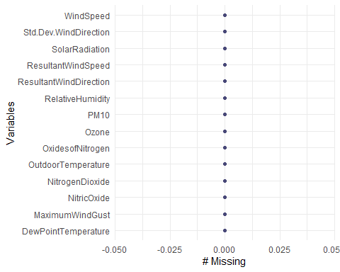
From the above results, it is evident that my dataset contains no missing values. Also, all the predictor features are numerical, except the response variable “Ozone,” which is Categorical.

Exploratory Data Analysis
Here I perform some exploratory data analysis.

Inspecting the Frequency Distribution of the Target Variable
## Frequency distribution of the target variable
freq_table <- table(data$Ozone)
freq_df <- as.data.frame(freq_table)
names(freq_df) <- c("Ozone_Level", "Count")
## Where 0 represents 'Low Ozone' and 1 represents 'High Ozone'
freq_df$Ozone_Level <- ifelse(freq_df$Ozone_Level == 0, 'Low Ozone', 'High Ozone')
## Proportion
freq_df$Proportion <- (freq_df$Count / sum(freq_df$Count)) * 100
freq_df
## Ozone_Level Count Proportion
## 1 Low Ozone 600 61.66495
## 2 High Ozone 373 38.33505
## Visual Distribution
bp <- barplot(prop.table(freq_table), main = "Proportion of Ozone Levels",
ylab = "Proportion", xlab = "Ozone Level")
labels <- c("Low Ozone", "High Ozone")
text(x = bp, y = -0.03, labels = labels, srt = 0, adj = 0.5, xpd = T, cex = 1)
text(x = bp, y=prop.table(freq_table), labels=round(prop.table(freq_table), 4)
*100, pos = 1, cex = 1.2)
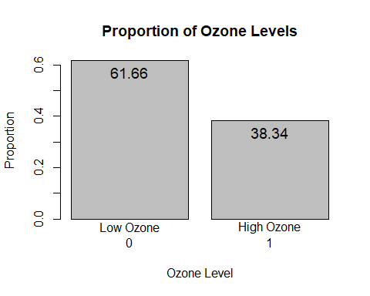
The result shows that out of the total observations, approximately 61.66% are categorized as ‘Low Ozone’ days, and 38.34% are ‘High Ozone’ days. This distribution provides a baseline understanding of the balance in the dataset, which is essential for further analysis and model training.

Inspecting the associations between target and other attributes
## calculate correlation for all predictor variables with the target variable
correlation_results <- sapply(data[, sapply(data, is.numeric)],
function(x) cor(x, data$Ozone, use = "complete.obs"))
correlation_results
## NitricOxide NitrogenDioxide OxidesofNitrogen
## -0.2027734 -0.2693558 -0.2706398
## WindSpeed ResultantWindSpeed ResultantWindDirection
## -0.3741233 -0.4783444 -0.1040115
## MaximumWindGust Std.Dev.WindDirection OutdoorTemperature
## -0.2048311 0.6446775 0.4968748
## DewPointTemperature RelativeHumidity SolarRadiation
## -0.1990995 -0.4423551 0.4779305
## PM10 Ozone
## -0.1006200 1.0000000

The dataset's correlation analysis reveals that higher temperatures and solar radiation are positively correlated with ozone levels, suggesting that warmer conditions are conducive to higher ozone levels. Conversely, higher wind speeds and humidity are associated with lower ozone levels. Notably, pollutants such as Nitric Oxide, Nitrogen Dioxide, and Oxides of Nitrogen are inversely correlated with ozone, indicating that ozone levels decrease with rising concentrations of these pollutants. Similarly, factors such as Wind Speed, Resultant Wind Speed, Resultant Wind Direction, and Maximum Wind Gust are negatively correlated with ozone, reinforcing the trend of lower ozone levels under stronger winds. Additionally, Dew Point Temperature and Relative Humidity are also negatively associated with ozone, further underscoring the trend of lower ozone levels in more humid conditions.

## Box Plot of the target variable and other attributes
## Box Plot of Ozone and MaximumWindGust
ggplot(data, aes(x = factor(Ozone), y = MaximumWindGust)) + geom_boxplot() +
labs(x = "Ozone Level", y = "MaximumWindGust") + theme_minimal()
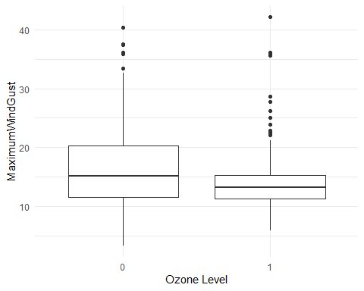
## Box Plot of Ozone and RelativeHumidity
ggplot(data, aes(x = factor(Ozone), y = RelativeHumidity)) + geom_boxplot() +
labs(x = "Ozone Level", y = "RelativeHumidity") + theme_minimal()
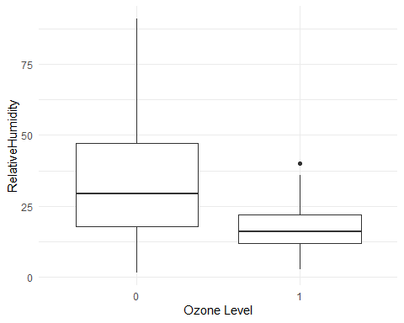
## Box Plot of Ozone and OutdoorTemperature
ggplot(data, aes(x = factor(Ozone), y = OutdoorTemperature)) + geom_boxplot() +
labs(x = "Ozone Level", y = "OutdoorTemperature") + theme_minimal()
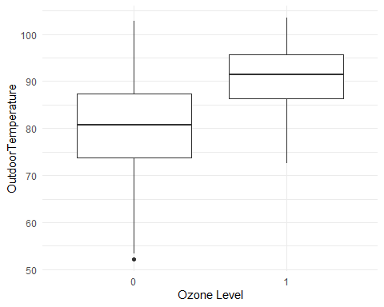
## Box Plot of Ozone and SolarRadiation
ggplot(data, aes(x = factor(Ozone), y = SolarRadiation)) + geom_boxplot() +
labs(x = "Ozone Level", y = "SolarRadiation") + theme_minimal()
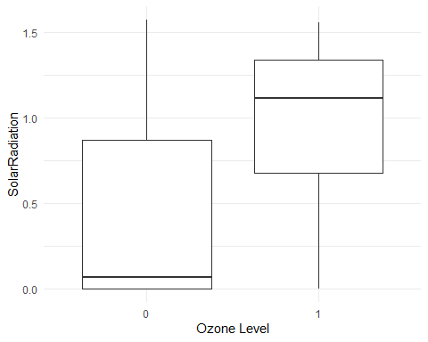

The box plots reveal a distinct pattern in environmental variables relative to ozone levels. On days classified as low-ozone, wind gusts and speeds are notably higher, suggesting that wind plays a role in dispersing or mitigating ozone. In contrast, high-ozone days feature lower wind gusts and lower wind speeds. Furthermore, these low-ozone days exhibit a greater range and median relative humidity, suggesting an inverse relationship with ozone concentration. On the other hand, high ozone days are characterized by elevated temperatures and solar radiation, indicating a direct correlation with increased ozone levels, which aligns with the findings from the correlation analysis.
I also observed some distinct outliers in both low and high ozone layers for NitricOxide, MaximumWindGust, NitrogenDioxide, OxidesofNitrogen, WindSpeed, ResultantWindSpeed, Std.Dev.WindDirection, DewPointTemperature, and PM10.

## Scatter plot of the target variable and other attributes
ggplot(data, aes(x = OutdoorTemperature, y = RelativeHumidity,
color = factor(Ozone))) + geom_point() + labs(x = "OutdoorTemperature",
y = "RelativeHumidity", color = "Ozone Level") + theme_minimal()
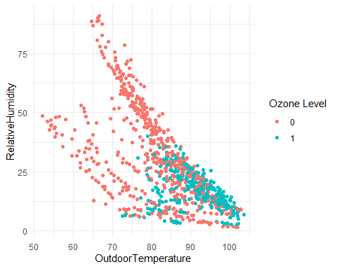

The first scatter plots shows that there is a visible trend showing that as outdoor temperature increases, relative humidity decreases. This trend is more pronounced on days with high ozone levels, suggesting that warmer, drier conditions may be conducive to higher ozone concentrations.
ggplot(data, aes(x = SolarRadiation, y = WindSpeed,
color = factor(Ozone))) + geom_point() + labs(x = "SolarRadiation",
y = "WindSpeed", color = "Ozone Level") + theme_minimal()
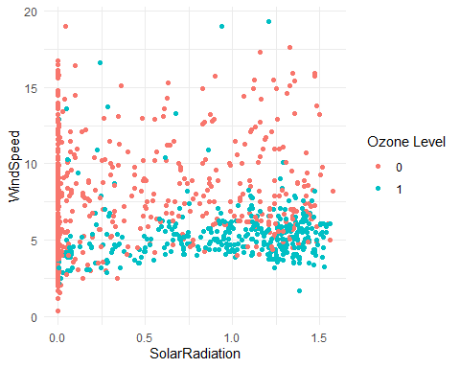

The second plot suggests a cluster of lower wind speeds associated with higher solar radiation on high ozone days. This could indicate that still conditions combined with strong solar radiation are favorable for the formation of ozone.
ggplot(data, aes(x = Std.Dev.WindDirection, y = NitricOxide ,
color = factor(Ozone))) + geom_point() + labs(x = "Std.Dev.WindDirection",
y = "NitricOxide ", color = "Ozone Level") + theme_minimal()
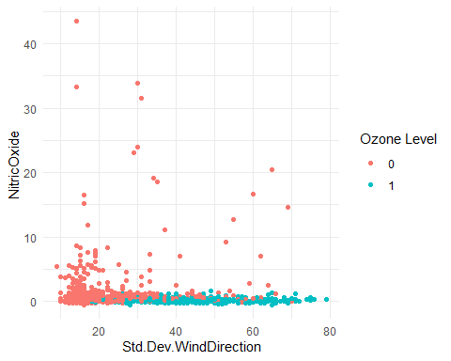

Lastly, high ozone levels appear to coincide with lower and more stable concentrations of nitric oxide, which is less dispersed on days with less variability in wind direction.

In conclusion, the Exploratory Data Analysis indicates that ozone levels have a positive association with higher temperatures and solar radiation, suggesting that warm, sunny conditions may elevate ozone concentrations. Conversely, increased wind speeds, wind gusts, and humidity are generally associated with lower ozone levels, implying a dispersing or mitigating effect on ozone by these factors. Furthermore, the presence of certain pollutants like Nitric Oxide and Nitrogen Dioxide is inversely related to ozone levels. Visual data analysis through scatter plots also supports these findings, showing higher ozone levels on days with lower humidity and wind speeds but increased temperatures and solar radiation, which reinforces the complex relationship between weather conditions and ozone concentration.

Data Partitioning
I randomly split the data into the training set train and the test set test with a ratio of 2:1 in sample size.
set.seed(123)
n <- nrow(data)
split_data <- sample(x=1:2, size = n, replace=TRUE, prob=c(0.67, 0.33))
train <- data[split_data == 1, ]
test <- data[split_data == 2, ]
y.train <- train$Ozone
yobs <- test$Ozone

Model Matrix Function
## Creating a input feature matrix from train data
## Trim off the first column and leaving only the predictors
formula0 <- factor(Ozone)~.
X.train <- model.matrix (as.formula(formula0), data = train)[, -1]
#head(X.train)
## Creating a input feature matrix from test data
X.test <- model.matrix (as.formula(formula0), data = test)[, -1]
#head(X.test)
Finally I are ready to begin modelling, I have the predictor attributes for the Training data labelled as “X.train” and the predicted variable labelled as “y.train” and the same for the test data labelled “X.test” and “yobs” respectively.

Logistic Regression
In the modeling phase of this project, I applied a regularized logistic regression model to the training data, utilizing the Elastic Net method. This method is chosen for its proficiency in managing correlated predictors while also adeptly selecting relevant features. I carefully calibrate the tuning parameter and displayed the coefficients of the model. Finally, I test the model’s performance by predicting the Ozone on the test dataset. This step evaluates the model’s ability to effectively identify Ozone levels.

Fitting Regularized Logistic Regression (Elastic Net) on Training Data
## Build a Logistic Regression using the Train Data
## Using cross validation to determine the optimal tuning parameter.
CV <- cv.glmnet(x=X.train, y=y.train, family="binomial", alpha = 0.5,
nlambda = 200, standardize = T, thresh = 1e-08, nfolds=6, maxit=10000)
plot(CV)
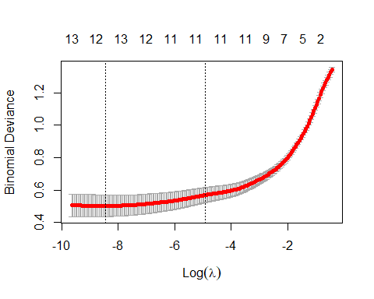
CV$lambda.min
## [1] 0.0002155779
CV$lambda.1se
## [1] 0.007265114
# Using lambda that gives the most regularized model within 1sd of minimum error
b.lambda <- CV$lambda.1se
I chose an alpha value of 0.5, which is a mix of lasso and ridge regularization (Elastic Net). As the Lambda value increases, the MSE initially reaches a minimum and then starts to increase as the lambda values increase, and the model becomes too simple. The optimal value of lambda that minimizes the cross-validation error is 0.0002155779, but the lambda value that provides the most regularized model and still yields a minimum error (within 1 standard deviation away from the minimum) is 0.007265114.
#Fit the best model using obtained lambda
Best_Model <- glmnet(x=X.train, y=y.train, family="binomial", alpha = 0.5,
lambda=b.lambda, standardize = T, thresh = 1e-07, maxit=1000)
The final model is fitted using the best tuning parameter 0.007265114- the lambda value that represents the most regularized model within one standard deviation of the minimum error.

Print the coefficients of the model.
#Print out the coefficient of the Model
(Best_Model$beta)
## 13 x 1 sparse Matrix of class "dgCMatrix"
## s0
## NitricOxide -0.399705169
## NitrogenDioxide -0.011602318
## OxidesofNitrogen -0.069798419
## WindSpeed -0.106751085
## ResultantWindSpeed -0.184565354
## ResultantWindDirection -0.003519789
## MaximumWindGust .
## Std.Dev.WindDirection 0.059632380
## OutdoorTemperature 0.033671210
## DewPointTemperature 0.009744016
## RelativeHumidity -0.062531932
## SolarRadiation 0.878309569
## PM10 0.013564112
It appears the coefficients of MaximumWindGust is shrunk towards zero. The Non-zero coefficients are considered significant in this model and the coefficients that go to zero are less significant to the data. The coefficients for SolarRadiation, NitricOxide, ResultantWindSpeed and WindSpeed are the largest, suggesting they have a strong relationship with the response variable Class.

Applying the logistic model to the test data.
Here, I utilized the best model to make predictions on the test data.
# Predicting the Test data
pred <- predict(Best_Model, newx = X.test, s=b.lambda, type="response")
dim(pred)
## [1] 318 1
pred<-pred[, 1]
The dimensions of the prediction are printed, showing that there are predictions for 318 test cases.

Model Evaluation

Mean Square Error
# Calculating MSE
MSE.a <- mean((yobs-pred)^2)
MSE.a
## [1] 0.09876387
The Mean Squared Error (MSE) is calculated as 0.0988 using the predicted probabilities and the observed values (yobs). This metric measures the average squared difference between the predicted values and the actual value. Although this value is quite low, which might initially seem to indicate good model performance, it’s important to remember that MSE in isolation might not always be the best metric to evaluate a model, especially for a classification problem where outcomes are categorical.

Misclassification Rate
# Finding missclassification rate
pred1 <- ifelse(pred>0.5, 1, 0)
(miss.rate <- mean(yobs != pred1))
## [1] 0.1415094
The misclassification rate is calculated at 0.142, which measures the proportion of incorrectly predicted instances when the probability threshold is 0.5 to make a binary decision. In other words, about 14.15% of the model’s predictions were incorrect. This is a relatively low rate, suggesting that the model is quite accurate in its predictions.
While both the MSE and the misclassification rate suggest that the model performs well, I also check the ROC curve and Confusion Matrix

ROC Curve
#Plotting ROC curve of the fit.best model.
AUC <-ci.cvAUC(predictions=pred, labels=yobs, folds=1:NROW(test), confidence=0.95)
AUC
## $cvAUC
## [1] 0.9371034
##
## $se
## [1] 0.01336124
##
## $ci
## [1] 0.9109158 0.9632909
##
## $confidence
## [1] 0.95
auc.AUC <- round(AUC$cvAUC, digits = 3) #Area Under the Curve
auc.se <- round(AUC$se, digits = 3) #Standard Error
auc.conf <- round(AUC$confidence, digits = 2) #Confidence Level
auc.ci <- round(AUC$ci, digits = 3) #Confidence interval
mod.glm <- verify(obs = yobs, pred = pred, baseline = NULL)
## If baseline is not included, baseline values will be calculated from the sample obs.
roc.plot(mod.glm, plot.thres=NULL)
text(x=0.5, y=0.05, paste("Area under ROC = ", auc.AUC, "with 95% CI (",
auc.ci[1], ",", auc.ci[2], ")", sep = " "), col="red", cex =1.0)
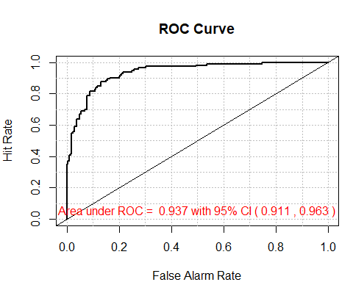
This display shows the Area Under the Curve (AUC) for a ROC curve. The AUC measures the model’s ability to discriminate between the two classes: High Level or Low Level. An AUC of approximately 0.94 is considered excellent, indicating that the model has a high ability to distinguish between days with High Level Ozone and Low Level Ozone. With 95% confidence, the true AUC is estimated to be between approximately 0.911 and 0.963. The narrow range of this interval further suggests a high level of precision in the AUC estimate

Confusion Matrix
## Confusion matrix
confusionMatrix( as.factor(pred1),as.factor(yobs),positive = "1")
## Confusion Matrix and Statistics
##
## Reference
## Prediction 0 1
## 0 174 14
## 1 31 99
##
## Accuracy : 0.8585
## 95% CI : (0.8153, 0.8949)
## No Information Rate : 0.6447
## P-Value [Acc > NIR] : < 2e-16
##
## Kappa : 0.7012
##
## Mcnemar's Test P-Value : 0.01707
##
## Sensitivity : 0.8761
## Specificity : 0.8488
## Pos Pred Value : 0.7615
## Neg Pred Value : 0.9255
## Prevalence : 0.3553
## Detection Rate : 0.3113
## Detection Prevalence : 0.4088
## Balanced Accuracy : 0.8624
##
## 'Positive' Class : 1
##
#precision(as.factor(yobs),as.factor(pred1))
#recall(as.factor(yobs), as.factor(pred1))
Confusion Matrix:
- 174 True Negatives (TN): The model correctly predicted low ozone (0) 174 times.
- 14 False Negatives (FN): The model incorrectly predicted low ozone (0) when it was actually high ozone (1) 14 times.
- 31 False Positives (FP): The model incorrectly predicted high ozone (1) when it was actually low ozone (0) 31 times.
- 99 True Positives (TP): The model correctly predicted high ozone (1) 99 times.
Accuracy: 85.85% - The model’s predictions are correct 85.85% of the time.
Sensitivity (Recall): 87.61% - The model correctly identifies 87.61% of actual high ozone days.
Specificity: 84.88% - The model correctly identifies 84.88% of actual low ozone days.
Positive Predictive Value (Precision): 76.15% - When the model predicts high ozone, it is correct 76.15% of the time.
Negative Predictive Value: 92.55% - When the model predicts low ozone, it is correct 92.55% of the time.
Prevalence: 35.53% - The proportion of actual high ozone days in the dataset.
Detection Rate: 31.13% - The proportion of actual high ozone days correctly identified by the model.
Detection Prevalence: 40.88% - The proportion of cases predicted as high ozone by the model.

Artificial Neural Network Model
In the second modeling phase of this project, I applied the artificial neural network to the training data. I decide to use 2 hidden layers and 4 and 3 neurons in the first and second layer respectively to give a high accuracy. I carefully selected the tuning parameters and displayed the visualization for the model. Finally, I tested the model’s performance by predicting the Ozone on the test dataset. This step evaluates the model’s ability to effectively identify Ozone levels.

Fitting Artificial Neural Network on Training Data
set.seed(12)
## Building a Artificial Neural Network Model using the Train Data
## Fit an ANN model to the training dataset
nnet <- neuralnet(Ozone~.,
data=train,
hidden=c( 4, 3), # No of neurons in the two hidden layers
act.fct='logistic', # Activation function
err.fct="ce", # Error function
linear.output=FALSE, # Indicates a classification problem
likelihood=TRUE, # Calculate likelihood
learningrate=0.01, # Learning rate
algorithm="backprop", # Algorithm for training (Standard backpropagation)
stepmax=200000, # Maximum number of steps (epochs)
rep=1, # No of times the network is trained with different initial weights
threshold=0.01, # Threshold for partial derivatives of the error function as stopping criteria
)
# Plot the neural network
plot(nnet, rep="best", show.weights=TRUE, dimension=7, information=FALSE, radius=.2,
col.hidden="red", col.hidden.synapse="black", lwd=0.8, fontsize=9)
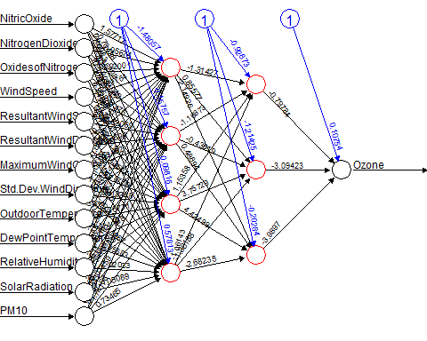

Tuning parameters
Here I used multiple hyperparameter which includes:
- The number of hidden layers (hidden=c( 4, 3)). Here I used 2 hidden layers.
- The number of neurons in each hidden layer (hidden=c( 4, 3)). Here I used 6 in the first layer and 4 in the second layer.
- The activation function (act.fct=‘logistic’). Here I used logistic sigmoid function, which is typical for binary classification tasks like this. Other are:
  - “tanh” The hyperbolic tangent function.
  - “relu” The rectified linear activation function.
  - “softplus” A smooth approximation to the ReLU function.
- The error function (err.fct=“ce”). Here I used cross-entropy, which is appropriate for a binary outcome like this. Others are:
  - “sse”: Sum of squared errors.
  - “mse”: Mean squared error.
  - “mae”: Mean absolute error.
- The output is linear or not (linear.output=FALSE). Here I used false, which indicates that the output is treated as a classification rather than a regression problem.
- The inclusion of likelihood calculation (likelihood=TRUE). Here I used true, which implies that the model fitting includes the calculation of the likelihood of the data given the model.
- The learning rate (learningrate=0.01). Here I used 0.01, which specifies the rate at which the model learns.
- The training algorithm (algorithm=“backprop”). Here I used the Standard backpropagation. Others are:
  - “rprop+”: Resilient backpropagation with weight backtracking.
  - “rprop”: Resilient backpropagation without weight backtracking.
  - “slr”: Scaled conjugate gradient descent.
- The max training step/epoch (stepmax=200000): Here I used 200000, which sets the maximum number of training steps and can be used as a stopping criteria for the model training.
- Others are (rep=1): which is the number of times the network is trained with different initial weights and (threshold=0.01) which is used as a stopping criteria as threshold for partial derivatives of the error function.

Applying the Artificial Neural Network model to the test data.
Here, I utilized the ANN model to make predictions on the test data.
# Predicting the Test data
ypred <- compute(nnet, covariate=X.test)$net.result
dim(ypred)
## [1] 318 1
ypred <- ypred[, 1]
The dimensions of the prediction are printed, showing that there are predictions for 318 test cases.

Model Evaluation

Mean Square Error
# Calculating MSE
MSE.b <- mean((yobs-ypred)^2)
MSE.b
## [1] 0.230807
The Mean Squared Error (MSE) is calculated as 0.231 using the predicted probabilities and the observed values (yobs). This metric measures the average squared difference between the predicted values and the actual value. Although this value is quite low, which might initially seem to indicate good model performance, it’s important to remember that MSE in isolation might not always be the best metric to evaluate a model, especially for a classification problem where outcomes are categorical.

Misclassification Rate
# Finding missclassification rate
ypred1 <- ifelse(ypred>0.5, 1, 0)
(miss.rate <- mean(yobs != ypred1))
## [1] 0.3553459
The misclassification rate is calculated at 0.355, which measures the proportion of incorrectly predicted instances when the probability threshold is 0.5 to make a binary decision. In other words, about 14.15% of the model’s predictions were incorrect. This is a relatively low rate, suggesting that the model is quite accurate in its predictions.
While both the MSE and the misclassification rate suggest that the model performs well, I also check the ROC curve and Confusion Matrix

ROC Curve
#Plotting ROC curve of the fit.best model.
AUC <-ci.cvAUC(predictions=ypred, labels=yobs, folds=1:NROW(test), confidence=0.95)
AUC
## $cvAUC
## [1] 0.5038852
##
## $se
## [1] 0.05792695
##
## $ci
## [1] 0.3903504 0.6174199
##
## $confidence
## [1] 0.95
auc.AUC <- round(AUC$cvAUC, digits = 3) #Area Under the Curve
auc.se <- round(AUC$se, digits = 3) #Standard Error
auc.conf <- round(AUC$confidence, digits = 2) #Confidence Level
auc.ci <- round(AUC$ci, digits = 3) #Confidence interval
mod.glm <- verify(obs = yobs, pred = ypred, baseline = NULL)
## If baseline is not included, baseline values will be calculated from the sample obs.
roc.plot(mod.glm, plot.thres=NULL)
text(x=0.5, y=0.05, paste("Area under ROC = ", auc.AUC, "with 95% CI (",
auc.ci[1], ",", auc.ci[2], ")", sep = " "), col="red", cex =1.0)
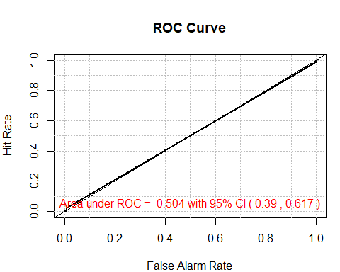
This analysis presents the Area Under the Curve (AUC) for a ROC curve, which evaluates the model’s ability to distinguish between two classes: High Level and Low Level Ozone. In this case, the AUC of approximately 0.508 suggests that the model performs only slightly better than random chance in discriminating between days with High Level and Low Level Ozone. The 95% confidence interval for the true AUC, ranging from approximately 0.394 to 0.622, indicates a moderate level of uncertainty in this estimate. While the interval is relatively narrow, the AUC value itself does not reflect a high level of predictive accuracy.

Confusion Matrix
## Confusion matrix
confusionMatrix( as.factor(ypred1),as.factor(yobs),positive = "1")
## Confusion Matrix and Statistics
##
## Reference
## Prediction 0 1
## 0 205 113
## 1 0 0
##
## Accuracy : 0.6447
## 95% CI : (0.5893, 0.6973)
## No Information Rate : 0.6447
## P-Value [Acc > NIR] : 0.5256
##
## Kappa : 0
##
## Mcnemar's Test P-Value : <2e-16
##
## Sensitivity : 0.0000
## Specificity : 1.0000
## Pos Pred Value : NaN
## Neg Pred Value : 0.6447
## Prevalence : 0.3553
## Detection Rate : 0.0000
## Detection Prevalence : 0.0000
## Balanced Accuracy : 0.5000
##
## 'Positive' Class : 1
##
#precision(as.factor(yobs),as.factor(pred1))
#recall(as.factor(yobs), as.factor(pred1))
Confusion Matrix:
- 205 True Negatives (TN): The model correctly predicted low ozone (0) 205 times.
- 113 False Negatives (FN): The model incorrectly predicted low ozone (0) when it was actually high ozone (1) 113 times.
- 0 False Positives (FP): The model did not incorrectly predict high ozone (1) when it was actually low ozone (0).
- 0 True Positives (TP): The model did not correctly predict high ozone (1) at all.
Accuracy: 64.5% - The model’s predictions are correct 64.5% of the time.
Sensitivity (Recall): 0% - The model failed to correctly identify any actual high ozone days.
Specificity: 100% - The model correctly identifies all actual low ozone days.
Positive Predictive Value (Precision): Not Applicable (NaN) - The model made no predictions for high ozone (1), so precision cannot be calculated.
Negative Predictive Value: 64.5% - When the model predicts low ozone, it is correct 64.5% of the time.
Prevalence: 35.5% - The proportion of actual high ozone days in the dataset.
Detection Rate: 0% - The proportion of actual high ozone days correctly identified by the model is zero.
Detection Prevalence: 0% - The proportion of cases predicted as high ozone by the model is zero.

Comparison
Between the Logistic Regression and Artificial Neural Network (ANN) models applied to the dataset, the Logistic Regression model appears to be more effective. This conclusion is drawn based on several performance metrics:
- Mean Squared Error (MSE):
  - Logistic Regression: MSE is 0.0988.
  - ANN: MSE is significantly higher at 0.231.
- The lower MSE in the Logistic Regression model indicates better prediction accuracy.
- Missclassification Rate:
  - Logistic Regression: The missclassification rate is 14.2%.
  - ANN: The missclassification rate is notably higher at 35.5%.
- This again favors the Logistic Regression model, as it has a lower rate of incorrectly classified observations.
- Area Under the ROC Curve (AUC):
  - Logistic Regression: The AUC is 0.937, with a 95% confidence interval ranging from 0.911 to 0.963.
  - ANN: The AUC is only 0.508, with a much broader 95% confidence interval from 0.394 to 0.622.
- The higher AUC for the Logistic Regression model implies superior ability to discriminate between High and Low Ozone levels. The AUC near 0.5 for the ANN model suggests it performs no better than random guessing.
- Accuracy and Other Metrics:
  - Logistic Regression: Shows good accuracy at 85.8% with a balanced accuracy of 86.2%, a good sensitivity (87.6%), and specificity (84.9%).
  - ANN: Shows lower accuracy at 64.5%, with a balanced accuracy of only 50%, and an extremely low sensitivity (0%), indicating it failed to correctly identify any high ozone days.
Considering these metrics, the Logistic Regression model not only shows better performance in terms of accuracy, sensitivity, and specificity, but also demonstrates a much higher capability in distinguishing between the two classes (High and Low Ozone levels) compared to the ANN model. The Logistic Regression model likely performed better than the Artificial Neural Network (ANN) because the dataset used in this study was relatively straightforward. ANNs are powerful for complex and large datasets, but they can be too intricate for simpler data, leading to overfitting where the model learns the noise rather than the actual pattern. On the other hand, Logistic Regression, being simpler and more direct, is often more suitable for less complex tasks like this one. It’s more efficient, easier to understand, and does well with clear, linear relationships, which is probably why it excelled in this case. Essentially, the dataset didn’t need the complexity of an ANN, making Logistic Regression a better fit.

Factors influencing the choice of layers and neurons in the ANN and preventing overfitting
- Factors Influencing the Design of ANN:
- Complexity of Data: The dataset had 14 features and relatively straightforward relationships, so a small ANN with two hidden layers and fewer neurons was sufficient.
- Dataset Size: With 973 rows, overly complex models (more layers and neurons) could overfit due to limited data.
- Nature of the Problem: Since this was a binary classification problem, logistic activation functions and a straightforward structure worked effectively.
- Experimentation: The chosen structure (two layers with 4 and 3 neurons) was likely selected after testing various configurations for optimal performance.
- Preventing Overfitting:
- Regularization
- Validation Split
- Early Stopping
- Simpler Model

Confusion Matrix Components and Sensitivity vs. Specificity for Classifying High/Low Ozone Days:
Confusion Matrix Components:
- True Positives (TP): 99
- False Negatives (FN): 14
- True Negatives (TN): 174
- False Positives (FP): 31
Importance of Sensitivity Over Specificity:
- Sensitivity (Recall): Measures the ability to identify actual high ozone days. It is crucial as high ozone levels can have severe health and environmental impacts, and missing these days (false negatives) could have significant consequences.
- Specificity: Measures the ability to correctly identify low ozone days. While important, misclassifying a low ozone day as high (false positives) has less severe consequences compared to missing high ozone days.
In the context of environmental health, minimizing false negatives (failing to detect high ozone days) is more critical, making sensitivity a higher priority than specificity.

Conclusion
In conclusion, this project successfully applied Logistic Regression and Artificial Neural Network (ANN) models to classify ozone levels in El Paso, using historical air pollutant and meteorological data. The comparative analysis revealed that Logistic Regression outperformed the ANN, likely due to the dataset’s relative simplicity and size, which didn’t require the complexity of an ANN. Logistic Regression demonstrated higher accuracy, better predictive capability, and was more efficient for this particular dataset. This study underscores the importance of choosing an appropriate modeling technique based on the data’s characteristics, highlighting that simpler models can often be more effective for less complex datasets.

