Predicting Taiwan Real Estate Using Linear Regression Models

Sikem Nkwawir
Date: May 7th, 2025

Introduction
Estimating residential property prices on a per‐unit‐area basis is critical for a wide range of stakeholders including prospective home-buyers and sellers who need accurate valuations to negotiate purchases, mortgage lenders and banks that rely on valuations to offer loans without taking on too much risk, planners and politicians who use neighborhood price trends to monitor housing affordability and inform zoning decisions, and real‐estate investors that depend on accurate pricing models to evaluate housing markets. To address this need, I turned to the Real Estate Valuation dataset curated by Yeh (2018) from the UCI Machine Learning Repository. Collected in Sindian District, New Taipei City, Taiwan, it records 414 transactions along with six predictors (transaction date, house age, distance to the nearest MRT station, count of nearby convenience stores, latitude, and longitude) and the corresponding price in 10,000 New Taiwan Dollars per Ping.

Methods
I began with a standard least squares linear regression model using all six predictors to establish a baseline. Diagnostic plots (residuals vs. fitted, Normal Q–Q, scale–location, Cook’s distance) revealed some possible heteroskedasticity and extremes that deviate from normality, Variance inflation factors showed no concerning multicollinearity, a Durbin–Watson test indicated residual independence, and a Shapiro–Wilk test formally rejected perfect normality, however, with over 200 observations I can assume that our predictions will still be accurate. Next, I applied stepwise model selection (forward and backward using AIC) to reduce the number of coefficients to the five most important, dropping longitude, resulting in virtually identical performance. Finally, I fitted a Lasso model using five-fold cross-validation to choose the optimal regularization parameter. This approach reduced the coefficients toward zero, slightly lowering test RMSE and raising R^2. Initially, I also experimented with adding interaction terms, but found they increased complexity while lowering accuracy, so I eventually abandoned them. Together, these three approaches demonstrate that no single model is perfect, with each having trade-offs among bias, variance, interpretability, and adherence to linear assumptions.

Conclusion
On test data, all three models achieved similar accuracy (R^2 ~0.63; RMSE ~8.1), with Lasso performing slightly better and the stepwise model offering the simplest formula. The traditional linear model remains valuable for its ease; stepwise selection further simplifies the model, and Lasso provides a bias-variance balance well-suited for code. Ultimately, the choice of model should align with stakeholder priorities: regulators and appraisers may favor the stepwise model for its clarity. At the same time, online platforms seeking optimal prediction accuracy may implement the Lasso model. I suggest the stepwise model, as it is the simplest and sacrifices little in predictive performance. Future work could explore more robust models or a combination of stepwise selection and Lasso penalization to improve the model further. In addition, another variable may improve accuracy. Still, it is entirely possible (and likely) that the error not captured by the model is due to negotiation or the lack thereof. Since a regulatory body does not determine housing prices, there will always be some deviation from what a model can predict.

References
Yeh, I. (2018). Real Estate Valuation [Dataset]. UCI Machine Learning Repository. https://doi.org/10.24432/C5J30W.

Acknowledgements
I want to extend our heartfelt thanks to Dr. Matt Jones for his instruction throughout the semester, all of which heavily contributed to the completion of this project.

Full Code and Observations
# install.packages(c("MASS","glmnet","caret","ggplot2","gridExtra"))
library(MASS) # for stepAIC()
library(glmnet) # for Lasso
## Loading required package: Matrix
## Loaded glmnet 4.1-8
library(caret) # for data splitting & metrics
## Loading required package: ggplot2
## Loading required package: lattice
library(ggplot2) # for plotting
library(gridExtra) # for arranging plots
set.seed(42)
# Splitting the data for modeling
df <- read.csv("real_estate.csv", row.names=1)
colnames(df) <- c("X1","X2","X3","X4","X5","X6","Y")
train_idx <- createDataPartition(df$Y, p = 2/3, list = FALSE)
train <- df[train_idx, ]
test <- df[-train_idx, ]
x_train <- train[,1:6]; y_train <- train$Y
x_test <- test[,1:6]; y_test <- test$Y
First, I will split the data into training and test sets. All subsequent tests and model building will be conducted using the training data, and the final comparisons will be conducted using the test data. Originally, I was going to remove date as a predictor. Still, after some thought, I realized that the data from when the transaction occurred captured information about the market at that time. This would undoubtedly influence the purchase price and allow future predictions to increase over time.
# Linear Regression Model
lm_mod <- lm(Y ~ ., data = train)
summary(lm_mod)
##
## Call:
## lm(formula = Y ~ ., data = train)
##
## Residuals:
## Min 1Q Median 3Q Max
## -35.659 -5.016 -1.058 3.898 74.428
##
## Coefficients:
## Estimate Std. Error t value Pr(>|t|)
## (Intercept) -1.551e+04 8.180e+03 -1.896 0.05907 .
## X1 5.894e+00 1.971e+00 2.990 0.00305 **
## X2 -2.885e-01 5.028e-02 -5.739 2.56e-08 ***
## X3 -4.482e-03 8.553e-04 -5.241 3.23e-07 ***
## X4 1.068e+00 2.321e-01 4.601 6.48e-06 ***
## X5 2.490e+02 5.414e+01 4.600 6.50e-06 ***
## X6 -2.083e+01 5.681e+01 -0.367 0.71413
## ---
## Signif. codes: 0 '***' 0.001 '**' 0.01 '*' 0.05 '.' 0.1 ' ' 1
##
## Residual standard error: 9.231 on 270 degrees of freedom
## Multiple R-squared: 0.5595, Adjusted R-squared: 0.5497
## F-statistic: 57.16 on 6 and 270 DF, p-value: < 2.2e-16
# Linear Assumption Check
# 4-panel diagnostic plots
par(mfrow = c(2, 2))
plot(lm_mod, which = 1:4)
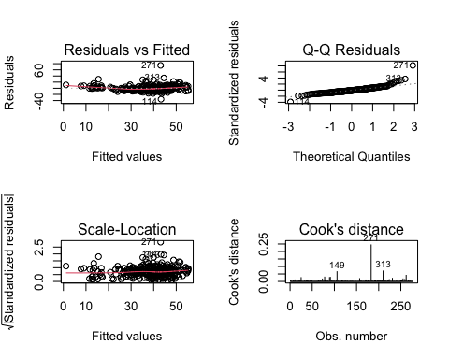
Residuals vs Fitted: Points form a roughly horizontal cloud but show a slight spread as the fitted values increase, indicating some heteroskedasticity. Based on this, I can assume linearity.
Normal Q–Q: Most points fall along the QQ line, but the extremes deviate. This is evidence of some non-normality in the extremes.
Scale–Location: The standardized residuals are fairly flat across the fitted values, matching the findings of the residuals vs. fitted plot, suggesting only a mild heteroskedasticity issue.
Cook’s Distance: No points exceed the cutoff value (4 / (n–p) ≈ 0.017), so no single observation strongly influences the fit.
# 2. Variance Inflation Factors (multicollinearity)
library(car)
## Loading required package: carData
vif_vals <- vif(lm_mod)
print(vif_vals)
## X1 X2 X3 X4 X5 X6
## 1.014598 1.011840 3.777671 1.576298 1.489352 2.518987
All VIFs are below 5, so I can assume there is no multicollinearity between the predictors.
# 3. Durbin–Watson test (independence)
library(lmtest)
## Loading required package: zoo
##
## Attaching package: 'zoo'
## The following objects are masked from 'package:base':
##
## as.Date, as.Date.numeric
dw <- dwtest(lm_mod)
print(dw)
##
## Durbin-Watson test
##
## data: lm_mod
## DW = 2.1982, p-value = 0.9517
## alternative hypothesis: true autocorrelation is greater than 0
Since the DW is close to 2, the residuals are independent.
# 4. Shapiro–Wilk test of residual normality
shapiro <- shapiro.test(residuals(lm_mod))
print(shapiro)
##
## Shapiro-Wilk normality test
##
## data: residuals(lm_mod)
## W = 0.84084, p-value = 3.39e-16
While the residuals fail the Shapiro-Wilks test, based on the previous plots, I have a large dataset, so this should not cause any issues with our predictions.
# Model 2: Stepwise feature selection
step_mod <- stepAIC(lm_mod,
direction = "both",
trace = FALSE)
cat("Stepwise selected model:\n")
## Stepwise selected model:
print(formula(step_mod))
## Y ~ X1 + X2 + X3 + X4 + X5
Stepwise AIC dropped X6 (longitude), while the other 5 predictors remained in the model.
# Model 3: Lasso with cross‐validation
xmat_train <- as.matrix(x_train)
xmat_test <- as.matrix(x_test)
cv_lasso <- cv.glmnet(xmat_train, y_train,
alpha = 1,
nfolds = 5)
lasso_mod <- glmnet(xmat_train, y_train,
alpha = 1,
lambda = cv_lasso$lambda.min)
cat("Chosen lambda for Lasso:", cv_lasso$lambda.min, "\n")
## Chosen lambda for Lasso: 0.2157724
Five-fold cross-validation selects 0.216 as the optimal lambda: this balances bias and variance by reducing the coefficients, which should lower the MSE.
# Predict & evaluate on test set
eval_metrics <- function(actual, pred) {
data.frame(
RMSE = RMSE(pred, actual),
R2 = R2(pred, actual)
)
}
pred_lm <- predict(lm_mod, newdata = test)
pred_step <- predict(step_mod, newdata = test)
pred_lasso <- as.numeric(predict(lasso_mod, xmat_test))
res_lm <- eval_metrics(y_test, pred_lm)
res_step <- eval_metrics(y_test, pred_step)
res_lasso <- eval_metrics(y_test, pred_lasso)
results <- rbind(
Trad_LM = res_lm,
Stepwise_LM = res_step,
Lasso = res_lasso
)
print(results)
## RMSE R2
## Trad_LM 8.107421 0.6296345
## Stepwise_LM 8.103694 0.6299573
## Lasso 8.079777 0.6318972
Based on the test RMSE and R^2, I see very little difference among the three models, with the Lasso-penalized model performing best.
# Plot Actual vs Predicted
p1 <- ggplot(data.frame(Actual=y_test, Pred=pred_lm),
aes(Actual,Pred)) +
geom_point(alpha=0.6) + geom_abline(linetype="dashed") +
labs(title="Traditional LM")
p2 <- ggplot(data.frame(Actual=y_test, Pred=pred_step),
aes(Actual,Pred)) +
geom_point(alpha=0.6) + geom_abline(linetype="dashed") +
labs(title="Stepwise LM")
p3 <- ggplot(data.frame(Actual=y_test, Pred=pred_lasso),
aes(Actual,Pred)) +
geom_point(alpha=0.6) + geom_abline(linetype="dashed") +
labs(title="Lasso")
grid.arrange(p1,p2,p3, ncol=3)
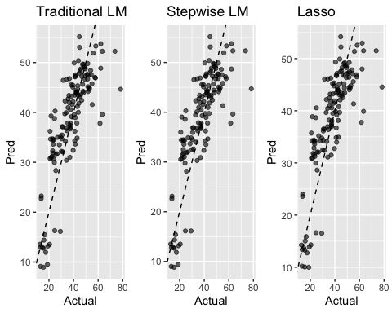
The three plots show just how close the models are in terms of prediction accuracy. Each plot is nearly identical, with the predictions matching the data’s increasing trend.

