Before going further we will understamd the core algorithm well. To understand thsi algorithm I have taken an image a example.
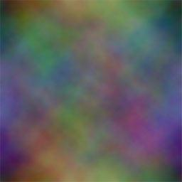

This image is made up of various colours. Actually an image is a 3D dataset having R, G, B array at the back.
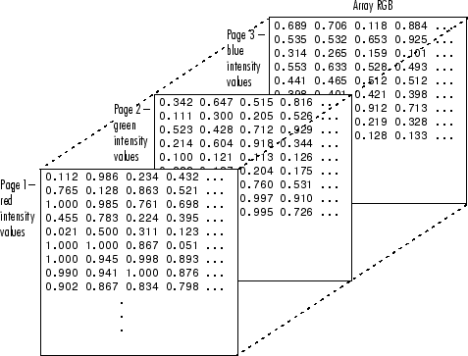

Image taken from Mathworks site
It is very much clear from the above figure that each image is made up of 3D array of intensities of blue green and red. If such 4D dataset was provided then we would not be able to see it as we see this image.
As we see this image, it is having various colours. Visual colour is a visible part of this image. The values behind this image is hidden part of this image. Hidden data is acually responsible for visual colours.
Such diamentions (here RGB) is known as weights in SOM. As we have taken image as an exmaple, we can visualize form beginning and can recored the progress of algorithm. It is absolutely not necessary to have visual data from biginnning. We have data of 100 dimention and hence 100 such weight associated to decide ultimate cluster in which that points will go and sit in the end.

Put an image here wih RGB as weights.
Main Algorithm
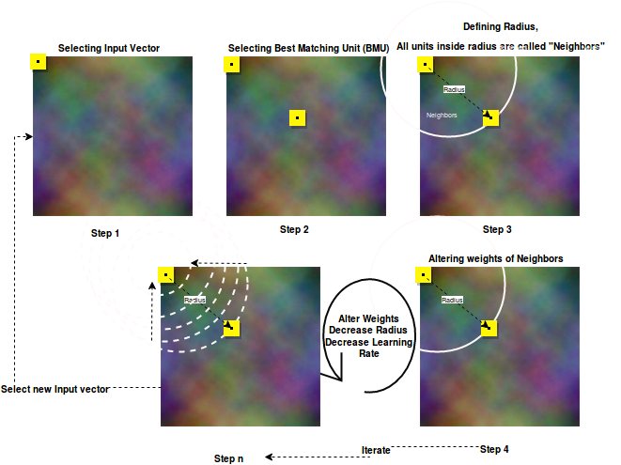
Entire algorithm is explained in above given flow.SOM involves following steps:
1)In given multidiamerional datset, select a point callled input vector,
2)Find a another point in datset called BEST MATCHING UNIT (BMU), using eucledien distance.
3)Define a radius between input vector and BMU, all units in this radius are called “Neighbours”
4) Alter weights of neighbours using learning rate
5) Decrease learning rate and radius exponentially
6)Alter weights of neighbours using learning rate
7) repeate Steps 4 5 6 for specified number of iteration

Now we will see each step in detail
STEP – 1. Selecting Input vector.
We have a 256*256 pixel image. Virually any point can be the Input vector. Here I have taken (0,0) the first pixel as starting point.

STEP - 2 Finding best matching unit.
Best matching unit is found out by using eucledian distance, Eucleadian distance of all units (pixel) w.r.t. Input vector is measured. And the one which is at least eucledian distance is selected as BMU. Lets say e.g. we got point at (102,105) as BMU.
We can call these input vector as well as BMU as lettice also as per formal SOM naming convention.
STEP – 3 Defining Neighbours
An imagibnary cirlce is taken keeping radius equal to distance between Input vector and BMU and Input vector as center of circle. All those units which lies in this circle are clalled neighbors. Neighbors are the units, whose weight will be altered in next iteration to make them simillar to Input vecor.
STEP – 4 Altering Weights
For altering weights following step are followed
1) Each neighbor is selected turn by turn.
2) For the selected neighbour new weight are calculated as follow.
newweight = Weights of Seleted Neighbour + (learning rate * difference of weight of input vector and weights of Seleted Neighbour)
Selected neighbor will be updated with new weights
In above described way weights of all neighbour are changed in given radius.
STEP – 5 Updating Radius and Learning Rate
Once step-3 is completed as described, the radius of circle and learnign rate are exponentially decresed.
Learnign rate is decreased as follow :
new learnig rate = initial Learning Rate * (math.exp(-time Or Iterations / rateOfDecay))
Radius is decreased as follow :
new radius = initialRadius * (math.exp(-timeOrIterations / rateOfDecay))

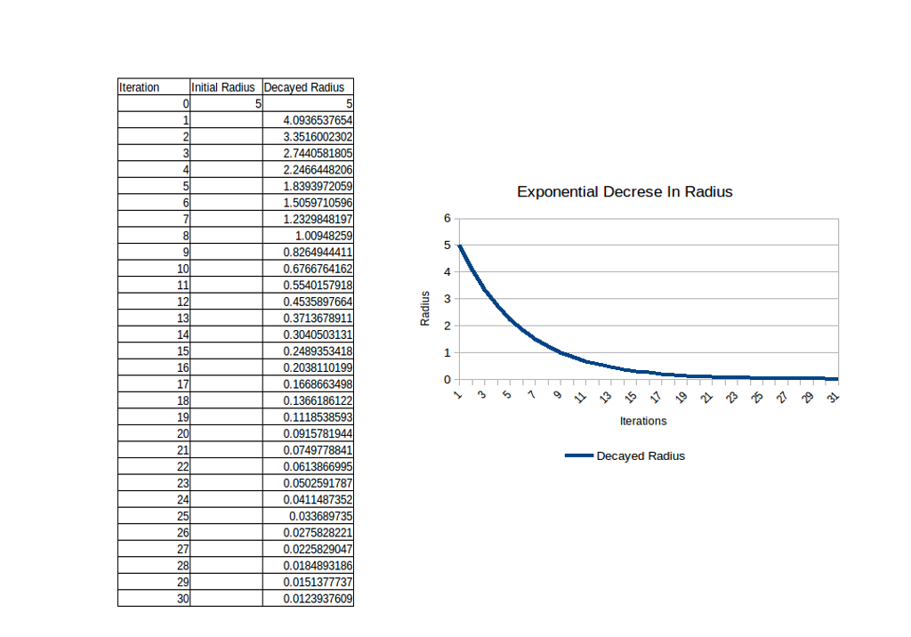
Above given picture is worth 100 words. You can clearly see the change in Radius exponentially. Such exponential decrease occur in learning rate too.

STEP – 6 Iteration
Once learning rate and radius are decresed steps 3,4,5 are performed for the number of iteration specified. Here in this implementation I have specified it as 10.
STEP – 7 Selection Next Input Vector
Earlier we have started with pixel (0,0) as input vector now we will move to (0,1) as input vetor and perform all steps 2,3,4,5,6 agian and again untill we cover entire lenght and bredth of the image.

This is all about the entire algorithm. Once have clear picture in mind, we are now moving to actual implementation. We will understand each function first and then overall flow of algorithm as discussed.
LoadImage in the form of numpy array :
def load_image(infilename):
"""
will load image from the file
:param infilename: filename
:return: numpy array of image
"""
img = ndimage.imread(infilename)
data = np.asarray(img, dtype="int32")
resized = data.reshape(data.shape[2], data.shape[0], data.shape[1])
return resized

To get RGB value for given pixel
def getRGBForPixel(imageArray, i, j):
"""
for a particular pixel, it return RGB value
:param imageArray:
:param i:
:param j:
:return:
"""
return imageArray[i, j]

Set RGB value for pixel
def setRGBforPixel(imageData, i, j, RGBValue):
"""
for a particular pixel, it set RGB value
:param imageArray:
:param i:
:param j:
:return: imageArray
"""
imageData[i, j] = tuple(RGBValue)
return imageData

To get Eucleadian distance between two pixel (here called as lattice). e.g. we have taken (0,0) as input vector and (102,105) as BMU. Eucleadian disnce between such two pixels is measured by below given fumction.
def findEucledeanDistanceBetweeenLattice(lattice1, lattice2):
"""
if two point on 2d surface are given, it will return distance between two points
:param lattice1: list [x,y]
:param lattice2: list [x1,y1]
:return:
"""
return math.sqrt(math.pow(lattice1[0] - lattice2[0], 2) + math.pow(lattice1[1] - lattice2[1], 2))

findNeighbours will find all neighbours between input vector and BMU
def findNeighbours(BMU, Radius, imageData, imageObject):
"""
If best matching unit (BMU) is found, it will find neighbours in given radius
:param BMU: x y axis for winner node
:param Radius:
:param imageArray:
:return: loacation of all pixel in 2-D plane [[1,2],[3,2],[4,2],....]
"""
width = imageObject.size[0]
height = imageObject.size[1]
neighbours = []
for i in range(0, height):
for j in range(0, width):
if findEucledeanDistanceBetweeenLattice(BMU, [i, j]) < Radius:
neighbours.append([i, j])
return neighbours
findBMU - Finds Best matching unit for givan input vector specifiied by location
def findBMU(inputVectorI, inputVectorJ, imageData, imageObject):
"""
will find best matching unit for given inputVectorI and inputVectorJ
:param inputVectorI: x
:param inputVectorJ: y
:param imageArray:
:return: return x1 and y1 coordinates for BMU
"""
imageDataArray = PIL2array(imageObject)
# print imageData, imageObject.size

minDistance = 9999999
width = imageObject.size[0]
height = imageObject.size[1]
minI = width + 1
minJ = height + 1
inputVector = getRGBForPixel(imageData, inputVectorI, inputVectorJ)
for i in range(0, height):
for j in range(0, width):
R, G, B = getRGBForPixel(imageData, i, j)
# print R,G,B
distance = math.pow(inputVector[0] - R, 2) + math.pow(inputVector[1] - G, 2) + math.pow(inputVector[2] - B,
2)
if (distance < minDistance and i != inputVectorI and j != inputVectorJ):
minI = i
minJ = j
minDistance = distance
break
return minI, minJ

Calculate decay in Learning Rate and Radius
def decayRadius(initialRadius, timeOrIterations):
"""
will perform exponential decay of given radius
:param initialRadius: radius at time t0
:param timeOrIterations: iteration number
:return:
"""
rateOfDecay = 5 # MORE THE RATE MORE WILL BE THE TIME TAKEN TO REACH 0
return initialRadius * (math.exp(-timeOrIterations / rateOfDecay))

def decayLearningrate(initialLearningRate, timeOrIterations):
"""
will perform exponential decay of given radius
:param initialRadius: radius at time t0
:param timeOrIterations: iteration number
:return:
"""
rateOfDecay = 5 # MORE THE RATE MORE WILL BE THE TIME TAKEN TO REACH 0
return initialLearningRate * (math.exp(-timeOrIterations / rateOfDecay))

Updating weights of given neighbor. neighbor’s location in image is specified by co-ordinate (i,j).

def updateWeights(weightAtGivenNeighbour, inputVectorWeight, learningRate):
"""
will update weight and will return new weights, weights are basically RGB color of the image
:param weightAtGivenNeighbour: RGB
:param inputVectorWeight: RGB
:return:
"""
newWeights = []
for eachweightNo in range(0, len(weightAtGivenNeighbour)):
newweight = weightAtGivenNeighbour[eachweightNo] + (learningRate * (inputVectorWeight[eachweightNo] - weightAtGivenNeighbour[eachweightNo]))
newWeights.append(int(newweight))
return newWeights

