ONLINE INDUSTRY REGISTRATION SYSTEM & E-SERVICES

User Manual
Date: 24th May, 2017

Young Minds Creation (P) Ltd
Young Minds Tower, Prayag Marg, Shanti Nagar, Kathmandu, Nepal
T: 01-4115132, E: info@youngminds.com.np
Table of Contents

1. General Project Information 1
2. Project Description: 2
3. User Manual End User 5
3.1 End User main page 5
3.2 End User login or register 5
4. User Manual Admin User 7
4.1 Admin login 7
4.2 Admin Dashboard 7
4.3 To view online registered companies 8
4.4 To Add/view old companies 9
4.5 Different applications (निवेदन) 9
4.6 Reports (रिपोर्ट) 11
4.7 Configuration (कन्फिगरेसन) 12

General Project Information
 | Description
Project Name | Online Industry Registration System & e-Services
Project Description | Refer to ToR
Project URL
Company | Young Minds Creation Pvt. Ltd.
Managing Director | Mr. Shreedhar Marasini

 | Baseline
Start Date | 12th April, 2016
Software Development Completion Date | 3rd July, 2016

Project DESCRIPTION:
The project consists of two sides. One is Admin and other is End User. They have their respective login page and dashboards. It consists of following specifications and features:
- Admin side
All the features of project are handled from this side, including which documents or which information’s are needed.
- Multiple users for login (There are many roles defined in admin sides like Creator, Reviewer, Approver, Biller, District Admin and Super Admin)
- Super Admin
  - Can Add/Update/Delete/Reset password of all users.
  - Can oversee all the registered companies, users and progress, reports of all the users.
  - Configuration features provided to Super Admin only.
- District Admin
  - Can Add/Update/Delete/Reset password of Creator, Reviewer, Approver, and Biller.
  - Can oversee the progress and registered companies of only the particular district he/she is assigned to.
- The document uploaded by end user will be first accepted or rejected by Creator then Reviewer, Approver and finally Biller. However, the application can be seen by all users simultaneously.
- List all online (new) and pre-registered companies. These companies can be searched and filtered by category, NSICC code, industry, name, date, email and district (in case of master admin)
- Permanent certificate of the applicant can be printed by either creator or master admin after all the documents are uploaded and verified.
- User creating facility for the Super Admin and District Admin only.
- Other admin can view the reports from their particular office/district. However, master admin can view them according to district as well as from all the districts together.
- The reports consists of:
  - कार्य प्रगति विवरण
  - वर्गिकरणका आधारमा प्रगति विवरण
  - औद्योगिक बर्गीकरणको आधारमा
  - कानुनी स्वरुपको आधारमा
  - उद्योग प्रशासन प्रगति विवरणको आधारमा
Note: The documents mentioned in above boolean points are namely:
- 3/]n' tyf ;fgf pBf]ux? btf{ ug]{ .
- 3/]n' tyf ;fgf pBf]ux?sf] gjLs/0f ug]{ .
- 3/]n' tyf ;fgf pBf]usf] gfd;f/L ug]{ .
- 3/]n' tyf ;fgf pBf]usf] 7fpF;f/L ug]{ .
- 3/]n' tyf ;fgf pBf]usf] k"FhL a[l4 jf Ifdtf a[l4 ug]{ .
- 3/]n' tyf ;fgf pBf]usf] p2]Zo ;+zf]wg -yk jf kl/jt{g_ ug]{ .
- 3/]n' tyf ;fgf pBf]usf] btf{ vf/]h ug]{ .

- User side:
- User can apply for new company by providing the information of the proposed company name in both nepali and english, by choosing the companies types, NSICC code and category, choosing district, office name, address, current capital, fixed capital, yearly capacity, manpower:(male, female, other), technical, non-technical, and other skills, with proper name, address and valid email.
- After verifying from the email provided earlier the user can finally login to the system and apply for checking name.
- Then after the name is finally approved other files and documents related to registration need to be uploaded.
- The applicant applying for new company register can know after the application is accepted or rejected.
- If rejected then the applicant can re-apply by changing the mistakes and/or uploading remaining necessary documents.
- After all the process is completed and the company is approved, the applicant can print the temporary certificate.
- The user can also change their password and other information except the email address.

User Manual End User

End User main page

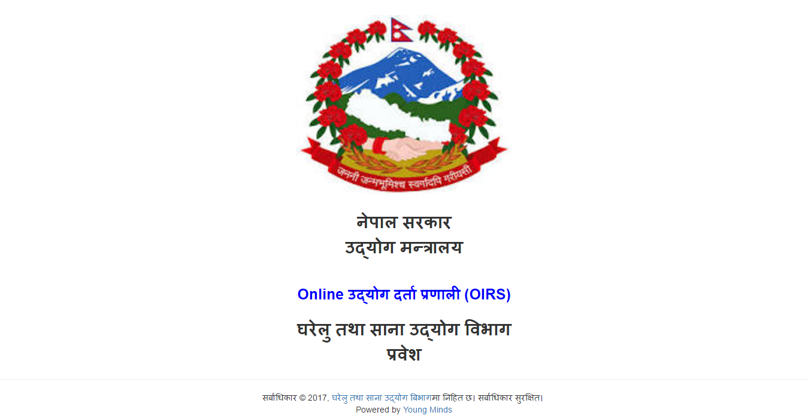
This is the main page the end user sees. Then by clicking anywhere they can now proceed to login or register page i.e. in section 3.2

End User login or register

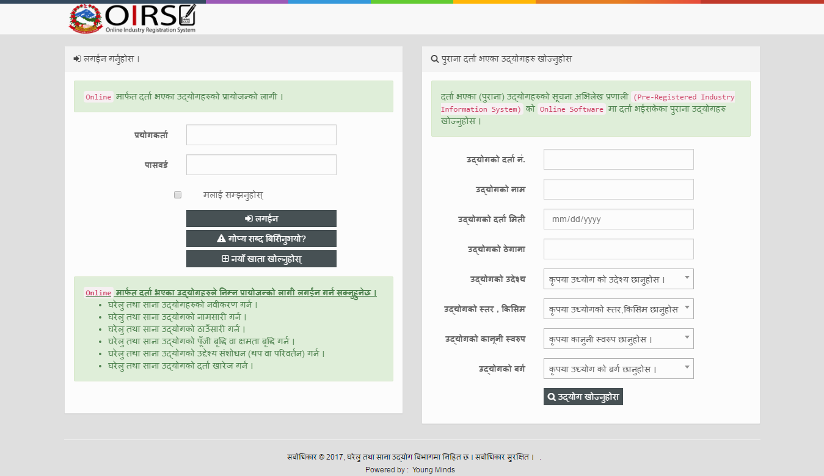
End User can login to the system from left part in the above image. In right part of the image user can search for the registered company in the system by entering all the required fields.
To register as a new user the users have to click on
Then the users have to enter all the information of the person who is trying to register the company. After the user enters all the information and saves the information, then they can apply for the company.
After the user is accepted and all the entered information are verified the admin of this system can approve the user. After the user is approved then they can upload all the required documents as seen in the below image.
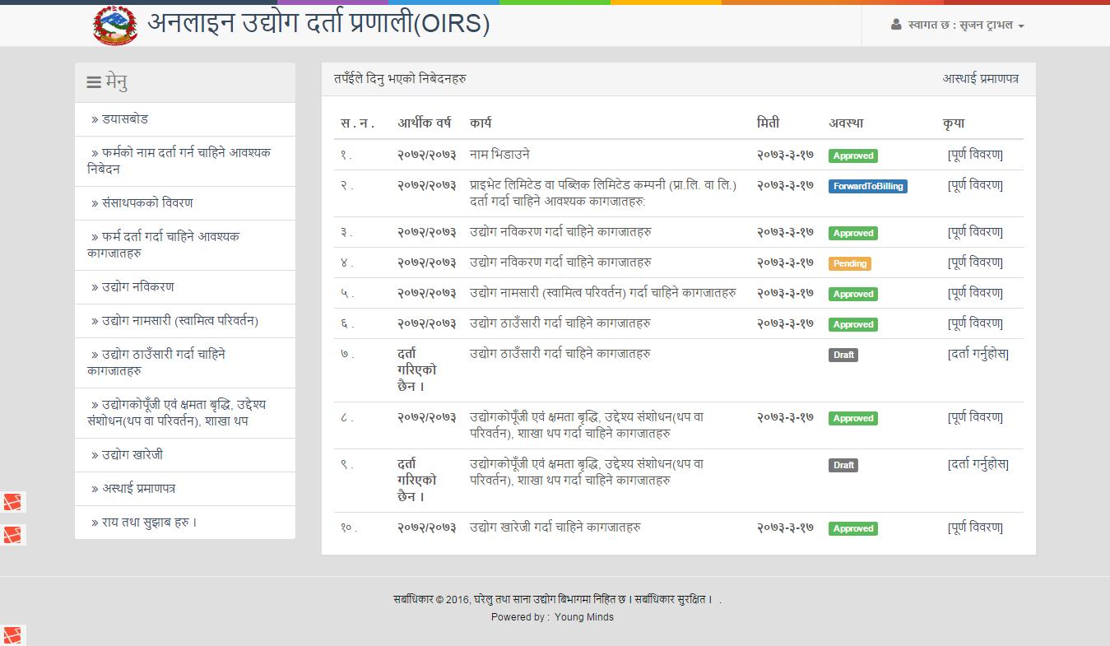

user manual admin user

Admin login

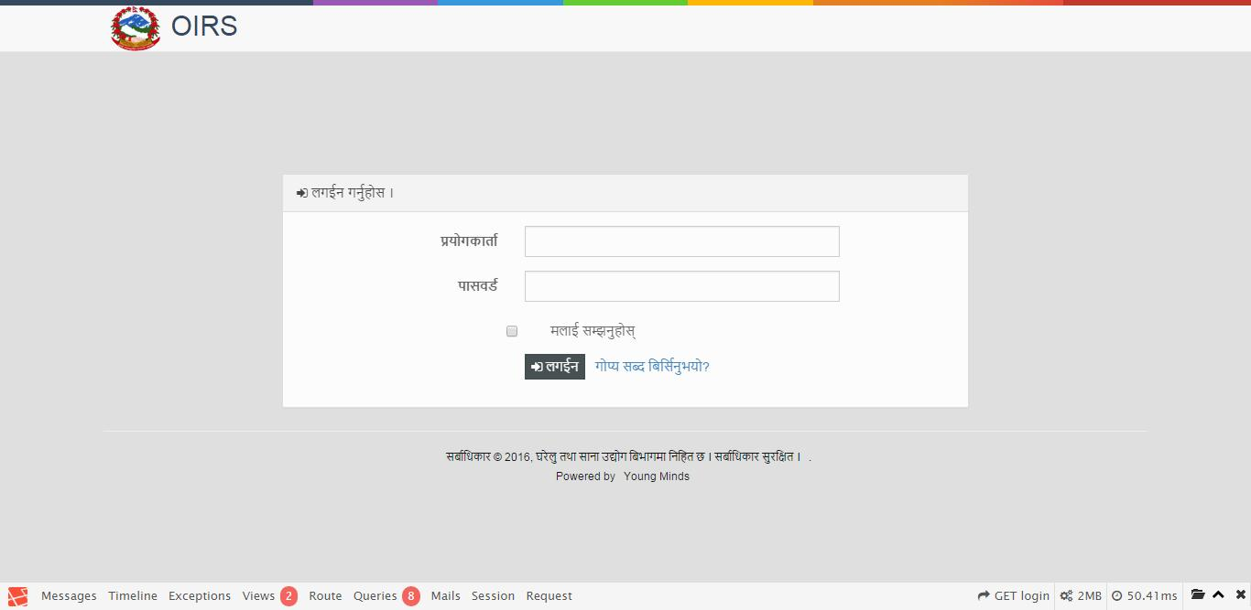

Admin Dashboard

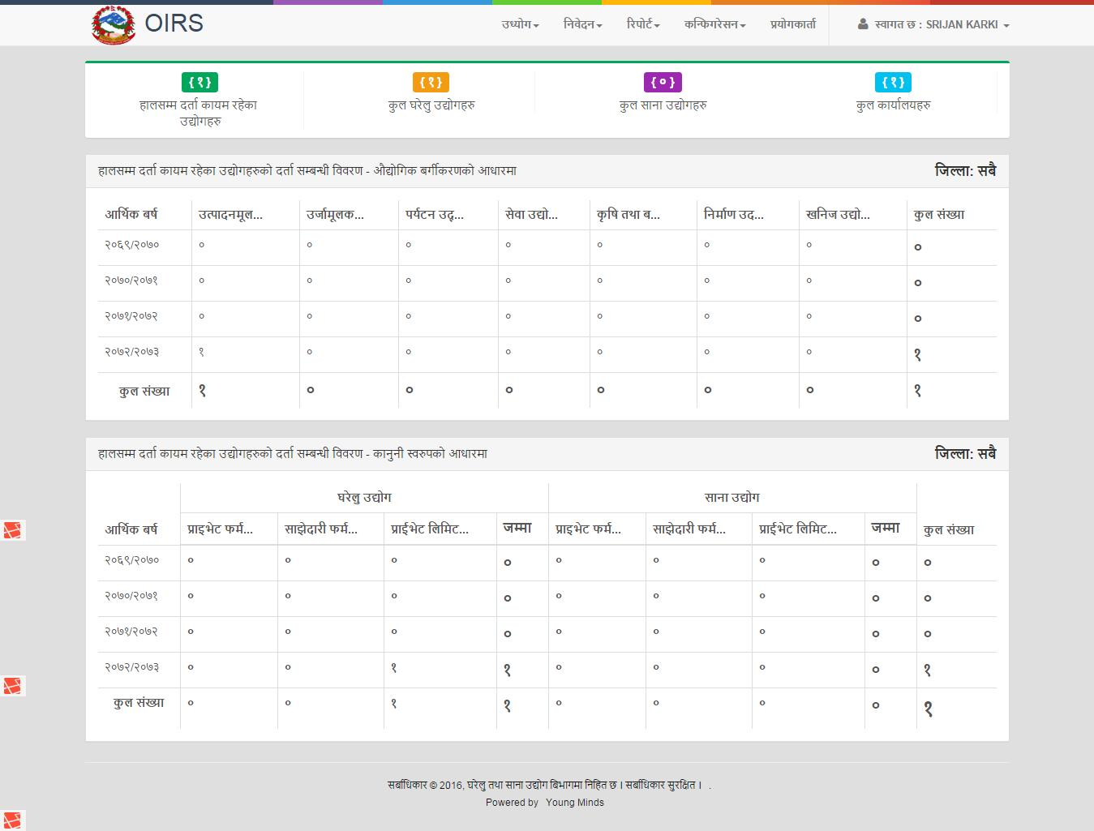

To view online registered companies
Go to: उद्योग => अनलाइन
- Can view the registered companies. By viewing the information the admin can approve the user. Admin can also print the final certificate of company register from this system by clicking in print button. The final certificate after the application is approved will look like below:
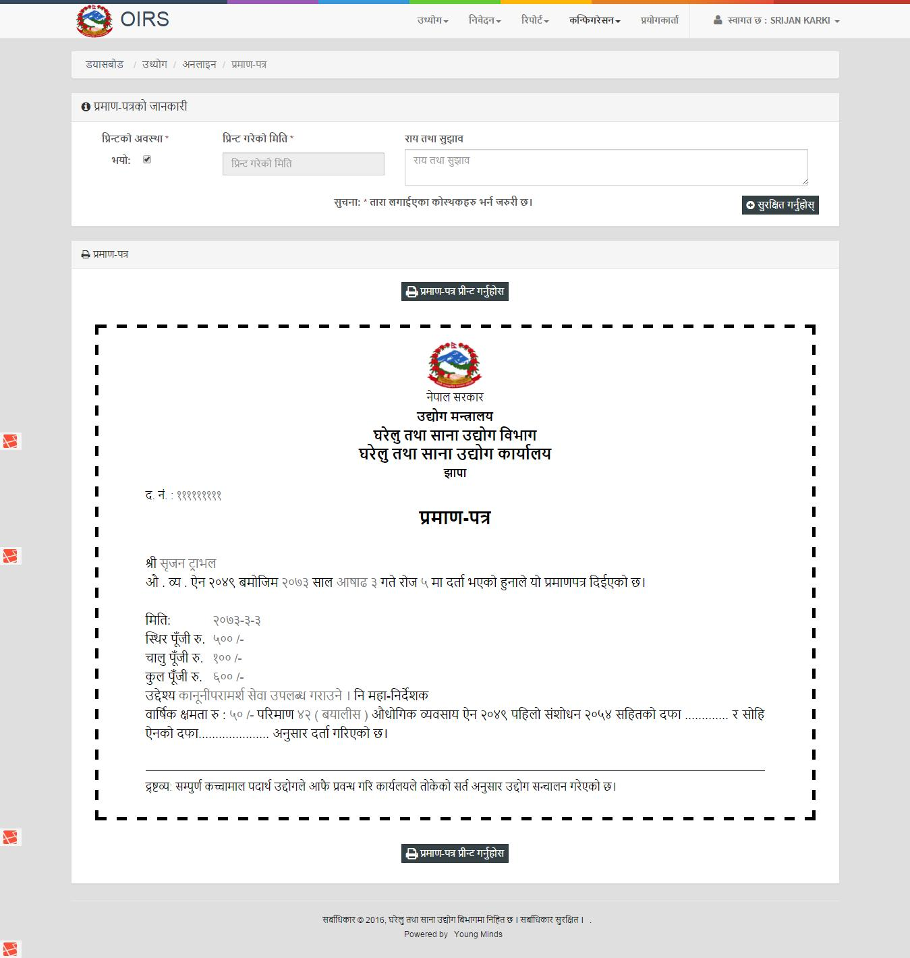

To Add/view old companies
Go to: उद्योग => पुर्व-दर्ता
Can add the old companies by clicking in: नयाँ थप्नुहोस्

Different applications (निवेदन)
There are different types of applications in this system and they are:
- नाम भिडाउने
  - After the end user applies for the document, the application arrives here. Here the creator checks whether the requested name of the company by the user is available or not. If available the application is approved and can be further processed. But if the name is not available the application is rejected and the user gets the mail stating that the application was rejected due to these reasons.
- नँया कागजात दर्ता
  - After the name of the company is approved then the users have to upload all the required documents requested by the admin. The reviewer then reviews the documents and further the company process if the documents are valid. Then the document is received by approver and biller. If the biller clears the application by saying that the payment is already received then the approver approves the application of the company. Then the company will be registered and the user can visit the office to collect the Company Register Certificate.
- नविकरण
  - The requested नविकरण applications can be viewed from here.
- नामसारी
  - The requested नामसारी applications can be viewed from here.
- ठाँउसारी
  - The requested ठाँउसारी applications can be viewed from here.
- पुँजी तथा क्षमता बृद्दि
  - The requested पुँजी तथा क्षमता बृद्दि applications can be viewed from here.
- दर्ता खारेजी
  - The requested दर्ता खारेजी applications can be viewed from here.
To go to each application click: निवेदन => निवेदनको नाम
For example:
- To go to नाम भिडाउने. Go to निवेदन => नाम भिडाउने

Reports (रिपोर्ट)
There are five different types of reports. To go to each report:
Go to: रिपोर्ट => रिपोर्टको नाम
For example:
- To go to रिपोर्ट . Go to रिपोर्ट => कार्य प्रगति विवरण
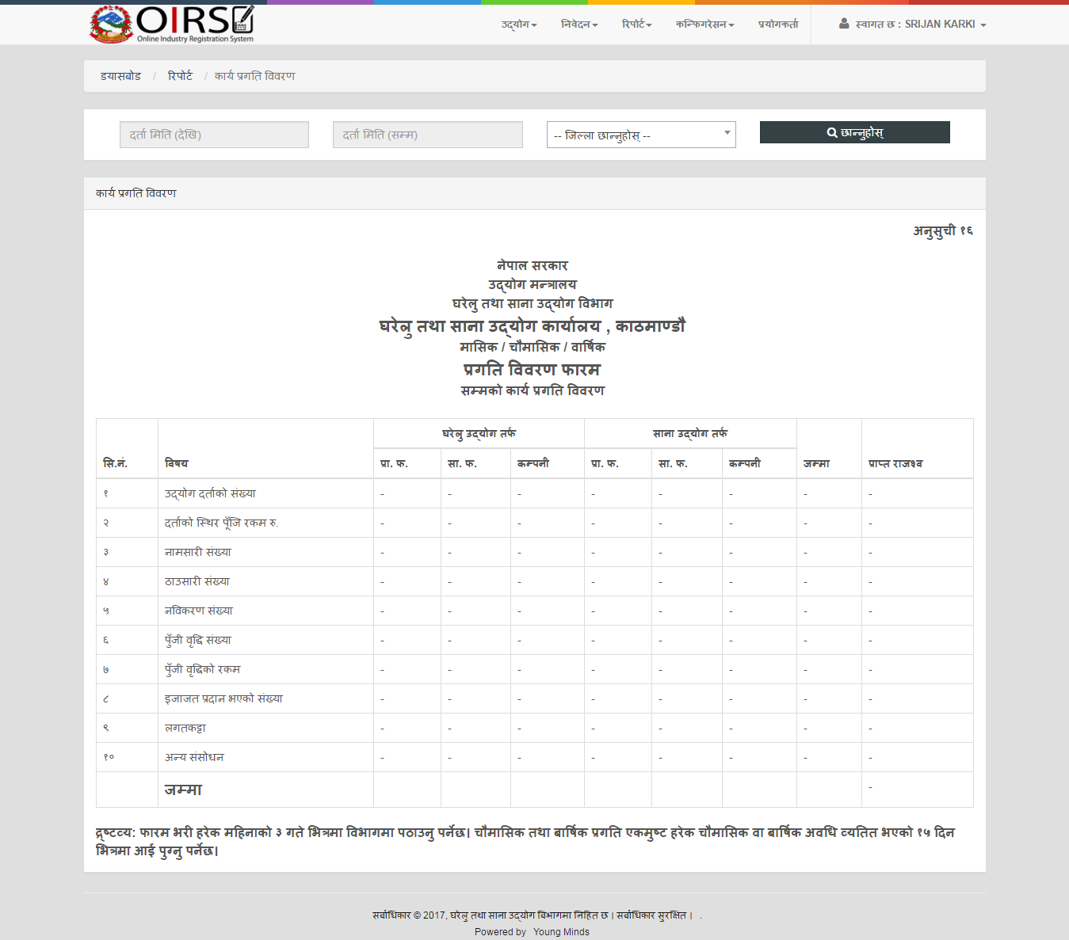

Configuration (कन्फिगरेसन)
There are 12 different types of configuration settings namely:
- आर्थिक बर्ष
  - To Add/Edit/Delete fiscal year. Only one fiscal year can be active at a time. And all the added documents and industry registration will be added to the active Fiscal Year.

- जिल्ला
  - To Add/Edit/Delete new Districts

- कार्यालय
  - To Add/Edit/Delete Offices in each districts.

- दर्जा
  - To Add/Edit/Delete Post.

- उद्योग उदेश्य
  - To Add/Edit/Delete industries objective with unique NSICC Code.

- उद्योगको कानुनी स्वरुप
  - To Add/Edit/Delete industries Legal types.

- उद्योग किसिम
  - To Add/Edit/Delete industries types (i.e. घरेलु / साना).

- उद्योगको बर्ग
  - To Add/Edit/Delete industries categories.

- उद्योगको उपबर्ग
  - To Add/Edit/Delete industries sub-categories.

- कागजातको वर्ग
  - To Add/Edit/Delete document categories.
- कागजातको प्रकार
  - To Add/Edit/Delete document types.

- राजश्व तथा शुल्क (प्रा.फ. / सा.फ.)
  - To Add/Edit/Delete document types.

