Age-sex variation in diet of chacma baboons: analysis of composition and bout length

Background
Non-human primates (NHP) need to meet varying nutritional requirements that are contingent on energetic factors such body size, growth and reproductive energetic demands, and activity budgets (Vogel et al. 2016; Emery Thompson 2017). The metabolic demands of growth and reproductive output can vary by age and sex classification in primates (Amato et al. 2014; Emery-Thompson 2017) which can change nutritional needs. Plant parts and other foods vary in their composition of macronutrients and micronutrients, and primates may select these foods based on their nutritional goals (Lambert and Rothman 2015; Johnson et al. 2013). When characterizing a primate population’s diet, comparing age-sex class variation in diet composition informs our understanding of the nutritional demands that are tied to life history. This is especially important in determining nutritional factors that may be limiting growth and reproduction of a species or population (van Schaik et al. 1985; Vogel et al. 2016).
Additionally, NHPs often play a vital role in their ecosystems by dispersing and destroying seeds. The ecological landscapes that NHPs occupy are made up of both native and introduced plant species, some of which are considered invasive species to their environment (Lambert 1999; Pamla et al. 2024). Depending on the wild plant resources, this may be due to nutritional content of such foods (Applegate 2015; Rothman and Bryer 2019), but little is known about the comparative composition of these foods. Depending on the nutritional goals the age-sex classes, this may increase the usage of certain plant foods in the diet and potentially differentiating their capacity to disperse or destroy the seeds of these plants. Understanding the services NHPs provide to their environment is informative for both ecosystem health and primate conservation (Tew et al. 2018; Pamla et al. 2024).
Primate diet composition is commonly measured in time spent eating (bout length), which is reflective of foraging effort (Chivers 1998) and processing differences (Nakayama et al. 2002; Hanya 2003). Duration of feeding bout on different food types can therefore indicate both importance of a food type to the diet as well as processing effort. When comparing between age-sex classes, this may inform differences in feeding behaviors that may correspond to nutrient intake (Nakayama et al. 2002; Rose 1994). However, estimating nutrient composition of the diet is not possible without intake rate using the mass of food items ingested (Chivers 1998; Aristizabal et al. 2016) and analyzing the foods eaten by the primate for their nutrient content (Rothman et al. 2012). Diet composition based on duration alone can therefore provide only a preliminary look at nutritional goals, especially when using generalized assumptions of nutrient composition in the foods types (Lambert and Rothman 2015).
Chacma baboons (Papio ursinus) are good candidates to answer these questions due to their highly flexible diet (Johnson et al. 2013; Pebsworth 2020). Known to eat a variety of plant species, mushrooms, insects, small vertebrates, and human-sourced foods, chacma baboons allow for the study of a generalist feeder that additionally balances nutrients daily (Johnson et al. 2013). Less is known about how age-sex classes differ in the dietary composition and feeding effort in this species, though previous research has investigated age-sex class and diet in relation to growth (Altmann and Alberts 2005) and gut microbiota (Bambi et al. 2024). Research into the age-sex class relationship of the chacma baboon diet composition is additionally important regarding their use of indigenous and exotic plants in the diet, as well as incorporating anthropogenic food sources, as these foods influence potential for human-wildlife conflict for this species (Pebsworth and Radhakrishna 2021).
Aims
To explore this gap in the research, I analyzed a dataset from a group of chacma baboon adult females and juveniles to answer three questions. (1) Do adult female and juvenile baboons differ in their diet composition of plants by their “status” of indigenous or alien species? This will inform whether there is a potential difference in capacity for seed dispersal. (2) Do adult females and juveniles differ in their diet composition of food types (fruit, leaves, shoots, seeds, roots, mushrooms, soil, bark, flowers, insects, human foods, and “other”)? If there is a difference, this may point to a different nutritional composition of the diet for accommodation of energetic requirements of reproduction and growth (respectively). (3) Do adult females and juveniles differ in the average bout length of these foods? If a difference is found, this could point to differing foraging effort required for the food by each group, or other feeding behavior differences.
Methods
Study site and data collection: Nature’s Valley Baboon Project (NVBP) is associated with NVT, an NGO that operates out of Nature’s Valley, South Africa. The chacma baboons (Papio ursinus) living here inhabit an Afrotemperate forest environment that intersects with the town of Nature’s Valley, proving opportunity for the baboons to exploit this anthropogenic landscape. This data set covers a period from June 24th, 2024, to November 7th, 2024. At the time of this data set, the troop consisted of nine individually identifiable baboons. Focal individuals are categorized into age and sex classes, with six adult females, two male juveniles, and one female juvenile present during this study period. Feeding data was collected via ten-minute focal follows (TMF) (Altmann 1974), with the individual (focal ID), TMF start and end time, feeding bout start and end time, food species name (when identifiable), and food part consumed recorded. Plant species were categorized as indigenous, alien invasive, or non-invasive alien when identifiable.
Data cleaning: Juveniles were grouped together due to low sample size, making the comparison between adult females and juveniles; juvenility for baboon males and females has similar growth requirements (Johnson 2002). Duration of feeding on food items was calculated by using feeding bout start to end time, but TMF start time is used when the focal ID had started eating before TMF. Similarly, if focal ID continues eating after TMF ends, TMF end time is used for ending feeding duration. This means that if an individual is eating for the entirety of the TMF, the feeding duration will be ten minutes (or 600 seconds). The identifiable plant species are marked as being “alien” or “indigenous” in status, which combines both alien invasives and non-invasives into one category due to low frequency of non-invasives. The “other” status category contains insects and mushrooms, excluded to illustrate plant status only. Unidentified plants are those which we have yet to characterize. Food types were placed into 12 distinct categories, which involved placing instances of sticks, moss, and bulbs into the “other” category due to having very low bouts numbers. “Other” also encompassed entries were marked with “unknown” or “N/A” for their food part in data entry. Leaf and fruit maturity was not included in these analyses as there were not enough entries to test effects. For entries containing multiple food parts eaten at once, durations per part were made equal to the bout total, effectively treating them as separate entries of the same length; this assumes that time spent on each part is equal.
Analyses: All statistical analyses were run using R (R Core Team 2025) via the RStudio environment (Posit 2025) with additional use of ChatGPT to assist with coding errors (OpenAI 2026). All data visualizations were made using the ggplot2 package (Wickham 2016).
Diet composition by alien vs. indigenous plants: Proportions of feeding time on food “status” (plants identified as alien, indigenous, and unidentified, as well as human foods and “other” foods) were calculated for adult females and juveniles by diving the duration of time spent on each food part by the total recorded time spent feeding. To assess difference between adult females and juveniles in entire diet composition of food status, a permutational multivariate analysis of variance (PERMANOVA) was performed using the vegan package in R (Oksanen et al. 2026). A PERMANOVA can measure the difference between samples in a distance matrix, making them non-parametric and able to handle the non-normal nature of the proportional data (Souza 2025). The dispersions of the groups’ distance matrixes were tested for equal variance using an ANOVA. Additionally, to measure differences in proportions dedicated to specifically feeding on plants of either alien or indigenous status, two Wilcoxon rank-sum tests were performed. Wilcoxon rank-sum tests are non-parametric, used to assess two independent groups on a continuous dependent variable (Kim 2014); this test was selected over parametric alternatives due to the non-normality of my data. Tests were run on both alien and indigenous proportions, with age-sex class the grouping. Wilcoxon rank-sum test assumes that data points are independent and have similar distribution shape when comparing medians (Laerd Statistics). Each focal ID was independent, but my low sample size created violation in similar distribution shape, making this analysis on the distributions of these groups rather than the medians (Laerd Statistics).
Diet composition by food types: Proportions of feeding duration on food types (fruit, leaves, shoots, seeds, mushrooms, roots, insects, bark, flowers, soil, human foods, and “other”) were calculated for adult females and juveniles by dividing the total duration spent on each food group by the total recorded time spent feeding. To calculate difference in total diet composition between adult females and juveniles, a PERMANOVA was run using the focal ID proportion of time per food type. The dispersions of the groups’ distance matrixes were tested for equal variance using an ANOVA. To analyze differences in proportion of time spent by food type, Wilcoxon rank-sum tests were run on individual food types with age-sex class as the grouping. A similar test of assumptions indicated that this Wilcoxon rank-sum test on proportions of food types was testing variation in distribution rather than medians. (Laerd Statistics).
Bout length per food type: To assess differences in bout length duration per food type between females and juveniles, a generalized linear mixed-effects model (GLMM) with a gamma distribution was run using the glmmTMB package in R (Brooks et al. 2017). This model examined variation in feeding bout duration as a response to the predictors of age-sex class, food type, and their interaction. GLMMs are robust to repeated data, handling the random effect of focal ID on the data distribution (Whitehouse et al. 2023; Madden and Ojiambo 2024). Additionally, GLMMs can handle data of varying distributions (non-normal). A gamma distribution (with link = log) was chosen due to right-skewed duration data; however, it is important to note a high frequency of “600 second” (10 minute) bout lengths, representing a ceiling imposed by the TMF. Therefore, while AIC tables comparing models of varying distributions suggest gamma is the best fit comparatively, model fit is not perfect, and this is represented in residual testing. Log family was chosen for this gamma distribution due to the more meaningful interpretation of proportional change between age-sex class; the log link is commonly used for positive continuous data (Lo and Andrews 2015). An important note is that the log link function of the GLMM does not transform the response variable (as in data-transformation) but rather applies the log to the fitted mean of the predictors (Lo and Andrews 2015; Harrison et al. 2018). The comparison of model distribution was done using an AIC (Akaike information criterion) comparison.
Results
Diet composition by alien vs. indigenous plants: Total composition of foods by “status” (Figure 1) of adult female and juvenile diet indicates a large proportion of the diet comes from indigenous plant foods (42% and 50% respectively), whereas a smaller proportion off time is spent on alien plant foods (10% and 7%). A large proportion of the plants in the diet for both groups remains unidentified (47% and 37%), and the proportions of non-plant foods also encompassing a smaller proportion (totaling 2% and 6%). Analysis using PERMANOVA showed no significant effect of age-sex class (F = 1.60, R² = 0.19, p = 0.24). This statistic indicates that about 19% of diet composition differences was explained by the age-sex class groupings, but this was not significant; the differences were greater between individuals than between groups (Figure 2). The dispersion of the data was verified to meet assumptions, indicating that dispersion variance did not have effect on results (F = 0.03, p = 0.872). The result of no significant differences was confirmed when verifying specific proportional differences of alien (W = 12, p = 0.55) and indigenous (W = 5, p = 0.38) with the univariate Wilcoxon rank-sum test.
Diet composition by food types: Total composition of food types in the diet (Figure 3) showed that adult female baboons spent the most time on shoots (25%), followed by leaves (25%), fruit (21%), seeds (14%), roots (9%), “other” (6%, encompassing food types that fell under 1% of the diet), and human foods (1%). The juvenile group composition showed that fruit was highest (23%) followed by leaves (22%), shoots (20%), seeds (19%), roots (7%), human foods (4%), “other” (3%), and mushrooms (2%). However, differences between adult females and juveniles calculated by PERMANOVA indicated no significant difference (F = 1.73, R² = 0.20, p = 0.15). This suggests, similar to food status composition, that composition differences between individuals were greater than between age-sex classes (Figure 4). Dispersion verification validated the PERMANOVA results (F = 0.38, p = 0.56). Wilcoxon rank-sum univariate tests were then used to compare individual food type proportions; nearly all food types had no significant differences between age-sex classes (reported in Table 1). The Wilcoxon rank-sum test on difference in proportion of shoots to the diet had slight significance (W = 17, p = 0.048).
Bout length per food part: A gamma GLMM with a log link was used to examine differences in duration across food types. The baseline food type of fruit showed the longest feeding durations, most food types were associated with significantly shorter feeding durations: shoots (β = −0.78, SE = 0.14, p < .001), leaves (β = −0.63, SE = 0.14, p < .001), seeds (β = −0.44, SE = 0.17, p = .009), roots (β = −0.52, SE = 0.19, p = .006), human foods (β = −1.34, SE = 0.29, p < .001), and others (full results reported in Table 2). The interaction between age-sex class and food type revealed that juveniles differed from adults only in their use of human foods. Juveniles exhibited significantly longer bouts for human foods compared to adults (β = 1.41, SE = 0.47, p = .003), corresponding to an approximately 4.09x increase in predicted bout duration on the response scale. No significant differences between juveniles and adults were detected for other food categories.
Model predictions were plotted (Figure 5) using the package ggpredict in R (Ludecke 2018), which uses fitted GLMM predictions to get predicted means, confidence intervals, and back-transform the predictor means into the correct scale (seconds). Error bars are reflective of confidence intervals, with low bout frequency food type categories (insects, soil, mushrooms, and human foods) observed as showing greater uncertainty. Caution is therefore warranted for these rarely-observed food types due to increased uncertainty (compare with raw data distributions in Figure 6).
Residuals of GLMM: Residual diagnostics for the GLMM of bout duration were tested using the simulated residuals generated with the DHARMa package in R (Hartig 2024). Residual uniformity, dispersion, and outliers were tested, as well as plotted against fitted values and predictors to verify model fit; uniformity and outliers showed no substantial violations. DHARMa dispersion test indicated significant underdispersion (dispersion = 0.63, p < 0.001) which suggests the model shows less variability than expected under the gamma distribution. This is likely due to the ceiling imposed on the durations at 600 seconds, which does suggest a misfit in using this distribution. Exploratory diagnostics indicated this pattern is associated with fruit bouts where residuals show reduced variability. Fruit bouts exhibit a higher frequency of these 600 second “ceiling” durations. Future work on these analyses will assess potential model fitting for this type of distribution. See Supplementary Figures 7-10.
Discussion
This study examined age-sex related differences in diet composition in feeding behavior and diet composition of chacma baboons. Overall, my results indicate that there is little difference between adult females and juveniles in diet composition across plant status or food types. However, juveniles exhibited longer feeding bout durations on human foods compared to adult females.
This analysis finds that the chacma baboons at Nature’s Valley did not vary significantly in the proportion of feeding duration for alien versus indigenous plants based on age-sex class. Both groups spent a far greater proportion of the diet feeding on indigenous plants compared to alien plants. This result indicates that the groups may not differ in the capacity to be seed disperses and destroyers of native and alien plants, though more research is warranted to investigate seed handling processes in each age-sex class, as well as intake rate to understand if similar amounts of material are being consumed and processed.
Food categories can be broadly lumped into categories containing higher amounts of protein (e.g. leaves), fats and non-structural carbohydrates (e.g. fruits), as well as varying degrees of fiber, micronutrients, and antifeedants (Lambert and Rothman 2015). Human foods are also generally known to have higher fats and sugars and less fiber in comparison to wild plant foods (Rothman and Bryer 2019). The results of this study suggest that chacma baboons at Nature’s Valley do not differ in their composition of food types based on age-sex class, indicating that nutritional composition in the diet is similar. These generalizations must be taken lightly, as plants can vary drastically between species, location, and ripeness/maturity (Rothman et al. 2012). Interpreting nutritional information from duration data without intake rate and composition of the actual foods is therefore not the aim of this analysis, rather looking broadly at composition patterns and infer foraging effort. With future work into nutritional properties of these foods, we can know more about the intake variation between groups, which is more informative than feeding duration for nutritional purposes (Chivers 1998; Aristizabal et al. 2016).
NHPs differ in their energetic needs depending on their age sex class: adult females have more reproductive energic demands due to gestation, lactation, and infant care, whereas juveniles require energy to be allocated to body and brain growth (Emery Thompson 2017). Nutrition is a factor in this energetic balancing, but there are other ways in which NHPs can change their energy budgets to compensate for these demands. Changing activity budgets, such as more time resting or more time foraging, is one way in which primates may circumvent changing nutritional input (Droscher et al. 2016; Emery Thompson 2017). Additionally, microbiome compositions of adult female and juvenile howler monkeys have been shown to assist in specific nutritional acquisition that aids in energy balance (Clayton et al. 2018). These alternative energy sources may be why my results show that there is little difference in diet composition between juveniles and adult females. Given the small sample size, these results are interpreted cautiously and as a preliminary look at patterns among the age-sex classes.
Feeding bout duration was also largely comparable between the two groups, showing that fruit exhibited the longest bout lengths on average for both adult females and juveniles. Juveniles differed from adult females in only one category, with the model predicting 4.09x increase in bout length from adults. This may be related to the nutrient properties of these foods (Rothman and Bryer 2019), handling differences between adults and juveniles (Hanya 2003), or potentially risk-taking behaviors of juveniles. However, it also may be due to low sample size, low frequency of human food feeding bouts, and certain individuals driving up the feeding bout length. For instance, one juvenile individual spent the entirety of the ten-minute focal period eating human foods on three separate instances. More data in the future will help indicate if this pattern holds in juveniles.
Future directions:
This data analysis project serves as a preliminary investigation into the foraging effort and diet of the Nature’s Valley chacma baboons on several different scales: plant status (native versus exotic), food types, and bout length. Future fieldwork and data collect on the troop at its current post-fusion event size (n = 30) will allow for further investigation of these patterns in age-sex class. More focal IDs in each class will allow for higher statistical power, as well as create more age-sex classes to be explored (adult males, subadults). Data cleaning of the group post-fusion will allow for a larger dataset for analysis.
Another avenue of research already underway at NVBP is identification of food species, which will further elucidate the “unidentified” status category. Species identification will inform the role of alien and native plants to the diet and provide further insight on dispersal and destruction patterns. Paired with seed handling information, dispersal and destruction of indigenous and alien plant foods could advance our understanding of the role that these baboons play as in their ecosystem, especially with initiatives to remove alien-invasive plants underway in Nature’s Valley.
Additionally, acquiring dietary intake rate would be meaningful for eventually analyzing the nutritional composition of the baboon diet. Paired with analysis of the composition of foods eaten by the baboons, we will have a more comprehensive look at nutritional differences between age-sex classes. This will also help better understand bout length differences between groups.

Figures
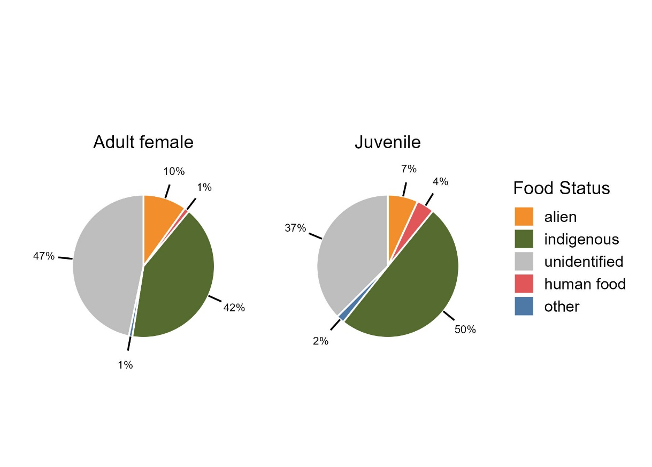
Figure 1: Total composition of adult female and juvenile diet based on food status

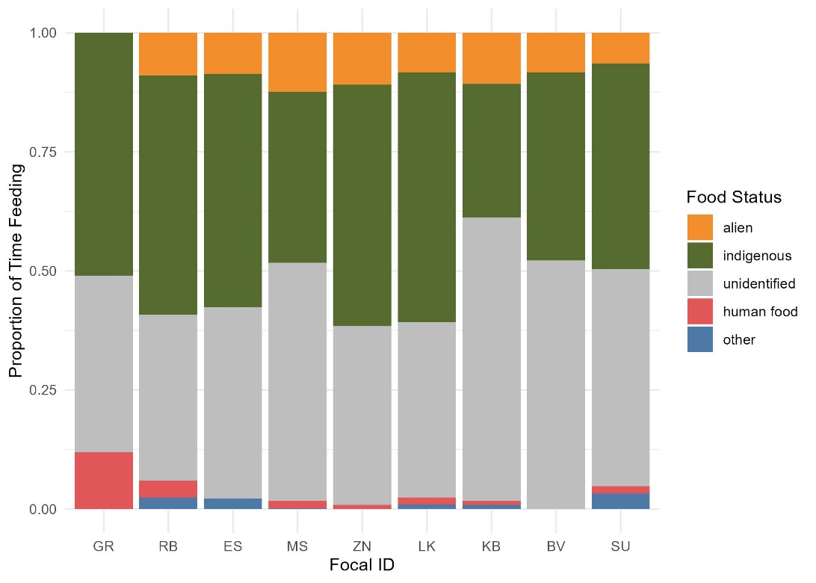
Figure 2: Individual variation in food status composition. First 3 Focal IDs from left are juveniles.
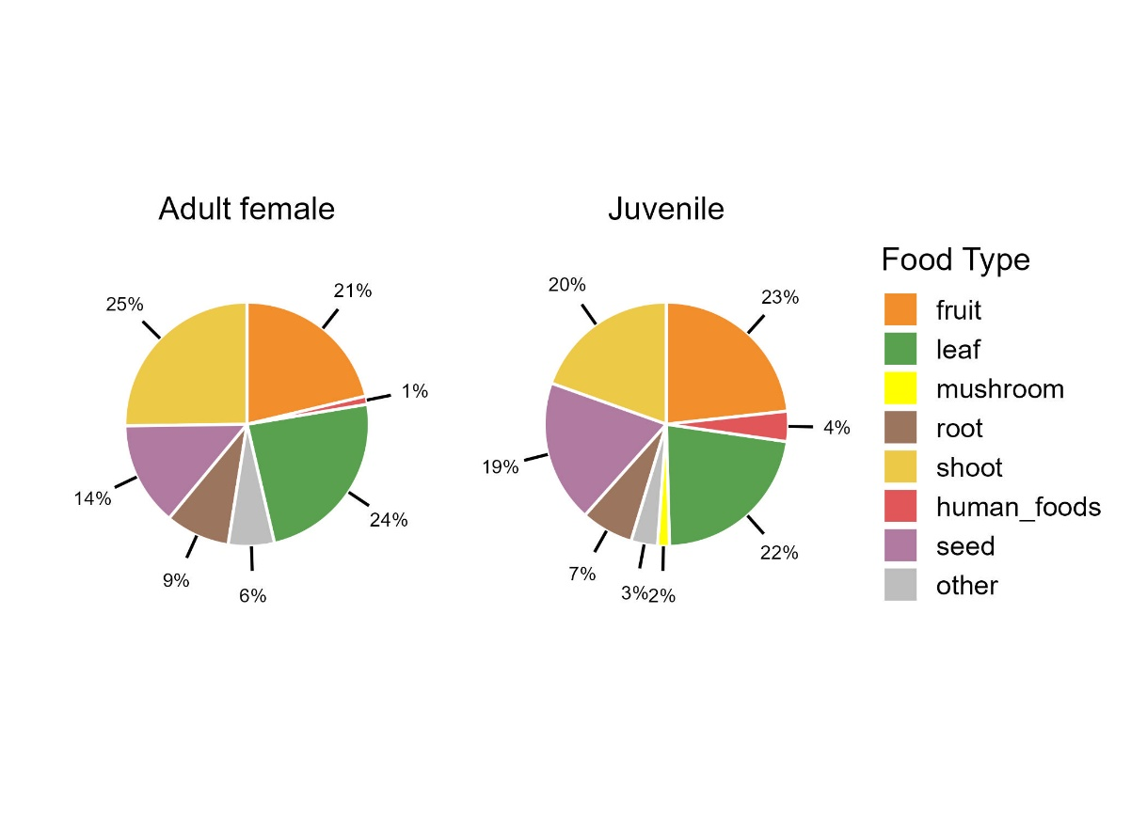
Figure 3: Total composition of adult female and juvenile diet based on food type.

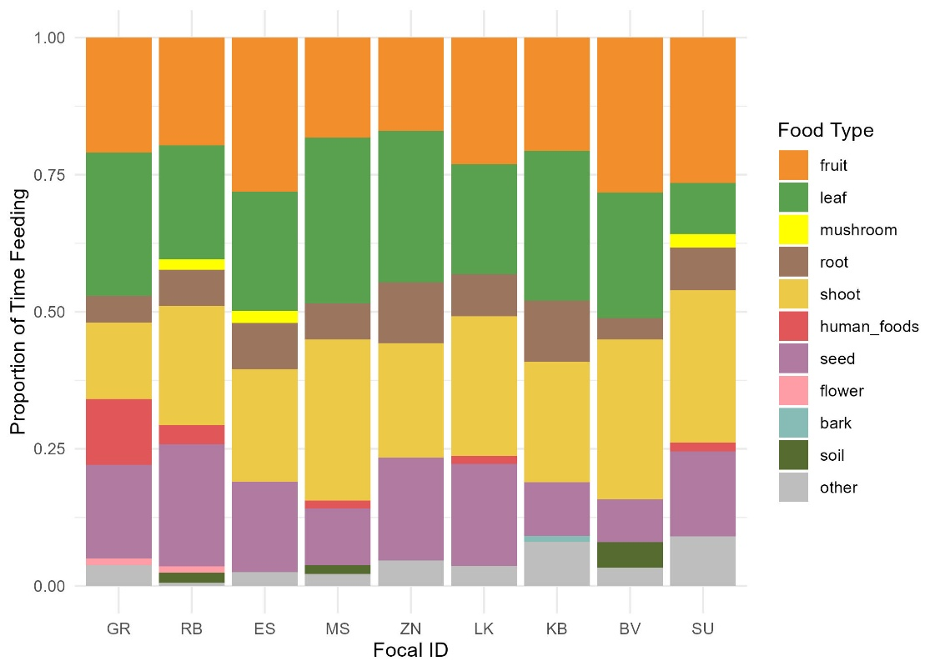
Figure 4: Individual variation in food status composition. First 3 Focal IDs from left are juveniles.

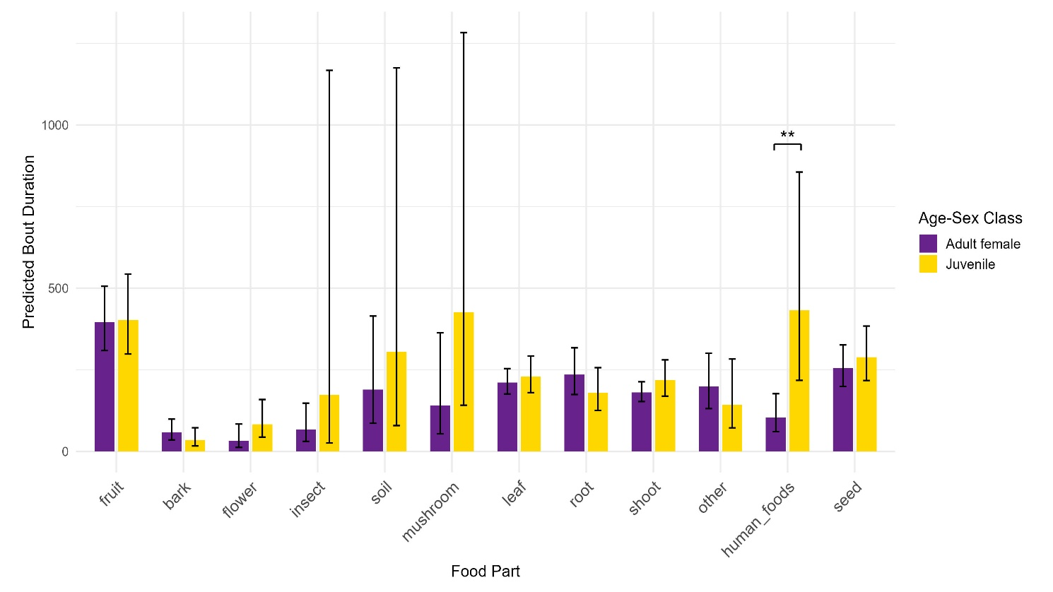
Figure 5: GLMM predictions. Error bars indicate 95% confidence intervals. Significance marker on difference between juvenile and adult human food bout length.

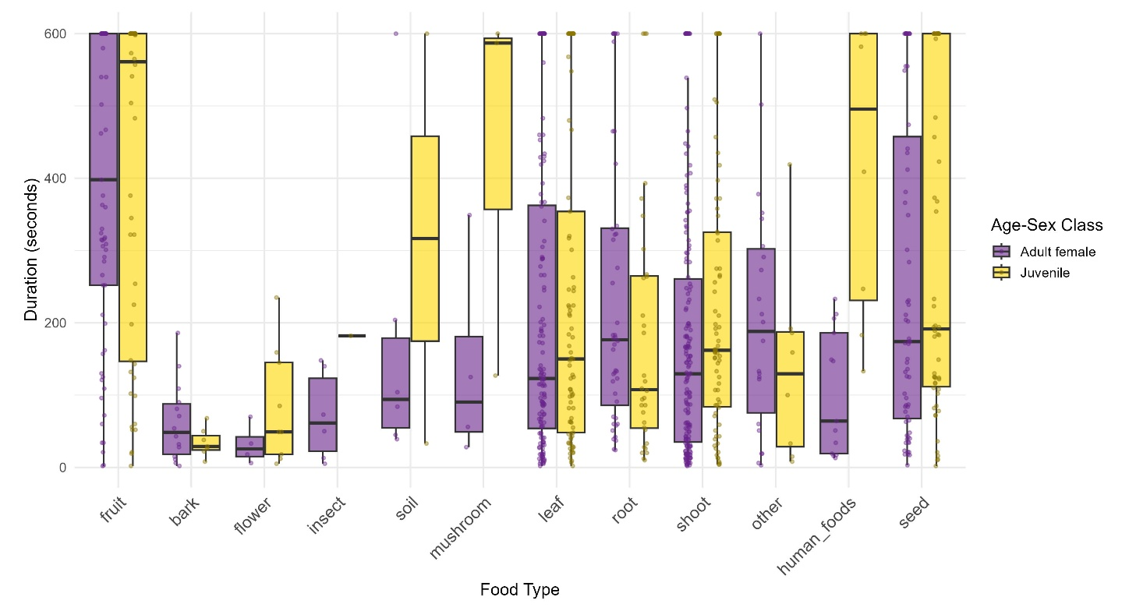
Figure 6: Raw duration data, showing distributions of food type bout lengths by age-sex class.
Tables
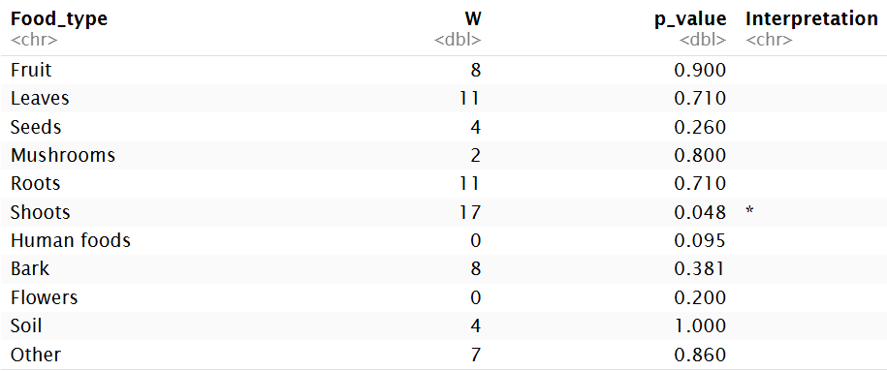
Table 1: Results of Wilcoxon rank-sum tests on food type. Shoots show slight significance.
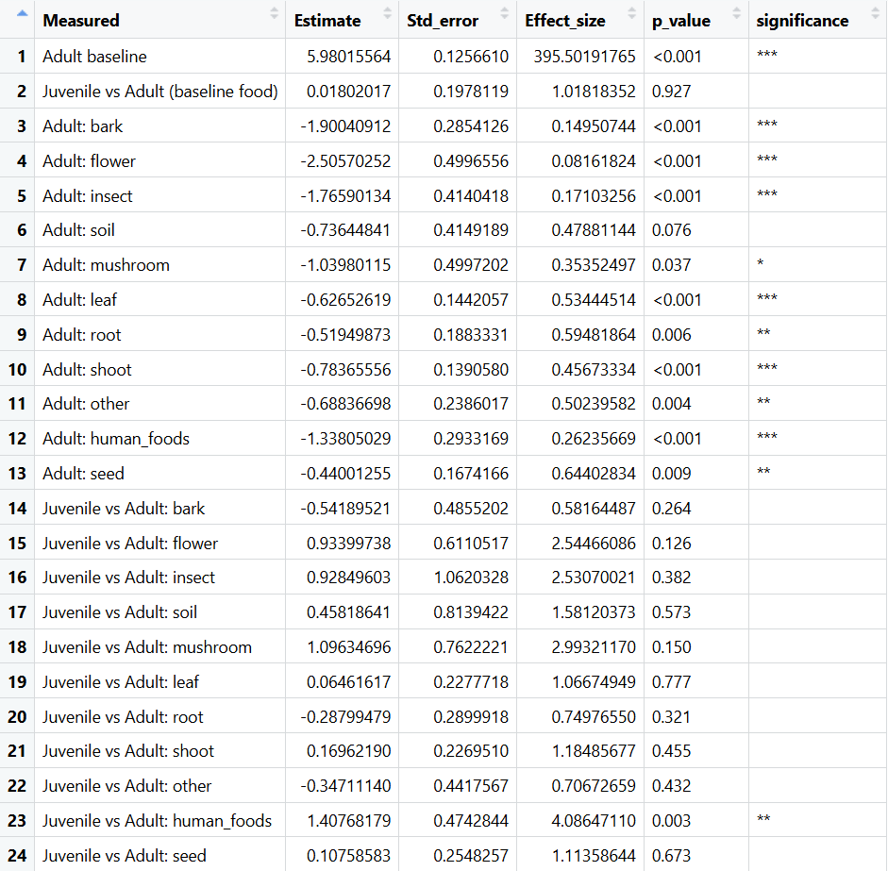
Table 2: GLMM output. Indicates significant interaction of juveniles and human foods.
Supplemental Figures

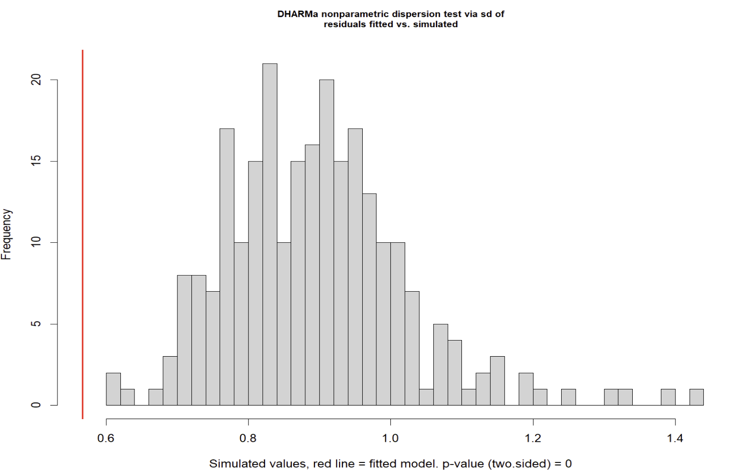
Figure 7: DHARMa simulated residuals versus fitted dispersion plot (dispersion = 0.63, p < 0.001). Indicates imperfect model fit.
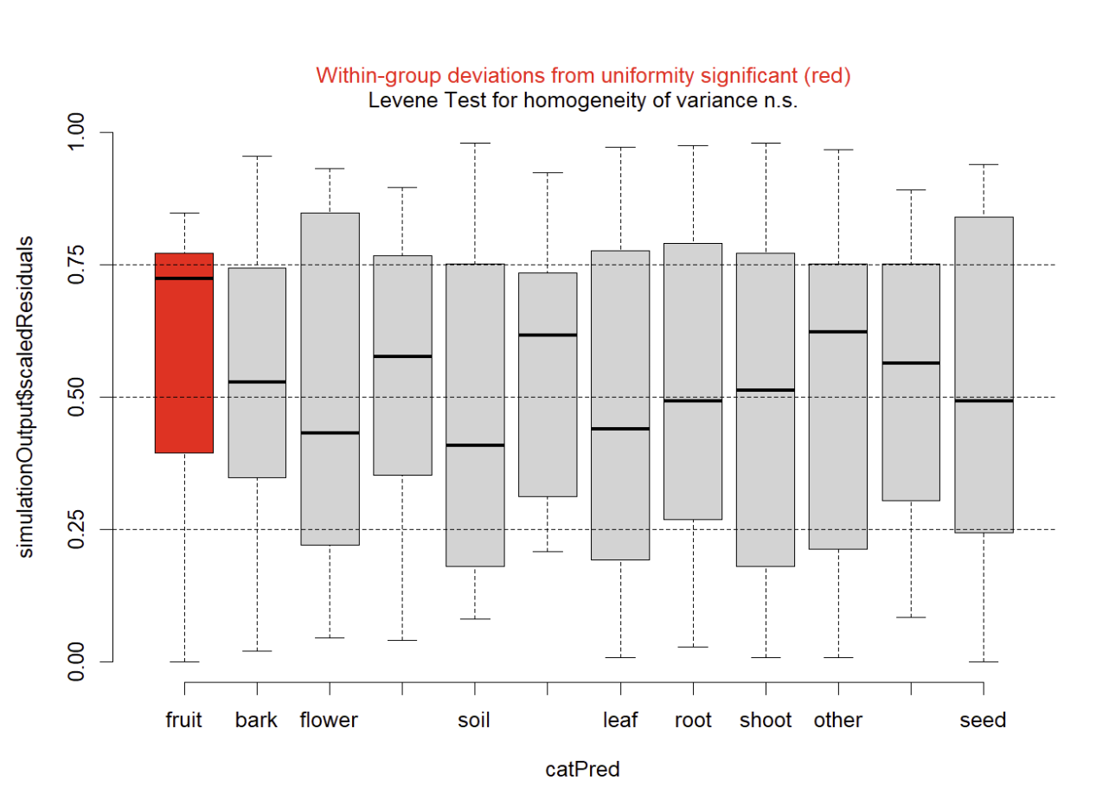
Figure 8: Within-group simulated residuals test, indicating fruit has more homogeneous bouts.
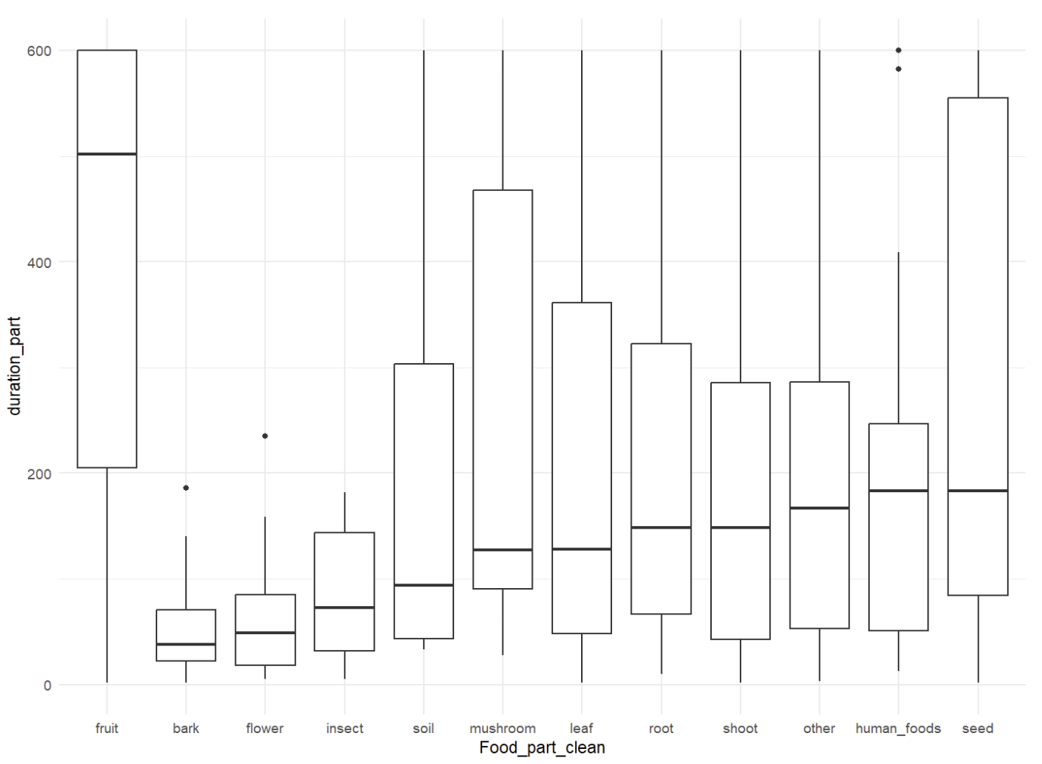
Figure 9: Across entire dataset, fruit shows longer durations (more reaching the 600 second ceiling). This, paired with the more homogeneous variance, indicates fruit is most affected by the TMF ceiling of 600 seconds (10 minutes) and suggests that Gamma distribution is not capturing this well.

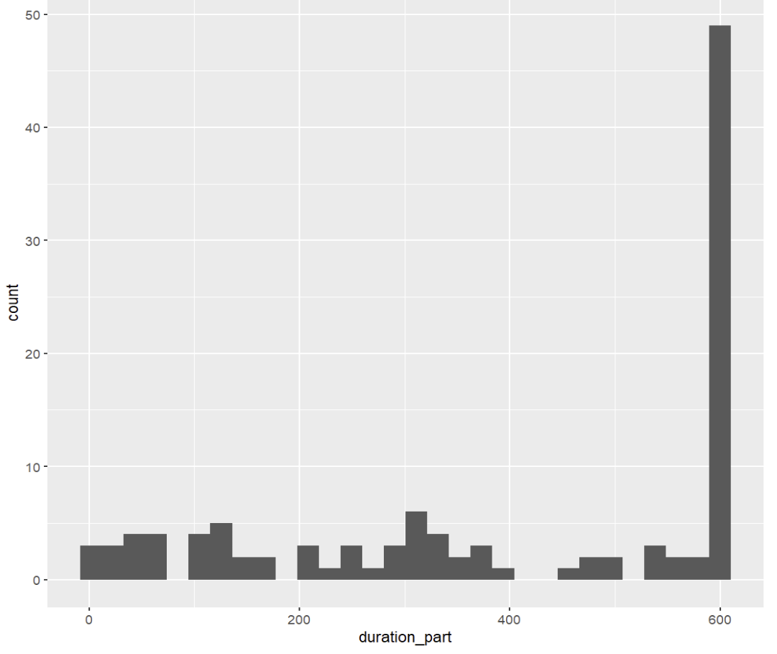
Figure 10: Histogram of frequencies for fruit bouts, with many instances of reaching the 600 second imposed ceiling (38% of fruit bouts span entire TMF).

Works Cited
Altmann, J. (1974) Observational study of behavior: Sampling methods. Behaviour 49(3), 227–67. https://doi.org/10.1163/156853974x00534.
Altmann, J., & Alberts, S. C. (2005). Growth rates in a wild primate population: Ecological influences and maternal effects. Behavioral Ecology and Sociobiology 57(5). 490–501. https://doi.org/10.1007/s00265-004-0870-x.
Amato, K. R., Leigh, S. R., Kent, A., Mackie, R. I., Yeoman, C. J., Stumpf, R. M., Wilson, B. A., Nelson, K. E., White, B. A., & Garber, P. A. (2014). The role of gut microbes in satisfying the nutritional demands of adult and juvenile wild, black howler monkeys (Alouatta pigra). American Journal of Physical Anthropology, 155(4), 652–664. https://doi.org/10.1002/ajpa.22621
Applegate, R. D. (2015). Native plants provide equal or better nutrition than crop plants in wildlife plantings. Native Plants Journal, 16(1), 28–36. https://doi.org/10.3368/npj.16.1.28.
Aristizabal, J. F., Rothman, J. M., García-Fería, L. M., & Serio-Silva, J. C. (2017). Contrasting time-based and weight-based estimates of protein and energy intake of black howler monkeys (Alouatta pigra). American Journal of Primatology, 79(4), e22611. https://doi.org/10.1002/ajp.22611
Bambi, M., Galla, G., Donati, C., Rovero, F., Hauffe, H. C., & Barelli, C. (2024). Gut microbiota variations in wild yellow baboons (Papio cynocephalus) are associated with sex and habitat disturbance. Scientific Reports, 14, 869. https://doi.org/10.1038/s41598-023-50126-z
Brooks, M. E., Kristensen, K., van Benthem, K. J., Magnusson, A., Berg, C. W., Nielsen, A., Skaug, H. J., Maechler, M., & Bolker, B. M. (2017). glmmTMB balances speed and flexibility among packages for zero-inflated generalized linear mixed modeling. The R Journal, 9(2), 378–400. doi: 10.32614/RJ-2017-066.
Chivers, D. J. (1998). Measuring food intake in wild animals: Primates. Proceedings of the Nutrition Society, 57(2), 321–332. https://doi.org/10.1079/PNS19980047
Clayton, J. B., Gomez, A., Amato, K., Knights, D., Travis, D. A., Blekhman, R., Knight, R., Leigh, S., Stumpf, R., Wolf, T., Glander, K. E., Cabana, F., & Johnson, T. J. (2018). The gut microbiome of nonhuman primates: Lessons in ecology and evolution. American Journal of Primatology, 80(6), e22867. https://doi.org/10.1002/ajp.22867
Dröscher, I., Rothman, J. M., Ganzhorn, J. U., & Kappeler, P. M. (2016). Nutritional consequences of folivory in a small-bodied lemur (Lepilemur leucopus): Effects of season and reproduction on nutrient balancing. American Journal of Physical Anthropology, 160(2), 197–207. https://doi.org/10.1002/ajpa.22952
Emery Thompson, M. (2017). Energetics of feeding, social behavior, and life history in non-human primates. Hormones and Behavior, Field Endocrinology of Nonhuman Primates and Humans, 91, 84–96. https://doi.org/10.1016/j.yhbeh.2016.08.009
Hanya, G. (2003). Age differences in food intake and dietary selection of wild male Japanese macaques. Primates, 44(4), 333–339. https://doi.org/10.1007/s10329-003-0047-7
Harrison, X. A., Donaldson, L., Correa-Cano, M. E., Evans, J., Fisher, D. N., Goodwin, C. E. D., Robinson, B. S., Hodgson, D. J., & Inger, R. (2018). A brief introduction to mixed effects modelling and multi-model inference in ecology. PeerJ, 6, e4794. https://doi.org/10.7717/peerj.4794
Hartig F. (2024). _DHARMa: Residual Diagnostics for Hierarchical (Multi-Level / Mixed) Regression Models_. doi:10.32614/CRAN.package.DHARMa <https://doi.org/10.32614/CRAN.package.DHARMa>, R package version 0.4.7.
Johnson, C. A., Raubenheimer, D., Rothman, J. M., Clarke, D., & Swedell, L. (2013). 30 Days in the life: Daily nutrient balancing in a wild chacma baboon. PLOS ONE, 8(7), e70383. https://doi.org/10.1371/journal.pone.0070383
Johnson, S. E. (2002). Life history and the competitive environment: Trajectories of growth, maturation, and reproductive output among chacma baboons. American Journal of Physical Anthropology, 120(1), 83–98. https://doi.org/10.1002/ajpa.10139
Kim, H.-Y. (2014). Statistical notes for clinical researchers: Nonparametric statistical methods: 1. Nonparametric methods for comparing two groups. Restorative Dentistry & Endodontics, 39(3), 235–239. https://doi.org/10.5395/rde.2014.39.3.235
Laerd Statistics. (n.d.). Mann-Whitney U test assumptions. Retrieved April 25, 2026, from https://statistics.laerd.com/statistical-guides/mann-whitney-u-test-assumptions.php
Lambert, J. E. (1999) Seed handling in chimpanzees (Pan Troglodytes) and redtail monkeys (Cercopithecus Ascanius): Implications for understanding hominoid and cercopithecine fruit-processing strategies and seed dispersal. American Journal of Physical Anthropology 109(3), 365–86. https://doi.org/10.1002/(SICI)1096-8644(199907)109:3%253C365::AID-AJPA6%253E3.0.CO;2-Q.
Lambert, J., & Rothman, J. (2015). Fallback foods, optimal diets, and nutritional targets: Primate responses to varying food availability and quality. Annual Review of Anthropology, 44, 150820161231002. https://doi.org/10.1146/annurev-anthro-102313-025928
Lo, S., & Andrews, S. (2015)“To transform or not to transform: Using generalized linear mixed models to analyze reaction time data.” Frontiers in Psychology 6. https://doi.org/10.3389/fpsyg.2015.01171.
Lüdecke D (2018). “ggeffects: Tidy data frames of marginal effects from regression models.” Journal of Open Source Software, 3(26), 772. doi:10.21105/joss.00772
Madden, L. V., & Ojiambo, P. S. (2024). The value of generalized linear mixed models for data analysis in the plant sciences. Frontiers in Horticulture, 3. https://doi.org/10.3389/fhort.2024.1423462
Nakayama, Y., Matsuoka, S., & Watanuki, Y. (2002). Feeding rates and energy deficits of juvenile and adult Japanese monkeys in a cool temperate area with snow coverage. Ecological Research, 14(3), 291–301. https://doi.org/10.1046/j.1440-1703.1999.143306.x
Oksanen J., Simpson G., Blanchet F., Kindt R., Legendre P., Minchin P., O'Hara R., Solymos P., Stevens M., Szoecs E., Wagner H., Barbour M., Bedward M., Bolker B., Borcard D., Borman T., Carvalho G., Chirico M., De Caceres M., Durand S., Evangelista H., FitzJohn R., Friendly M., Furneaux B., Hannigan G., Hill M., Lahti L., Martino C., McGlinn D., Ouellette M., Ribeiro Cunha E., Smith T., Stier A., Ter Braak C., Weedon J (2026). Community Ecology Package. doi:10.32614/CRAN.package.vegan https://doi.org/10.32614/CRAN.package.vegan
OpenAI. (2026). ChatGPT (April 30 version) [Large language model]. https://chat.openai.com/
Pamla, L., Vukeya, L. R., & Mokotjomela, T. M. (2024). The Potential of foraging chacma baboons (Papio ursinus) to disperse seeds of alien and invasive plant species in the Amathole Forest in Hogsback in the Eastern Cape Province, South Africa. Diversity, 16(3). https://doi.org/10.3390/d16030168
Pebsworth, P. A., & Radhakrishna, S. (2021). The costs and benefits of coexistence: What determines people’s willingness to live near nonhuman primates? American Journal of Primatology, 83(9), e23310. https://doi.org/10.1002/ajp.23310
Posit (2025). RStudio: Integrated Development Environment for R. Posit Software, PBC, Boston, MA. URL http://www.posit.co/.
R Core Team (2025). R: A language and environment for statistical computing. R Foundation for Statistical Computing, Vienna, Austria. https://www.R-project.org/
Rose, L. M. (1994). Sex differences in diet and foraging behavior in white-faced capuchins (Cebus capucinus). International Journal of Primatology, 15(1), 95–114. https://doi.org/10.1007/BF02735236
Rothman, J. M., & Bryer, M. A. H. (2019). The effects of humans on the primate nutritional landscape: A review. In A. M. Behie, J. A. Teichroeb, & N. Malone (Eds.), Primate Research and Conservation in the Anthropocene (pp. 199–215). Cambridge University Press. https://doi.org/10.1017/9781316662021.012
Rothman, J. M., Chapman, C. A., & Van Soest, P. J. (2012). Methods in Primate Nutritional Ecology: A User’s Guide. International Journal of Primatology, 33(3), 542–566. https://doi.org/10.1007/s10764-011-9568-x
Rothman, J. M., Raubenheimer, D., & Chapman, C. A. (2011). Nutritional geometry: Gorillas prioritize non-protein energy while consuming surplus protein. Biology Letters, 7(6), 847–849. https://doi.org/10.1098/rsbl.2011.0321
Souza, T. (2025). PERMANOVA. In T. Souza (Ed.), Advanced Statistical Analysis for Soil Scientists (pp. 1–13). Springer Nature Switzerland. https://doi.org/10.1007/978-3-031-88161-9_1
Tew, E., Marietjie L., and Kerley, G. (2018). The contribution of the chacma baboon to seed dispersal in the eastern karoo, South Africa.” African Journal of Wildlife Research, 48(2). 023002. https://doi.org/10.3957/056.048.023002
van Schaik, C. P. van, & Noordwijk, M. A. van. (1985). Interannual variability in fruit abundance and the reproductive seasonality in Sumatran long‐tailed macaques (Macaca fascicularis). Journal of Zoology, 206(4), 533-549. https://doi.org/10.1111/j.1469-7998.1985.tb03557.x
Vogel, E. R., Alavi, S. E., Utami-Atmoko, S. S., van Noordwijk, M. A., Bransford, T. D., Erb, W. M., Zulfa, A., Sulistyo, F., Farida, W. R., & Rothman, J. M. (2017). Nutritional ecology of wild Bornean orangutans (Pongo pygmaeus wurmbii) in a peat swamp habitat: Effects of age, sex, and season. American Journal of Primatology, 79(4), e22618. https://doi.org/10.1002/ajp.22618
Whitehouse, J., Clark, P. R., Micheletta, J., Liebal, K., Slocombe, K. E., & Waller, B. M. (2024). Pseudoreplication in Primate Communication Research: 10 Years On. International Journal of Primatology, 45(2), 246–258. https://doi.org/10.1007/s10764-023-00399-y
Wickham, H. (2016). ggplot2: Elegant graphics for data analysis. Springer. https://doi.org/10.1007/978-3-319-24277-4

