# Conceptual test: One Slurp or Two, With and Without Irrigation & Fertiliser

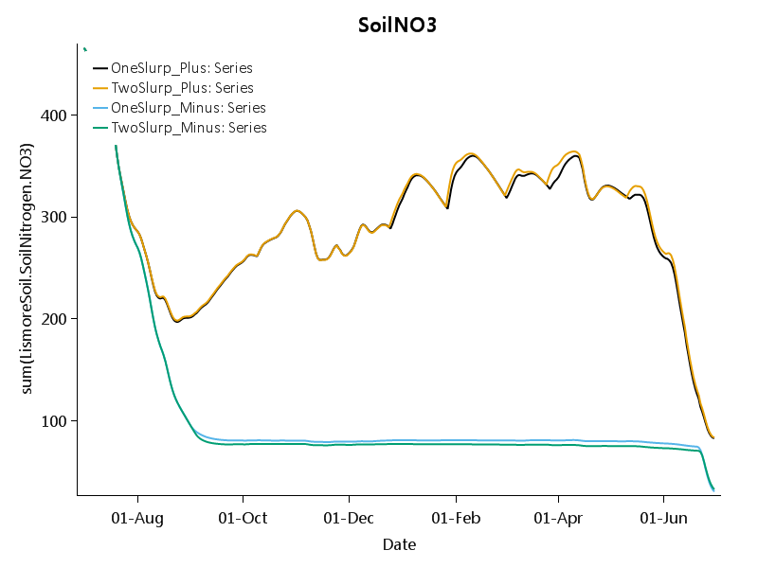

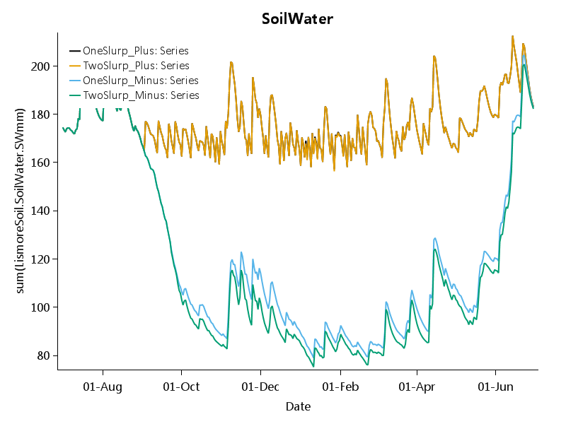

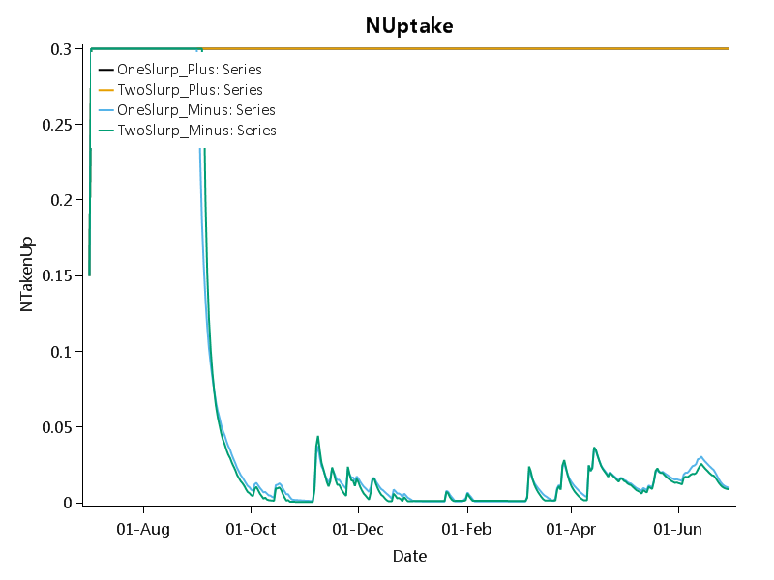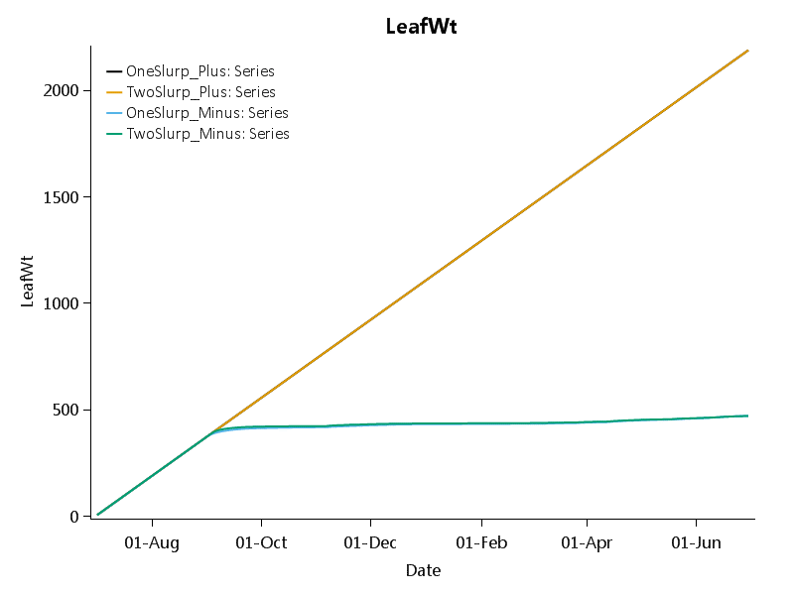

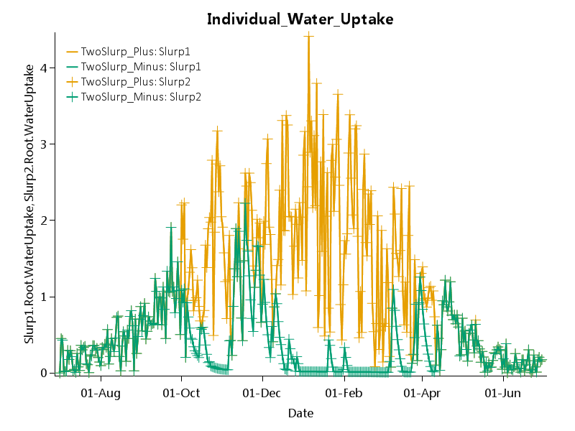

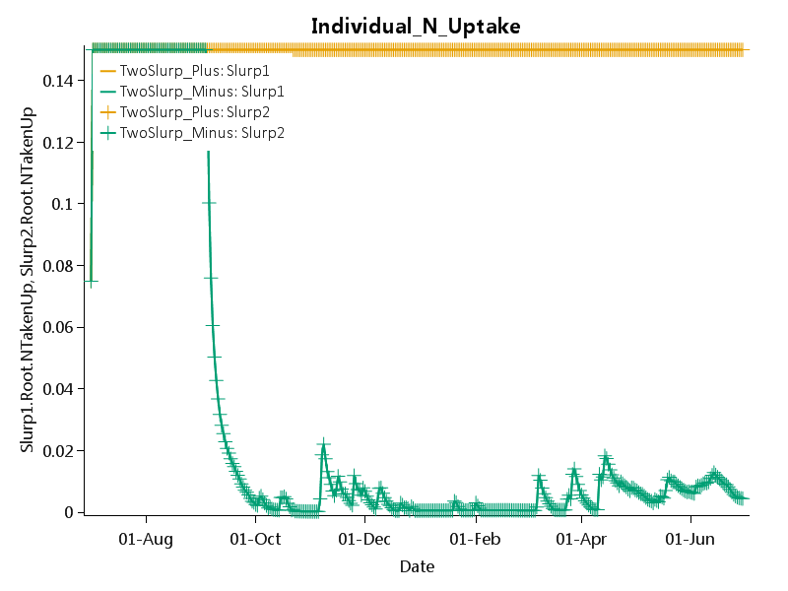

# Conceptual test: Two Ryegrasses in six configurations

The two ryegrasses have either the same root depth (Equal) or a deep root depth for Rye1 and shallow for Rye2 (Unequal) and with varying combinations of irrigation (+I, -I) and fertiliser (-F, +F).

Below is a soil with 150 mm PAW in Canterbury.

Sensible things happen. When the two rye grasses are equal they yield equally (0.5 PropRye1). The proportion of the total yield that is from the deep ryegrass (Rye1) is highest with –I+F and least with +I+F.

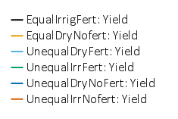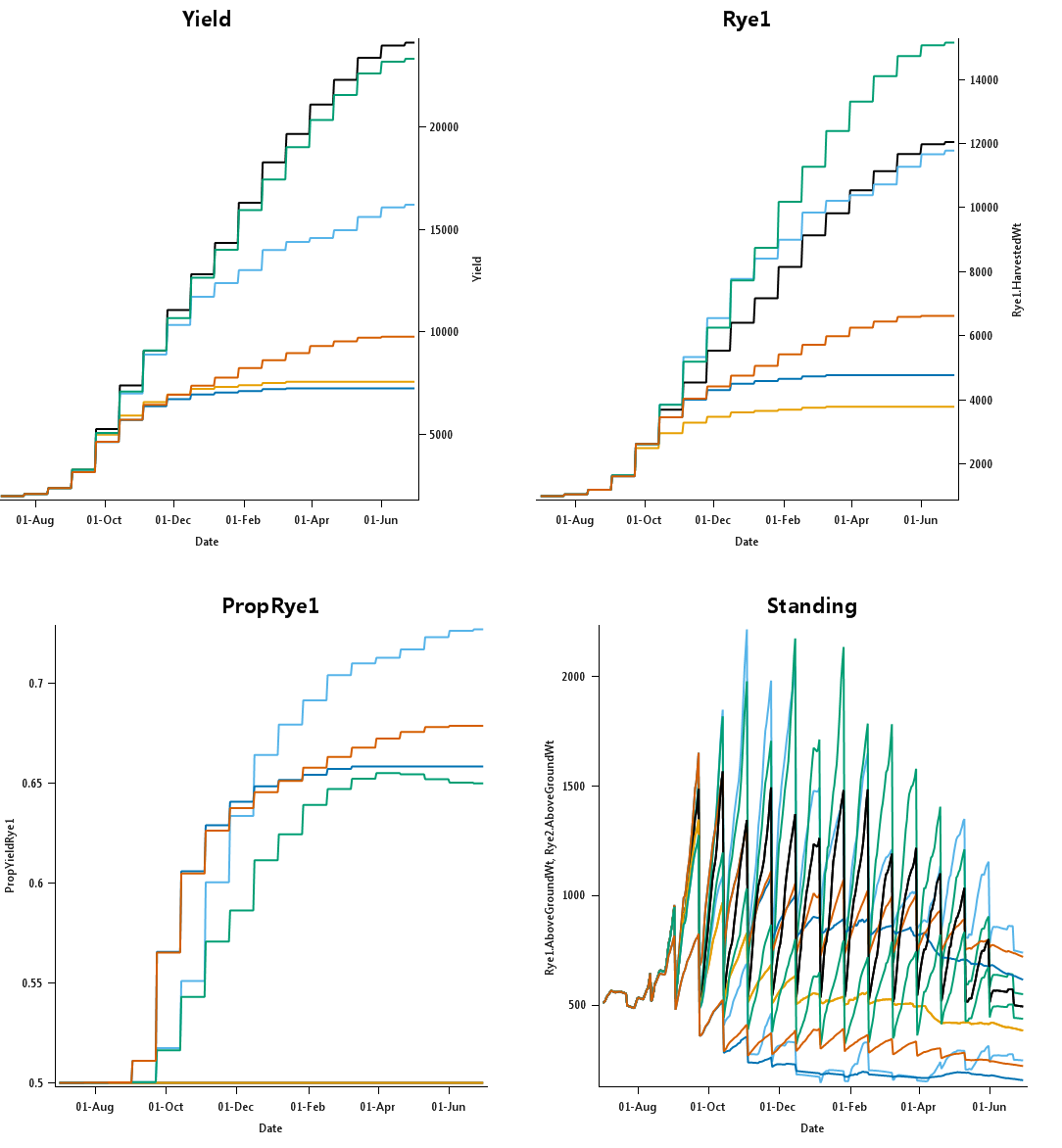

Below is a soil with 50 mm PAW for the deep root system in Canterbury.

Sensible things happen. When the two rye grasses are equal they yield equally (0.5 PropRye1). The proportion of the total yield that is from the deep ryegrass (Rye1) is highest with –I+F and least with +I+F but the pattern are more abrupt with this shallow soil..

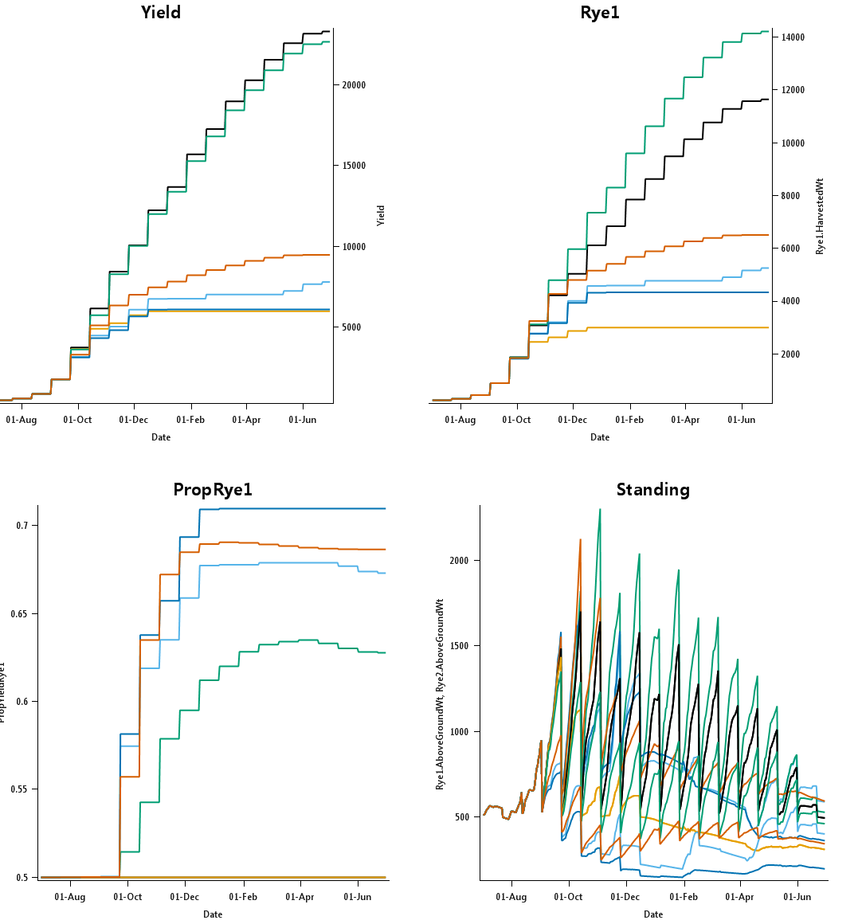

Deep soil +I+F for rooting depths in Rye2 of 750 mm (i.e. equal to Rye1), 500, 350, 225 and 100 mm. There is a yield penalty as the root systems become more unequal. Whole system yield for 225mm is slightly less than 100mm however – unclear why. The proportion of Rye1 (which always has a rooting depth of 750 mm) in the total yield monotonically increases with decreasing root depth of Rye2.

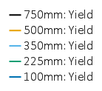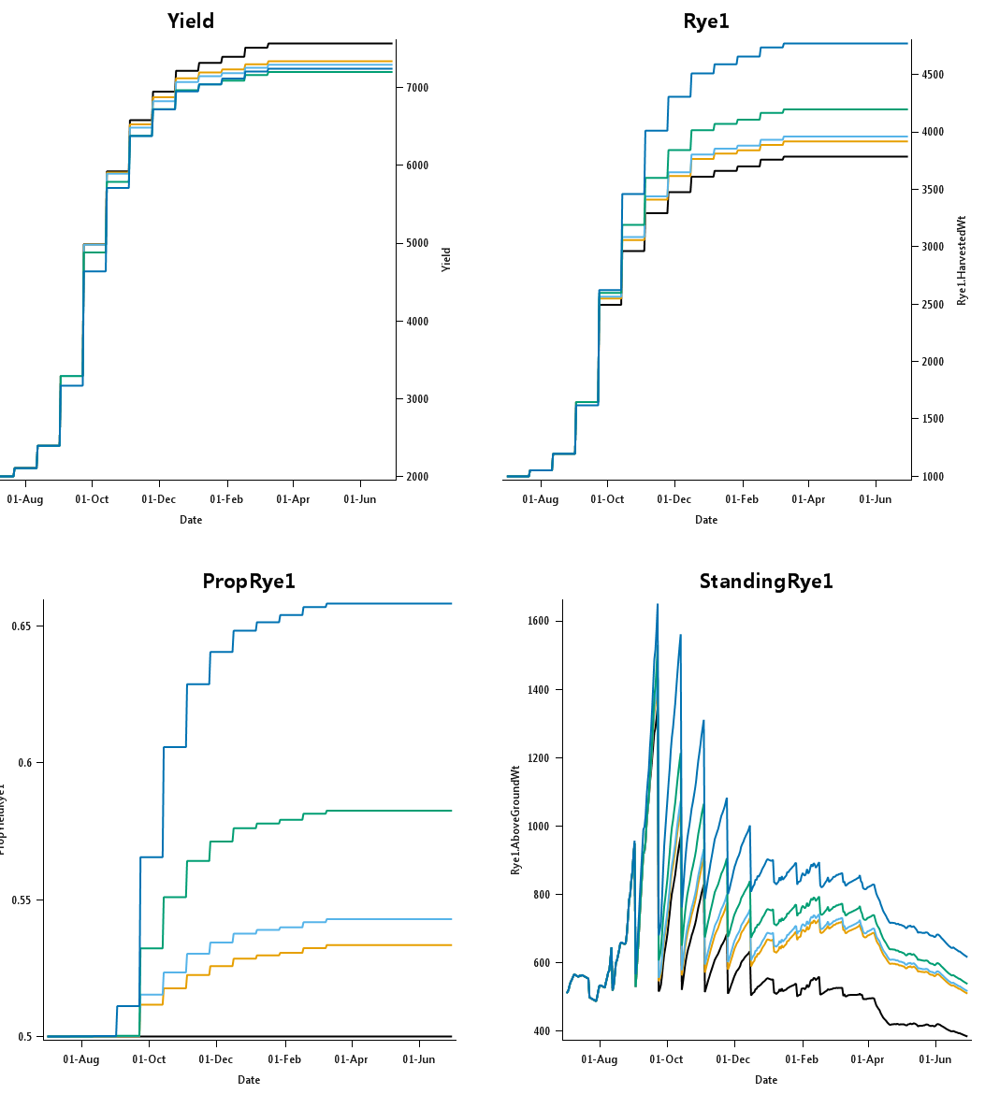

Shallow soil +I+F for rooting depths in Rye2 of 750 mm (i.e. equal to Rye1), 500, 350, 225 and 100 mm. There is a yield penalty as the root systems become more unequal and this is monotonic with decreasing Rye2 root depth. The proportion of Rye1 (which always has a rooting depth of 750 mm) in the total yield monotonically increases with decreasing root depth of Rye2.

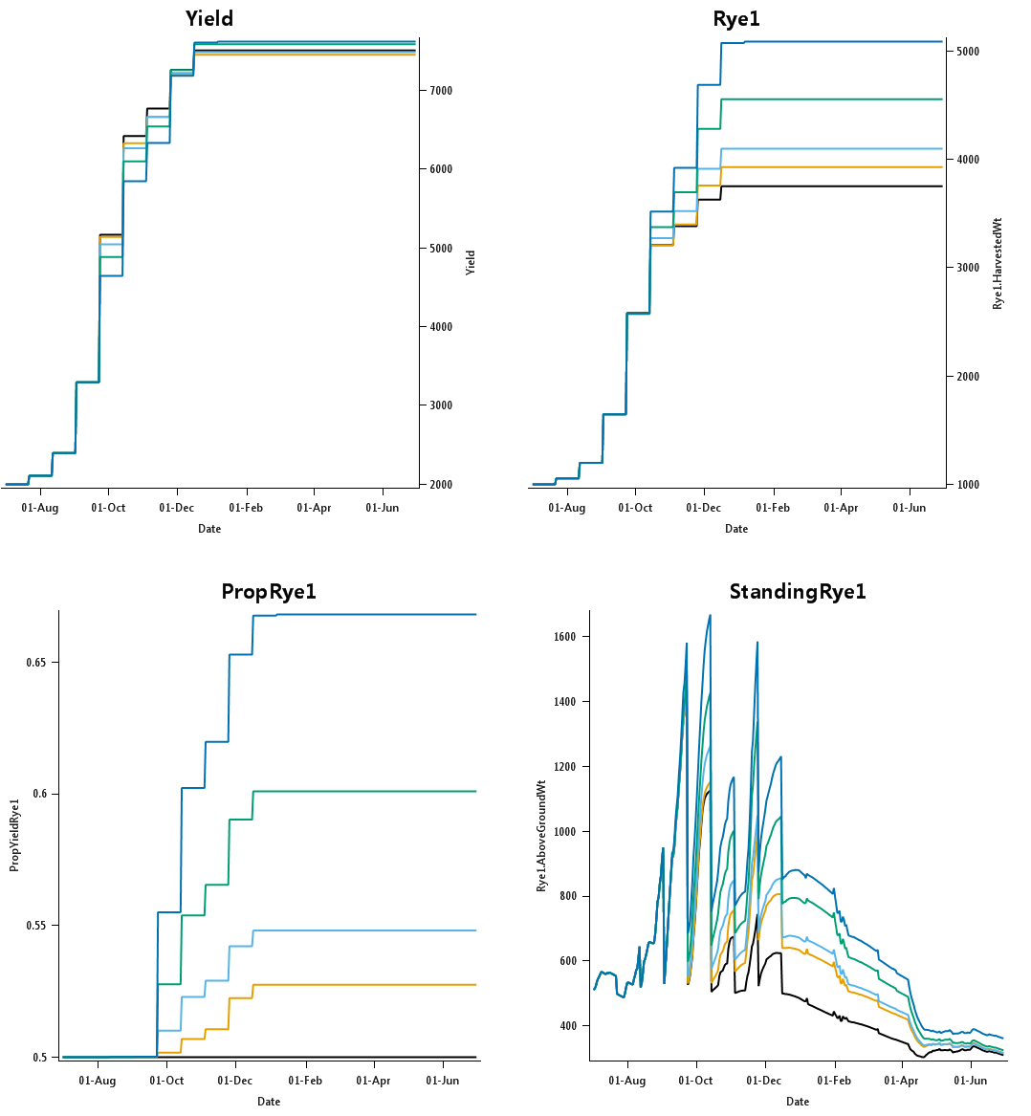

# A Practical test: Ryegrass and WhiteCLover in four configurations

|  |  |
| --- | --- |
| Deep (150 mm) soil, no irrigation or fertiliser, Canterbury, ryegrass and white clover. Becomes very clover dominant – maybe a bit much but the clover does get the best of the management conditions here | |
|  |  |
|  |  |

|  |  |
| --- | --- |
| Deep (150 mm) soil, with irrigation and fertiliser, Canterbury, ryegrass and white clover. Now becomes grass dominant as expected. Clover growth delayed in the season compared to grass. | |
|  |  |
|  |  |

|  |  |
| --- | --- |
| Very shallow (50 mm) soil, without irrigation and fertiliser, Canterbury, ryegrass and white clover. Now becomes grass dominant as expected. Struggles to grow without any irrigation and this is sensible. Becomes quite clover dominant and that is also expected. | |
|  |  |
|  |  |

|  |  |
| --- | --- |
| Very shallow (50 mm) soil, with irrigation and fertiliser, Canterbury, ryegrass and white clover. Now becomes grass dominant as expected. As expected. Compared to the deep soil the clover does better and that makes sense given the low fertility of this soil (even with fertiliser) | |
|  |  |
|  |  |