1. You need to download the archive "pf_ph.rar"  
     
   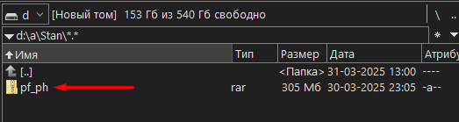
2. Unzip this archive:  
     
   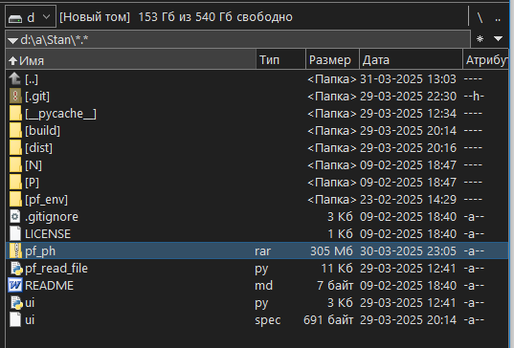
3. Find the “dist” folder among the unpacked files, go into it and run the “ui.exe” file:  
     
   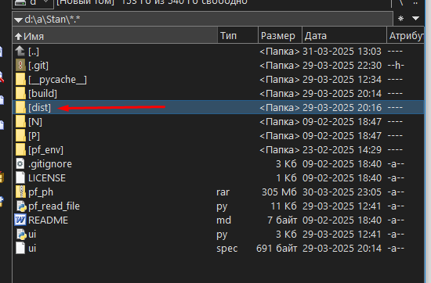

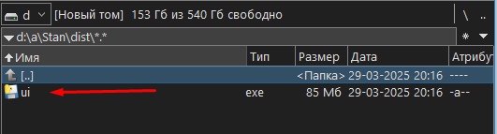

1. A window will appear that will look like this:  
     
   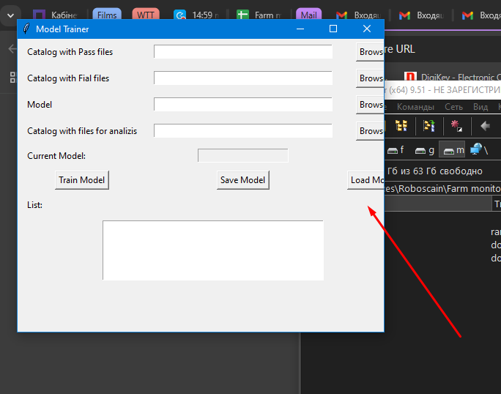
2. You need to stretch the window so that all the buttons are visible:  
     
   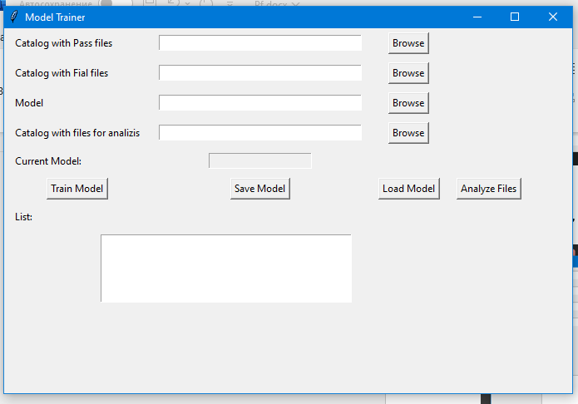
3. Next, we need to provide the program with a folder of files containing positive test results:  
     
   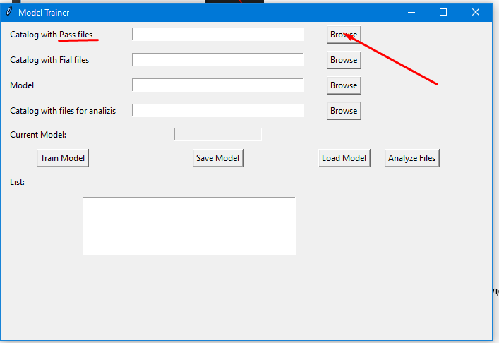

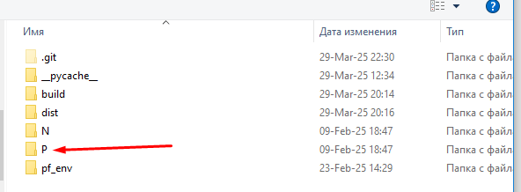

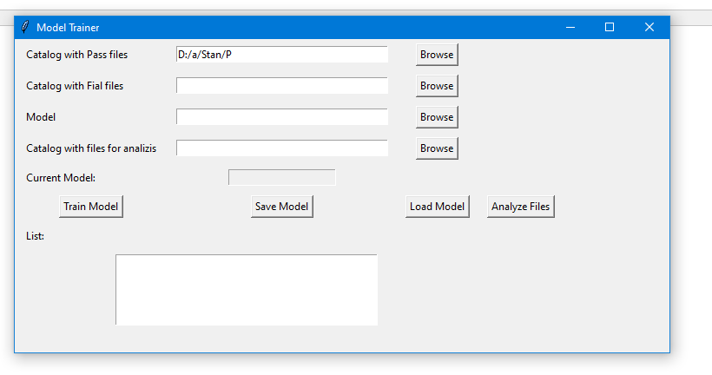

1. Next, we need to provide the program with a folder of files containing the negative test results:  
     
   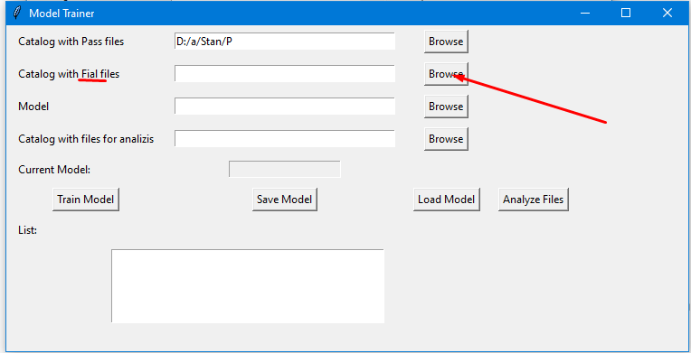

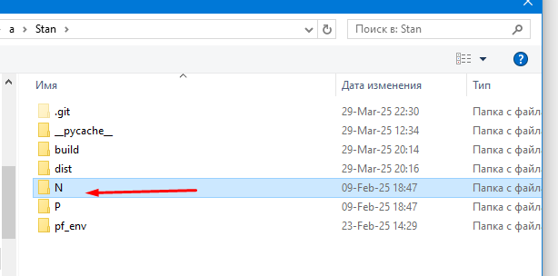

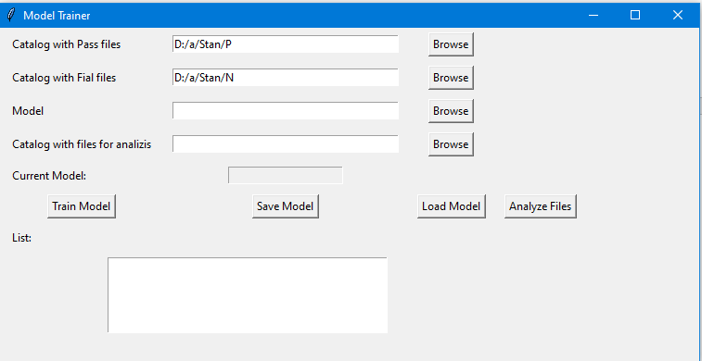

1. We give the command "train the model":

(this command may take some time to execute - depends on the power of the computer)  
  
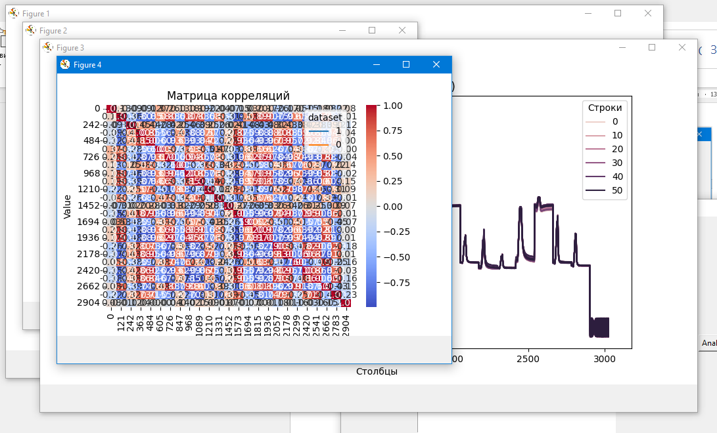

1. After this, we must provide the program with a folder containing the files that we want to analyze:  
     
   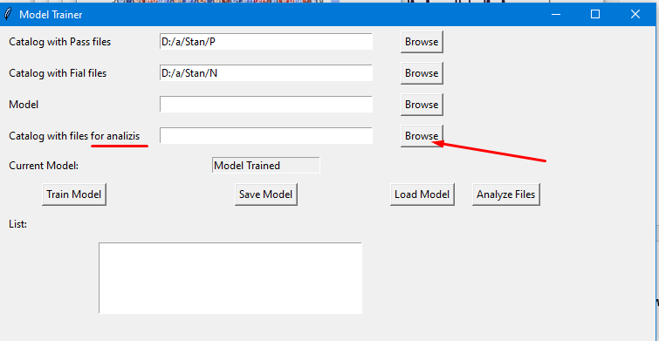
2. Since we don’t have such a folder available, for example I will choose one of the folders N or P (you must substitute there a folder with your real files that need to be examined):  
     
   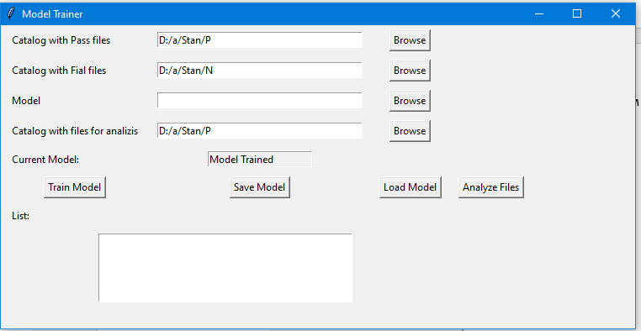
3. To launch the program, click “Analyze Files”  
     
   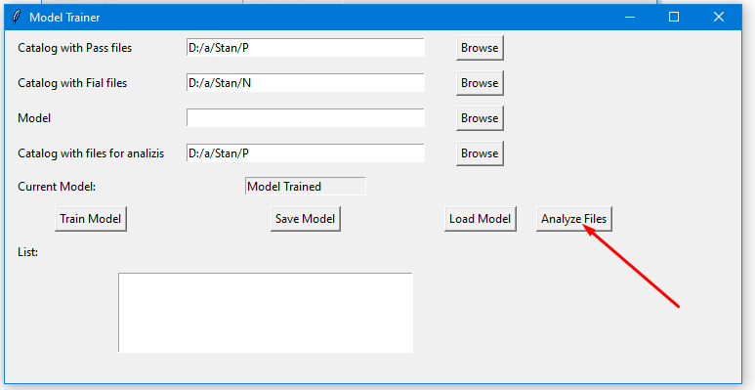

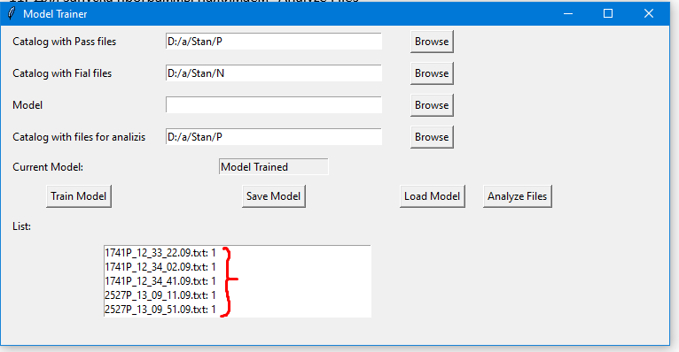

As a result, we get the names of the files being examined, to which a number is added:

- if this number is greater than 0.5, this means that this result refers to "Pass"  
- if this number is less than 0.5, this means that this result refers to "Fail"

Since in the example I substituted the folder with the "P" files, then in the example all results = 1. Real files should give other numbers.