**QUESTION 1**

**Note: This question is part of a series of questions that use the same scenario. For you convenience, the scenario is repeated in each question. Each question presents a different goal and answer choices, but the text of the scenario is exactly the same in each question in this series.**

**Start of repeated scenario.**

You work for a company named Contoso, Ltd.

The network contains an Active Directory forest named contoso.com. A forest trust exists between contoso.com and an Active Directory forest named adatum.com.

The contoso.com forest contains the objects configured as shown in the following table.

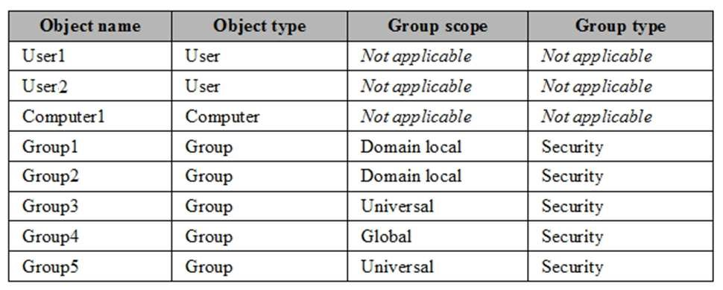

Group1 and Group2 contain only user accounts.

Contoso hires a new remote user named User3. User3 will work from home and will use a computer named Computer3 that runs Windows 10. Computer3 is currently in a workgroup.

An administrator named Admin1 is a member of the Domain Admins group in the contoso.com domain.

From Active Directory Users and Computers, you create an organizational unit (OU) named OU1 in the contoso.com domain, and then you create a contact named Contact1 in OU1.

An administrator of the adatum.com domain runs the Set-ADUser cmdlet to configure a user named User1 to have a user logon name of User1@litwareinc.com.

**End of repeated scenario.**

You need to ensure that User2 can add Group4 as a member of Group5.

What should you modify?

1. the group scope of Group5
2. the Managed By settings of Group4
3. the group scope of Group4
4. the Managed By settings of Group5

**Correct Answer:** D

**Section: Install and Configure Active Directory Domain Services (AD DS) Explanation**

**Explanation/Reference:** Explanation:

**QUESTION 2**

**Note: This question is part of a series of questions that use the same scenario. For your convenience, the scenario is repeated in each question. Each question presents a different goal and answer choices, but the text of the scenario is exactly the same in each question in this series.**

**Start of repeated scenario.**

You work for a company named Contoso, Ltd.

The network contains an Active Directory forest named contoso.com. A forest trust exists between contoso.com and an Active Directory forest named adatum.com.

The contoso.com forest contains the objects configured as shown in the following table.

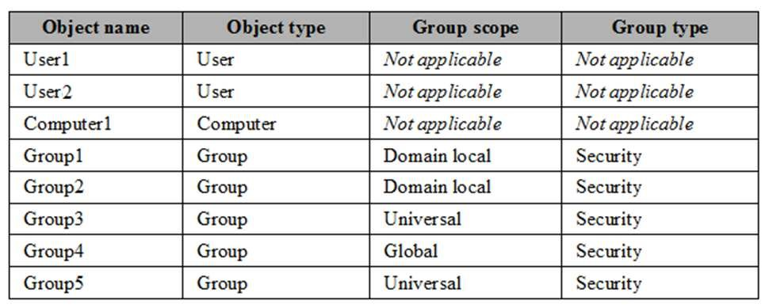

Group1 and Group2 contain only user accounts.

Contoso hires a new remote user named User3. User3 will work from home and will use a computer named Computer3 that runs Windows 10. Computer3 is currently in a workgroup.

An administrator named Admin1 is a member of the Domain Admins group in the contoso.com domain.

From Active Directory Users and Computers, you create an organizational unit (OU) named OU1 in the contoso.com domain, and then you create a contact named Contact1 in OU1.

An administrator of the adatum.com domain runs the Set-ADUser cmdlet to configure a user named User1 to have a user logon name of User1@litwareinc.com.

**End or repeated scenario.**

You need to ensure that Admin1 can add Group2 as a member of Group3.

What should you modify?

1. Modify the Security settings of Group3.
2. Modify the group scope of Group3.
3. Modify the group type of Group3.
4. Set Admin1 as the manager of Group3.
5. Add Admin1 to the Enterprise Admins group

**Correct Answer:** B

**Section: Install and Configure Active Directory Domain Services (AD DS) Explanation**

**Explanation/Reference:**

Explanation:

A domain local group (group2) can only be a member of another domain local group. Therefore, we need to change the scope of Group3 from Universal to Domain Local.

**QUESTION 3**

Your network contains an Active Directory forest named contoso.com

Your company plans to hire 500 temporary employees for a project that will last 90 days.

You create a new user account for each employee. An organizational unit (OU) named Temp contains the user accounts for the employees.

You need to prevent the new users from accessing any of the resources in the domain after 90 days.

What should you do?

1. Run the Get-ADUser cmdlet and pipe the output to the Set-ADUser cmdlet.
2. Create a group that contains all of the users in the Temp OU. Create a Password Setting object (PSO) for the new group.
3. Create a Group Policy object (GPO) and link the GPO to the Temp OU. Modify the Password Policy settings of the GPO.
4. Run the Get-ADOrganizationalUnit cmdlet and pipe the output to the Set-Date cmdlet.

**Correct Answer:** A

**Section: Install and Configure Active Directory Domain Services (AD DS) Explanation**

**Explanation/Reference:** Explanation:

**QUESTION 4**

Your network contains an Active Directory forest. The forest contains two domains named litwarenc.com and contoso.com. The contoso.com domain contains two domains controllers named LON-DC01 and LON-DC02.

The domain controllers are located in a site named London that is associated to a subnet of 192.168.10.0/24

You discover that LON-DC02 is not a global catalog server. You need to configure LON-DC02 as a global catalog server.

What should you do?

1. From Active Directory Sites and Services, modify the properties of the 192.168.10.0/24 IP subnet.
2. From Windows PowerShell, run the Set-NetNatGlobal cmdlet.
3. From Active Directory Sites and Services, modify the NTDS Settings object of LON-DC02.
4. From Windows PowerShell, run the Enable-ADOptionalFeature cmdlet.
5. From the properties of the LON-DC02 computer account in Active Directory Users and Computers, modify the NTDS settings.
6. From the properties of the LON-DC02 computer account in Active Directory Users and Computers, modify the City attribute.
7. From the properties of the Domain Controllers organizational unit (OU) in Active Directory Users and Computers, modify the Security settings.

**Correct Answer:** C

**Section: Install and Configure Active Directory Domain Services (AD DS) Explanation**

**Explanation/Reference:** Explanation:

**QUESTION 5**

Your network contains an Active Directory domain named contoso.com. The domain functional level is Windows Server 2012 R2.

You need to secure several high-privilege user accounts to meet the following requirements:

 Prevent authentication by using NTLM.

 Use Kerberos to verify authentication request to any resources.

 Prevent the users from signing in to a client computer if the computer is disconnected from the domain.

What should you do?

1. Create a universal security group for the user accounts and modify the Security settings of the group.
2. Add the users to the Windows Authorization Access Group group.
3. Add the user to the Protected Users group.
4. Create a separate organizational unit (OU) for the user accounts and modify the Security settings of the OU.

**Correct Answer:** C

**Section: Install and Configure Active Directory Domain Services (AD DS) Explanation**

**Explanation/Reference:**

Explanation:

**QUESTION 6**

Your network contains an Active Directory forest named contoso.com. Users frequently access the website of an external partner company. The URL of the website is http://partners.adatum.com.

The partner company informs you that it will perform maintenance on its Web server and that the IP addresses of the Web server will change.

After the change is complete, the users on your internal network report that they fail to access the website. However, some users who work from home report that they can access the website.

You need to ensure that your DNS servers can resolve partners.adatum.com to the correct IP address immediately.

What should you do?

1. Run **dnscmd** and specify the **CacheLockingPercent** parameter.
2. Run **Set-DnsServerGlobalQueryBlockList**.
3. Run **ipconfig** and specify the **Renew** parameter.
4. Run Set**-DnsServerCache**.

**Correct Answer:** D

**Section: Install and Configure Active Directory Domain Services (AD DS) Explanation**

**Explanation/Reference:**

**QUESTION 7**

You network contains one Active Directory domain named adatum.com. The domain contains a DNS server named Server1 that runs Windows Server 2016. All domain computers use Server1 for DNS.

You sign adatum.com by using DNSSEC.

You need to configure the domain computers to validate DNS responses for adatum.com records.

What should you configure in Group Policy?

1. Network List Manager Policies
2. Network Access Protection (NAP)
3. Name Resolution Policy
4. Public Key Policy

**Correct Answer:** C

**Section: Install and Configure Active Directory Domain Services (AD DS) Explanation**

**Explanation/Reference:**

**QUESTION 8**

**Note: This question is part of a series of questions that use the same scenario. For you convenience, the scenario is repeated in each question. Each question presents a different goal and answer choices, but the text of the scenario is exactly the same in each question in this series.**

You work for a company named Contoso, Ltd.

The network contains an Active Directory forest named contoso.com. A forest trust exists between contoso.com and an Active Directory forest named adatum.com. The contoso.com forest contains the objects configured as shown in the following table.



Group1 and Group2 contain only user accounts.

Contoso hires a new remote user named User3. User3 will work from home and will use a computer named Computer3 that runs Windows 10. Computer3 is currently in a workgroup.

An administrator named Admin1 is a member of the Domain Admins group in the contoso.com domain.

From Active Directory Users and Computers, you create an organizational unit (OU) named OU1 in the contoso.com domain, and then you create a contact named Contact1 in OU1.

An administrator of the adatum.com domain runs the **Set-ADUser** cmdlet to configure a user named User1 to have a user logon name of [User1@litwareinc.com](mailto:User1@litwareinc.com).

You need to ensure that Admin1 can convert Group1 to a global group.

What should you do?

1. Add Admin1 to the Enterprise Admins group.
2. Remove all the members from Group1.
3. Modify the Security settings of Group1.
4. Convert Group1 to a universal security group.

**Correct Answer:** B

**Section: Install and Configure Active Directory Domain Services (AD DS) Explanation**

**Explanation/Reference:**

**QUESTION 9**

Your network contains an Active Directory domain named contoso.com. The domain contains five domain controllers.

You have a branch office that has a local support technician named Tech1. Tech1 installs Windows Server 2016 on a server named RODC1 in a workgroup.

You need Tech1 to deploy RODC1 as a read-only domain controller (RODC) in the contoso.com domain.

Which three actions should you perform? Each correct answer presents part of the solution.

1. Instruct Tech1 to run the Active Directory Domain Services Configuration Wizard.
2. Create an RODC computer account by using Active Administrative Center.
3. Instruct Tech1 to run **dcpromo.exe** on RODC1.
4. Instruct Tech1 to install the Active Directory Domain Services server role on RODC1.
5. Modify the permissions of the Domain Controllers organizational unit (OU).

**Correct Answer:** ABD

**Section: Install and Configure Active Directory Domain Services (AD DS) Explanation**

**Explanation/Reference:**

**QUESTION 10**

**Note: This question is part of a series of questions that use the same or similar answer choices. An answer choice may be correct for more than one question in the series. Each question is independent of the other questions in this series. Information and details provided in a question apply only to that question.**

Your network contains an Active Directory domain named contoso.com. The domain functional level is Windows Server 2012 R2.

Your company hires a new security administrator to manage sensitive user data. You create a user account named Security1 for the security administrator.

You need to ensure that the password for Security1 has at least 12 characters and is modified every 10 days. The solution must apply to Security1 only.

Which tool should you use?

1. Dsadd quota
2. Dsmod
3. Active Directory Administrative Center
4. Dsacls
5. Dsamain
6. Active Directory Users and Computers
7. Ntdsutil
8. Group Policy Management Console

**Correct Answer:** C

**Section: Install and Configure Active Directory Domain Services (AD DS) Explanation**

**Explanation/Reference:**

**QUESTION 11**

Your network contains an Active Directory domain. All client computers run Windows 10.

A client computer named Computer1 was in storage for five months and was unused during that time. You attempt to sign in to the domain from Computer1 and receive an error message.

You need to ensure that you can sign in to the domain from Computer1.

What should you do?

1. Unjoin Computer1 from the domain, and then join the computer to the domain.
2. From Active Directory Administrative Center, reset the computer account of Computer1.
3. From Active Directory Administrative Center, disable Computer1, and then enable the computer account of Computer1.
4. From Active Directory Users and Computers, run the Delegation of Control Wizard.
5. From Windows PowerShell on Computer1, run the **Restore-Computer** cmdlet
6. From a command prompt, run the **Systemreset.exe** command
7. From Windows PowerShell on Computer1, run the **Set-ADComputer** cmdlet

**Correct Answer:** A

**Section: Install and Configure Active Directory Domain Services (AD DS) Explanation**

**Explanation/Reference:** Reference: https://mcpmag.com/articles/2015/03/05/rejoin-a-computer-from-a-domain.aspx

**QUESTION 12**

Your network contains an Active Directory forest. The forest contains two domains named contoso.com and fabrikam.com. The functional level of the forest and the domains is Windows Server 2008 R2.

You have a global group named Group1 in the contoso.com domain. Group1 contains the user accounts in the contoso.com.

You need to ensure that you can add the user accounts in the fabrikam.com domain to Group1.

What should you do?

1. Assign the Domain Controllers group in fabrikam.com permissions to Group1.
2. Modify the scope of Group1 to Universal.
3. Raise the domain functional level contoso.com to Windows Server 2016.
4. Raise the domain functional level of fabriakm.com Windows Server 2016.
5. Change Group1 to a distribution group

**Correct Answer:** B

**Section: Install and Configure Active Directory Domain Services (AD DS) Explanation**

**Explanation/Reference:**

**QUESTION 13**

**Note: This question is part of a series of questions that present the same scenario. Each question in the series contains a unique solution that might meet the stated goals. Some question sets might have more than one correct solution, while others might not have a correct solution.**

**After you answer a question in this section, you will NOT be able to return to it. As a result, these questions will not appear in the review screen.**

Your network contains an Active Directory domain named contoso.com. The domain contains a server named Server1 that runs Windows Server 2016. The computer account for Server1 is in organizational unit (OU) named OU1.

You create a Group Policy object (GPO) named GPO1 and link GPO1 to OU1.

You need to add a domain user named User1 to the local Administrators group on Server1.

Solution: From a domain controller, you run the Set-AdComputer cmdlet.

Does this meet the goal?

1. Yes
2. No

**Correct Answer:** B

**Section: Install and Configure Active Directory Domain Services (AD DS) Explanation**

**Explanation/Reference:**

Explanation:

The Set-AdComputer cmdlet modifies an Active Directory computer object. It will not allow you to add a domain user to a local Administrators group.

References: https://technet.microsoft.com/es-es/library/hh852268(v=wps.620).aspx

**QUESTION 14**

**Note: This question is part of a series of questions that present the same scenario. Each question in the series contains a unique solution that might meet the stated goals. Some question sets might have more than one correct solution, while others might not have a correct solution.**

**After you answer a question in this section, you will NOT be able to return to it. As a result, these questions will not appear in the review screen.**

Your network contains an Active Directory domain named contoso.com. The domain contains a server named Server1 that runs Windows Server 2016. The computer account for Server1 is in organizational unit (OU) named OU1.

You create a Group Policy object (GPO) named GPO1 and link GPO1 to OU1.

You need to add a domain user named User1 to the local Administrators group on Server1.

Solution: From the Computer Configuration node of GPO1, you configure the Local Users and Groups preference.

Does this meet the goal?

1. Yes
2. No

**Correct Answer:** A

**Section: Install and Configure Active Directory Domain Services (AD DS) Explanation**

**Explanation/Reference:**

Explanation:

to add uses to the Local Administrator built In group on all the computers using Group Policy, open group policy editor and create or edit existing GPO. Go to User Configuration -> Preferences -> Control Panel Settings -> Local users and groups.

References: https://www.ntweekly.com/2015/01/10/how-to-add-users-to-local-admin-group-using-group-policy-windows-server-2012/

**QUESTION 15**

**Note: This question is part of a series of questions that present the same scenario. Each question in the series contains a unique solution that might meet the stated goals. Some question sets might have more than one correct solution, while others might not have a correct solution.**

**After you answer a question in this section, you will NOT be able to return to it. As a result, these questions will not appear in the review screen.**

Your network contains an Active Directory domain named contoso.com. The domain contains a server named Server1 that runs Windows Server 2016. The computer account for Server1 is in organizational unit (OU) named OU1.

You create a Group Policy object (GPO) named GPO1 and link GPO1 to OU1.

You need to add a domain user named User1 to the local Administrators group on Server1.

Solution: From the Computer Configuration node of GPO1, you configure the Account Policies settings.

Does this meet the goal?

1. Yes
2. No

**Correct Answer:** B

**Section: Install and Configure Active Directory Domain Services (AD DS) Explanation**

**Explanation/Reference:**

Explanation:

Account Lockout Policy settings encapsulates Password Policy, Account Lockout Policy, and Kerberos Policy. It will not allow you to add a domain user to a local Administrators group.

References: https://technet.microsoft.com/pt-pt/library/cc757692(v=ws.10).aspx

**QUESTION 16**

**Note: This question is part of a series of questions that present the same scenario. Each question in the series contains a unique solution that might meet the stated goals. Some question sets might have more than one correct solution, while others might not have a correct solution.**

**After you answer a question in this section, you will NOT be able to return to it. As a result, these questions will not appear in the review screen.**

Your network contains an Active Directory domain named contoso.com. The domain contains a server named Server1 that runs Windows Server 2016.

The Computer account for Server1 is in organizational unit (OU) named OU1.

You create a Group Policy object (GPO) named GPO1 and link GPO1 to OU1.

You need to add a domain user named User1 to the local Administrators group on Server1.

Solution: From the Computer Configuration node of GPO1, you configure the Restricted Groups settings.

Does this meet the goal?

1. Yes
2. No

**Correct Answer:** A

**Section: Install and Configure Active Directory Domain Services (AD DS) Explanation**

**Explanation/Reference:**

**QUESTION 17**

Your network contains an Active Directory domain named contoso.com.

All users are in an organizational unit (OU) named Corp_Users.

You plan to modify the description of all the users who have a string of 514 in their mobile phone number.

You need to view a list of the users that will be modified.

What should you run?

1. **Get-ADOrganizationalUnit-Filter “mobilePhone-Like ‘*514*’ ”**
2. **Get-ADUser-LDAPFilter “(mobilePhone= ‘*514*’)”**
3. **Get-ADUser-Filter “mobilePhone-Like ‘*514*’ ”**
4. **Get-ADOrganizationalUnit-LDAPFilter “(mobilePhone= ‘*514*’)”**

**Correct Answer:** C

**Section: Install and Configure Active Directory Domain Services (AD DS) Explanation**

**Explanation/Reference:**

**QUESTION 18**

Your network contains an Active Directory domain. The domain contains a computer named Computer1 and an organizational unit (OU) named TestOU. TestOU contains 10 computer accounts that are used for testing. A Group Policy object (GPO) named GPO1 is linked to TestOU.

On Computer1, you modify the User Right Assignment by using the local policy.

You need to apply the User Right Assignment from Computer1 to the 10 test computers.

What should you do?

1. On Computer1 run the **secedit.exe** command and specify the **/export** parameter. Edit GPO1, and then import a security template.
2. On Computer1, run the **gpresult.exe** command and specify the **/x** parameter. Edit GPO1, and then import a security template.
3. On Computer1, run the **secedit.exe** command and specify the **/export** parameter. From Group Policy Management, run the Import Settings Wizard.
4. On Computer1, run the **gpresult.exe** command and specify the **/x** parameter. From Group Policy Management, run the Restore Group Policy Object Wizard.

**Correct Answer:** A

**Section: Install and Configure Active Directory Domain Services (AD DS) Explanation**

**Explanation/Reference:**

**QUESTION 19**

Your network contains a single-domain Active Directory forest named contoso. com. The forest functional level is Windows Server 2016. The forest has Dynamic Access Control enabled. The domain contains two domain controllers named DC1 and DC2. Privileged user accounts used to manage Active Directory reside in a group named Contoso\AD_Admins.

You create an authentication policy named Policy1 and an authentication policy silo named Silo1.

You need to ensure that the accounts in the Contoso\AD_Admins group can sign in to the domain controllers only.

Which three configurations should you perform? Each correct answer presents part of the solution.

**NOTE:** Each correct selection is worth one point.

1. Create an access control condition in Policy1.
2. Create a managed service account and add the account to Permitted Accounts in Silo1.
3. Add the domain controllers to the Contoso\AD_Admins group.
4. Add the privileged user accounts and the domain controllers to Permitted Accounts in Silo1.
5. Assign Silo1 to the privileged user accounts and the domain controllers.

**Correct Answer:** ADE

**Section: Install and Configure Active Directory Domain Services (AD DS) Explanation**

**Explanation/Reference:**

**QUESTION 20**

**Note: This question is part of a series of questions that present the same scenario. Each question in the series contains a unique solution that might meet the stated goals. Some question sets might have more than one correct solution, while others might not have a correct solution.**

**After you answer a question in this section, you will NOT be able to return to it. As a result, these questions will not appear in the review screen.**

Your network contains an Active Directory domain.

You have a user account that is a member of the Domain Admins group.

You have 100 laptops that have a standard corporate image installed. The laptops are in workgroups and have random names.

A technician named Tech1 is assigned the task of joining the laptops to the domain. The computer accounts of each laptop must be in an organizational unit (OU) that is associated to the department of the user who will use the laptop. The laptop names must start with four characters indicating the department, followed by a four-digit number.

Tech1 is a member of the Domain Users group only. Tech1 has the administrator logon credentials for all the laptops.

You need Tech1 to join the laptops to the domain. The solution must ensure that the laptops are named correctly, and the computer accounts of the laptops are in the correct OUs.

Solution: You instruct Tech1 to sign in to each laptop, to rename each laptop by using System in Control Panel, and then to join each laptop to the domain by using the Netdom join command.

Does this meet the goal?

1. Yes
2. No

**Correct Answer:** A

**Section: Install and Configure Active Directory Domain Services (AD DS) Explanation**

**Explanation/Reference:**

**QUESTION 21**

**Note: This question is part of a series of questions that present the same scenario. Each question in the series contains a unique solution that might meet the stated goals. Some question sets might have more than one correct solution, while others might not have a correct solution.**

**After you answer a question in this section, you will NOT be able to return to it. As a result, these questions will not appear in the review screen.**

Your network contains an Active Directory domain.

You have a user account that is a member of the Domain Admins group.

You have 100 laptops that have a standard corporate image installed. The laptops are in workgroups and have random names.

A technician named Tech1 is assigned the task of joining the laptops to the domain. The computer accounts of each laptop must be in an organizational unit (OU) that is associated to the department of the user who will use the laptop. The laptop names must start with four characters indicating the department, followed by a four-digit number.

Tech1 is a member of the Domain Users group only. Tech1 has the administrator logon credentials for all the laptops.

You need Tech1 to join the laptops to the domain. The solution must ensure that the laptops are named correctly, and the computer accounts of the laptops are in the correct OUs.

Solution: You pre-create the computer account of each laptop in Active Directory Users and Computers.

You instruct Tech1 to sign in to each laptop, to rename each laptop, and then to join each laptop to the domain by using System in Control Panel.

Does this meet the goal?

1. Yes
2. No

**Correct Answer:** B

**Section: Install and Configure Active Directory Domain Services (AD DS) Explanation**

**Explanation/Reference:**

**QUESTION 22**

**Note: This question is part of a series of questions that present the same scenario. Each question in the series contains a unique solution that might meet the stated goals. Some question sets might have more than one correct solution, while others might not have a correct solution.**

**After you answer a question in this section, you will NOT be able to return to it. As a result, these questions will not appear in the review screen.**

Your network contains an Active Directory domain named contoso.com.

A user named User1 is in an organizational unit (OU) named OU1.

You are troubleshooting a folder access issue for User1.

You need a list of groups to which User1 is either a direct member or an indirect member.

Solution: You run Get-ADGroup –Identity User1 –Property MemberOf.

Does this meet the goal?

1. Yes
2. No

**Correct Answer:** B

**Section: Install and Configure Active Directory Domain Services (AD DS) Explanation**

**Explanation/Reference:**

Explanation:

The Get-ADGroup cmdlet does not include the MemberOf property. The command above is, therefore, not valid. References: https://docs.microsoft.com/en-us/powershell/module/addsadministration/get-adgroup?view=win10-ps

**QUESTION 23**

**Note: This question is part of a series of questions that present the same scenario. Each question in the series contains a unique solution that might meet the stated goals. Some question sets might have more than one correct solution, while others might not have a correct solution.**

**After you answer a question in this section, you will NOT be able to return to it. As a result, these questions will not appear in the review screen.**

Your network contains an Active Directory domain named contoso.com.

A user named User1 is in an organizational unit (OU) named OU1.

You are troubleshooting a folder access issue for User1.

You need a list of groups to which User1 is either a direct member or ab indirect member.

Solution: You run dsget user cn=User1, ou=OU1, dc=contoso, dc=com –memberof –expand.

Does this meet the goal?

1. Yes
2. No

**Correct Answer:** A

**Section: Install and Configure Active Directory Domain Services (AD DS) Explanation**

**Explanation/Reference:**

Explanation:

DSGET displays the properties of a user in the directory. There are two variations of this command. The first variation displays the properties of multiple users. The second variation displays the group membership information of a single user.

To show the list of groups, recursively expanded, to which the user Mike Danseglio belongs, type: dsget user "CN=Mike Danseglio,CN=users,dc=ms,dc=tld" -memberof –expand

References: https://docs.microsoft.com/en-us/previous-versions/windows/it-pro/windows-server-2008-R2-and-2008/cc732535%28v%3dws.10%29

**QUESTION 24**

**Note: This question is part of a series of questions that present the same scenario. Each question in the series contains a unique solution that might meet the stated goals. Some question sets might have more than one correct solution, while others might not have a correct solution.**

**After you answer a question in this section, you will NOT be able to return to it. As a result, these questions will not appear in the review screen.**

Your network contains an Active Directory domain named contoso.com.

A user named User1 is in an organizational unit (OU) named OU1.

You are troubleshooting a folder access issue for User1.

You need a list of groups to which User1 is either a direct member or an indirect member.

Solution: You instruct User 1 to sign in and runwhoami.exe/groups.

Does this meet the goal?

1. Yes
2. No

**Correct Answer:** A

**Section: Install and Configure Active Directory Domain Services (AD DS) Explanation**

**Explanation/Reference:**

References: https://www.thewindowsclub.com/whoami-windows

**QUESTION 25**

You create a user account that will be used as a template for new user accounts.

Which setting will be copied when you copy the user account from Active Directory Users and Computers?

1. the Department attribute
2. the Description attribute
3. Permission
4. Remote Desktop Services Profile
5. the User logon name attribute
6. Published Certificates
7. the Office attribute

# Correct Answer: A

# Section: Install and Configure Active Directory Domain Services (AD DS)

**Explanation**

# Explanation/Reference:

Explanation:

A user template in Active Directory can be used if you are creating users for a **specific department**, with exactly the same properties, and membership to the same user groups. A user template is nothing more than a disabled user account that has all these settings already in place.

References: www.rebeladmin.com/2014/07/create-users-with-user-templates-in-ad/

**QUESTION 26**

Your network contains an Active Directory forest.

Some users report experiencing difficulties signing in to domain controllers. You suspect that the service location (SRV) records might be causing the issue.

What are two possible commands that you can run to verify the SRV records? Each correct answer presents a complete solution.

**NOTE**: Each correct selection is worth one point.

1. **dnscmd /DirectoryPartitionInfo**
2. **dcdiag.exe /test:DNS**
3. **dcdiag.exe /test:connectivity**
4. **dnscmd /IpValidate**
5. **dcdiag.exe /test:DnsRecordRegistration**
6. **dnscmd /info**

**Correct Answer:** CE

**Section: Install and Configure Active Directory Domain Services (AD DS) Explanation**

**Explanation/Reference:**

**QUESTION 27**

Your company has multiple branch offices.

The network contains an Active Directory domain named contoso.com.

In one of the branch offices, a new technician is hired to add computers to the domain.

After successfully joining multiple computers to the domain, the technician fails to join any more computers to the domain.

You need to ensure that the technician can join an unlimited number of computers to the domain.

What should you do?

1. Run the Delegation of Control Wizard on the Computers container.
2. Run the **redircmp.exe** command.
3. Modify the Security settings of the technician’s user account.
4. Add the technician to the Windows Authorization Access group.
5. Configure the technician’s user account as a manager service account.
6. Run the Set-ADComputer cmdlet.
7. Add the technician to the Domain Computers group.

**Correct Answer:** A

**Section: Install and Configure Active Directory Domain Services (AD DS) Explanation**

**Explanation/Reference:**

References:

https://www.itprotoday.com/active-directory/delegating-privileges-active-directory

**QUESTION 28**

You create a user account that will be used as a template for new user accounts.

Which setting will be copied when you copy the user account from Active Directory Users and Computers?

1. Published Certificates
2. the Member of attribute
3. the Office attribute
4. the Description attribute
5. Permissions
6. Remote Desktop Services Profile

**Correct Answer:** B

**Section: Install and Configure Active Directory Domain Services (AD DS) Explanation**

**Explanation/Reference:**

References: http://www.rebeladmin.com/2014/07/create-users-with-user-templates-in-ad/

**QUESTION 29**

Your network contains two Active Directory forests named fabrikam.com and contoso.com. Each forest contains two sites. Each site contains two domain controllers.

You need to configure all the domain controllers in both the forests as global catalog servers.

Which snap-in should you use?

1. Active Directory Users and Computers
2. Active Directory Sites and Services
3. Active Directory Domains and Trusts
4. Active Directory Federation Services

**Correct Answer:** B

**Section: Install and Configure Active Directory Domain Services (AD DS) Explanation**

**Explanation/Reference:**

**QUESTION 30**

**Note: This question is part of a series of questions that present the same scenario. Each question in the series contains a unique solution that might meet the stated goals. Some question sets might have more than one correct solution, while others might not have a correct solution.**

**After you answer a question in this section, you will NOT be able to return to it. As a result, these questions will not appear in the review screen.**

Your network contains the Active Directory forests and domains shown in the following table:

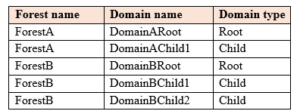

A two-way forest trust exists between ForestA and ForestB.

Each domain in ForestB contains user accounts that are used to manage servers.

You need to ensure that the user accounts used to manage the servers in ForestB are members of the Server Operators in ForestA.

Solution: In DomainBRoot, you add the users to the Server Operators group. You modify the membership of the Server Operators in ForestA.

Does this meet the goal?

1. Yes
2. No

**Correct Answer:** B

**Section: Install and Configure Active Directory Domain Services (AD DS) Explanation**

**Explanation/Reference:**

References: https://docs.microsoft.com/en-us/windows/security/identity-protection/access-control/active-directory-security-groups#bkmk-serveroperators

**QUESTION 31**

**Note: This question is part of a series of questions that present the same scenario. Each question in the series contains a unique solution that might meet the stated goals. Some question sets might have more than one correct solution, while others might not have a correct solution.**

**After you answer a question in this section, you will NOT be able to return to it. As a result, these questions will not appear in the review screen.**

Your network contains the Active Directory forests and domains shown in the following table:



A two-way forest trust exists between ForestA and ForestB.

Each domain in ForestB contains user accounts that are used to manage servers.

You need to ensure that the user accounts used to manage the servers in ForestB are members of the Server Operators in ForestA.

Solution: In each domain in ForestB, you create a global group that contains the user accounts of the respective domain. You create a universal group in DomainBRoot. You add the new global groups to the new universal group. You modify the membership of the Server Operators in ForestA.

Does this meet the goal?

1. Yes
2. No

**Correct Answer:** A

**Section: Install and Configure Active Directory Domain Services (AD DS) Explanation**

**Explanation/Reference:**

References: https://docs.microsoft.com/en-us/windows/security/identity-protection/access-control/active-directory-security-groups#bkmk-serveroperators

**QUESTION 32**

**Note: This question is part of a series of questions that present the same scenario. Each question in the series contains a unique solution that might meet the stated goals. Some question sets might have more than one correct solution, while others might not have a correct solution.**

**After you answer a question in this section, you will NOT be able to return to it. As a result, these questions will not appear in the review screen.**

Your network contains the Active Directory forests and domains shown in the following table.

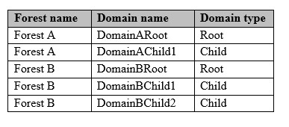

A two-way forest trust exists between ForestA and ForestB. Each domain in ForestB contains user accounts that are used to manage servers. You need to ensure that the user accounts used to manage the servers in ForestB are members of the server Operators groups in ForestA.

Solution: In each domain in ForestB, you add the users to the Server Operators group. You modify the membership of the Server Operations in ForestA.

Does this meet the goal?

1. Yes
2. No

**Correct Answer:** B

**Section: Install and Configure Active Directory Domain Services (AD DS)**

**Explanation**

**Explanation/Reference:**

References: https://docs.microsoft.com/en-us/windows/security/identity-protection/access-control/active-directory-security-groups#bkmk-serveroperators

**QUESTION 33**

Your network contains an Active Directory forest. The forest contains two domains named contoso.com and fabrikam.com. The functional level of the forest and the domains is Windows Server 2008 R2.

You have a global group named Group1 in the contoso.com domain. Group1 contains the user accounts in contoso.com.

You need to ensure that you can add the user accounts in the fabrikam.com domain to Group1.

What should you do?

1. Raise the domain functional level of fabrikam.com to Windows Server 2016
2. Modify the scope of Group1 to Domain local
3. Assign the Domain Controllers group in fabrikam.com permissions to Group1
4. Run the Set-LocalGroup cmdlet
5. Change Group1 to a distribution group
6. Raise the domain functional level of contoso.com to Windows Server 2016
7. In both domains, run the **adprep.exe** command and specify the /domainprep parameter

**Correct Answer:** B

**Section: Install and Configure Active Directory Domain Services (AD DS) Explanation**

**Explanation/Reference:**

Explanation:

A domain local group can have a universal group as a member. A universal group can have users or global groups from any domain in the forest as a member. To adhere to Microsoft best practice, we should add the Fabrikam.com users to a global group in the Fabrikam.com domain. Add the global group to a universal group. Convert Group1 to a domain local group and add the universal group to Group1.

Reference: https://www.netwrix.com/active_directory_group_management.html

**QUESTION 34**

**Note: This question is part of a series of questions that present the same scenario. Each question in the series contains a unique solution that might meet the stated goals. Some question sets might have more than one correct solution, while others might not have a correct solution.**

**After you answer a question in this section, you will NOT be able to return to it. As a result, these questions will not appear in the review screen.**

Your network contains an Active Directory forest named contoso.com.

You need to identify which server is the schema master.

Solution: You open **Active Directory Users and Computers**, right-click **contoso.com** in the console tree, and then click **Operations Master**.

Does this meet the goal?

1. Yes
2. No

**Correct Answer:** B

**Section: Install and Configure Active Directory Domain Services (AD DS) Explanation**

**Explanation/Reference:**

Explanation:

You need to use the Schema snap-in to find the schema master. The Schema snap-in is not installed by default but can be installed by using Schmmgmt.dll.

References: https://www.petri.com/determining_fsmo_role_holders

**QUESTION 35**

**Note: This question is part of a series of questions that present the same scenario. Each question in the series contains a unique solution that might meet the stated goals. Some question sets might have more than one correct solution, while others might not have a correct solution.**

**After you answer a question in this section, you will NOT be able to return to it. As a result, these questions will not appear in the review screen.**

Your network contains an Active Directory forest named contoso.com.

You need to identify which server is the schema master.

Solution: From Windows PowerShell, you run Get-ADDomainController –Discover –Service 2.

Does this meet the goal?

1. Yes
2. No

**Correct Answer:** B

**Section: Install and Configure Active Directory Domain Services (AD DS) Explanation**

**Explanation/Reference:**

Explanation:

This command gets a global catalog in the current forest using Discovery.

References: https://docs.microsoft.com/en-us/powershell/module/addsadministration/get-addomaincontroller?view=win10-ps

**QUESTION 36**

**Note: This question is part of a series of questions that use the same scenario. For your convenience, the scenario is repeated in each question. Each question presents a different goal and answer choices, but the text of the scenario is exactly the same in each question in this series.**

You work for a company named Contoso, Ltd.

The network contains an Active Directory forest named contoso.com. A forest trust exists between contoso.com and an Active Directory forest named adatum.com.

The contoso.com forest contains the objects configured as shown in the following table.



Group1 and Group2 contain only user accounts.

Contoso hires a new remote user named User3. User3 will work from home and will use a computer named Computer3 that runs Windows 10. Computer3 is currently in a workgroup.

An administrator named Admin1 is a member of the Domain Admins group in the contoso.com domain.

From Active Directory Users and Computers, you create an organizational unit (OU) named OU1 in the contoso.com domain, and then you create a contact named Contact1 in OU1.

An administrator of the adatum.com domain runs the **Set-ADUser** cmdlet to configure a user named User1 to have a user logon name of User1@litwareinc.com.

Admin1 attempts to delete OU1 and receives an error message.

You need to ensure that Admin1 can delete OU1.

What should you do first?

1. Modify the Object settings for OU1
2. Add Admin1 to the Enterprise Admins group
3. Delete Contact1
4. Disable the Active Directory Recycle Bin

**Correct Answer:** A

**Section: Install and Configure Active Directory Domain Services (AD DS) Explanation**

**Explanation/Reference:**

References: https://www.dtonias.com/access-denied-delete-move-ou-active-directory/

**QUESTION 37**

Your network contains an Active Directory forest named contoso.com.

Your company plans to hire 500 temporary employees for a project that will last 90 days.

You create a new user account for each employee. An organizational unit (OU) named Temp contains the user accounts for the employees.

You need to prevent the new users from accessing any of the resources in the domain after 90 days.

What should you do?

1. Run the **Get-ADOrganizationalUnit** cmdlet and pipe the output to the **Set-Date** cmdlet.
2. Run the **Get-ADOrganizationalUnit** cmdlet and pipe the output to the **Set-ADAccountPassword** cmdlet.
3. Run the **Get-ADUser** cmdlet and pipe the output to the **Set-ADAccountExpiration** cmdlet.
4. Create a Group Policy object (GPO) and link the GPO to the Temp OU. Modify the Account Lockout Policy of the GPO.

**Correct Answer:** C

**Section: Install and Configure Active Directory Domain Services (AD DS) Explanation**

**Explanation/Reference:**

References: https://docs.microsoft.com/en-us/powershell/module/addsadministration/set-adaccountexpiration?view=win10-ps

**QUESTION 38**

Your network contains an Active Directory forest. The forest contains a forest root domain named contoso.com and a child domain named eu.contoso.com. Each domain contains two domain controllers that run Windows Server 2012 R2.

The forest functional level is Windows Server 2008 R2. The domain functional level of contoso.com is Windows Server 2012 R2. The domain functional level of eu.contoso.com is Windows Server 2008 R2.

You need to raise the domain functional level of contoso.com to Windows Server 2016. The solution must minimize administrative effort.

What should you do before you raise the domain functional level?

1. Raise the forest functional level
2. Upgrade all of the domain controllers in the forest
3. Upgrade all of the domain controllers in contoso.com
4. Raise the domain functional level of eu.contoso.com

**Correct Answer:** C

**Section: Install and Configure Active Directory Domain Services (AD DS) Explanation**

**Explanation/Reference:**

References: https://docs.microsoft.com/en-us/windows-server/identity/ad-ds/active-directory-functional-levels

**QUESTION 39**

**Note: This question is part of a series of questions that use the same scenario. For your convenience, the scenario is repeated in each question. Each question presents a different goal and answer choices, but the text of the scenario is exactly the same in each question in this series.**

You work for a company named Contoso, Ltd.

The network contains an Active Directory forest named contoso.com. A forest trust exists between contoso.com and an Active Directory forest named adatum.com.

The contoso.com forest contains the objects configured as shown in the following table.



Group1 and Group2 contain only user accounts.

Contoso hires a new remote user named User3. User3 will work from home and will use a computer named Computer3 that runs Windows 10. Computer3 is currently in a workgroup.

An administrator named Admin1 is a member of the Domain Admins group in the contoso.com domain.

From Active Directory Users and Computers, you create an organizational unit (OU) named OU1 in the contoso.com domain, and then you create a contact named Contact1 in OU1.

An administrator of the adatum.com domain runs the **Set-ADUser** cmdlet to configure a user named User1 to have a user logon name of User1@litwareinc.com.

You need to ensure that User1 can back up the data stored on Computer1. The solution must prevent the user from restoring the data on Computer1.

What should you do?

1. Add User1 to the Backup Operators group of the domain
2. Modify the Security Settings of the local Group Policy on Computer1
3. Add User1 to the Power Users group on Computer1
4. Add User1 to the Backup Operators group on Computer1

**Correct Answer:** B

**Section: Install and Configure Active Directory Domain Services (AD DS) Explanation**

**Explanation/Reference:**

References:

https://docs.microsoft.com/en-us/windows/security/threat-protection/security-policy-settings/back-up-files-and-directories

**QUESTION 40**

Your network contains an Active Directory domain.

You have a user account that is a member of the Domain Admins group.

You have 100 laptops that have a standard corporate image installed. The laptops are in workgroups and have random names.

A technician named Tech1 is assigned the task of joining the laptops to the domain. The computer accounts of each laptop must be in an organizational unit (OU) that is associated to the department of the user who will use the laptop. The laptop names must start with four characters indicating the department, followed by a four-digit number.

Tech1 is a member of the Domain Users group only. Tech1 has the administrator logon credentials for all the laptops.

You need Tech1 to join the laptops to the domain. The solution must ensure that the laptops are named correctly, and the computer accounts of the laptops are in the correct OUs.

Solution: You script the creation of files domain join, and then you give the files to Tech1.

You instruct Tech1 to sign in to each laptop, and then to run djoin.exe.

Does this meet the goal?

1. Yes
2. No

**Correct Answer:** B

**Section: Install and Configure Active Directory Domain Services (AD DS) Explanation**

**Explanation/Reference:**

**QUESTION 41**

**Note: This question is part of a series of questions that present the same scenario. Each question in the series contains a unique solution that might meet the stated goals. Some question sets might have more than one correct solution, while others might not have a correct solution.**

**After you answer a question in this section, you will NOT be able to return to it. As a result, these questions will not appear in the review screen.**

Your network contains an Active Directory domain named contoso.com. You have an organizational unit (OU) named LondonUsers that contains 10,000 users. You need to modify the office attribute of all the users in the LondonUsers OU.

Solution: From PowerShell, you run the Get-ADUser cmdlet and specify the –SearchBase parameter. You pipe the results to the Set-Aduser cmdlet.

Does this meet the goal?

1. Yes
2. No

**Correct Answer:** A

**Section: Install and Configure Active Directory Domain Services (AD DS) Explanation**

**Explanation/Reference:** References: https://webactivedirectory.com/2011/07/18/simple-powershell-script-to-bulk-update-or-modify-active-directory-user-attributes/

**QUESTION 42**

**Note: This question is part of a series of questions that present the same scenario. Each question in the series contains a unique solution that might meet the stated goals. Some question sets might have more than one correct solution, while others might not have a correct solution.**

**After you answer a question in this section, you will NOT be able to return to it. As a result, these questions will not appear in the review screen.**

Your network contains an Active Directory domain named contoso.com. You have an organizational unit (OU) named LondonUsers that contains 10,000 users. You need to modify the office attribute of all the users in the LondonUsers OU.

Solution: You create an LDIF file. You run ldifde.exe and specify the –i and –f parameters.

Does this meet the goal?

1. Yes
2. No

**Correct Answer:** B

**Section: Install and Configure Active Directory Domain Services (AD DS)**

**Explanation**

**Explanation/Reference:**

References: https://webactivedirectory.com/2011/07/18/simple-powershell-script-to-bulk-update-or-modify-active-directory-user-attributes/

**QUESTION 43**

Your network contains an Active Directory domain named contoso.com.

You need to ensure that the Administrators group on each computer in the domain always contains Contoso\Domain Admins.

What should you do?

1. Modify the Default Domain Policy and enable the Accounts: Administrator Account status setting.
2. Modify the Default Domain Policy and configure the Restricted Groups setting.
3. Modify the Default Domain Controllers Policy and enable the Accounts: Administrator account status setting.
4. Modify the Default Domain Controllers Policy and configure the Restricted Groups setting.

**Correct Answer:** B

**Section: Install and Configure Active Directory Domain Services (AD DS) Explanation**

**Explanation/Reference:** References: https://www.grouppolicy.biz/2010/01/how-to-use-group-policy-preferences-to-secure-local-administrator-groups/

**QUESTION 44**

Your network contains an Active Directory forest. The forest contains two domains named contoso.com and fabrikam.com. The functional level of the forest and the domains is Windows Server 2008 R2.

You have a global group named Group1 in the contoso.com domain. Group1 contains the user accounts in the contoso.com.

You need to ensure that you can add the user accounts in the fabrikam.com domain to Group1.

What should you do?

1. Modify the scope of Group1 to Universal.
2. Raise the domain functional level contoso.com to Windows Server 2016.
3. Run the Set-LocalGroup cmdlet.
4. Change Group1 to a distribution group.

**Correct Answer:** A

**Section: Install and Configure Active Directory Domain Services (AD DS) Explanation**

**Explanation/Reference:**

**QUESTION 45**

**Note: This question is part of a series of questions that present the same scenario. Each question in the series contains a unique solution that might meet the stated goals. Some question sets might have more than one correct solution, while others might not have a correct solution.**

**After you answer a question in this section, you will NOT be able to return to it. As a result, these questions will not appear in the review screen.**

Your network contains an Active Directory domain named contoso.com. You have an organizational unit (OU) named LondonUsers that contains 10,000 users. You need to modify the office attribute of all the users in the LondonUsers OU.

Solution: From PowerShell, you run the Get-ADObject cmdlet and specify the –SearchBase and LdapFilter parameter. You pipe the results to the Set-ADObject cmdlet.

Does this meet the goal?

1. Yes
2. No

**Correct Answer:** A

**Section: Install and Configure Active Directory Domain Services (AD DS) Explanation**

**Explanation/Reference:**

References: https://docs.microsoft.com/en-us/powershell/module/activedirectory/get-adobject?view=winserver2012-ps

**QUESTION 46**

Note: This question is part of a series of questions that use the same or similar answer choices. An answer choice may be correct for more than one question in the series. Each question is independent of the other questions in this series. Information and details provided in a question apply only to that question.

Your network contains an Active Directory domain named contoso.com.

You need to limit the number of Active Directory Domain Services (AD DS) objects that a user can create in the domain.

Which tool should you use?

1. Dsadd quota
2. Dsmod
3. Active Directory Administrative Center
4. Dsacls
5. Dsamain
6. Active Directory Users and Computers
7. Ntdsutil
8. Group Policy Management Console

**Correct Answer:** A

**Section: Manage and Maintain AD DS Explanation**

**Explanation/Reference:**

Explanation:

Dsadd quota adds a quota specification to a directory partition. A quota specification determines the maximum number of directory objects that a given security principal can own in a specified directory partition.

References: https://blogs.technet.microsoft.com/activedirectoryua/2009/03/19/active-directory-quotas/

**QUESTION 47**

Note: This question is part of a series of questions that use the same or similar answer choices. An answer choice may be correct for more than one question in the series. Each question is independent of the other questions in this series. Information and details provided in a question apply only to that question.

Your network contains an Active Directory forest named contoso.com. The forest functional level is Windows Server 2012 R2.

You need to ensure that a domain administrator can recover a deleted Active Directory object quickly.

Which tool should you use?

1. Dsadd quota
2. Dsmod
3. Active Directory Administrative Center
4. Dsacls
5. Dsamain
6. Active Directory Users and Computers
7. Ntdsutil
8. Group Policy Management Console

**Correct Answer:** C

**Section: Manage and Maintain AD DS Explanation**

**Explanation/Reference:**

Explanation:

You can restore objects from the Active Directory Recycle Bin by using Active Directory Administrative Center.

References: https://blogs.technet.microsoft.com/canitpro/2014/07/28/step-by-step-restoring-a-deleted-object-via-active-directory-recycle-bin/

**QUESTION 48**

Your network contains an Active Directory forest named contoso.com.

A partner company has a forest named fabrikam.com. Each forest contains one domain.

You need to provide access for a group named Research in fabrikam.com to resources in contoso.com. The solution must use the principle of least privilege.

What should you do?

1. Create an external trust from fabrikam.com to contoso.com. Enable Active Directory split permissions in fabrikam.com.
2. Create an external trust from contoso.com to fabrikam.com. Enable Active Directory split permissions in contoso.com.
3. Create a one-way forest trust from contoso.com to fabrikam.com that uses selective authentication.
4. Create a one-way forest trust from fabrikam.com to contoso.com that uses selective authentication.

**Correct Answer:** C

**Section: Manage and Maintain AD DS Explanation**

**Explanation/Reference:** Explanation:

**QUESTION 49**

**Note: This question is part of a series of questions that present the same scenario. Each question in the series contains a unique solution that might meet the stated goals. Some question sets might have more than one correct solution, while others might not have a correct solution.**

**After you answer a question in this section, you will NOT be able to return to it. As a result, these questions will not appear in the review screen.**

You deploy a new Active Directory forest.

You need to ensure that you can create a group Managed Service Account (gMSA) for multiple member servers.

Solution: From Windows PowerShell on a domain controller, you run the Set-KdsConfiguration cmdlet.

Does this meet the goal?

1. Yes
2. No

**Correct Answer:** B

**Section: Manage and Maintain AD DS Explanation**

**Explanation/Reference:**

**QUESTION 50**

**Note: This question is part of a series of questions that use the same or similar answer choices. An answer choice may be correct for more than one question in the series. Each question is independent of the other questions in this series. Information and details provided in a question apply only to that question.**

Your network contains an Active Directory domain named contoso.com. You recently deleted 5,000 objects from the Active Directory database.

You need to reduce the amount of disk space used to store the Active Directory database on a domain controller.

Which tool should you use?

1. Dsadd quota
2. Dsmod
3. Active Directory Administrative Center
4. Dsacls
5. Dsamain
6. Active Directory Users and Computers
7. Ntdsutil
8. Group Policy Management Console

**Correct Answer:** G

**Section: Manage and Maintain AD DS Explanation**

**Explanation/Reference:**

**QUESTION 51**

**Note: This question is part of a series of questions that present the same scenario. Each question in the series contains a unique solution that might meet the stated goals. Some question sets might have more than one correct solution, while others might not have a correct solution.**

**After you answer a question in this section, you will NOT be able to return to it. As a result, these questions will not appear in the review screen.**

You deploy a new Active Directory forest.

You need to ensure that you can create a group Managed Service Account (gMSA) for multiple member servers.

Solution: You configure Kerberos constrained delegation on the computer account of each member server.

Does this meet the goal?

1. Yes
2. No

**Correct Answer:** B

**Section: Manage and Maintain AD DS**

**Explanation**

**Explanation/Reference:**

**QUESTION 52**

Your network contains an Active Directory forest. The forest functional level is Windows Server 2016.

You have a failover cluster named Cluster1. Cluster1 has two nodes named Server1 and Server2. All the optional features in Active Directory are enabled.

A junior administrator accidentally deletes the computer object named Cluster1.

You discover that Cluster1 is offline.

You need to restore the operation of Cluster1 in the least amount of time possible.

What should you do?

1. Run the **Enable-ADAccount** cmdlet from Windows PowerShell.
2. Perform an authoritative restore by running **ntdutil.exe**.
3. Perform a tombstone reanimation by running **ldp.exe**.
4. Recover a deleted object from the Active Directory Recycle Bin.

**Correct Answer:** D

**Section: Manage and Maintain AD DS**

**Explanation**

**Explanation/Reference:**

**QUESTION 53**

**Note: This question is part of a series of questions that use the same or similar answer choices. An answer choice may be correct for more than one question in the series. Each question is independent of the other questions in this series. Information and details provided in a question apply only to that question.**

Your network contains an Active Directory domain named contoso.com.

The domain contains a domain controller named DC1 that runs Windows Server 2016.

You need to create a snapshot of the Active Directory database on DC1.

Which tool should you use?

1. Dsadd quota
2. Dsmod
3. Active Directory Administrative Center
4. Dsacls
5. Dsamain
6. Active Directory Users and Computers
7. Ntdsutil
8. Group Policy Management Console

**Correct Answer:** G

**Section: Manage and Maintain AD DS Explanation**

**Explanation/Reference:**

**QUESTION 54**

Your company has two offices. The offices are located in Montreal and Seattle. The network contains an Active Directory forest named contoso.com.

The forest contains three domain controllers configured as shown in the following table.

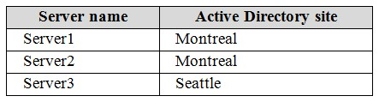

The company physically relocates Server2 from the Montreal office to the Seattle office.

You discover that both Server1 and Server2 authenticate users who sign in to the client computers in the Montreal office. Only Server3 authenticates users who sign in to the computers in the Seattle office.

You need to ensure that Server2 authenticates the users in the Seattle office during normal network operations.

What should you do?

1. From Windows PowerShell, run the **Set-ADReplicationSite** cmdlet.
2. From Active Directory Users and Computers, modify the Location Property of Server2.
3. From Network Connections on Server2, modify the Internet Protocol Version 4 (TCP/IPv4) configuration.
4. From Windows PowerShell, run the **Move-ADDirectoryServer** cmdlet.

**Correct Answer:** D

**Section: Manage and Maintain AD DS**

**Explanation**

**Explanation/Reference:**

**QUESTION 55**

Your network contains an Active Directory domain named contoso.com.

The domain contains a web application that uses Kerberos authentication.

You change the domain name of the web application.

You need to ensure that the service principal name (SPN) for the application is registered.

Which tool should you use?

1. Rdspnf
2. Active Directory Users and Computers
3. Dnscmd
4. Ldifde
5. Netsh
6. Internet Information Services (IIS) Manager
7. Repladmin

**Correct Answer:** D

**Section: Manage and Maintain AD DS Explanation**

**Explanation/Reference:**

Reference:

https://blogs.technet.microsoft.com/tristank/2006/05/08/3-simple-rules-to-kerberos-authenticationdelegation-spns/

**QUESTION 56**

**Note: This question is part of a series of questions that present the same scenario. Each question in the series contains a unique solution that might meet the stated goals. Some question sets might have more than one correct solution, while others might not have a correct solution.**

**After you answer a question in this section, you will NOT be able to return to it. As a result, these questions will not appear in the review screen.**

Your network contains an Active Directory domain named contoso.com. The domain contains a server named Server1 that runs Windows Server 2016.

On Server1, you create a local user named User1. User1 is a member of the local Administrators group.

Server1 has the following local Group Policies:

Local Computer Policy

Local Computer\User1 Policy

Local Computer\Administrators Policy

You need to force User1 to change his password every 14 days.

Solution: You create a Password Setting object (PSO) in the domain.

Does this meet the goal?

1. Yes
2. No

**Correct Answer:** B

**Section: Manage and Maintain AD DS Explanation**

**Explanation/Reference:**

**QUESTION 57**

**Note: This question is part of a series of questions that present the same scenario. Each question in the series contains a unique solution that might meet the stated goals. Some question sets might have more than one correct solution, while others might not have a correct solution.**

**After you answer a question in this section, you will NOT be able to return to it. As a result, these questions will not appear in the review screen.**

Your network contains an Active Directory domain named contoso.com. The domain contains a server named Server1 that runs Windows Server 2016.

On Server1, you create a local user named User1. User1 is a member of the local Administrators group.

Server1 has the following local Group Policies:

Local Computer Policy

Local Computer\User1 Policy

Local Computer\Administrators Policy

You need to force User1 to change his password every 14 days.

Solution: You configure the Password Policy settings in a Group Policy object (GPO) that is linked to the Domain Controllers organizational unit (OU).

Does this meet the goal?

1. Yes
2. No

**Correct Answer:** B

**Section: Manage and Maintain AD DS Explanation**

**Explanation/Reference:**

**QUESTION 58**

**Note: This question is part of a series of questions that present the same scenario. Each question in the series contains a unique solution that might meet the stated goals. Some question sets might have more than one correct solution, while others might not have a correct solution.**

**After you answer a question in this section, you will NOT be able to return to it. As a result, these questions will not appear in the review screen.**

Your network contains an Active Directory forest. The forest contains a domain named contoso.com. The domain contains three domain controllers.

A domain controller named lon-dc1 fails. You are unable to repair lon-dc1.

You need to prevent the other domain controllers from attempting to replicate to lon-dc1.

Solution: From Active Directory Sites and Services, you remove the object of lon-dc1.

Does this meet the goal?

1. Yes
2. No

**Correct Answer:** A

**Section: Manage and Maintain AD DS Explanation**

**Explanation/Reference:**

**QUESTION 59**

**Note: This question is part of a series of questions that present the same scenario. Each question in the series contains a unique solution that might meet the stated goals. Some question sets might have more than one correct solution, while others might not have a correct solution.**

**After you answer a question in this section, you will NOT be able to return to it. As a result, these questions will not appear in the review screen.**

Your network contains an Active Directory forest. The forest contains a domain named contoso.com. The domain contains three domain controllers.

A domain controller named lon-dc1 fails. You are unable to repair lon-dc1.

You need to prevent the other domain controllers from attempting to replicate to lon-dc1.

Solution: From ntdsutil.exe, you perform a metadata cleanup.

Does this meet the goal?

1. Yes
2. No

**Correct Answer:** A

**Section: Manage and Maintain AD DS Explanation**

**Explanation/Reference:**

**QUESTION 60**

**Note: This question is part of a series of questions that present the same scenario. Each question in the series contains a unique solution that might meet the stated goals. Some question sets might have more than one correct solution, while others might not have a correct solution.**

**After you answer a question in this section, you will NOT be able to return to it. As a result, these questions will not appear in the review screen.**

Your network contains an Active Directory forest. The forest contains a domain named contoso.com. The domain contains three domain controllers.

A domain controller named lon-dc1 fails. You are unable to repair lon-dc1.

You need to prevent the other domain controllers from attempting to replicate to lon-dc1.

Solution: From Active Directory Domains and Trusts, you transfer the operations master roles from lon-dc1.

Does this meet the goal?

1. Yes
2. No

**Correct Answer:** A

**Section: Manage and Maintain AD DS**

**Explanation**

**Explanation/Reference:**

**QUESTION 61**

**Note: This question is part of a series of questions that present the same scenario. Each question in the series contains a unique solution that might meet the stated goals. Some question sets might have more than one correct solution, while others might not have a correct solution.**

**After you answer a question in this section, you will NOT be able to return to it. As a result, these questions will not appear in the review screen.**

Your network contains an Active Directory forest named contoso.com. The forest contains 10 domains. The root domain contains a global catalog server named DC1.

You remove the global catalog server role from DC1.

You need to decrease the size of the Active Directory database on DC1.

Solution: You restart DC1 in Directory Services Repair Mode. You run compact.exe, and then restart DC1.

Does this meet the goal?

1. Yes
2. No

**Correct Answer:** B

**Section: Manage and Maintain AD DS Explanation**

**Explanation/Reference:**

Explanation:

You need to run ntdsutil.exe with the ‘compact to’ option.

References: https://theitbros.com/active-directory-database-compact-defrag/

**QUESTION 62**

**Note: This question is part of a series of questions that present the same scenario. Each question in the series contains a unique solution that might meet the stated goals. Some question sets might have more than one correct solution, while others might not have a correct solution.**

**After you answer a question in this section, you will NOT be able to return to it. As a result, these questions will not appear in the review screen.**

Your network contains an Active Directory forest named contoso.com. The forest contains 10 domains.

The root domain contains a global catalog server named DC1.

You remove the global catalog server role from DC1.

You need to decrease the size of the Active Directory database on DC1.

Solution: You restart DC1 in Safe Mode. You run ntdsutil.exe, use the files option, and then restart DC1.

Does this meet the goal?

1. Yes
2. No

**Correct Answer:** B

**Section: Manage and Maintain AD DS Explanation**

**Explanation/Reference:**

References: https://theitbros.com/active-directory-database-compact-defrag/

**QUESTION 63**

Your network contains an Active Directory domain named contoso.com.

You create a domain security group named Group1 and add several users to it.

You need to force all of the users in Group1 to change their password every 35 days. The solution must affect the Group1 users only.

What should you do?

1. Create a forms authentication provider, and then set the forms authentication credentials.
2. From Active Directory Administrative Center, create a Password Setting object (PSO).
3. Modify the Password Policy settings in a Group Policy object (GPO) that is linked to the domain, and then filter the GPO to Group1 only.
4. From Windows PowerShell, run the **Set-ADDomain** cmdlet, and then run the **Set-ADAccountPassword** cmdlet.

**Correct Answer:** B

**Section: Manage and Maintain AD DS**

**Explanation**

**Explanation/Reference:**

**QUESTION 64**

Your network contains an Active Directory domain named contoso.com.

You discover that users can use passwords that contain only numbers.

You need to ensure that all the user passwords in the domain contain at least three of the following types of characters:

Numbers

Uppercase letters

Lowercase letters  
Special characters

What should you edit?

1. The Default Domain Controllers Policy
2. The local policy on each client computer
3. The Default Domain Policy
4. The local policy on each domain controller

**Correct Answer:** C

**Section: Manage and Maintain AD DS Explanation**

**Explanation/Reference:**

**QUESTION 65**

Your network contains an Active Directory forest named contoso.com The forest contains a member server named Server1.

Server1 has several line-of-business applications. Each application runs as a service that uses the Network Service account.

You need to configure the line-of-business applications to run by using a virtual account.

What should you do?

1. From Windows PowerShell, run the **Install-ADServiceAccount** cmdlet.
2. From the Services console, modify the Log On properties of the services.
3. From the Microsoft Application Compatibility Toolkit (ACT), create a shim.
4. From Windows PowerShell, run the **New-ADServiceAccount** cmdlet.

**Correct Answer:** B

**Section: Manage and Maintain AD DS Explanation**

**Explanation/Reference:**

**QUESTION 66**

**Note: This question is part of a series of questions that present the same scenario. Each question in the series contains a unique solution that might meet the stated goals. Some question sets might have more than one correct solution, while others might not have a correct solution.**

**After you answer a question in this section, you will NOT be able to return to it. As a result, these questions will not appear in the review screen.**

Your network contains an Active Directory domain named contoso.com. The domain contains two domain controllers named DC1 and DC2.

DC1 holds the RID master operations role. DC1 fails and cannot be repaired. You need to move the RID role to DC2.

Solution: On DC2, you open Windows PowerShell and run Move-AddirectoryServerOperationMasterRole -OperationMasterRidMaster -Identity DC2.Adatum.com

Does this meet the goal?

1. Yes
2. No

**Correct Answer:** B

**Section: Manage and Maintain AD DS Explanation**

**Explanation/Reference:**

Explanation:

You would need to use the -Force parameter because the server that held the role (DC1) if offline.

**QUESTION 67**

**Note: This question is part of a series of questions that present the same scenario. Each question in the series contains a unique solution that might meet the stated goals. Some question sets might have more than one correct solution, while others might not have a correct solution.**

**After you answer a question in this section, you will NOT be able to return to it. As a result, these questions will not appear in the review screen.**

Your network contains an Active Directory domain named contoso.com. The domain contains two domain controllers named DC1 and DC2.

DC1 holds the RID master operations role. DC1 fails and cannot be repaired. You need to move the RID role to DC2.

Solution: On DC2, you open the command prompt, run dsmgmt.exe, connect to DC2, and use the Seize RID master opinion.

Does this meet the goal?

1. Yes
2. No

**Correct Answer:** B

**Section: Manage and Maintain AD DS Explanation**

**Explanation/Reference:**

**QUESTION 68**

Your network contains an Active Directory domain named contoso.com.

The domain contains a read-only domain controller (RODC) named RODC1.

You need to retrieve a list of accounts that have their password cached on RODC1.

Which command should you run?

1. repadmin.exe
2. ntdsutil.exe
3. dcdiag.exe
4. netdom.exe

**Correct Answer:** A

**Section: Manage and Maintain AD DS Explanation**

**Explanation/Reference:**

Explanation:

To list the user and computer accounts for the passwords that are cached on the RODC, run the following command:

repadmin /prp view <read-only domain controller> reveal

References https://support.microsoft.com/en-za/help/2028962/the-active-directory-users-and-computers-mmc-snap-in-does-not-list-all

**QUESTION 69**

Your network contains an Active Directory domain named adatum.com. The domain contains a security group named G_Research and an organizational unit (OU) named OU_Research.

All the users in the research department are members of G_Research and their user accounts are in OU_Research.

You need to ensure that all the research department users change their password every 28 days and enforce a complex password that is 12 characters long.

What should you do?

1. From a Group Policy Management, create and link a Group Policy object (GPO) to OU_Research. Modify the password policy in the GPO.
2. From a Group Policy Management, create and link a Group Policy object (GPO) to the domain. Modify the password policy in the GPO. Filter the GPO to apply to G_Research only.
3. From Active Directory Users and Computers, modify the properties of the Password Settings Container.
4. From Active Directory Administrative Center, create a new Password Settings object (PSO).

**Correct Answer:** D

**Section: Manage and Maintain AD DS Explanation**

**Explanation/Reference:**

**QUESTION 70**

Your network contains an Active Directory forest. The forest functional level is Windows Server 2016.

The network contains Linux servers that use MIT Kerberos V5 to provide an authentication, authorization, and access service.

You need to ensure that users can use their Active Directory credentials to access the resources on the Linux servers. The solution must minimize administrative effort.

What should you implement?

1. an external trust
2. a realm trust
3. Active Directory Federation Services (AD FS)
4. a Web Application Proxy

**Correct Answer:** B

**Section: Manage and Maintain AD DS Explanation**

**Explanation/Reference:**

References: http://techgenix.com/active-directory-trusts/ https://www.rootusers.com/how-to-join-centos-linux-to-an-active-directory-domain/

**QUESTION 71**

**Note: This question is part of a series of questions that present the same scenario. Each question in the series contains a unique solution that might meet the stated goals. Some question sets might have more than one correct solution, while others might not have a correct solution.**

**After you answer a question in this section, you will NOT be able to return to it. As a result, these questions will not appear in the review screen.**

Your network contains an Active Directory domain named contoso.com.

The user account for a user named User1 is in an organizational unit (OU) named OU1.

You need to enable User1 to sign in as user1@adatum.com.

Solution: From Active Directory Domains and Trusts, you configure an alternative UPN suffix. From Active Directory Administrative Center, you configure the User UPN logon property of User1.

Does this meet the goal?

1. Yes
2. No

**Correct Answer:** A

**Section: Manage and Maintain AD DS Explanation**

**Explanation/Reference:**

**QUESTION 72**

**Note: This question is part of a series of questions that present the same scenario. Each question in the series contains a unique solution that might meet the stated goals. Some question sets might have more than one correct solution, while others might not have a correct solution.**

**After you answer a question in this section, you will NOT be able to return to it. As a result, these questions will not appear in the review screen.**

Your network contains an Active Directory domain named contoso.com.

The user account for a user named User1 is in an organizational unit (OU) named OU1.

You need to enable User1 to sign in as user1@adatum.com.

Solution: From Active Directory Users and Computers, you set the E-mail property of User1 to user1@adatum.com.

Does this meet the goal?

1. Yes
2. No

**Correct Answer:** B

**Section: Manage and Maintain AD DS**

**Explanation**

**Explanation/Reference:**

**QUESTION 73**

**Note: This question is part of a series of questions that present the same scenario. Each question in the series contains a unique solution that might meet the stated goals. Some question sets might have more than one correct solution, while others might not have a correct solution.**

**After you answer a question in this section, you will NOT be able to return to it. As a result, these questions will not appear in the review screen.**

Your network contains an Active Directory domain named contoso.com.

The user account for a user named User1 is in an organizational unit (OU) named OU1.

You need to enable User1 to sign in as user1@adatum.com.

Solution: From Windows PowerShell, you run Set-ADuser User1 –UserPrincipalName User1@Adatum.com.

Does this meet the goal?

1. Yes
2. No

**Correct Answer:** B

**Section: Manage and Maintain AD DS Explanation**

**Explanation/Reference:**

**QUESTION 74**

**Note: This question is part of a series of questions that present the same scenario. Each question in the series contains a unique solution that might meet the stated goals. Some question sets might have more than one correct solution, while others might not have a correct solution.**

**After you answer a question in this section, you will NOT be able to return to it. As a result, these questions will not appear in the review screen.**

Your network contains an Active Directory domain named contoso.com.

The user account for a user named User1 is in an organizational unit (OU) named OU1.

You need to enable User1 to sign in as user1@adatum.com.

Solution: From Windows PowerShell, you run

Set-ADObject 'CN=User1,OU=OU1,DC=Contoso,DC=com'

–Add @{UserPrincipalName='User1@Adatum.com'} –Remove @ {UserPrincipalName='User1@Contoso.com'}.

Does this meet the goal?

1. Yes
2. No

**Correct Answer:** B

**Section: Manage and Maintain AD DS Explanation**

**Explanation/Reference:**

**QUESTION 75**

**Note: This question is part of a series of questions that present the same scenario. Each question in the series contains a unique solution that might meet the stated goals. Some question sets might have more than one correct solution, while others might not have a correct solution.**

**After you answer a question in this section, you will NOT be able to return to it. As a result, these questions will not appear in the review screen.**

You deploy a new Active Directory forest.

You need to ensure that you can create a group Managed Service Account (gMSA) for multiple member servers.

Solution: You configure Kerberos constrained delegation on the computer account of each domain controller.

Does this meet the goal?

1. Yes
2. No

**Correct Answer:** B

**Section: Manage and Maintain AD DS Explanation**

**Explanation/Reference:**

**QUESTION 76**

Your network contains an Active Directory domain named contoso.com. The domain functional level is Windows Server 2016. The domain contains the servers shown in the following table.

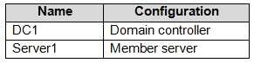

The domain has several Managed Service Accounts.

Server1 hosts a service named Service1 that runs in the security context of the LocalSystem account.

You need to implement a group Managed Service Account to run Service1.

Which two actions should you perform? Each correct answer presents part of the solution.

**NOTE:** Each correct selection is worth one point.

1. On Server1, modify the properties of Service1.
2. On DC1, run Add-ADComputerServiceAccount.
3. On DC1, run New-ADServiceAccount.
4. On DC1, run Add-KDSRootKey.

**Correct Answer:** AC

**Section: Manage and Maintain AD DS Explanation**

**Explanation/Reference:**

**QUESTION 77**

**Note: This question is part of a series of questions that use the same or similar answer choices. An answer choice may be correct for more than one question in the series. Each question is independent of the other questions in this series. Information and details provided in a question apply only to that question.**

Your network contains an Active Directory domain named contoso.com. The domain contains a domain controller named Server1.

You recently restored a backup of the Active Directory database from Server1 to an alternate Location. The restore operation does not interrupt the Active Directory services on Server1.

You need to make the Active Directory data in the backup accessible by using Lightweight Directory Access Protocol (LDAP).

Which tool should you use?

1. Dsadd quota
2. Dsmod
3. Active Directory Administrative Center
4. Dsacls
5. Dsamain
6. Active Directory Users and Computers
7. Ntdsutil
8. Group Policy Management Console

**Correct Answer:** E

**Section: Manage and Maintain AD DS Explanation**

**Explanation/Reference:**

Explanation:

Dsamain.exe, allows an ntds.dit file to be mounted and exposed as an LDAP server, which means you can use such familiar tools as ADSIEdit, LDP.exe, and Active Directory Users and Computers to interact with a mounted database.

References: http://www.itprotoday.com/windows-8/using-active-directory-snapshots-and-dsamain-tool

**QUESTION 78**

You network contains an Active Directory domain named contoso.com. The domain contains 1,000 desktop computers and 500 laptops. An organizational unit (OU) named OU1 contains the computer accounts for the desktop computers and the laptops.

You create a Windows PowerShell script named Script1.ps1 that removes temporary files and cookies. You create a Group Policy object (GPO) named GPO1 and link GPO1 to OU1.

You need to run the script once weekly only on the laptops.

What should you do?

1. In GPO1, create a File preference that uses item-level targeting.
2. In GPO1, create a Scheduled Tasks preference that uses item-level targeting.
3. In GPO1, configure the File System security policy. Attach a WMI filter to GPO1.
4. In GPO1, add Script1.ps1 as a startup script. Attach a WMI filter to GPO1.

**Correct Answer:** B

**Section: Create and Manage Group Policy Explanation**

**Explanation/Reference:**

Explanation:

**QUESTION 79**

Your network contains an Active Directory domain named contoso.com.

You have an organizational unit (OU) named TestOU that contains test computers.

You need to enable a technician named Tech1 to create Group Policy objects (GPOs) and to link the GPOs to TestOU. The solution must use the principle of least privilege.

Which two actions should you perform? Each correct answer presents part of the solution.

1. Add Tech1 to the Group Policy Creator Owners group.
2. From Group Policy Management, modify the Delegation settings of the TestOU OU.
3. Add Tech1 to the Protected Users group.
4. From Group Policy Management, modify the Delegation settings of the contoso.com container.
5. Create a new universal security group and add Tech1 to the group.

**Correct Answer:** AB

**Section: Create and Manage Group Policy**

**Explanation**

**Explanation/Reference:**

Explanation:

The Group Policy Creator Owners group lets its members create new GPOs.

You can delegate the ability for users to be given the ability to link GPOs to an OU or domain via the Delegation tab of the OU/domain/site within the GPMC.

References:

http://www.itprotoday.com/management-mobility/what-group-policy-creator-owners-group http://www.itprotoday.com/management-mobility/how-do-i-delegate-permissions-someone-edit-gpo

**QUESTION 80**

Your company recently deployed a new child domain to an Active Directory forest.

You discover that a user modified the Default Domain Policy to configure several Windows components in the child domain.

A company policy states that the Default Domain Policy must be used only to configure domain-wide security settings.

You create a new Group Policy object (GPO) and configure the settings for the Windows components in the new GPO.

You need to restore the Default Domain Policy to the default settings from when the domain was first installed.

What should you do?

1. From Group Policy Management, click Starter GPOs, and then click Manage Backups.
2. From a command prompt, run the dcgpofix.exe command.
3. From Windows PowerShell, run the Copy-GPO cmdlet.
4. Run ntdsutil.exe to perform a metadata cleanup and a semantic database analysis.

**Correct Answer:** B

**Section: Create and Manage Group Policy Explanation**

**Explanation/Reference:** Explanation:

**QUESTION 81**

Your network contains an Active Directory domain named contoso.com.

You have an organizational unit (OU) named OU1 that contains the computer accounts from two servers and the user account of a user named User1. A Group Policy object (GPO) named GPO1 is linked to OU1.

You have an application named App1 that installs by using an application installer named App1.exe.

You need to publish App1 to OU1 by using Group Policy.

What should you do?

1. Create a Config.zap file and add a file to the File System node to the Computer Configuration node of GPO1.
2. Create a Config.xml file and add a software installation package to the User Configuration node of GPO1.
3. C. Create a Config.zap file and add a software installation package to the User Configuration node of GPO1.
4. Create a Config.xml file and add a software installation package to the Computer Configuration node of GPO1.

**Correct Answer:** C

**Section: Create and Manage Group Policy Explanation**

**Explanation/Reference:** Explanation:

**QUESTION 82**

Your network contains an Active Directory domain named contoso.com.

You open Group Policy Management as shown in the exhibit. (Click the Exhibit button.)

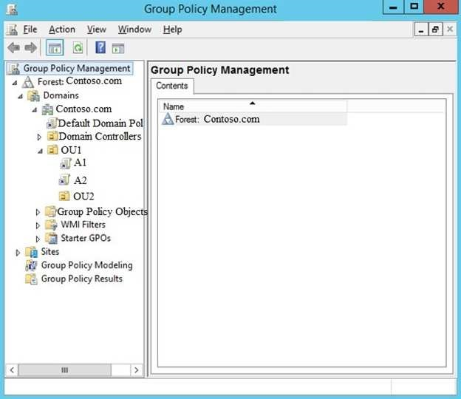

You discover that some of the settings configured in the A1 Group Policy object (GPO) fail to apply to the users in the OU1 organizational unit (OU). You need to ensure that all of the settings in A1 apply to the users in OU1.

What should you do?

1. Link the A2 GPO to the domain.
2. Modify the policy processing order for contoso.com.
3. Modify the policy processing order OU1.
4. Modify the GPO Status of A1.

**Correct Answer:** C

**Section: Create and Manage Group Policy Explanation**

**Explanation/Reference:**

Reference:

https://blogs.technet.microsoft.com/musings_of_a_technical_tam/2012/02/15/group-policy-basics-part-2-understanding-which-gpos-to-apply/

**QUESTION 83**

Your network contains an Active Directory domain named contoso.com.

You have a Group Policy object (GPO) named GPO1. GPO1 is linked to an organizational unit (OU) named OU1.

GPO1 contains several corporate desktop restrictions that apply to all computers.

You plan to deploy a printer to the computers in OU1.

You need to ensure that any user who signs in to a computer that runs Windows 10 in OU1 receives the new printer. All of the computers in OU1 must continue to apply the corporate desktop restrictions from GPO1.

What should you configure?

1. a user preference and a WMI filter on GPO1.
2. a computer preference that uses item-level targeting
3. a computer preference and WMI filter on GPO1
4. a user preference that uses item-level targeting

**Correct Answer:** B

**Section: Create and Manage Group Policy Explanation**

**Explanation/Reference:**

Explanation:

**QUESTION 84**

Note: This question is part of a series of questions that use the same or similar answer choices. An answer choice may be correct for more than one question in the series. Each question is independent of the other questions in this series. Information and details provided in a question apply only to that question.

Your network contains an Active Directory domain named contoso.com. The domain contains 5,000 user accounts.

You have a Group Policy object (GPO) named DomainPolicy that is linked to the domain and a GPO named DCPolicy that is linked to the Domain Controllers organizational unit (OU).

You need to use the application control policy settings to prevent several applications from running on the network.

What should you do?

1. From the Computer Configuration node of DCPolicy, modify Security Settings.
2. From the Computer Configuration node of DomainPolicy, modify Security Settings.
3. From the Computer Configuration node of DomainPolicy, modify Administrative Templates.
4. From the User Configuration node of DCPolicy, modify Security Settings.
5. From the User Configuration node of DomainPolicy, modify Folder Redirection.
6. From user Configuration node of DomainPolicy, modify Administrative Templates.
7. From Preferences in the User Configuration node of DomainPolicy, modify Windows Settings.
8. From Preferences in the Computer Configuration node of DomainPolicy, modify Windows Settings.

**Correct Answer:** B

**Section: Create and Manage Group Policy Explanation**

**Explanation/Reference:** Explanation:

**QUESTION 85**

Note: This question is part of a series of questions that use the same or similar answer choices. An answer choice may be correct for more than one question in the series. Each question is independent of the other questions in this series. Information and details provided in a question apply only to that question.

Your network contains an Active Directory domain named contoso.com. The domain contains 5,000 user accounts.

You have a Group Policy object (GPO) named DomainPolicy that is linked to the domain and a GPO named DCPolicy that is linked to the Domain Controllers organizational unit (OU).

You need to configure the Documents folder of every user to be stored on a server named FileServer1.

What should you do?

1. From the Computer Configuration node of DCPolicy, modify Security Settings.
2. From the Computer Configuration node of DomainPolicy, modify Security Settings.
3. From the Computer Configuration node of DomainPolicy, modify Administrative Templates.
4. From the User Configuration node of DCPolicy, modify Security Settings.
5. From the User Configuration node of DomainPolicy, modify Folder Redirection.
6. From user Configuration node of DomainPolicy, modify Administrative Templates.
7. From Preferences in the User Configuration node of DomainPolicy, modify Windows Settings.
8. From Preferences in the Computer Configuration node of DomainPolicy, modify Windows Settings.

**Correct Answer:** E

**Section: Create and Manage Group Policy**

**Explanation**

**Explanation/Reference:** Explanation:

**QUESTION 86**

Note: This question is part of a series of questions that use the same or similar answer choices. An answer choice may be correct for more than one question in the series. Each question is independent of the other questions in this series. Information and details provided in a question apply only to that question.

Your network contains an Active Directory domain named contoso.com. The domain contains 5,000 user accounts.

You have a Group Policy object (GPO) named DomainPolicy that is linked to the domain and a GPO named DCPolicy that is linked to the Domain Controllers organizational unit (OU).

You need to force users to change their account password at least every 30 days.

What should you do?

1. From the Computer Configuration node of DCPolicy, modify Security Settings.
2. From the Computer Configuration node of DomainPolicy, modify Security Settings.
3. From the Computer Configuration node of DomainPolicy, modify Administrative Templates.
4. From the User Configuration node of DCPolicy, modify Security Settings.
5. From the User Configuration node of DomainPolicy, modify Folder Redirection.
6. From user Configuration node of DomainPolicy, modify Administrative Templates.
7. From Preferences in the User Configuration node of DomainPolicy, modify Windows Settings.
8. From Preferences in the Computer Configuration node of DomainPolicy, modify Windows Settings.

**Correct Answer:** B

**Section: Create and Manage Group Policy Explanation**

**Explanation/Reference:** Explanation:

**QUESTION 87**

**Note: This question is part of a series of questions that use the same scenario. For your convenience, the scenario is repeated in each question. Each question presents a different goal and answer choices, but the text of the scenario is exactly the same in each question in this series.**

**Start of repeated scenario.**

Your network contains an Active Directory domain named contoso.com. The domain contains a single site named Site1. All computers are in Site1.

The Group Policy objects (GPOs) for the domain are configured as shown in the exhibit. (Click the Exhibit button.)

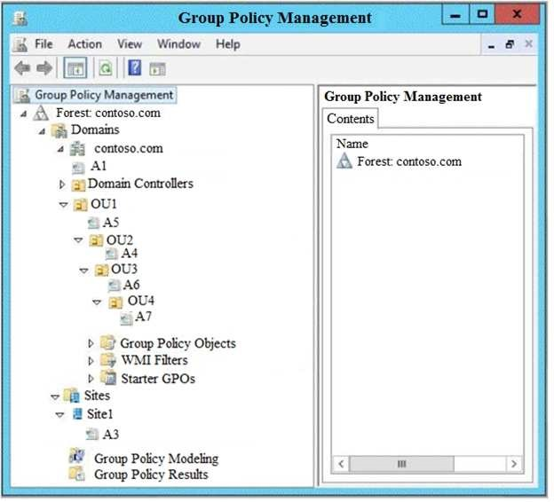

The relevant users and client computer in the domain are configured as shown in the following table.

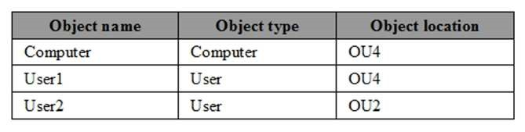

**End of repeated scenario.**

You are evaluating what will occur when you block inheritance on OU4.

Which GPO or GPOs will apply to User1 when the user signs in to Computer1 after block inheritance is configured?

1. A1, A5, and A6
2. A3, A1, A5, and A7
3. A3 and A7 only
4. A7 only

**Correct Answer:** D

**Section: Create and Manage Group Policy Explanation**

**Explanation/Reference:** Explanation:

**QUESTION 88**

**Note: This question is part of a series of questions that use the same scenario. For your convenience, the scenario is repeated in each question. Each question presents a different goal and answer choices, but the text of the scenario is exactly the same in each question in this series.**

**Start of repeated scenario.**

Your network contains an Active Directory domain named contoso.com. The domain contains a single site named Site1. All computers are in Site1.

The Group Policy objects (GPOs) for the domain are configured as shown in the exhibit. (Click the Exhibit button.)

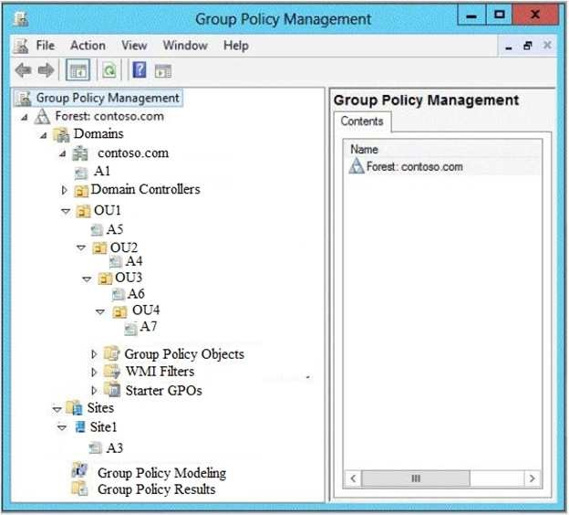

The relevant users and client computer in the domain are configured as shown in the following table.



**End of repeated scenario.**

You are evaluating what will occur when you disable the Group Policy link for A6.

Which GPOs will apply to User2 when the user signs in to Computer1 after the link for A6 is disabled?

1. A1 and A5 only
2. A3, A1, and A5 only
3. A3, A1, A5, and A4 only
4. A3, A1, A5, and A7

**Correct Answer:** C

**Section: Create and Manage Group Policy Explanation**

**Explanation/Reference:** Explanation:

**QUESTION 89**

Your network contains an Active Directory domain named contoso.com. The domain contains a user named User1 and an organizational unit (OU) named OU1.

You create a Group Policy object (GPO) named GPO1.

You need to ensure that User1 can link GPO1 to OU1.

What should you do?

1. Modify the security settings of User1.
2. Add User1 to the Group Policy Creator Owner group.
3. Modify the security settings of OU1.
4. Modify the security settings of GPO1.

**Correct Answer:** C

**Section: Create and Manage Group Policy Explanation**

**Explanation/Reference:**

**QUESTION 90**

You network contains an active Directory domain. The domain contains 20 domain controllers. You discover that some Group Policy objects (PROs) are not being applied by all the domain controllers.

You need to verify whether GPOs replicate successfully to all the domain controllers.

What should you do?

1. Set BurFlags in the registry, and then restart the File Replication Service (FRS). Run **dcdiag.exe** for each domain controller.
2. Set BurFlags in the registry, and then restart the File Replication Service (FRS). View the Directory Service event log.
3. From Group Policy Management, view the Status tab for the domain.
4. Run **repadmin.exe** for each GPO.

**Correct Answer:** C

**Section: Create and Manage Group Policy Explanation**

**Explanation/Reference:**

**QUESTION 91**

Your company has a marketing department and a security department. The network contains an Active Directory domain named contoso.com. The domain contains an enterprise certification authority (CA).

You have two organizational units (OUs) named MKT_UsersOU and MKT_ComputersOU. MKT_UsersOU contains the user accounts for the users in the marketing department. MKT_ComputersOU contains the computer accounts for the computers in the marketing department.

A Group policy object (GPO) named GPO1 is linked to MKT_UsersOU.

A GPO named GPO2 linked to MKT_ComputersOU.

You plan to deploy a web application for the marketing department users.

The application will require certificates for authentication.

The security department configures the CA to support the planned deployment.

You need to ensure that the web application can authenticate the marketing department users. What should you do?

1. From the User Configuration node of GPO1, create an Internet Setting preference.
2. From the User Configuration node of GPO1, configure the Certificate Services Client - Auto-enrollment settings.
3. From the Computer Configuration node of GPO2, configure the Certificate Services Client - Certificate Enrollment Policy settings.
4. From the Computer Configuration node of GPO2, create the Automatic Certificate Request Settings.

**Correct Answer:** B

**Section: Create and Manage Group Policy Explanation**

**Explanation/Reference:**

**QUESTION 92**

Your network contains an Active Directory domain named contoso.com. The domain contains a server named Server1 that runs Windows Server 2016.

Server1 has IP Address Management (IPAM) installed. IPAM is configured to use the Group Policy based provisioning method. The prefix for the IPAM Group Policy objects (GPOs) is IP.

From Group Policy Management, you manually rename the IPAM GPOs to have a prefix of IPAM.

You need to modify the GPO prefix used by IPAM.

What should you do?

1. Click Configure server discovery in Server Manager.
2. Run the **Set-IpamConfiguration** cmdlet.
3. Run the **Invoke-IpamGpoProvisioning** cmdlet.
4. Click Provision the IPAM server in Server Manager.

**Correct Answer:** B

**Section: Create and Manage Group Policy Explanation**

**Explanation/Reference:**

Explanation:

The Set-IpamConfiguration cmdlet modifies the configuration for the computer that runs the IPAM server.

The -GpoPrefix<String> parameter specifies the unique Group Policy object (GPO) prefix name that IPAM uses to create the group policy objects. Use this parameter only when the value of the ProvisioningMethod parameter is set to Automatic.

References: https://docs.microsoft.com/en-us/powershell/module/ipamserver/set-ipamconfiguration?view=win10-ps

**QUESTION 93**

Your network contains an Active Directory domain named contoso.com. The domain contains a member server named Server1 and a domain controller named DC1. Both servers run Windows Server 2016. Server1 is used to perform administrative tasks, including managing Group Polices.

After maintenance is performed on DC1, you open a Group Policy object (GPO) from Server1 as shown in the exhibit.

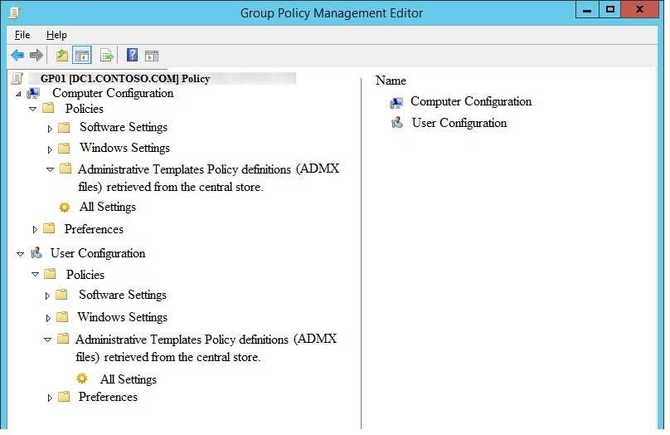

You need to be able to view all of the Administrative Templates settings in GPO1. What should you do?

1. From File Explorer, copy the administrative templates from \\contoso.com\SYSVOL\contoso.com\Policies to the PolicyDefinitions folder on Server1.
2. From File Explorer, delete \\contoso.com\SYSVOL\contoso.com\Policies\PolicyDefinitions.
3. From File Explorer, delete the PolicyDefinitions folder from Server1.
4. From Group Policy Management Editor, configure the Filter Options for GPO1.

**Correct Answer:** B

**Section: Create and Manage Group Policy Explanation**

**Explanation/Reference:**

**QUESTION 94**

**Note: This question is part of a series of questions that present the same scenario. Each question in the series contains a unique solution that might meet the stated goals. Some question sets might have more than one correct solution, while others might not have a correct solution.**

**After you answer a question in this section, you will NOT be able to return to it. As a result, these questions will not appear in the review screen.**

Your network contains an Active Directory domain named contoso.com. All the accounts of the users in the sales department are in an organizational unit (OU) named SalesOU.

An application named App1 is deployed to the user accounts in SalesOU by using a Group Policy object (GPO) named Sales GPO.

You need to set the registry value of \HKEY_CURRENT_USER\Software\App1\Collaboration to 0.

Solution: You add a user preference that has an Update action.

Does this meet the goal?

1. Yes
2. No

**Correct Answer:** A

**Section: Create and Manage Group Policy Explanation**

**Explanation/Reference:**

**QUESTION 95**

**Note: This question is part of a series of questions that present the same scenario. Each question in the series contains a unique solution that might meet the stated goals. Some question sets might have more than one correct solution, while others might not have a correct solution.**

**After you answer a question in this section, you will NOT be able to return to it. As a result, these questions will not appear in the review screen.**

Your network contains an Active Directory domain named contoso.com. All the accounts of the users in the sales department are in an organizational unit (OU) named SalesOU.

An application named App1 is deployed to the user accounts in SalesOU by using a Group Policy object (GPO) named Sales GPO.

You need to set the registry value of \HKEY_CURRENT_USER\Software\App1\Collaboration to 0.

Solution: You add a computer preference that has a Replace action.

Does this meet the goal?

1. Yes
2. No

**Correct Answer:** A

**Section: Create and Manage Group Policy Explanation**

**Explanation/Reference:**

**QUESTION 96**

**Note: This question is part of a series of questions that present the same scenario. Each question in the series contains a unique solution that might meet the stated goals. Some question sets might have more than one correct solution, while others might not have a correct solution.**

**After you answer a question in this section, you will NOT be able to return to it. As a result, these questions will not appear in the review screen.**

Your network contains an Active Directory domain named contoso.com. All the accounts of the users in the sales department are in an organizational unit (OU) named SalesOU.

An application named App1 is deployed to the user accounts in SalesOU by using a Group Policy object (GPO) named Sales GPO.

You need to set the registry value of \HKEY_CURRENT_USER\Software\App1\Collaboration to 0.

Solution: You add a user preference that has a Replace action.

Does this meet the goal?

1. Yes
2. No

**Correct Answer:** B

**Section: Create and Manage Group Policy Explanation**

**Explanation/Reference:**

**QUESTION 97**

**Note: This question is part of a series of questions that present the same scenario. Each question in the series contains a unique solution that might meet the stated goals. Some question sets might have more than one correct solution, while others might not have a correct solution.**

**After you answer a question in this section, you will NOT be able to return to it. As a result, these questions will not appear in the review screen.**

Your network contains an Active Directory domain named contoso.com. The domain contains a user named User1, a group named Group1, and an organizational unit (OU) named OU1.

You need to enable User1 to link Group Policies to OU1.

Solution: From Active Directory Users and Computers, you add User1 to the Group Policy Creator owners group.

Does this meet the goal?

1. Yes
2. No

**Correct Answer:** B

**Section: Create and Manage Group Policy Explanation**

**Explanation/Reference:**

Explanation:

The Group Policy Creator Owners group also has no permission to link GPOs to a container such as a domain or OU; that permission still must be manually given.

References: http://www.itprotoday.com/management-mobility/what-group-policy-creator-owners-group

**QUESTION 98**

**Note: This question is part of a series of questions that present the same scenario. Each question in the series contains a unique solution that might meet the stated goals. Some question sets might have more than one correct solution, while others might not have a correct solution.**

**After you answer a question in this section, you will NOT be able to return to it. As a result, these questions will not appear in the review screen.**

Your network contains an Active Directory domain named contoso.com. The domain contains a user named User1, a group named Group1, and an organizational unit (OU) named OU1.

You need to enable User1 to link Group Policies to OU1.

Solution: From Active Directory Administrative Center, you add User1 to Group1. From ADSI Edit, you grant Group1 Full Control permissions to the “CN=Policies, CN=System, DC=Contoso, DC=com” object.

Does this meet the goal?

1. Yes
2. No

**Correct Answer:** B

**Section: Create and Manage Group Policy Explanation**

**Explanation/Reference:**

**QUESTION 99**

**Note: This question is part of a series of questions that present the same scenario. Each question in the series contains a unique solution that might meet the stated goals. Some question sets might have more than one correct solution, while others might not have a correct solution.**

**After you answer a question in this section, you will NOT be able to return to it. As a result, these questions will not appear in the review screen.**

Your network contains an Active Directory domain named contoso.com. The domain contains a username User1, a group named Group1, and an organizational unit (OU) named OU1.

You need to enable User1 to link Group Policies to OU1.

Solution: From Active Directory Administrative Center, you add User1 to Group1. From Group Policy Management, you click the **Group Policy Objects** container. From the Delegation tab, you add Group1.

Does this meet the goal?

1. Yes
2. No

**Correct Answer:** B

**Section: Create and Manage Group Policy Explanation**

**Explanation/Reference:**

**QUESTION 100**

**Note: This question is part of a series of questions that present the same scenario. Each question in the series contains a unique solution that might meet the stated goals. Some question sets might have more than one correct solution, while others might not have a correct solution.**

**After you answer a question in this section, you will NOT be able to return to it. As a result, these questions will not appear in the review screen.**

Your network contains an Active Directory domain named contoso.com. The domain contains a user named User1, a group named Group1, and an organizational unit (OU) named OU1.

You need to enable User1 to link Group Policies to OU1.

Solution: From Active Directory Administrative Center, you add User1 to Group1 and grant Group1 Full Control permissions to OU1.

Does this meet the goal?

1. Yes
2. No

**Correct Answer:** A

**Section: Create and Manage Group Policy**

**Explanation**

**Explanation/Reference:**

**QUESTION 101**

Your network contains an Active Directory domain named contoso.com.

A Group Policy object (GPO) named GPO1 is linked to contoso.com.

GPO1 has computer configuration policies, user configuration policies, and user preferences configured.

You need to ensure that the user preferences in GPO1 apply only to users who sign in to computers that runs Windows 10. All the other settings in GPO1 must be applied, regardless of the computer to which the users sign in.

What should you configure?

1. WMI Filtering
2. Item-level targeting
3. Security Settings
4. Security Filtering

**Correct Answer:** B

**Section: Create and Manage Group Policy**

**Explanation**

**Explanation/Reference:**

**QUESTION 102**

Your company has a marketing department.

The network contains an Active Directory domain named contoso.com.

The domain contains two top-level organizational units (OUs) named MKT_Comps and MKT_Users. MKT_Comps contains the computer accounts for the computers in the marketing department. MKT_Users contains the user accounts for the users in the marketing department.

You link a new Group Policy object (GPO) named GPO1 to MKT_Comps.

You need to deploy a VPN connection to all of the users who sign in to the marketing department computers. The users must be able to modify the VPN connection settings.

Where in GPO1 should you create the settings for the VPN connection?

1. Computer Configuration/Policies/Administrative Templates/Network/network Connections
2. User Configuration/Policies/Administrative Templates/Network/Network Connections
3. User Configuration/Preferences/Control Panel Settings/Network Options
4. Computer Configuration/Preferences/Control Panel Settings/Network Options

**Correct Answer:** D

**Section: Create and Manage Group Policy Explanation**

**Explanation/Reference:**

**QUESTION 103**

Your network contains an Active Directory domain named contoso.com. The network contains several IP subnets. One of the subnets uses a network ID if 192.168.10.0/24.

You link a Group Policy object (GPO) named GPO1 to the domain.

You need to map a drive to a specific file share on the computers in the 192.168.10.0/24 network only.

What should you do?

1. From the User Configuration node of GPO1, configure the Folder Redirection settings. Link a WMI filter to GPO1.
2. From the Computer Configuration node of GPO1, configure the Network Connections settings. Link a WMI filter to GPO1.
3. From the User Configuration node of GPO1, create a Group Policy preference that uses item-level targeting.
4. From the Computer Configuration node of GPO1, create a Group Policy preference that uses item-level targeting.

**Correct Answer:** C

**Section: Create and Manage Group Policy**

**Explanation**

**Explanation/Reference:**

**QUESTION 104**

Your network contains an Active Directory domain.

Users do not have administrative privileges to their client computer.

You modify a computer setting in a Group Policy object (GPO).

You need to ensure that the setting is applied to five client computers as soon as possible.

What should you do?

1. From each client computer, run the **gpresult.exe** command and specify the **/r** parameter.
2. From a domain controller, run the **gpupdate.exe** command and specify the **Force** parameter.
3. From a domain controller, run the **Invoke-GPUpdate** cmdlet.
4. From each client, run the **Get-Gpo** cmdlet and specify the **–all** parameter.

**Correct Answer:** C

**Section: Create and Manage Group Policy Explanation**

**Explanation/Reference:**

**QUESTION 105**

Your network contains two Active Directory forests named fabrikam.com and contoso.com. Each forest contains a single domain.

Contoso.com has a Group Policy object (GPO) named Cont_GPO1.

You need to apply the settings from Cont_GPO1 to the computers in fabrikam.com.

Which two actions should you perform? Each correct answer presents a complete solution.

**NOTE:** Each correct selection is worth one point.

1. Back up Cont_GPO1. In fabrikam.com, create and link a new GPO by using the Group Policy Management Console (GPMC), and then run the Import Settings Wizard.
2. Back up Cont_GPO1. In fabrikam.com, run the **Restore-GPO** cmdlet, and then run the **New-GPLink** cmdlet.
3. Back up Cont_GPO1. In fabrikam.com run the **Import-GPO** cmdlet, and then run the **New-GPLink** cmdlet.
4. Copy\\contoso.com\SysVol\contoso.com\Policies to \\fabrikam.com\SysVol\ fabrikam.com\Policies. In fabrikam.com, run the **New-GPLink** cmdlet.
5. Back up Cont_GPO1. In fabrikam.com, create and link a new GPO by using the Group Policy Management Console (GPMC), and then run the Restore Group Policy Object Wizard.

**Correct Answer:** AC

**Section: Create and Manage Group Policy Explanation**

**Explanation/Reference:**

**QUESTION 106**

**Note: This question is part of a series of questions that use the same scenario. For your convenience, the scenario is repeated in each question. Each question presents a different goal and answer choices, but the text of the scenario is exactly the same in each question in this series.**

**Start of repeated scenario.**

Your network contains an Active Directory domain named contoso.com. The domain contains a single site named Site1. All computers are in Site1.

The Group Policy objects (GPOs) for the domain are configured as shown in the exhibit. (Click the Exhibit button.)



The relevant users and client computer in the domain are configured as shown in the following table.



End of repeated scenario.

You are evaluating what will occur when you set user Group Policy loopback processing mode to Replace in A7.

Which GPO or GPOs will apply to User2 when the user signs in to Computer1 after loopback processing is configured?

1. A1 and A7 only
2. A3, A1, A5, A6 and A7
3. A3, A5, A1, and A7 only
4. A7 only

**Correct Answer:** D

**Section: Create and Manage Group Policy Explanation**

**Explanation/Reference:** Explanation:

In Replace Mode, the user's list of GPOs is not gathered. Only the list of GPOs based on the computer object is used.

References: https://support.microsoft.com/en-us/help/231287/loopback-processing-of-group-policy

**QUESTION 107**

Your network contains an Active Directory domain named contoso.com.

You have an application named App1 that is deployed to all the client computers in the domain. App1 writes a registry value named LocalStorage on all the client computers.

You need to delete the LocalStorage registry value from all the client computers in the domain that have less than 100 GB of free disk space on their system volume.

What should you do?

1. Configure Software Settings in a Group Policy object (GPO) and enable a WMI filter.
2. Configure a Group Policy setting to modify the security of the LocalStorage registry value.
3. Create an administrative template file that contains the LocalStorage registry setting, and then add the administrative template to a Group Policy object (GPO).
4. Configure a Group Policy preference that uses item-level targeting.

**Correct Answer:** D

**Section: Create and Manage Group Policy Explanation**

**Explanation/Reference:**

Explanation:

In Windows Server 2008 Microsoft introduced a Group Policy extension, named Group Policy Preferences (GPP). GPP that includes registry settings, allows you to add, remove or modify key values.

References: https://theitbros.com/add-modify-and-delete-registry-keys-using-group-policy/

**QUESTION 108**

Your network contains an Active Directory domain. The domain contains an organizational unit (OU) named FileServersOU. A Group Policy object (GPO) named GPO1 is linked to FileServersOU. FileServersOU contains all the file servers in the domain.

You make an urgent security edit to GPO1.

You need to ensure that all the file servers receive the updated setting as soon as possible.

What should you do?

1. Right-click **FileServersOU** and click **Group Policy Update**…
2. Right-click the GPO link for GPO1 and click **Enforced**.
3. Right-click **Group Policy Results** and click **Group Policy Results Wizard**…
4. Right-click **FileServersOU** and click **Refresh**.

**Correct Answer:** A

**Section: Create and Manage Group Policy**

**Explanation**

**Explanation/Reference:**

**QUESTION 109**

**Note: This question is part of a series of questions that use the same scenario. For your convenience, the scenario is repeated in each question. Each question presents a different goal and answer choices, but the text of the scenario is exactly the same in each question in this series.**

Your network contains an Active Directory domain named contoso.com. The domain contains a single site named Site1. All computers are in Site1.

The Group Policy objects (GPOs) for the domain are configured as shown in the exhibit. (Click the **Exhibit** tab.)

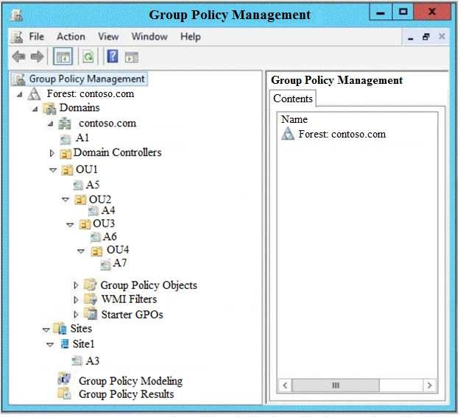

The relevant users and client computer in the domain are configured as shown in the following table.

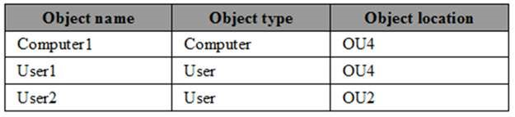

You are evaluating what will occur when you set user Group Policy loopback processing mode to **Replace** in A4.

Which GPO or GPOs will apply to User2 when the user signs in to Computer1 after loopback processing is configured?

1. A1, A5, A6 and A4
2. A3, A1, A4, and A7
3. A3, A1, A5 and A4
4. A4 only

**Correct Answer:** D

**Section: Create and Manage Group Policy Explanation**

**Explanation/Reference:**

**QUESTION 110**

You have a server named Server1 in a workgroup.

You need to configure a Group Policy setting on Server1 that will apply to only non-administrative users.

What should you do?

1. Open **Local Group Policy Editor**. From the View menu, modify the Customize settings.
2. Open **Local Group Policy Editor**. From the File menu, modify the Options settings.
3. Open **Local Users and Groups**. Create a new group. Run New-GPO.
4. Run mmc.exe. Add the Group Policy Object Editor snap-in and change the Group Policy object (GPO).

**Correct Answer:** D

**Section: Create and Manage Group Policy Explanation**

**Explanation/Reference:**

References:

https://www.windowscentral.com/how-apply-local-group-policy-settings-specific-users-windows-10

**QUESTION 111**

Your company has a main office and three branch offices. The network contains an Active Directory domain named contoso.com.

The main office contains three domain controllers. Each branch office contains one domain controller.

You discover the new settings in the Default Domain Policy are not applied in one of the branch offices, but all other Group Policy objects (GPOs) are applied.

You need to check the replication of the Default Domain Policy for the branch office.

What should you do from a domain controller in the main office?

1. From Group Policy Management, click **Default Domain Policy** under Contoso.com, and then open the **Scope** tab.
2. From a command prompt, run **dcdiag.exe**.
3. From a command prompt, run **repadmin.exe**.
4. From Windows PowerShell, run the **Get-GPOReport** cmdlet.
5. From Group Policy Management, click **Default Domain Policy** under Contoso.com, and then open the **Details** tab.
6. From a command prompt, run **gpresult.exe**.

**Correct Answer:** C

**Section: Create and Manage Group Policy Explanation**

**Explanation/Reference:**

**QUESTION 112**

Your network contains an Active Directory domain named contoso.com. The domain contains servers that run Windows Server 2016 and client computers that run Windows 10. The naming conventions for the computers and the servers is inconsistent.

You plan to create a Group Policy object (GPO) named GPO1 and to link GPO1 to the domain. GPO1 will contain custom Group Policy preference settings.

You need to ensure that the preference settings in GPO1 will apply only to member servers. GPO1 must NOT apply to domain controllers or client computers.

Which type of item level targeting should you use?

1. Security Group
2. Processing Mode
3. Operating System
4. Environment Variable
5. Domain

**Correct Answer:** C

**Section: Create and Manage Group Policy Explanation**

**Explanation/Reference:**

References: https://docs.microsoft.com/en-us/previous-versions/windows/it-pro/windows-server-2008-R2-and-2008/cc733022(v=ws.11) https://docs.microsoft.com/en-us/previous-versions/windows/it-pro/windows-server-2008-R2-and-2008/cc753566%28v%3dws.10%29

**QUESTION 113**

Your network contains an Active Directory domain named contoso.com.

You have an organizational unit (OU) named OU1. A Group Policy object (GPO) named GPO1 is linked to OU1.

You create a user named User1, and you assign User1 the Full control permission to OU1.

Which administrative action for GPOs can User1 perform?

1. Link an existing GPO from the domain to OU1
2. Create a new GPO and link the GPO to OU1
3. Add an administrative template to GPO1
4. Edit the User Rights Assignment in GPO1

**Correct Answer:** A

**Section: Create and Manage Group Policy**

**Explanation**

**Explanation/Reference:**

**QUESTION 114**

Your network contains an Active Directory forest named contoso.com. The domain contains a server named Server1 that runs Windows Server 2016. The computer account of Server1 is an organizational unit (OU) named OU1.

You open Group Policy Management as shown in the exhibit. (Click the **Exhibit** button.)

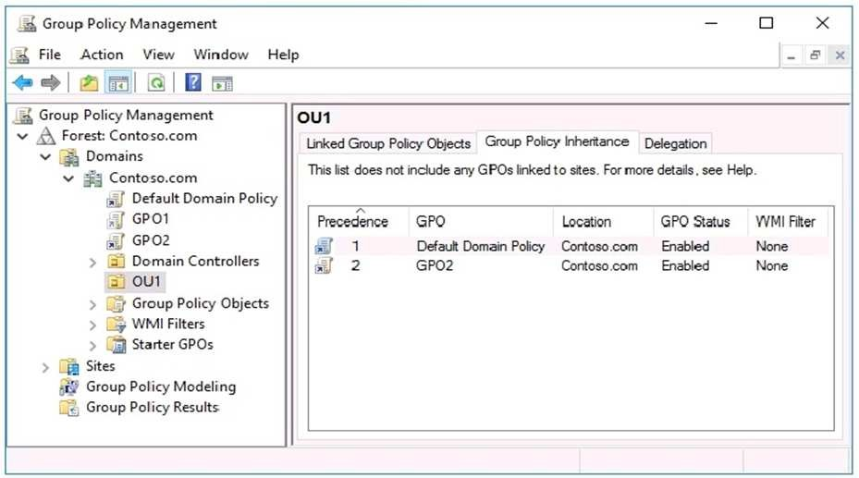

An administrator reports that the settings from GPO1 are not applied to Server1.

You need to ensure that the settings from GPO1 are applied to Server1.

What should you do?

1. Enable the link of GPO1
2. Enforce GPO1
3. Disable Block inheritance
4. Remove the security filtering

**Correct Answer:** A

**Section: Create and Manage Group Policy**

**Explanation**

**Explanation/Reference:**

Explanation:

If the GPO link is enabled, the settings of the GPO are applied when Group Policy is processed for the site, domain or OU.

References:

https://docs.microsoft.com/en-us/powershell/module/grouppolicy/set-gplink?view=win10-ps

**QUESTION 115**

Your network contains an Active Directory domain named contoso.com. The relevant objects in the domain are configured as shown in the following table.

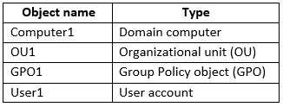

User1 is in OU1. GPO1 is linked to OU1.

The settings in GPO1 are configured as shown in the exhibit. (Click the **Exhibit** tab.)

Computer1 does not have any shortcuts on the desktop.

How many shortcuts appear on the desktop after User1 signs in to Computer1?

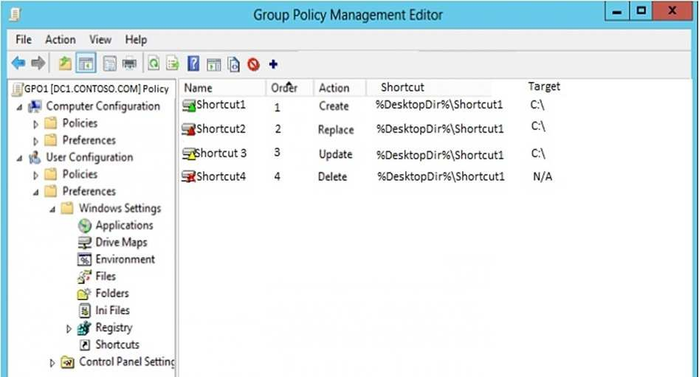

1. 1
2. 2
3. 3
4. 4

**Correct Answer:** A

**Section: Create and Manage Group Policy Explanation**

**Explanation/Reference:**

**QUESTION 116**

Your network contains an Active Directory domain named contoso.com. The domain contains a server named Server1 that runs Windows Server 2016. All domainjoined computers have Fast Logon Optimization enabled.

You need to ensure that the next time a user signs in to Server1, the user-targeted Group Policy objects (GPOs) are processed fully before the user gains access to the desktop.

What should you run on Server?

1. secedit with the /configure switch
2. Invoke-Gpupdate with the –Boot switch
3. gpupdate with the /force switch
4. Invoke-Gpupdate with the –Sync switch

**Correct Answer:** D

**Section: Create and Manage Group Policy**

**Explanation**

**Explanation/Reference:**

Reference: https://docs.microsoft.com/en-us/powershell/module/grouppolicy/invoke-gpupdate?view=win10-ps

**QUESTION 117**

You network contains an Active Directory Domain named contoso.com.

You modify a Group Policy object (GPO) as shown in the exhibit.

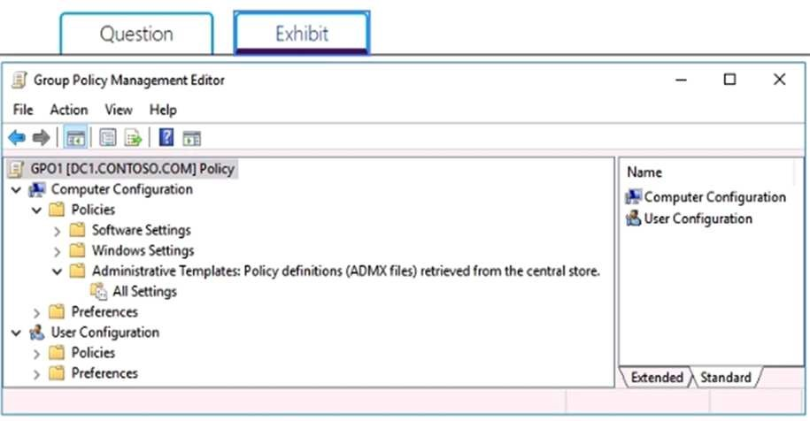

You need to ensure that the Administrative Templates and their settings appear in Group Policy Management Editor.

What should you do?

1. Modify the members of the Group Policy Creator Owners group.
2. Configure the Group Policy filtering options.
3. On DC1, delete the PolicyDefinitions folder from the C:\Windows\SYSVOL\sysvol\Contoso.com\Policies folder.
4. On DC1, delete the PolicyDefinitions folder from C:\Windows.

**Correct Answer:** B

**Section: Create and Manage Group Policy Explanation**

**Explanation/Reference:**

**QUESTION 118**

Your network contains an Active Directory domain named contoso.com. The domain contains two servers named Server1 and Server2 that run Windows Server 2016. The computer accounts of Server1 and Server2 are in the Computers container.

A Group Policy object (GPO) named GPO1 is linked to the domain. GPO1 has multiple computer settings defined and has following configurations.

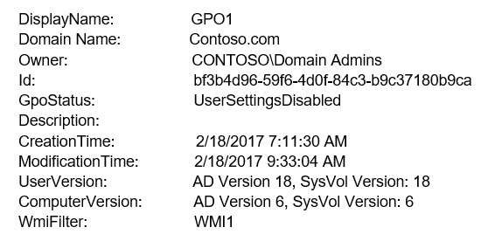

An administrator discovers that GPO1 is not applied to Server1. GPO1 is applied to Server2.

Which configuration possibly prevents GPO1 from being applied to Server1?

1. The permissions on GPO1
2. The **Enforced** setting of GPO1
3. The permissions on the **Computers** container
4. The permissions on the domain object of contoso.com

**Correct Answer:** A

**Section: Create and Manage Group Policy**

**Explanation**

**Explanation/Reference:**

**QUESTION 119**

Your network contains an Active Directory domain named contoso.com. The domain contains a member server named Server1 and a domain controller named DC1. Both servers run Windows Server 2016. Server1 is used to perform administrative tasks, including managing Group Polices.

After maintenance is performed on DC1, you open a Group Policy object (GPO) from Server1 as shown in the exhibit.

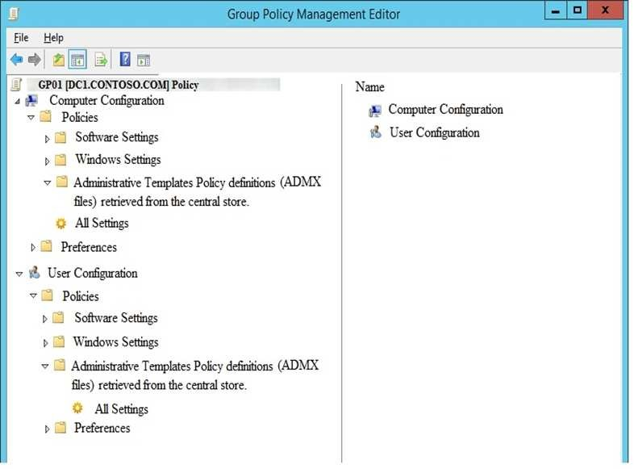

You need to be able to view all of the Administrative Templates settings in GPO1.

What should you do?

1. From Group Policy Management Editor, configure item-level targeting in GPO1.
2. From File Explorer, delete \\contoso.com\SYSVOL\contoso.com\Policies\PolicyDefinitions.
3. From Group Policy Management, configure Security Filtering for GPO1.
4. From Group Policy Management Editor, configure the Filter Options for GPO1.

**Correct Answer:** B

**Section: Create and Manage Group Policy Explanation**

**Explanation/Reference:**

**QUESTION 120**

Your network contains an Active Directory domain named contoso.com.

You open Group Policy Management as shown in the exhibit. (Click the Exhibit button.)

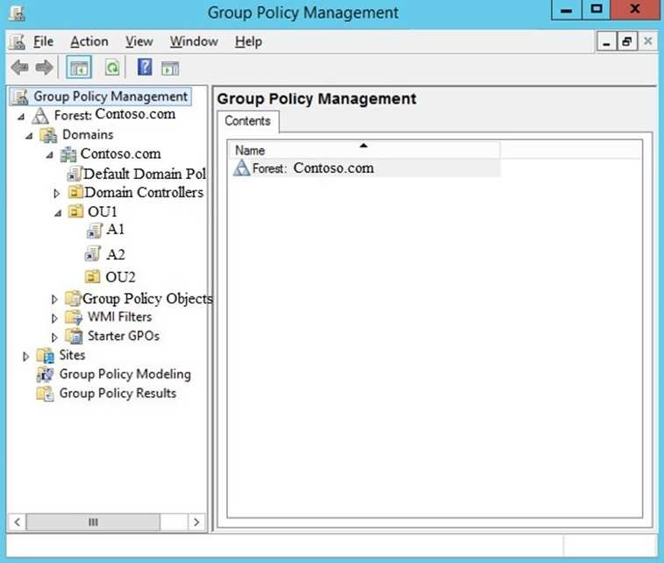

You discover that some of the settings configured in the A1 Group Policy object (GPO) fail to apply to the users in the OU1 organizational unit (OU). You need to ensure that all of the settings in A1 apply to the users in OU1.

What should you do?

1. Link the A2 GPO to the domain.
2. Configure the Enforced setting for the A1 link on OU1.
3. Modify Security Settings for A1.
4. Block inheritance on OU1.

**Correct Answer:** B

**Section: Create and Manage Group Policy Explanation**

**Explanation/Reference:**

References:

https://docs.microsoft.com/en-us/archive/blogs/musings_of_a_technical_tam/group-policy-basics-part-2-understanding-which-gpos-to-apply

**QUESTION 121**

Your network contains an Active Directory domain named contoso.com. The domain contains 10 servers that run Windows Server 2016. The computer accounts of the servers are in an organizational unit (OU) named OU1.

You create a global group named Server Admins.

You need to ensure that the members of Server Admins can stop and start the Server service on the servers in OU1. The solution must use the principle of least privilege.

What should you do?

1. Create a Group Policy object (GPO) linked to OU1. Modify the Computer Configuration\Windows Settings\Security Settings\Local Policies\User Rights Assignment settings.
2. On each new server deployed to OU1, configure Computer Configuration\Policies\Windows Settings\Security Settings for Local Computer Policy\NonAdministrators Policy.
3. Create a Group Policy object (GPO) linked to OU1. Modify the Computer Configuration\Policies\Windows Settings\Security Settings\System Services settings.
4. From the Local Computer Policy on each new server deployed to OU1, configure Computer Configuration\Policies\Windows Settings\Security Settings.

**Correct Answer:** C

**Section: Create and Manage Group Policy Explanation**

**Explanation/Reference:**

References:

https://social.technet.microsoft.com/Forums/ie/en-US/e9d3a8d3-5301-4961-96be-99f586c6fc1c/using-ad-to-allow-a-user-to-startstop-a-service?forum=winserverDS

**QUESTION 122**

Your network contains an Active Directory domain named contoso.com. The domain contains a server named Server1 that runs Windows Server 2016. All domainjoined computers have Fast Logon Optimization enabled.

You need to ensure that the next time a user signs in to Server1, the user-targeted Group Policy objects (GPOs) are processed fully before the user gains access to the desktop.

What should you run on Server?

1. secedit with the /analyze switch
2. Invoke-Gpupdate with the –Boot switch
3. gpupdate with the /wait switch
4. gpupdate with the /Sync switch

**Correct Answer:** D

**Section: Create and Manage Group Policy Explanation**

**Explanation/Reference:**

References:

https://docs.microsoft.com/en-us/windows-server/administration/windows-commands/gpupdate

**QUESTION 123**

You have an enterprise certification authority (CA) named CA1. You have a certificate template named UserAutoEnroll that is based on the User certificate template. Domain users are configured to autoenroll for UserAutoEnroll.

A user named User1 has an email address defined in Active Directory. A user named User2 does not have an email address defined in Active Directory. You discover that User1 was issued a certificate based on UserAutoEnroll template automatically.

A request by user2 for a certificate based on the UserAutoEnroll template fails.

You need to ensure that all users can autoenroll for certificated based on the UserAutoEnroll template.

Which setting should you configure from the properties on the UserAutoEnroll certificate template?

1. Issuance Requirements
2. Request Handling
3. Cryptography
4. Subject Name

**Correct Answer:** D

**Section: Implement Active Directory Certificate Services**

**Explanation**

**Explanation/Reference:**

**QUESTION 124**

Which of the following CA types would you deploy if you wanted to deploy a CA at the top of a hierarchy that could issue signing certificates to other CAs and which would be taken offline if not issuing, renewing, or revoking signing certificates?

1. Enterprise root
2. Enterprise subordinate
3. Standalone root
4. Standalone subordinate

**Correct Answer:** C

**Section: Implement Active Directory Certificate Services Explanation**

**Explanation/Reference:**

**QUESTION 125**

You need to ensure that clients will check at least every 30 minutes as to whether a certificate has been revoked. Which of the following should you configure to accomplish this goal?

1. Key recovery agent
2. CRL publication interval
3. Delta CRL publication interval
4. Certificate templates.

**Correct Answer:** C

**Section: Implement Active Directory Certificate Services Explanation**

**Explanation/Reference:**

**QUESTION 126**

Your network contains an Active Directory domain named contoso.com. The domain contains an enterprise certification authority (CA) named CA1.

You duplicate the Computer certificate template, and you name the template Cont_Computers.

You need to ensure that all of the certificates issued based on Cont_Computers have a key size of 4,096 bits.

What should you do?

1. From the properties of CA1, modify the Security settings.
2. From the properties of CA1, modify the Request Handling settings.
3. From the properties of the Computer template, modify the Key Attestation settings.
4. From the properties of Cont_Computers, modify the Cryptography settings.

**Correct Answer:** D

**Section: Implement Active Directory Certificate Services Explanation**

**Explanation/Reference:**

**QUESTION 127**

You have an enterprise certification authority (CA).

You create a global security group named Group1.

You need to provide members of Group1 with the ability to issue and manage certificates.

The solution must prevent the Group1 members from managing certificates requested by members of the Domain Admins group.

Which two actions should you perform? Each correct answer presents part of the solution.

**NOTE:** Each correct selection is worth one point.

1. From the CA properties, modify the Policy Module settings.
2. From the Certificate Templates console, modify the Security settings of the Administrator certificate template.
3. From the CA properties, modify the security settings.
4. From the CA properties, modify the Enrollment Agents settings.
5. From the CA properties, modify the Certificate Managers Settings.
6. From the Certificate Templates console, modify the Security settings of the User certificate template.

**Correct Answer:** CE

**Section: Implement Active Directory Certificate Services Explanation**

**Explanation/Reference:**

**QUESTION 128**

Your network contains an Active Directory forest named contoso.com. The forest contains an enterprise root certification authority (CA) on a server that runs Windows Server 2016.

You plan to create and issue a custom subordinate CA template.

You need to prevent subordinate CAs from issuing subordinate certificates.

What should you configure in the template?

1. The Cryptography settings
2. The Request Handling settings
3. The Basic Constraints extension
4. The Security settings

**Correct Answer:** C

**Section: Implement Active Directory Certificate Services Explanation**

**Explanation/Reference:**

**QUESTION 129**

Your network contains an Active directory domain named contoso.com. The domain has an enterprise certification authority (CA).

You duplicate the Basic EFS template, and you name the template Template1.You configure the CA to issue Template1.

Users are configured to obtain a new certificate automatically when they sign in to a computer in the domain.

You need to enable the users to automatically obtain a certificate based on Template1.

What should you modify?

1. The Publication Settings for the CA.
2. The Security Settings for Template1.
3. The Request Handling properties for Template1.
4. The Request Handling properties for the CA.

**Correct Answer:** B

**Section: Implement Active Directory Certificate Services Explanation**

**Explanation/Reference:**

**QUESTION 130**

You have an offline root certification authority (CA) named CA1. CA1 is hosted on a virtual machine.

You only turn on CA1 when the CA must be patched or you must generate a key for subordinate CAs.

You start CA1, and you discover that the filesystem is corrupted.

You resolve the filesystem corruption and discover that you must reload the CA root from a backup.

When you attempt to run the **Restore-CARoleService** cmdlet, you receive the following error message: “The process cannot access the file because it is being used by another process.”

You need to ensure that you can restore the CA.

What should you do first?

1. Stop the Active Directory Certificate Services (AD CS) service.
2. Run the **Restore-CARoleService** cmdlet and specify the **–Force** parameter.
3. Stop the Active Directory Domain Services (AD DS) service.
4. Run the **Restore-CARoleService** cmdlet and specify the path to a valid CA key.

**Correct Answer:** A

**Section: Implement Active Directory Certificate Services Explanation**

**Explanation/Reference:**

**QUESTION 131**

Your network contains an Active Directory domain named contoso.com.

You deploy a standalone root certification authority (CA) named CA1.

You need to autoenroll domain computers for certificates by using a custom certificate template.

What should you do first?

1. Modify the Policy Module for CA1.
2. Modify the Exit Module for CA1.
3. Install a standalone subordinate CA.
4. Install an enterprise subordinate CA.

**Correct Answer:** D

**Section: Implement Active Directory Certificate Services Explanation**

**Explanation/Reference:**

Explanation:

You can’t create templates or configure auto-enrollment on a standalone CA.

**QUESTION 132**

Your network contains an Active Directory domain named contoso.com.

The domain contains an enterprise root certification authority (CA) on a server that runs Windows Server 2016.

You need to configure the CA to support Online Certificate Status Protocol (OCSP) responders.

Which two actions should you perform? Each correct selection presents part of the solution.

NOTE: Each correct selection is worth one point.

1. Add a new certificate template to issue.
2. Modify the Authority Information Access (AIA) of the CA.
3. Configure an enrollment agent.
4. Install a standalone subordinate CA.
5. Modify the CRL distribution point (CDP) of the CA.

**Correct Answer:** AB

**Section: Implement Active Directory Certificate Services**

**Explanation**

**Explanation/Reference:**

Explanation:

Once the OCSP service is configured, we need to configure the OCSP Response Signing template. This process includes adding an Authority Information Access (AIA) extension and then issuing a new certificate template.

References: https://www.poweradmin.com/blog/deploying-active-directory-certificate-services-and-online-responder/

**QUESTION 133**

You have a standalone root certification authority (CA).

You have a new security policy requirements specifying that any changes to the CA configuration must be logged.

You need to ensure that the CA meets the new security requirement.

Which two actions should you perform? Each correct answer presents part of the solution.

1. From the Certification Authority console, modify the Auditing settings for the CA.
2. From the Certification Authority console, modify the Security settings for the CA.
3. From Local Group Policy Editor, configure auditing for policy change.
4. From the Certification Authority console, modify the Certificate Managers settings for the CA.
5. From Local Group Policy Editor, configure auditing for object access.

**Correct Answer:** CE

**Section: Implement Active Directory Certificate Services Explanation**

**Explanation/Reference:**

Explanation:

Audit policy change defines whether every incident of a change to user rights assignment policies, audit policies, or trust policies is audited.

Audit object access defines whether the event of a user accessing an object--for example, a file, folder, registry key, printer, and so forth--that has its own system access control list (SACL) specified is audited.

References: https://docs.microsoft.com/en-us/windows/security/threat-protection/auditing/basic-audit-policy-change https://docs.microsoft.com/en-us/windows/security/threat-protection/auditing/basic-audit-object-access

**QUESTION 134**

Your network contains an Active Directory domain named contoso.com. The domain contains servers that run Windows Server 2016. The servers are configured as shown in the following table:

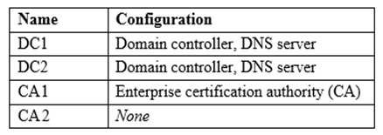

You have a research department. The computers in the research department are not domain-joined.

You need to ensure that the research department computers can use automatic certificate enrollment to receive and renew certificates from the CA.

Which two role services should you install and configure on CA1? Each correct answer presents part of the solution.

**NOTE:** Each correct selection is worth one point.

1. Certificate Enrollment Policy Web Service
2. Certificate Authority Web Enrollment
3. Online Responder
4. Certificate Enrollment Web Service
5. Network Device Enrollment Service

**Correct Answer:** AB

**Section: Implement Active Directory Certificate Services Explanation**

**Explanation/Reference:**

References:

https://www.ejbca.org/docs/Part_2__Microsoft_Certification_Authority_and_Group_Policies.html

**QUESTION 135**

You have a certification authority (CA) named CA1. You create a certificate template named Template1 that has the following configurations:

Minimum key size: 2048

Cryptographic provider: Microsoft Strong Cryptographic Provider   
Compatibility Settings-Certification Authority: Windows server 2012 R2   
Compatibility Settings-Certificate recipient: Windows 8.1 /Windows Server 2012 R2

You plan to configure Template1 to require that computers requesting certificates based on Template1 must have a TPM-protected private key.

You need to modify Template1 to ensure that you can configure the Key Attestation settings.

What should you change?

1. Compatibility Settings – Certification Authority to Windows Server 2016
2. Compatibility Settings – Certificate recipient to Windows 10/Windows Server 2016
3. Cryptographic provider to Microsoft Platform Crypto Provider
4. Minimum key size to 4096

**Correct Answer:** C

**Section: Implement Active Directory Certificate Services Explanation**

**Explanation/Reference:** References:

https://docs.microsoft.com/en-us/windows-server/identity/ad-ds/manage/component-updates/tpm-key-attestation

**QUESTION 136**

Your network contains an Active Directory domain. All servers run Windows Server 2016. All client computers run Windows 10 Enterprise.

You deploy an enterprise certification authority (CA).

You are implementing an online responder.

You need to ensure that any clients that are issued certificated by the CA will use the online responder.

How should you configure the extension settings of the CA?

1. Configure the CRL Distribution Point extension by adding a location that has the **Publish CRLs to this location** check box and the **Publish Delta CRLs to this location** check box selected.
2. Configure the Authority Information Access (AIA) extension by adding a location that has the **Include in the AIA extension of issued certificates** check box selected.
3. Configure the Authority Information Access (AIA) extension by adding a location that has the **Include in the online certificate status protocol (OCSP) extension** check box selected.
4. Configure the CRL Distribution Point extension by adding a location that has the **Include in the CDP extension of issued certificates** check box selected.

**Correct Answer:** C

**Section: Implement Active Directory Certificate Services Explanation**

**Explanation/Reference:**

References:

https://www.poweradmin.com/blog/deploying-active-directory-certificate-services-and-online-responder/

**QUESTION 137**

Your network contains an Active Directory forest named contoso.com.

You have an Active Directory Federation Services (AD FS) farm. The farm contains a server named Server1 that runs Windows Server 2012 R2.

You add a server named Server2 to the farm. Server2 runs Windows Server 2016.

You remove Server1 from the farm.

You need to ensure that you can use role separation to manage the farm.

Which cmdlet should you run?

1. Set-AdfsFarmInformation
2. Update-AdfsRelyingPartyTrust
3. Set-AdfsProperties
4. Invoke-AdfsFarmBehaviorLevelRaise

**Correct Answer:** D

**Section: Implement Identity Federation and Access Solutions Explanation**

**Explanation/Reference:** Explanation:

**QUESTION 138**

Your network contains an Active Directory forest named contoso.com. The forest contains a member server named Server1 that runs Windows Server 2016. Server1 is located in the perimeter network.

You install the Active Directory Federation Services server role on Server1. You create an Active Directory Federation Services (AD FS) farm by using a certificate that has a subject name of sts.contoso.com.

You need to enable certificate authentication from the Internet on Server1.

Which two inbound TCP ports should you open on the firewall? Each correct answer presents part of the solution.

1. 389
2. 443
3. 3389
4. 8531
5. 49443

**Correct Answer:** BE

**Section: Implement Identity Federation and Access Solutions Explanation**

**Explanation/Reference:** Explanation:

**QUESTION 139**

You have a server named Server1 that runs Windows Server 2016.

You need to configure Server1 as a Web Application Proxy.

Which server role or role service should you install on Server1?

1. Remote Access
2. Active Directory Federation Services
3. Web Server (IIS)
4. DirectAccess and VPN (RAS)
5. Network Policy and Access Services

**Correct Answer:** A

**Section: Implement Identity Federation and Access Solutions**

**Explanation**

**Explanation/Reference:** Explanation:

**QUESTION 140**

You are configuring AD FS. Which server should you deploy on your organization's perimeter network?

1. Web application proxy
2. Relying-party server
3. Federation server
4. Claims-provider server

**Correct Answer:** A

**Section: Implement Identity Federation and Access Solutions Explanation**

**Explanation/Reference:**

**QUESTION 141**

You have an Active Directory Rights Management Services (AD RMS) server named RMS1. Multiple documents are protected by using RMS1.

RMS1 fails and cannot be recovered. You install the AD RMS server role on a new server named RMS2. You restore the AD RMS database from RMS1 to RMS2.

Users report that they fail to open the protected documents and to protect new documents.

You need to ensure that the users can access the protected content.

What should you do?

1. From Active Directory Rights Management, update the Service Connection Point (SCP) for RMS1.
2. From DNS, create an alias (CNAME) record for RMS2.
3. From DNS, modify the service location (SRV) record for RMS1.
4. From RMS2, register a service principal name (SPN) in Active Directory.

**Correct Answer:** D

**Section: Implement Identity Federation and Access Solutions Explanation**

**Explanation/Reference:**

**QUESTION 142**

**Note: This question is part of a series of questions that present the same scenario. Each question in the series contains a unique solution that might meet the stated goals. Some question sets might have more than one correct solution, while others might not have a correct solution.**

**After you answer a question in this section, you will NOT be able to return to it. As a result, these questions will not appear in the review screen.**

You have a server named Web1 that runs Windows Server 2016.

You need to list all the SSL certificates on Web1 that will expire during the next 60 days. Solution: You run the following command.

**Get-ChildItem Cert:\LocalMachine\My |? { $_.NotAfter –It (Get-Date).AddDays( 60 ) }** Does this meet the goal?

1. Yes
2. No

**Correct Answer:** A

**Section: Implement Identity Federation and Access Solutions Explanation**

**Explanation/Reference:**

**QUESTION 143**

You network contains an Active Directory domain named contoso.com. The domain contains an Active Directory Federation Services (AD FS) server named ADFS1, a Web Application Proxy server named WAP1, and a web server named Web1.

You need to publish a website on Web1 by using the Web Application Proxy. Users will authenticate by using OAuth2 preauthentication.

What should you do first?

1. On Web1, add site bindings.
2. On Web1, add handler mappings.
3. On ADFS1, enable an endpoint.
4. On ADFS1, add a claims provider trust.

**Correct Answer:** C

**Section: Implement Identity Federation and Access Solutions Explanation**

**Explanation/Reference:**

**QUESTION 144**

Your network contains an Active Directory domain. The domain contains an Active Directory Rights Management Services (AD RMS) cluster and a certification authority (CA).

You need to ensure that all the documents that are protected by using AD RMS can be decrypted if the account used to encrypt the documents is deleted.

What should you do?

1. Configure super users in the AD RMS deployment.
2. Manually configure the AD RMS cluster key password.
3. Back up the AD-RMS-protected files by using Windows Server Backup.
4. Configure key archival on the CA.

**Correct Answer:** A

**Section: Implement Identity Federation and Access Solutions Explanation**

**Explanation/Reference:**

**QUESTION 145**

You have an internal web server that hosts websites. The websites use HTTP and HTTPS.

You deploy a Web Application Proxy to your perimeter network.

You need to ensure that users from the Internet can access the websites by using HTTPS only. Internet access to the websites must use the Web Application Proxy.

Which two actions should you perform? Each correct answer presents part of the solution.

**NOTE:** Each correct selection is worth one point.

1. From the web server, enable HTTP Redirect on the Web Application Proxy server.
2. Configure the Web Application Proxy to perform preauthentication by using Oauth2.
3. From the Remote Access Management Console, publish the websites. Configure pass-through authentication and select Enable HTTP to HTTPS redirection.
4. On external DNS name servers, create DNS entries that point to the private IP address of the web server.
5. On external DNS name servers, create DNS entries that point to the public IP address of the Web Application Proxy. **Correct Answer:** CE

**Section: Implement Identity Federation and Access Solutions Explanation**

**Explanation/Reference:**

**QUESTION 146**

Your network contains an Active Directory domain named contoso.com.

You plan to deploy a new Active Directory Rights Management Services (AD RMS) cluster on a server named Server1.

You need to create the AD RMS service account. The solution must use the principle of least privilege.

What should you do?

1. Create a local user account on Server1 and add the account to the Administrators group on Server1.
2. Create a domain user account and add the account to the Administrators group on Server1.
3. Create a domain user account and add the account to the Domain Users group in the domain.
4. Create a domain user account and add the account to the Account Operators group in the domain.

**Correct Answer:** C

**Section: Implement Identity Federation and Access Solutions Explanation**

**Explanation/Reference:**

**QUESTION 147**

You use Application Request Routing (ARR) to make internal web applications available to the Internet by using NTLM authentication.

You need to replace ARR by using the Web Application Proxy.

Which server role should you deploy first?

1. Active Directory Certificate Services
2. Active Directory Federation Services
3. Active Directory Lightweight Directory Services
4. Active Directory Rights Management Services

**Correct Answer:** B

**Section: Implement Identity Federation and Access Solutions Explanation**

**Explanation/Reference:**

**QUESTION 148**

Your network contains an Active Directory forest named contoso.com. All domain controllers run Windows Server 2012 R2.

You deploy a new server named Server1 that runs Windows Server 2016.

A server administrator named ServerAdmin01 is a member of the Doman users group. You add ServerAdmin01 to the Administrators group on Server1.

ServerAdmin01 signs in to Server1 and successfully configures a new Active Directory Rights Management Services (AD RMS) cluster.

You need to ensure that clients discover the AD RMS cluster by querying Active Directory.

What should you do?

1. Update the Active Directory schema.
2. Register a Service Connection Point (SCP).
3. Modify the Security settings of the computer account of Server1.
4. Upgrade one domain controller to Windows Server 2016.

**Correct Answer:** B

**Section: Implement Identity Federation and Access Solutions Explanation**

**Explanation/Reference:**

**QUESTION 149**

Your network contains an Active Directory forest named contoso.com. The domain contains an Active Directory Federation Services (AD FS) server named Server1.

On a standalone server named Server2, you install and configure the Web Application Proxy.

You have an internal web application named WebApp1. AD FS has a relying party trust for WebApp1.

You need to provide external users with access to WebApp1. Authentication to WebApp1 must use AD FS preauthentication.

Which tool should you use to publish WebApp1?

1. Remote Access Management on Server2
2. Remote Access Management on Server1
3. AD FS Management on Server2
4. AD FS Management on Server1
5. Routing and Remote Access on Server1

**Correct Answer:** A

**Section: Implement Identity Federation and Access Solutions Explanation**

**Explanation/Reference:**

Explanation:

To publish a claims-based application

1. On the Web Application Proxy server, in the Remote Access Management console, in the Navigation pane, click Web Application Proxy, and then in the Tasks pane, click Publish.
2. On the Publish New Application Wizard, on the Welcome page, click Next.
3. On the Preauthentication page, click Active Directory Federation Services (AD FS), and then click Next.
4. On the Supported Clients page, select Web and MSOFBA, and then click Next.
5. On the Relying Party page, in the list of relying parties select the relying party for the application that you want to publish, and then click Next.
6. On the Publishing Settings page, do the following, and then click Next:

 In the Name box, enter a friendly name for the application.

 This name is used only in the list of published applications in the Remote Access Management console.

 In the External URL box, enter the external URL for this application; for example, https://sp.contoso.com/app1/.

 In the External certificate list, select a certificate whose subject covers the external URL.

 In the Backend server URL box, enter the URL of the backend server. Note that this value is automatically entered when you enter the external URL and you should change it only if the backend server URL is different; for example, http://sp/app1/.

1. On the Confirmation page, review the settings, and then click Publish. You can copy the PowerShell command to set up additional published applications.
2. On the Results page, make sure that the application published successfully, and then click Close.

References:

https://docs.microsoft.com/en-us/windows-server/remote/remote-access/web-application-proxy/publishing-applications-using-ad-fs-preauthentication

**QUESTION 150**

Your network contains an Active Directory forest named adatum.com.

A partner organization has an Active Directory forest named contoso.com.

Adatum.com contains an Active Directory Rights Management (AD RMS) cluster installed on a server named adat1.adatum.com.

Contoso.com contains an Active Directory Rights Management Services (AD RMS) cluster installed on a server named cont1.contoso.com.

You need to allow the AD RMS cluster in adatum.com to accept rights account certificates (RACs) from contoso.com.

What should you do?

1. In contoso.com, import the trusted user domain file from adat1.adatum.com
2. In adatum.com, import the trusted publishing domain file from adat1.adatum.com
3. In contoso.com, import the trusted publishing domain file from cont1.contoso.com
4. In adatum.com, import the trusted user domain file from cont1.contoso.com

**Correct Answer:** D

**Section: Implement Identity Federation and Access Solutions Explanation**

**Explanation/Reference:** References: https://winintro.ru/rms_help.en/html/59c802d0-3982-432c-b06f-3e148dca0166.htm

**QUESTION 151**

**Note: This question is part of a series of questions that present the same scenario. Each question in the series contains a unique solution that might meet the stated goals. Some question sets might have more than one correct solution, while others might not have a correct solution.**

**After you answer a question in this section, you will NOT be able to return to it. As a result, these questions will not appear in the review screen.**

You have a server named Web1 that runs Windows Server 2016.

You need to list all the SSL certificates on Web1 that will expire during the next 60 days.

Solution: You run the following command.

**Get-ChildItem Cert:\CurrentUser\Trust |? { $_.NotAfter –It (Get-Date).AddDays( 60 ) }** Does this meet the goal?

1. Yes
2. No

**Correct Answer:** B

**Section: Implement Identity Federation and Access Solutions Explanation**

**Explanation/Reference:**

**QUESTION 152**

**Note: This question is part of a series of questions that present the same scenario. Each question in the series contains a unique solution that might meet the stated goals. Some question sets might have more than one correct solution, while others might not have a correct solution.**

**After you answer a question in this section, you will NOT be able to return to it. As a result, these questions will not appear in the review screen.**

You have a server named Web1 that runs Windows Server 2016.

You need to list all the SSL certificates on Web1 that will expire during the next 60 days.

Solution: You run the following command.

**Get-ChildItem Cert:\CurrentUser\My |? { $_.NotAfter –It (Get-Date).AddDays( 60 ) }** Does this meet the goal?

1. Yes
2. No

**Correct Answer:** B

**Section: Implement Identity Federation and Access Solutions Explanation**

**Explanation/Reference:**

**QUESTION 153**

You have a server named Server1 that has the Active Directory Federation Services server role installed.

You need to configure Server1 as the authorization server. Server1 will be used to authorize access to a web API from a web application. The web application will use OAuth 2.0 and OpenID Connect to access the web API as the authenticated user. The solution must minimize administrative effort.

What should you do first?

1. Run New-AdfsApplicationGroup
2. Add a web API application
3. Run Add-AdfsNativeClientApplication
4. Run Add-AdfsWebApiApplication

**Correct Answer:** D

**Section: Implement Identity Federation and Access Solutions Explanation**

**Explanation/Reference:**

References:

https://docs.microsoft.com/en-us/powershell/module/adfs/add-adfswebapiapplication?view=win10-ps

**QUESTION 154**

Your network contains an Active Directory domain. The domain contains the servers shown in the following table.

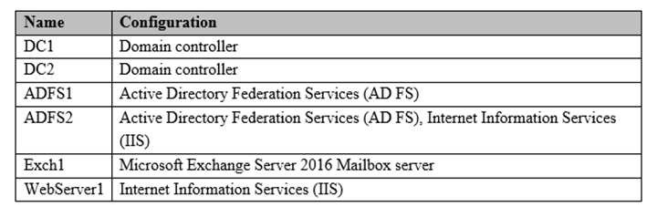

You have a server named WebServer2 in a workgroup. WebServer2 has the Web Server (IIS) server role installed. You plan to deploy a Web Application Proxy to provide preauthentication for HTTP Basic application publishing to allow users to connect to mailboxes by using Exchange ActiveSync.

You need to install the Web Application Proxy role service. The solution must minimize the attack surface.

On which server should you install the role service?

1. WebServer2
2. WebServer1
3. ADFS1
4. ADFS2

**Correct Answer:** A

**Section: Implement Identity Federation and Access Solutions Explanation**

**Explanation/Reference:**

References: https://www.techsupportpk.com/2016/12/deploy-web-application-proxy-windows-server-2016.html https://docs.microsoft.com/en-us/sharepoint/hybrid/configure-web-application-proxy-for-a-hybrid-environment https://docs.microsoft.com/en-us/windows-server/storage/work-folders/deploy-work-folders-adfs-step4

**QUESTION 155**

Your company uses Active Directory Rights Management Services (AD RMS).

You need to ensure that only users who use AD RMS client version 2.1 or newer can obtain a rights account certificate from the AD RMS cluster.

What should you enable first?

1. decommissioning
2. user exclusion
3. lockbox exclusion
4. Application Exclusion

**Correct Answer:** C

**Section: Implement Identity Federation and Access Solutions Explanation**

**Explanation/Reference:**

References: https://forsenergy.com/en-us/rms_help/html/9a944ab7-f0d9-4224-97c6-b2543f537827.htm

**QUESTION 156**

**Note: This question is part of a series of questions that present the same scenario. Each question in the series contains a unique solution that might meet the stated goals. Some question sets might have more than one correct solution, while others might not have a correct solution.**

**After you answer a question in this section, you will NOT be able to return to it. As a result, these questions will not appear in the review screen.**

You network contains an Active Directory forest named contoso.com. The forest contains an Active Directory Rights Management Services (AD RMS) deployment.

Your company establishes a partnership with another company named Fabrikam, Inc. The network of Fabrikam contains an Active Directory forest named fabrikam.com and an AD RMS deployment.

You need to ensure that the users in contoso.com can access rights protected documents sent by the users in fabrikam.com.

Solution: From AD RMS in contoso.com, you configure fabrikam.com as a trusted publisher domain.

Does this meet the goal?

1. Yes
2. No

**Correct Answer:** A

**Section: Implement Identity Federation and Access Solutions Explanation**

**Explanation/Reference:**

Explanation:

By default, an AD RMS Licensing Server can issue use licenses for only content where it originally issued the publishing license. In some situations, this may not be acceptable. In order to specify a cluster that is allowed to issue use licenses for content protected by a different cluster, the first cluster must be defined as a trusted publishing domain. If content was published by another certification cluster either in your organization, for example, a subsidiary organization in another forest, or in a separate organization, your AD RMS cluster can grant use licenses to users for this content by configuring a Trusted Publishing Domain on your AD RMS cluster. By adding a Trusted Publishing Domain, you set up a trust relationship between your AD RMS cluster and the other certification cluster by importing the Trusted Publishing Certificate of the other cluster.

References: https://books.google.co.za/books?id=gjR-BAAAQBAJ&pg=PA397&lpg=PA397&dq=configure+a+partners+forest+as+a+trusted+publishing+domain+-+AD

+RMS&source=bl&ots=mohQXTyW9s&sig=NJ7oFHuLYOs72o9EM-

yQiIscUW8&hl=en&sa=X&ved=0ahUKEwjuivW24sPbAhWGRMAKHQcEB6EQ6AEIOzAD#v=onepage&q=configure%20a%20partners%20forest%20as%20a% 20trusted%20publishing%20domain%20-%20AD%20RMS&f=false

**QUESTION 157**

**Note: This question is part of a series of questions that present the same scenario. Each question in the series contains a unique solution that might meet the stated goals. Some question sets might have more than one correct solution, while others might not have a correct solution.**

**After you answer a question in this section, you will NOT be able to return to it. As a result, these questions will not appear in the review screen.**

Your network contains an Active Directory forest named contoso.com. The forest contains a member server named Server1 that runs Windows Server 2016. All domain controllers run Windows Server 2012 R2.

Contoso.com has the following configuration.

PS C:\> (Get-ADForest).ForestMode Windows2008R2Forest

PS C:\> (Get-ADDomain).DomainMode

Windows2008R2Domain PS C:\>

You plan to deploy an Active Directory Federation Services (AD FS) farm on Server1 and to configure device registration.

You need to configure Active Directory to support the planned deployment.

Solution: You run adprep.exe from the Windows Server 2016 installation media.

Does this meet the goal?

1. Yes
2. No

**Correct Answer:** A

**Section: Implement Identity Federation and Access Solutions Explanation**

**Explanation/Reference:**

Explanation:

Device Registration requires Windows Server 2012 R2 forest schema. We can run adprep.exe to upgrade the schema.

References:

https://docs.microsoft.com/en-us/windows-server/identity/ad-fs/deployment/configure-a-federation-server-with-device-registration-service https://docs.microsoft.com/en-us/windows-server/identity/ad-ds/deploy/upgrade-domain-controllers-to-windows-server-2012-r2-and-windows-server-2012

**QUESTION 158**

**Note: This question is part of a series of questions that present the same scenario. Each question in the series contains a unique solution that might meet the stated goals. Some question sets might have more than one correct solution, while others might not have a correct solution.**

**After you answer a question in this section, you will NOT be able to return to it. As a result, these questions will not appear in the review screen.**

Your network contains an Active Directory forest named contoso.com. The forest contains a member server named Server1 that runs Windows Server 2016. All domain controllers run Windows Server 2012 R2.

Contoso.com has the following configuration.

PS C:\> (Get-ADForest).ForestMode Windows2008R2Forest

PS C:\> (Get-ADDomain).DomainMode

Windows2008R2Domain PS C:\>

You plan to deploy an Active Directory Federation Services (AD FS) farm on Server1 and to configure device registration.

You need to configure Active Directory to support the planned deployment.

Solution: You upgrade a domain controller to Windows Server 2016.

Does this meet the goal?

1. Yes
2. No

**Correct Answer:** A

**Section: Implement Identity Federation and Access Solutions Explanation**

**Explanation/Reference:**

Explanation:

Device Registration requires Windows Server 2012 R2 forest schema. Upgrading a domain controller will run adprep.exe to upgrade the schema as part of the upgrade process.

References:

https://docs.microsoft.com/en-us/windows-server/identity/ad-fs/deployment/configure-a-federation-server-with-device-registration-service https://docs.microsoft.com/en-us/windows-server/identity/ad-ds/deploy/upgrade-domain-controllers-to-windows-server-2012-r2-and-windows-server-2012

**QUESTION 159**

**Note: This question is part of a series of questions that present the same scenario. Each question in the series contains a unique solution that might meet the stated goals. Some question sets might have more than one correct solution, while others might not have a correct solution.**

**After you answer a question in this section, you will NOT be able to return to it. As a result, these questions will not appear in the review screen.**

Your network contains an Active Directory forest named contoso.com. The forest contains a member server named Server1 that runs Windows Server 2016. All domain controllers run Windows Server 2012 R2.

Contoso.com has the following configuration.

PS C:\> (Get-ADForest).ForestMode Windows2008R2Forest

PS C:\> (Get-ADDomain).DomainMode

Windows2008R2Domain PS C:\>

You plan to deploy an Active Directory Federation Services (AD FS) farm on Server1 and to configure device registration.

You need to configure Active Directory to support the planned deployment.

Solution: You raise the domain functional level to Windows Server 2012 R2.

Does this meet the goal?

1. Yes
2. No

**Correct Answer:** B

**Section: Implement Identity Federation and Access Solutions Explanation**

**Explanation/Reference:**

Explanation:

Device Registration requires Windows Server 2012 R2 forest schema (not just domain schema).

References: https://docs.microsoft.com/en-us/windows-server/identity/ad-fs/deployment/configure-a-federation-server-with-device-registration-service

**QUESTION 160**

Your network contains an Active Directory domain. The domain contains an Active Directory Rights Management Services (AD RMS) cluster.

All client computers run Windows 10 Enterprise.

You need to control from which versions of Windows users can access rights-protected content.

What should you create?

1. a security policy
2. a trust policy
3. an exclusion policy

**Correct Answer:** C

**Section: Implement Identity Federation and Access Solutions Explanation**

**Explanation/Reference:**

References:

https://books.google.co.za/books?id=G9Y5DwAAQBAJ&pg=PA385&lpg=PA385&dq=rights-protected+content+-+exclusion

+policy&source=bl&ots=MeKgOC82dG&sig=ACfU3U1DLYH3Eud3XrtFyvVR-

j80rY0JuA&hl=en&sa=X&ved=2ahUKEwi4vsvO1svnAhXs6eAKHb73Bb4Q6AEwBnoECAoQAQ#v=onepage&q=rights-protected%20content%20-%20exclusion% 20policy&f=false