QUESTION 1

Your network contains an Active Directory domain named contoso.com. The domain contains a member server named Server1 that runs Windows Server 2016 and has the DNS Server role installed. Automatic scavenging of stale records is enabled and the scavenging period is set to 10 days.

All client computers dynamically register their names in the contoso.com DNS zone on Server1.

You discover that the names of multiple client computers that were removed from the network several weeks ago can still be resolved.

You need to configure Server1 to automatically remove the records of the client computers that have been offline for more than 10 days.

Solution: You run the dnscmd.exe command and specify the /AgeAllRecords parameter for the zone.

Does this meet the goal?

A. Yes

B. No

Correct Answer: B

Explanation

<https://technet.microsoft.com/en-us/library/cc772069(v=ws.11).aspx>

QUESTION 2

Your network contains an Active Directory domain named contoso.com. The domain contains a member server named Server1 that runs Windows Server 2016 and has the DNS Server role installed. Automatic scavenging of stale records is enabled and the scavenging period is set to 10 days.

All client computers dynamically register their names in the contoso.com DNS zone on Server1.

You discover that the names of multiple client computers that were removed from the network several weeks ago can still be resolved.

You need to configure Server1 to automatically remove the records of the client computers that have been offline for more than 10 days.

Solution: You set the Time to live (TTL) value of all of the records in the zone.

Does this meet the goal?

A. Yes

B. No

Correct Answer: B

Explanation

<https://technet.microsoft.com/en-us/library/cc958972.aspx>

QUESTION 3

Your network contains an Active Directory domain named contoso.com. The domain contains a member server named Server1 that runs Windows Server 2016 and has the DNS Server role installed. Automatic scavenging of stale records is enabled and the scavenging period is set to 10 days.

All client computers dynamically register their names in the contoso.com DNS zone on Server1.

You discover that the names of multiple client computers that were removed from the network several weeks ago can still be resolved.

You need to configure Server1 to automatically remove the records of the client computers that have been offline for more than 10 days.

Solution: You modify the Zone Aging/Scavenging properties of the zone.

Does this meet the goal?

A. Yes

B. No

Correct Answer: A

Explanation

<https://technet.microsoft.com/en-us/library/cc771362(v=ws.10).aspx>

QUESTION 4

Your network contains an Active Directory domain named contoso.com. The domain contains a DNS server named Server1. All client computers run Windows 10.

On Server1, you have the following zone configuration.

You have the following subnets defined on Server1.

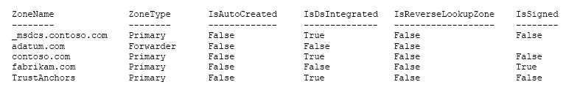

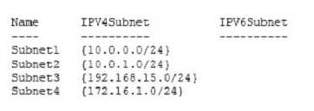

You need to prevent Server1 from resolving queries from DNS clients located on Subnet4. Server1 must resolve queries from all other DNS clients.

Solution: From Windows Firewall with Advanced Security on Server1, you create an inbound rule.

Does this meet the goal?

A. Yes

B. No

Correct Answer: A

Explanation

<https://technet.microsoft.com/en-us/library/dd421709(v=ws.10).aspx>

QUESTION 5

Your network contains an Active Directory domain named contoso.com. The domain contains a DNS server named Server1. All client computers run Windows 10.

On Server1, you have the following zone configuration.



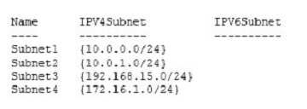

You have the following subnets defined on Server1.

You need to prevent Server1 from resolving queries from DNS clients located on Subnet4. Server1 must resolve queries from all other DNS clients.

Solution: From Windows PowerShell on Server1, you run the Add-DnsServerQueryResolutionPolicy cmdlet.

Does this meet the goal?

A. Yes

B. No

Correct Answer: A

Explanation

<https://docs.microsoft.com/en-us/powershell/module/dnsserver/add-dnsserverqueryresolutionpolicy?view=win10-ps>

QUESTION 6

Your company has a main office in London and a branch office in Seattle. The offices connect to each other by using a WAN link.

In the London office, you have a Distributed File System (DFS) server named FS1 that contains a folder named Folder1.

In the Seattle office, you have a DFS server named FS2. All servers run Windows Server 2016. You configure replication of Folder1 to FS2. Users in both offices frequently add files in Folder1. You monitor DFS Replication, and you discover excessive replication over the WAN link during business hours.

You need to reduce the amount of bandwidth used for replication during business hours. The solution must ensure that the users can continue to save content to Folder1.

What should you do?

A. Modify the quota settings on Folder1 on FS2.

B. Modify the properties of the replication group.

C. Configure the copy of Folder1 on FS2 as read-only.

D. Modify the replicated folder properties of Folder1 on FS1.

Correct Answer: B

Explanation

QUESTION 7

Your company owns the public Internet IP address range of 131.107.20.0 to 131.107.20.255.

You need to create a subnet that supports four hosts. The solution must minimize the number of addresses available to the subnet. 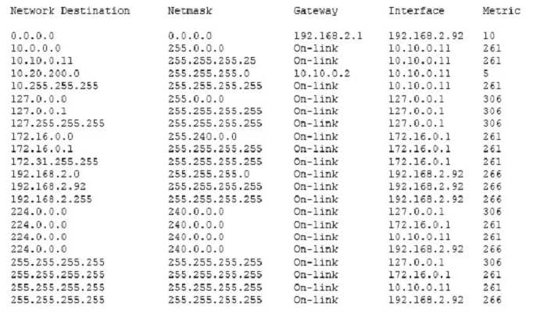

Which subnet should you use?

A. 131.107.20.16/28

B. 131.107.20.16/30

C. 131.107.20.0/29

D. 131.107.20.0 with subnet mask 255.255.255.224

E. 131.107.20.16 with subnet mask 255.255.255.252

Correct Answer: C

Explanation

<http://jodies.de/ipcalc?host=131.107.20.0&mask1=29&mask2=>

QUESTION 8

You have a server named Server1 that runs Windows Server 2016. Server1 has the following routing table.

What will occur when Server1 attempts to connect to a host that has an IP address of 172.20.10.50?

A. Server1 will attempt to connect directly to 172.20.10.50.

B. Server1 will route the connection to 10.10.0.2.

C. Server1 will silently drop the connection attempt.

D. Server1 will route the connection to 192.168.2.1.

Correct Answer: D

Explanation

<http://www.techrepublic.com/article/understanding-routing-tables/>

QUESTION 9

Your company has two main offices. The offices are located in London and Seattle. All servers run Windows Server 2016.

In the Seattle office, you have a Distributed File System (DFS) server named FS1. FS1 has a folder named Folder1 that contains large Windows image files.

In the London office, you deploy a DFS server named FS2, and you then replicate Folder1 to FS2.

After several days, you discover that the replication of certain files failed to complete.

You need to ensure that all of the files in Folder1 can replicate to FS2.

What should you do?

A. Modify the disk quota of the drive that contains Folder1.

B. From a command prompt, run dfsutil /purgemupcache.

C. Create a quota for Folder1 by using File Server Resource Manager (FSRM).

D. Modify the size of the staging area of Folder1.

Correct Answer: D

Explanation

QUESTION 10

You have a server named Server1 that runs Windows Server 2016 and is configured as a domain controller.

You install the DNS Server server role on Server1.

You plan to store a DNS zone in a custom Active Directory partition.

You need to create a new Active Directory partition for the zone.

What should you use?

A. Set-DnsServer

B. Active Directory Sites and Services

C. Dns.exe

D. Dnscmd.exe

E. New-ADObject

F. Active Directory Administrative Center

G. DNS Manager

Correct Answer: D

Explanation

dnscmd <ServerName> /CreateDirectoryPartition <FQDN>

https://docs.microsoft.com/en-us/windows-server/administration/windows-commands/dnscmd#BKMK\_5

QUESTION 11

You have a server named Server1 that runs Windows Server 2016. Server1 is a Hyper-V host that hosts a virtual machine named VM1.

Server1 has three network adapter cards that are connected to virtual switches named vSwitch1, vSwitch2 and vSwitch3.

You configure NIC Teaming on VM1 as shown in the exhibit. (Click the Exhibit button.) 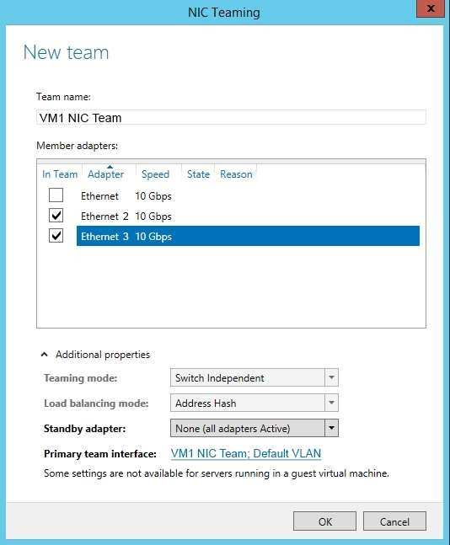

You need to ensure that VM1 will retain access to the network if a physical network adapter card fails on Server1.

What should you do?

A. From Windows PowerShell on VM1, run the Set-VmNetworkAdapterTeamMapping cmdlet.

B. From Hyper-V Manager on Server1, modify the settings of VM1.

C. From Windows PowerShell on Server1, run **the** Set-VmNetworkAdapterFailoverConfiguration cmdlet.

D. From the properties of the NIC team on VM1, add the adapter named Ethernet to the NIC team.

E. From Windows PowerShell on Server1, run the Set-VmSwitch cmdlet.

F. From Hyper-V Manager on Server1, modify the properties of vSwitch1.

G. From the properties of the NIC team on VM1, change the load balancing of the NIC team.

Correct Answer: B

Explanation

References: <https://technet.microsoft.com/en-us/windows-server-docs/networking/technologies/nic-teaming/nic-teaming>

QUESTION 12

You have an application named App1. App1 is distributed to multiple Hyper-V virtual machines in a multitenant environment.

You need to ensure that the traffic is distributed evenly among the virtual machines that host App1.

What should you include in the environment?

A. Network Controller and Windows Server Network Load Balancing (NLB) nodes

B. an RAS Gateway and Windows Server Software Load Balancing (SLB) nodes

C. an RAS Gateway and Windows Server Network Load Balancing (NLB) nodes

D. Network Controller and Windows Server Software Load Balancing (SLB) nodes

Correct Answer: B

Explanation

[https://technet.microsoft.com/en-us/library/mt403307(v=ws.11).aspx#bkmk\_slb](https://technet.microsoft.com/en-us/library/mt403307(v=ws.11).aspx" \l "bkmk_slb)

QUESTION 13

You have an Active Directory domain that contains several Hyper-V hosts that run Windows Server 2016.

You plan to deploy network virtualization and to centrally manage Datacenter Firewall policies.

Which component must you install for the planned deployment?

A. the Data Center Bridging feature

B. the Network Controller server role

C. the Routing role service

D. the Canary Network Diagnostics feature

Correct Answer: B

Explanation

<https://technet.microsoft.com/en-us/library/mt403307(v=ws.11).aspx#bkmk_slb>

QUESTION 14

You have two Hyper-V hosts named Server1 and Server2 that run Windows Server 2016. Server1 and Server2 are connected to the same network.

On Server1 and Server2, you create an external network switch named Switch1.

You have the virtual machine shown in the following table.

All three virtual machines are connected to Switch1.

You need to prevent applications in VM3 from being able to capture network traffic from VM1 or VM2. The solution must ensure that VM1 retains network connectivity.

What should you do?

A. Configure network virtualization for VM1 and VM2.

B. Modify the subnet mask of VM1 and VM2.

C. On Server2, configure the VLAN ID setting of Switch1.

D. On Server2, create an external switch and connect VM3 to the switch.

Correct Answer: A

Explanation

<https://blogs.technet.microsoft.com/networking/2016/10/26/network-virtualization-with-ws2016-sdn/>

QUESTION 15

Your company has 10 offices. Each office has a local network that contains several Hyper-V hosts that run Windows Server 2016. All of the offices are connected by high speed, low latency WAN links.

You need to ensure that you can use QoS policies for Live Migration traffic between the offices.

Which component should you install?

A. the Data Center Bridging feature

B. the Routing role service

C. the Network Controller server role

D. the Multipath I/O feature

E. the Canary Network Diagnostics feature

Correct Answer: A

Explanation

<https://technet.microsoft.com/en-us/library/jj735302(v=ws.11).aspx>

QUESTION 16

Your company has 5,000 users who work remotely.

You have 40 VPN servers that host the remote connections for the users.

You plan to deploy a RADIUS solution that contains five RADIUS servers.

You need to ensure that client authentication requests are distributed evenly between the five RADIUS servers.

What should you do?

A. Install the Network Load Balancing role service on all of the RADIUS server. Configure all of the RADIUS clients to connect to a virtual IP address.

B. Deploy RAS Gateway to a new server. Configure all of the RADIUS clients to connect to RAS Gateway.

C. Install the Failover Clustering role service on all of the RADIUS servers. Configure all of the RADIUS clients to connect to the IP address of the cluster.

D. Deploy a RADIUS proxy to a new server. Configure all of the RADIUS clients to connect to the RADIUS proxy.

Correct Answer: D

Explanation

<https://technet.microsoft.com/en-us/library/dd197433(v=ws.10).aspx>

QUESTION 17

Your network contains an Active Directory forest named contoso.com. The functional level of the forest is Windows Server 2012.

The forest contains five domain controllers and five VPN servers that run Windows Server 2016.

Five hundred users connect to the VPN servers daily.

You need to configure a new server named Server1 as a RADIUS server.

What should you do first?

A. On Server1, deploy the Remote Access server role.

B. On Server1, deploy the Network Policy and Access Services role.

C. On a domain controller, set the forest functional level to Windows Server 2016.

D. On each VPN server, run the New-NpsRadiusClient cmdlet.

Correct Answer: B

Explanation

<http://www.nyazit.com/configure-network-policy-server-2016/>

QUESTION 18

Your network contains an Active Directory forest named contoso.com. The forest contains two domains named contoso.com and litwareinc.com.

Your company recently deployed DirectAccess for the members of a group named DA\_Computers. All client computers are members of DA\_Computers.

You discover that DirectAccess clients can access the resources located in the contoso.com domain only. The clients can access the resources in the litwareinc.com domain by using an L2TP VPN connection to the network.

You need to ensure that the DirectAccess clients can access the resources in the litwareinc.com domain.

What should you do?

A. From a Group Policy object (GPO), modify the Name Resolution Policy Table (NRPT).

B. From the properties of the servers in litwareinc.com, configure the delegation settings.

C. On an external DNS server, create a zone delegation for litwareinc.com.

D. Add the servers in litwareinc.com to the RAS and IAS Servers group.

Correct Answer: A

Explanation

<https://blogs.technet.microsoft.com/tomshinder/2010/04/01/directaccess-client-location-awareness-nrpt-name-resolution/>

QUESTION 19

You have an Active Directory domain named Contoso.com. The domain contains servers named Server1 and Server2 that run Windows Server 2016.

You install the Remote Access server role on Server1. You install the Network Policy and Access Services server role on Server2.

You need to configure Server1 to use Server2 as a RADIUS server.

What should you do?

A. From the Connection Manager Administration Kit, create a Connection Manager profile.

B. From Routing and Remote Access, configure the authentication provider.

C. From Active Directory Users and Computers, modify the Delegation settings of the Server1 computer account.

D. From Server Manager, create an Access Policy.

Correct Answer: B

Explanation

QUESTION 20

You company has a main office in London. The company has 1,000 users who are located in many countries.

You plan to deploy a large remote access solution for the company.

The London office has three servers named Server1, Server2, and Server3 that run Windows Server 2016.

You plan to use Server1 as a VPN server, Server2 as a RADIUS proxy, and Server3 as a RADIUS server.

You need to configure Server2 to support the planned deployment.

Which three actions should you perform on Server2? Each correct answer presents part of the solution.

A. Create a connection request policy.

B. Deploy a Windows container.

C. Add a RADIUS client.

D. Create a network policy.

E. Create a remote RADIUS server group.

Correct Answer: A­CE

Explanation

<https://ittrainingday.wordpress.com/2014/01/03/how-to-configure-radius-proxy-servers/>

QUESTION 21

You have a server named Host1 that runs Windows Server 2016. You configure Host1 as a virtualization host and create 20 new virtual machines on Host1. You need to ensure that all of the virtual machines can connect to the Internet through Host1.

Which three actions should you perform? Each correct answer presents part of the solution.

A. On a virtual machine, install the Remote Access server role.

B. From the properties of each virtual machine, enable virtual LAN identification.

C. From the properties of each virtual machine, connect to the virtual machine switch.

D. On Host1, configure the network address translation (NAT) network.

E. On Host1, create an internal virtual machine switch and specify an IP address for the switch.

Correct Answer: CDE

Explanation

<https://technet.microsoft.com/en-us/library/ee449441(v=ws.10).aspx>

QUESTION 22

You have a DHCP server named Server1 that has three network cards. Each network card is configured to use a static IP address. Each network card connects to a different network segment.

Server1 has an IPv4 scope named Scope1.

You need to ensure that Server1 only uses one network card when leasing IP addresses in Scope1.

What should you do?

A. From the properties of Scope1, modify the Conflict detection attempts setting.

B. From the properties of Scope1, configure Name Protection.

C. From the properties of IPv4, configure the bindings.

D. From IPv4, create a new filter.

E. From the properties of Scope1, create an exclusion range.

F. From IPv4, run the DHCP Policy Configuration Wizard.

G. From Control Panel, modify the properties of Ethernet.

H. From Scope1, create a reservation.

Correct Answer: C

**Explanation:**

<https://technet.microsoft.com/en-us/library/cc770650(v=ws.11).aspx>

QUESTION 23

You have a DHCP server named Server1 that has three network cards. Each network card is configured to use a static IP address.

You need to prevent all client computers that have physical address beginning with 98-5F from leasing an IP address from Server1.

What should you do?

A. From the properties of Scope1, modify the Conflict detection attempts setting.

B. From the properties of Scope1, configure Name Protection.

C. From the properties of IPv4, configure the bindings.

D. From IPv4, create a new filter.

E. From the properties of Scope1, create an exclusion range.

F. From IPv4, run the DHCP Policy Configuration Wizard.

G. From Control Panel, modify the properties of Ethernet.

H. From Scope1, create a reservation.

Correct Answer: D

Explanation

<https://technet.microsoft.com/en-us/library/ee941125(v=ws.10).aspx>

QUESTION 24

Your network contains an Active Directory domain named contoso.com. The functional level of the domain is Windows Server 2012.

The network uses an address space of 192.168.0.0/16 and contains multiple subnets. The network is not connected to the Internet. The domain contains three servers configured as shown in the following table.

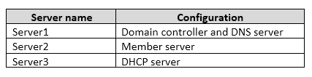

Client computers obtain TCP/IP settings from Server3.

You add a second network adapter to Server2. You connect the new network adapter to the Internet. You install the Routing role service on Server2.

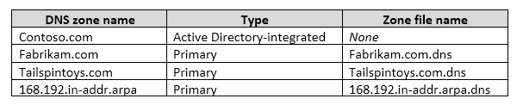Server1 has four DNS zones configured as shown in the following table.

You need to ensure that when a computer is removed from the network, the associated records are deleted automatically after 15 days.

Which two actions should you perform? Each correct answer presents part of the solution.

A. Create a scheduled task that runs the Remove-Computer cmdlet.

B. Modify the Zone Aging/Scavenging Properties of the zone.

C. Modify the Time to live (TTL) value of the start of authority (SOA) record.

D. Set the Scavenging period of Server1.

E. Modify the Expires after value of the start of authority (SOA) record.

Correct Answer: BD

Explanation

<https://technet.microsoft.com/en-us/library/cc771362(v=ws.10).aspx>

QUESTION 25

Your network contains an Active Directory domain named contoso.com. The functional level of the domain is Windows Server 2012.

The network uses an address space of 192.168.0.0/16 and contains multiple subnets. The network is not connected to the Internet. The domain contains three servers configured as shown in the following table.



Client computers obtain TCP/IP settings from Server3.

You add a second network adapter to Server2. You connect the new network adapter to the Internet. You install the Routing role service on Server2.

Server1 has four DNS zones configured as shown in the following table.



You need to create a zone to ensure that Server1 can resolve single-label names.

What should you name the zone on Server1?

A. . (root)

B. WINS

C. NetBIOS

D. GlobalNames

Correct Answer: D

Explanation

<https://technet.microsoft.com/en-us/library/cc816610(v=ws.10).aspx>

QUESTION 26

You have servers named Server1 and DHCP1. Both servers run Windows Server 2016. DHCP1 contains an IPv4 scope named Scope1.

You have 1,000 client computers.

You need to configure Server1 to lease IP addresses for Scope1. The solution must ensure that Server1 is used to respond to up to 30 percent of the DHCP client requests only.

You install the DHCP Server server role on Server1.

What should you do next?

A. From the DHCP console, run the Configure Failover wizard.

B. From Server Manager, install the Network Load Balancing feature.

C. From Server Manager, install the Failover Clustering feature.

D. From the DHCP console, create a superscope.

Correct Answer: A

Explanation

<https://technet.microsoft.com/en-us/library/hh831385(v=ws.11).aspx>

QUESTION 27

Your network contains an Active Directory domain named contoso.com. The domain contains a DNS server named Server1. All client computers run Windows 10.

On Server1, you have the following zone configuration. 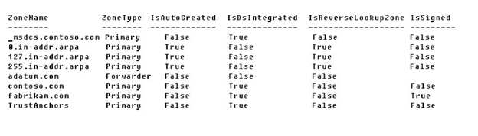

You need to ensure that all of the client computers in the domain perform DNSSEC validation for the fabrikam.com namespace.

Solution: From a Group Policy object (GPO) in the domain, you add a rule to the Name Resolution Policy Table (NRPT).

Does this meet the goal?

A. Yes

B. No

Correct Answer: A

Explanation

The NRPT stores configurations and settings that are used to deploy DNS Security Extensions (DNSSEC), and also stores information related to DirectAccess, a remote access technology.

Note: The Name Resolution Policy Table (NRPT) is a new feature available in Windows Server 2008 R2. The NRPT is a table that contains rules you can configure to specify DNS settings or special behavior for names or namespaces. When performing DNS name resolution, the DNS Client service checks the NRPT before sending a DNS query. If a DNS query or response matches an entry in the NRPT, it is handled according to settings in the policy. Queries and responses that do not match an NRPT entry are processed normally.

<https://technet.microsoft.com/en-us/library/ee649207(v=ws.10).aspx>

QUESTION 28

Your network contains an Active Directory domain named contoso.com. The domain contains a DNS server named Server1. All client computers run Windows 10.

On Server1, you have the following zone configuration.

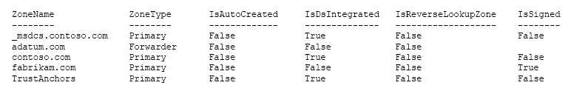

You need to ensure that all of the client computers in the domain perform DNSSEC validation for the fabrikam.com namespace.

Solution: From Windows PowerShell on Server1, you run the Add-DnsServerTrustAnchor cmdlet.

Does this meet the goal?

A. Yes

B. No

Correct Answer: B

Explanation

The Add-DnsServerTrustAnchor command adds a trust anchor to a DNS server. A trust anchor (or trust “point”) is a public cryptographic key for a signed zone.

Trust anchors must be configured on every nonauthoritative DNS server that will attempt to validate DNS data. Trust Anchors have no direct relation to DSSEC validation.

<https://docs.microsoft.com/en-us/powershell/module/dnsserver/add-dnsservertrustanchor?view=win10-ps>

<https://technet.microsoft.com/en-us/library/dn593672(v=ws.11).aspx>

QUESTION 29

Your network contains an Active Directory domain named contoso.com. The domain contains a DNS server named Server1. All client computers run Windows 10.

On Server1, you have the following zone configuration.



You have the following subnets defined on Server1.

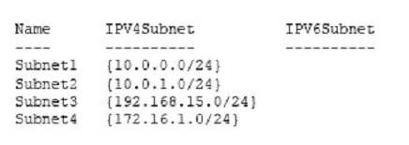

You need to prevent Server1 from resolving queries from DNS clients located on Subnet4. Server1 must resolve queries from all other DNS clients.

Solution: From the Security setting of each zone on Server1, you modify the permissions.

Does this meet the goal?

A. Yes

B. No

Correct Answer: B

Explanation

QUESTION 30

You have an IP Address Management (IPAM) server named IPAM1 that runs Windows Server 2016. IPAM1 manages 10 DHCP servers.

You need provide a user with the ability to track which clients receive which IP addresses from DHCP. The solution must minimize administrative privileges.

A. IPAM MSM Administrators

B. IPAM ASM Administrators

C. IPAM IP Audit Administrators

D. IPAM User

Correct Answer: C

Explanation

<https://technet.microsoft.com/en-us/library/jj878348(v=ws.11).aspx>

QUESTION 31

You have an IP Address Management (IPAM) deployment that is used to manage all of the DNS servers on your network. IPAM is configured to use Group Policy provisioning.

You discover that a user adds a new mail exchanger (MX) record to one of the DNS zones.

You want to identify which user added the record.

You open Event Catalog on an IPAM server, and you discover that the most recent event occurred yesterday.

You need to ensure that the operational events in the event catalog are never older than one hour.

What should you do?

A. From the properties on the DNS zones, modify the refresh interval.

B. From an IPAM\_DNS Group Policy object (GPO), modify the Group Policy refresh interval.

C. From Task Scheduler, modify the Microsoft\Windows\IPAM\Audit task.

D. From Task Scheduler, create a scheduled task that runs the Update-IpamServer cmdlet.

Correct Answer: C

Explanation

<https://technet.microsoft.com/en-us/library/jj878342(v=ws.11).aspx>

QUESTION 32

You have a remote access server named Server1 that runs Windows Server 2016. Server1 has DirectAccess enabled.

You have a proxy server named Server2. All computers on the internal network connect to the Internet by using the proxy.

On Server1, you run the command Set-DAClient -Force Tunnel Enabled.

You need to ensure that when a Direct Access client connects to the network, the client accesses all the Internet resources through the proxy.

What should you run on Server1?

A. Set-DnsClientGlobalSetting

B. Set-DAEntryPoint

C. Set-DnsClientNrptRule

D. Set-DnsClientNrptGlobal

E. Set-DAServer

F. Set-DANetworkLocationServer

Correct Answer: C

Explanation

<https://directaccess.richardhicks.com/2017/07/27/directaccess-force-tunneling-and-proxy-server-configuration/>

QUESTION 33

You have a server named Server1 that runs Windows Server 2016. Server1 has the DHCP Server and the Windows Deployment Service server roles installed.

Server1 is located on the same subnet as client computers.

You need to ensure that clients can perform a PXE boot from Server1.

Which two IPv4 options should you configure in DHCP? Each correct answer presents part of the solution.

NOTE: Each correct selection is worth one point.

A. 003 Router

B. 066 Boot Server Host Name

C. 015 DNS Domain Name

D. 006 DNS Servers

E. 060 Option 60

Correct Answer: BE

Explanation

QUESTION 35

Refer to the exhibit:

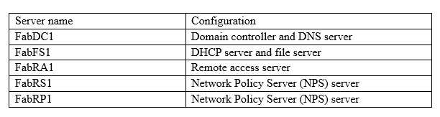

Your network contains an Active Directory forest named fabrikam.com. The forest contains the servers configured as shown in the following table: You plan to implement a VPN. FabRA1 will use the RADIUS proxy for authentication.

You need to ensure that VPN clients can be authenticated and can access internal resources. The solution must ensure that FabRS1 is used as a RADIUS server and FabRP1 is used as a RADIUS proxy.

Which two actions should you perform? Each correct answer presents part of the solution.

NOTE: Each correct selection is worth one point.

A. Create a connection request policy on FabRS1.

B. Create a connection request policy on FabRP1.

C. Create a network policy on FabRS1.

D. Delete the default connection request policy on FabRS1.

E. Create a network policy on FabRP1.

Correct Answer: BC

Explanation

QUESTION 36

You have a test environment that includes two servers named Server1 and Server2. The servers run Windows Server 2016.

You need to ensure that you can implement SMB Direct between the servers.

Which feature should the servers support?

A. Remote Direct Memory Access (RDMA)

B. Multipath I/O (MPIO)

C. Virtual Machine queue (VMQ)

D. Single root I/O virtualization (SR-IOV)

Correct Answer: A

Explanation

<https://technet.microsoft.com/en-us/library/jj134210(v=ws.11).aspx>

QUESTION 37

You have a Hyper-V server named Server1 that runs Windows Server 2016. Server1 has an IP address of 192.168.1.78.

Server1 has a container named Container1 that hosts a web application on port 84. Container1 has an IP address of 172.16.5.6. Container1 has a port mapping from port 80 on Server1 to port 84 on Container1.

You have a server named Server2 that has an IP address of 192.168.1.79. You need to connect to the web application from Server2.

To which IP address and port should you connect?

A. 172.16.5.6:80

B. 192.168.1.78:80

C. 172.16.5.6:84

D. 192.168.1.78:84

Correct Answer: B

Explanation

<https://www.assistanz.com/configure-port-mapping-for-windows-container/>

QUESTION 38

You have a DHCP server named Server1. Server1 has an IPv4 scope that serves 75 client computers that run Windows 10. When you review the address leases in the DHCP console, you discover several leases for devices that you do not recognize.

You need to ensure that only the 75 Windows 10 computers can obtain a lease from the scope.

What should you do?

A. Run the Add-DhcpServer4ExclusionRange cmdlet.

B. Create and enable a DHCP filter.

C. Create a DHCP policy for the scope.

D. Run the Add-DhcpServer4OptionDefinition cmdlet.

Correct Answer: C

Explanation

QUESTION 39

You have a DHCP server named Server1.

Server1 has an IPv4 scope that contains 100 addresses for a subnet named Subnet1. Subnet1 provides guest access to the Internet. There are never more than 20 client computers on Subnet1 simultaneously; however, the computers that connect to Subnet1 are rarely the same computers.

You discover that some client computers are unable to access the network. The computers that have the issue have IP addresses in the range of 169.254.0.0/16.

You need to ensure that all of the computers can connect successfully to the network to access the Internet.

What should you do?

A. Create a new scope that uses IP addresses in the range of 169.254.0.0/16.

B. Modify the scope options.

C. Modify the lease duration.

D. Configure Network Access Protection (NAP) integration on the existing scope.

Correct Answer: C

Explanation

QUESTION 40

You have an Active Directory forest that contains 30 servers and 6,000 client computers. You deploy a new DHCP server that runs Windows Server 2016.

You need to retrieve the list of the authorized DHCP servers.

Which command should you run?

A. Get-DCHPServerDatabase

B. Netstat-p IP –s –a

C. Get-DHCPServerInDc

D. Show-ADAuthenticationPolicyExpression-AllowedToAuthenticateTo

E. Netsh DHCP server initiate auth

F. Get-DHCPServerSetting

Correct Answer: C

Explanation

<https://docs.microsoft.com/en-us/powershell/module/dhcpserver/get-dhcpserverindc?view=win10-ps>

QUESTION 41

You have a Hyper-V host named Server1. Server1 connects to your corporate network.

Server1 has the virtual switches configured as shown in the following table.

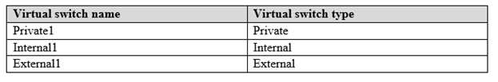

Server1 has two virtual machines named VM1 and VM2 that run Windows Server 2016. VM1 connects to Private1. VM2 has two network adapters.

You need to ensure that VM1 connects to the corporate network by using NAT.

Solution: You connect VM1 to Inernal1. You run the New-NetNatIpAddress and the New-NetNat cmdlets on Server1. You configure VM1 to use Server1 as the default gateway.

Does this meet the goal?

A. Yes

B. No

Correct Answer: A

Explanation

QUESTION 42

Your network contains an Active Directory domain named adatum.com. The domain contains two DHCP servers named Server1 and Server2.

Server1 has the following IP configuration. 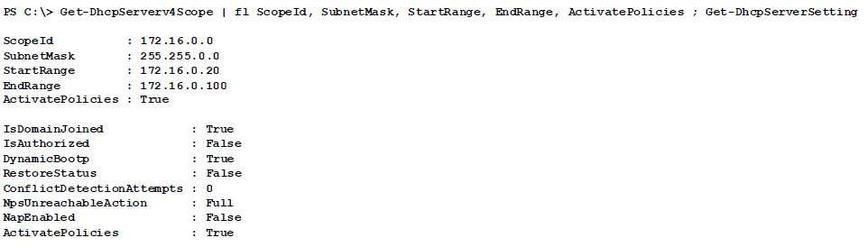

Server2 has the following IP configuration.

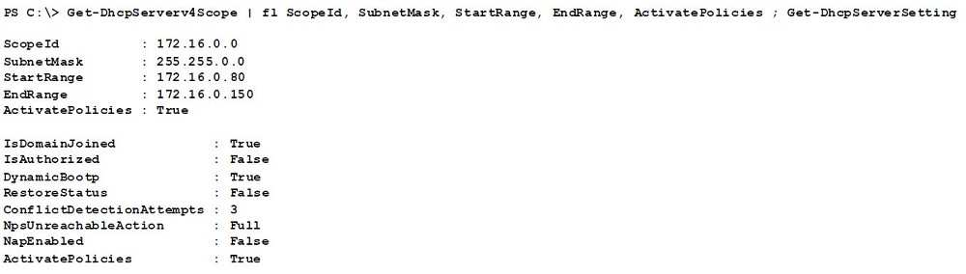

Some users report that sometimes they cannot access the network because of conflicting IP addresses. You need to configure DHCP to avoid leasing addresses that are in use already.

Solution: On Server2, you modify the ConflictDetectionAttempts value for IPv4.

Does this meet the goal?

A. Yes

B. No

Correct Answer: B

Explanation

QUESTION 43

Your network contains an Active Directory forest named contoso.com. The forest has three sites located in London, Paris, and Berlin.

The London site contains a web server named Web1 that runs Windows Server 2016.

You need to configure Web1 as an HTTP content server for the hosted cache servers located in the Paris and Berlin sites.

Solution: You install the Static Content role service, and then you restart the IIS Admin Service.

Does this meet the goal?

A. Yes

B. No

Correct Answer: B

Explanation

QUESTION 44

Your network contains an Active Directory forest named contoso.com. The forest has three sites located in London, Paris, and Berlin.

The London site contains a web server named Web1 that runs Windows Server 2016.

You need to configure Web1 as an HTTP content server for the hosted cache servers located in the Paris and Berlin sites.

Solution: You install the BranchCache feature, and then you start the BranchCache service.

Does this meet the goal?

A. Yes

B. No

Correct Answer: A

Explanation

QUESTION 45

Your network contains an Active Directory forest named contoso.com. The forest has three sites located in London, Paris, and Berlin.

The London site contains a web server named Web1 that runs Windows Server 2016.

You need to configure Web1 as an HTTP content server for the hosted cache servers located in the Paris and Berlin sites.

Solution: You install the Deployment Server role service, and then you restart the World Wide Web Publishing Service.

Does this meet the goal?

A. Yes

B. No

Correct Answer: B

Explanation

QUESTION 46

Your network contains an Active Directory domain named contoso.com. The domain contains a member server named Server1 that runs Windows Server 2016 and has the DNS Server server role installed. Automatic scavenging of stale records is enabled and the scavenging period is set to 10 days.

All client computers dynamically register their names in the contoso.com DNS zone on Server1.

You discover that the names of multiple client computers that were removed from the network several weeks ago can still be resolved.

You need to configure Server1 to automatically remove the records of the client computers that have been offline for more than 10 days.

Solution: You set the Expires after value of the zone.

Does this meet the goal?

A. Yes

B. No

Correct Answer: B

Explanation

QUESTION 47

You have a server named Server1 that has the Network Policy and Access Services server role installed.

You create a Shared Secret Network Policy Server (NPS) template named Template1. You need to view the shared secret string used for Template1.

Solution: From Windows PowerShell, you run Get-NpsSharedSecretTemplate -Name Template1.

Does this meet the goal?

A. Yes

B. No

Correct Answer: B

Explanation

QUESTION 48

You have a server named Server1 that has the Network Policy and Access Services server role installed.

You create a Shared Secret Network Policy Server (NPS) template named Template1. You need to view the shared secret string used for Template1.

Solution: From the Network Policy Server console, you export the configuration, and you view the exported XML file.

Does this meet the goal?

A. Yes

B. No

Correct Answer: A

Explanation

QUESTION 49

You have a server named Server1 that has the Network Policy and Access Services server role installed. You create a Shared Secret Network Policy Server (NPS) template named Template1. You need to view the shared secret string used for Template1.

Solution: From the Network Policy Server console, you view the properties of Template1.

Does this meet the goal?

A. Yes

B. No

Correct Answer: B

Explanation

QUESTION 50

Your network contains an Active Directory domain named contoso.com. The domain contains a DHCP server named Server2 than runs Windows Server 2016.

Users report that their client computers fail to obtain an IP address.

You open the DHCP console as shown in the Exhibit. 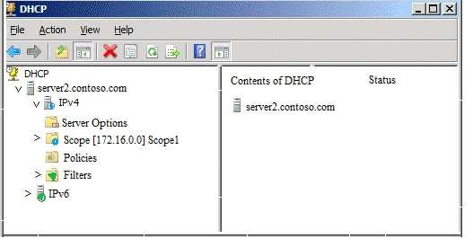

Scope1 has an address range of 172.16.0.10 to 172.16.0.100 and a prefix length of 23 bits.

You need to ensure that all of the client computers on the network can obtain an IP address from Server2.

Solution: You run the Set-DhcpServerv4MulticastScope cmdlet.

Does this meet the goal?

A. Yes

B. No

Correct Answer: B

Explanation

QUESTION 51

You manage a Windows Server 2016 software-defined network. Network Controller is installed on a three-node domain-joined cluster of virtual machines.

You need to add a new access control list (ACL) for the network controller to the network interface on a tenant virtual machine. The ACL will have only one rule that prevents only outbound traffic from the 10.10.10.0/24 subnet.

You plan to run the following Windows PowerShell commands.

$ruleproperties = new-object Microsoft.Windows.NetworkController.AclRuleProperties $ruleproperties.SourcePortRange = “0-65535”

$ruleproperties.DestinationPortRange = “0-65535”

$ruleproperties.Action = “Deny”

$ruleproperties.Priority = “100”

$ruleproperties.Type = “Outbound”

$ruleproperties.Logging = “Enabled”

Which three remaining properties should you add to the rule? Each correct answer presents part of the solution. (Choose three.) NOTE: Each correct selection is worth one point.

A. $ruleproperties.SourceAddressPrefix = “10.10.10.0/24”

B. $ruleproperties.DestinationAddressPrefix = “10.10.10.0/24”

C. $ruleproperties.Protocol = “ALL”

D. $ruleproperties.Protocol = “TCP”

E. $ruleproperties.SourceAddressPrefix = “\*”

F. $ruleproperties.DestinationAddressPrefix = “\*”

Correct Answer: ACF

Explanation

QUESTION 52

You have multiple servers that run Windows Server 2016. The DNS Server server role is installed on a server named Server1.

You need to configure Server1 to use a DNS forwarder that has an IP address of 192.168.10.15.

What should you run?

A. dism.exe

B. dns.exe

C. dnscmd.exe

D. netsh.exe

E. Set-DhcpServerDatabase

F. Set-DhcpServerv4DnsSetting

G. Set-DhcpServerv6DnsSetting

H. Set-DNSServerSetting

Correct Answer: C

Explanation

QUESTION 53

You have multiple servers that run Windows Server 2016. You need to install the DNS Server server role on one of the servers.

What should you run?

A. dism.exe

B. dns.exe

C. dnscmd.exe

D. netsh.exe

E. Set-DhcpServerDatabase

F. Set-DhcpServerv4DnsSetting

G. Set-DhcpServerv6DnsSetting

H. Set-DNSServerSetting

Correct Answer: A

Explanation

QUESTION 54

You have a server named Server1 that runs Windows Server 2016. You need to configure Server1 as a multitenant RAS Gateway.

What should you install on Server1?

A. the Network Controller server role

B. the Data Center Bridging feature

C. the Remote Access server role

D. the Network Policy and Access Services server role

Correct Answer: C

Explanation

QUESTION 55

You have a server named Server1 that runs Windows Server 2016. You install the Hyper-V server role on Server1. Server1 has eight network adapters that are dedicated to virtual machines. The network adapters are Remote Direct Memory Access (RDMA)-enabled.

You plan to use Software Defined Networking (SDN). You will host the virtual machines for multiple tenants on the Hyper-V host.

You need to ensure that the network connections for the virtual machines are resilient if one or more physical network adapters fail.

What should you implement?

A. single root I/O virtualization (SR-IOV)

B. NIC Teaming on the Hyper-V host

C. virtual Receive-side Scaling (vRSS)

D. Switch Embedded Teaming (SET)

Correct Answer: D

Explanation

QUESTION 56

You have a Hyper-V host named Server1 that runs Windows Server 2016. Server1 has two network adapters that are Remote Direct Memory Access (RDMA)-enabled.

You need to verify whether Switch Embedded Teaming (SET) is enabled.

Which cmdlet should you use?

A. Get-NetworkSwitchFeature

B. Get-VMNetworkAdapter

C. Get-VMSwitch

D. Get-VMNetworkAdapterFailoverConfiguration

Correct Answer: C

Explanation

QUESTION 57

You have three servers named Server1, Server2, and Server3 that run Windows Server 2016. On all three servers, Windows Firewall is configured to allow ICMP traffic. Server2 has two network adapters named NIC1 and NIC2.

Your network is configured as shown in the exhibit. 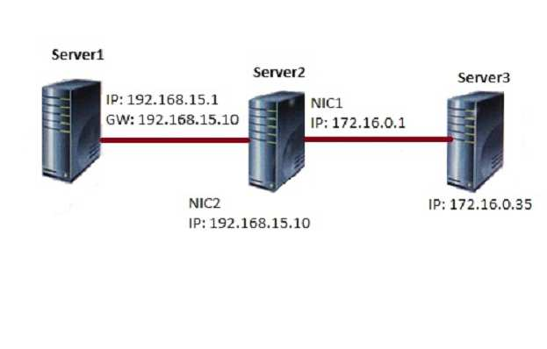

The parameters for NIC2 on Server1 are shown in the following output.

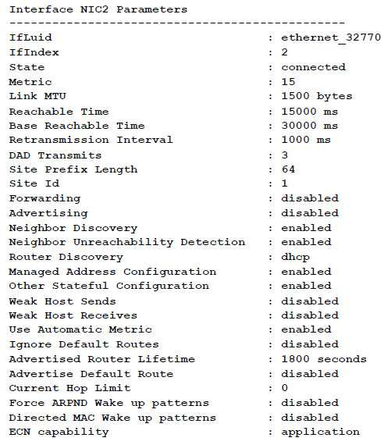

Which ping request will result in a reply from the destination host?

A. From Server2, ping 192.168.15.1

B. From Server3, ping 192.168.15.1

C. From Server1, ping 172.16.0.1

D. From Server1, ping 172.16.0.35

Correct Answer: A

Explanation

QUESTION 58

You have a server named Server1 that runs Windows Server 2016. Server1 has two network cards. One network card connects to your internal network and the other network card connects to the Internet.

You plan to use Server1 to provide Internet connectivity for client computers on the internal network.

You need to configure Server1 as a network address translation (NAT) server.

Which server role or role service should you install on Server1 first?

A. Web Application Proxy

B. DirectAccess and VPN (RAS)

C. Network Controller

D. Routing

Correct Answer: D

Explanation

QUESTION 60

Your network contains an Active Directory domain named contoso.com. The domain contains a DHCP server named Server1 that runs Windows Server 2016.

You have a DHCP scope for the 10.0.0.0/24 IP subnet. One hundred and fifty clients reside in the subnet. Fifty of the DHCP clients are NOT domain-joined.

You need to ensure that DHCP clients without a configured DNS suffix register automatically in a DNS zone named workgroup.contoso.com. The other DHCP clients must register in the DNS zone of their respective domain.

What should you do?

A. Configure the 015 DNS Domain Name scope option in the 10.0.0.0/24 DHCP scope.

B. Configure the DNS properties of the 10.0.0.0/24 DHCP scope.

C. Create a DHCP policy that has a condition based on the fully qualified domain name (FQDN) criterion. Configure the IP address range properties of the policy.

D. Create a DHCP policy that has a condition based on the fully qualified domain name (FQDN) criterion. Configure the DNS properties of the policy.

Correct Answer: D

Explanation

QUESTION 61

You have two DNS servers named Server1 and Server2. All client computers run Windows 10 and are configured to use Server1 for DNS name resolution.

Server2 hosts a primary zone named contoso.com. Your network recently experienced several DNS spoofing attacks on the contoso.com zone.

You need to prevent further attacks from succeeding.

What should you do on Server2?

A. Sign the contoso.com zone.

B. Configure Response Rate Limiting (RRL).

C. Configure DNS-based Authentication of Named Entities (DANE) for the contoso.com zone.

D. Configure the contoso.com zone to be Active Directory-integrated.

Correct Answer: A

Explanation

QUESTION 62

You have a Microsoft Azure subscription and an on-premises network. To the on-premises network, you deploy a new server named Server1 that runs Windows Server 2016. In Azure, you configure a virtual gateway on an Azure virtual network.

You need to ensure that the computers on the on-premises network can access virtual machines on the Azure virtual network.

What should you do on Server1?

A. Install the Remote Access server role. From the Routing and Remote Access Server Setup Wizard, select Secure connection between two private networks.

B. Install the Data Center Bridging (DCB) feature, and then run the Install-RemoteAccess cmdlet.

C. Install the Remote Access server role. From the Routing and Remote Access Server Setup Wizard, select Virtual private network (VPN) access and NAT.

D. Install the Data Center Bridging (DCB) feature, and then run the Enable-RemoteAccessRoutingDomain cmdlet.

Correct Answer: A

Explanation

QUESTION 63

Your network contains an Active Directory domain. The domain contains a certification authority (CA) and a Network Policy Server (NPS) server.

You plan to deploy Remote Access Always On VPN.

Which authentication method should you use?

A. Microsoft: EAP-TTLS

B. Microsoft: Secured password

C. Microsoft: Protected EAP

D. Microsoft: EAP-AKA

Correct Answer: C

Explanation

QUESTION 64

You have a DNS server named Server1 that runs Windows Server 2016. Server1 has an Active Directory-integrated zone named adatum.com.

All client computers run Windows 10. You recently encountered unexpected responses to DNS client queries in the adatum.com zone.

You need to log all the records written to the zone.

Which cmdlet should you run?

A. Add-DnsServerQueryResolutionPolicy

B. Set-DnsServerDsSetting

C. Set-DnsServerDiagnostics

D. Set-DnsServer

Correct Answer: C

Explanation

QUESTION 65

You have a DHCP server named Server1 that runs Windows Server 2016. You plan to implement IPv6 on your network.

You need to configure Server1 for stateless DHCPv6.

What should you do from the DHCP console?

A. Configure the Advanced Properties for Server1

B. Configure the IPv6 Server Options

C. Create an IPv6 scope

D. Configure the General IPv6 Properties

Correct Answer: B

Explanation

QUESTION 66

Your company has three offices. The offices are located in Seattle, Chicago, and Montreal.

You are configuring a new WAN link between the three offices by using the Remote Access server role in Windows Server 2016. You will use Border Gateway Protocol (DGP) as a routing protocol between the sites.

You need to configure the server in the Seattle office for BGP routing.

What should you do first?

A. From Routing and Remote Access, add a new IPv4 routing protocol

B. From Windows PowerShell, run the Add-BgpPeer cmdlet and specify the –LocalASN parameter

C. From Routing and Remote Access, add a new IPv6 routing protocol

D. From Windows PowerShell, run the Add-BgpRouter cmdlet and specify the –LocalASN parameter

Correct Answer: D

Explanation

QUESTION 67

You have two servers named Server1 and Server2 that run Windows Server 2016. Both servers have the DHCP Server server role installed.

Server1 has a DHCP scope named Scope1. Server2 has a DHCP scope named Scope2.

You need to ensure that client computers can get an IP address if a single DHCP server fails. You must be able to control the percentage of requests to which each DHCP server responds during normal network operations.

What should you do?

A. Add Server1 and Server2 as nodes in a failover cluster, and then configure the DHCP Server server role.

B. Add Server1 and Server2 as nodes in a failover cluster, and then configure the quorum mode.

C. On Server1 and Server2, configure DHCP failover for Scope1 and Scope2.

D. Add Server1 and Server2 as nodes in a failover cluster, and then configure port rules for UDP 67 and UDP 68.

Correct Answer: C

Explanation

QUESTION 68

You are implementing a new network. The network contains a DHCP server named DHCP1 that runs Windows Server 2016. DHCP1 contains a scope named Scope1 for the 192.168.0/24 subnet.

Your company has the following policy for allocating IP addresses:  
- All server addresses must be excluded from DHCP scopes  
- All client computers must receive IP addresses from Scope1  
- All Windows servers must have IP addresses in the range of 192.168.0.200 to 192.168.0.240  
- All other network devices must have IP addresses in the range of 192.168.0.180 to 192.168.0.199

You deploy a print device named Print1.

You need to ensure that Print1 adheres to the policy for allocating IP addresses.

Which command should you use?

A. Add-DhcpServerv4Lease

B. Add-DhcpServerv4ExclusionRange

C. Add-DhcpServerv4Filter

D. Add-DhcpServerv4Reservation

Correct Answer: D

Explanation

QUESTION 69

Your network contains an Active Directory domain named contoso.com that contains a domain controller named DC1. All DNS servers for the network run BIND 10.

Your perimeter network contains a DHCP server named DHCP1 that runs Windows Server 2016. DHCP1 is a member of a workgroup named WORKGROUP. DHCP1 provides IP address leases to guests accessing the Wi-Fi network.

Several engineers access the network remotely by using a VPN connection to a remote access server that runs Windows Server 2016. All of the VPN connections use certificate-based authentication and are subject to access policies in Network Policy Server (NPS). Certificates are issued by an enterprise certification authority (CA) named CA1.

All Windows computers on the network are activated by using Key Management Service (KMS). On-premises users use Remote Desktop Services (RDS).

You plan to deploy IP Address Management (IPAM) to the network.

Which action can you perform on the network by using IPAM?

A. Manage the DNS zones on the DNS servers.

B. Audit logon events on the RDS server.

C. Audit authentication events from DC1.

D. Manage activations on the KMS server.

E. Create DHCP reservations on DHCP1.

F. Audit certificate enrollment requests on CA1.

Correct Answer: C

Explanation

QUESTION 70

You have multiple servers that run Windows Server 2016 and are configured as VPN servers. You deploy a server named NPS1 that has Network Policy Server (NPS) installed.

You need to configure NPS1 to accept authentication requests from the VPN servers.

What should you configure on NPS1?

A. From RADIUS Clients and Servers, add a remote RADIUS server group.

B. From Policies, add a connection request policy.

C. From Policies, add a network policy.

D. From RADIUS Clients and Servers, add RADIUS clients.

Correct Answer: D

Explanation

QUESTION 71

You are deploying a small network that has 30 client computers. The network uses the 192.168.1.0/24 address space. All computers obtain IP configurations from a DHCP server named Server1.

You install a server named Server2 that runs Windows Server 2016. Server2 has two network adapters named Internal and Internet. Internet connects to an Internet Service Provider (ISP) and obtains the 131.107.0.10 IP address. Internal connects to the internal network and is configured to use the 192.168.1.250 IP address.

You need to provide Internet connectivity for the client computers.

What should you do?

A. On Server2, select the Internet and Internal network adapters and bridge the connections. From the DHCP console on Server1, authorize Server2.

B. On Server1, stop the DHCP server. On the Internal network adapter on Server2, enable Internet Connection Sharing (ICS).

C. On Server2 run the New-NetNat –Name NAT1 -InternalIPInterfaceAddressPrefix 192.168.1.0/24 cmdlet. Configure Server1 to provide the 003 Router option of 131.107.0.10.

D. Install the Routing role service on Server2 and configure the NAT routing protocol. Configure Server1 to provide the 003 Router option of 192.168.1.250.

E. Install the Routing role service on Server2 and configure the NAT routing protocol. Configure Server1 to provide the 003 Router option of 131.107.0.10.

F. Recreate the DHCP scope on Server1 to lease addresses from the 131.107.0.0/24 address space. On Server2, change the IP address of the internal network adapter to 131.107.0.1. Configure Server1 to provide the 003 Router option of 131.107.0.1.

Correct Answer: C

Explanation

<https://docs.microsoft.com/en-us/virtualization/hyper-v-on-windows/user-guide/setup-nat-network>

<https://www.pctips3000.com/add-default-gateway-information-to-dhcp-in-windows-server-2008/>

QUESTION 72

Your network contains an Active Directory domain named contoso.com. The domain contains a domain-based Distributed File System (DFS) namespace named Namespace1 that has access-based enumeration enabled. Namespace1 has a folder named folder1. Folder1 has a target of \\Server1\Folder1.

The Permission for folder1 are configured as shown in the following table. 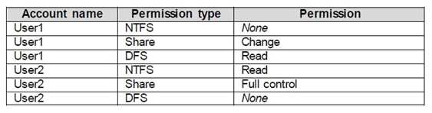

Access-based enumeration is disabled for the share of Folder1. You need to ensure that both User1 and User2 can see Folder1 when they access \\Contoso.com\NameSpace1.

What should you do?

A. Enable access-based enumeration for Folder1.

B. Disable access-based enumeration for Namespace1.

C. Assign User1 the read NTFS permission to Folder1.

D. Deny User1 the read DFS permission to Folder1.

E. Run the Set-DfsnFolder cmdlet.

F. Run the Set-DfsnFolderTarget cmdlet.

G. Assign User1 the read Share permission to Folder1

Correct Answer: B

Explanation

<https://docs.microsoft.com/en-us/windows-server/storage/dfs-namespaces/enable-access-based-enumeration-on-a-namespace>

QUESTION 73

Your network contains an Active Directory domain named contoso.com. You need to create a Nano Server image named Nano1 that will be used as a virtualization host. The windows server 2016 source files are located in drive D.

Solution: You run the following cmdlet.

New-NanoServerImage –Edition Datacenter –DeploymentType Host –Package Microsoft-NanoServerSCVMM-Package –MediaPath ‘D:\ -TargetPath C:\nano1\Nano1.wim –ComputerName Nano1 – Domainname Contoso.com

Does this meet the goal?

A. Yes

B. No

Correct Answer: B

Explanation

QUESTION 74

Your network contains an Active Directory domain named contoso.com. You need to create a Nano Server image named Nano1 that will be used as a virtualization host. The windows server 2016 source files are located in drive D.

Solution: You run the following cmdlet.

New-NanoServerImage -Edition Datacenter -DeploymentType Host -Package Microsoft-NanoServerCompute-Package -MediaPath ‘D:\’ -TargetPath C:\Nano1\Nano1.wim -ComputerName Nano1 -DomainName Contoso.com

Does this meet the goal?

A. Yes

B. No

Correct Answer: A

Explanation

QUESTION 75

After you answer a question in this sections, you will NOT be able to return to it. As a result, these questions will not appear in the review screen.

Your network contains an Active Directory domain named contoso.com.

You need to create a Nano Server image named Nano1 that will be used as a virtualization host. The windows server 2016 source files are located in drive D.

Solution: You run the following cmdlet.

New-NanoServerImage -Edition Datacenter -DeploymentType Host -Compute -Media ‘D:\’ -TargetPath c:\Nano1\Nano1.wim -ComputerName Nano1 -DomainName Contoso.com Does this meet the goal?

A. Yes

B. No

Correct Answer: A

Explanation

QUESTION 76

You have a Hyper-V host named Server1 that hosts a virtual machine named VM1. Server1 and VM1 run Windows Server 2016.

The settings for VM1 are configured as shown in the exhibit below.

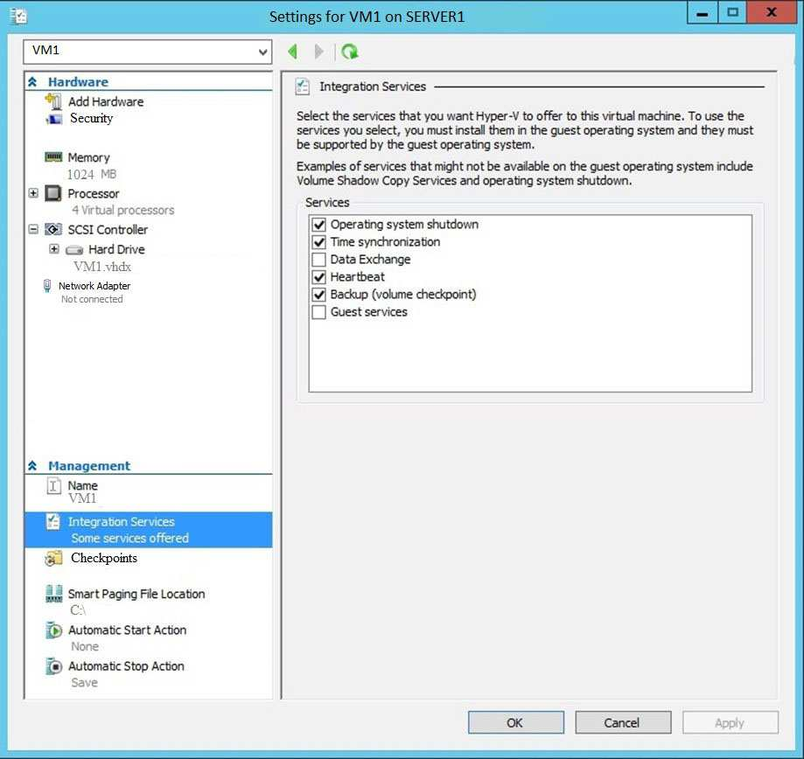

You need to ensure that you can use the Copy-VMFile cmdlet on Server1 to copy files from VM1.

Solution: You need to enable the Data Exchange integration service for VM1.

Does this meet the goal?

A. Yes

B. No

Correct Answer: B

Explanation

QUESTION 77

You have a Hyper-V host named Server1 that hosts a virtual machine named VM1. Server1 and VM1 run Windows Server 2016.

The settings for VM1 are configured as shown in the exhibit below.



You need to ensure that you can use the Copy-VMFile cmdlet on Server1 to copy files from VM1.

Solution: You enable the Guest Service integration service for VM1.

Does this meet the goal?

A. Yes

B. No

Correct Answer: A

Explanation

QUESTION 78

You have a Hyper-V host named Server1 that hosts a virtual machine named VM1. Server1 and VM1 run Windows Server 2016.

The settings for VM1 are configured as shown in the exhibit below.



You need to ensure that you can use the Copy-VMFile cmdlet on Server1 to copy files from VM1.

Solution: You start the Hyper-V Guest Service Interface service on VM1.

Does this meet the goal?

A. Yes

B. No

Correct Answer: B

Explanation

QUESTION 79

You have two Hyper-V hosts named Server1 and Server2 that run windows server 2012 R2. The servers are nodes in a failover cluster named Cluster1.

You perform a rolling upgrade of the cluster nodes to Windows Server 2016.

You need to ensure that you can implement the Virtual Machine Load Balancing feature.

Which cmdlet should you use?

A. Update-ClusterFunctionalLevel

B. Set-CauClusterRole

C. Update-ClusterNetWorkNameResource

D. Set-ClusterGroupSet

Correct Answer: A

Explanation

QUESTION 80

Your network contains an Active Directory domain named contoso.com. The domain contains a Hyper-V host named Server1 that runs Windows Server 2016.

Server1 hosts four machines that are members of the domain. The virtual machines are configured as shown in the following table. 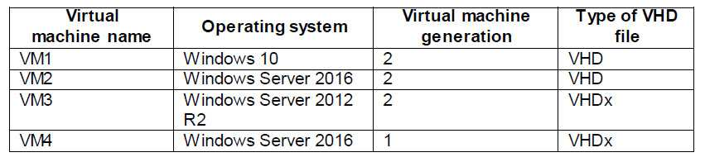

Which virtual machines can you manage by using PowerShell Direct?

A. Only VM2

B. VM1, VM2, and VM4

C. only VM4

D. VM1, VM2, and VM3

Correct Answer: B

Explanation

QUESTION 81

You need to implement network virtualization.

On which object should you configure the virtual subnet ID?

A. Virtual switch

B. Hyper-V server

C. VM

D. Virtual network adapter

Correct Answer: D

Explanation

QUESTION 82

Your network contains an Active Directory forest named contoso.com. The forest has three sites located in London, Paris, and Berlin. The London site contains a web server named Web1 that runs Windows Server 2016.

You need to configure Web1 as an HTTP content server for the hosted cache servers located in the Paris and Berlin sites.

Solution: You install the DFS Replication role service, and then you start the Network Connections service.

Does this meet the goal?

A. Yes

B. No

Correct Answer: B

Explanation

QUESTION 83

You have a server named Server1 that runs Windows Server 2016. Server1 is configured as a VPN server. Server1 is configured to allow domain users to establish VPN connections from 06:00 to 18:00 every day of the week.

You need to ensure that domain users can establish VPN connections only between Monday and Friday.

Solution: From Server Manager, you modify the Access Policies on Server1.

Does this meet the goal?

A. Yes

B. No

Correct Answer: A

Explanation

QUESTION 84

You have a server named Server1 that runs Windows Server 2016. Server1 is configured as a VPN server. Server1 is configured to allow domain users to establish VPN connections from 06:00 to 18:00 everyday of the week.

You need to ensure that domain users can establish VPN connections only between Monday and Friday.

Solution: From Routing and Remote Access, you configure the Properties of Server1.

Does this meet the goal?

A. Yes

B. No

Correct Answer: B

Explanation

QUESTION 85

You have 2000 devices. One hundred of the devices are mobile devices that have physical addresses beginning with 98-5F.

You have a DHCP server named Server1.

You need to ensure that the mobile devices register their host name by using a DNS suffix of mobile.contoso.com.

What should you do on Server1?

A. From the properties of Scope1, modify the Conflict detection attempts setting.

B. From the properties of Scope1, configure Name Protection.

C. From the Properties of IPV4, configure the bindings.

D. From IPV4, create a new filter.

E. From the properties of Scope1, create an exclusion range.

F. From IPv4, run the DHCP Policy Configuration Wizard.

G. From Control Panel, modify the properties of Ethernet.

H. From Scope1, create a reservation

Correct Answer: F

Explanation

QUESTION 87

You are a network administrator for a company named Contoso, Ltd. The network is configured as shown in the exhibit.

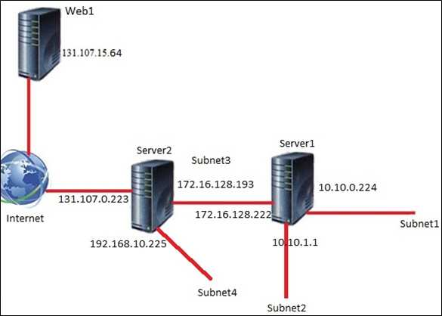

You install the Remote Access server role on Server2. Server2 has the following configured: - Network address translation (NAT)  
- The DHCP Server server role  
- The Security Policy of Contoso states that only TCP ports 80 and 443 are allowed from the internet to Server2.

You identify the following requirements:  
- Add 28 devices to subnet2 for a temporary project.   
- Configure Server2 to accept VPN connections from the internet.   
- Ensure that devices on Subnet2 obtain TCP/IP settings from DHCP on Server2.

You add a computer to subnet1. The computer has an IP address of 10.10.0.129. Web1 receives a request from the new computer and sends a response.

To which IP address will Web1 reply?

A. 10.10.0.129

B. 10.10.0.224

C. 131.107.0.223

D. 172.16.128.222

Correct Answer: C

Explanation

QUESTION 88

You are a network administrator for a company named Contoso, Ltd. The network is configured as shown in the exhibit.



You install the Remote Access server role on Server2. Server2 has the following configured: - Network address translation (NAT)  
- The DHCP Server server role  
- The Security Policy of Contoso states that only TCP ports 80 and 443 are allowed from the internet to Server2.

You identify the following requirements:  
- Add 28 devices to subnet2 for a temporary project.   
- Configure Server2 to accept VPN connections from the internet.   
- Ensure that devices on Subnet2 obtain TCP/IP settings from DHCP on Server2.

What should you do to meet the DHCP connectivity requirement for Subnet2?

A. Install the Routing role service on Server2.

B. Install the IP address Management (IPAM) Server feature on Server2.

C. Install the Routing role service on Server1.

D. Install the DHCP Server server role on Server1.

Correct Answer: C

Explanation

QUESTION 89

You plan to deploy several Hyper-V hosts that run Windows Server 2016. The deployment will use Software defined Networking (SDN) and VXLAN.

Which server role should you install on the network to support the planned deployment?

A. Network Controller

B. Network Policy and Access Services

C. Remote Access

D. Host Guardian Service

Correct Answer: A

Explanation

QUESTION 90

Your network contains an Active Directory domain named adatum.com. The domain contains two DHCP servers named Server1 and Server2.

Server1 has the following IP configuration.

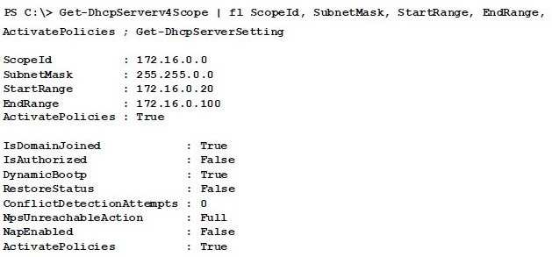

Server2 has the following IP configuration.

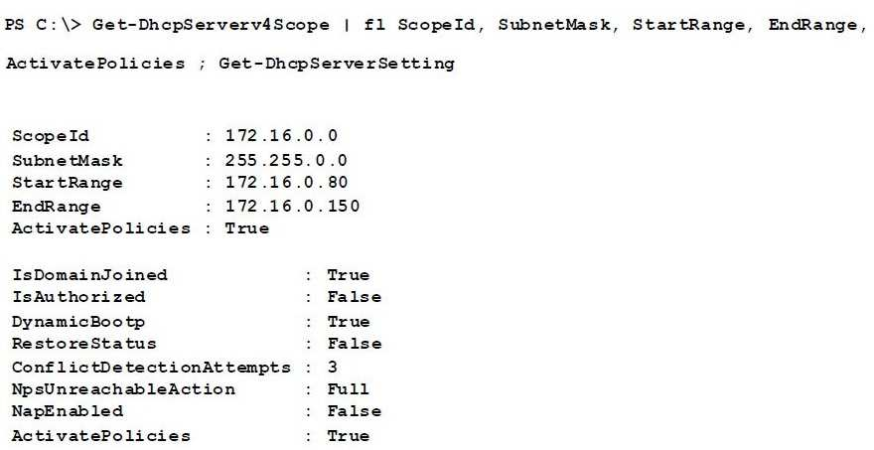

Some users report that sometimes they cannot access the network because of conflicting IP addresses. You need to configure DHCP to avoid leasing addresses that are in use already.

Solution: On Server2, you modify the StartRange IP address of the scope.

Does this meet the goal?

A. Yes

B. No

Correct Answer: A

Explanation

QUESTION 91

You have a server named Server1 that runs Windows Server 2016. Server1 will be used as a VPN server. You need to configure Server1 to support VPN Reconnect.

Which VPN protocol should you use?

A. SSTP

B. IKEv2

C. PPTP

D. L2TP

Correct Answer: B

Explanation

VPN Reconnect, which requires the VPN server to be set up on Windows Server 2016, uses the Internet Key Exchange v2 (IKEv2) tunneling protocol with a MOBIKE extension. MOBIKE prevents disconnected VPN clients from having to perform IKEv2 renegotiation once Internet connectivity with the VPN server has been reestablished.

More information about VPN Reconnect, please refer to the following article: <https://technet.microsoft.com/en-us/library/dd637803(v=ws.10).aspx>

QUESTION 92

Your network contains an Active Directory domain named contoso.com. The domain contains a Hyper-V host. You are deploying Software Defined Network (SDN) by using Windows Server 2016.

You deploy a virtual machine that runs Windows Server 2016, and you install the Network Controller server role.

You need to configure the virtual machine as the network controller.

What should you do?

A. Run the Install-NetworkControllerCluster cmdlet and set ClientAuthentication to X509.

B. Run the Install-NetworkController cmdlet and set ClientAuthentication to None.

C. Run the Install-NetworkControllerCluster cmdlet and set ClientAuthentication to None.

D. Run the Install-NetworkController cmdlet and set ClientAuthentication to Kerberos.

Correct Answer: D

Explanation

<https://github.com/MicrosoftDocs/windowsserverdocs/blob/master/WindowsServerDocs/networking/sdn/deploy/Deploy-Network-Controller-using-Windows-PowerShell.md#bkmk_script>

QUESTION 93

Your company has five departments, including a web research department. You have a DHCP server named Server1 and two DNS servers named DNS1 and DNS2.

Server1 has an Ipv4 scope named Scope1. All client computers are configured to use DNS1 for name resolution.

You need to ensure that users in the web research department use DNS2 for name resolution.

What should you do on Server1?

A. From the properties of Scope1, modify the Conflict detection attempts setting.

B. From the properties of Scope1, configure Name Protection.

C. From the properties of IPv4, configure the bindings.

D. From IPv4, create a new filter.

E. From the properties of Scope1, create an exclusion range.

F. From IPv4, run the DHCP Policy Configuration Wizard.

G. From Control Panel, modify the properties of Ethernet.

H. From Scope1, create a reservation.

Correct Answer: A

Explanation

<https://technet.microsoft.com/en-us/library/ff606371.aspx>

QUESTION 94

Your network contains an Active Directory domain named contoso.com. The functional level of the domain is Windows Server 2012.

The network uses an address space of 192.168.0.0/16 and contains multiple subnets. The network is not connected to the Internet.

The domain contains three servers configured as shown in the following table.

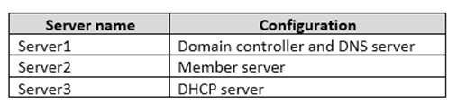

Client computers obtain TCP/IP settings from Server3.

You add a second network adapter to Server2. You connect the new network adapter to the Internet. You install the Routing role service on Server2.

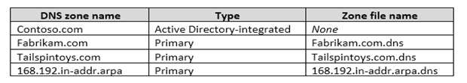Server1 has four DNS zones configured as shown in the following table.

You need to ensure that when computers query for records in tailspintoys.com, the query results are based on the subnet of the computer that generates the query.

What should you do?

A. Modify the Priority settings of each resource record.

B. Configure DNS policies.

C. Create zone delegation records.

D. Enable DNS round robin.

Correct Answer: B

Explanation

<https://docs.microsoft.com/en-us/windows-server/networking/dns/deploy/dns-policies-overview>

QUESTION 95

You have an IP Address Management (IPAM) server named Server1 that runs Windows Server 2016. You have five DHCP servers. Server1 manages all of the DHCP servers.

On Server1, an administrator uses Purge Event Catalog Data to remove all of the events from the last 30 days.

You need to view all of these lease requests that were denied during the last two days.

What should you do?

A. On each DHCP server, run the \Microsoft\Windows\Server Manager\CleanUpOldPerfLogs scheduled task, and then review the event catalog on Server1.

B. On Server1, run the Purge Event Catalog Data action and then open Event Viewer on Server1.

C. Review the log data in C:\Windows\System32\ipam\Database on Server1.

D. On each DHCP server, review the DHCP Server operational event log.

Correct Answer: C

Explanation

QUESTION 96

You have a server named Server1 that runs Windows Server 2016. Server1 is configured as a VPN server. Server1 is configured to allow domain users to establish VPN connections from 06:00 to 18:00, every day of the week.

You need to ensure that domain users can establish VPN connections only between Monday and Friday.

Solution: From Network Policy Server, you modify the Network Policies on Server1.

Does this meet the goal?

A. Yes

B. No

Correct Answer: A

Explanation

QUESTION 97

You have a Hyper-V host named Server 1. Server1 connects to your corporate network. Server1 has the virtual switches configured as shown in the following table. 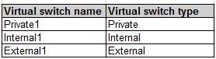

Server1 has two virtual machines named VM1 and VM2 that run Windows Server 2016. VM1 connects to Private1. VM2 has two network adapters.

You need to ensure that VM1 connects to the corporate network by using NAT.

Solution: You connect VM1 to External1. You install the Remote Access server role on Server1, and you configure NAT in the Routing and Remote Access console.

Does this meet the goal?

A. Yes

B. No

Correct Answer: B

Explanation

QUESTION 98

You have Hyper-V host named Server1. Server1 has a network adapter that has virtual machine queue (VMQ) enabled. The network adapter connects at 10 Gbps and has an IPV4 address.

Server1 hosts a virtual machine named VM1. VM1 has a single network adapter and four processors.

You need to distribute the network processing load across the VM1 processors.

What should you do?

A. From Windows PowerShell on Server1, run the Enable-NetAdapterPacketDirect cmdlet.

B. From Windows PowerShell on VM1, run the Enable-NetAdapterPacketDirect cmdlet.

C. From Device Manager on VM1, configure Receive Side Scaling.

D. From Windows PowerShell on Server1, run the Enable-NetAdapterRSS cmdlet.

Correct Answer: C

Explanation

<https://docs.microsoft.com/en-us/windows-server/networking/technologies/vrss/vrss-enable>

QUESTION 99

You have a server named Server1 that runs Windows Server 2016. Server1 is an IP Address Management (IPAM) server that collects DHCP and DNS logs and events for your entire network.

You need to get the IP addresses that were assigned to a client computer named Computer1 during the last week.

What should you do on Server1?

A. From the IPAM node in Server Manager, click Event Catalog, and then review the IP Address Tracking.

B. Open Event Viewer and click Windows Logs. Filter the Security log for Computer1.

C. Run the Export-IpamAddress cmdlet.

D. From the IPAM node in Server Manager, click IP Address Space, and then review the IP Address Inventory.

E. Run the Get-IpamDhcpConfigurationEvent cmdlet.

F. Run the Get-IpamAddress cmdlet.

Correct Answer: A

Explanation

QUESTION 100

You have an IP Address Management (IPAM) server named IPAM1 that runs Windows Server 2016. IPAM1 manages all of the DHCP servers on your network.

You are troubleshooting an issue for a client that fails to receive an IP address from DHCP.

You need to ensure that from IPAM1, you can view all of the event data for the DHCP leases from the last 24 hours.

Solution: From Task Scheduler, you run the Microsoft\Windows\IPAM\Audit task.

Does this meet the goal?

A. Yes

B. No

Correct Answer: B

Explanation

QUESTION 101

You have an IP Address Management (IPAM) server named IPAM1 that runs Windows Server 2016. IPAM1 manages all of the DHCP servers on your network.

You are troubleshooting an issue for a client that fails to receive an IP address from DHCP.

You need to ensure that from IPAM1, you can view all of the event data for the DHCP leases from the last 24 hours.

Solution: From Windows PowerShell, you run the Invoke-IpamServerProvisioning cmdlet.

Does this meet the goal??

A. Yes

B. No

Correct Answer: B

Explanation

QUESTION 102

You have a server named Server1 that has the Network Policy and Access Services server role installed.

You create a Shared Secret Network Policy Server (NPS) template named Template1. You need to view the shared secret string used for Template1.

Solution: From the Network Policy Server console, you export the templates, and you view the exported XML file.

Does this meet the goal?

A. Yes

B. No

Correct Answer: B

Explanation

QUESTION 103

You are implementing a secure network. The network contains a DHCP server named Server1 that runs Windows Server 2016. You create a DHCP allow filter that contains all of the computers on the network that are authorized to receive IP addresses.

You discover that unauthorized computers can obtain an IP address from Server1.

You need to ensure that only authorized computers can receive an IP address from Server1.

Solution: You run the following command: Set-DhcpServerv4FilterList –ComputerName Server1 –Allow False –Deny True Does this meet the goal?

A. Yes

B. No

Correct Answer: B

Explanation

QUESTION 104

You are implementing a secure network. The network contains a DHCP server named Server1 that runs Windows Server 2016.

You create a DHCP allow filter that contains all of the computers on the network that are authorized to receive IP addresses.

You discover that unauthorized computers can obtain an IP address from Server1.

You need to ensure that only authorized computers can receive an IP address from Server1.

Solution: You run the following command: Add-DHCPServerv4Filter –ComputerName Server1 –MacAddress \* -List Deny Does this meet the goal?

A. Yes

B. No

Correct Answer: B

Explanation

QUESTION 105

You have a virtual machine named Server1 that runs Windows Server 2016. You plan to use Server1 as part of a Software Defined Networking (SDN) solution.

You need to implement the Border Gateway Protocol (BGP) on Server1.

What should you install?

A. the Peer Name Resolution Protocol (PNRP) feature

B. the Routing role service

C. the Network Device Enrollment Service role service

D. the Network Policy and Access Services server role

Correct Answer: B

Explanation

<https://docs.microsoft.com/en-us/windows-server/remote/remote-access/bgp/border-gateway-protocol-bgp>

QUESTION 106

You are deploying Software Defined Networking (SDN) by using Windows Server 2016.

You plan to deploy a three-node Network Controller cluster. You plan to use virtual machines for the network controller and the management client. The virtual machines will NOT be domain-joined.

You need to configure authentication for the cluster.

Which command should you run?

A. Install-NetworkController –Node @{Node1, Node2, Node3} –ClientAuthentication X509

B. Install-NetworkControllerCluster –Node @{Node1, Node1, Node3} –ClientAuthentication Kerberos

C. Install-NetworkControllerCluster –Node @{Node1, Node1, Node3} –ClientAuthentication X509

D. Install-NetworkControllerCluster –Node @{Node1, Node1, Node3} –ClientAuthentication None E. Install-NetworkController –Node @{Node1, Node2, Node3} –ClientAuthentication Kerberos

Correct Answer: C

Explanation

<https://docs.microsoft.com/en-us/windows-server/networking/sdn/security/nc-security>

QUESTION 107

You have an IP Address Management (IPAM) server named IPAM1 that runs Windows Server 2016. IPAM1 manages all of the DHCP servers on your network.

You are troubleshooting an issue for a client that fails to receive an IP address from DHCP.

You need to ensure that from IPAM1, you can view all of the event data for the DHCP leases from the last 24 hours.

Solution: From Server Manager, you run Retrieve Event Catalog Data.

Does this meet the goal?

A. Yes

B. No

Correct Answer: A

Explanation

<http://www.techblogopedia.com/blog/ip-address-managementipam-windows-server-2012-r2-part-3/>

QUESTION 108

You implement Software Defined Networking (SDN) by using the Network Controller server role. You have a virtual network named VNET1 that contains servers used by developers.

You need to ensure that only devices from the 192.168.0.0/24 subnet can access the virtual machine in VNET1.

What should you configure?

A. a network security group (NSG)

B. role-based access control

C. a universal security group

D. Dynamic Access Control

Correct Answer: A

Explanation

<https://docs.microsoft.com/en-us/azure/virtual-network/tutorial-restrict-network-access-to-resources>

QUESTION 109

You have a remote access server named Server1 that runs Windows Server 2016. Server1 has DirectAccess enabled.

You have a proxy server named Server2. All computers on the internet connect to the Internet by using the proxy.

On Server1, you run the command Set-DAClient -ForceTunnel Enabled.

You need to ensure that when a Direct Access client connects to the network, the client accesses all the Internet resources through the proxy.

What should you run on Server1?

A. Set-DAClient

B. Set-DnsClientGlobalSetting

C. Set-DAClientDNSConfiguration

D. Set-DAEntryPoint

Correct Answer: C

Explanation

<https://docs.microsoft.com/en-us/powershell/module/remoteaccess/set-daclientdnsconfiguration?view=win10-ps>

QUESTION 110

You have a server named Server1 that runs Windows Server 2016 and is configured as a domain controller.

You install the DNS Server server role on Server1.

You plan to store a DNS zone in a custom Active Directory partition.

You need to create a new Active Directory partition for the zone.

What should you use?

A. Set-DnsServer

B. DNS Manager

C. New-ADObject

D. Ntdsutil.exe

E. Active Directory Sites and Services

Correct Answer: B

Explanation

<https://www.businessnewsdaily.com/11019-set-up-configure-dns-on-windows-server-2016.html>

QUESTION 111

Your network contains an Active Directory domain named contoso.com that contains a domain controller named DC1. All DNS servers for the network run BIND 10.

Your perimeter network contains a DHCP server named DHCP1 that runs Windows Server 2016. DHCP1 is a member of a workgroup named WORKGROUP.

DHCP1 provides IP address leases to guests accessing the Wi-Fi network.

Several engineers access the network remotely by using a VPN connection to a remote access server that runs Windows Server 2016. All of the VPN connections use certificate-based authentication and are subject to access policies in Network Policy Server (NPS). Certificates are issued by an enterprise certification authority (CA) named CA1.

All Windows computers on the network are activated by using Key Management Service (KMS). On-premises users use Remote Desktop Services (RDS).

You plan to deploy IP Address Management (IPAM) to the network.

Which action can you perform on the network by using IPAM?

A. Audit user and device logon event from NPS.

B. Audit logon events on the RDS server.

C. Audit configuration changes to the remote access server.

D. Audit certificate enrollment requests on CA1.

Correct Answer: A

Explanation

<https://blogs.technet.microsoft.com/canitpro/2013/08/15/step-by-step-setup-windows-server-2012-ipam-in-your-environment/>

QUESTION 112

Your network contains an Active Directory forest named contoso.com. The forest contains five domains. You manage DNS for the contoso.com domain only.

You are not responsible for managing DNS for the child domains. The DNS servers in a child domain named research.contoso.com are reconfigured often.

You need to ensure that clients in contoso.com can resolve addresses in research.contoso.com. The solution must minimize zone replication traffic.

What should you do?

A. Create a primary zone for research.contoso.com on the DNS servers of contoso.com

B. Create a secondary zone for research.contoso.com on the DNS servers of contoso.com

C. Create a stub zone for research.contoso.com on the DNS servers of contoso.com

D. Create a delegation for research.contoso.com

Correct Answer: D

Explanation

<https://blogs.msmvps.com/acefekay/2010/10/01/dns-parent-child-dns-delegation-how-to-create-a-dns-delegation/>

QUESTION 114

You have a server named Server1 that runs Windows Server 2016. Server1 is in a workgroup and has the DNS Server role installed.

You need to enable DNS analytical diagnostic logging on Server1.

What should you do?

A. From Local Group Policy Editor, configure Audit Policy.

B. From DNS Manager, configure Monitoring.

C. From Windows PowerShell, run the Enable-DnsServerPolicy cmdlet.

D. From DNS Manager, configure Event Logging.

E. From Event Viewer, configure DNS-Server Applications and Services Logs.

Correct Answer: E

Explanation

<https://www.yourdigitalmind.com/tutorials/how-to-enable-dns-logging-and-diagnostics-in-windows-server-2012-r2/>

QUESTION 115

Your network contains an Active Directory domain named contoso.com. The domain contains a server named Server1 that runs Windows Server 2016.

Server1 has IP Address Management (IPAM) installed. IPAM is configured to use the Group Policy based provisioning method. The prefix for the IPAM Group Policy objects (GPOs) is IP.

From Group Policy Management, you manually rename the IPAM GPOs to have a prefix of IPAM.

You need to modify the GPO prefix used by IPAM.

What should you do?

A. Click Configure server discovery in Server Manager.

B. Run the Set-IpamConfiguration cmdlet.

C. Click Provision the IPAM server in Server Manager.

D. Run the Invoke-IpamGpoProvisioning cmdlet.

Correct Answer: B

Explanation

The Set-IpamConfiguration cmdlet modifies the configuration for the computer that runs the IPAM server.

The -GpoPrefix<String> parameter specifies the unique Group Policy object (GPO) prefix name that IPAM uses to create the group policy objects. Use this parameter only when the value of the ProvisioningMethod parameter is set to Automatic.

<https://docs.microsoft.com/en-us/powershell/module/ipamserver/set-ipamconfiguration?view=win10-ps>

QUESTION 116

Your network contains an Active directory forest named contoso.com. The forest has a Distributed File System (DFS) namespace named \\contoso.com\namespace1/

The domain contains a file server named Server1 that runs Windows Server 2016. You create a folder named Folder1 on Server1.

You need to use Folder1 as a target for Namespace1.

Which two cmdlets should you use? Each correct answer presents part of the solution.

NOTE: Each correct selection is worth one point.

A. Grant-DfsnAccess

B. New-DfsnFolder

C. New-DfsReplicatedFolder

D. New-DfsnFolderTarget

E. New-SmbShare

F. Install-WindowsFeature

Correct Answer: AD

Explanation

<https://docs.microsoft.com/en-us/powershell/module/dfsn/new-dfsnfoldertarget?view=win10-ps>

<https://docs.microsoft.com/en-us/powershell/module/dfsn/grant-dfsnaccess?view=win10-ps>

QUESTION 117

You are a network administrator for a company named Contoso, Ltd. The network is configured as shown in the exhibit. 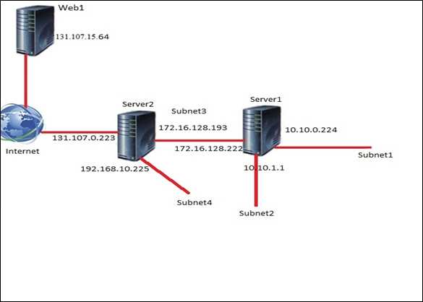

You install the Remote Access server role on Server2.

Server2 has the following configured:  
- Network address translation (NAT)  
- The DHCP Server server role  
- The Security Policy of Contoso states that only TCP ports 80 and 443 are allowed from the internet to Server2.

You identify the following requirements:  
- Add 28 devices to subnet2 for a temporary project.   
- Configure Server2 to accept VPN connections from the internet.   
- Ensure that devices on Subnet2 obtain TCP/IP settings from DHCP on Server2.

Which VPN protocol should you configure on Server2?

A. L2TP

B. IKEv2

C. PPTP

D. SSTP

Correct Answer: C

Explanation

QUESTION 118

You are a network administrator for a company named Contoso, Ltd. The network is configured as shown in the exhibit.



You install the Remote Access server role on Server2. Server2 has the following configured: - Network address translation (NAT)  
- The DHCP Server server role  
- The Security Policy of Contoso states that only TCP ports 80 and 443 are allowed from the internet to Server2.

You identify the following requirements:  
- Add 28 devices to subnet2 for a temporary project.   
- Configure Server2 to accept VPN connections from the internet.   
- Ensure that devices on Subnet2 obtain TCP/IP settings from DHCP on Server2.

You deploy a computer named ComputerA to Subnet1. ComputerA has an IP address of 10.10.0.129 and a subnet mask of 255.255.255.0.

You plan to use ComputerA to access the resources on Web1.

Which IP address should you use as the default gateway on ComputerA?

A. 10.10.1.1

B. 10.10.0.224

C. 131.107.0.223

D. 172.16.128.193

Correct Answer: B

Explanation

QUESTION 119

You have a Hyper-V host named Server 1. The network adapters on Server1 have single root I/O virtualization (SR-IOV) enabled. Server1 hosts a virtual machine named VM1 that runs Windows Server 2016.

You need to identify whether SR-IOV is used by VM1.

Solution: You sign in to VM1. You view the properties of the network connections.

Does this meet the goal?

A. Yes

B. No

Correct Answer: B

Explanation

QUESTION 120

You have a Hyper-V host named Server 1. The network adapters on Server1 have single root I/O virtualization (SR-IOV) enabled.

Server1 hosts a virtual machine named VM1 that runs Windows Server 2016. You need to identify whether SR-IOV is used by VM1.

Solution: On Server1, you open Hyper-V Manager and view the Integration Services settings of VM1.

Does this meet the goal?

A. Yes

B. No

Correct Answer: B

Explanation

QUESTION 121

You have a DHCP server named Server1 that runs Windows Server 2016. Server1 has the scopes configured as shown in the following table.

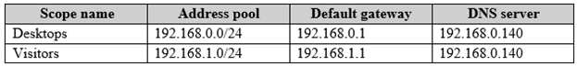

All other scope settings are set to the default values. There is no available address space for another scope to be created.

Your network has 150 desktop computers that have access to the corporate network. Your company also provides visitors with WI-FI access to the network. There can be up to 200 visitors each day.

You discover that some visitors fail to access the WI-FI network because there are no available addresses to allocate to the visitors.

You need to prevent this issue from reoccurring.

What should you do?

A. For the Visitors scope, run the Dhcp Split Configuration Wizard.

B. Run Set-DhcpServerv4Scope –ActivatePolicies $True –Name Visitors –MaxBootPClients 200.

C. Configure a superscope that contains the Visitors scope.

D. Run Set-DhcpServerv4Scope –Name Visitors –LeaseDuration 0.02:00:00.

Correct Answer: B

Explanation

<https://docs.microsoft.com/en-us/previous-versions/windows/desktop/dhcpserverpsprov/dhcpserverv4scope>

QUESTION 122

You are deploying a small network that has 30 client computers. The network uses the 192.168.1.0/24 address space. All computers obtain IP configurations from a DHCP server named Server1.

You install a server named Server2 that runs Windows Server 2016. Server2 has two network adapters named Internal and Internet. Internet connects to an Internet Service Provider (ISP) and obtains the 131.107.0.10 IP address. Internal connects to the internal network and is configured to use the 192.168.1.250 IP address.

You need to provide Internet connectivity for the client computers.

What should you do?

A. On Server1, stop the DHCP server. On the Internal network adapter on Server2, enable Internet Connection Sharing (ICS).

B. On Server2 run the New-NetNat –Name NAT1 -InternalIPInterfaceAddressPrefix 192.168.1.0/24 cmdlet. Configure Server1 to provide the 003 Router option of 192.168.1.250.

C. On Server1, stop the DHCP server. On the Internet adapter on Server2, enable internet Connection Sharing (ICS).

D. Recreate the DHCP scope on Server1 to lease addresses from the 131.107.0.0/24 address space. On Server2, change the IP address of the internal network adapter to 131.107.0.1. Configure Server1 to provide the 003 Router option of 131.107.0.1.

E. Install the Routing role service on Server2 and configure the NAT routing protocol. Configure Server1 to provide the 003 Router option of 192.168.1.250.

Correct Answer: B

Explanation

<https://docs.microsoft.com/en-us/virtualization/hyper-v-on-windows/user-guide/setup-nat-network>

<https://www.pctips3000.com/add-default-gateway-information-to-dhcp-in-windows-server-2008/>

QUESTION 123

Your network contains an Active Directory domain named contoso.com. The domain contains a server named Server2 that runs Windows Server 2016.

The DHCP Server server role is installed on Server2. The DNS server role is installed on a server named Server3.

The network contains 500 non-Windows devices that are registered in the DNS zone of contoso.com.

You configure Server2 to lease IP addresses to the non-Windows devices.

You need to prevent Server2 from overwriting the host (A) records for the non-Windows devices.

What should you run?

A. dism.exe

B. dns.exe

C. dnscmd.exe

D. netsh.exe

E. Set-DhcpServerDatabase

F. Set-DhcpServerv4DnsSetting

G. Set-DhcpServerv6DnsSetting

H. Set-DNSServerSetting

Correct Answer: C

Explanation

<https://docs.microsoft.com/en-us/windows-server/administration/windows-commands/dnscmd>

QUESTION 124

You are configuring the network for a small branch office. Currently, the branch office does not connect directly to the Internet.

In the branch office, you deploy a new server named Server1 that has a server Core installation of Windows Server 2016. Server1 has two network adapters configured as shown in the following table.

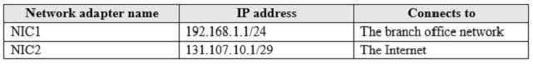

You plan to use Server1 to provide Internet connectivity for the branch office.

Routing and Remote Access (RRAS) in installed and configured for VPN remote access on Server1.

You need to configure RRAS on Server1 to provide network address translation (NAT).

Which command or cmdlet should you use first?

A. netsh.exe routing ip nat install

B. New-NetNat NAT1 –ExternalIPInterfaceAddressPrefix 131.107.10.1/29

C. route.exe add 192.168.1.1 255.255.255.0 131.107.10.1 metric 1

D. Enable-NetNatTranstionConfiguration

Correct Answer: A

Explanation

<https://social.technet.microsoft.com/Forums/exchange/en-US/5cd50748-af62-4d29-ab92-1a010b9a1a9f/how-to-configure-rras-for-nat-using-powershell?forum=Offtopic>

QUESTION 125

You have a server named Server1 that runs Windows Server 2016. Server1 is an IP Address Management (IPAM) server that collects DHCP and DNS logs and events for your entire network.

You need to enable a user named TECH1 to create pointer (PTR), host (A) and service location (SRV) records on all of the DNS servers on the network.

What should you do on Server1?

A. Run the Set-IpamRange cmdlet, and then run the Set-IpamAddressSpace cmdlet.

B. Run the Set-IpamCustomField cmdlet, and then run the Set-IpamAccessScope cmdlet.

C. From the IPAM node in Server Manager, assign the IPAM DNS Administrator Role to TECH1 and create a new access policy.

D. From the IPAM node in Server Manager, assign the IPAM DNS Administrator Role to TECH1 and create a new access scope.

Correct Answer: D

Explanation

<https://docs.microsoft.com/en-us/windows-server/networking/technologies/ipam/view-roles-and-role-permissions>

QUESTION 126

Your network contains an Active Directory forest. The forest contains a domain named contoso.com. All of the DHCP servers and the DNS servers in the forest are managed by using an IP Address Management (IPAM) server named Cont\_IPAM1.

You acquire a new company that has an Active Directory forest. The forest contains a domain named fabrikam.com.

You have six servers that are configured as shown in the following table.

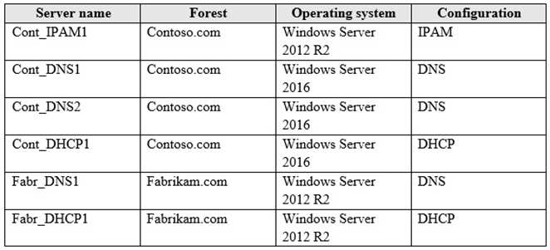

You need to ensure that all of the DHCP and DNS servers in both of the forest can be managed by using Cont-IPAM1. The solution must use the principle of least privileges.

Which two actions should you perform? Each correct answer presents part of the solution.

A. Create an outgoing forest trust from contoso.com to fabrikam.com

B. Upgrade Fabr\_DNS1 to Windows Server 2016

C. Upgrade Cont\_IPAM1 to Windows Server 2016

D. Upgrade Fabr\_DHCP1 to Windows Server 2016

E. Create a two-way forest trust between contoso.com and fabrikam.com

Correct Answer: CE

Explanation

<https://github.com/MicrosoftDocs/windowsserverdocs/blob/master/WindowsServerDocs/networking/technologies/ipam/Manage-Resources-in-Multiple-Active-Directory-Forests.md>

QUESTION 127

You have a server named Server1 that has a Server Core installation of Windows Server 2016. Server1 is configured to obtain an IP address automatically.

You need to configure the IPv4 address, netmask, and default gateway manually for a network interface named Ethernet on Server1.

What should you run?

A. ipconfig.exe

B. New-NetIPAddress

C. Set-NetAdapter

D. Set-NetIPv4Protocol

Correct Answer: B

Explanation

<https://docs.microsoft.com/en-us/powershell/module/nettcpip/new-netipaddress?view=win10-ps>

QUESTION 128

You have a server named Server1 that runs Windows Server 2016 and is configured as a domain controller.

You install the DNS Server server role on Server1. You plan to store a DNS zone in a custom Active Directory partition.

You need to create a new Active Directory partition for the zone.

What should you use?

A. Set-DnsServer

B. DNS Manager

C. Ntdsutil.exe

D. Active Directory Administrative Center

Correct Answer: C

Explanation

<https://www.dell.com/support/article/za/en/zabsdt1/sln288363/how-to-create-a-custom-application-directory-partition-in-active-directory?lang=en>

QUESTION 129

You are planning the deployment of DNS to a new network. You have four internal DNS servers configured as shown in the following table.

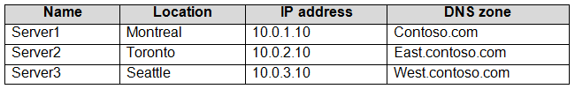

The contos.com zone contains delegations for east.contoso.com, west.contoso.com, and south.contoso.com. All the DNS servers use root hints.

You need to ensure that all the DNS servers can resolve the names of all the internal namespaces and internet hosts.

Solution: On Server2, you create a conditional forwarder for west.contoso.com. On Server3, you create a conditional forwarder for east.contoso.com.

Does this meet the goal?

A. Yes

B. No

Correct Answer: B

Explanation

QUESTION 130

You are planning the deployment of DNS to a new network. You have four internal DNS servers configured as shown in the following table.



The contos.com zone contains delegations for east.contoso.com, west.contoso.com, and south.contoso.com. All the DNS servers use root hints.

You need to ensure that all the DNS servers can resolve the names of all the internal namespaces and internet hosts.

Solution: You configure Server2 and Server3 to forward DNS requests to 10.0.1.10.

Does this meet the goal?

A. Yes

B. No

Correct Answer: B

Explanation

QUESTION 131

You have a server named Server1 that runs Windows Server 2016. Server1 is an IP Address Management (IPAM) server that collects DHCP and DNS logs and events for your entire network.

You need to enable a user named TECH1 to create pointer (PTR), host (A) and service location (SRV) records on all of the DNS servers on the network.

What should you do on Server1?

A. Run the Set-IpamCustomField cmdlet, and then run the Set-IpamAddressSpace cmdlet.

B. Run the Set-IpamCustomField cmdlet, and then run the Set-IpamAccessScope cmdlet.

C. From the IPAM node in Server Manager, assign the IPAM DNS Administrator Role to TECH1 and create a new access policy.

D. Run the Set-IpamRange cmdlet, and then run the Set-IpamAccessScope cmdlet.

Correct Answer: D

Explanation

<https://docs.microsoft.com/en-us/powershell/module/ipamserver/set-ipamrange?view=win10-ps>

<https://docs.microsoft.com/en-us/windows-server/networking/technologies/ipam/manage-role-based-access-control-with-windows-powershell>

<https://docs.microsoft.com/en-us/powershell/module/ipamserver/set-ipamaccessscope?view=win10-ps>

QUESTION 132

Your network contains an Active Directory domain named contoso.com. The domain contains a domain-based Distributed File System (DFS) namespace named Namespace1 that has access-based enumeration enabled. Namespace1 has a folder named folder1. Folder1 has a target of \\Server1\Folder1.

The permissions for folder1 are configured as shown in the following table.

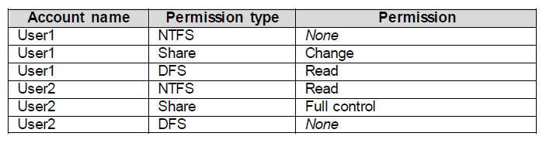

Access-based enumeration is disabled for the share of Folder1. You need to ensure that both User1 and User2 can see Folder1 when they access \\Contoso.com\NameSpace1.

What should you do?

A. Assign User2 the read DFS permission to Folder1.

B. Assign User1 the read NTFS permission to Folder1

C. Run the Set-DfsnFolderTarget cmdlet.

D. Assign User1 the read Share permission to Folder1

Correct Answer: A

Explanation

<https://docs.microsoft.com/en-us/windows-server/storage/dfs-namespaces/enable-access-based-enumeration-on-a-namespace>

QUESTION 133

You have the computers shown in the following table.

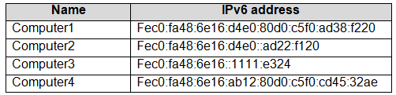

Which computers are on the same IPv6 subnet as Computer1?

A. Computer2 and Computer3 only

B. Computer2 and Computer4 only

C. Computer2 only

D. Computer2, Computer3, and Computer4

Correct Answer: C

Explanation

<http://www.firewall.cx/networking-topics/protocols/877-ipv6-subnetting-how-to-subnet-ipv6.html>