Phase 4 – Usability Test Report

Series Tracker

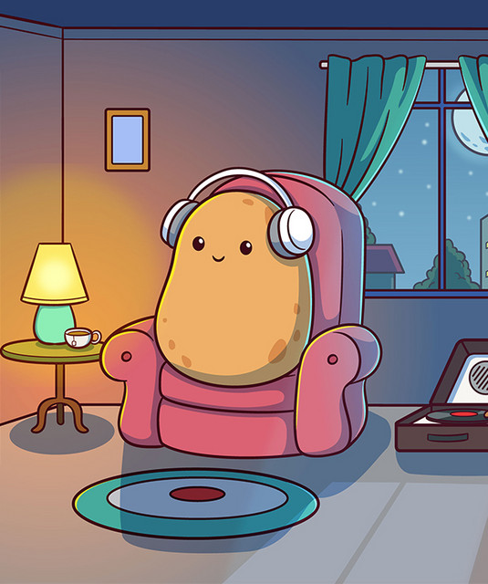

Couch Potatoes

Ambelal, S u21439321

Moshokoa, IJ u21785742

Modise, ZM u21508322

Siphuma, AT u21556416

| Introduction (3) | Monitoring (5) | Data collection (13) | Session facilitating (15) | Time management (5) | Subtotal (35) |
| --- | --- | --- | --- | --- | --- |
|  |  |  |  |  |  |
| Planning (7) | Process (5) | Tasks (5) | Debrief (5) | Evaluation (5) | Results  (5) | Conclusions (5) | Appendices (3) | Subtotal (40) |
|  |  |  |  |  |  |  |  |  |

Email address for feedback: [u21785742@tuks.co.za](mailto:u21785742@tuks.co.za)

# Appendices

* Usability Test Video 2
* Pre-Test Planning 3
* Process followed 3
* Tasks performed by users 4
* Initial findings from debriefing 5
* Evaluation methods 5
* Conclusions 7
* Script 8
* Consent 10
* Incentives 14
* Questionnaire Responses 15

[UsabilityTest.mp4](https://drive.google.com/file/d/1L5_x4_CHIX1zLN9rA_SDWV25EFjdWl0K/view?usp=drive_link)

<https://drive.google.com/file/d/1L5_x4_CHIX1zLN9rA_SDWV25EFjdWl0K/view?usp=drive_link>

# 

# 

# Pre-Test Planning

Before conducting the usability test for our series tracking app, we thoroughly prepared to ensure accurate results. The first step involved defining our user base. We selected participants who represented the user base that we identified as Binge Watcher, Social Viewers and Educationally Driven Users. These users were chosen because they represent a broad spectrum of our potential audience, providing a well-rounded understanding of the app’s usability across different demographics.

Next, we decided on specific tasks that needed to be performed during the test. These tasks were chosen based on common user scenarios and key functionalities of the app. We aimed to cover essential actions such as setting up a watchlist, adding series to a playlist, discovering new series, creating a watch party and adjusting user preferences. Each task was designed to reflect real-world usage, ensuring that we could observe users interacting with the app in ways that mirror their typical behaviours.

To plan our interactions with the users, we developed a structured yet flexible approach. During the test sessions, we intended to adopt a moderated testing style, where we would guide the users through the tasks without influencing their actions or decisions. This approach allows us to gather direct feedback and observe user interactions naturally. We prepared a script to introduce the test, explain the objectives, how the test will be conducted, and provide clear instructions for each task. We regularly encouraged users to think aloud, to help us understand their thought processes and identify any or areas of confusion.

# Process followed

Conducting a usability test for our prototype online involved several key steps. Initially, we defined objectives, recruited participants, and prepared materials such as task scripts and feedback forms.

During the test, participants joined via GoogleMeet , and we provided a brief introduction and obtained consent for recording. Participants were asked to perform specific tasks while thinking aloud, with us observing their interactions and noting any difficulties.

Differences between planning and actuality included:

* **Technical Issues:** One participant faced connectivity/technical problems. We offered support by sharing the screen on our side to ensure completion of the task.
* **Task Clarification:** Instructions for certain tasks were misinterpreted. We clarified these in real-time and adjusted the script.
* **Unexpected User Behaviour:** Participants interacted with the app in unanticipated ways, revealing usability issues. We allowed this to continue to gather valuable insights.
* **Feedback Collection:** The initial feedback form was too lengthy and had access issues. We simplified it during the test to ensure comprehensive responses.

Our real-time decisions, such as providing technical support and clarifying instructions, ensured the test's success. Observing natural interactions and simplifying feedback collection improved the quality of insights, guiding future app design improvements.

# Tasks performed by users

* User to sign up a new account
* Enter user details
* Pick favourite genres
* Pick your favourite series
* Click on a series to view the description from the home page
* View more details (description, episodes, and more) about the particular series
* Add the series to your watchlist
* Navigate to the menu page
* Got to the watch party
* Start a Watch Party
* Share link to invite friends to watch party
* Log in to your account
* Navigate to the search bar
* Search for a series
* Add the series to your playlist
* Click on the series to watch it
* Switch to dark mode for a better viewing experience
* Navigate to your profile playlist
* Select a series to watch from your playlist
* While watching, type a message in the chat box
* Send the message to the chat
* Check up on what your friends are watching
* Search for one of your friends
* View their profile
* Go to settings to alter some preferences
* Change your password
* Confirm the change of password and check the privacy policy
* Read up on the terms and conditions
* Delete your account

# 

# Initial findings from debriefing

Our participants in the usability test gave us valuable feedback and made us aware of our personal oversights when it came to designing the series tracker app. We thought that our app was easy to navigate and has a logical flow that could be understood quickly however the feedback suggested otherwise. Many of our users had confused and cautious facial expressions while performing the tasks from the scenarios. A few users found the navigation tedious as there is no back button in some cases where they felt there should be. The navigation system primarily relies on the user to go to the Menu page frequently thus making it a tedious process and a back button would make it easier to go back to the page you were on previously. Users suggested that certain aspects of the app were not appropriately labelled such as distinguishing between adding a series to your playlist and adding to your watchlist. One user mentioned that they would rather have the watch party feature on the home page instead of the settings feature in the bottom quick access bar. Additionally two users found that having the “Browse More Shows” and the “Discover” button both on the home page was redundant and that we should either make each of them have different functionality or remove one of them. Lastly we thought that the chat box on the Watch Party page was easy to use and functional however one user found that it could be placed elsewhere for easier access and another user was unable to send a message. When testing the functionality it does work however when the user testing it, for some reason it did not work.

# Evaluation methods

We recorded the time it took our participants to navigate through the app in a specific scenario for several important reasons:

1. To understand how long it takes the average user to find what they are looking for.
2. To evaluate the ease or difficulty of navigating through the app.
3. To gain insights on how we can make improvements to facilitate easier navigation.
4. To gather quantitative data to support and future design decisions

Additionally, we ranked how well a user performed in completing the task by considering the following factors:

* **Time:** How long it took to complete the task.
* **Number of clicks:** The number of clicks made to navigate through the app.
* **Number of questions asked**

We used a ranking system from 1 to 5, where:

* **1:** Poor performance: they were unable to perform any of the tasks
* **2:** Below average performance: barely completed all the tasks.
* **3:** Average performance: completed most tasks and took very long.
* **4:** Above average performance: took some time to complete tasks however still completely all
* **5:** Excellent performance: all tasks performed efficiently

This ranking helps us objectively evaluate and improve the user experience.

Results 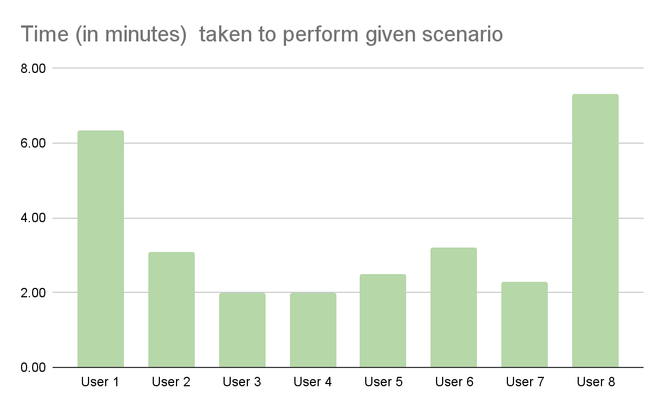**Time taken per user to navigate through given scenario**

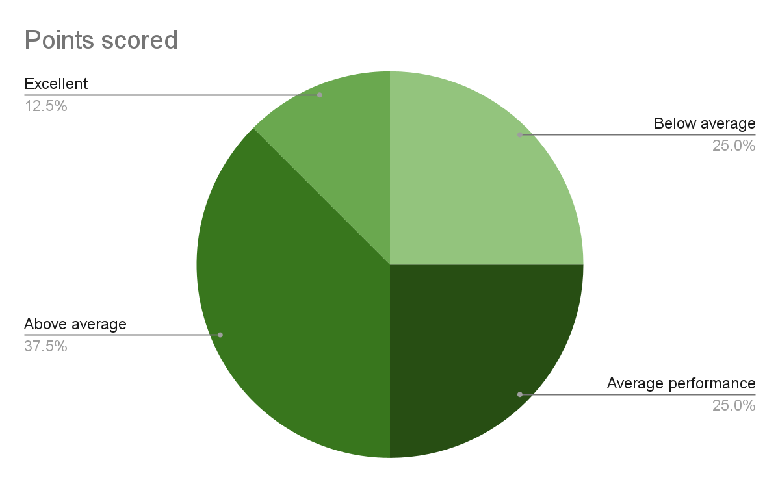

**Performance of users when given a specific task**

# Conclusions

The usability testing was highly successful, providing valuable insights into user expectations and application functionality. Here are the key findings:

* **Average Navigation Time:** Users took an average of 3 minutes and 34 seconds to navigate through the given scenario. This duration included pauses for users to ask questions or comment on areas they felt needed improvement.This allowed us to understand that though it does not take a long time to navigate through our app there is still room for improvement.
* **User Feedback:** Most users found the navigation well-planned and familiar. However, they encountered difficulties with certain buttons and were confused when clicking on components that did not respond as expected.
* **Task Completion:** More than half of the users completed the task successfully, demonstrating above average performance.

The feedback and data gathered from this usability testing will guide us in making necessary improvements to enhance the user experience and ensure that the application aligns with user expectations. This usability test has also provided us with a valuable perspective: seeing the app through the eyes of our users.

As designers and developers, we might have assumed that navigating and understanding our app was straightforward. However, some of our users experienced difficulties that we hadn't anticipated. This testing phase has highlighted the crucial lesson that our understanding as developers does not always match the understanding of our users.

This is precisely why usability testing is so important. It allows us to gain insight into how users feel about the app, ensuring that it truly meets their needs and expectations. After all, the app is designed for them. We greatly appreciate your participation and the invaluable feedback you've provided, which will help us make the app better for everyone.

#### Script

#### **Team Introduction**

Hello and welcome! We are excited to have you here today. Let's start by introducing ourselves:

Asa, Joyce, Zandile and Sonaly

#### **What This Study is About**

Welcome to our usability test! Today, we aim to evaluate the acceptability and usability of our design prototype. It's crucial for us to determine if our app meets user requirements. In this session, you will help us test our app design by navigating through it and performing different tasks based on a simple scenario.

Remember, you are not being tested. Instead, you are helping us test our app. As you navigate the app, if you encounter anything you are unsure about, please mention it and then move on. We encourage you to use the think-aloud technique as you navigate through the app verbalising your thoughts and any comments you may have.

#### **Description of the App**

We have redesigned a series tracker app that allows you to keep up to date with your favourite series and access as many series as possible through different platforms. The app also enables users to interact with each other through a community and offers a watch party feature to catch up on your favourite series with friends.

#### **Details of What You Must Do**

For navigating the app, we will be using Figma. A link was sent to you before the meeting, so please click on it and navigate to the Figma page. On this page, you will see a phone with our design on it. Please interact with it as you would with any other app. Participants will be asked to share their screens two at a time.

#### **Verbal Acknowledgement**

Before we begin, please acknowledge the following:

* This is a voluntary session, and you have the right to leave at any time.
* Any data collected from this session will be used for our study.
* The session will be recorded.
* You are welcome to ask questions at any time.

Thank you for your participation and support in helping us improve our app! Let's get started.

**Scenarios given**

1. You and your friends have planned a binge-watching session for the upcoming weekend. You download the series tracking app and register an account. You then browse through the home page, where you discover a highly-rated series that piques your interest. You navigate to where you think the series description will be to gain more insight on the series. Satisfied with what you see, you add it to your personalised playlist on your profile page. As you scroll through the menu page, you notice the option for a watch party feature. Excited about the idea, you invite your friends to join you. You all decide on a time and start the watch party, enjoying the series together in sync.
2. It's Friday evening, and you're in the mood for some entertainment after a long week. You open the series tracking app and explore your options. Browsing through, you find something interesting and decide to add it to your watchlist. You make a few adjustments to your settings for a comfortable viewing experience and settle in to enjoy your evening.
3. You're a student preparing for exams, but you need a break from studying. You open the series tracking app and log in to your account. You browse through some options undecided what to watch. You then decide to revert to your comfort and find something in your personal playlists. You select one from your playlist and start streaming. While watching, you decide to leave a comment on the series in the chat box, sharing your thoughts and insights. As you finish the episode, you realise it's getting late, so you switch off dark mode and bookmark the series to continue later.
4. You've planned a cosy movie night with your family, including your 10-year-old daughter. You get onto a series tracking app and create an account. You find a family-friendly series that suits everyone's taste. You read the series description, ensuring it's suitable for your daughter. After looking through the movie's details, you add it to your profile's watchlist. As you scroll through, you decide you want to host a watch party and decide it could be a fun experience for the family. You invite your relatives to join, and everyone eagerly agrees. With the preparations done, you dim the lights, switch on dark mode for a comfortable viewing experience, and enjoy quality time with your loved ones

Thank you for taking time out of your busy day to help us with this, we really appreciate all the help and feedback you have given us.

#### Consent

#### **Verbal Acknowledgement**

(asked for verbal consent in the google meeting)

Before we begin, please acknowledge the following:

* This is a voluntary session, and you have the right to leave at any time.
* Any data collected from this session will be used for our study.
* The session will be recorded.
* You are welcome to ask questions at any time.

Thank you for your participation and support in helping us improve our app! Let's get started.

Notes

**Observations:**

Users generally looked confused and frustrated initially but then as they figured out how to navigate through the app their expressions eased up into a sense of accomplishment and success.

Some of their body language looked tense and uneasy at first but later on became more relaxed as time went on.  
 **Notes:**

User A:

Could not use the Apple log in option

Could not click on some series - interaction did not work

Took quite long

Could not find the chat box section

User B:

Did not like the placement of the chat box

Performed well and efficient

Wanted Watch Party feature on the home page

User C:

Efficient

Said that buttons were labelled incorrectly

Wants a back button

User D:

Thought navigation was easy to figure out

LIked the Menu page

User E:

Found that the series in the “Haven't watched” section were not clickable.

Wanted to select Young Sheldon but couldn't.

Confused by the scenario whether to sign up or log in

Wanted a back button

User F:

Found that the series in the “Haven't watched” section were not clickable.

Said that the discover and browse more shows button is redundant.

Liked the aesthetic.

User G:

Struggled with connecting

Took long to find things

Did not understand the scenario.

Could not locate a lot of things in the app.

Thought that they broke the app because they could not click on some things

User H:

Could not share their screen, Zandile shared her screen on their behalf

Could not click on any of the Havent watched section series.

Wanted a back button.

We need to label buttons better.

Participant A was unable to share their screen so the next participants began

Participants B seemed to be unsure of whether they were done with scenario they were given

We made participants aware that they could think aloud

Participant C struggled with certain parts of the the prototype being clickable

Participant C could not complete one of the first scenario's tasks because they were unsure where it was located

Participants D and E navigated through the app fairly quickly. They found everything straightforward

Participant F was under the impression that it is an actual app that requires downloading

Participant E also experienced issues with clickability. We guided them around the issue without telling them exactly how to do that.

Participant G was unable to share their screen so we navigated through the app on their behalf. They verbally communicated how they would have navigated through the app.

Participant H couldn't complete the first task of their scenario

Majority of participants experienced clickability issues

Participant H completed their task fairly quickly

Overall the usability test went smoother than expected

**Satisfaction Questionnaire Questions:**

**1. Overall Satisfaction:**

Please rate your overall satisfaction with the Series Tracking App.

Very Satisfied

Satisfied

Neutral

Dissatisfied

Very Dissatisfied

**2. User Interface:**

How satisfied are you with the user interface of the Series Tracking App?

Very Satisfied

Satisfied

Neutral

Dissatisfied

Very Dissatisfied

**3. Features:**

Please rate your satisfaction with the features available in the Series Tracking App.

Very Satisfied

Satisfied

Neutral

Dissatisfied

Very Dissatisfied

**4. Ease of Use:**

How easy was it for you to navigate and use the Series Tracking App?

Very Easy

Easy

Neutral

Difficult

Very Difficult

**5. Performance:**

Please rate your satisfaction with the performance (speed, responsiveness) of the Series Tracking App.

Very Satisfied

Satisfied

Neutral

Dissatisfied

Very Dissatisfied

**6. Would You Recommend:**

Based on your experience with the Series Tracking App, how likely are you to recommend it to others?

Very Likely

Likely

Neutral

Unlikely

Very Unlikely

**7. Suggestions for Improvement:**

Please provide any suggestions or comments you have for improving the Series Tracking App.

Incentives:  
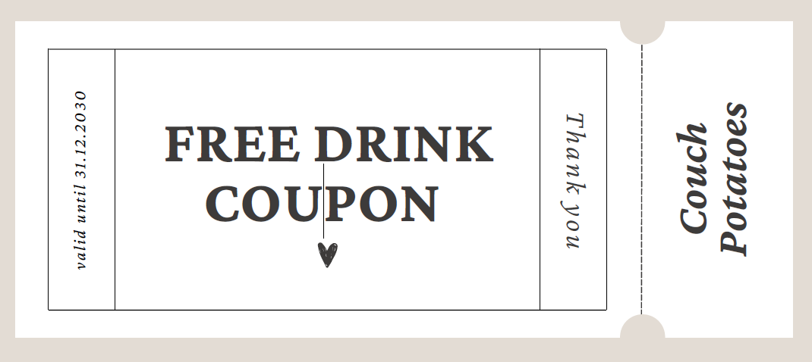

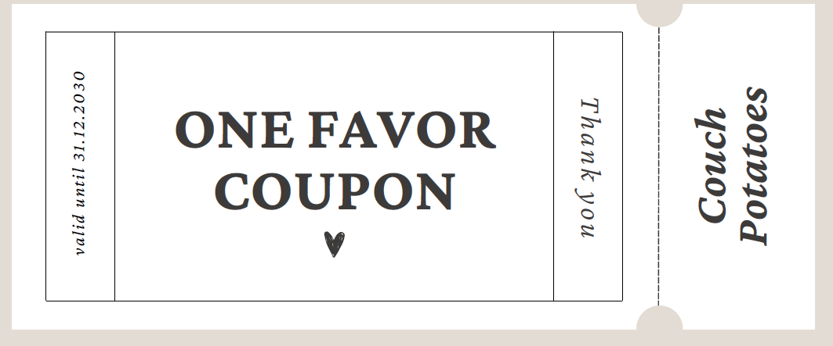

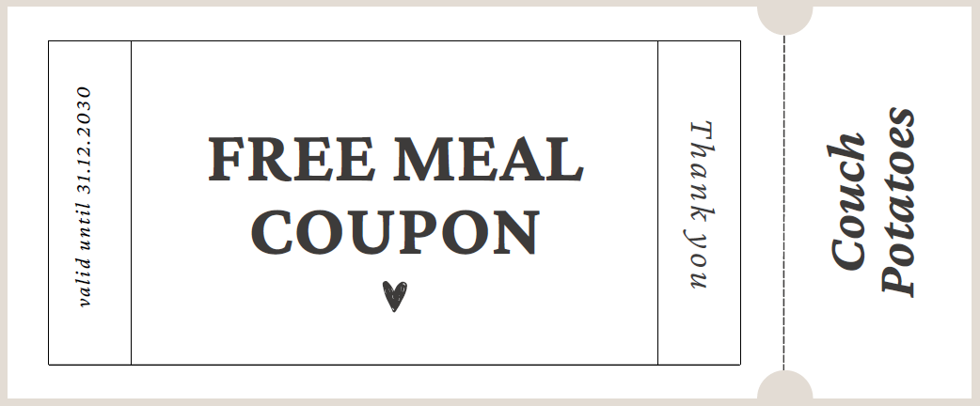

Questionnaire Responses:

<https://docs.google.com/document/d/1IuADZMNsReGyCcjaDcu21qpeqGRg_j1OsC7D5luE0AA/edit>