Kevin Fredericks
Waterworks LLC

C964 Capstone Project - MDP1

Environmental Risk Model

Table of Contents
A1. Letter of Transmittal | 3

A2. Project Recommendation
Problem Summary
Application Benefits
Application Description
Data Description
Objective and Assumptions
Methods
Funding Requirements
Stakeholder Impact
Data Precautions
Developer Expertise

B. Project Proposal
Problem Statement
Customer Summary
Existing Systems
Data
Project Methods
Project Outcomes
Implementation Plan
Evaluation Plan
Resources and Costs
Timeline and Milestones

C. Post-Implementation Report
Purpose Statement
Datasources
Verification
Visualization
Accuracy Analysis
Application Testing
Files
User Guide
Summation of Learning Experience

E. Sources

A1. Letter of Transmittal
August 1, 2020
Domzux Antebellum, Project Manager
Waterworks LLC
4001 700 E #700
Salt Lake City, UT 84107

Dear Mr. Antebellum,
Changing climate conditions are impacting public and private lands in the Western United States. The area bounded by the Northern Canadian Border and the Southern Mexican Border between the Pacific Ocean and the Rocky Mountain ranges has become a highly active area of wildfire and drought incidents. Investment is needed for strategic tools to manage private and public lands. The management practices that inform land use need to be up-to-date and accurate.
This document proposes a data aggregation and analysis tool that takes advantage of the wealth of public information on climatic and atmospheric conditions in the United States. Billions of dollars can be saved through accurate analysis of current and forecasted conditions. However, the training required to use modern Geographic Information System (GIS) tools can be cumbersome. This tool will provide powerful capability with a very intuitive interface to helpidentify areas at risk for wildfire with a small team of capable developers and a completely free platform that will provide all stakeholders with an extensible data product.
Finally, on the matter of data integrity. The Environment Risk Model is built on the Google Earth Engine. This tool is connected to datasets maintained by some of the most reliable organizations on Earth including: USGS, NOAA, United Nations, and LANCE. This tool will be useful in the present and the distant future without legal or financial barriers.

A2. Project Recommendation

Problem Summary
Accurate prediction of climate events is a difficult challenge. Multi-year averaging methods and 10-year cycles have become unreliable as our environment becomes a more entropic system. It is necessary to form forecasts based on shorter timeframes as climatic shifts begin to reflect immediate climatic events. Globally, wildfires cost up to $280Bn USD in 2017^{[1]}. This is discounting extremely severe fire seasons in proceeding years. Drought conditions leading to these fires are difficult to predict.
There is a great need for accurate prediction models to provide better service to governments, agriculture groups, and private citizens. The quality of forecasting enables precise risk mediation strategies. The velocity of data can overwhelm clients that do not have the ability to hire skilled analysts, forcing increased costs and institutional burden.

Application Benefits
The application will provide an output of geographical points in the Western United States that are experiencing increased risk for wildfire in the upcoming months. The application will allow firms to identify previously overlooked problem zones that may require intervention to prevent disasters or loss of arable land.
The application will feature a simple user interface that allows the geographic output to be modulated according to time precision and intensity of risk. This will allow users to define high priority regions.This tool will enable analysts to make informed decisions on the climatic risks in a given region.

Application Description
This application is a web-based interface that requires inputs from the National Land Cover Database ( NLCD ) and the Global Forecast System ( GFS ). These datasets are accessed through the Google Earth Engine API. The reliability and computational efficiency of the the Google Earth Engine is highly scalable. The cloud-based computing model takes advantage of Google's server architecture and queries made to the NLCD and GFS systems are compared against an optimized cache system built in to the Google Earth Engine.
The User Interface is a web form that allows users to specify the number of days from the current date that should be computed. This is a maximum-based calculation that finds the highest risk level for each 30 meter land pixel in the Western United States. The query is processed using customized Javascript calls to the Google Earth Engine API.

Data Description

National Land Cover Database
The NLCD is a 30 meter resolution dataset of the natural and man-made types of land cover in the United States. The following chart provides a summary of the land cover types included in each band of the dataset:
Bands
Name | Description
landcover | All images except NCLD2011_HI and NLCD2011_PR include the landcover classification scheme described in the 2016 Product Legend.
impervious | Percent of the pixel covered by developed impervious surface.
impervious_descriptor | Defines which impervious layer pixels are roads and provides the best fit description for impervious pixels that are not roads.
percent_tree_cover | Percent of the pixel that's covered by tree canopy. No masking of obvious non-tree areas is performed for this product.
percent_tree_error | Standard error for the model as a percentage from 0 to 45.
shrubland_annual_herbaceous | The annual only grass and forest proportion.
shrubland_bare_ground | The bare ground proportion in each 30m pixel.
shrubland_big_sagebrush | The proportion of big sagebrush canopy in each 30m pixel.
shrubland_herbaceous | The annual and perennial grass and forb proportion in each 30m pixel.
shrubland_litter | The dead plant material proportion in each 30m pixel.
shrubland_sagebrush | The proportion of sagebrush canopy in each 30m pixel.
shrubland_sagebrush_height | Average height of sagebrush.
shrubland_shrub | The proportion of shrub canopy in each 30m pixel.
shrubland_shrub_height | Average height of shrubs.

Global Forecast System
The Global Forecast System is an internationally verified dataset of the 384-hour weather forecast at a resolution of 0.25 arc degrees of the Earth's surface. The dataset includes the current humidity and temperature of a point in the Earth's atmosphere and temperatures for the 30 m above the land surface are provided as separate bands.

Objective and Assumptions
The Objective of this application is to provide an assisted user experience for climate analysts. The application should provide predications for high-risk areas which are about to experience sharp drops in humidity or rainfall and increases in surface temperature. Herbaceous land cover should be included in the application output.
The assumptions of this application rely heavily on the data provided and the entropic nature of climate systems. The GFS is a 384-hour forecast but weather patterns beyond the 168-day forecast are notoriously difficult to assess accurately. The user's understanding of this unpredictability should be assumed in order to provide meaningful insight to any analyst using this application.

Methods
This application is built using a SASHIMI waterfall method with continuous feedback. The reliance on the Google Earth Engine requires a period of application authorization that will be used as a major milestone for the project. Each phase of the project has a finish-start relationship. This method is appropriate given the precise parameters of the project, the small team that is building the application, and the high reliability of data inputs to the project.

Funding Requirements
The Google Earth Engine is a free resource. The development team is composed of one full time software engineer and two members of a support staff. The total time committed to this project is 84 hours, the breakdown is as follows:
Name | Hours | Rate
Kevin Fredericks | 80 | $122 / hr
Lakshmir Vulf | 2 | $180 / hr
Smoxie Tanderbilt | 2 | $170 / hr
 |  | Total
 |  | $10, 460

Stakeholder Impact
The stakeholders at Waterworks LLC will receive license to use the Environmental Risk Model and application support for five ( 5 ) years. The consolidation of data sources will allow Waterworks LLC to scout for new clients. The extensibility of the Google Earth Engine architecture allows for Waterworks LLC to explore new climatic risk assessment based on unexplored business opportunities. With continued use, the application will provide a standard for all analysts and Waterworks can expect to see increased output from analysts alongside systemic benefits that emerge from shared tools.

Data Precautions
The United States Geological Survey is a highly reliable provider of data. The recent change to the NLCD came in the form of several new bands of data which did not collide with the previous landcover band. It can be expected that any future changes to the data structure may require changes in the data architecture of the Environmental Risk Model. These changes should be monitored on an annual basis.
The Global Forecast System has existed for many decades and has become increasingly accurate with the growth of knowledge in machine learning algorithms and stochastic mathematics. This does not prohibit caution when using data exceeding the 168-day forecast.

Developer Expertise
The software engineer in charge of this project is Kevin Fredericks, a recent graduate of the prestigious Western Governors University Computer Science program. The support staff consists of an accountant, Lakshmir Vulf, and a data shaman, Smoxie Tanderbilt. Lakshmir has 20 years in accounts payable and receivable operations. Ze have ensured accurate and timely accounting of funds amounting to $350,000,000 over two decades of work. Kevin Fredericks has produced web applications as a consultant for firms such as Nordas Inc. in Norway and EnviroCoLogoMatics in Boston, MA, USA. Kevin's personal data shaman, Smoxie Tanderbilt, has registered eight months of experience at the universally recognized School of Masterful Analysis in Programming ( SMAP ).

B. Project Proposal

Problem Statement
Waterworks LLC is a monumental figure in the world of Environmental Resource Management and Climatic Research. This esteemed position allows Waterworks LLC opportunities to explore new clients with the advantage of a strong pedigree. Environmental consultancy, by its nature, requires a deep undersanding of the climatic, geological, and biological factors of a region. It will be advantageous for a business to have thorough data on a new area of interest when exploring a region for possible clients. Extremely complex GIS tools and datasets must be used to identify new opportunities in both established businesss operations and potential markets.

Customer Summary
Waterworks LLC has worked with many clients in the Sourthern Nevada and Arizona regions. These areas have reliable conditions of drought and human development which have led to predictable business opportunities. The executive management and GIS analysts work together closely. Environmental Science knowledge is deeply embedded in the company and advanced computational tools are fundamental to the business. Government contracts account for the majority of Waterworks LLC's revenue. The company has limited contacts in the Orevada and Pacific Northwest Region and wildfire risk assessment has become a large focus of concern by governmental partners in the Southern California region.

Existing Systems
The suite of tools currently used to identify and analyze risk areas are built on the ArcGIS system. This is a highly robust data aggregation tool that requires many months of training and many of the endpoint API access is controlled by expensive service contracts with governmental and private firms. These tools allow band separation, climate prediction, and Bayesian probability analysis.

Data
The data used in the NLCD and GFS datasets are ImageCollection datatypes in the Google Earth Engine built on a variety of data sources managed by their respective governemental bodies. These data source can be accessed as multi-column .CSV or .JSON objects through their respective API endpoints.
The ImageCollection datatype includes GIS Images with epoch separation. This allows analysis on temporal parameters which is crucial for predictive methods. Each Image includes multiple bands of information which each serve to identify a different range of parameters or results from different sensors. The majority of the data is collected by satellite-based remote sensing with verification provided by surface level sensors.

Project Methods
Development will be divided in to five phases: Requirements, Unit Builds, Integration, Testing, and Support.
- Requirements – Analysis of business needs for Waterworks LLC
- Unit Builds – Development of functionally separate code modules
- Integration – Stability and User Experience of fully integrated application
- Testing – Wildfire and drought prediction model will be compared to past data
- Support – Interface changes will be assessed and implemented based on client needs
The Testing phase will use historical climate events to verify the efficacy of the prediction model.

Project Outcomes
The project will have one short-term outcome and one long-term outcome. The short-term outcome will be the deployment of the Environmental Risk Model. The success of the model will be based on the ability of the application to correctly define wildfire-prone areas at a granularity of 30m.
The long-term outcome of the model will be based on the ability of Waterworks LLC to define new clients based on previously unexplored regions.

Implementation Plan
Implementation will be based on a finish-start dependency between phases with affordance for regression to preceding phases if crucial changes need to be made to the project. Integration and Testing will require feedback to be implemented.
The development environment will be based on a Node.js web server and Javascript application code. The view layer will be handled by a HTML / CSS user interface. All actions taken by users in the view layer will be handled by Javascript running on the Node.js server.
Testing will be automated with Javascript-based test models.

Evaluation Plan
Wildfire detection will be based on the occurrence of wildfires or an increase in the fire risk assessment by the governing authority in a given region. The occurrence of wildfires must reach a sufficient intensity to be measured by the MODIS satellite cluster. This omits many small brushfires that did not produce a high heat signature.
The Environmental Risk Model will use historical data to verify the efficacy of 120-day and 240-day predictions. In the event that a historical wildfire occurs, this will also indicate efficacy of the Environmental Risk Model.

Resources and Costs
The resources defined in the Project Recommendations will be sufficient to cover all technical expertise needed to complete the project. The following resources are already in ownership and add no cost to the project:
- Mac and Windows PCs for Implementation and Testing
- Office space used by Kevin Fredericks and support staff
- Google accounts and Google Earth licenses owned by Kevin Fredericks
- Internet connectivity owned by Kevin Fredericks
The total costs for this project are entirely covered by the wages of the employees.

Name | Hours | Rate
Kevin Fredericks | 80 | $122 / hr
Lakshmir Vulf | 2 | $180 / hr
Smoxie Tanderbilt | 2 | $170 / hr
 |  | Total
 |  | $10, 460

Timeline and Milestones
The following dates will be used to determine project status: 84
ID | Milestone | Start | End | Dependencies | Resources
1 | API Connectivity | 07/14/20 | 07/20/20 | NONE | Dev Team
2 | Acceptance Testing | 07/22/20 | 07/26/20 | 1 | Dev Team
3 | Deployment | 07/28/20 | 07/29/20 | 2 | Dev Team
4 | Financial Auditing | 07/30/20 | 07/31/20 | 3 | Accounting

C. Post-Implementation Report

Purpose Statement
This documentation serves to outline key observations from the development process. These observations may be used to aid the process of implementing changes. Any insights learned from the development process may also be used for guidance in future project planning.

Datasources
The National Land Cover Database maintained by the USGS contains highly detailed surface descriptions of the land cover for the United States. The dataset contains 8 epochs with a 2-3 year gap between images collected since 2000.^{[3]} The database contains several bands of interest to this application: total dead plant material identified as 'shrubland_litter' and a collection of various forest and shrubland attributes identified as 'landcover'.
The Global Forecast System is 384-hour weather forecasting dataset compounded by a network of international weather forecasting agencies in multiple countries. The dataset includes temperature forecasting bands relevant to this application^{[4]}.

Security
The application is verified using client-side authorization or server-side authorization at the discretion of the user.

Client-Side Authentication
The client-side authorization method requires the end-user to have a Google Account that has been authorized to use the Google Earth Engine. An Oauth2 token is generated for the app and a handshake is performed between the client and the Google Earth Engine server.

Server-side Authentication
The server-side authentication method uses a private key generated for a Service Account of the application developer. This token is stored in a web server hosting the application, allowing any user to access the GUI and application without a Google account.

Development App
As of 07-07-2020 the public Development App is available at the following link:
https://snoogans775.users.earthengine.app/view/enviroriskmodel

Verification
The Environemental Risk Model was tested against the MODIS MYD14A1 dataset. This dataset is a filtered Image Collection based on active fire detection capabilities of the MODIS satellite cluster.[4]

Visualization
The following code is used to isolate high temperature regions:
function getTemperatureImage(temperatureDate, geometry) {
// Define current temperature predictions
var temperature = gfs
.filterDate(temperatureDate)
.select('temperature_2m_above_ground')
.max();
var temperatureHigh = temperature.gt(HIGH_TEMP);
print('Temperatures: ');
print(temperatureHigh);

return temperatureHigh;
}

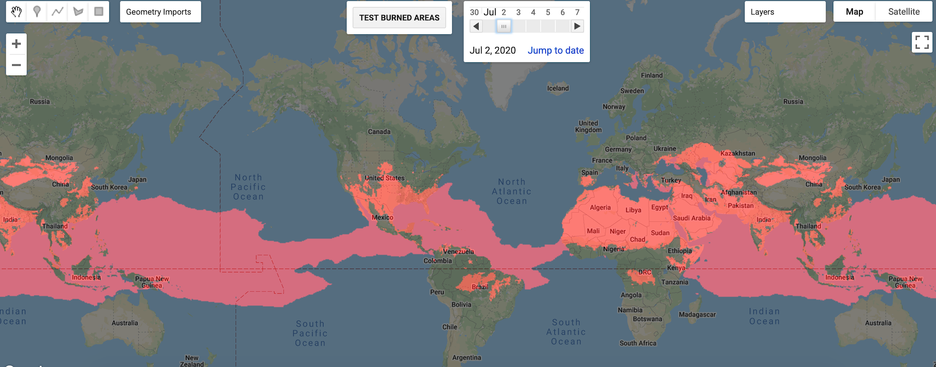
Global geometry and a high temp of 32 degrees Celsius during July 2019

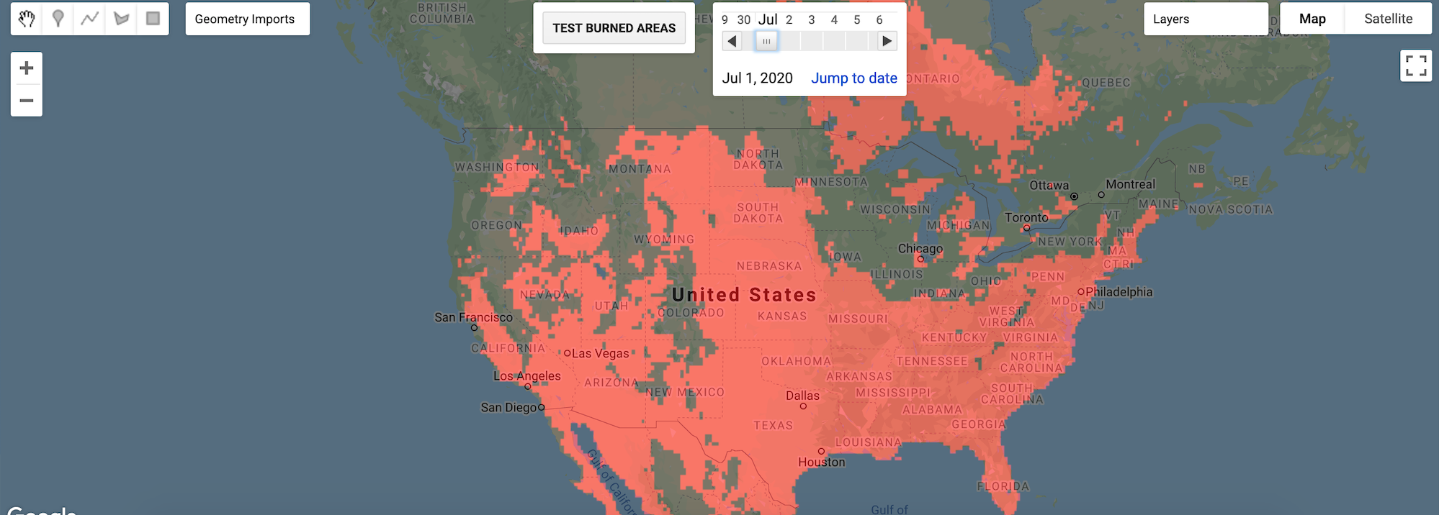
United States above 32 degrees Celsius during July 2020

The following code is used to identify areas with high levels of dead plant material:
function getLandCoverImage(date, geometry) {
// Define shrubland values
var herbaceous = nlcd
.filterDate(HERBACEOUS_DATE, addDays(HERBACEOUS_DATE, 365))
.select( 'shrubland_litter' )
.first();
var herbaceousHigh = herbaceous.gt( HIGH_HERBACEOUS );
print('Herbacity: ');
print(herbaceousHigh);

return herbaceousHigh;
}

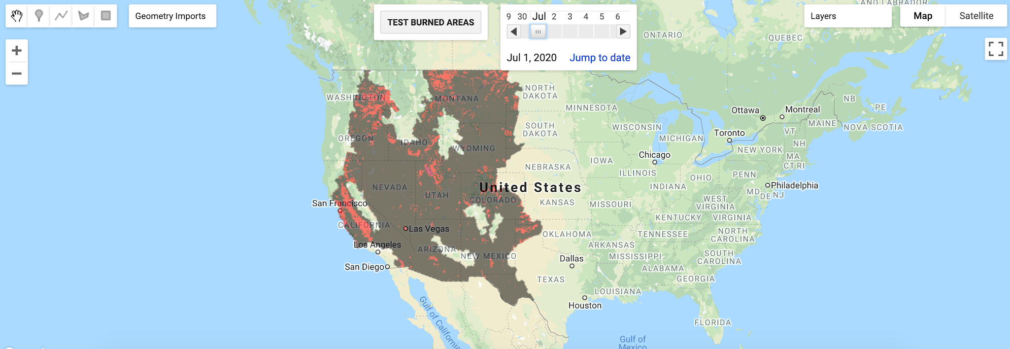
Medium ground litter: Gray, High ground litter: Red

The following code uses the previously defined calculations to isolate areas with increased wildfire risk:
function getHighRiskImage(date, geometry) {

var landCover = getLandCoverImage(date, geometry);
var hotSpots = getTemperatureImage(date, geometry);

// Define intersection of shrub and high temperature
var shrubAtHighRisk = hotSpots.mask( landCover ).gt(1);

return shrubAtHighRisk;
}

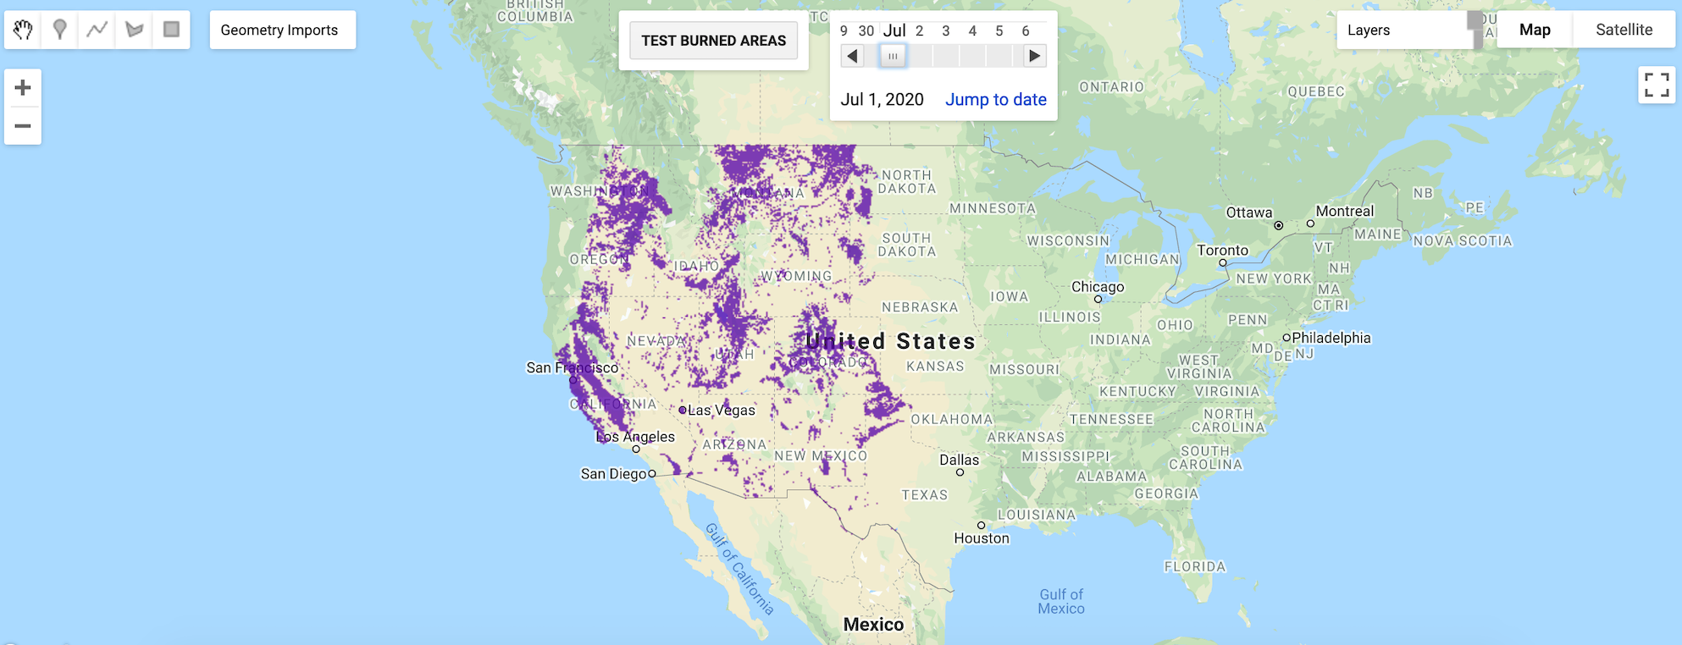
Areas with elevated risk of wildfire

Accuracy Analysis
Images were collected for at-risk regions. Once the images are filtered for a specified date, an efficacy test is performed on real world brushfire data for 365 days following the specified date. The total area where fires occurred is masked over an are identified as at risk. The final accuracy quotient is:

Total Area Identified At Risk  Areas Correctly Identified | = % Correctly Identified Areas

The results of a study period lasting from January 1st, 2019 to December 31st, 2019 produced the following results:
Region | Total Area (m²) | Correctly Identified Area (m²) | Accuracy Quotient
WESTERN U.S. | 34396616951 | 429345234 | 1.24%
OREGON | 4519412443 | 77,456,544 | 1.70%
PROVO | 1,145,517,887 | 83,443,324 | 7.60%

The results of this test indicate that the prediction parameters are too broad for specific region based analysis. However, in an area that experienced extreme wildfires, the model demonstrated a statistically significant indication of risk.
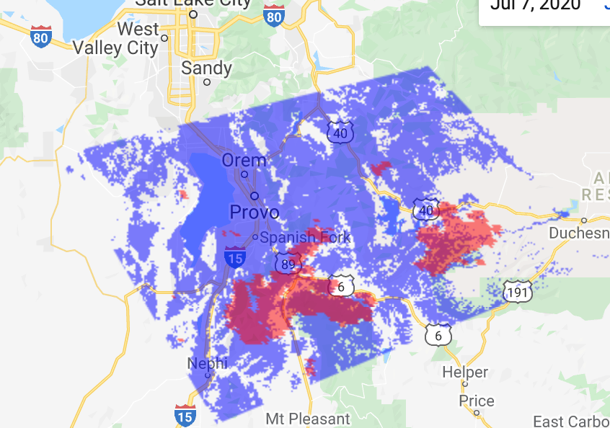
Fire Predictions: Purple
Actual Wildfres: Red

Application Testing
While checking for the presence of wildfires in areas identified as at risk, values needed to be adjusted to minimize the regions considered by the model.

Temperature Values
The maximum values for temperature were used in place of the mean values for temperature. This allowed more realistic interpretation of the data. Risk is best assessed by periods of heat with sharp spikes in temperature. This requires a maximum value calculation for an effective prediction.

Date Ranges
The application receives input of a date from the user. The date input was tested for all dates occurring two weeks from the current system current time of the development environment. The date input was also tested for 3 years before the current time of the development environment. Errors occurring in these dates were constrained by the application logic.

User Interface
The user interface was tested with a human hallways tester. User Experience was measured qualitatively following a black-box interactive session. Changes to the position and sie of GUI elements were considered based on this testing procedure and implemented accordingly.

Files
The complete codebase for the Environmental Risk Model is provided below:
// Environmental Risk Model
// Kevin Fredericks 2020
// MIT License

// CONSTANTS
var HIGH_TEMP = 33;
var HIGH_HERBACEOUS = 55;
var HERBACEOUS_DATE = Date.parse('2016-01-01');
var DATE_START = addDays(Date.now(), -365);
var DATE_END = Date.now();
var DATE_TEST = Date.parse('2019-01-01');
var HIGHLIGHT = 'red';

// DATA SOURCES //
// USGS Land Cover Map
var nlcd = ee.ImageCollection("USGS/NLCD");
// Global Forecast System
var gfs = ee.ImageCollection('NOAA/GFS0P25');

// USER INTERFACE //
// Construct test Button
var testButton = ui.Button('TEST BURNED AREAS');
testButton.onClick( function() {
displayTest(DATE_TEST, PROVO);
});

// Construct DateSlider
var dateSlider = ui.DateSlider( DATE_START, DATE_END );
dateSlider.onChange( function() {
var selectedUTC = dateSlider.getValue()[0];
var selectedDate = parseUTC(selectedUTC);
// Compute and display image for date
var highRiskImage = getHighRiskImage(selectedDate, OREGON);
display(highRiskImage);
});

// Display GUI
Map.add(testButton);
Map.add(dateSlider);

// FUNCTIONS //

function getArea(image, geometry) {
var count = image.eq([0]);
var total = count.multiply(ee.Image.pixelArea());
var area = total.reduceRegion({
reducer:ee.Reducer.sum(),
geometry: geometry,
scale:1000,
maxPixels: 1e9,
bestEffort:true,
tileScale:16
});
var areaPixels = ee.Number(area);
return areaPixels;
}

function display(image) {
// Display map with highlighted areas
var visParams = {
palette: HIGHLIGHT,
opacity: 0.5
};
Map.addLayer( image, visParams, 'highTemps');
}

function displayTest(date, geometry) {
var atRiskImage = getHighRiskImage(date, geometry).clip(geometry);
var burnedImage = getBurnedImage(date, geometry).clip(geometry);

var totalAtRisk = getArea(atRiskImage, geometry);
var totalBurned = getArea(burnedImage, geometry);
var totalAccurate = getArea( atRiskImage.mask(burnedImage));

HIGHLIGHT = 'blue';
display(atRiskImage);
HIGHLIGHT = 'red';
display(burnedImage);
}

function addDays(date, days) {
var result = new Date(date);
result.setDate(result.getDate() + days);
return result;
}

function parseUTC(timestamp) {
var date = new Date(timestamp);
return date;
}

// ImageCollection Functions //

function getHighRiskImage(date, geometry) {

var landCover = getLandCoverImage(date, geometry);
var hotSpots = getTemperatureImage(date, geometry);

// Define intersection of shrub and high temperature
var shrubAtHighRisk = hotSpots.mask( landCover ).gt(1);

return shrubAtHighRisk;
}

function getTemperatureImage(temperatureDate, geometry) {
// Define current temperature predictions
var temperature = gfs
.filterDate(temperatureDate)
.select('temperature_2m_above_ground')
.max();
var temperatureHigh = temperature.gt(HIGH_TEMP);
print('Temperatures: ');
print(temperatureHigh);

return temperatureHigh;
}

function getLandCoverImage(date, geometry) {
// Define shrubland values
var herbaceous = nlcd
.filterDate(HERBACEOUS_DATE, addDays(HERBACEOUS_DATE, 365))
.select( 'shrubland_litter' )
.first();
var herbaceousHigh = herbaceous.gt( HIGH_HERBACEOUS );
print('Herbacity: ');
print(herbaceousHigh);

return herbaceousHigh;
}

function getBurnedImage(date, geometry) {
var burnedImage = ee.ImageCollection('MODIS/006/MOD14A1')
.filterBounds(geometry)
.filterDate(addDays(date, -365), date)
.select('MaxFRP')
.max();

return burnedImage;
}

User Guide
Navigate a capable web browser (Chrome, Firefox, Opera) to the url provided below:
https://snoogans775.users.earthengine.app/view/enviroriskmodel
Select a date using the Date Slider at the top of the map screen. This will identify an input date for the Environmental Risk Model.
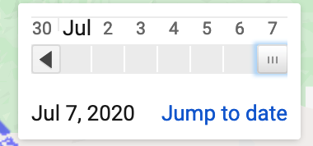
Once a date has been selected, Select a visualization filter from the available buttons:
Visualization | Description
BURNED AREAS | Contrasts prediction output with 365-day fire occurrences
AT RISK AREAS | Display an overlay of predicted at-risk areas
FOREST DENSITY | Displays an underlay of forest canopy densities

After a few seconds, the output will be shown on the map.

Global Variables
Any of the following constants can be modified to alter the behavior of the application:

Constant | Behavior
HIGH_TEMP | Minimum temperature to be isolated by the model
HIGH_HERBACEOUS | Minimum herbacity to be isolated by the model (ground litter)
HERBACEOUS_DATE | Date of earliest Land Cover Image
DATE_START | Start of model prediction timeframe
DATE_END | End of model prediction timeframe
DATE_TEST | Date for Accuracy assessment
HIGHLIGHT | Color of at-risk regions on map

Testing Accuracy
The 'BURNED AREAS' button provides an overlay of actual burned areas for the year specified by DATE_TEST. The total area of any map image can be tested with the getArea() function.

Summation of Learning Experience

Kevin Fredericks
I have found this API to be extremely powerful and the community resources are staggering. Geographic Information Systems have been nortoriously difficult to use so I was intimidated to attempt a project with a predictive output. The Google Earth Engine was approachable and science driven. I learned a good deal of Environmental Science by navigating the documentation and building the application.
The algorithmic component of the project was straightforward. I could have applied a weighted model or a machine learning model to this problem. I believe that the number of variables leading to wildfires create a very stochastic system so a Linear Regression model would be very interesting. I attempted to implement humidity, urban expansion, and thunderstorms in to the model but these data points did not provide very substantial changes to the model's predications. The level of granularity possible for a model like this could be refined infinitely. The final application demonstrates to myself and hopefully to others that I have developed a comfort with the algorithmic fundamentals of computer science. This allows me to look at the more human and system level components of a problem while moving through computational tasks without unnecessary pain and effort.

D.Sources

[1] The Cost and Losses of Wildfires. Douglas S. Thomas, David T. Butry, Stanley W. Gilbert, David H. Webb, Juan F. Fung https://www.nist.gov/publications/costs-and-losses-wildfires

[2] MYD14A1 Dataset. MODIS. https://developers.google.com/earth-engine/datasets/catalog/MODIS_006_MYD14A1

[3] National Land Cover Database. USGS. https://developers.google.com/earth-engine/datasets/catalog/USGS_NLCD

[4] Global Forecast System. Google. https://developers.google.com/earth-engine/datasets/catalog/NOAA_GFS0P25?hl=pl#description

