1. **c1.pyで変更された部分は次のようです。**

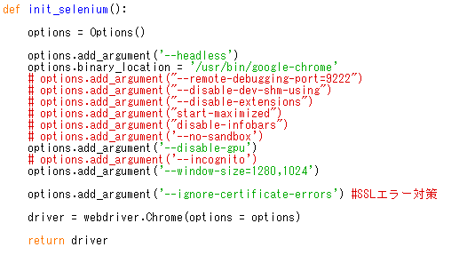

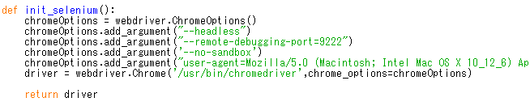

** : chromeOptions.add_argument("user-agent=Mozilla/5.0 (Macintosh; Intel Mac OS X 10_12_6) AppleWebKit/537.36 (KHTML, like Gecko) Chrome/61.0.3163.100 Safari/537.36")

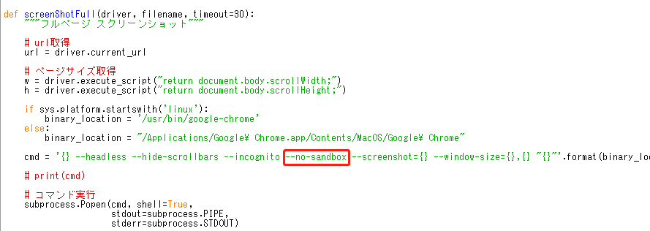

1. **実行命令は次のようです。**
2. **Pythonの設置**

sudo yum install -y https://centos7.iuscommunity.org/ius-release.rpm

sudo yum update

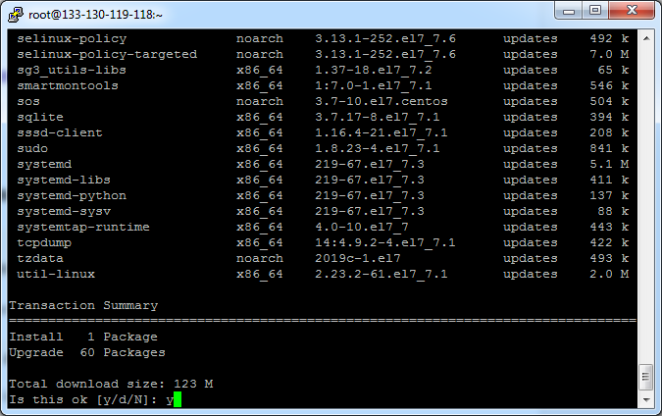

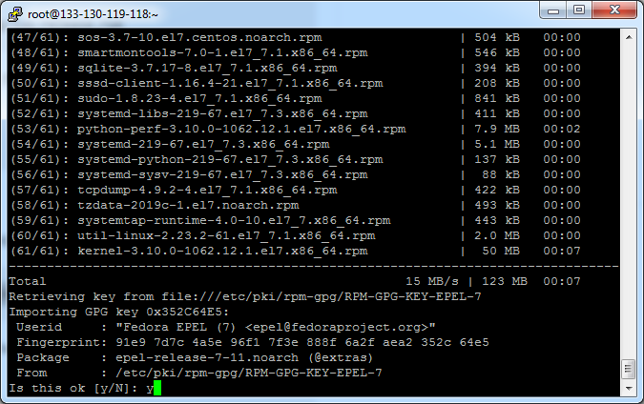

sudo yum install -y python36u python36u-libs python36u-devel python36u-pip

python3.6 -V

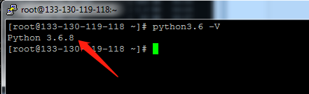

1. **Chromeの設置**

wget https://dl.google.com/linux/direct/google-chrome-stable_current_x86_64.rpm

yum localinstall google-chrome-stable_current_x86_64.rpm

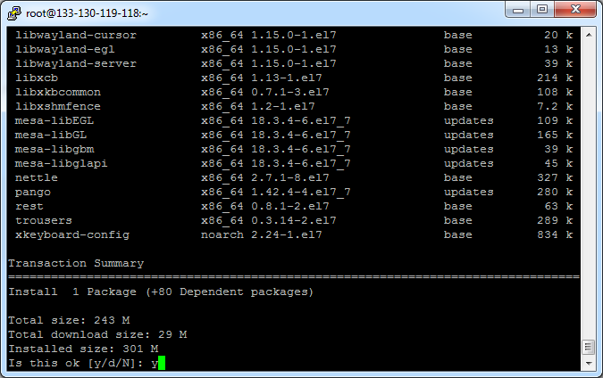

google-chrome --version

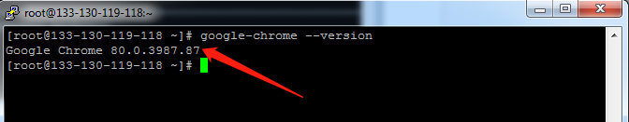

1. **ChromeDriverの設置**

yum install chromedriver

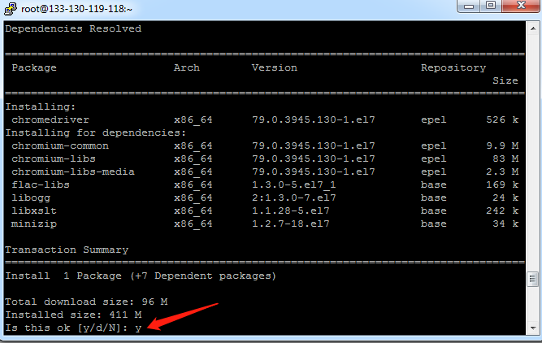

1. **Pythonモジュルの設置**

pip3 install pandas

pip3 install selenium

pip3 install requests

pip3 install lxml

pip3 install orator

pip3 install PyMySQL

1. **MySQLの設置**

rpm -Uvh https://repo.mysql.com/mysql80-community-release-el7-3.noarch.rpm

sed -i 's/enabled=1/enabled=0/' /etc/yum.repos.d/mysql-community.repo

yum --enablerepo=mysql80-community install mysql-community-server

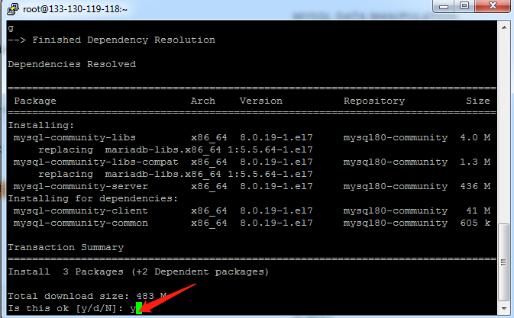

service mysqld start

grep "A temporary password" /var/log/mysqld.log

[Note] A temporary password is generated for root@localhost: **hjkygMukj5+t783**

mysql_secure_installation



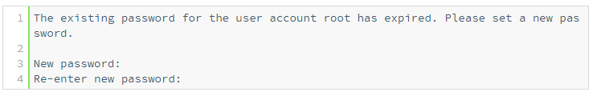

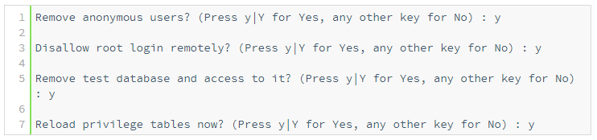

service mysqld restart

chkconfig mysqld on

mysql -u root -p

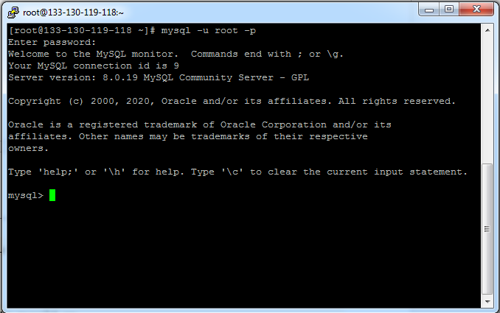

mysql> CREATE DATABASE yahoo_ad CHARACTER SET utf8mb4 COLLATE utf8mb4_0900_ai_ci;

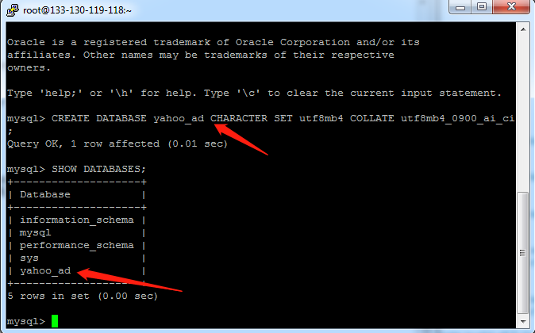

Mysql –u root –p yahoo_ad < yahoo_ad.sql

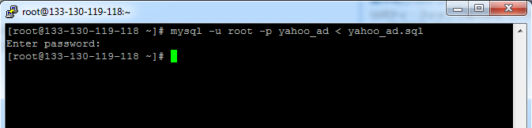

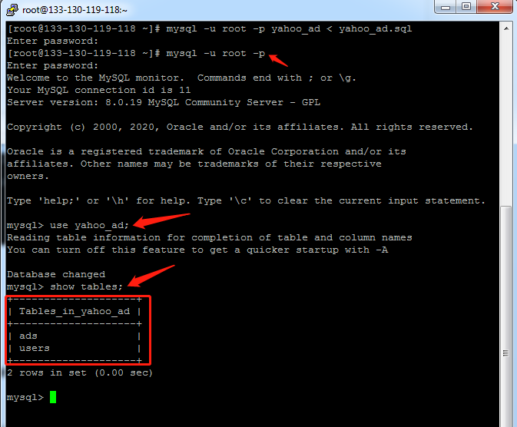

1. **fontの設置**

yum -y install libX11 GConf2 fontconfig

yum -y install ipa-gothic-fonts ipa-mincho-fonts ipa-pgothic-fonts ipa-pmincho-fonts

fc-cache -fv

1. **動作確認**

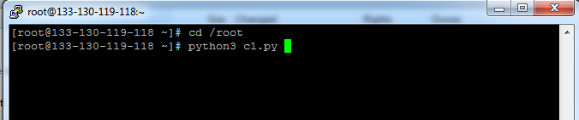

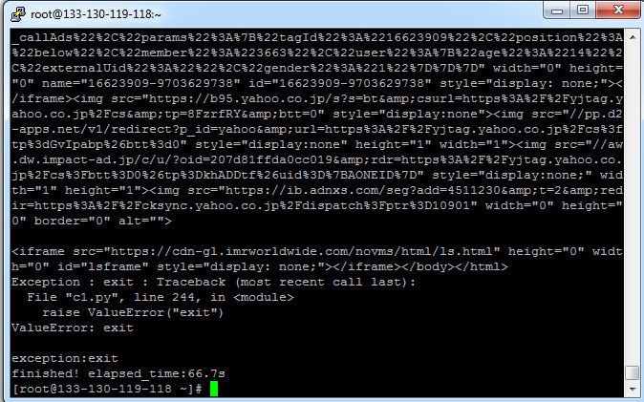

ありがとうございます!