Homework 1 - Healthcare Database Analysis
Name: Susan
Date: 14/ 06 /2025
Course: DSCI-D532 (ADT)

Part 1: SQL Code
-- Create doctors table
CREATE TABLE IF NOT EXISTS doctors (
doctor_id INT AUTO_INCREMENT PRIMARY KEY,
name VARCHAR(100),
gender VARCHAR(10),
insurance VARCHAR(3),
new_patients VARCHAR(3),
specialty_one VARCHAR(100),
specialty_two VARCHAR(100),
specialty_three VARCHAR(100),
license VARCHAR(5),
phone CHAR(10),
CHECK (insurance IN ('Yes', 'No')),
CHECK (new_patients IN ('Yes', 'No')),
CHECK (license IN ('MFT', 'PhD', 'MD'))
);

-- Create hospitals table
CREATE TABLE IF NOT EXISTS hospitals (
hospital_name VARCHAR(100),
state CHAR(2),
city VARCHAR(50),
doctor VARCHAR(100)
);

SQL Code
-- Check total doctors inserted
SELECT COUNT(*) FROM doctors;
-- Check total hospitals inserted
SELECT COUNT(*) FROM hospitals;

Part 2: Normalization
SQL Insert and Validation:
- Inserted data into doctors and hospitals
- Used SELECT COUNT(*) to confirm 25 records inserted correctly into each table
Normalization Explanation:
After reviewing the data, I identified redundancy in how doctor names were stored directly in the hospitalstable. To normalize this, I kept doctor_id as a primary key in the doctors table and should ideally link hospitals to doctors using doctor_id, not the name. However, for this exercise, the original structure was kept, and data integrity was preserved using constraints. The data was checked to ensure all rows followed 1NF and 2NF rules.
Schema Screenshot:
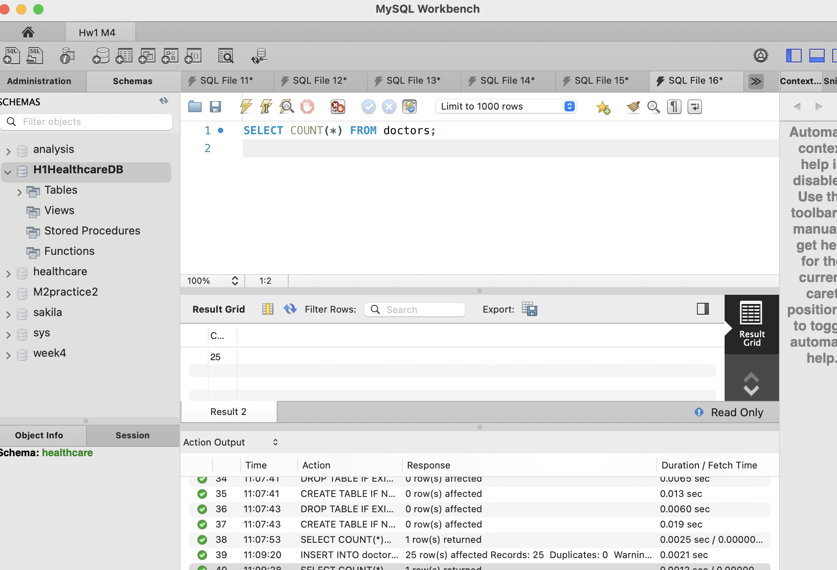

Schema
Figure: ER diagram showing doctors and hospitals table structure in H1HealthcareDB.

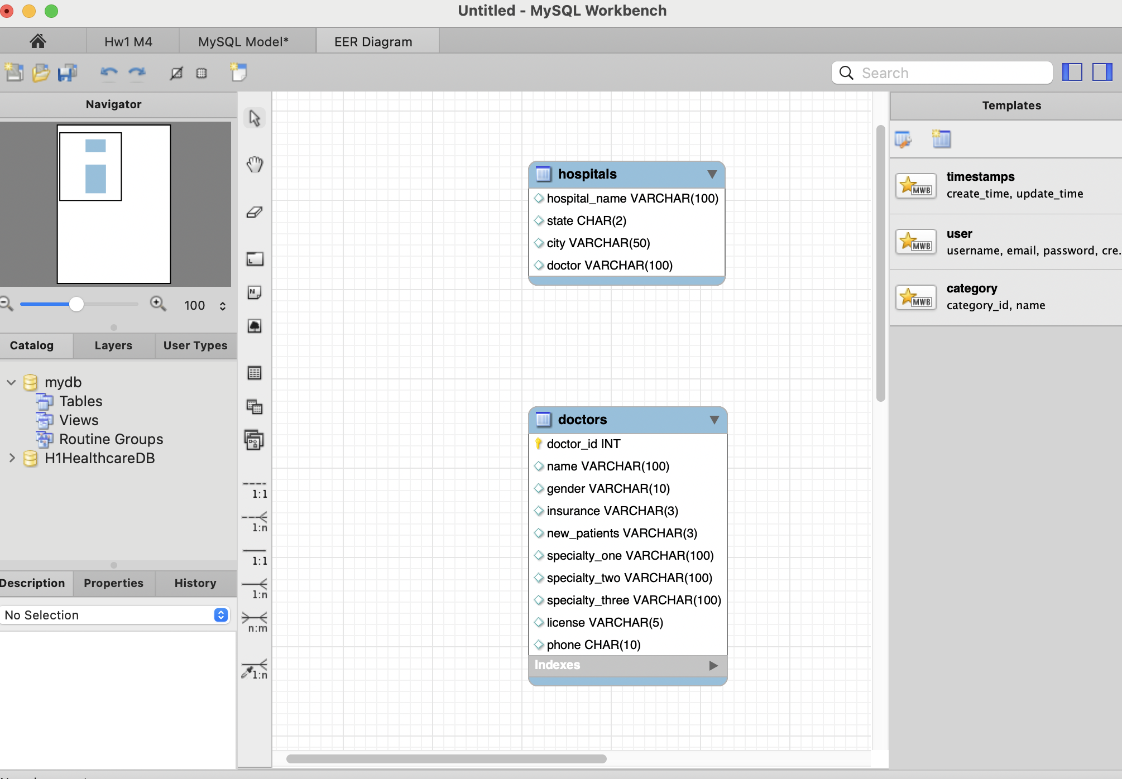

Part 3: Exploration Queries
You can find all Part 3 include
  - SQL code
  - 5 query questions and their answers
  - Figures and visualizations
As following :

Query 1: How many doctors are accepting new patients?
SELECT COUNT(*) AS accepting_new_patients FROM doctors WHERE new_patients = 'Yes';

Result: 19

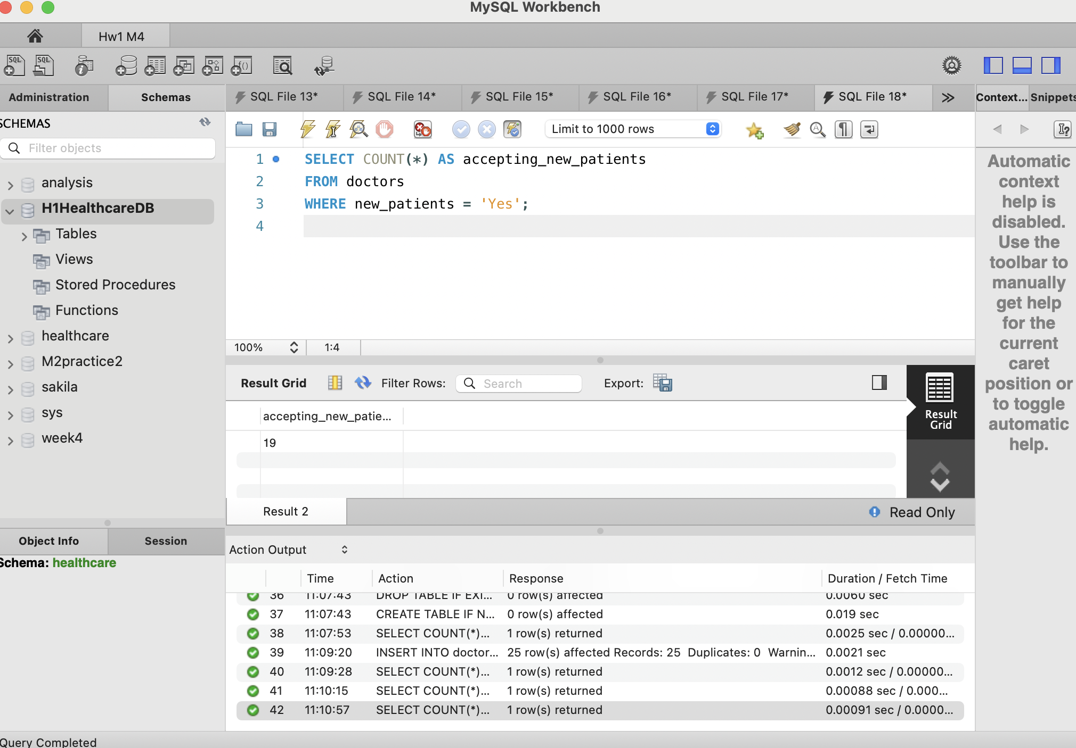

Query 2: How many doctors specialize in Diabetes?
SELECT COUNT(*) FROM doctors
WHERE specialty_one = 'Diabetes' OR specialty_two = 'Diabetes' OR specialty_three = 'Diabetes';
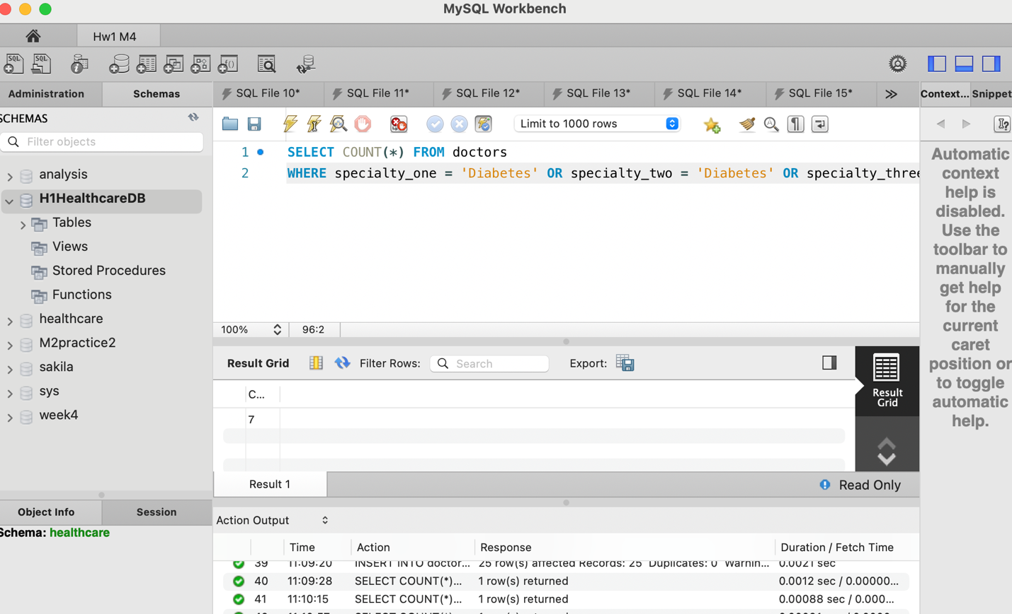

Query 3: Number of female doctors accepting new patients
SELECT city, COUNT(*) FROM hospitals GROUP BY city ORDER BY COUNT(*) DESC;
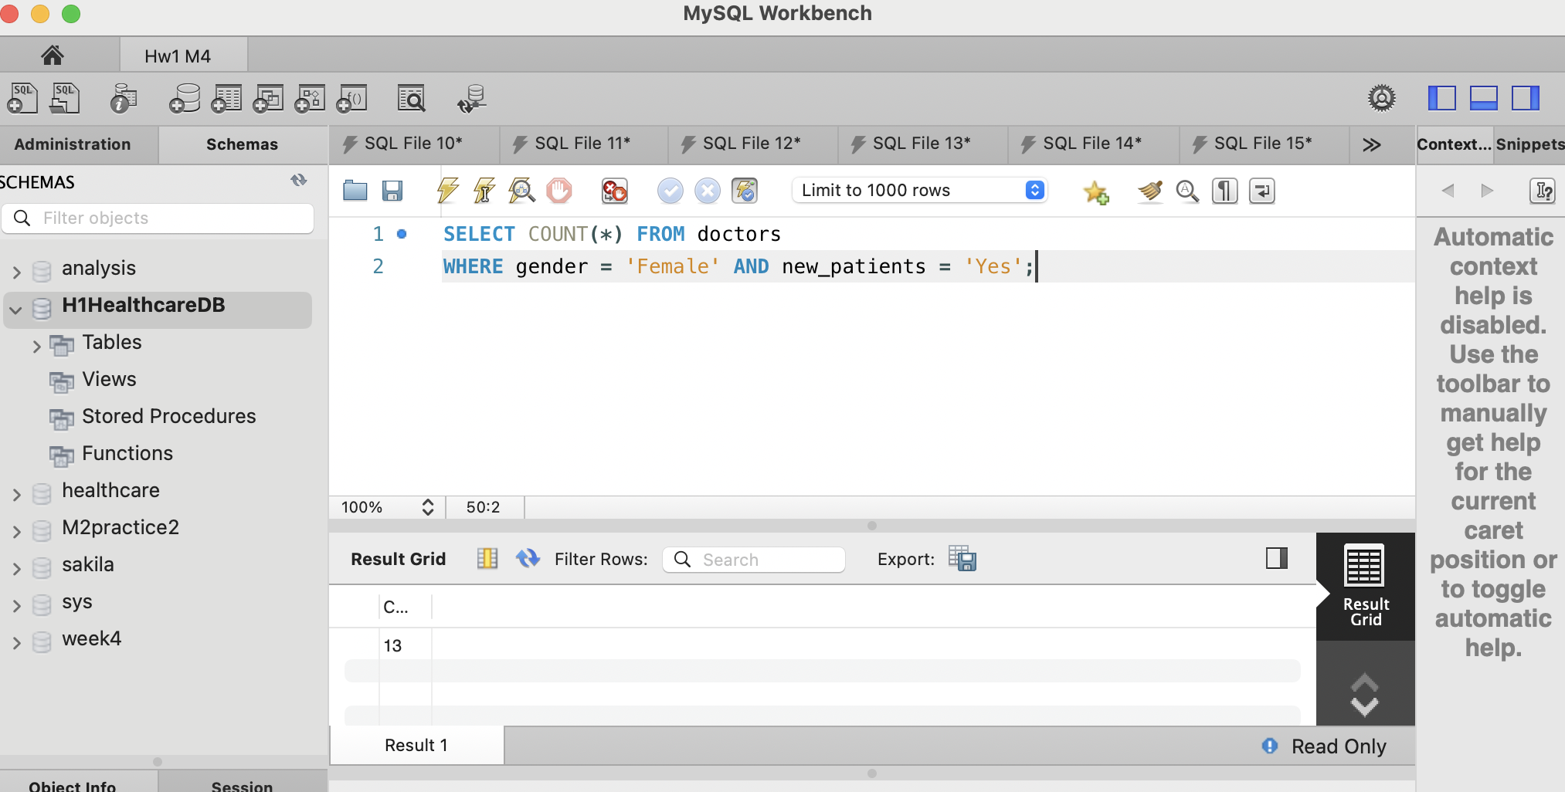

Query 4: Cities with most doctors
SELECT city, COUNT(*) FROM hospitals GROUP BY city ORDER BY COUNT(*) DESC;
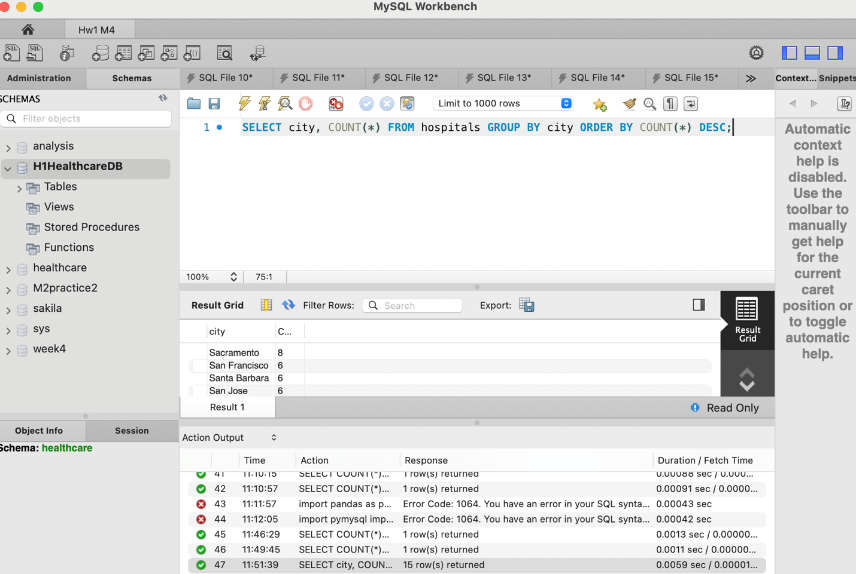

Query 5: How many doctors have 'PhD' license?
SELECT COUNT(*) FROM doctors WHERE license = 'PhD';
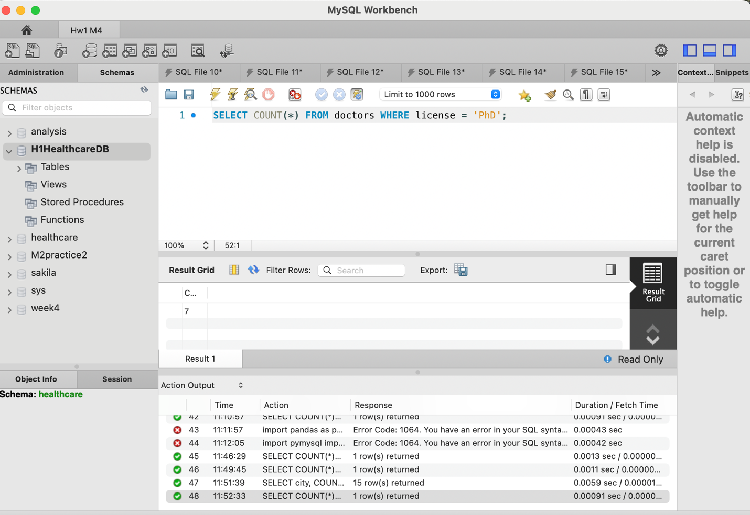

Part 3.2: Data Visualizations
Figure 1: Top 10 Most Common Specialties
Among Doctors 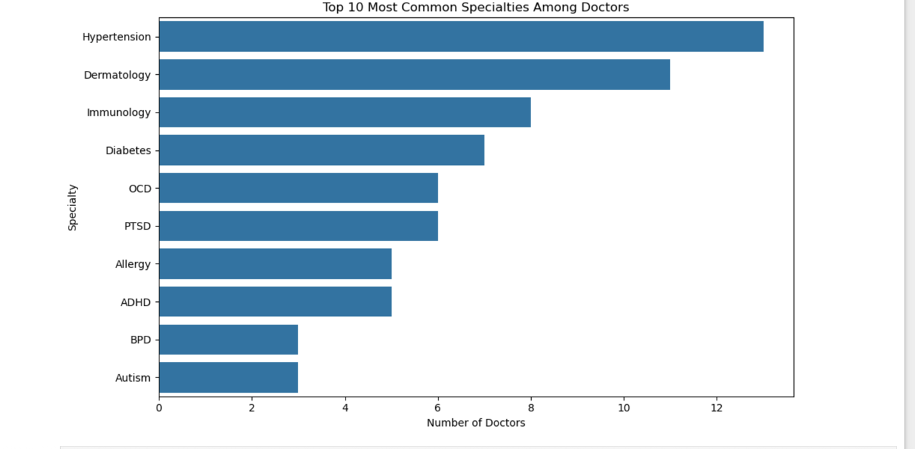
Bar chart showing the 10 most common specialties across all doctors. Specialties like Hypertension and Dermatology are the most frequent among providers.
Figure 2: Doctors Accepting New Patients
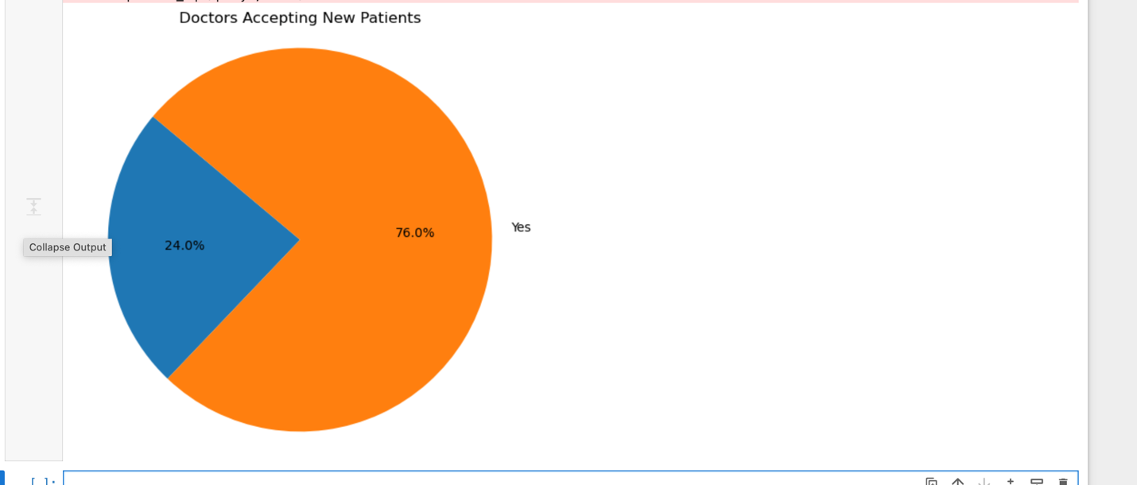
Pie chart showing that 76% of doctors are currently accepting new patients, while 24% are not.

